Software Requirement Specification

Hospital Management System



Submitted by
Muhammad Hamza
Roll No
F22BINFT1M01169
Submitted to
Ms.Kainat

Department of Information Technology
Faculty of Computing
The Islamia University of Bahawalpur

Summary:

The Hospital Management System (HMS) is designed to digitalize and streamline hospital operations, including patient registration, appointment scheduling, doctor management, staff records, billing, and medical reports. The system ensures smooth workflow between patients, doctors, and administrators by providing a centralized platform for managing hospital-related activities.
This system aims to improve service delivery, reduce manual workload, and enhance accuracy in hospital processes. Ideal for academic projects, the HMS also provides a foundation for future integration such as cloud-based health records, IoT-enabled patient monitoring, and mobile app support.

Table of Contents
1. Introduction
1.1 Purpose
1.2 Scope
1.3 Intended Audience
1.4 Definitions and Acronyms
2. Overall Description
2.1 Product Perspective
2.2 Product Functions
2.3 Use Case Diagram
2.4 User Characteristics
2.5 Constraints
2.6 Assumptions and Dependencies
3. Specific Requirements
3.1 Functional Requirements
3.2 Non-Functional Requirements
3.3 Hardware Requirements
4. System Design Constraints
5. Appendices
5.1 Tools and Software
5.2 Future Improvements

1. Introduction

1.1 Purpose

This document specifies all functional and non-functional requirements for the Hospital Management System. It serves as a guideline for developers, evaluators, and stakeholders involved in the design and implementation of the HMS.

1.2 Scope

The HMS automates hospital operations including patient handling, appointments, doctor schedules, billing, and report management. It is designed for academic use and prototype demonstration.

1.3 Intended Audience
- Academic supervisors and evaluators
- Students and development team
- Future contributors to the project
- Anyone studying hospital automation systems

1.4 Definitions and Acronyms

HMS: Hospital Management System
OPD: Outpatient Department
IPD: Inpatient Department
Admin: Hospital administrator managing the system
EMR: Electronic Medical Record

2. Overall Description

2.1 Product Perspective

The HMS is a standalone desktop/web-based system. It uses a centralized database for storing hospital information such as patients, doctors, staff, and appointments.

2.2 Product Functions
The system provides the following features:
- Patient registration and record management
- Appointment scheduling
- Doctor profile and schedule management
- Billing and payment processing
- Prescription and medical report generation
- User login and role-based authentication
- Pharmacy and inventory tracking (optional)
2.3 Use Case Diagram

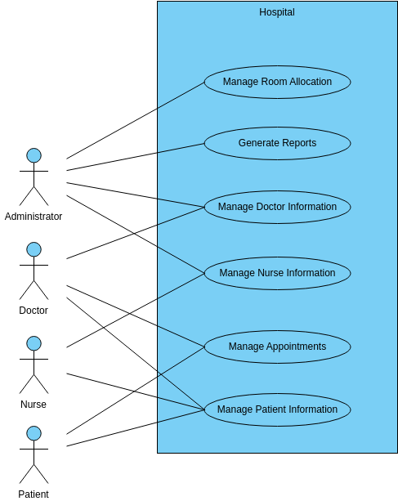

2.4 User Characteristics
- Basic computer knowledge
- Familiarity with healthcare processes (admin & doctors)
- General operational skills for using the UI

2.5 Constraints
- Requires stable power and device availability
- Limited to single hospital implementation
- Depends on accurate data entry
- Internet required only for cloud-based expansion (optional)

2.6 Assumptions and Dependencies
- Hospital staff will be trained to use the system
- All required hardware is available
- Database connection remains stable
- Users enter correct data into forms

3.1 Functional Requirements
ID | Requirement | Explanation
FR1 | Patient Registration | System stores new patient details including name, age, CNIC, phone, etc.
FR2 | Appointment Scheduling | Admin/patient can book appointments with available doctors.
FR3 | Doctor Management | System maintains doctor profiles, specializations, and timings.
FR4 | Billing System | Generates bills for services, treatments, and medicines.
FR5 | Medical Records | Stores diagnosis, prescriptions, lab results, and treatments.
FR6 | Authentication System | Separate login for Admin, Doctor, and Staff.
FR7 | Pharmacy (optional) | Tracks medicine stock and availability.
FR8 | Search & Reports | Admin can search patient records and generate reports.

3.2 Non-Functional Requirements

ID | Requirement | Explanation
NFR1 | Performance | System must respond to user actions within 2 seconds.
NFR2 | Reliability | Must run continuously for at least 8 hours without crash.
NFR3 | Security | Patient data must be protected with authentication and encryption.
NFR4 | Usability | Interface should be easy and intuitive for hospital staff.

3.3 Hardware & Software Requirements

Hardware
- Computer/ Laptop
- Minimum 4GB RAM
- 120GB Storage
- Printer (optional)
Software
- MySQL / SQL Server
- XAMPP / WAMP (if web-based)
- VS Code / PHP Storm / PyCharm
- Windows / Linux OS
- Browser (Chrome / Firefox)

4. System Design Constraints
- Storage limitations depending on hardware
- Database size grows with hospital records
- Data backup must be managed manually unless automated
- Requires careful role management to avoid unauthorized access

5. Appendices

5.1 Tools and Technologies
- HTML, CSS, JavaScript (Frontend)
- PHP / Python / Java (Backend)
- MySQL / SQL Database
- Figma or Canva (UI designing)
- MS Word / Google Docs (Documentation)

5.2 Future Improvements
- Mobile app for patients and doctors
- IoT-based patient monitoring
- SMS/Email appointment reminders
- AI-based disease prediction
- Cloud-based EMR sharing

