Set SASS environment.

1/ install node.js
in the terminal, type : “node --version”

2/ create folder, open it in terminal and type :
“npm init “

continue configuration by clicking on enter key.

Result : a file called “package” (json file) created inside the folder.

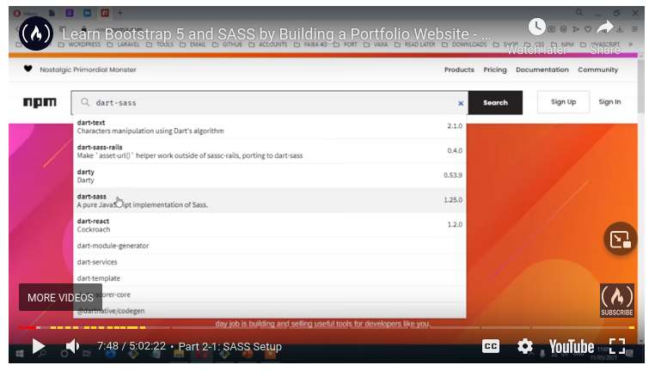
3/ go to : www.npmjs.com and search for dart-sass
install it in the folder with this commande : npm install --save-dev sass
results : in the main folder will be appear a sub-folder called node.modules and a file called package.lock (json file).

4/ install boostrap : npm install bootstrap --save

5/ install fontawesome : www.fontawesome.com and click on start for free.
Scroll down and click on “npm”, you will get the command to install it in the terminal : npm install –save @fontawesome/fontawesome-free

6/ install the autoprefixer : back to www.npmjs.com and search for autoprefixer.
In the terminal type : npm install postcss-cli autoprefixer --save

** --save = we need the package installed as a dependency**
7/ ssas to css compiling script :
open the package.json file in text editor, remove the existing script, and replace it with this one : “compile:sass”: “sass --watch scss:assets/css”
nb : double quotes are part of the code.
Inside the project create a folder called scss, then in the terminal run “npm run compile:sass”
from here, write your css in the scss folder. Files should be named like this “file.scss”.

8/ Customizing bootstrap
inside the SCSS folder create a file named “_custom.scss”. The underscore means that the file is only a partial and should not be generated into a style sheet.

Do overrides in this file by importing variable from : bootstrap/variables and by using “../node_modules/bootstrap/scss/bootstrap.scss”.
Link the style sheet at the top of theming-kit.html to watch changes.

