Blockchain Distributed Applications
Steve Huckle

Copyright © University of Sussex, 2016.
CC-BY-NC-SA 4.0 International
The work here is licensed under a Creative Commons Attribution-NonCommercial-ShareAlike 4.0 International License (CC BY-NC-SA 4.0). It is attributed to the University of Sussex. The license lets you remix, tweak, and build upon the work non-commercially, as long as you credit the University of Sussex and license your new creations under the identical terms.

VirtualBox Install
These are the installation instructions for running the The Answer and Currency Exchange demonstrator applications from within VirtualBox.
These instructions assume you have access to the file Sussex.ova. If you do not, please email s.huckle@sussex.ac.uk.

Dependencies
Download and install VirtualBox. If you are using Windows, you may wish to install PuTTY, which will allow you to ssh onto the VirtualBox Guest OS (ssh -l sussex 192.168.56.100). On a MAC or Linux machine, you will be able to do that from a terminal window.

Import the Tutorial
The following steps show you how to install the pre-installed image, Sussex.ova, which contains all the code and tools you will need for this tutorial.
Step 1: Import the appliance
Open VirtualBox and select the command Import Appliance from the VirtualBox File menu. See Figure 1.
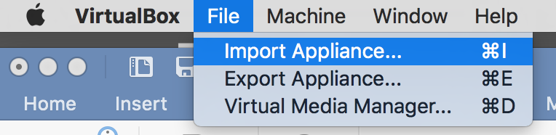
Figure 1: Install the pre-installed image using the ‘Import Appliance’ command
Select the file Sussex.ova from the USB drive supplied. See Figure 2.
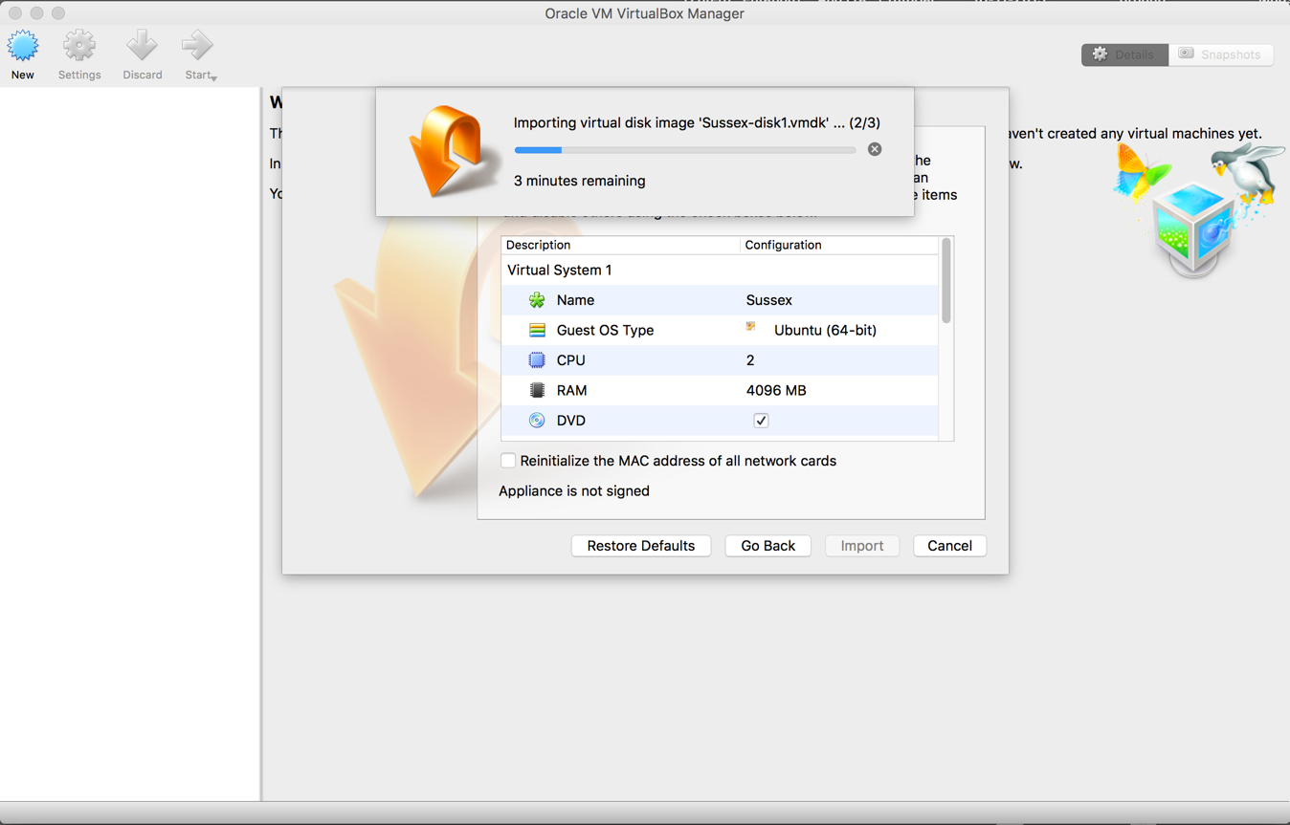
Figure 2: Navigate to the Sussex.ova file on the USB stick supplied
Once the VirtualBox image is installed you should have an Ubunto 64-bit operating system called Sussex, which is currently Powered Off, inside your VirtualBox Manager. See Figure 3.
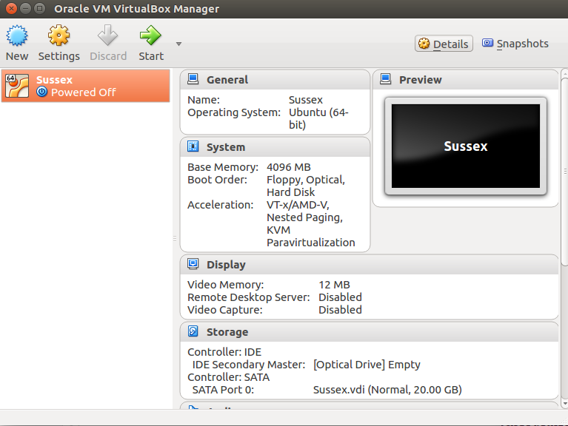
Figure 3: The Ubunto 64-bit operating system inside VirtualBox
You will be creating (or configuring) the smart contract applications The Answer and Currency Exchange demonstrator applications from within this version of Ubunto running inside VirtualBox.
Step 2: Create the Network
Create a Host-only Network. On MAC OS X, Go to VirtualBox VM on the main menu bar, select Preferences, Network, Host-only Networks. See Figure 4.
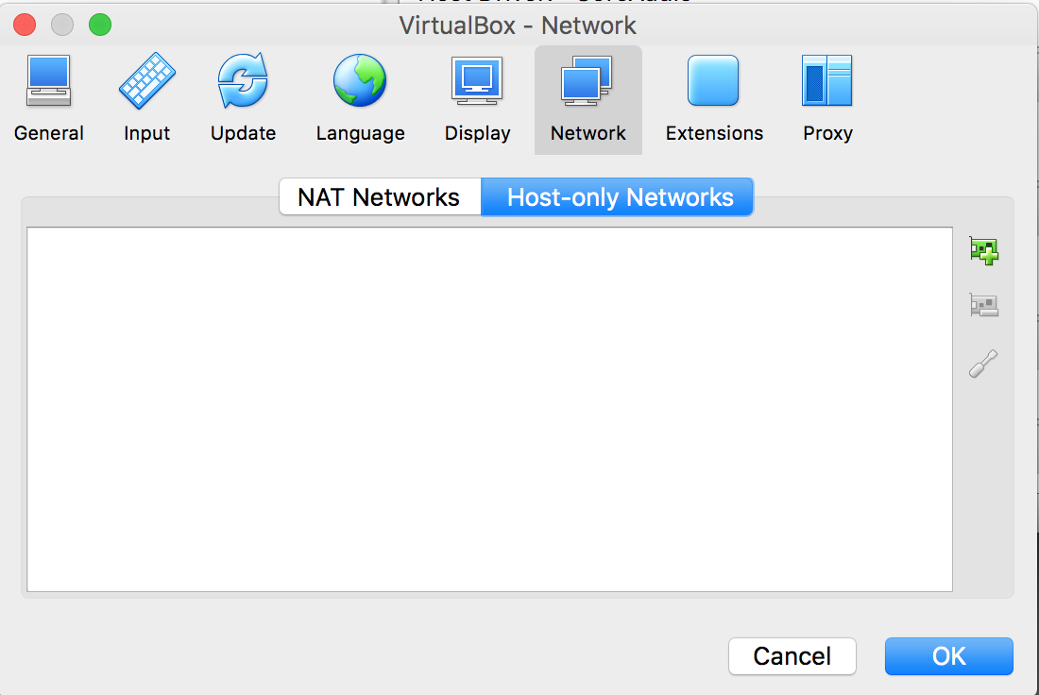
Figure 4: Set up the VirtualBox Host-only Network
Add a new Host-only Network: 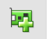. See Figure 5.
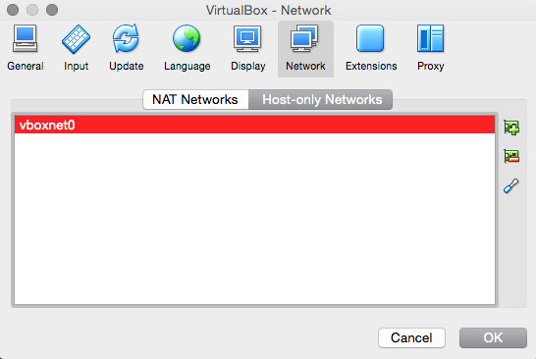
Figure 5: Add the Host-only Network — vboxnet0
Edit the default vboxnet0 and make sure the DHCP Server is disabled. See Figure 6.
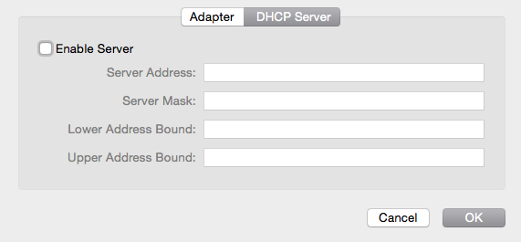
Figure 6: Disable the DHCP Server
Click OK a couple of times to return to the VirtualBox main screen.

Install The Answer
You have six steps to follow to install and write the smart contract for running The Answer.
- Start the Sussex Ubunto Operating System.
- Login to the OS and load the atom text editor.
- Write the smart contract (The Answer — a blockchain equivalent of Hello World).
- Deploy the smart contract to the blockchain.
- Install the front-end (the user interface) to the smart contract.
- Load up the front-end, which is a simple web page and use the smart contract.

Preamble - The Answer Architecture Overview
The Answer has the following architecture:
- An Ethereum blockchain back end. The Answer uses the Embark Framework to ease smart contract deployment. Once you have booted the VirtualBox Guest OS and logged in, you will find this in the directory /home/sussex/gitrepos/ExchangeCurrency/src/TheAnswer.
- A React Javascript front end. You will find this in the directory /home/sussex/gitrepos/ExchangeCurrency/src/react-the-answer.
geth is the the command line interface for running a full Ethereum node, and the command embark blockchain, run from the directory /home/sussex/gitrepos/ExchangeCurrency/src/TheAnswer, will load a correctly configured geth for you. However, you do need to do that because embark blockchain has been called at system startup. In fact, load a terminal window (by launching LXTerminal from the Application Launch Bar: ) and run the command pgrep -a geth - you will see the running process.
There is another process loaded at system startup which is monitoring for changes in the javascript front end directory, /home/sussex/gitrepos/ExchangeCurrency/src/react-the-answer. Hence, when you make changes to the front end later, the build process is done for you. The process is webpack -d watch.
Finally, there’s another process loaded at system startup that establishes a simple web-server on port 8082, which you’ll use to communicate with the front end javascript application for The Answer. pgrep -a node | grep the-answer will show both the build and web server processes.
Note: Subsequently, if you need other terminal windows, there are at least three ways to do this, 1) by launching another LXTerminal, 2) by creating a new tab within the existing LXTerminal window (shift+ctrl+t), 3) by using ssh to login to the Guest OS from the host (ssh -l sussex 192.168.56.100).
Step 1: Start the Guest OS
To start the Guest OS (Ubunto), simply double click on the Sussex Powered Off button in the VirtualBox Manager. See Figure 7.
Figure 7: The Ubunto 64-bit OS — click on the power button to turn it on
When you start the Guest OS, you should see a new window appear with the Ubunto OS booting up. See Figure 8. Eventually, it should show the login window.
Note: You can close the two warning messages. They are just telling you that when you are active in the VirtualBox window, the Guest OS will process input may hang onto the keyboard and mouse when you try to use them back in your host operating system. In which case, you’ll need to press the designated ‘Host Key’, which for the Mac is the left CMD key.
Step 2: Login and Load the Text Editor atom
Once the Guest OS has booted, you will see a login prompt. Login to the account sussex with the password h3ll0w0rld. See Figure 8.
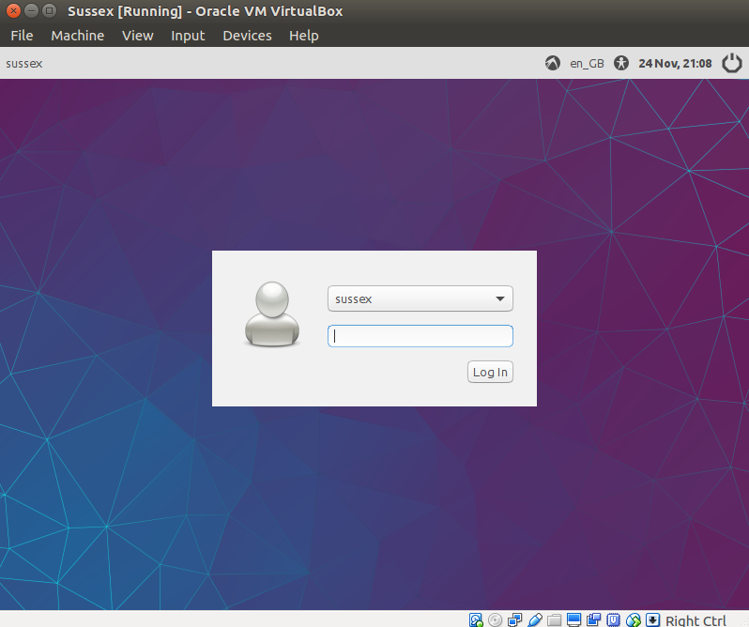
Figure 8: The Guest OS Login Screen
You should now be logged into the Guest OS. See Figure 9.

Figure 9: Logged into the Guest OS
Step 3: Write the Smart Contract
You will now code the smart contract The Answer using the atom text editor, whose icon you will find on the Application Launch Bar at the bottom left of the Guest OS: . Click on atom to the launch the editor. See Figure 10.
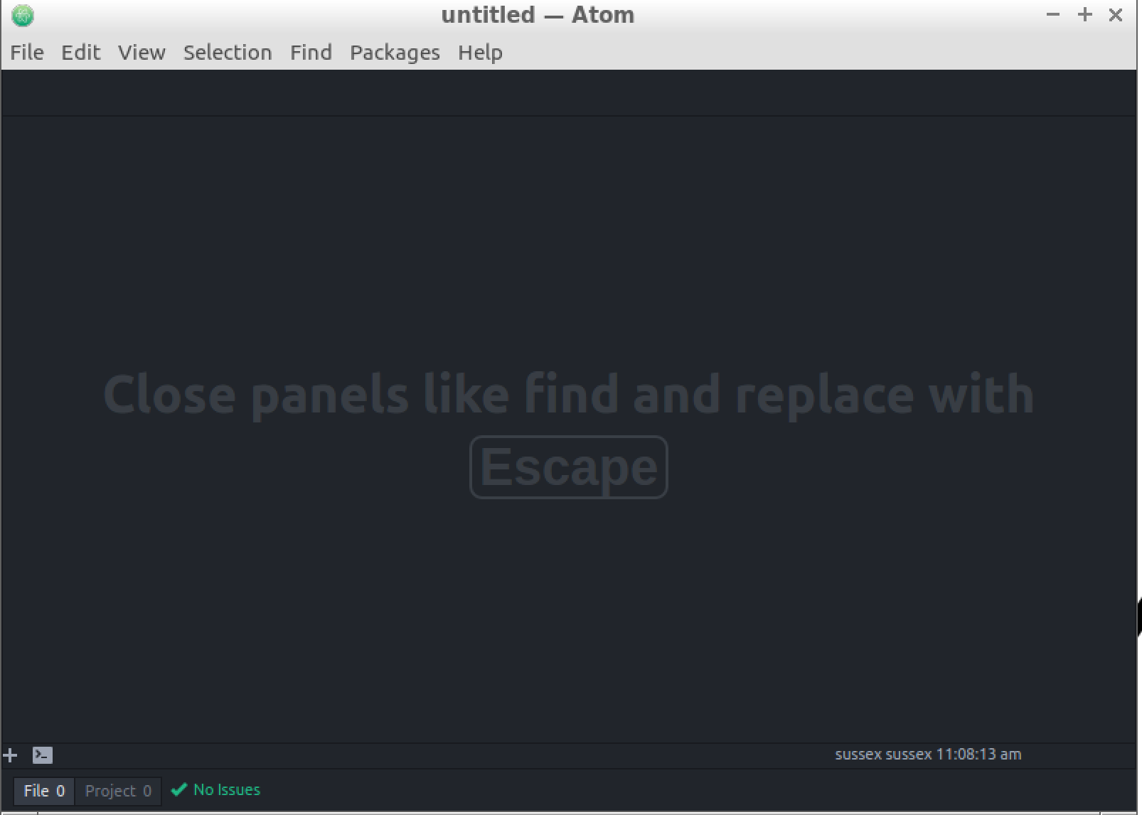
Figure 10: The Atom text editor
From within atom, open the folder /home/sussex/gitrepos/ExchangeCurrency. See Figure 11.
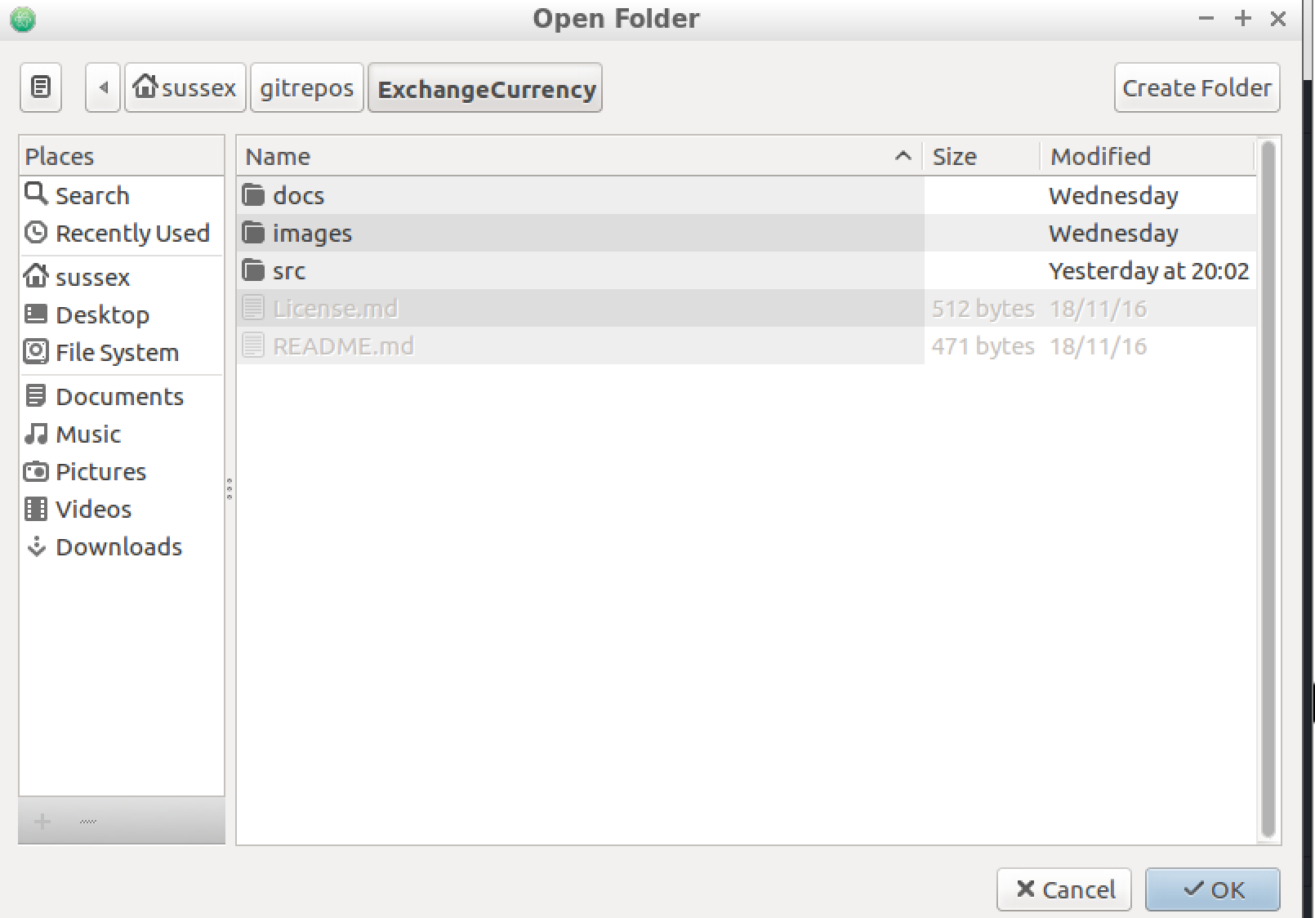
Figure 11: Navigate to the ExchangeCurrency folder
The directory tree of the files you’ll be working on are now open within atom. Navigate to the file src/TheAnswer/app/contracts/TheAnswer.sol and open it. See Figure 12.
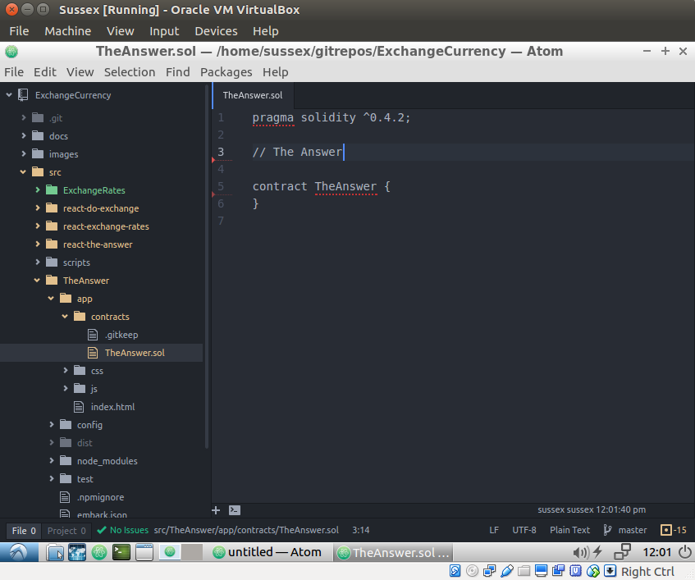
Figure 12: Edit TheAnswer.sol to create the smart contract
Edit the file so it looks EXACTLY like this:
pragma solidity ^0.4.2;
// The answer to any question.
contract TheAnswer {
string private question;
uint256 constant answer = 42;
event Question(string question, uint256 answer);
function TheAnswer () {
question = "";
}
function setQuestion(string thisQuestion) public {
question = thisQuestion;
Question(question,answer);
}
}
Save the file.
Step 4: Deploy the Contract
If you still have the terminal window open, go to that now. Otherwise, load a terminal window by launching LXTerminal from the Application Launch Bar: .
In the terminal window, change directory to /home/sussex/gitrepos/ExchangeCurrency/src/TheAnswer by running the command cd /home/sussex/gitrepos/ExchangeCurrency/src/TheAnswer.
The command embark run will deploy the contract to the blockchain running as a system daemon. It will do so by loading a console window telling you the status of the deployment. While deploying, the contract will show pending. See Figure 13.
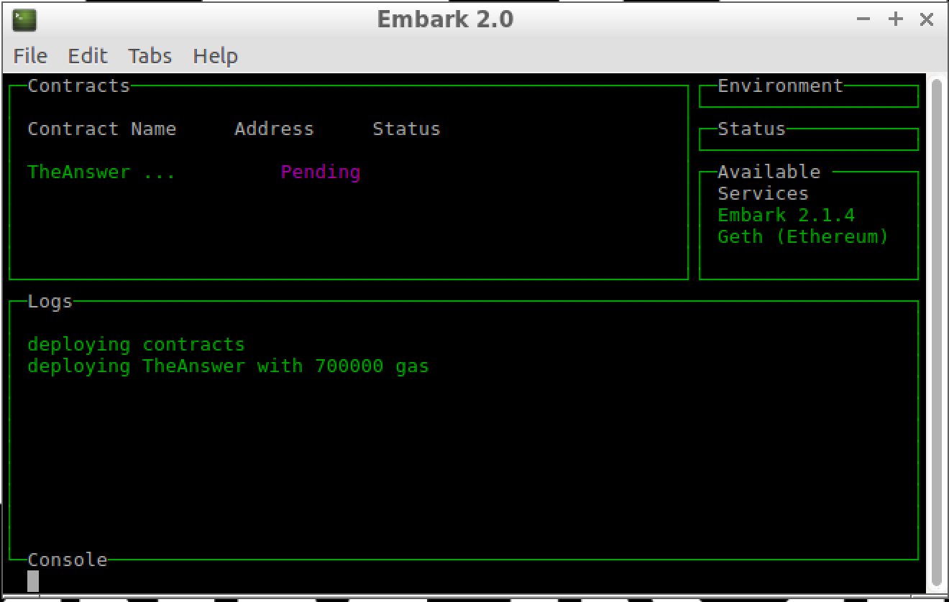
Figure 13: The smart contract deploying on the blockchain (showing pending)
Once the contract has been successfully deployed (it may take up to 5 minutes or more), the screen will look similar to that shown in Figure 14.
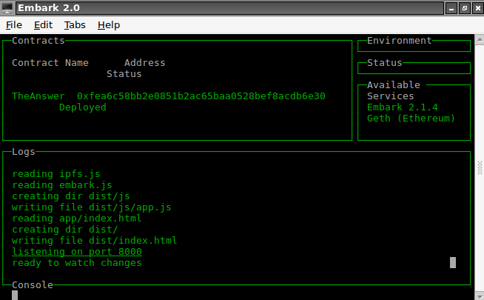
Figure 14: The smart contract now deployed on the blockchain (showing its address)
To see how the mining is progressing, you can tail the blockchain log by running the command tail -f /var/log/supervisor/blockchain.err.log. You should see a block commit when the contract is pending, and a mined block once it has been deployed. See Figure 15.
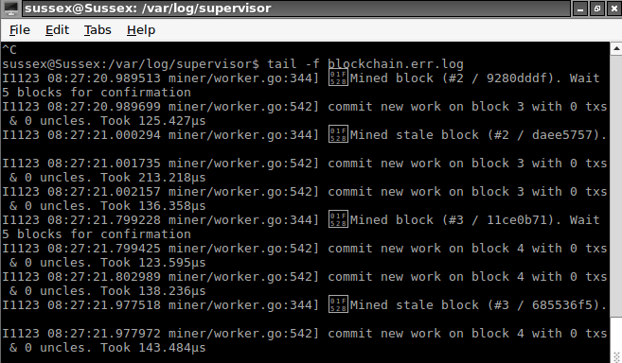
Figure 15: Monitoring the Blockchain Log
Step 5. Install the Front End
Now you need to connect to the smart contract with some kind of an application interface. You are going to use the React Javascript Framework for this because blockchains require asynchronous programming techniques (since you have to wait for blocks to be mined) and React manages ‘State’ really nicely. Due to its complexity, the front end has already been written for you. However, you still need to ensure it has the correct value for its smart contract address.
From within atom, navigate to the file src/react-the-answer/app/index.jsx. Figure 16 shows a version of the file.
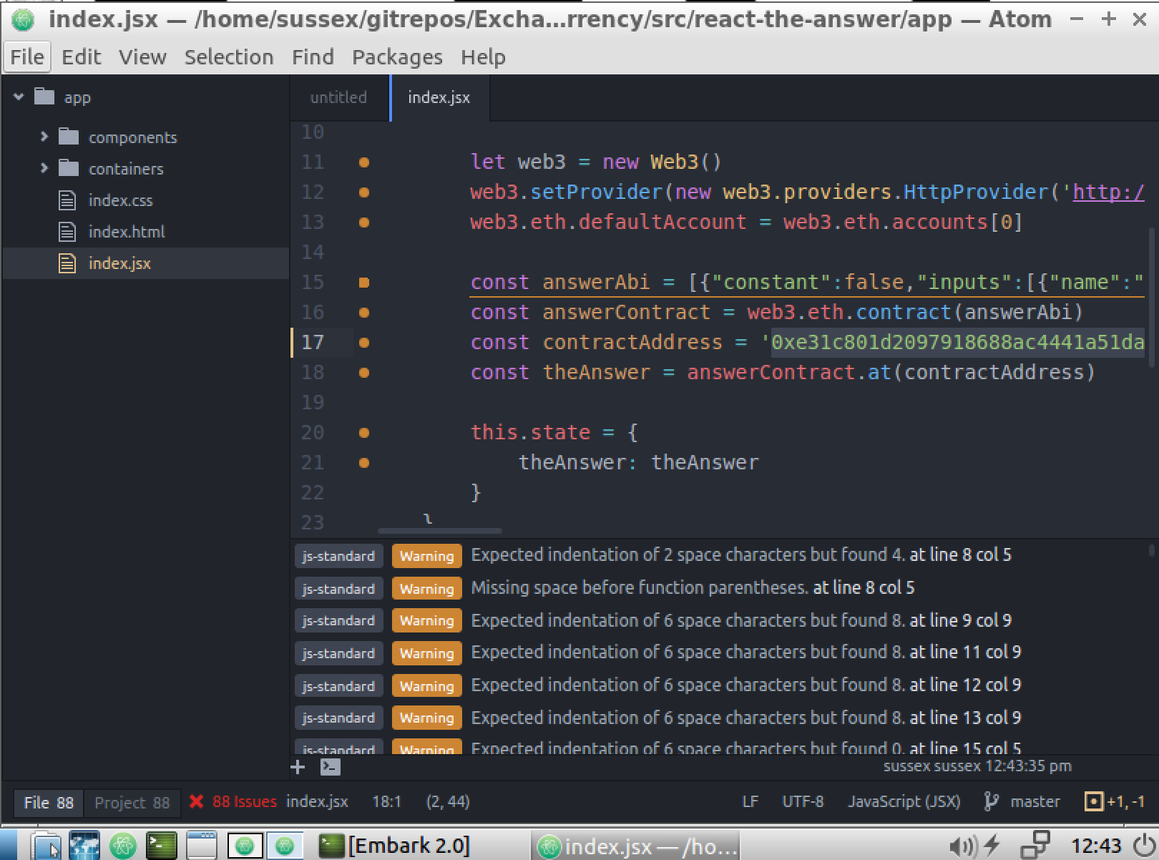
Figure 16: index.jsx file open in atom
In Figure 16, you can see the constructor function variable contractAddress, which is where the code stores the smart contract address.
To get the new value for the smart contract address, open the file /home/sussex/gitrepos/ExchangeCurrency/src/TheAnswer/chains.json by running the command cat /home/sussex/gitrepos/ExchangeCurrency/src/TheAnswer/chains.json from a terminal window. As the name implies, chains.json is a JSON formatted text file that stores the smart contract address. See Figure 17.
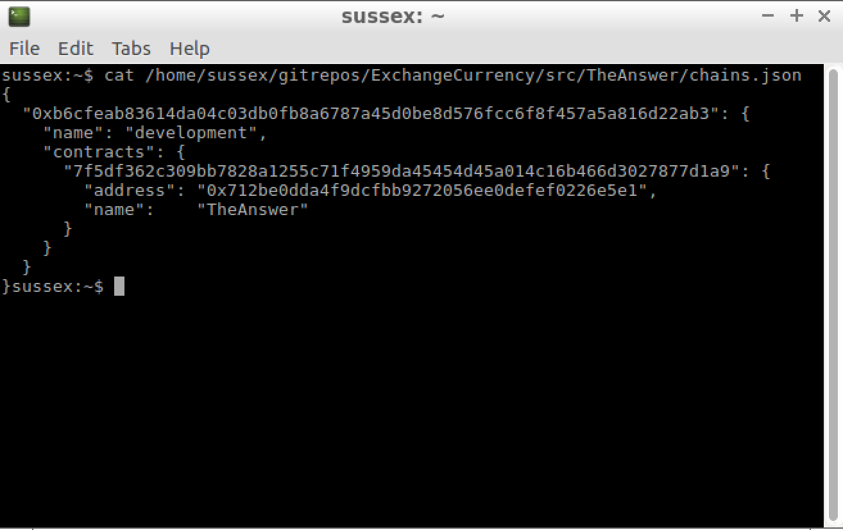
Figure 17: The terminal window showing the JSON formatted smart contract address
Alternatively, just open the file in atom.
The contractAddress variable in index.jsx, shown in Figure 16 above, requires the value of the address json key from chains.json. It will look something similar to:0x11bcf0e4dfeacd5d68a05180ceee4d50cc7cf720. Copy that value to the contractAddress variable.
Once you save index.jsx, the daemon running in the background will notice the change and will build the front end application for you.
Step 6: Load the URI
Load a web browser by launching Web Browser from the Application Launch Bar: .
Go to the following URL:
- http://blockchain.sussex.ac.uk:8082
You should see a screen like the one shown in Figure 18:
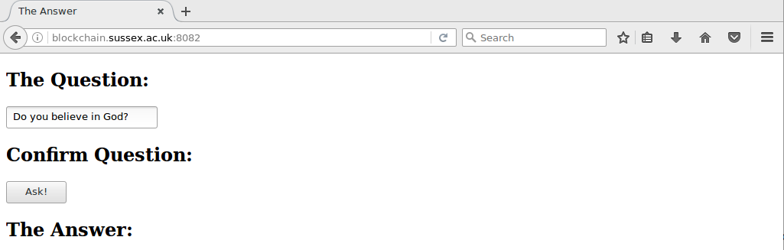
Figure 18: The smart contract front-end application as a web page in Mozilla Firefox

Using The Answer Demonstrator Application
To use the smart contract frontend application, simply type in a question and hit the Ask! Button.
The answer may take a while to appear (on some machines, it may take 5 minutes or more). Can you explain why it does not return instantly?

Examine the Front End Application
From within atom, open the files src/react-the-answer/app/index.jsx, src/react-the-answer/app/containers/answer.jsx and src/react-the-answer/app/components/answer.jsx.
- Do you understand the architecture of the front end application? Would you architect it that way? If not, how would you build the application?
- Why does the application use an event to get The Answer?

Install The Currency Exchange Application
You have six steps to follow to install and write the smart contract for running Currency Exchange.
- Start the Sussex Ubunto Operating System.
- Login to the Guest OS.
- Deploy the smart contract to the blockchain.
- Load atom.
- Install the front-end (the user interface) to the smart contract for the Currency Exchange Administrator.
- Install the front-end (the user interface) to the smart contract fo the Currency Exchanger.
- Load up the front-end, which are two simple web pages, and use the smart contract.
Below are the instructions for running the Currency Exchange demonstration from within VirtualBox.

Preamble - The Currency Exchange Architecture Overview
The Currency Exchange application has the following architecture:
- An Ethereum blockchain back end. Again, the Currency Exchange uses the Embark Framework to ease smart contract deployment. Once you have booted the VirtualBox Guest OS and logged in, you will find this in the directory /home/sussex/gitrepos/ExchangeCurrency/src/ExchangeRates.
- A React Javascript front end for the Currency Exchange Administrator. You will find this in the directory /home/sussex/gitrepos/ExchangeCurrency/src/react-exchange-rates.
- A React Javascript front end for the Currency Exchanger application itself. You will find this in the directory /home/sussex/gitrepos/ExchangeCurrency/src/react-do-exchange.
During the tutorial for The Answer, you learned that geth is the the command line interface for running a full Ethereum node, and the command embark blockchain, run this time from the directory /home/sussex/gitrepos/ExchangeCurrency/src/ExchangeRates, will load a correctly configured geth for you. However, you do need to do that because embark blockchain has been called at system startup; opening a terminal window and running the command pgrep -a geth will show you the running process.
As with The Answer, there are processes loaded at system startup which are monitoring for changes in the javascript front end directories, /home/sussex/gitrepos/ExchangeCurrency/src/react-exchange-rates (which is the Currency Exchange Administrator frontend) and /home/sussex/gitrepos/ExchangeCurrency/src/react-do-exchange (the Currency Exchanger). Hence, when you make changes to the front end javascript files later, the build process is done for you. The process is webpack -d watch.
Again, much like The Answer, there are other processes loaded at system startup that establish simple web-servers on ports 8080 and 8081. You’ll use those to communicate with the front end javascript applications. pgrep -a node | grep exchange will show both the build and web server processes.
Step 1: Start the Guest OS
To start the Guest OS (Ubunto), simply double click on the Sussex Powered Off button in the VirtualBox Manager. See Figure 19.
Figure 19: The Ubunto 64-bit OS — click on the power button to turn it on
When you start the Guest OS, you should see a new window appear with the Ubunto OS booting up. Eventually, it should show the login window.
Note: You can close the two warning messages. They are just telling you that when you are active in the VirtualBox window, the Guest OS will process input may hang onto the keyboard and mouse when you try to use them back in your host operating system. In which case, you’ll need to press the designated ‘Host Key’, which for the Mac is the left CMD key.
Step 2: Login
Once the Guest OS has booted, you will see a login prompt. Login to the account sussex with the password h3ll0w0rld.
Step 3: Deploy the Contract
Load a terminal window by launching LXTerminal from the Application Launch Bar: .
Change directory to /home/sussex/gitrepos/ExchangeCurrency/src/ExchangeRates by running the command cd /home/sussex/gitrepos/ExchangeCurrency/src/ExchangeRates.
The smart contracts for this application have been written for you. Unfortunately, the design and coding of the Currency Exchange smart contracts are quite complicated. Hence, it is beyond beyond the scope of this session to write them from scratch. So, in this case, you just need to deploy the smart contracts that have already been written to the blockchain. Do so with the command embark run.
embark run loads a console window telling you the status of the deployment. While deploying, the contract will show pending. The console will display contract addresses once they have been successfully deployed (to deploy every contract, it may take up to 5 minutes or more). See Figure 20.
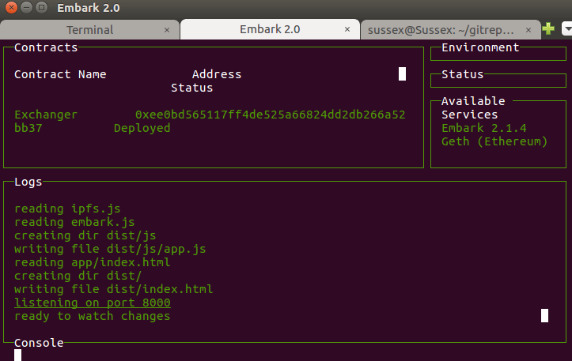
Figure 20: Contract deployment completed
Step 4: Load atom
Launch atom from the Application Launch Bar: .
From within atom, open the folder /home/sussex/gitrepos/ExchangeCurrency. See Figure 21.
Figure 21: Navigate to the ExchangeCurrency folder
Step 5: Install the Front End Currency Exchange Administrator
The React Javascript front end has been written for you.
However, you still need to ensure the front end has the correct value for its smart contract address. Open the file src/react-exchange-rates/app/index.jsx in atom. Figure 22 shows the file.
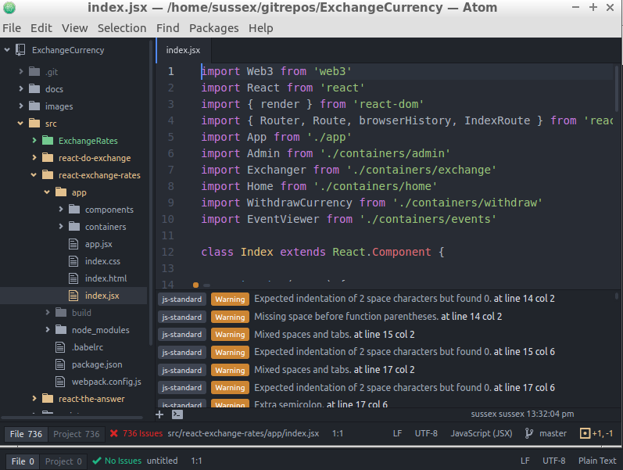
Figure 22: The Exchange Rates index.jsx
The constructor function variable contractAddress is where the code stores the address. To get the necessary value, open the file /home/sussex/gitrepos/ExchangeCurrency/src/ExchangeRates/chains.json by running the command cat /home/sussex/gitrepos/ExchangeCurrency/src/ExchangeRates/chains.json from a terminal window. As the name implies, chains.json is a JSON formatted text file that stores the smart contract address.
Alternatively, just open the file in atom.
The contractAddress variable in index.jsx requires the value of the address json key from chains.json for the contract Exchanger (Note: not Exchange - that’s its abstract interface). It will look something similar to:0x11bcf0e4dfeacd5d68a05180ceee4d50cc7cf720. See Figure 23 for a version of chains.json. Copy that value to the contractAddress variable.
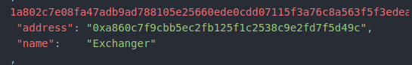
Figure 23: The Exchanger smart contract#s address in chains.json
Once you save index.jsx, the daemon running in the background will notice the change and will build the front end application for you.
Step 6: Install the Front End Currency Exchange Application
Similarly to the previous step, you still need to ensure the front end has the correct value for its smart contract address. Open the file src/react-do-exchange/app/index.jsx and make sure the contractAddress variable has the same value for its exchanger smart contract address as above. Once that’s so, save the file. The daemon will notice the change you just made and will build the front end application for you.
Step 7: Load the URIs
Load a web browser by launching Web Browser from the Application Launch Bar: .
Load the following URIs,which are the front-end applications:
- The Currency Exchange Administrator. See Figure 24.
  - http://blockchain.sussex.ac.uk:8081
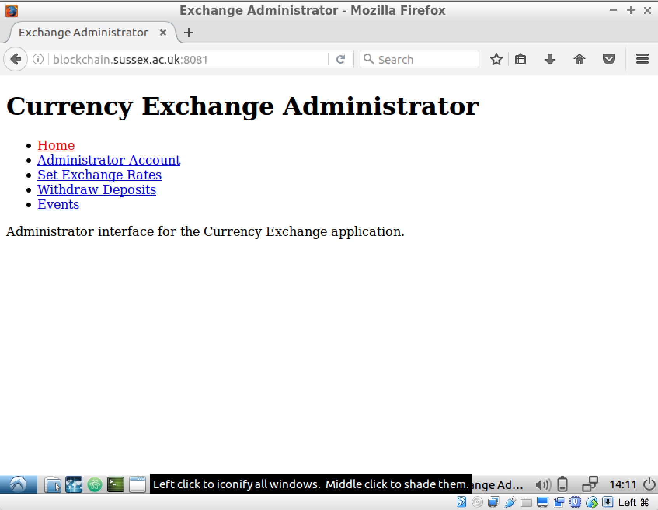
Figure 24: The Currency Exchange Administrator
- The Currency Exchanger. See Figure 25.
  - http://blockchain.sussex.ac.uk:8080
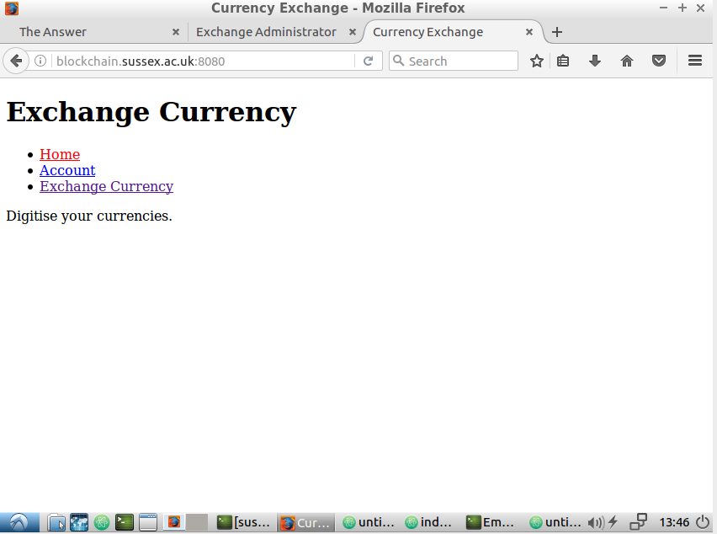
Figure 25: The Currency Exchanger

Using the Currency Exchange Demonstrator Application
Below are the instructions for using the Currency Exchange application.
Step 1: Run the Currency Exchange Administrator
- Fund the contract from the Administrator account. Why didn’t the funding happen instantly (it may take up to 5 minutes or more on some machines)? After the funding, you might have expected the Administrator account to have the original funds minus those you just gave to the contract. Why is that not so?
- Set some Exchange Rates (again, these actions may take a while to complete). Again, note that the Administrator’s funds will have changed. You should now be able to explain why.
Step 2: Run the Currency Exchanger
- Choose a currency whose rate we set above. You should see that rate here. Exchange some of that currency. Note what happens to the account’s Ether funds. Once again, you should be able to explain why that account has more Ether than you expected.
- If you successfully exchanged the currency, go back to the Currency Exchange Administrator and withdraw some of the currency just deposited.

Known Limitations and Bugs
The application is at the early stages of development, so there are many ways it can be improved. Indeed, imagine you are part of the development team; how could you improve the product?
Below are some of the known limitations/bugs of the application. There will be (many) others too!
- Blockchain transactions would normally need ‘signing’ to identify the sender. See Ethereum Contracts and Transactions. That behaviour has not been implemented because you are using a private Ethereum blockchain whose default account is automatically ‘unlocked’. In a ‘live’ environment, that signing requirement will need implementing.
- There’s no account security because the default account is unlocked. You can steal its Ether!
- The application isn’t really distributed, since the frontend relies on (centralised) web servers. You can deploy to Mist to overcome that; see Dapps deployment. dApp resources, such as files and images, can be deployed to IPFS, or the forthcoming Swarm, and referenced.
- You can (try) and give more Ether to the contract that the Administrator owns. What happens if you do that?
- The Administrator’s Events page only shows events for the current session. It could show all events.
- Should the Administrator set the exchange rates? If not, how should the rates be set?
- Could this application exchange real currency?
- What does the deposit do? How could it behave?
- What does a withdraw do? How could it behave?
- You can (try) and exchange for more Ether than the contract contains. What happens if you do that?

