LWMC OPERATIONS

Fleet Dashboard
Complete user manual
Live fleet visibility, vehicle-level investigation, and operational reporting for Lahore.
Version 1.0 | 11 September 2026
Scope: Lahore city fleet operations. This manual describes the packaged desktop application and its daily data workflow.

Contents
Section | Use it for
1. Purpose and scope | Understand what the dashboard includes and what a snapshot means.
2. Daily operating procedure | Prepare files, launch the app, validate today's data.
3. Data sources | Import or reset source files and understand auto-detection.
4. Map & Analytics | Read KPIs, map state, alerts, filters and exports.
5. Fleet Table | Investigate vehicles using status and responsibility filters.
6. Reports | Generate registry, TM, FM and combined workbooks.
7. Data definitions | Interpret deployment, registry, working-hours and assignment fields.
8. Troubleshooting | Resolve stale data, missing files and report errors.

1. Purpose And Scope
LWMC Fleet Dashboard is a Lahore-focused desktop application for reviewing a live VTMS snapshot together with the fleet establishment registry, vehicle-status data, Lahore UC and zone boundaries, employee coverage, trip reports and optional GPS history.
IMPORTANT The dashboard shows a point-in-time operational snapshot. It does not by itself prove how long a vehicle remained inside or outside its assigned area. Compare dated master files when a time series is required.

What the application provides
- Map & Analytics: KPIs, operational cards, vehicle map, analytics views, alerts and an interactive fleet table.
- Fleet Table: every registered vehicle joined to the current live VTMS snapshot, with searchable filters and a fleet registry report button.
- Reports: Fleet Registry, TM Performance, FM Performance and Combined workbooks saved in the reports folder.
- Persistent data source controls: choose files from the interface, or use automatic file detection when the source names follow the documented patterns.

2. Daily Operating Procedure
Use this sequence at the start of each operating day. It keeps the data date, the displayed snapshot and the generated reports aligned.
- Download the current VTMS active-log CSV and vehicle-status export. Add the employee roster, fleet registry, trip reports or vehicle-history CSV when those sources are available.
- Place the files in the project folder or select them using the Import buttons at the top of the application. Keep old exports in a separate archive folder if automatic detection is being used.
- Launch LWMC_Fleet_Dashboard.exe from the packaged folder. Keep the executable and its _internal folder together.
- Wait for loading to finish. The app regenerates derived reference data and the dashboard snapshot in the background.
- Check the snapshot date, source labels, vehicle count and the Map & Analytics view before making an operational decision.
- Use filters or reports for the question at hand. Allow report generation to finish before opening the workbook or closing the application.
EXPECTED BEHAVIOR The app may write dashboard_data.json, the standalone HTML dashboard and reference data next to the executable. This is normal and indicates that the current source set was processed.

Launch checks
Check | Expected result | What to do if it fails
Snapshot date | Matches today's VTMS export date. | Review the selected VTMS file and its filename/date.
Source strip | Each required source shows a filename or auto-detected status. | Use the matching Import button.
Vehicle count | A plausible count for the Lahore fleet. | Check whether the source was filtered or stale.
Map & Analytics | Overview cards and fleet rows are visible. | Confirm dashboard_data.json and HTML exist; reload sources.

3. Data Sources
The source strip is visible above all three tabs. Selecting a file is remembered for future launches and automatically reloads the application.
Button | Accepted source | Used for
Import VTMS Export | CSV active logs | Live position, status, UC and zone.
Import Vehicle Status | XLS/XLSX export | Vehicle-status and battery fields.
Import Employee Roster | XLSX roster | TM, FM, ZO, AM Yard and MVI responsibility.
Import Trip Reports | One or more XLSX files | TM/FM trip scoring by date and circle.
Import Fleet Registry | XLSX establishment registry | Registered category, town and fleet targets.
Import Vehicle Tracks | CSV GPS history | Historical route tracks and activity context.

Automatic detection
When no override is selected, the application looks for recognized filename patterns and generally uses the most recently modified matching file. Use Reset to auto-detect after a one-off import, or when the status strip points to the wrong file.
GOOD PRACTICE Do not leave multiple competing current-day exports in the same folder when relying on auto-detection. A clean input folder makes the selected source obvious.

4. Map & Analytics
Map & Analytics is the operational overview. It combines the current snapshot with summary metrics, map layers, analytics cards, alerts and a vehicle table. The standalone HTML dashboard can also be opened in a browser; map tiles require internet access, while the embedded data and tables work offline.
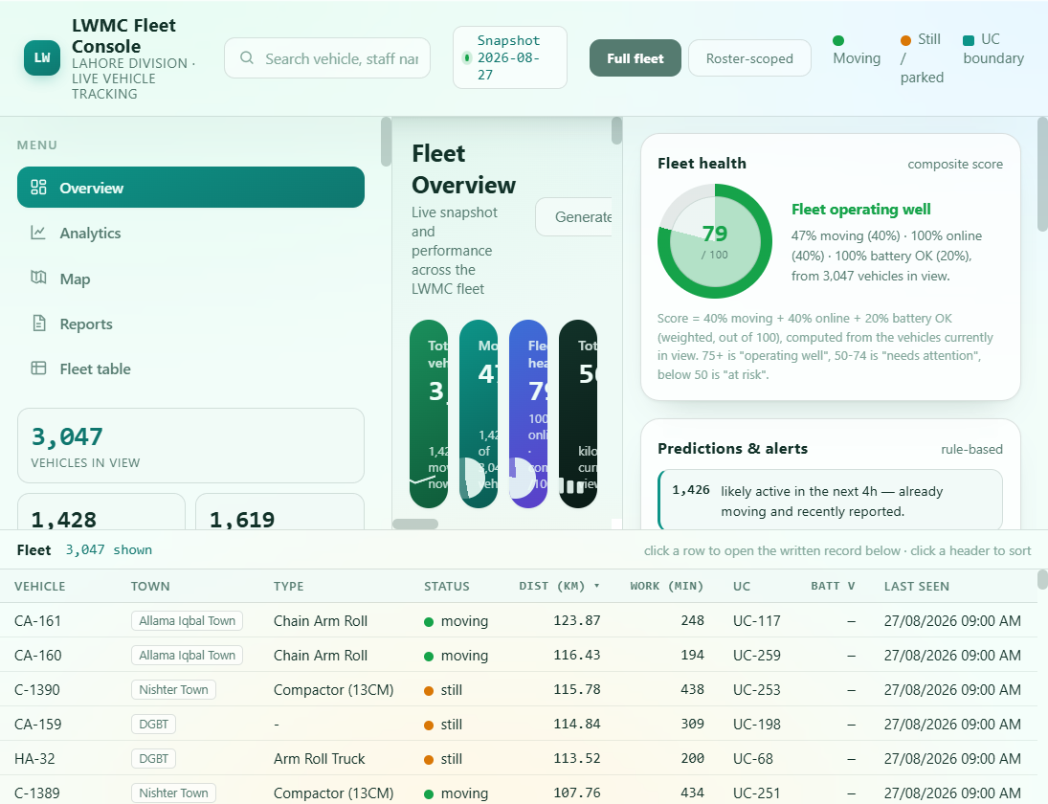
Figure 1. Current Map & Analytics view captured from the dashboard.

How to read the overview
- Snapshot: confirms the data date currently displayed.
- Full fleet / Roster-scoped: Full fleet includes Lahore vehicles; Roster-scoped limits the view to vehicles inside UCs covered by the employee roster.
- Moving and Still / parked legend: explains the primary live-status colors.
- Fleet health: a composite score based on moving, online and battery-OK proportions for vehicles currently in view.
- KPI cards and table: provide counts and a fast way to open the written vehicle record below the dashboard.

Navigation and investigation
- Use Overview for the fleet-wide signal and Analytics for comparisons such as town targets, working-hours distribution and top zones by distance.
- Use Map to inspect vehicle locations, boundaries and route history. Select a vehicle or use the search field to focus the view.
- Use Reports for the written export. Use Fleet table when the question needs a precise combination of status, category, town, zone, UC or employee.
- Use the Full fleet / Roster-scoped toggle when you need either the organization-wide picture or only the staff-covered operational area.

Roster-scoped mode
Roster-scoped mode restricts map, KPIs, charts, table, written report and Excel export to vehicles in UCs that are covered by the roster. The Employee selector drills into one person's resolved UCs. An unresolved employee remains visible and is labeled as unresolved area so coverage gaps can be corrected in the source roster.

5. Fleet Table
Use Fleet Table for vehicle-level work: finding a moving vehicle, checking a town or zone, reviewing registry-only vehicles, or preparing the fleet registry report.
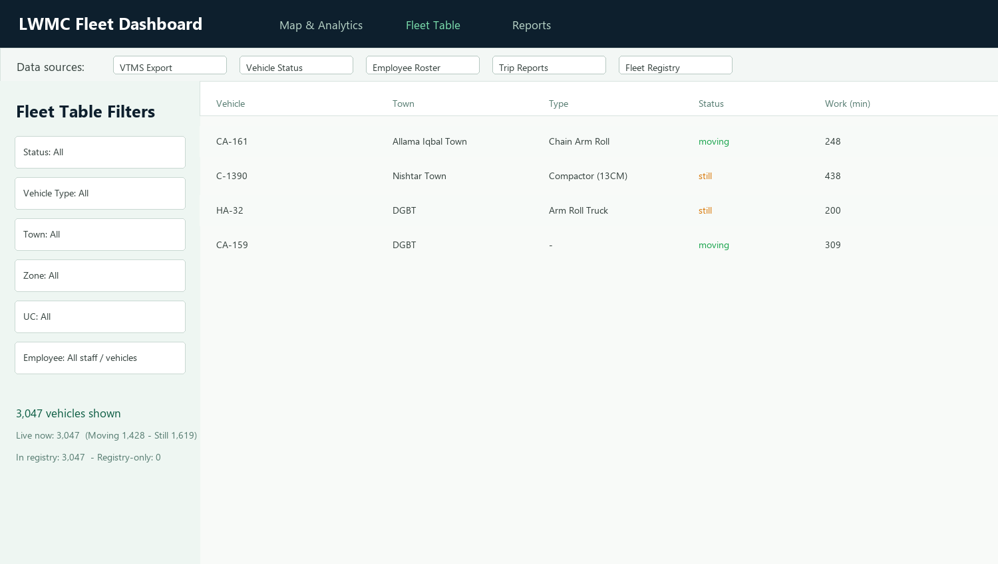
Figure 2. Fleet Table with the live filter sidebar and vehicle rows.

Apply filters
- Choose a Status: All, Moving, Still or Not Live (registry only).
- Choose a Vehicle Type, Town, Zone or UC. Each dropdown supports type-to-search.
- Choose an Employee to show vehicles currently reporting inside that person's resolved UCs. The note beneath the filters reports the person's role, coverage and moving/still counts.
- Read the summary after every change. It reports vehicles shown, live count, moving/still counts, registry count and registry-only count.
- Use Reset filters to return every selector to All.
FILTER LOGIC Town, zone, UC and employee filters compose with AND logic. For example, Town + Zone shows only rows satisfying both selections.

Generate a Fleet Registry report
The button at the bottom of the Fleet Table sidebar generates the current Fleet Registry workbook from the live snapshot. The report includes the registry/live vehicle table, town summary, employee coverage and status exceptions. The result is written to the reports folder and a completion dialog confirms the path.

6. Reports
The Reports tab creates Excel workbooks in the reports folder. Select the report type on the left, optionally set dates or a circle for performance reports, then click Generate report (.xlsx).
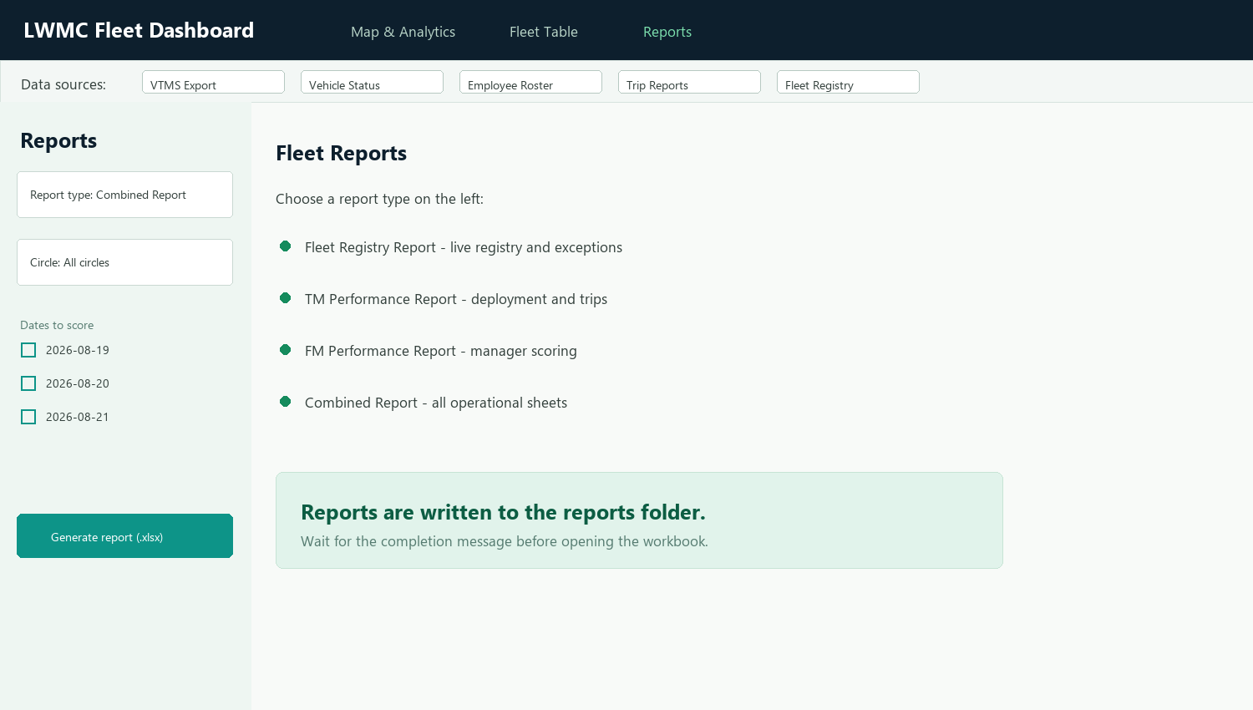
Figure 3. Reports tab with report type, date and circle controls.
Report | When to use it | Main contents
Fleet Registry | Current live operational snapshot. | Every vehicle, town summary, employee coverage and exceptions.
TM Performance | Score Town Managers. | Deployment marks and trip-weightage marks by day.
FM Performance | Score Fleet Managers. | Same scoring approach for Fleet Managers.
Combined | Share one complete workbook. | Overview, registry, TM performance and FM performance sheets.

Date and circle filters
- Date and circle controls appear for TM, FM and Combined reports. They are hidden for Fleet Registry because that report always uses the current live snapshot.
- Check one or more dates to score only those dates. Leave every date unchecked to include all available trip-report dates.
- Choose All circles or a specific circle. Date and circle filters work together.
- Wait for the status message and completion dialog before opening the workbook. Close an existing workbook if Windows reports that the output file is locked.

Where files go
Generated workbooks are written to the reports folder in the project directory. The Reports tab includes Open reports folder for quick access.

7. Data Definitions
Term | Meaning
Live | A vehicle present in the current VTMS snapshot.
Moving | Current VTMS status indicates movement.
Still | Current VTMS status indicates the vehicle is not moving.
Registry only | Registered vehicle with no current live row.
Town target | Target fleet count from the establishment registry; loader-rickshaw and full-fleet targets are separate.
Assigned town | Registry town when the vehicle ID matches; a coarser tehsil-code fallback may be used otherwise.
In assigned area | Whether the current GPS point is inside the vehicle's assigned town; it is a current status, not a duration.
Working hours | Per-vehicle working time bucketed as Below 2h, 2-4h, 4-6h, 6-8h or Above 8h.
Zone | A fixed group of Lahore UCs. Zone filters compose with town and UC filters.

Performance scoring
TM and FM performance uses a score out of 100: 20 deployment marks plus 80 trip-weightage marks. The score is evaluated per day against the manager's assigned zones and UCs, using the trip-report workbooks selected for the report.
INTERPRET CAREFULLY A current 'in assigned area' flag is not a historical compliance percentage. Use stacked master_<date>.csv files or dated reports when looking for trends.

8. Troubleshooting
Symptom | Likely cause | Resolution
Numbers look stale | The wrong or older source file was selected. | Check the source strip, use Import VTMS Export, then wait for reload.
Map is empty or missing | dashboard_data.json or the dashboard HTML is missing or could not be rebuilt. | Confirm the files are beside the executable and reselect the VTMS source.
Vehicle status fields are blank | The vehicle-status export is missing or has a changed layout. | Import a valid XLS/XLSX status export and reload.
Employee list is empty | Roster is missing, unreadable or does not match the expected sheets. | Import the employee roster and confirm its Town Managers, Fleet Managers, Zonal Officers, AM Yards and MVI sheets.
Trip dates are empty | No trip-report workbooks were found. | Import one or more trip-report XLSX files or place them in New folder.
Report generation fails | Output workbook is locked or input layout is incompatible. | Close the workbook, verify source files and retry. Review the error dialog for the exact source.
Some staff show unresolved area | The roster's town/area text could not map to Lahore UC geometry. | Correct the source roster's area text and rebuild; unresolved staff remain visible by design.

Support checklist
- Record the snapshot date shown in the app.
- Record the source filenames displayed in the source strip.
- Capture the exact error message or report name.
- Keep the relevant source files and generated report together when escalating an issue.

Appendix A. Recognized File Locations
Location | Contents
Project root | Executable, source exports, dashboard HTML and JSON.
New folder | Daily Rickshaw Trips Report workbooks.
Reference Documents | town_targets.json and other cleaned reference data.
reports | Generated Excel workbooks.
_internal | Packaged runtime files. Do not move or edit independently of the executable.
For scripted operation, the packaged project also supports the documented build_master and report-generation commands in README.txt. The graphical workflow is recommended for day-to-day users.

