Visit the website using

<https://hamza5588.pythonanywhere.com/>

you will seen that interface

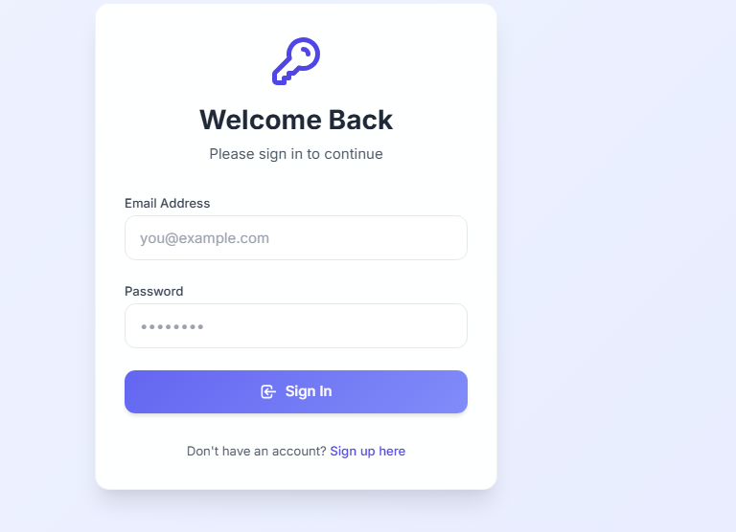

First you have to create the account

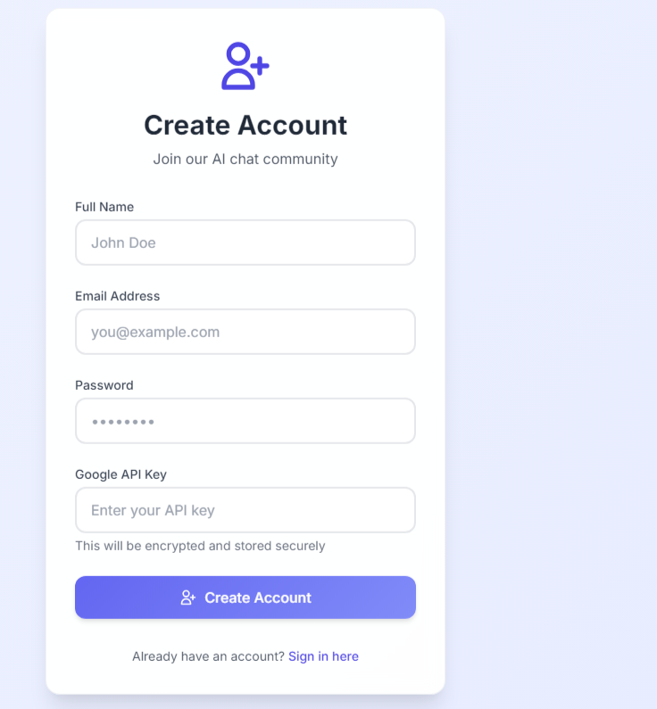

Here you see the following attribute

Name

Put your name

Email address

Put any email address like

[abc@gmail.com](mailto:abc@gmail.com)

password

put the password

Google api key:

Visit the link to get the api key

<https://aistudio.google.com/app/apikey>

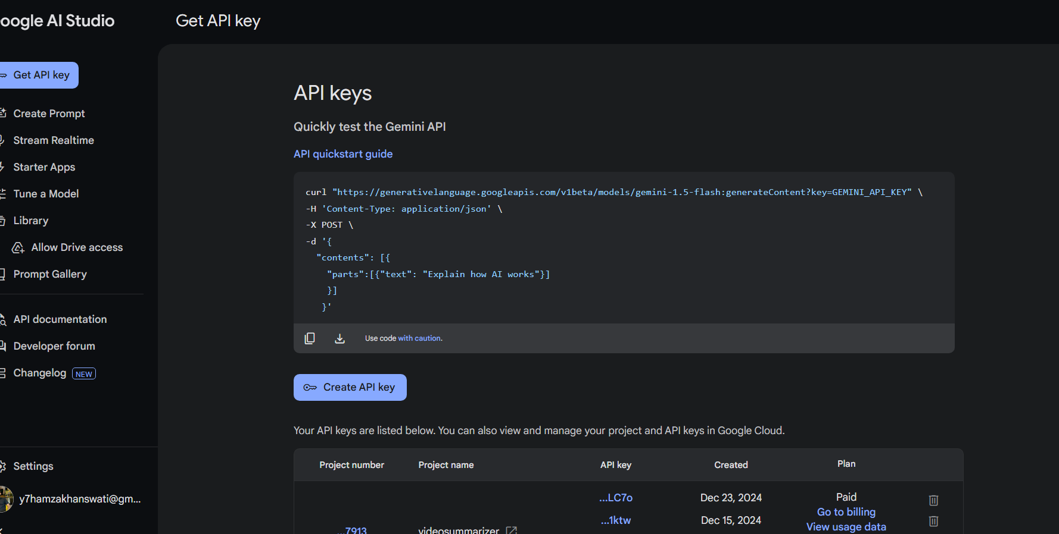

Then click on apikey

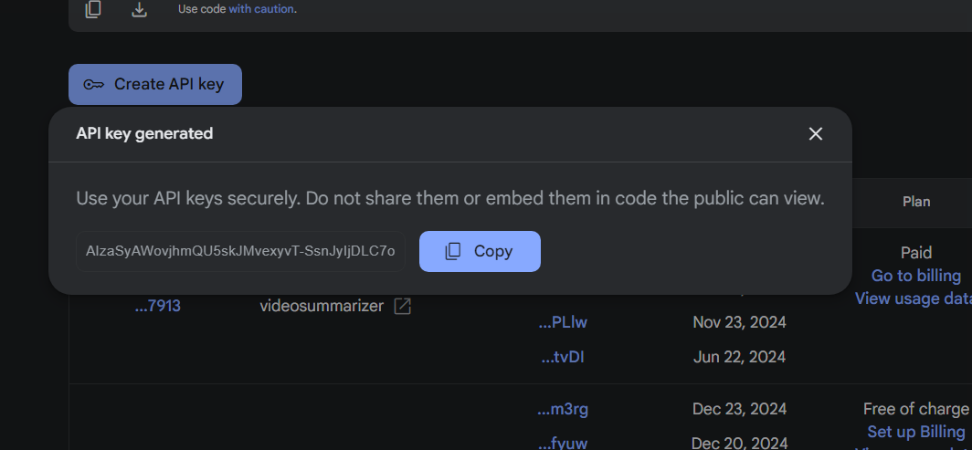

Then copy the api key and paste it on the above field

Your account will be created

Then simply sign in

Using email and password

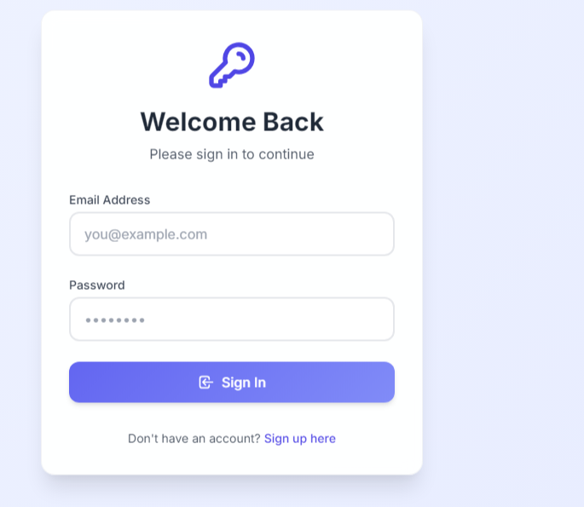

After sign in you will get this interface

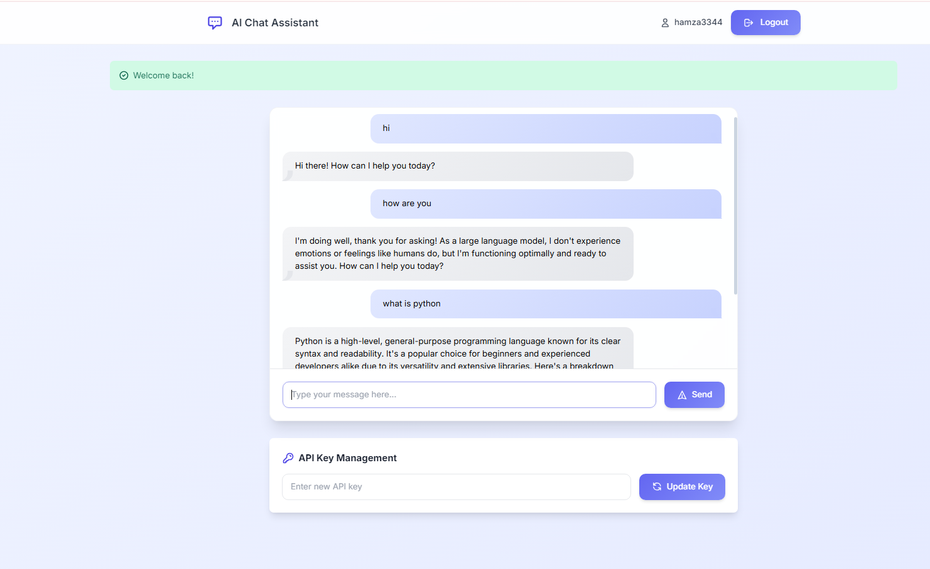

If your credit expire you can also update the apikey from the interface