IQBAL AI — How Analytics Works
A simple guide: Student diagnostic → Score → Learning Path → Teacher Analytics
Live app: https://iqbalai.com
Red numbered circles on screenshots match the numbered list under each figure. Arrow tips were placed from live UI element positions (Playwright).

1. The big picture (one sentence)
When a student finishes a diagnostic or quiz, the system counts correct answers, saves a score for each topic, builds a learning path for weak topics, and shows all of that to the teacher in Class Analytics.
- Student takes Diagnostic (or a teacher Quiz)
- System scores answers: correct ÷ total × 100 = overall %
- Each topic also gets its own % (e.g. Fractions 50%)
- Topics under 60% are marked weak → Learning Path / Learning Chat
- Teacher opens Analytics and sees class + student progress

2. Student flow — start here

2.1 Student dashboard (fresh student)
After login, a new student sees the LMS Overview. From here they open Diagnostic, My Quizzes, and later their Learning Path (after diagnostic scores exist).
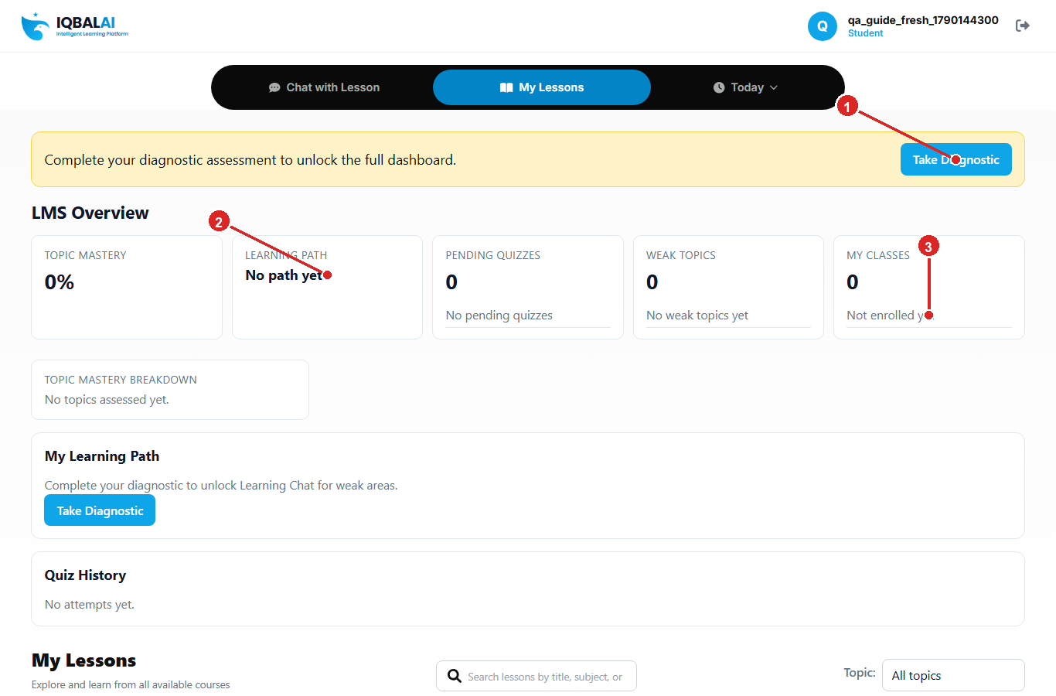
Figure 1 — Student dashboard (starting point — fresh student, diagnostic not done yet)
① Take Diagnostic (banner) — start the platform diagnostic
② Learning Path card — fills in after diagnostic scores exist
③ My Classes — enroll with a join code (shows 0 until joined)

2.2 Taking the diagnostic
The diagnostic is a timed MCQ test. First you see a short “Before you begin” screen, then Start opens the questions. Select an answer, tap Next, and on the last question tap Submit. If time runs out, answered questions still count.
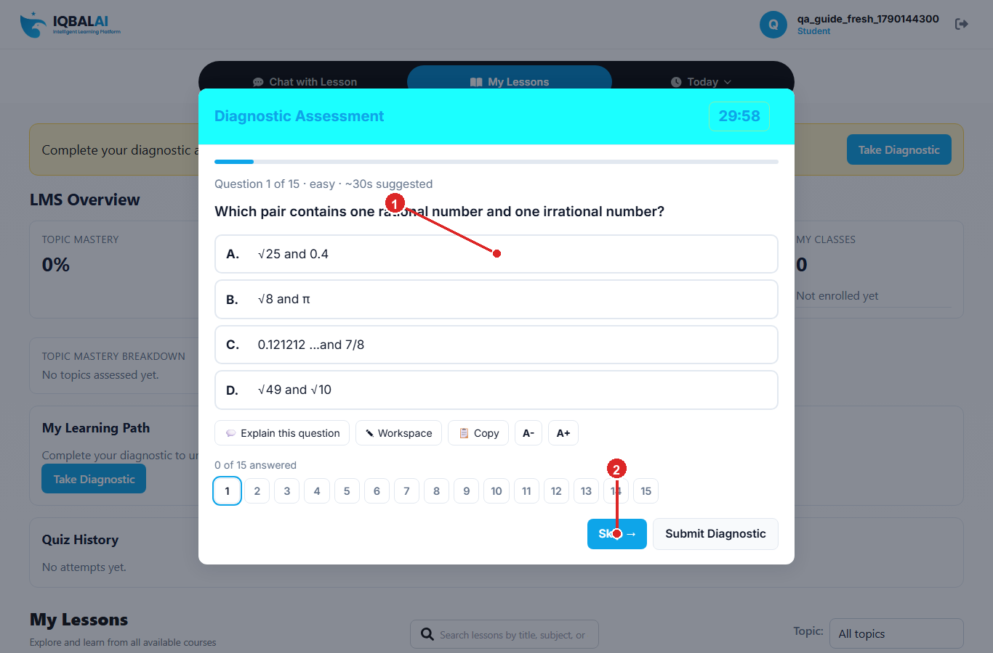
Figure 2 — Diagnostic assessment (fresh student — not “already completed”)
① Question + answer choices (A/B/C/D)
② Skip → / Next / Submit Diagnostic

2.3 How the score is calculated (very simple)
Each question is worth 1 point. Correct answer = 1. Wrong or skipped = 0.
Overall score formula:
Score % = (number of correct answers ÷ total questions) × 100
Example A — overall score
Situation | Math | Result
10 questions, 7 correct | 7 ÷ 10 × 100 | 70%
20 questions, 8 correct | 8 ÷ 20 × 100 | 40%
5 questions, 5 correct | 5 ÷ 5 × 100 | 100%
Skipped questions | Count as wrong (0) | Lower overall %

Example B — topic score (this feeds analytics)
Topic | Correct | Total | Topic % | Status
Fractions | 1 | 2 | 50% | Weak (< 60%)
Algebra | 4 | 4 | 100% | Mastered (≥ 85%)
Geometry | 2 | 3 | 67% | Needs practice (60–84%)

- Below 60% → Weak (needs help)
- 60% to 84% → Needs practice / Improving
- 85% or above → Mastered

2.4 What happens right after Submit
- Save the score (correct / total / %)
- Update each topic’s StudentTopicScore
- Rebuild the Learning Path from weak topics
- Mark diagnostic complete (other LMS features unlock)
- If it was a class quiz — mark that assignment submitted

2.5 Learning Path — after diagnostic
After diagnostic, weak topics (under 60%) drive the Learning Path / Learning Chat practice. This screenshot uses a student who already finished diagnostic so you can see filled cards.
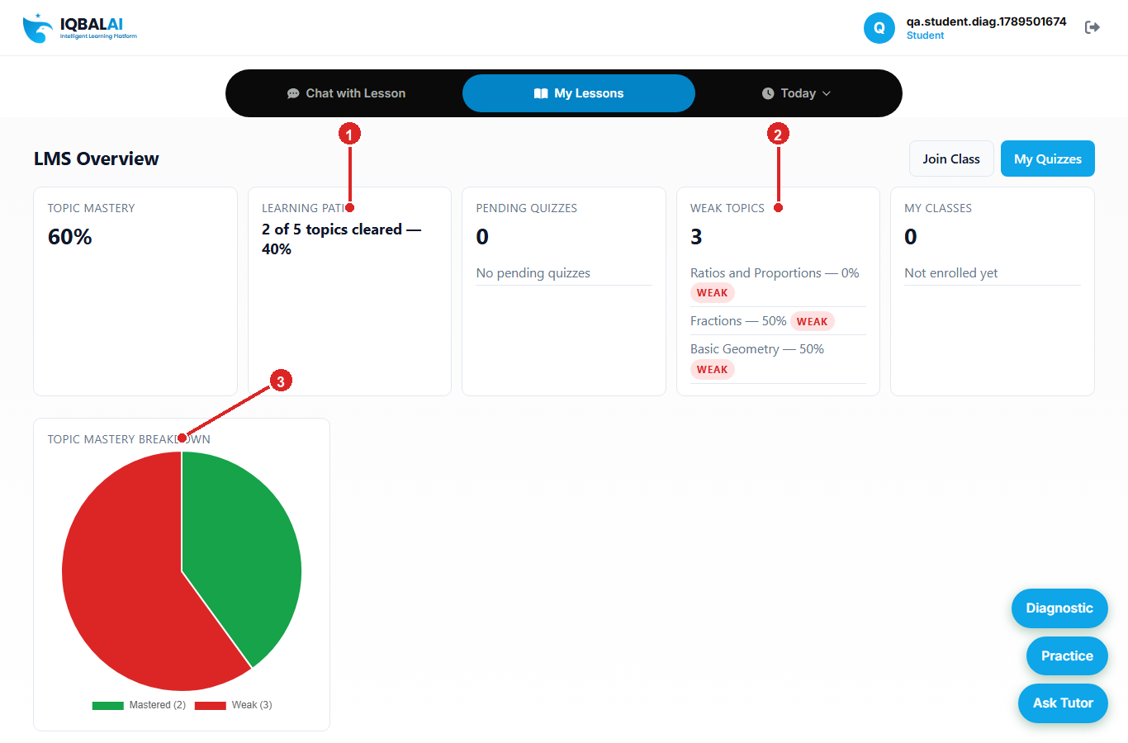
Figure 3 — Student view after diagnostic (Learning Path + Weak Topics)
① Learning Path progress card
② Weak Topics list (scores under 60%)
③ Topic Mastery breakdown pie chart

Example C — learning path from Example B
Topic result | Goes into Learning Path?
Fractions 50% (weak) | Yes — practice in Learning Chat
Geometry 67% (needs practice) | Not listed as weak (<60%), still room to grow
Algebra 100% (mastered) | No — already strong

2.6 Teacher quizzes (My Quizzes)
When the teacher assigns a quiz, the student opens My Quizzes, starts it, and submits. Scoring works the same way. That quiz then appears on the teacher Topic Progress chart.
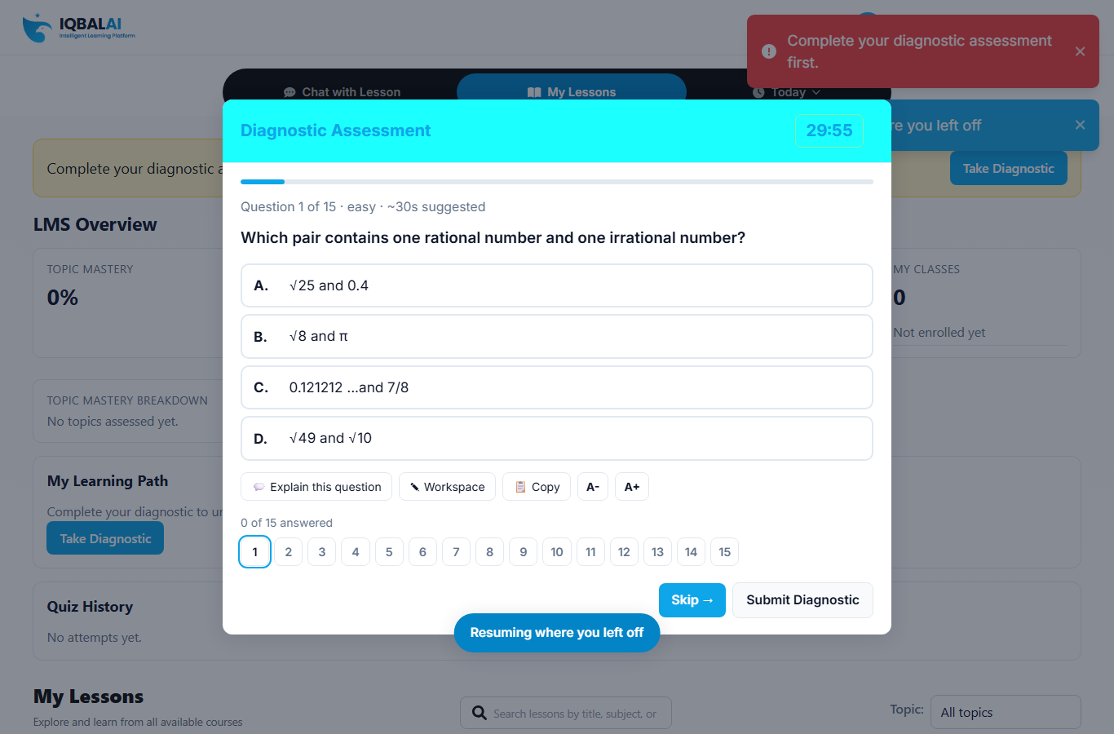
Figure 4 — My Quizzes (teacher assignments)

3. Teacher side — Class Analytics
Teacher opens the dashboard and clicks Analytics. Class Analytics opens. First pick a class.
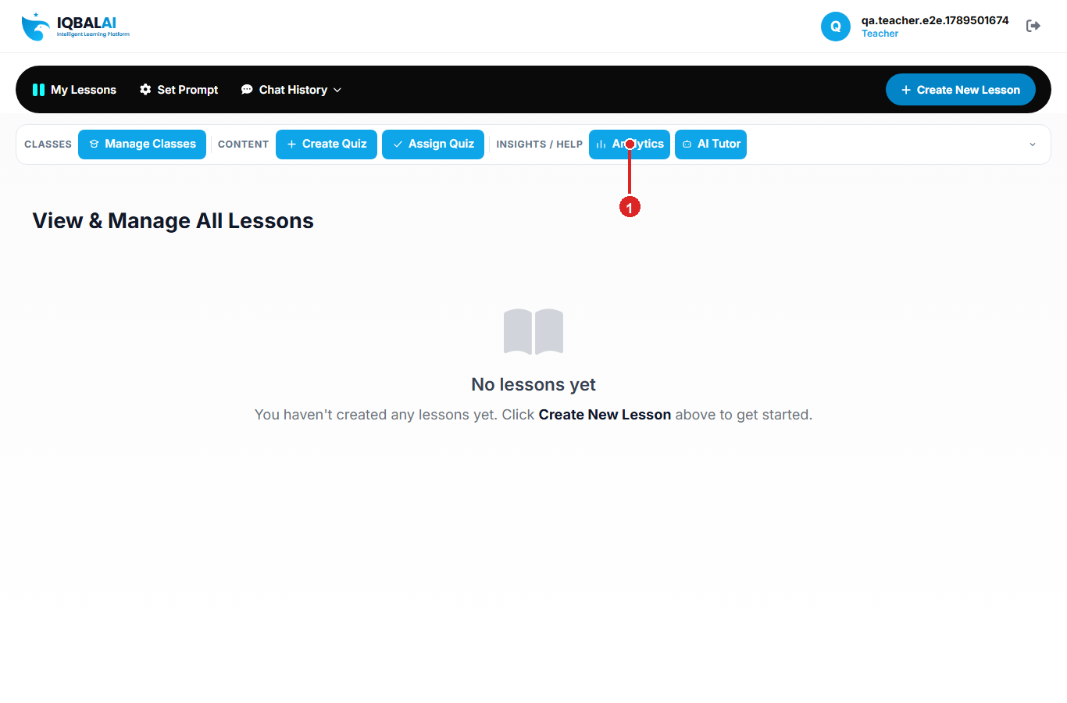
Figure 5 — Teacher dashboard / opening Analytics
① Analytics button — opens Class Analytics

3.1 Topic Performance
Shows each topic’s class average and how many students are struggling. Click the struggling count to see names and scores.
Logic:
- Reads each enrolled student’s latest topic scores
- Average = sum of scores ÷ number of scores
- Struggling on a topic = score under 60%
- Topics sorted weakest-first
Example D — Topic Performance row
Student | Fractions score
Ali | 40%
Sara | 55%
Omar | 90%
Class avg | (40+55+90) ÷ 3 = 61.7%
Struggling count | 2 (Ali + Sara, both < 60%)

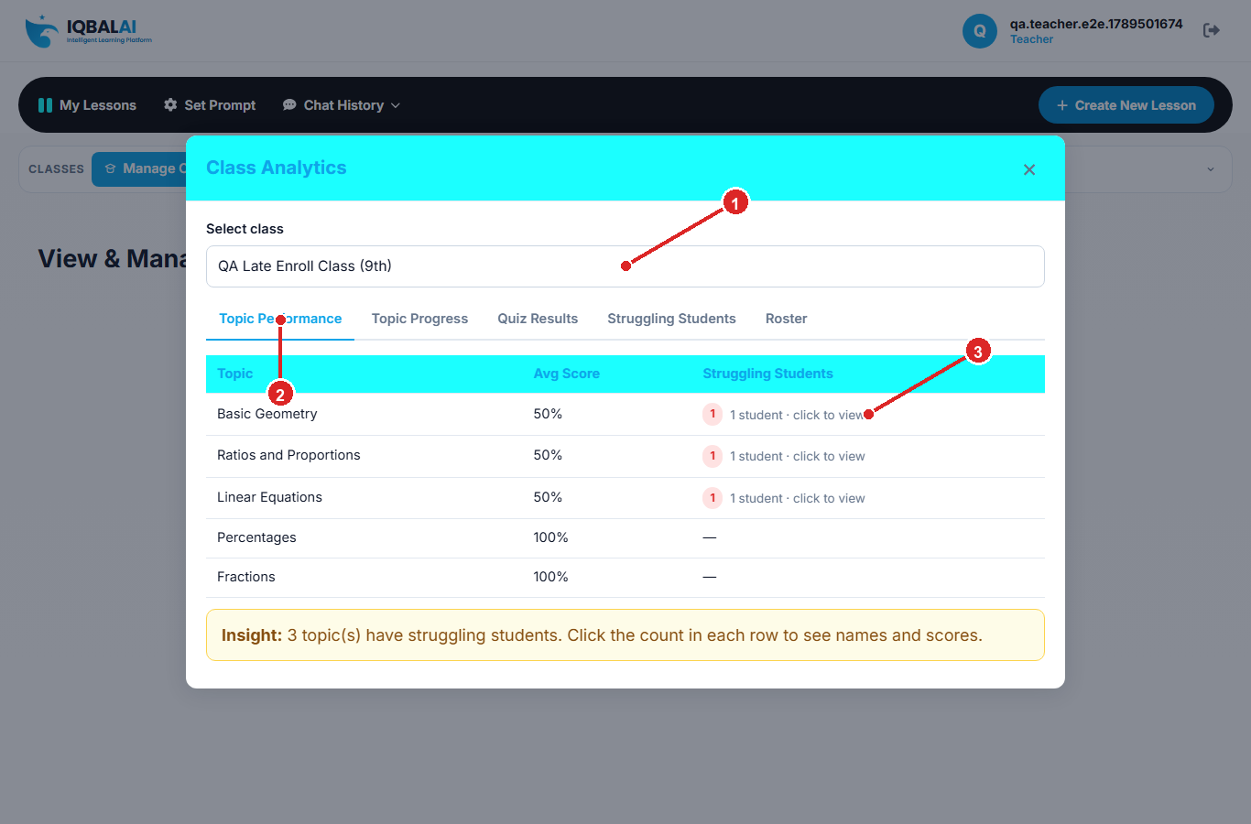
Figure 6 — Topic Performance tab
① Class dropdown
② Topic Performance tab
③ Struggling students count (click to expand names)

3.2 Topic Progress (diagnostic vs quiz over time)
Pick one student and one topic. The chart shows every diagnostic and quiz for that topic.
Logic:
- Purple bar = Diagnostic
- Cyan / blue bar = Quiz
- Bar height = topic % on that assessment
- Stats: Assessments, First score, Latest score, Change
Example E — Fractions for one student
Assessment | Correct / Total | Bar height | Color
Diagnostic | 2 / 2 | 100% | Purple
QA Quiz 1 | 1 / 2 | 50% | Cyan
Change | Latest 50 − First 100 | −50 pts | Needs help

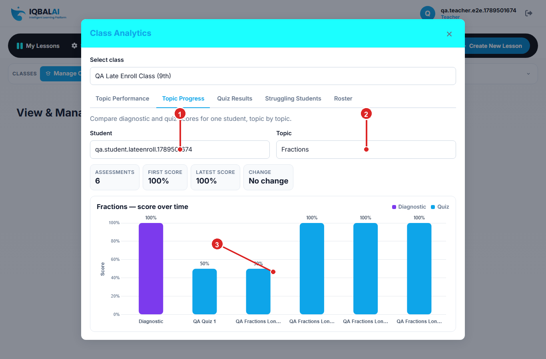
Figure 7 — Topic Progress chart (student + topic selected)
① Student dropdown
② Topic dropdown
③ Chart bars (Diagnostic purple, Quiz cyan)

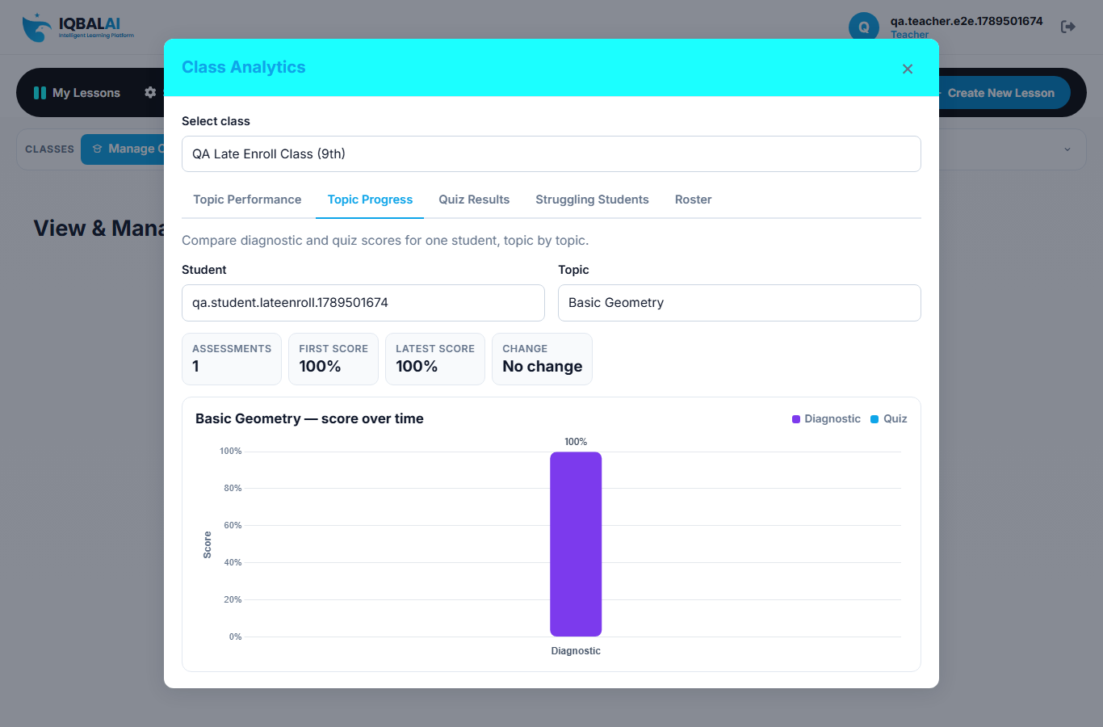
Figure 8 — Topic Progress tab layout

3.3 Quiz Results
Lists each published class assignment: completion %, class average, and expandable student scores.
Logic:
- Completion % = submitted ÷ enrolled × 100
- Avg score = average of submitted attempts only
- UI hint: ≥70% good, 50–69% warn
Example F
Class size | Submitted | Scores | Completion | Avg
4 students | 3 | 80%, 60%, 40% | 75% | (80+60+40)÷3 = 60%

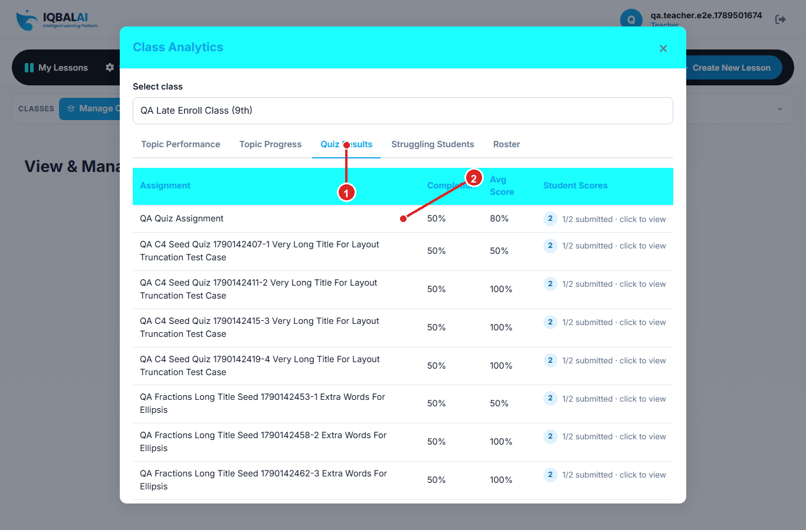
Figure 9 — Quiz Results tab
① Quiz Results tab
② Assignment row (completion + avg score)

3.4 Struggling Students
Students who need teacher attention.
Logic — struggling if either:
- 2 or more weak topics (score under 60%), OR
- Overall progress under 60%
Example G
Student | Weak topics | Overall progress | Struggling?
Ali — Fractions + Ratios weak | 2 | 45% | Yes
Sara — only Fractions weak | 1 | 72% | No (unless overall < 60%)
Omar — no weak topics | 0 | 88% | No

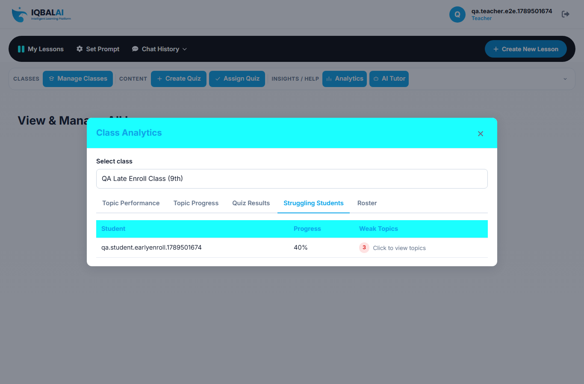
Figure 10 — Struggling Students tab

3.5 Roster
Full class list with overall progress and weak-topic count. Overall progress = weighted average of topic scores.
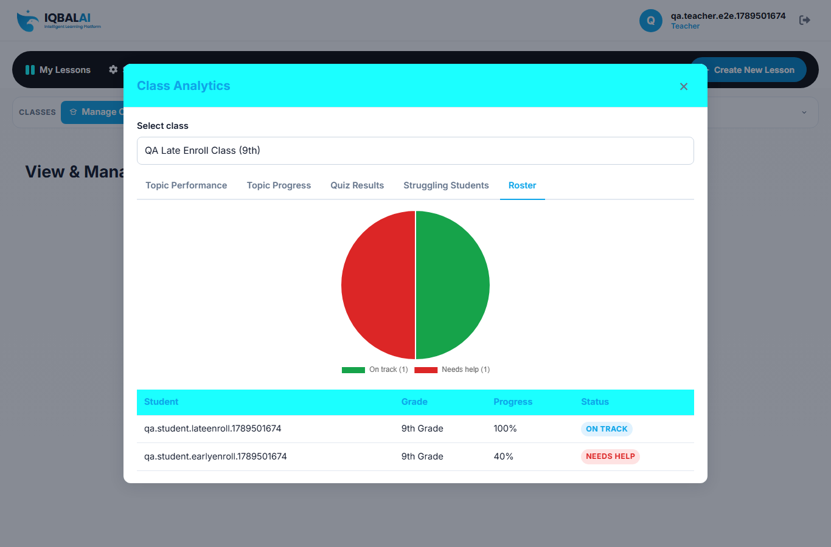
Figure 11 — Roster tab

4. One story from start to finish
Meet Sara (example student)
- Sara takes Diagnostic: 10 questions → 6 correct → overall 60%.
- By topic: Fractions 50% (weak), Algebra 100% (mastered), Geometry 0% (weak).
- Learning Path → Learning Chat for weak areas.
- Teacher assigns a quiz; Sara’s Fractions quiz score appears next to diagnostic on Topic Progress.
- Teacher uses Topic Performance + Struggling Students to decide who needs help.

5. Quick reference card
Thing | Simple rule
Overall score % | Correct ÷ total questions × 100
Topic score % | Correct on topic ÷ questions on topic × 100
Weak topic | Topic score < 60%
Mastered topic | Topic score ≥ 85%
Learning Path | Built from weak topics → Learning Chat
Struggling student | ≥2 weak topics OR overall < 60%
Topic Progress chart | One student + one topic; purple=diagnostic, cyan=quiz
Class topic average | Average of enrolled students’ scores for that topic
Quiz completion | Submitted ÷ enrolled × 100

Regenerate: cd iqbal_ai_stg && python scripts/generate_analytics_guide.py

