IQBAL AI — LMS User Guide
End-to-End Guide: Admin Diagnostic • Teacher (Analytics, PDF Quiz, AI Tutor) • Student Diagnostic
Application URL: https://209.23.10.34

Table of Contents
- 1. [Admin] Admin: Upload & Publish Platform Diagnostic
- 2. [Teacher] Teacher: Class Analytics
- 3. [Teacher] Teacher: PDF Quiz Builder
- 4. [Teacher] Teacher: Assign Quiz to Class
- 5. [Teacher] Teacher: Manage Classes
- 6. [Teacher] Teacher: AI Tutor
- 7. [Student] Student: Diagnostic Assessment
- 8. [Student] Student: My Quizzes (Teacher Assignments)
- 9. [Student] Student: Learning Chat (After Diagnostic)
- 10. [Student] Student: Join Class

How the LMS Flow Works
1. Admin platform diagnostic publish karta hai (Q&A PDF + target content PDFs).
2. Student diagnostic leta hai — weak topics identify hote hain.
3. Student Learning Chat se weak areas par practice karta hai.
4. Teacher PDF se quiz banata hai aur class ko assign karta hai.
5. Teacher Analytics se class performance monitor karta hai.

[Admin] Admin: Upload & Publish Platform Diagnostic

Overview
Admin ek baar platform-wide diagnostic publish karta hai. Is mein Diagnostic Q&A PDF aur Target content PDFs shamil hain.

Step-by-Step
- Login karein: /auth/login → Admin dashboard (/admin/)
- Sidebar se 'Diagnostic Assessment' select karein
- Diagnostic Q&A PDF upload karein (questions + answer key)
- Ek ya zyada Target content PDFs add karein (Learning Chat ke liye)
- 'Upload & Publish Diagnostic' par click karein
- Progress bar complete hone ke baad diagnostic auto-publish ho jata hai

UI Screenshot (annotated)
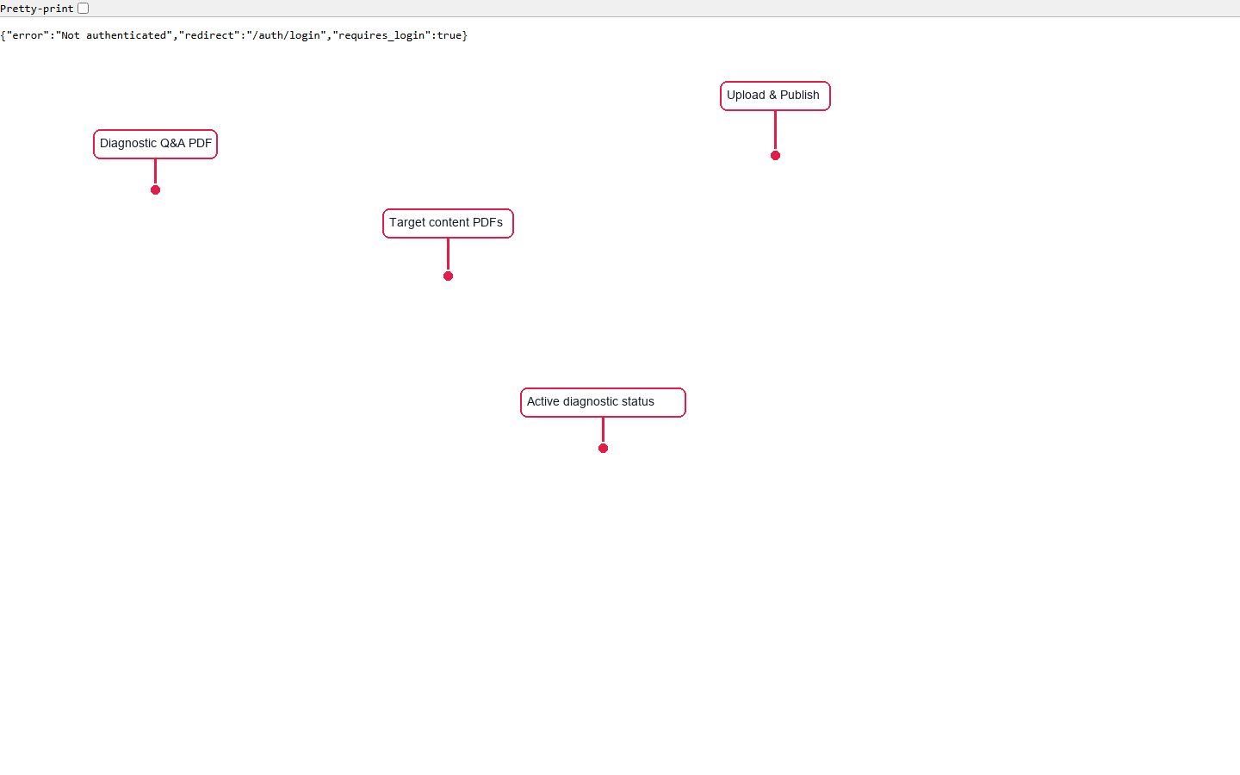
Red arrows = important UI controls

[Teacher] Teacher: Class Analytics

Overview
Teacher har class ka performance dekh sakta hai — topics, quiz results, struggling students, aur roster.

Step-by-Step
- Teacher dashboard par 'Analytics' FAB button click karein
- Class dropdown se class select karein
- Topic Performance: weak students count par click karke names dekhein
- Quiz Results: har assignment ke student scores expand karein
- Struggling Students: weak topics count par click karke topic list dekhein
- Roster: overall progress aur status dekhein

UI Screenshot (annotated)
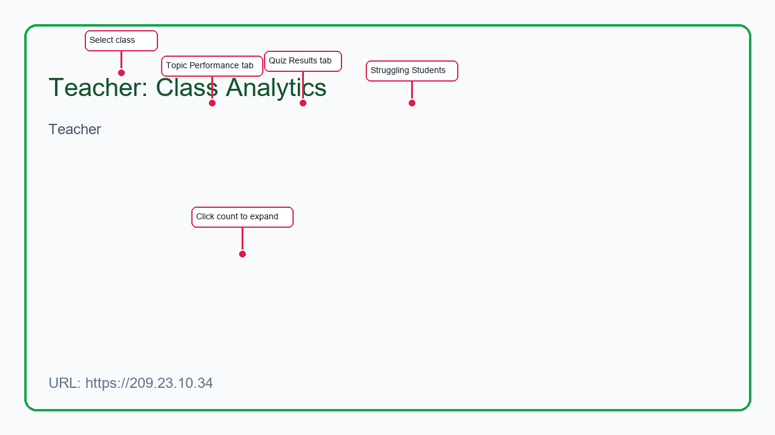
Red arrows = important UI controls

[Teacher] Teacher: PDF Quiz Builder

Overview
Teacher apni PDF se MCQ quiz generate karta hai aur publish karta hai.

Step-by-Step
- 'PDF Quiz' FAB button click karein
- Q&A PDF upload karein
- 'Upload & Generate MCQs' — pipeline MCQs banata hai
- Preview questions check karein
- 'Publish Quiz' — ab ye Assign Quiz mein available hoga

UI Screenshot (annotated)
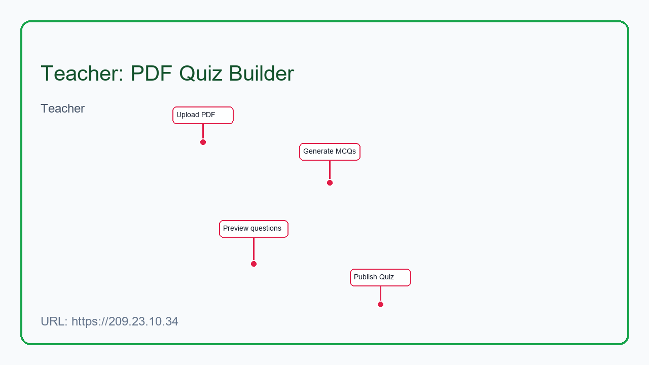
Red arrows = important UI controls

[Teacher] Teacher: Assign Quiz to Class

Overview
Published quiz ko class ke students ko assignment ke tor par bhejna.

Step-by-Step
- 'Assign Quiz' FAB click karein
- Assignment title, class, aur published quiz select karein
- Optional due date set karein
- 'Create & Publish' — students ko 'My Quizzes' mein dikhega

UI Screenshot (annotated)
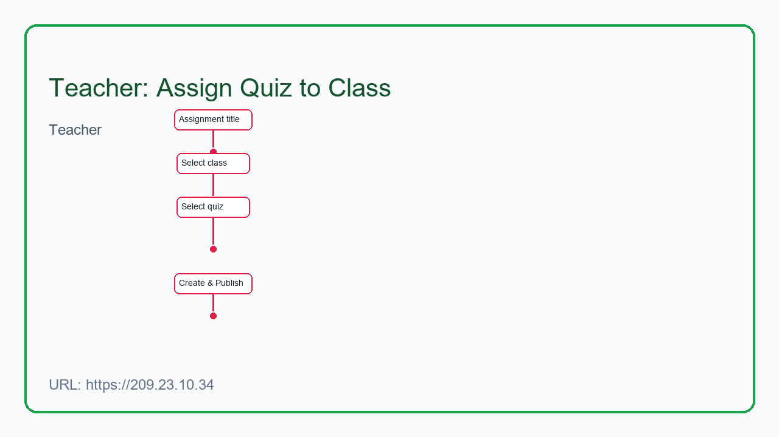
Red arrows = important UI controls

[Teacher] Teacher: Manage Classes

Overview
Classes create karna, join code share karna, aur students manage karna.

Step-by-Step
- 'Classes' FAB click karein
- Nayi class create karein (name + grade)
- Join code students ko share karein
- 'Manage' se roster dekhein ya students manually add karein

UI Screenshot (annotated)
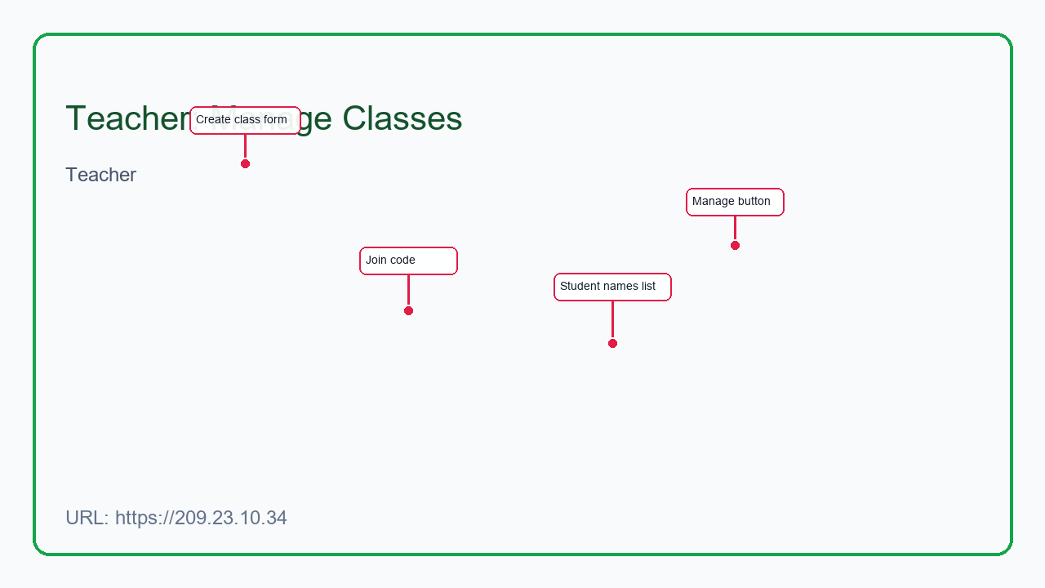
Red arrows = important UI controls

[Teacher] Teacher: AI Tutor

Overview
Teaching assistant chat — pedagogy, question design, aur classroom help.

Step-by-Step
- 'AI Tutor' FAB click karein
- Apna sawal type karein
- AI step-by-step guidance deta hai (direct answer nahi)

UI Screenshot (annotated)
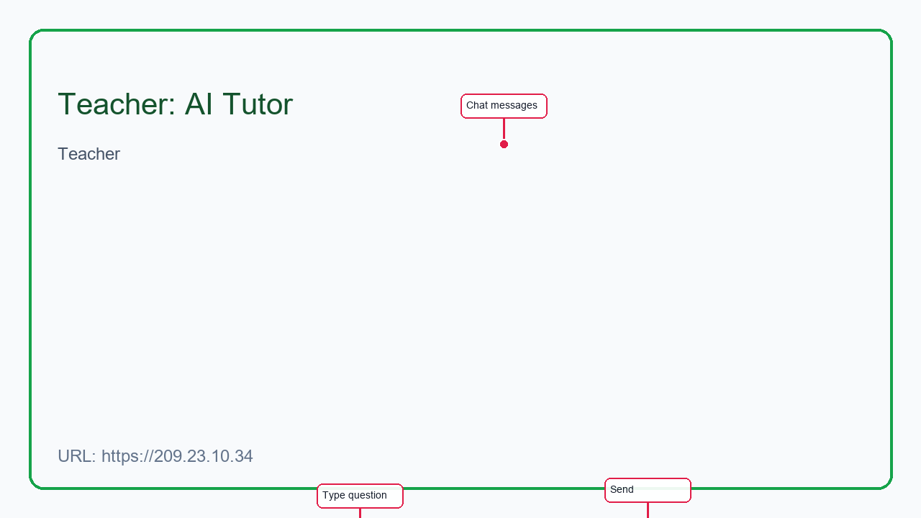
Red arrows = important UI controls

[Student] Student: Diagnostic Assessment

Overview
Platform diagnostic ek martaba liya jata hai. Timer ke sath MCQs, phir weak/strong topics result.

Step-by-Step
- 'Diagnostic' FAB ya onboarding se start karein
- Har question ka jawab select karein → Next
- Back button left side par hai — peechle sawal par ja sakte hain
- Last question par 'Submit Diagnostic'
- Results: score, weak topics, aur 'Start Learning Chat' option

UI Screenshot (annotated)
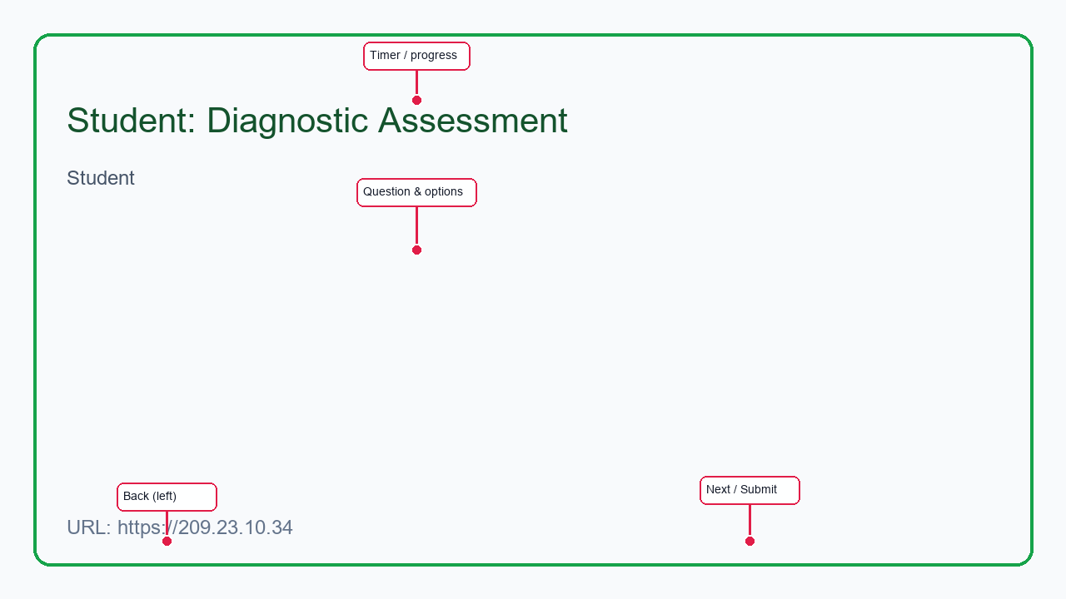
Red arrows = important UI controls

[Student] Student: My Quizzes (Teacher Assignments)

Overview
Teacher ki assigned quizzes yahan dikhti hain.

Step-by-Step
- 'My Quizzes' FAB click karein
- Assignment par 'Start' click karein
- Har question answer karke Next karein
- Submit par score aur learning path update hota hai

UI Screenshot (annotated)
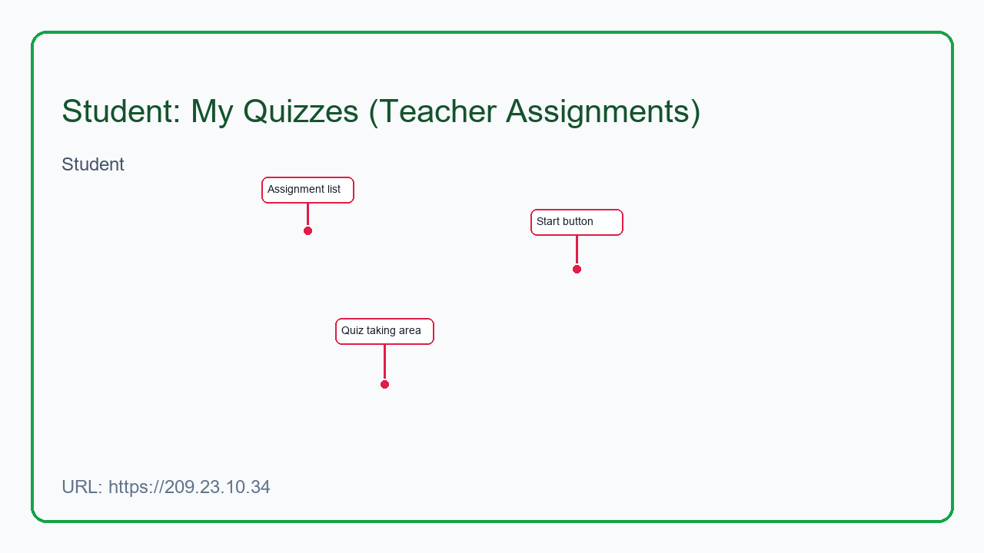
Red arrows = important UI controls

[Student] Student: Learning Chat (After Diagnostic)

Overview
Diagnostic ke baad weak topics par PDF-grounded Learning Chat — tutor hints deta hai, direct answer nahi.

Step-by-Step
- Diagnostic submit ke baad 'Start Learning Chat' click karein
- Ya Learning Path se weak topic step open karein
- Har MCQ ka jawab submit karein
- 'Ask Tutor' / 'Need more help' se guided hints lein
- 'Pause & Exit' se baad mein resume kar sakte hain

UI Screenshot (annotated)
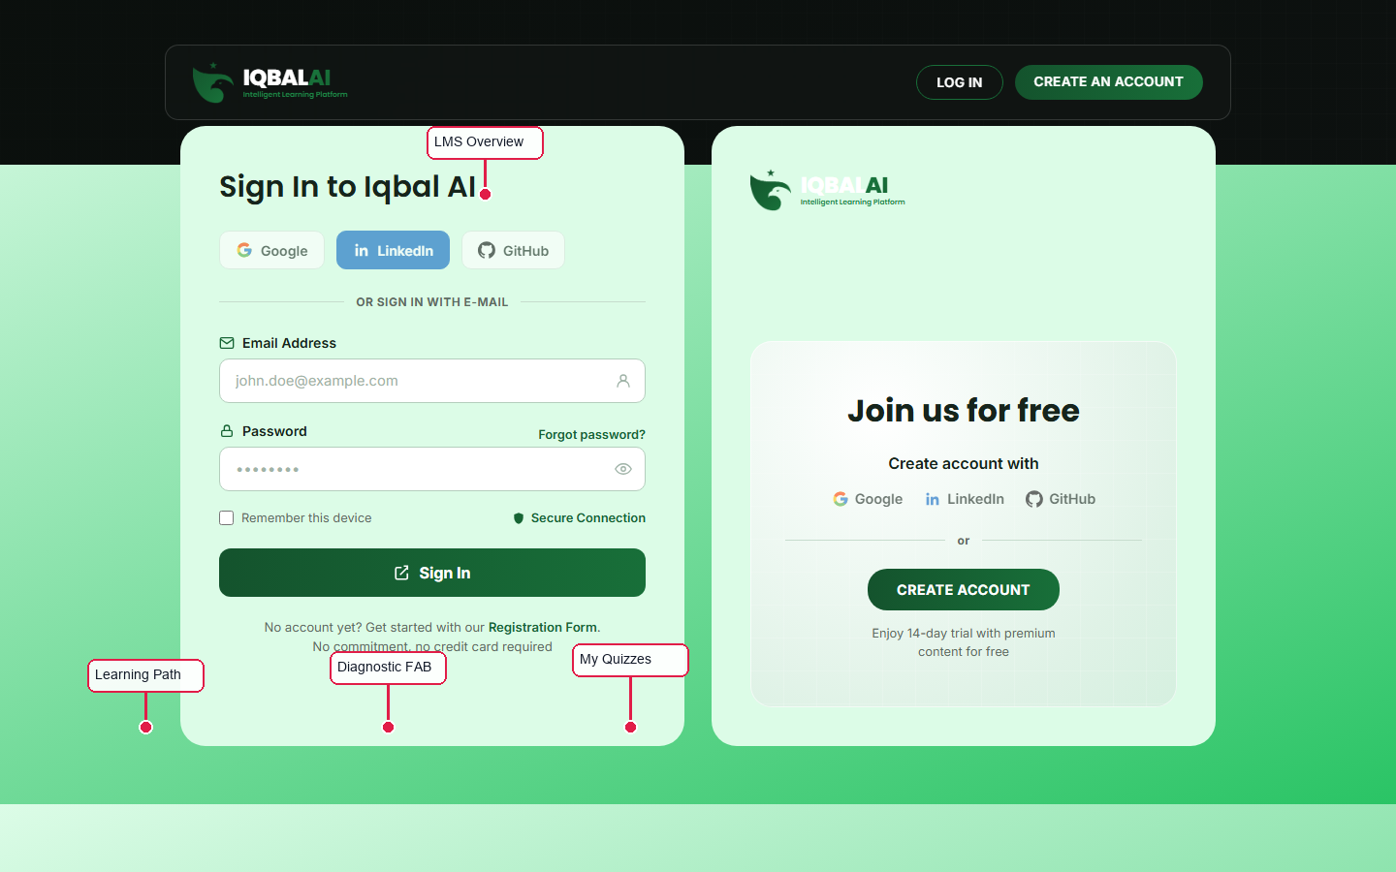
Red arrows = important UI controls

[Student] Student: Join Class

Overview
Teacher ka diya hua join code se class mein enroll hona.

Step-by-Step
- 'Join Class' FAB click karein
- Join code enter karein (teacher se milega)
- Join — ab teacher ki assignments aur analytics mein show honge

UI Screenshot (annotated)
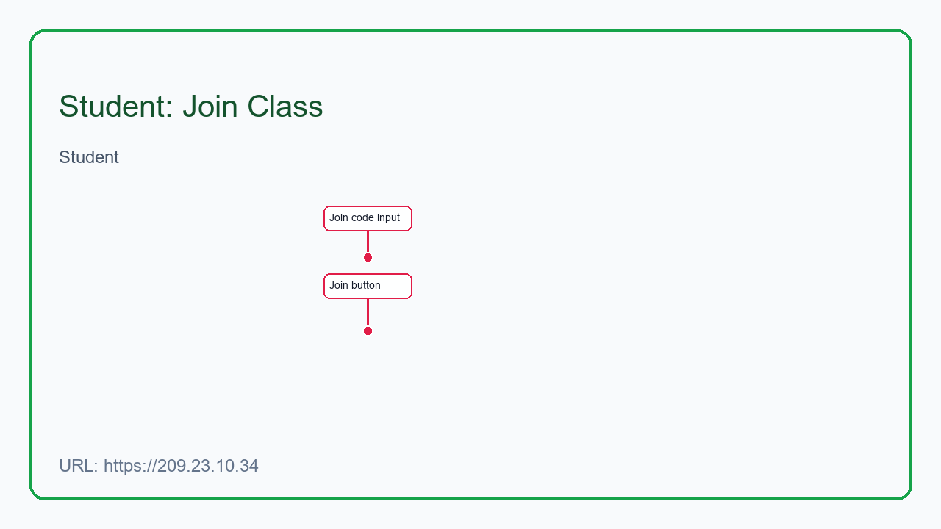
Red arrows = important UI controls

