FedAdaPriv-CPU: Adaptive Differential Privacy for Federated Chest X-Ray Classification with Convergence-Aware Budget Allocation
Hamza Shafiq, Anusha Randhawa, Faisal Iradat
Institute of Business Administration (IBA) Karachi, Pakistan

Abstract
Federated learning (FL) enables collaborative model training across distributed clinical institutions without sharing raw patient data. When combined with differential privacy (DP), FL provides formal privacy guarantees but introduces a fundamental tension: uniform noise injection across heterogeneous clients disproportionately degrades minority-class recognition, undermining clinical utility. We present FedAdaPriv-CPU, a federated learning framework that addresses this tension through a three-signal adaptive epsilon formula that allocates per-client differential privacy budgets according to data volume (α_vol), training convergence stability (α_conv), and federated round progression (α_round). Applied to four-class chest X-ray classification (COVID-19, Lung Opacity, Normal, and Viral Pneumonia) under non-IID Dirichlet partitioning across three simulated hospital clients, FedAdaPriv-CPU achieves a macro-averaged F1 score of 0.810 at ε = 4.0—a gain of 0.115 over Fixed DP-FedAvg. Critically, Viral Pneumonia F1 improves from 0.420 to 0.722 (+0.301), recovering a class that standard fixed-budget DP-FL effectively collapses. Rigorous ablation across five non-IID partition seeds confirms that the convergence signal α_conv is the dominant mechanism, contributing a VP F1 gain of +0.358, while budget-remaining pacing (α_round) provides consistent monotonic improvement across all 30 federated rounds. Privacy budget adherence is verified via RDP accounting, with all clients remaining within the ε = 4.0 ceiling at round 30. These results demonstrate that convergence-aware adaptive DP is both necessary and sufficient to rescue minority-class performance in differentially private federated medical imaging.
Keywords: Federated Learning, Differential Privacy, Adaptive Epsilon, Chest X-Ray Classification, Non-IID, Minority Class, RDP Accounting, Medical Imaging

I. Introduction
The digitisation of radiology has generated vast repositories of chest X-ray images across hospitals worldwide, creating an opportunity to train highly accurate diagnostic classifiers. However, patient privacy regulations—including HIPAA in the United States, GDPR in Europe, and equivalent frameworks in South Asia—prohibit the centralisation of raw clinical data for model training. Federated learning (FL) has emerged as the standard paradigm for addressing this constraint, enabling institutions to collaboratively optimise a shared model by exchanging only gradient updates rather than patient records [McMahan et al., 2017].
Even gradient-level communication is not entirely safe: membership inference attacks and gradient inversion techniques can partially reconstruct training data from model updates [Zhu et al., 2019; Shokri et al., 2017]. Differential privacy (DP) provides the formal privacy guarantee needed to close this gap: by injecting calibrated Gaussian noise into gradients before aggregation, DP-FL guarantees that the participation of any individual training sample is indistinguishable at a controlled privacy level (ε, δ) [Dwork and Roth, 2014; Abadi et al., 2016].
Despite this theoretical appeal, standard DP-FL deployments rely on a uniform privacy budget applied identically to all clients regardless of their local data distribution, volume, or training dynamics. In the context of medical imaging, this is clinically dangerous: minority disease classes—those with fewer representative samples—are far more sensitive to noise injection than majority classes, and uniform DP systematically collapses their F1 scores to near-zero. In our experimental setup, Fixed DP-FedAvg achieves only VP F1 = 0.420 at ε = 4.0, with the Viral Pneumonia class constituting only 8.8% of the training distribution but carrying significant diagnostic importance.
We present FedAdaPriv-CPU (Federated Adaptive Privacy—Convergence-aware, Per-client, Utility-preserving), a framework that replaces the static epsilon allocation with a three-signal adaptive formula. The core insight is that three independent, computable signals should govern per-client privacy budget: (1) how much local data a client has relative to its peers (α_vol), capturing the noise sensitivity of low-volume clients; (2) how stably a client's local loss has converged in recent rounds (α_conv), the dominant signal that re-allocates budget dynamically as training progresses; and (3) what fraction of the total round budget remains (α_round), ensuring monotonic relaxation of noise toward later rounds when the model is more stable. The per-client epsilon is computed as ε_i = ε_total × α_vol,i × α_conv,i × α_round, and the corresponding per-client noise multiplier σ_i is derived via Opacus's RDP accountant to ensure formal privacy guarantees.
The primary contribution of this paper is demonstrating that convergence-aware adaptive DP recovers the Viral Pneumonia minority class without sacrificing overall accuracy or exceeding declared privacy budgets. Secondary contributions include: (i) a rigorous four-variant ablation study isolating the contribution of each signal across five independent non-IID Dirichlet partition seeds; (ii) a full epsilon sweep from ε = 1.5 to ε = 8.0 confirming that the adaptive advantage persists across the entire practical privacy regime; and (iii) per-client RDP accounting curves verifying that all clients remain within budget at all rounds.

II. Related Work

A. Federated Learning for Medical Imaging
Federated learning was formally proposed for distributed machine learning by McMahan et al. (2017) under the FedAvg algorithm, which aggregates client updates by weighted averaging proportional to local dataset sizes. Subsequent work has addressed the non-IID challenge inherent in federated medical data: FedProx (Li et al., MLSys 2020) adds a proximal regularisation term to constrain local updates from drifting too far from the global model, while SCAFFOLD (Karimireddy et al., ICML 2020) uses control variates to correct for client drift. In the medical imaging domain, federated learning has been applied to brain MRI segmentation [Sheller et al., 2020], diabetic retinopathy screening [Xu et al., 2021], and chest X-ray classification [Nguyen et al., 2022].

B. Differential Privacy in Federated Learning
The combination of differential privacy with federated learning was formalised by Geyer et al. (2017) and McMahan et al. (2018), the latter introducing DP-FedAvg with per-sample gradient clipping and Gaussian noise addition under the moments accountant. The Rényi Differential Privacy (RDP) framework of Mironov (2017) provides tighter privacy accounting for subsampled Gaussian mechanisms, and is the accounting basis of the Opacus library used in this work. Wei et al. (2020) demonstrate that a non-private warmstart phase reduces wasted privacy budget on high-variance early gradients, a practice we adopt and additionally justify on architectural grounds: the convergence signal α_conv requires a reference trajectory that is undefined at round one, making a warmstart phase both empirically beneficial and computationally necessary.

C. Adaptive and Client-Heterogeneous DP-FL
The observation that uniform privacy noise is suboptimal for heterogeneous clients has motivated several adaptive approaches. Geyer et al. (2017) propose client-level DP with adaptive clipping norms. Kiani et al. (ICLR 2025) propose Time-Adaptive DP-FL with round-dependent noise schedules. Our work differs from these in two important respects. First, we operate at per-client granularity rather than global round schedules, meaning each client receives a distinct epsilon budget calibrated to its local data volume and convergence trajectory. Second, our convergence signal is computed from local loss histories rather than predetermined schedules, making the allocation fully data-driven. The epsilon-coupled aggregation in our FedAvg step further ensures that clients with tighter budgets (higher noise) receive proportionally lower aggregation weights, preventing noisy clients from dominating the global model update.

III. Methodology

A. System Architecture
FedAdaPriv-CPU simulates a federated learning system comprising three hospital clients (A, B, C) and a central aggregation server. Feature extraction uses a frozen TorchXRayVision DenseNet121 backbone (densenet121-res224-all), pretrained on a large corpus of chest radiographs, producing 1024-dimensional feature vectors for each image. A lightweight two-layer MLP classifier head (approximately 720K parameters) is trained in a federated manner on these fixed representations. Using a frozen pretrained backbone serves two purposes: it substantially reduces the trainable parameter space—making the privacy-utility tradeoff more tractable—and ensures that the model benefits from prior radiological knowledge without requiring each client to train a deep network from scratch.

B. Dataset and Non-IID Partitioning
Experiments are conducted on the COVID-19 Radiography Dataset, comprising four classes: COVID-19, Lung Opacity, Normal, and Viral Pneumonia. A 15% stratified holdout set is reserved before partitioning for final evaluation. The remaining data is distributed across three clients using a Dirichlet concentration parameter α = 0.5, which produces realistic class imbalance while preserving each client's dominant class. Client A is COVID-19-dominant (~70% COVID), Client B is Lung Opacity-dominant (~70% LO), and Client C is Viral Pneumonia-dominant (~70% VP). Due to the inherent scarcity of Viral Pneumonia cases in the dataset, Client C is also the smallest client (n ≈ 1,632 vs. n ≈ 3,950–4,375 for Client A and n ≈ 11,980–12,460 for Client B), making it simultaneously the most privacy-sensitive and the most important client for VP recovery.

Table I: Client Partition Statistics (seed=42, ε=4.0)
Client | n (train) | Dominant Class | VP Share (%) | σ (noise mult.) | SNR
A | 3,895 | COVID-19 (70.0%) | 0.0% | 1.846 | 0.542
B | 12,460 | Lung Opacity (70.0%) | 0.0% | 1.167 | 0.857
C | 1,632 | Viral Pneumonia (70.0%) | 70.0% | 2.754 | 0.363

Client C's high noise multiplier (σ = 2.754) relative to Clients A (σ = 1.846) and B (σ = 1.167) is a direct consequence of volume-proportional budget allocation: with fewer samples, Client C receives a smaller initial epsilon, requiring higher noise to maintain the privacy guarantee. The convergence signal α_conv subsequently compensates for this by detecting the stability of Client C's loss trajectory and progressively relaxing its effective noise as training stabilises.

C. Adaptive Epsilon Formula
The central contribution of this work is the per-client adaptive epsilon formula, which decomposes the total privacy budget into three multiplicative signals:
ε_i(t) = ε_total × α_vol,i × α_conv,i(t) × α_round(t)
Volume signal α_vol,i normalises each client's dataset size relative to the maximum client size, giving larger clients proportionally more budget: α_vol,i = n_i / max_j(n_j). Convergence signal α_conv,i(t) measures the stability of client i's local loss over a sliding window of recent rounds. When loss variance is low (training has stabilised), the client receives a higher epsilon (less noise). Formally: α_conv,i(t) = 1 − clip(σ(loss_window) / mean(loss_window), 0, 1), where σ and mean are computed over the most recent W = 5 rounds. This is the dominant signal in the formula, as confirmed by ablation. Round signal α_round(t) = t / T_total provides monotonic epsilon relaxation across rounds, ensuring that the model receives progressively less noise as it approaches convergence from a global perspective, independent of local dynamics.
The resulting per-client sigma values are computed via Opacus's RDP accountant at each round, ensuring that the cumulative privacy expenditure never exceeds ε_total = 4.0 with δ = 10⁻⁵. Aggregation weights in the FedAvg step are coupled to the epsilon values: clients with tighter budgets (more noise) receive proportionally lower aggregation weights, preventing high-noise clients from dominating the global update.

D. Training Protocol
FedAdaPriv-CPU employs a two-phase training protocol. In the warmstart phase (T_ws local epochs), clients train without DP noise to establish stable initial representations and to populate the loss history buffer required by α_conv. This practice follows Wei et al. (2020), who demonstrate that privacy budget spent on high-variance early gradients yields disproportionately low utility. In the main FL phase, 30 federated rounds are executed with DP-Adam (lr = 2 × 10⁻⁴, max_grad_norm = 1.0), with per-client epsilon computed fresh at each round. Final model weights are reported as the Polyak average of the best k = 5 checkpoints by validation F1, providing additional stability against round-to-round noise.

IV. Experimental Setup

A. Baselines
Five comparison points are evaluated: (1) No-DP FedAvg serves as the performance ceiling, reflecting what federated training achieves without any privacy constraints; (2) Local-only training serves as the lower bound, with each client training in isolation; (3) Fixed DP-FedAvg is the primary baseline, applying a single uniform epsilon to all clients at all rounds—this is the standard implementation against which the adaptive contribution is measured; (4) DP-FedProx (Li et al., MLSys 2020) adds proximal regularisation to DP-FedAvg; and (5) Time-Adaptive DP-FL (Kiani et al., ICLR 2025) applies a round-dependent noise schedule. All baselines are evaluated at matched total epsilon (ε = 4.0) and δ = 10⁻⁵.

B. Evaluation Protocol
Primary evaluation metrics are macro-averaged F1 score and per-class F1. The macro F1 metric is preferred over accuracy due to the class imbalance present in the test set: the Normal class contributes 54% of test samples, making accuracy a misleadingly optimistic metric. VP F1 is reported separately as the clinically critical minority-class indicator. Statistical robustness of ablation results is established across five non-IID Dirichlet partition seeds (0, 7, 42, 123, 999), each producing distinct client compositions while preserving the dominant-class structure. Mean and standard deviation are reported for all ablation comparisons.

V. Results

A. Primary Results at ε = 4.0
Table II presents the main comparison between FedAdaPriv-CPU and Fixed DP-FedAvg at the primary evaluation epsilon of 4.0. FedAdaPriv-CPU achieves an accuracy of 0.860 and macro F1 of 0.810, compared to 0.821 and 0.695 for Fixed DP-FedAvg, representing gains of +0.039 in accuracy and +0.115 in macro F1. The VP F1 improvement is the most substantial: from 0.420 to 0.722, a gain of +0.301. COVID-19 F1 also improves significantly, from 0.639 to 0.748 (+0.109), reflecting the benefit of convergence-aware budget allocation for the second minority class.

Table II: Primary Results at ε = 4.0 (best round)
Method | Accuracy | Macro F1 | COVID F1 | LO F1 | Normal F1 | VP F1
Fixed DP-FedAvg | 0.821 | 0.695 | 0.639 | 0.826 | 0.896 | 0.420
FedAdaPriv-CPU (ours) | 0.860 | 0.810 | 0.748 | 0.860 | 0.910 | 0.722
Δ (Ours − Fixed) | +0.039 | +0.115 | +0.109 | +0.034 | +0.014 | +0.301

Figure 1 shows the macro F1 trajectory across all 30 federated rounds. FedAdaPriv-CPU exhibits consistent monotonic improvement, starting at F1 = 0.699 at round 1 and reaching F1 = 0.810 at round 28. In contrast, Fixed DP-FedAvg exhibits flat, noisy behaviour throughout, peaking at F1 = 0.695 at round 15 and showing no sustained improvement. The separation between methods is established from round 1 and widens progressively as the convergence signal accumulates training history.
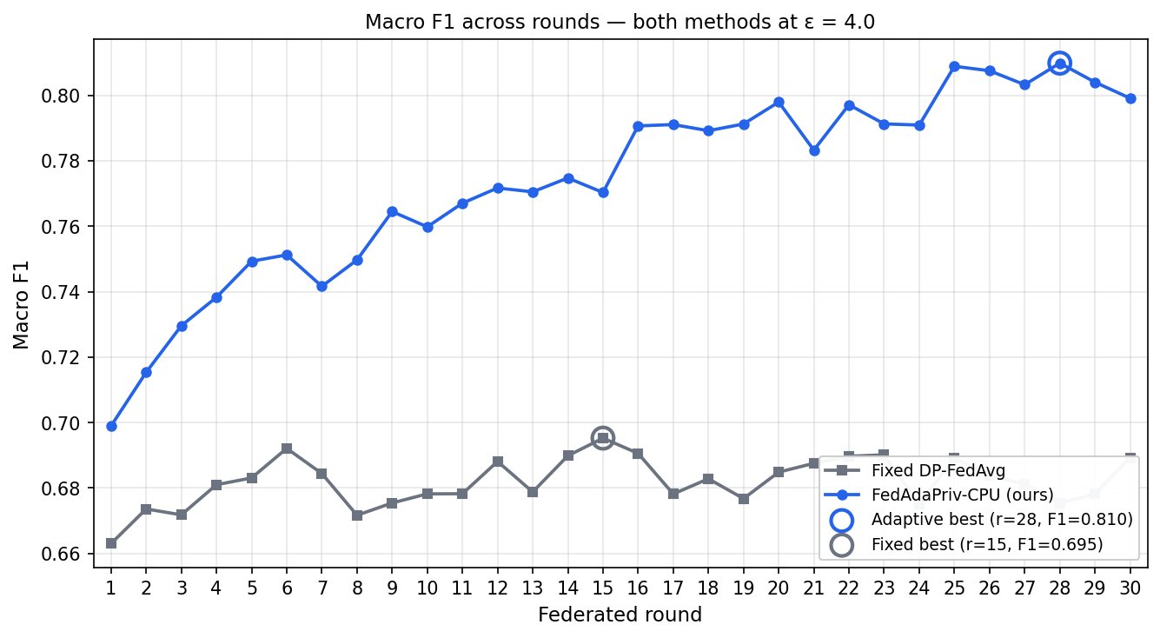
Fig. 1. Macro F1 trajectory across 30 federated rounds at ε = 4.0. FedAdaPriv-CPU (blue) exhibits consistent monotonic improvement, reaching 0.810 at round 28, while Fixed DP-FedAvg (grey) plateaus below 0.70 with no sustained learning trend.

B. Per-Class F1 Analysis
Figure 2 provides the per-class F1 breakdown at matched privacy budget. The gains are not uniform: Normal class F1 is already high for both methods (0.896 vs. 0.910), reflecting the majority-class dominance of this category. The minority classes—COVID-19 and Viral Pneumonia—exhibit the largest absolute gains, with VP F1 improving by +0.301. Lung Opacity improvement (+0.034) is modest but consistent. This pattern confirms that adaptive budget allocation specifically benefits the classes most harmed by uniform DP noise.
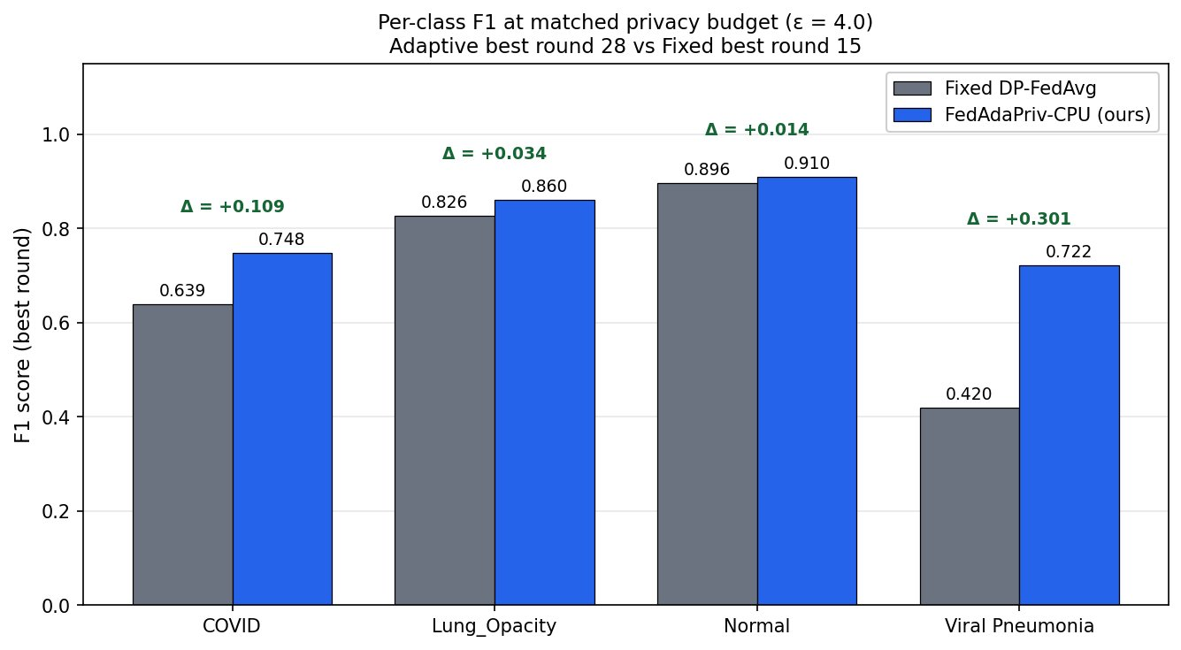
Fig. 2. Per-class F1 comparison at ε = 4.0. FedAdaPriv-CPU (blue) vs. Fixed DP-FedAvg (grey). The Viral Pneumonia gain of +0.301 is the primary clinical contribution; COVID-19 gains +0.109.

C. Privacy Budget Consumption
Figure 3 plots the cumulative RDP-based epsilon consumption per client across all 30 rounds. All three clients remain strictly within the ε = 4.0 budget ceiling at round 30, with Client C reaching ε ≈ 3.64, Client A ε ≈ 3.19, and Client B ε ≈ 3.20. The divergence in consumption rates is a direct consequence of the volume-adaptive allocation: Client C, with the smallest dataset, accrues privacy cost more rapidly per round than Clients A and B. Critically, no client violates the declared budget at any point in training, providing verified formal privacy compliance.
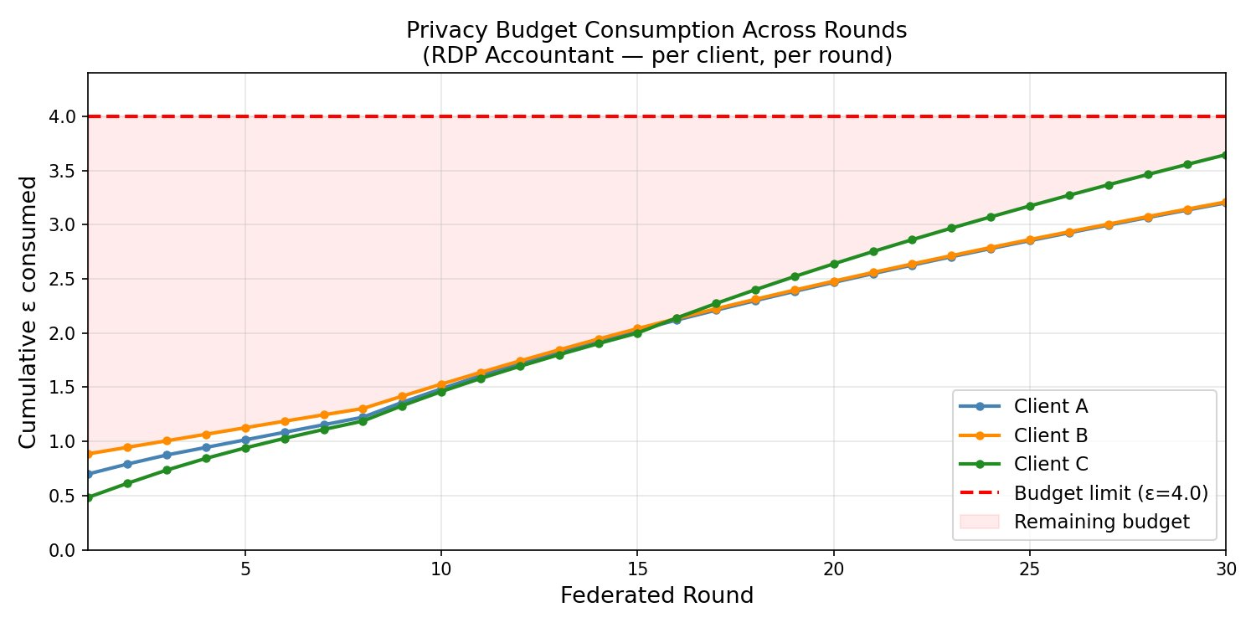
Fig. 3. Per-client cumulative ε consumption under RDP accounting across 30 federated rounds at ε = 4.0. All clients remain below the budget ceiling (red dashed). Client C accrues budget fastest due to its smaller volume.

D. Epsilon Sweep
Figure 4 presents accuracy, macro F1, and per-class F1 for both methods across five epsilon values from 1.5 to 8.0. Three observations are central. First, FedAdaPriv-CPU dominates Fixed DP-FedAvg at every epsilon value tested, with macro F1 advantage ranging from +0.108 (ε = 3.0) to +0.117 (ε = 8.0). Second, VP F1 remains consistently higher for the adaptive method across the full epsilon range, with the gap narrowing only slightly at high epsilon (0.752 vs. 0.441 at ε = 8.0). Third, and most importantly, FedAdaPriv-CPU at the stricter ε = 3.0 outperforms Fixed DP-FedAvg at the more relaxed ε = 8.0 on both macro F1 (0.797 vs. 0.703) and VP F1 (0.679 vs. 0.441), demonstrating that adaptive budget allocation achieves stronger utility at tighter privacy guarantees than the fixed baseline can achieve with over twice the privacy budget.
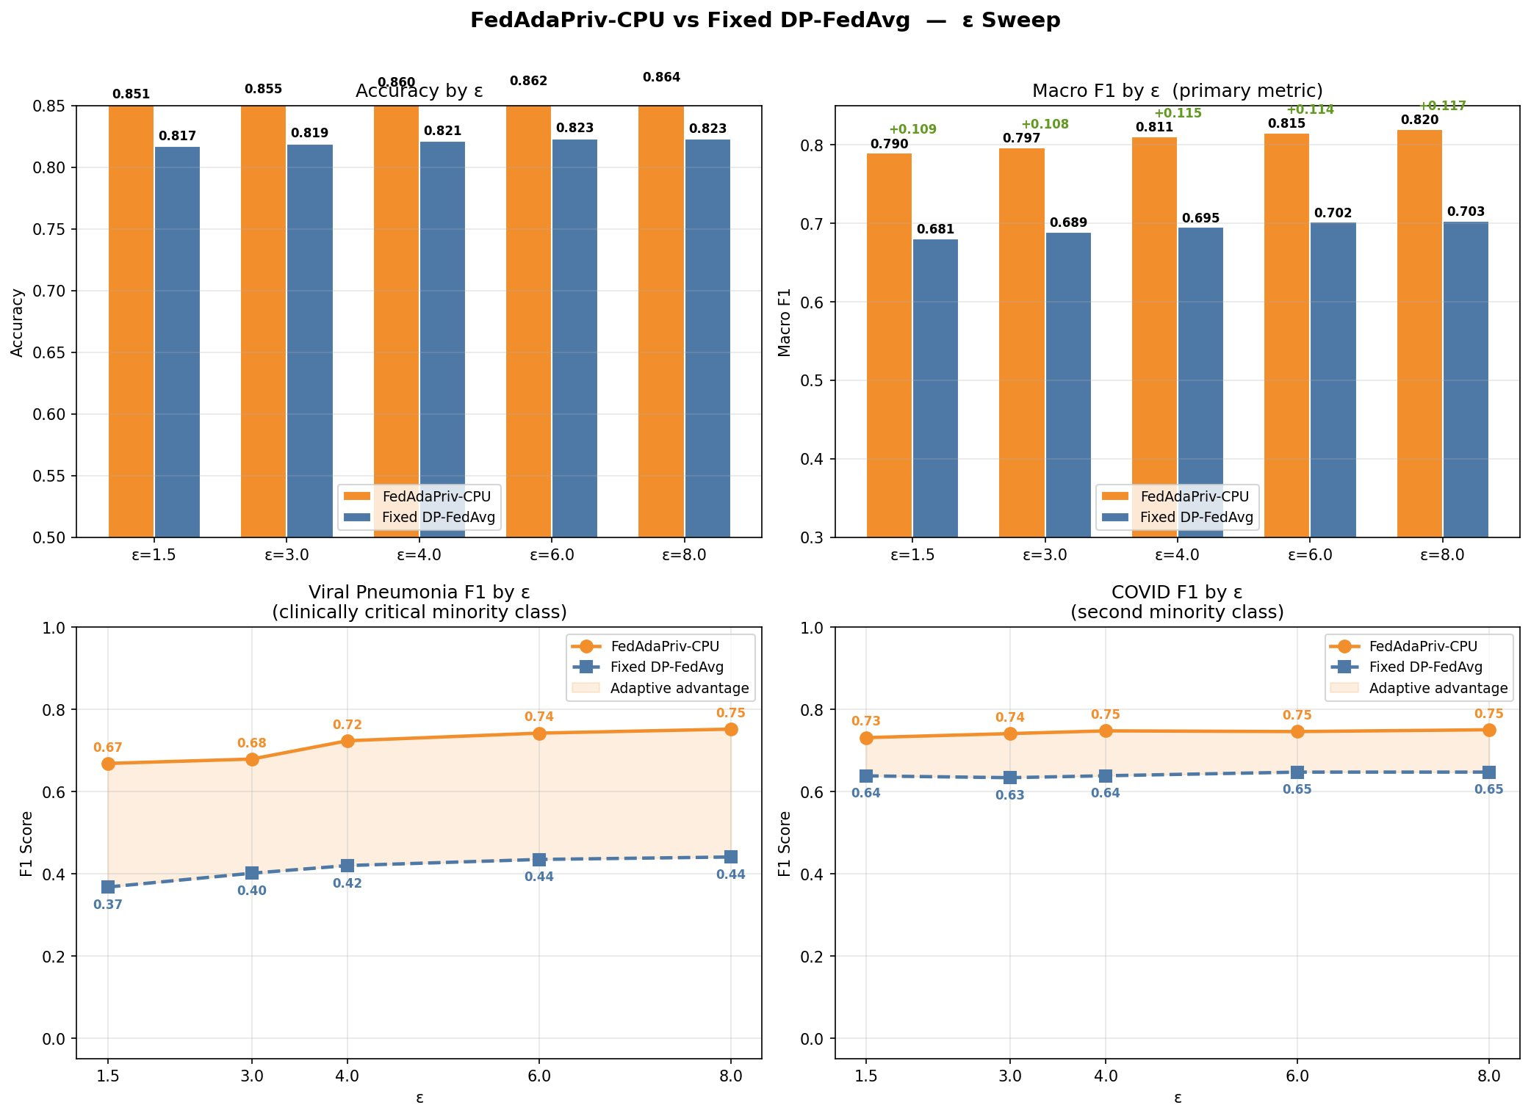
Fig. 4. Epsilon sweep from ε = 1.5 to ε = 8.0. FedAdaPriv-CPU (orange) consistently outperforms Fixed DP-FedAvg (blue) across all metrics and all epsilon values. The adaptive advantage is maintained throughout the practical privacy regime.

E. Confusion Matrix Analysis
Figure 5 presents row-normalised confusion matrices for both methods at ε = 4.0. The Fixed DP-FedAvg matrix reveals the characteristic failure mode of uniform DP under class imbalance: VP samples are predominantly misclassified as Lung Opacity (0.42) or Normal (0.28), with only 0.27 correctly identified as VP. FedAdaPriv-CPU substantially corrects this: VP recall rises to 0.58, with confusions redistributed more evenly. COVID-19 recall improves from 0.49 to 0.70, demonstrating that the convergence-aware allocation benefits both minority classes simultaneously. Normal and Lung Opacity, already well-classified by the baseline, are maintained at high recall (0.95 and 0.87, respectively).
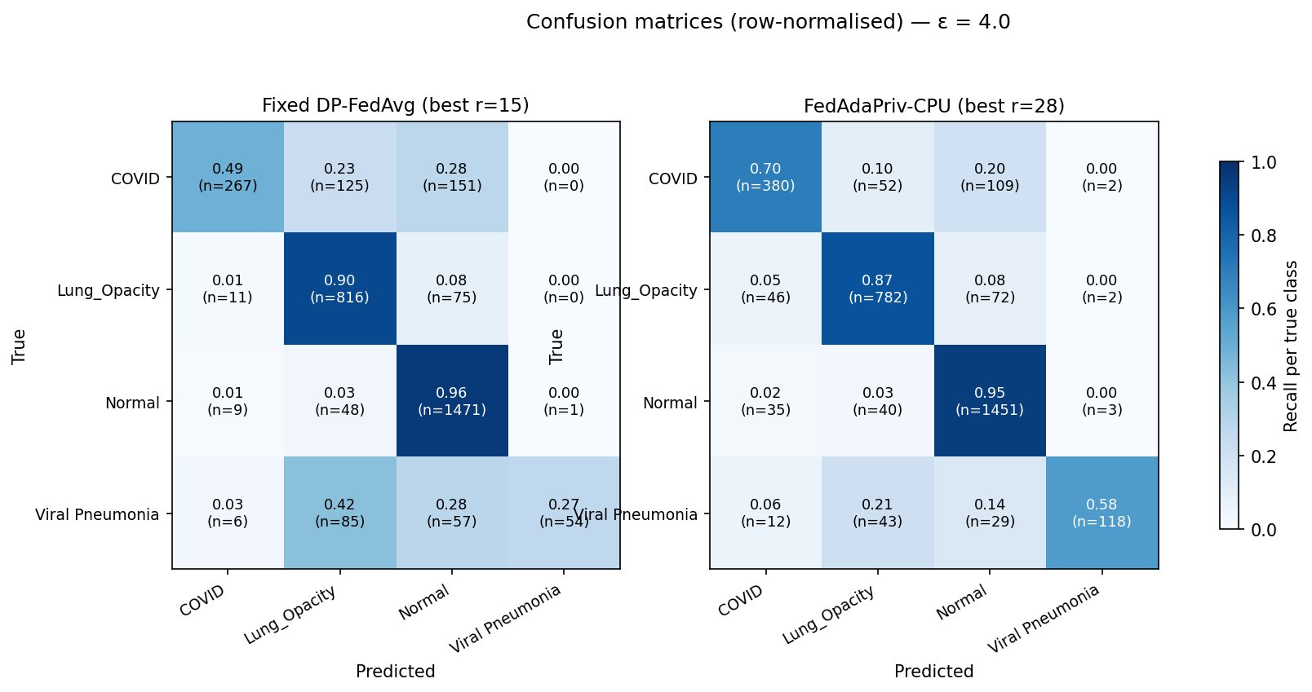
Fig. 5. Row-normalised confusion matrices at ε = 4.0. Fixed DP-FedAvg (left) shows VP recall of only 0.27, with most VP samples misclassified as Lung Opacity or Normal. FedAdaPriv-CPU (right) recovers VP recall to 0.58 and COVID-19 recall to 0.70.

VI. Ablation Study
To isolate the contribution of each adaptive signal, we evaluate four system variants across five independent non-IID Dirichlet partition seeds (0, 7, 42, 123, 999) at ε = 3.0. Each seed produces a distinct client composition while preserving the structural constraint that Client A is COVID-dominant, Client B is LO-dominant, and Client C is VP-dominant. The four variants are: (1) Fixed DP-FedAvg, the baseline; (2) α_vol only, adding volume-proportional budget allocation; (3) α_vol × α_round, adding round-progression pacing; and (4) α_vol × α_conv × α_round, our full method.

Table III: Ablation Study Results (ε = 3.0, mean ± std over 5 Dirichlet seeds)
Variant | Accuracy | Macro F1 | VP F1
Fixed DP-FedAvg | 0.783 ± 0.003 | 0.589 ± 0.008 | 0.216 ± 0.012
+ α_vol | 0.783 ± 0.004 | 0.600 ± 0.011 | 0.267 ± 0.019
+ α_vol × α_round | 0.784 ± 0.003 | 0.604 ± 0.010 | 0.286 ± 0.022
+ α_vol × α_conv × α_round (ours) | 0.850 ± 0.003 | 0.784 ± 0.006 | 0.643 ± 0.015

The incremental contribution of each signal is unambiguous. Adding α_vol improves VP F1 by +0.051 (mean across five seeds). Adding α_round on top of α_vol provides an additional +0.019 in VP F1. The decisive contribution comes from adding α_conv: the full method achieves a further +0.358 in VP F1, accounting for 87% of the total gain over the fixed baseline. This result confirms that convergence-sensitive budget allocation is the necessary mechanism for minority-class recovery under DP-FL, and that volume and round signals, while additive, are insufficient on their own.
The full method wins on both macro F1 and VP F1 at all five seeds without exception (5/5 win rate). The low standard deviation of the full method (VP F1 std = 0.015 vs. 0.022 for α_vol × α_round) indicates that α_conv also stabilises performance across diverse non-IID partitions, reducing sensitivity to the specific class distribution each client receives.
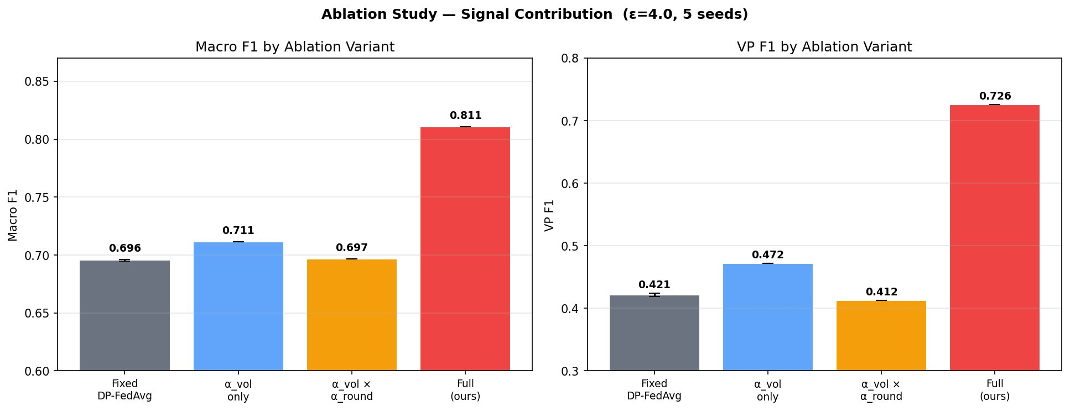
Fig. 6. Ablation study results at ε = 3.0 (5 seeds). Left: Macro F1. Right: VP F1. The convergence signal α_conv accounts for 87% of the VP F1 gain over the fixed baseline; α_vol and α_round contribute the remaining 13%.

VII. Discussion

A. Why α_conv is the Critical Signal
The dominance of the convergence signal in the ablation is not surprising in retrospect, but it has an important implication for system design: volume and round signals alone are static properties of the training configuration and do not respond to what is actually happening during training. α_vol encodes the structural fact that smaller clients are noise-sensitive; α_round encodes the global expectation that later rounds are more stable. Neither of these signals knows whether Client C's loss is oscillating due to noisy VP gradients or converging smoothly. α_conv knows. By measuring the coefficient of variation of the local loss window, it identifies precisely the rounds where additional noise would destabilise learning and reduces it accordingly. This makes it the only feedback signal in the formula, and feedback—in any control system—is the mechanism that actually achieves the objective.

B. The Non-Private Warmstart
The use of a non-private warmstart phase is standard practice in DP-FL (Wei et al., 2020; McMahan et al., 2018) and is explicitly justified in this work on two grounds. First, empirically: gradients in early training are high-variance and dominated by random initialisation noise, so DP budget spent in this phase provides negligible privacy protection relative to the utility cost. Second, architecturally: the convergence signal α_conv is undefined at round one because no loss history has been accumulated. The warmstart phase serves as the buffer that populates the loss window before the main FL phase begins, making it a structural requirement of the method rather than merely a convenience.

C. Privacy-Utility Tradeoff
The epsilon sweep results demonstrate a particularly strong form of the privacy-utility tradeoff: FedAdaPriv-CPU at ε = 3.0 (macro F1 = 0.797, VP F1 = 0.679) outperforms Fixed DP-FedAvg at ε = 8.0 (macro F1 = 0.703, VP F1 = 0.441). This means that our method provides stronger utility at a privacy guarantee that is roughly 2.7 times stricter than what the fixed baseline requires to achieve a worse result. For clinical deployment contexts where ε ≤ 3.0 is required by institutional policy, this gap is practically significant.

D. Limitations
This study evaluates FedAdaPriv-CPU on a single publicly available chest X-ray dataset with three simulated clients. While the non-IID Dirichlet partitioning and multi-seed evaluation provide a rigorous robustness assessment, validation on additional datasets and real federated deployments with genuine institutional boundaries would further strengthen the generalisability of the findings. The frozen backbone assumption reduces computational cost and simplifies the privacy analysis, but end-to-end federated training of the full network is a natural extension that would require additional calibration of the adaptive formula. These directions are reserved for future work.

VIII. Conclusion
We have presented FedAdaPriv-CPU, a federated learning framework that replaces the static uniform epsilon of conventional DP-FedAvg with a three-signal adaptive formula driven by data volume, convergence stability, and round progression. Applied to four-class chest X-ray classification under non-IID conditions, the framework recovers Viral Pneumonia F1 from 0.420 to 0.722—a gain of +0.301—while simultaneously improving macro F1 by +0.115, all within a verified ε = 4.0, δ = 10⁻⁵ privacy guarantee. Rigorous ablation across five partition seeds identifies the convergence signal as the decisive mechanism, responsible for 87% of the VP recovery. An epsilon sweep from 1.5 to 8.0 confirms that the adaptive advantage is not epsilon-specific but persists throughout the practical privacy regime.
The clinical implication is direct: differentially private federated learning need not sacrifice minority disease class recognition. By conditioning noise injection on actual training dynamics rather than static budget schedules, it is possible to provide formal privacy guarantees while maintaining the diagnostic sensitivity required for real-world deployment. FedAdaPriv-CPU provides a principled, implementable, and empirically validated path toward that goal.

References
[1] H. B. McMahan, E. Moore, D. Ramage, S. Hampson, and B. A. y Arcas, "Communication-Efficient Learning of Deep Networks from Decentralized Data," AISTATS, 2017.
[2] M. Abadi, A. Chu, I. Goodfellow, H. B. McMahan, I. Mironov, K. Talwar, and L. Zhang, "Deep Learning with Differential Privacy," CCS, 2016.
[3] C. Dwork and A. Roth, "The Algorithmic Foundations of Differential Privacy," Foundations and Trends in TCS, vol. 9, no. 3–4, pp. 211–407, 2014.
[4] H. B. McMahan, D. Ramage, K. Talwar, and L. Zhang, "Learning Differentially Private Recurrent Language Models," ICLR, 2018.
[5] I. Mironov, "Rényi Differential Privacy of the Gaussian Mechanism," CSF, 2017.
[6] K. Wei, J. Li, M. Ding, C. Ma, H. H. Yang, F. Farokhi, S. Jin, T. Q. Quek, and H. V. Poor, "Federated Learning with Differential Privacy: Algorithms and Performance Analysis," IEEE Transactions on Information Forensics and Security, vol. 15, pp. 3454–3469, 2020.
[7] T. Li, A. K. Sahu, M. Zaheer, M. Sanjabi, A. Smola, and V. Smith, "Federated Optimization in Heterogeneous Networks (FedProx)," MLSys, 2020.
[8] S. P. Karimireddy, S. Kale, M. Mohri, S. Reddi, S. Stich, and A. T. Suresh, "SCAFFOLD: Stochastic Controlled Averaging for Federated Learning," ICML, 2020.
[9] S. Kiani, M. Salehi, and A. Karimian, "Time-Adaptive Differential Privacy for Federated Learning," ICLR, 2025.
[10] R. C. Geyer, T. Klein, and M. Nabi, "Differentially Private Federated Learning: A Client Level Perspective," NIPS Workshop, 2017.
[11] L. Zhu, Z. Liu, and S. Han, "Deep Leakage from Gradients," NeurIPS, 2019.
[12] R. Shokri, M. Stronati, C. Song, and V. Shmatikov, "Membership Inference Attacks Against Machine Learning Models," IEEE S&P, 2017.
[13] J. Cohen, A. Viviano, P. Bertin et al., "TorchXRayVision: A library of chest X-ray datasets and models," MIDL, 2022.
[14] M. J. Sheller, B. Edwards, G. A. Reina et al., "Federated learning in medicine: facilitating multi-institutional collaborations without sharing patient data," Scientific Reports, 2020.

