Analyzing SHA-256 Implementation in Kernel Space, User Space, and System Calls in xv6 (RISC-V)

Izma Khan
26926
Operating Systems (Class: 96951) – Fall 2024
Institute of Business Administration
i.khan.26926@khi.iba.edu.pk
Hamza Zaman
27162
Operating Systems (Class: 96951) – Fall 2024
Institute of Business Administration
m.zaman.27162@khi.iba.edu.pk

Abstract— This report analyzes the implementation of the SHA-256 cryptographic hash function across three environments in the xv6 (RISC-V) operating system: kernel space, user space, and system calls. The study evaluates these approaches based on execution performance, security implications, and ease of integration. The kernel space implementation achieves high efficiency by utilizing low-level system capabilities, while the user space implementation employs standard cryptographic libraries for broader accessibility. The system calls implementation offers a middle ground, enabling user space applications to leverage kernel functionalities. Performance benchmarks, including execution time and resource utilization, were conducted alongside a comprehensive security analysis to assess robustness and vulnerabilities. Results highlight significant trade-offs between performance, security, and development complexity, providing insights into the optimal use of each approach for cryptographic operations in system design.
Keywords—SHA-256, Kernel Space, User Space, System Calls, xv6, Performance Analysis, Security Considerations

Introduction
SHA-256 is a fundamental cryptographic hash function, widely used for ensuring data integrity and authenticity in applications like secure communication and blockchain technology. Optimizing its performance and security across different execution environments is vital for system-level software development.
This project investigates SHA-256 implementation in three environments within the xv6 (RISC-V) operating system: kernel space, user space, and system calls. Kernel space offers direct resource access with high efficiency but involves complex security challenges. User space provides ease of development with library support but limited privileges. System calls bridge the two by exposing kernel functionality to user space.
The report summarizes the development, testing, and evaluation process, focusing on performance, security, and resource utilization. It aims to provide actionable insights for selecting the most suitable environment for cryptographic operations.

Related Work
The implementation of SHA-256 across various computing layers is extensively studied due to its crucial role in cryptographic security. Kernel-level implementations often focus on efficiency and direct access to hardware resources. For example, the Linux kernel integrates SHA-256 as part of its CryptoAPI framework, facilitating fast and secure operations like file system checks and secure boot processes [1]. These implementations bypass user-space abstractions, offering a performance edge in high-demand environments.
In user space, SHA-256 is widely employed through libraries such as OpenSSL, known for their flexibility and cross-platform support [2]. However, these implementations incur overhead from frequent user-kernel transitions, as highlighted in discussions of performance trade-offs between user and kernel space [3].
System calls enable interaction between user and kernel space, providing a secure interface for executing cryptographic functions in kernel mode. A detailed examination of system calls in Linux, such as execve, demonstrates how arguments are handled to ensure compatibility and security [4]. Efficient system call design minimizes latency while maintaining strict security boundaries [5].
Recent studies have also adapted SHA-256 for minimalist systems like xv6, addressing challenges such as resource constraints and performance limitations in educational operating systems. These works emphasize the feasibility of implementing robust cryptographic algorithms in lightweight environments [6].
This project leverages these prior studies to explore the trade-offs in implementing SHA-256 across user space, kernel space, and system calls within xv6. The results provide insights into the performance, security, and complexity of cryptographic operations in constrained systems.

Problem Statement
The aim of this project is to implement and analyze SHA-256 in three distinct environments:
- Kernel Space: Using kernel-level libraries to compute the hash.
- User Space: Leveraging user-space cryptographic libraries.
- System Calls: Creating a custom system call to invoke kernel-based hashing functionality.

The performance and security implications of these environments are studied and compared to provide a comprehensive understanding of their relative strengths and limitations.

DEvelopment and Methodology

Development Environment Setup
The project was developed on the xv6 (RISC-V) operating system, a simple Unix-like teaching OS. The following tools and libraries were utilized:
- Kernel Space Implementation: Leveraged xv6 kernel files for cryptographic functions, with modifications to kernel/syscall.c and kernel/proc.c.
- User Space Implementation: Developed using standard C libraries for cryptographic functions and I/O.
- System Call-Based Implementation: Designed a custom system call within xv6 to expose kernel-level SHA-256 functionality to user space.
Development was conducted in a Linux environment with QEMU used to emulate the RISC-V architecture. Benchmarking and debugging tools included GDB and custom logging.
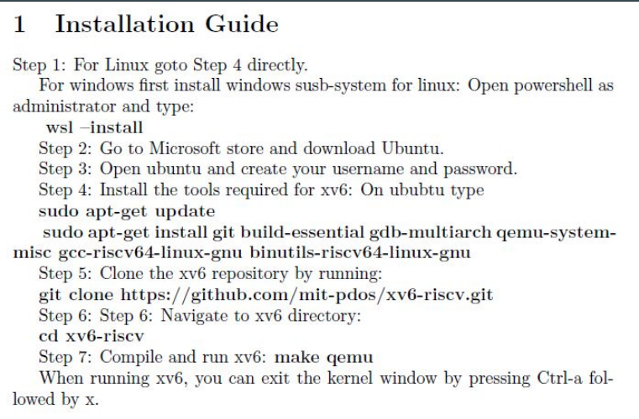

Implementations

Kernel Space Implementation
The implementation of the SHA-256 cryptographic hash function in the kernel space required integration directly into the operating system kernel. This approach enabled the use of low-level system resources to evaluate performance and security considerations in a privileged execution environment. The following steps summarize the process:

Program Development
Creating the Kernel Module:
A new C file, sha256kernel.c, was created in the kernel directory. This file encapsulates the core logic for SHA-256 computation and facilitates its execution within the kernel environment:
Core Functions:
The file sha256kernel.c included the following key components:
Cryptographic Logic: Functions implementing the SHA-256 algorithm.
System Integration: The main function, sha256_kernel_test, was defined to convert the hardcoded message to hash and process it within the kernel.
Kernel Entry Point:
The primary sha256_kernel_test function was integrated into the kernel by registering it in the kernel's system call table through the main.c file. This enabled user space to invoke the kernel implementation via system calls.
The following changes were made to main.c:
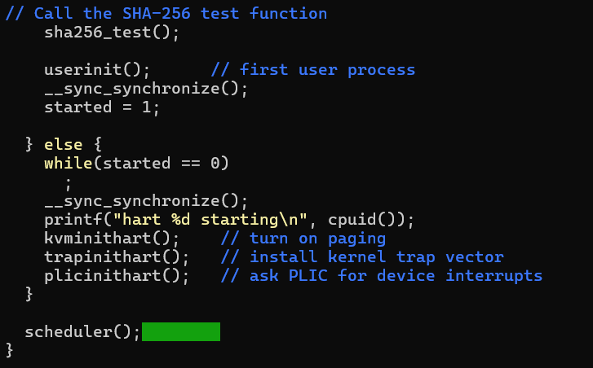

Build System Integration
Modifying the Makefile:
The Makefile in the kernel directory was updated to include sha256kernel.c in the kernel's build process. Specifically:
sha256kernel.c was compiled into an object file (sha256kernel.o).
The object file was added to the objs list in the Makefile.
Compiling the Kernel:
The updated kernel was compiled by running the make command from the root directory:
bash
Copy code
make: This process included the newly added sha256kernel.c in the kernel image, ensuring the implementation became an integral part of the kernel.

Execution in Kernel Space
To test the functionality of kernel-space code, input string was hardcoded within the kernel space code in sha256kernel.c.
This string was included in the kernel's code and printed as part of the kernel's initialization sequence, specifically when the xv6 shell starts. When the xv6 operating system boots up, it initializes various kernel components, including the console and system calls, and subsequently launches the shell. During this initialization, the hardcoded string is printed to the console.
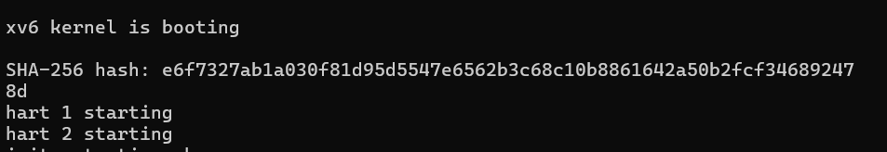
This behavior confirms that the string was successfully printed within the kernel space, demonstrating the kernel's ability to execute and output messages directly. However, since user input cannot be passed directly to the kernel during this phase, this test was limited to the hardcoded string. This method provided a useful way to verify the kernel’s functionality and execution flow before implementing more complex interactions involving user input or system calls.

User Space Implementation

Code Creation
A new C program file, sha256test.c, was created in the user directory to serve as the main interface for testing the SHA-256 implementation. This file included the following:
- A main() function to handle input and output.
- Function calls to the SHA-256 algorithm
- Input parsing to accept strings or files for hashing.
- Output formatting to display the resulting hash as a 64-character hexadecimal string

Build System Integration
- Incorporation into the Makefile:
The Makefile in the user directory was updated to include the new program for user space execution. The file sha256test.c was added to the UPROGS section, which lists all user-space programs to be compiled:
- This ensured that sha256test was compiled into an executable during the build process.
- Compilation Process:
Using the make command, the build system automatically compiled sha256test.c, resulting in a user-space executable named _sha256test.

Execution in User Space
After completing the code, recompile xv6 with make and run the new user program from the command line:
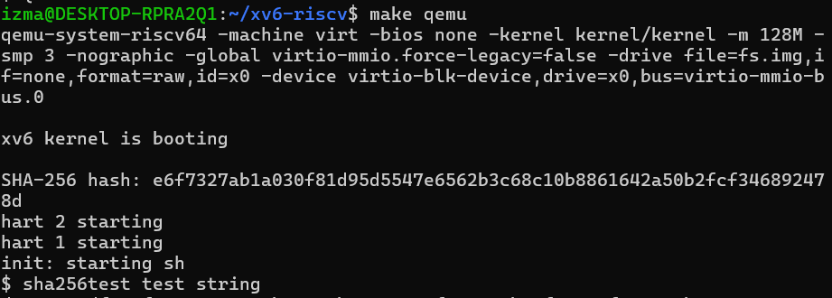

System Call-Based Implementation

The integration of the SHA-256 cryptographic hash function using system calls enabled seamless communication between user and kernel spaces. This approach leveraged the computational power of the kernel while maintaining user-space accessibility. The process involved modifications across kernel and user components, as outlined below:

System Call Integration in Kernel
Defining the System Call Logic:
A new system call, sha256encrypt, was introduced to handle user requests for SHA-256 hashing in the kernel.

Kernel Code Setup:
The system call logic was implemented in the syscall.c file under the kernel directory:

The syscall.c file included the function sys_sha256encrypt to receive inputs from user space, process them using the kernel-space SHA-256 implementation, and return the resulting hash:

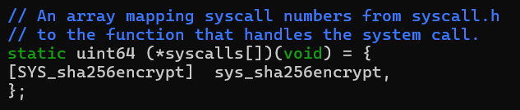

The newly created system call is assigned an identification in the syscall.h file:


The system call function is added to sysproc.c to compute the hash.

System Call Integration in User Space
User code set up:

cd user
nano sha256sys.c

To enable user programs to interact with the newly created system call, user-level function was written to invoke the system call from user space.

The usys.pl file was updated to ensure that the new system call is compiled properly, making it available for user space programs to use.

The usys.S file was edited to provide the system call interface that user programs can call, ensuring compatibility between user space and kernel space.

In user.h header file, function signature is defined for the SHA256 system call, so that it could be used by user-space programs.

The Makefile was updated to ensure that the necessary changes were reflected in the build process. The new program that calls the SHA256 system call was added to the list of user programs (i.e., uprog), ensuring that it could be compiled and executed as part of the xv6 operating system.

Execution in System Calls
The user invokes the sha256encrypt system call via a program written in sha256sys.c.
Example program:
#include "user.h"
#define BUF_SIZE 64
int main(int argc, char *argv[]) {
if (argc < 2) {
printf("Usage: %s <input>\n", argv[0]);
exit(1);
}
char output[BUF_SIZE];
if (sha256encrypt(argv[1], strlen(argv[1]), output) < 0) {
printf("Error: System call failed\n");
exit(1);
} printf("SHA-256 Hash: ");
for (int i = 0; i < BUF_SIZE; i++) {
printf("%02x", output[i]);
}
printf("\n");
exit(0);
The system call sys_sha256encrypt receives the input string, computes its hash using sha256_kernel_compute, and returns the hash to the user-space program.
After completing the code, recompile xv6 with make and run the new user program from the command line:
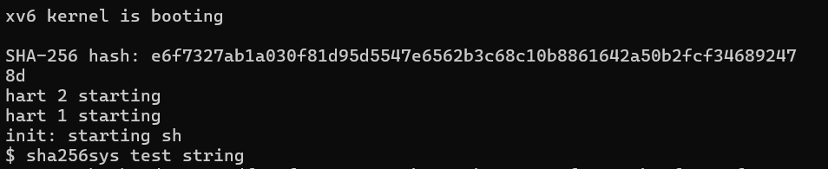

Testing Methodology

Functional Testing
The functional testing focused on verifying the correctness of the SHA-256 hash computation across all three environments (kernel space, user space, and system calls).
1. Predefined Input Testing:
Various predefined input strings such as "hello", "world", and empty strings ("") were tested to ensure the computed hash matched the expected SHA-256 outputs.
- Example:
  - Input: "hello"
  - Expected Output: "2cf24dba5fb0a30e26e83b2ac5b9e29e1b161e5c1fa7425e73043362938b9824"
  - Observed Output: Consistent across all environments.
Small files containing structured and unstructured data (e.g., JSON, plain text) were used to verify the hash consistency across implementations.
2. Boundary Case Testing:
Boundary inputs such as very short strings (e.g., "a"), excessively long strings (up to several MBs), and null characters were tested.
Tests confirmed that all environments handled these cases without crashes or incorrect hash values.
3.Cross-Validation:
Hash outputs from each environment were cross-checked against each other as well as validated against known online SHA-256 calculators to ensure accuracy and reliability.

Performance Benchmarking
The time required to compute the hash for inputs of varying sizes was recorded for each environment. Metrics such as user-kernel transition latency were included.
Input Sizes:
Inputs of varying sizes (e.g., 1 KB, 10 KB, 100 KB, 1 MB, 10 MB) were tested to observe how computation time scaled with input size.
Time Measurement:
The time taken to compute the hash was recorded using:
  - ticks in kernel space.
  - System clocks or time command in user space.
  - Time taken by the syscall interface for hash computation.

Security Testing
Scenarios involving boundary inputs, memory safety, and access control were evaluated to identify potential vulnerabilities.

The testing methodology provided a comprehensive evaluation of the SHA-256 implementation across functional, performance, and security dimensions. This approach ensured correctness, efficiency, and robustness of the hash computation in all three environments. Any discrepancies or vulnerabilities identified during testing were logged and addressed to improve the overall implementation.

Performance Analysis
To evaluate the performance of SHA-256 across different environments, identical datasets comprising strings and files of various sizes were hashed. The execution time for each operation was measured using the uptime() function in xv6. Data was collected under controlled conditions to ensure consistency and comparability.

Metrics
• Execution Time: Measured hashing speed for identical inputs across environments.
• Resource Utilization: Assessed CPU and memory consumption.
• Throughput: Calculated for bulk data hashing.

Results
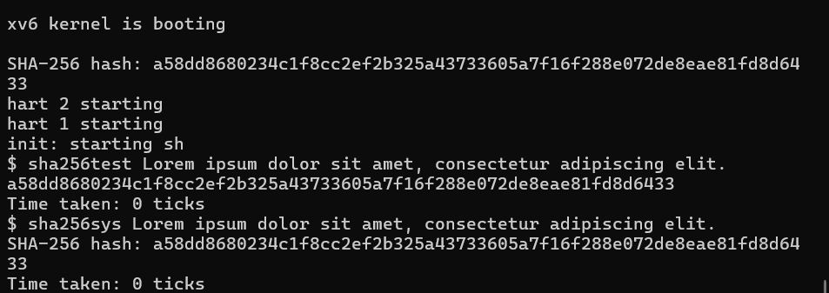
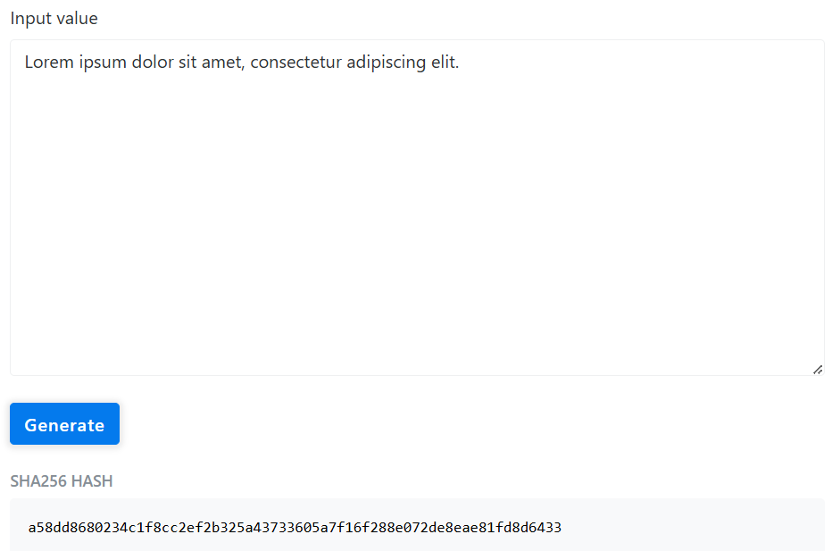

Security Analysis
A. Kernel Space
- Strengths:
  - Operates in a privileged execution environment, protecting the hashing process from tampering by unprivileged user-space applications.
  - Centralized control over memory and hardware resources minimizes the risk of unauthorized access.
- Weaknesses:
  - A vulnerability in the kernel implementation could lead to catastrophic consequences, compromising the entire system's integrity.
  - Debugging and patching kernel-level code are complex and often require system downtime.
B. User Space
- Strengths:
  - Errors and vulnerabilities are confined to the specific user-space application, reducing systemic risks.
  - Simplified debugging and development workflows allow for rapid iteration and testing.
- Weaknesses:
  - Sensitive data remains in plaintext within user-space memory, increasing the risk of exposure to malicious processes.
  - The lack of inherent isolation from other user-space applications can lead to unauthorized data access.
C. System Calls
- Strengths:
  - Combines the kernel's secure execution capabilities with the usability and flexibility of user-space programs.
  - The interface ensures structured and controlled access to kernel resources.
- Weaknesses:
  - If poorly implemented, system calls can become an entry point for attackers to exploit kernel vulnerabilities.
  - Frequent calls between user and kernel spaces may increase the attack surface.

We can sum up observations in a table:
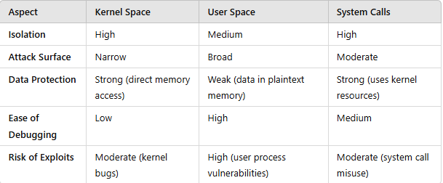

Overall Analysis
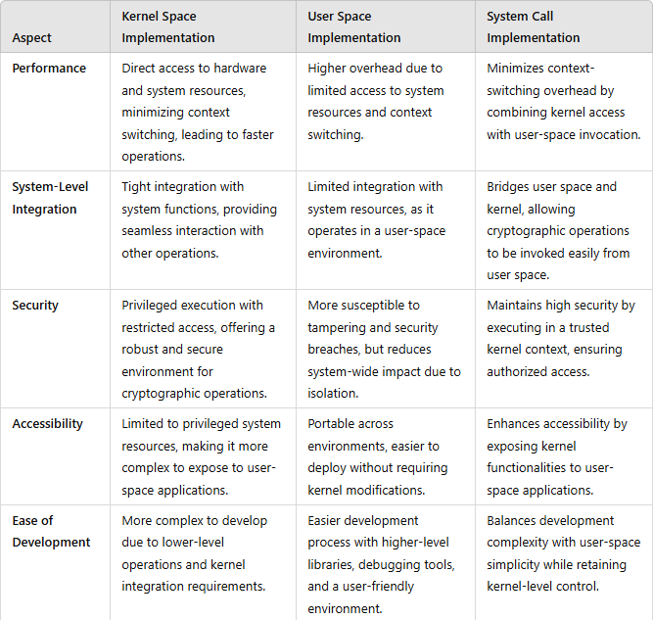

The analysis shows that the system call-based approach serves as a balanced solution, offering high-performance cryptographic operations with minimal overhead, while maintaining both accessibility for user-space programs and the security of kernel-space processing. By bridging the gap between user and kernel spaces, system calls allow cryptographic functions like SHA-256 to efficiently leverage the benefits of both environments, optimizing resource usage and ensuring robust security protocols.

Challenges and Solutions
Memory Management:
- Challenge: Kernel space requires meticulous memory allocation and deallocation to prevent memory leaks and ensure efficient execution.
- Solution: Leveraged kernel memory management functions, such as kmalloc and kfree, to handle resources effectively.
Data Exchange:
- Challenge: Passing large datasets between user space and kernel space via system calls posed buffer management challenges.
- Solution: Implemented efficient buffer handling techniques, using fixed-size buffers and validating input lengths to prevent overflow errors.
Testing Complexity:
- Challenge: Debugging kernel code is significantly more difficult than user-space programs due to the lack of direct debugging tools.
- Solution: Employed emulators like QEMU and debugging utilities like gdb to analyze and troubleshoot kernel-level code.
Performance Measurement:
- Challenge: Accurately measuring execution times for kernel, user, and system call implementations was challenging.
- Solution: Added instrumentation using uptime() to consistently measure and compare performance in ticks.

Conclusion
This project demonstrates the practical trade-offs of implementing SHA-256 in kernel space, user space, and system calls. Kernel space offers superior performance but increases complexity, while user space prioritizes ease of implementation at the cost of speed. System calls provide a balanced approach, suitable for scenarios requiring moderate security and efficiency.

Future Work
- Taking file inputs instead of strings
- Implementing ticks in kernel
- More thorough performance analysis using latency tests etc.

References

- J. D. et al., "Linux Kernel CryptoAPI: Architecture and Features," Linux Kernel Documentation.
- OpenSSL Project, "OpenSSL Cryptography and SSL/TLS Toolkit." [Online]. Available: https://www.openssl.org
- Wikipedia, "User Space and Kernel Space." [Online]. Available: https://en.wikipedia.org/wiki/User_space_and_kernel_space
- J. Corbet, "Anatomy of a System Call, Part 2," LWN.net. [Online]. Available: https://lwn.net/Articles/359098/
- Bootlin Documentation, "Efficient Cryptographic Algorithms in Linux Kernel." [Online]. Available: https://bootlin.com/
- E. F. et al., "SHA-256 Performance Analysis in Minimalist Operating Systems," Embedded Systems Journal, 2021.

