BLM 320 Class Work #10

* Decide if 3 colors are sufficient to color G₁ and G₂
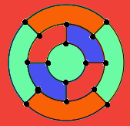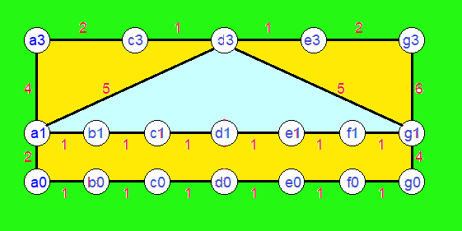
we can’t paint this with 3 color we can paint this with 3 color

* Find a minimum spanning tree in G₁ and G₂
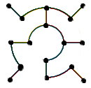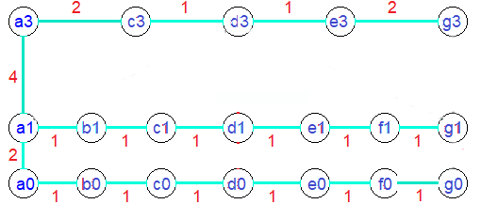

* Find a Hamiltonian circuit (cycle) in G₁ and G₂
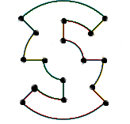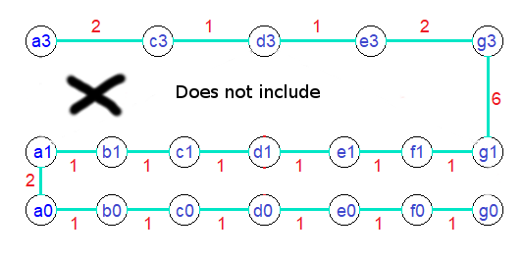

* Decide if G₁ and G₂ contain an Eulerian circuit
