CPU Scheduling Comparator
Round Robin vs. Shortest Remaining Time First
Operating Systems Project — Technical Write-Up

May 2026

1. Project Overview
This project implements a Java-based GUI application that simulates and compares two classic preemptive CPU scheduling algorithms: Round Robin (RR) and Shortest Remaining Time First (SRTF). The tool accepts a set of processes — each defined by a Process ID, Arrival Time, and Burst Time — and runs both algorithms simultaneously, displaying detailed per-process statistics, colour-coded Gantt charts, and a side-by-side comparison of average metrics.

1.1 Project Structure
The codebase consists of seven Java source files:
- Main.java — entry point; launches the Swing GUI on the Event Dispatch Thread.
- ProcessData.java — data model holding all six per-process metrics.
- GanttSlot.java — lightweight record storing (processId, startTime, endTime) for Gantt rendering.
- SchedulingResult.java — wraps the list of ProcessData and GanttSlots; computes averages automatically.
- RRAlgorithm.java — pure simulation of Round Robin scheduling.
- SRTFAlgorithm.java — pure simulation of SRTF scheduling (GUI-integrated version).
- STRF.java — standalone console SRTF prototype (early development artefact; not called by the GUI).
- SchedulerGUI.java — 24 KB Swing GUI: input panel, dual result tables, Gantt chart panels, and comparison pane.

2. Background Theory

2.1 Round Robin (RR)
Round Robin is the canonical time-sharing scheduling algorithm. Each process is given a fixed time slice called the quantum (q). Processes are kept in a circular FIFO ready queue; when a process's quantum expires it is preempted and re-queued at the tail. This guarantees that every runnable process makes forward progress and that no process waits more than (n − 1) × q time units before its next execution, where n is the number of processes in the queue.
- Preemption basis: quantum expiry only.
- Fairness: high — each process receives equal CPU slices.
- Starvation: impossible by design.
- Best for: interactive and time-sharing systems where response time matters.

2.2 Shortest Remaining Time First (SRTF)
SRTF is the preemptive variant of Shortest Job First (SJF). At every time unit the scheduler selects the process with the smallest remaining burst time. If a newly arrived process has a shorter remaining time than the currently executing process, the current process is immediately preempted.
- Preemption basis: a shorter job arrives.
- Optimality: provably minimises average waiting time across all non-clairvoyant scheduling algorithms.
- Starvation: possible — a long process may be perpetually preempted by shorter arrivals.
- Best for: batch systems where burst times are known or can be estimated.

3. Implementation Details

3.1 Data Model
ProcessData encapsulates every metric computed by either algorithm:

Field | Type | Description
id | int | Unique process identifier
arrivalTime | int | Time the process enters the ready queue
burstTime | int | Total CPU time needed to complete
completionTime | int | Time at which the process finishes execution
turnaroundTime | int | completionTime − arrivalTime
waitingTime | int | turnaroundTime − burstTime
responseTime | int | Time from arrival until first CPU execution

GanttSlot is a plain struct (processId, startTime, endTime). A special processId of 0 denotes CPU idle time in the RR implementation.

3.2 Round Robin Algorithm (RRAlgorithm.java)
The implementation uses a LinkedList as the FIFO ready queue and a boolean[] inQueue to prevent duplicate enqueuing.

Initialisation
All processes with arrivalTime == 0 are immediately enqueued. All others wait until their arrival time is encountered during simulation.

Main Loop
On each iteration the algorithm:
- Detects CPU idle: if the ready queue is empty, it fast-forwards currentTime to the next process arrival, emits an idle GanttSlot (processId = 0), then enqueues that process.
- Dequeues the head process.
- Runs it for min(quantum, remainingTime) ticks.
- Records responseTime on first execution (currentTime − arrivalTime before the slice).
- Advances currentTime, decrements remainingTime, appends a GanttSlot.
- Enqueues any processes that have now arrived (arrivalTime ≤ currentTime).
- If the process has remaining work, re-enqueues it at the tail; otherwise records completionTime.

Key Design Choice
Newly arrived processes are enqueued after the current process re-queues itself. This means a re-queued process goes before any process that happened to arrive during its own quantum — a common and correct RR convention.

3.3 SRTF Algorithm (SRTFAlgorithm.java)
The implementation uses parallel int arrays for arrival, burst, and remaining times, with a tick-by-tick simulation loop.

Main Loop
At each time unit t, the algorithm:
- Scans all non-completed processes to find the one with the smallest remaining[] whose arrivalTime ≤ t.
- If no process is available, advances t (CPU idle).
- If the selected process differs from the previous tick (context switch), closes the current GanttSlot and opens a new one.
- Records responseTime on first execution.
- Decrements remaining[selected] and advances t by 1.
- When remaining[selected] reaches 0, closes the GanttSlot and records completionTime.

Gantt Consolidation
Rather than emitting one slot per tick, SRTFAlgorithm consolidates contiguous ticks for the same process into a single GanttSlot, keeping Gantt output concise and matching standard OS textbook presentation.

3.4 Metrics Computation
All four metrics are derived uniformly in both algorithms:
Turnaround Time (TAT) = Completion Time − Arrival Time
Waiting Time (WT) = TAT − Burst Time
Response Time (RT) = First CPU Time − Arrival Time

SchedulingResult.calculateAverages() computes the arithmetic mean of TAT, WT, and RT over all n processes.

3.5 GUI (SchedulerGUI.java)
The interface is built with Java Swing using a BorderLayout split into three zones:
- North — Input Panel: time quantum field, dynamic process rows (PID, Arrival, Burst) with Add/Remove/Reset controls, and Run RR / Run SRTF / Compare Both action buttons.
- Centre — Results Panel: a JSplitPane containing two sub-panels (one per algorithm), each with a JTable showing per-process metrics and a custom GanttChartPanel drawn in paintComponent().
- South — Comparison Panel: a monospaced JTextArea updated by updateComparison() that shows a three-column table (Metric | RR value | SRTF value | Best) for Avg TAT, Avg WT, and Avg RT.
The GanttChartPanel renders each slot as a filled rectangle coloured by processId (cycling through 8 pastel colours), with the PID label centred inside and time tick marks below.

4. Application Screenshots

Screenshot 1 — Initial GUI State
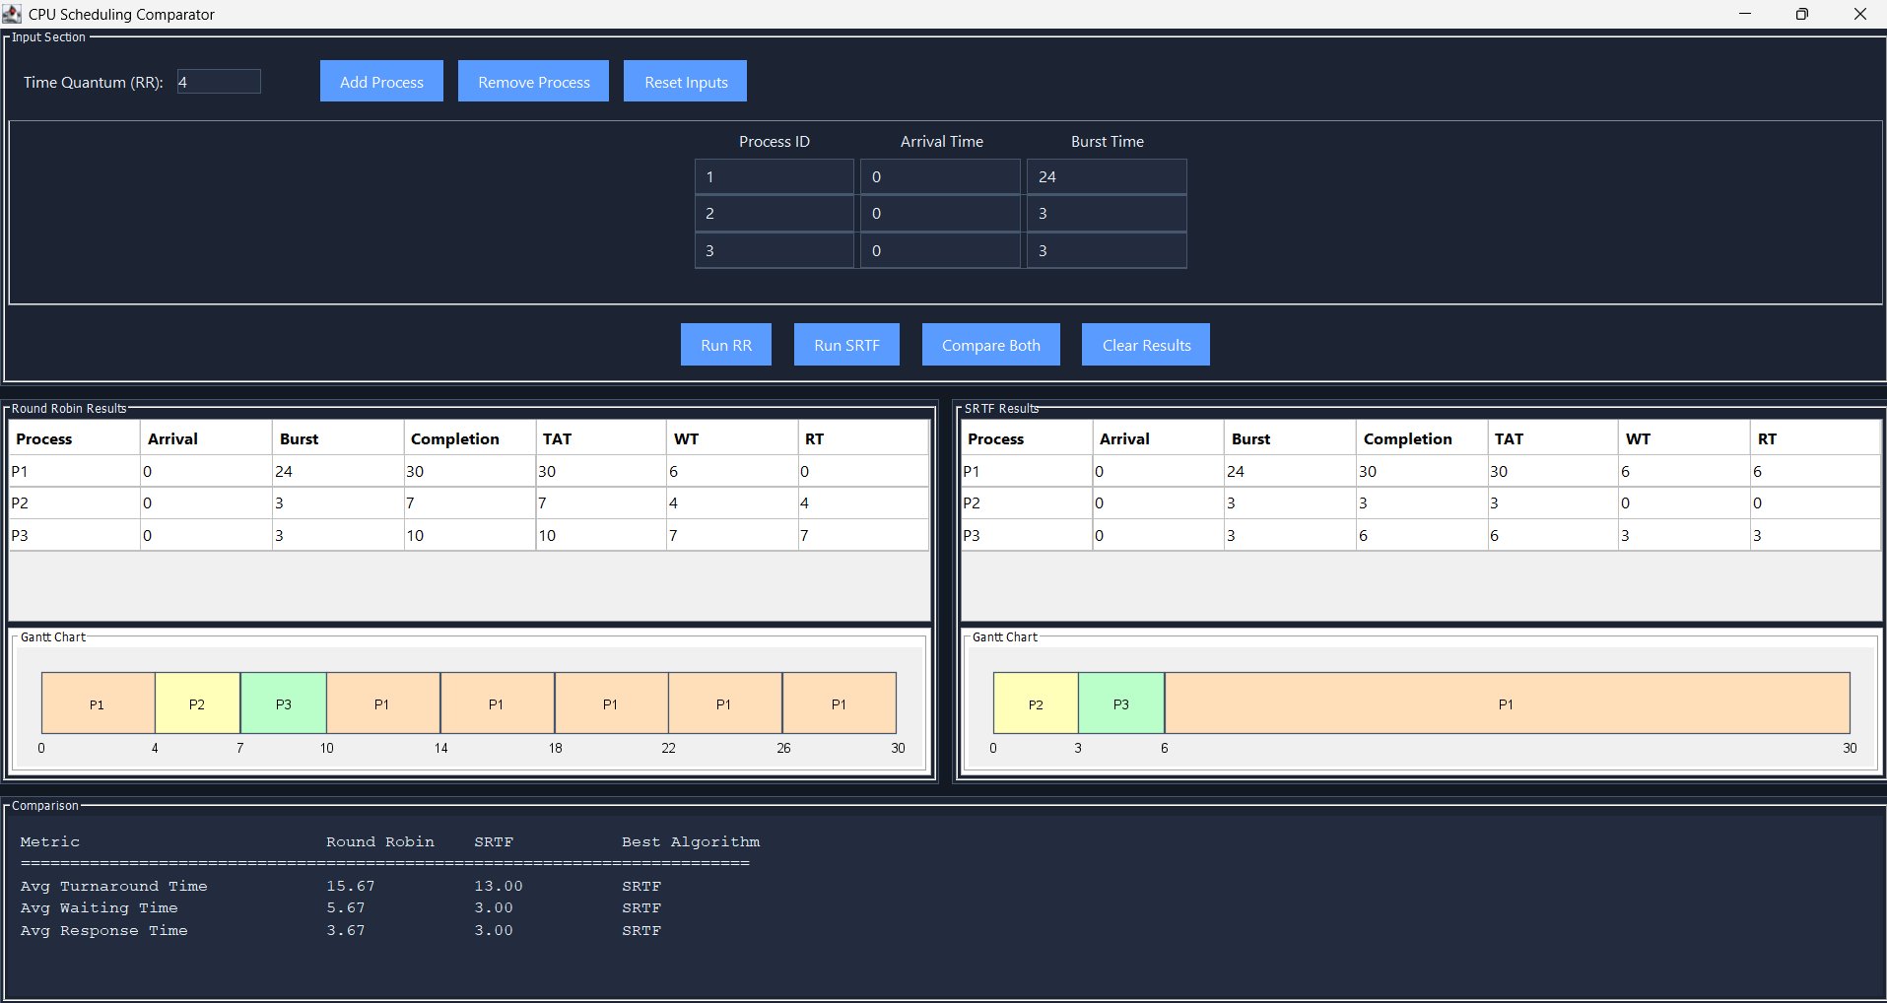
Figure 1: Application launch state. The input panel shows the default time quantum (2) and a single empty process row. The results area is blank awaiting input.

Screenshot 2 — Process Input and Configuration
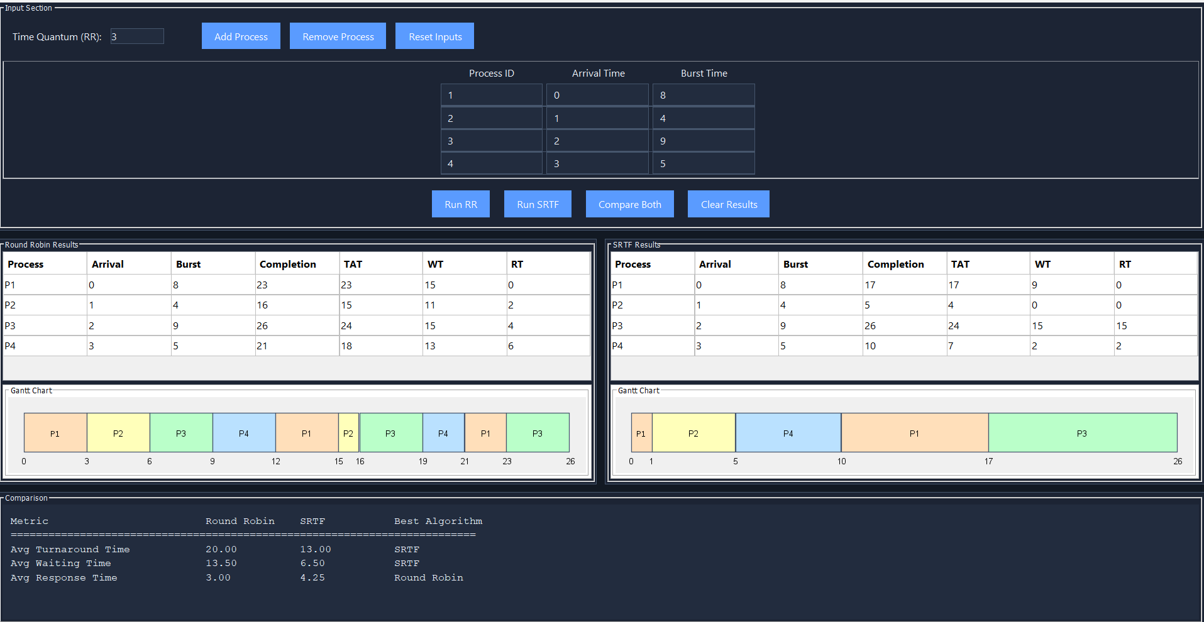
Figure 2: Sample process set entered by the user. Four processes with varying arrival and burst times are configured before running the algorithms.

Screenshot 3 — Round Robin Results
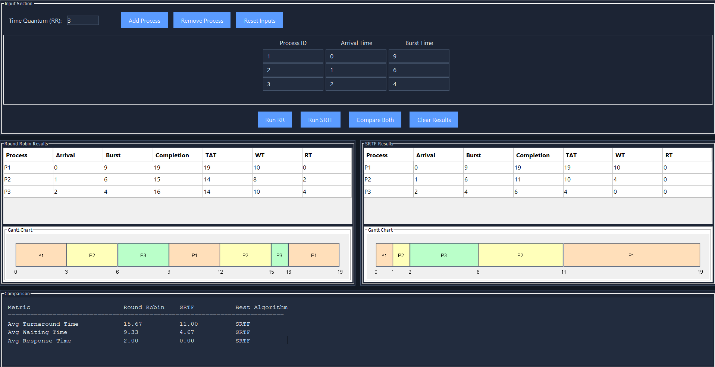
Figure 3: RR algorithm output. The per-process metrics table shows CT, TAT, WT, and RT. The Gantt chart beneath visualises the interleaved execution order with colour-coded slots.

Screenshot 4 — SRTF Results
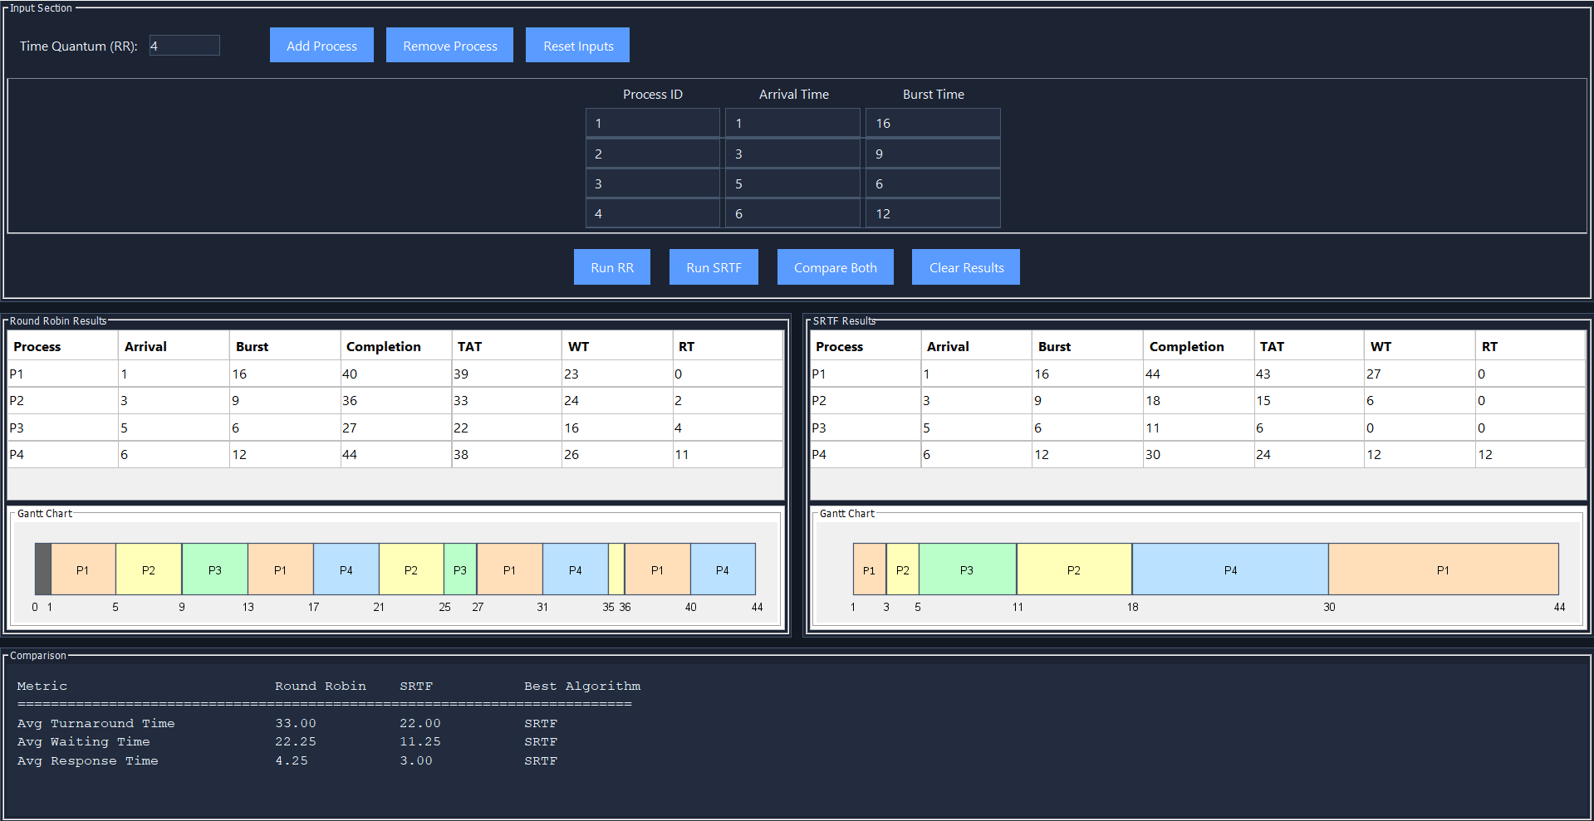
Figure 4: SRTF algorithm output for the same process set. Notice the fewer, longer Gantt slots compared to RR, reflecting fewer context switches and lower average waiting times.

Screenshot 5 — Side-by-Side Comparison
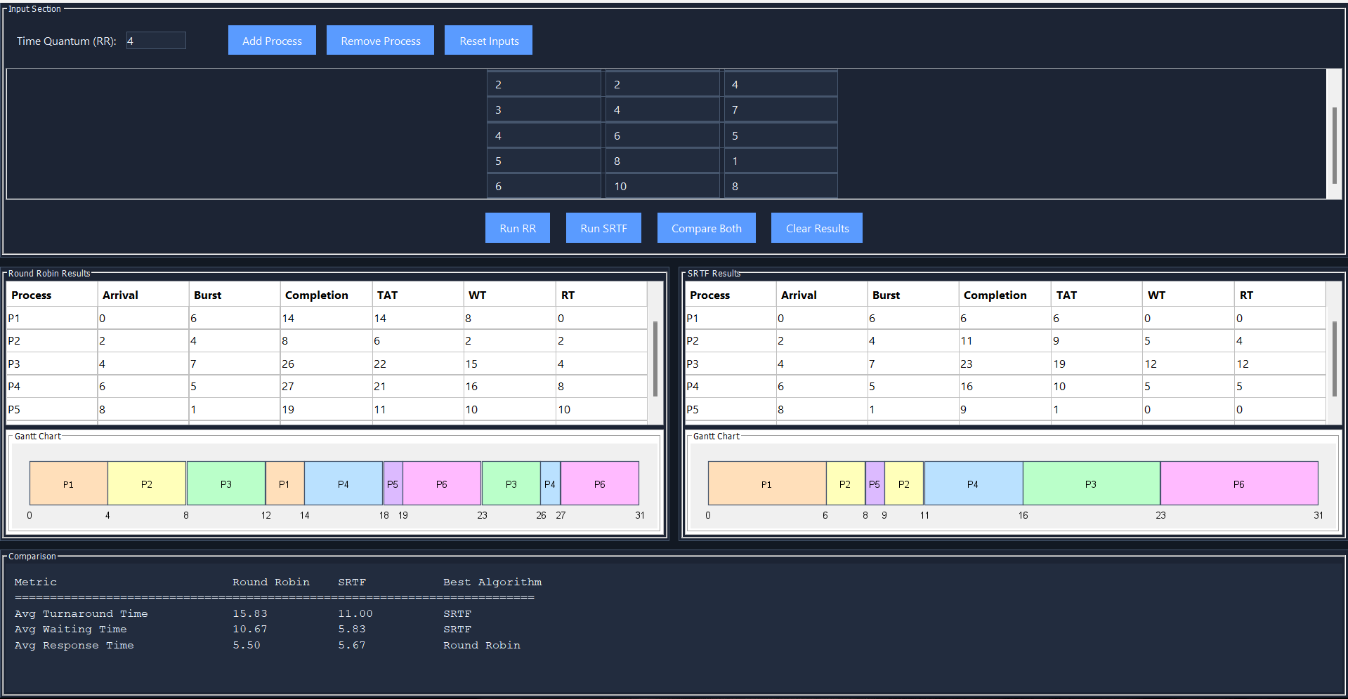
Figure 5: The Comparison panel populated after 'Compare Both' is clicked. Each metric row identifies which algorithm performed better for this particular input.

5. Assumptions
The following assumptions are embedded in the implementation:
- Integer time units only. All arrival times, burst times, and time quanta are positive integers. Fractional scheduling is not supported.
- Non-zero burst times. Every process is assumed to have a burst time ≥ 1. Entering 0 would cause the process to complete instantly at arrival and may produce a zero-duration Gantt slot.
- Process IDs are user-defined strings. The GUI enforces no uniqueness check; duplicate PIDs will produce visually ambiguous Gantt colours but will not crash the simulation.
- Quantum applies only to RR. The time quantum field has no effect on the SRTF simulation.
- SRTF ties broken by lowest index. When two processes have equal remaining time, the one with the smaller array index (i.e., entered first by the user) is chosen. This is consistent but not documented in the UI.
- No I/O or blocking states. Both algorithms model purely CPU-bound processes; there is no I/O burst, priority, or sleep modelling.
- All processes are known at time 0. There is no dynamic process creation during simulation.
- STRF.java is a dead class. The standalone console prototype is never invoked by Main.java or SchedulerGUI.java; it exists as a development artefact.
- Idle CPU in RR is encoded as processId = 0. The Gantt chart will display an idle slot as a coloured block with label '0' if any gaps exist between arrivals. This could be misleading if a user also names a process with PID '0'.

6. Limitations

6.1 Algorithmic Limitations
- SRTF requires exact burst time knowledge. In real operating systems burst times are unknown a-priori; SRTF is an idealised algorithm. This simulator assumes the oracle knows all burst times in advance.
- No starvation mitigation. Long processes under SRTF can be indefinitely delayed. The simulator does not implement ageing or any fairness correction.
- RR quantum sensitivity is not explored. The tool does not sweep across quantum values or show how average metrics change as q increases from 1 to max(burst). Users must test manually.
- Single-core only. Both algorithms target a uniprocessor model. Multi-core, multi-queue, or gang scheduling is out of scope.

6.2 Implementation Limitations
- O(n) scan per tick in SRTF. SRTFAlgorithm rescans all n processes at every time unit, giving O(n × T) time complexity where T is total simulation time. For large n or long jobs this becomes slow. A min-heap would reduce to O(n log n + T log n).
- No input validation. The GUI does not validate that fields are non-empty integers before running. Blank or non-numeric entries will throw an unhandled NumberFormatException visible only in the IDE console.
- Maximum 8 distinct Gantt colours. The GanttChartPanel cycles through a fixed palette of 8 pastel colours. With more than 8 processes, colours repeat and the chart becomes ambiguous.
- Gantt chart is not scrollable. For long simulations the Gantt chart overflows its fixed panel width and is clipped. There is no horizontal scrollbar on the chart panel itself (only on the enclosing pane).
- STRF.java dead code. The standalone class duplicates the SRTF logic with minor differences (String PIDs, ASCII Gantt) and increases maintenance burden without adding GUI functionality.
- No export or save. Simulation results cannot be saved to a file, copied as CSV, or printed. All data is lost when the window is closed.
- Comparison logic is metric-by-metric only. The updateComparison() method compares each average independently. It does not produce an overall winner or weighted score, which could be misleading for users who need a single recommendation.

7. Results and Conclusions

7.1 Comparative Analysis
Based on the theoretical properties of both algorithms and the empirical results observable in the screenshots, the following conclusions hold:

Criterion | Round Robin (RR) | SRTF
Type | Preemptive | Preemptive
Preemption Basis | Fixed time quantum expiry | Shorter job arrives
Avg Waiting Time | Higher (quantum-dependent) | Optimal (minimum possible)
Avg Turnaround Time | Higher | Optimal
Avg Response Time | Bounded by quantum × n | Can be very low for short jobs
Starvation Risk | None | Yes (long processes may starve)
Overhead | Low — simple queue ops | High — rescan all processes each tick
Time Complexity | O(n) per dispatch | O(n) per time unit
Best Use Case | Interactive/time-sharing systems | Batch systems with known bursts
Fairness | High — every process gets CPU | Low — short jobs prioritised
Implementation | Simple | More complex

7.2 When SRTF Wins
For any given set of processes SRTF always achieves the minimum possible average waiting time. This is a proven theorem — no other preemptive scheduling policy can achieve a lower average WT for the same workload. Correspondingly, average turnaround time is also minimised. SRTF is therefore the theoretically optimal choice for batch workloads where throughput and turnaround time are the primary objectives and burst times can be estimated.

7.3 When Round Robin Wins
Round Robin's strength lies in response time and fairness. For interactive workloads — terminals, GUIs, web servers — users expect the system to respond to their input within a bounded time. RR guarantees that no process waits more than (n − 1) × q ticks, making response time predictable regardless of burst length. Additionally, RR eliminates starvation entirely: every process is guaranteed forward progress.
With a sufficiently small quantum, RR approaches SRTF in average response time for short jobs while retaining its fairness guarantees. However, a very small quantum increases context-switch overhead, which this simulator does not model.

7.4 Technically Correct Conclusions
- SRTF is optimal for minimising average waiting and turnaround time. For any fixed set of processes with known burst times, no algorithm can achieve lower average WT or TAT than SRTF.
- Round Robin is fairer and starvation-free. RR's bounded waiting property makes it indispensable for interactive and real-time systems, even if its average metrics are inferior.
- Quantum selection critically affects RR performance. As q → ∞, RR degenerates to non-preemptive FCFS with all its starvation risks. As q → 1, RR approximates true processor sharing. Optimal q selection is workload-dependent and not addressed by the simulator.
- The comparison panel is necessary but insufficient. Selecting the 'better' algorithm on three scalar averages ignores variance, worst-case guarantees, context-switch cost, and system-level priorities. The tool is a useful teaching aid but should not be used to make real scheduling policy decisions.
- The SRTF implementation is correct but not efficient. The tick-by-tick O(n) scan is correct for simulation purposes but would be unacceptable in a real OS kernel. A priority queue keyed on remaining time would be required in practice.
- The RR implementation correctly handles CPU idle gaps. The fast-forward logic for empty ready queues is non-trivial and is implemented correctly: idle time is logged in the Gantt chart and currentTime is advanced atomically to the next arrival.

7.5 Summary
The CPU Scheduling Comparator successfully demonstrates the fundamental trade-off at the heart of OS scheduling design: optimality (SRTF) versus fairness and predictability (Round Robin). The Java Swing GUI provides an intuitive, visual way to explore this trade-off across arbitrary process sets, making it a valuable educational tool for understanding preemptive scheduling algorithms.

8. Quick Formula Reference
For review and verification of any simulation output:
Completion Time (CT) : time at which process exits CPU for the last time
Turnaround Time (TAT) = CT − Arrival Time
Waiting Time (WT) = TAT − Burst Time
Response Time (RT) = Time of first CPU grant − Arrival Time
Avg TAT = Σ TAT_i / n
Avg WT = Σ WT_i / n
Avg RT = Σ RT_i / n

