**Lab 7: MySQL & NodeJs**

1. **Setup programming tools**
   1. Install Visual Studio Code

Stable Version 1.43.1 for windows and darwin stable for mac from <https://code.visualstudio.com/download> based on your operating system.

* 1. Install Node.js

Latest LTS Version 12.16.1 from <https://nodejs.org/en/download/> based on your operating system. (npm was included when installing Node.js)

* 1. If Node.js is installed successfully, the result would look like this:

(for macOS, launch “Terminal” using Spotlight search or through **Applications 🡪 Utilities 🡪 Terminal**

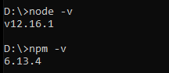

1.4 Download Lab 7 files from myCourseVille. Extract and rename the folder to 603zzzzz21_lab7 (replace zzzzz with your student ID), then with the given source code files and Visual Studio Code, follow the instruction accordingly (see step No. 3).

1. **Import the given Database to MySQLWorkbench**

Import the database with the sql script file named “registration_db.sql” as follows:

1) Select “Administration” tab.

2) Select “Data Import/Restore” under Management section.

3) Select “Import from Self-Contained File” and browse for the .sql file.

4) At “Default Target Schema”, click “New” button to create a new database.

5) Select “Dump Structure and Data” option.

6) Click “Start Import” button.

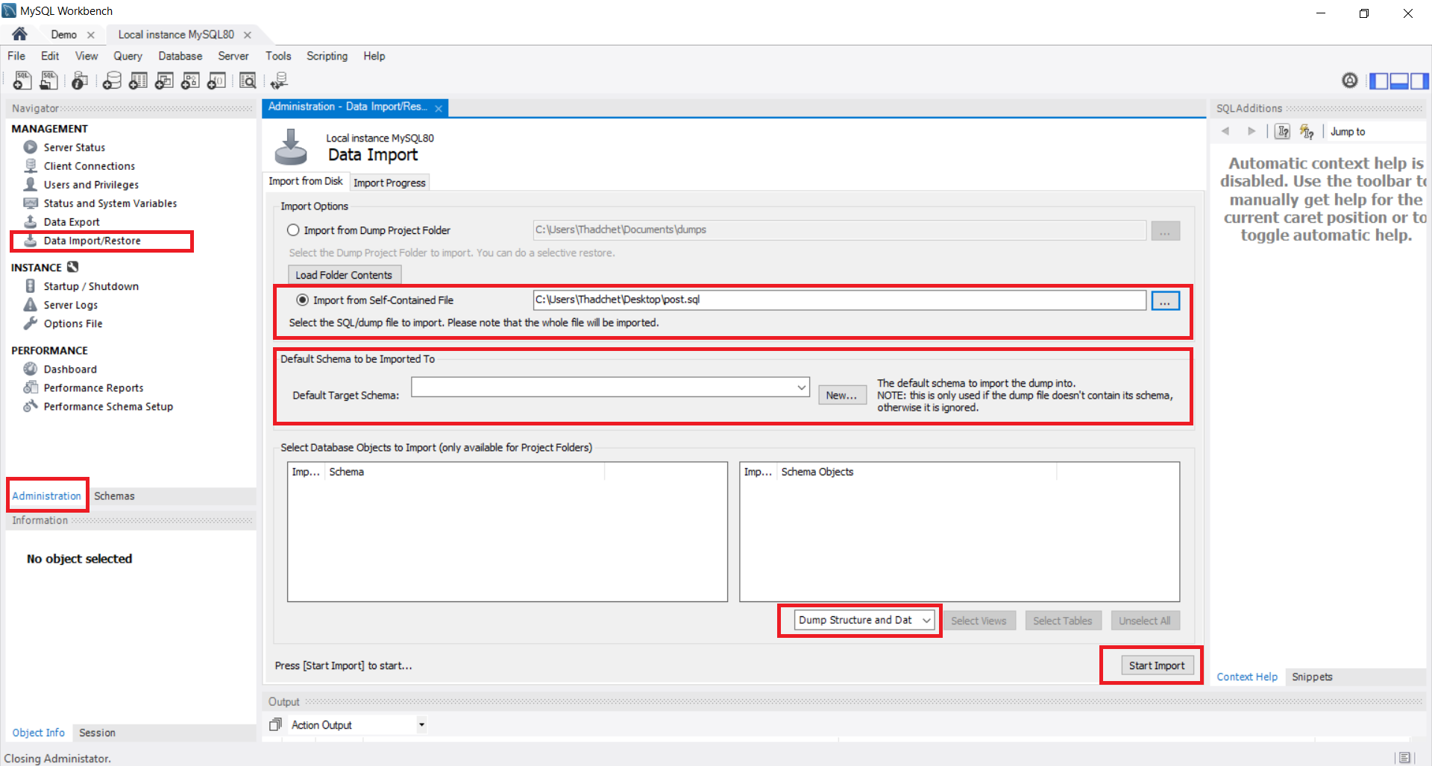

1. **Web implementation**

3.1 Open “server.js” in an editor, reconfigure the username and password according to your own database configuration.

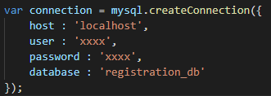

3.2 Click “Terminal” tab and Select “New Terminal” then install necessary libraries by typing “npm install”.

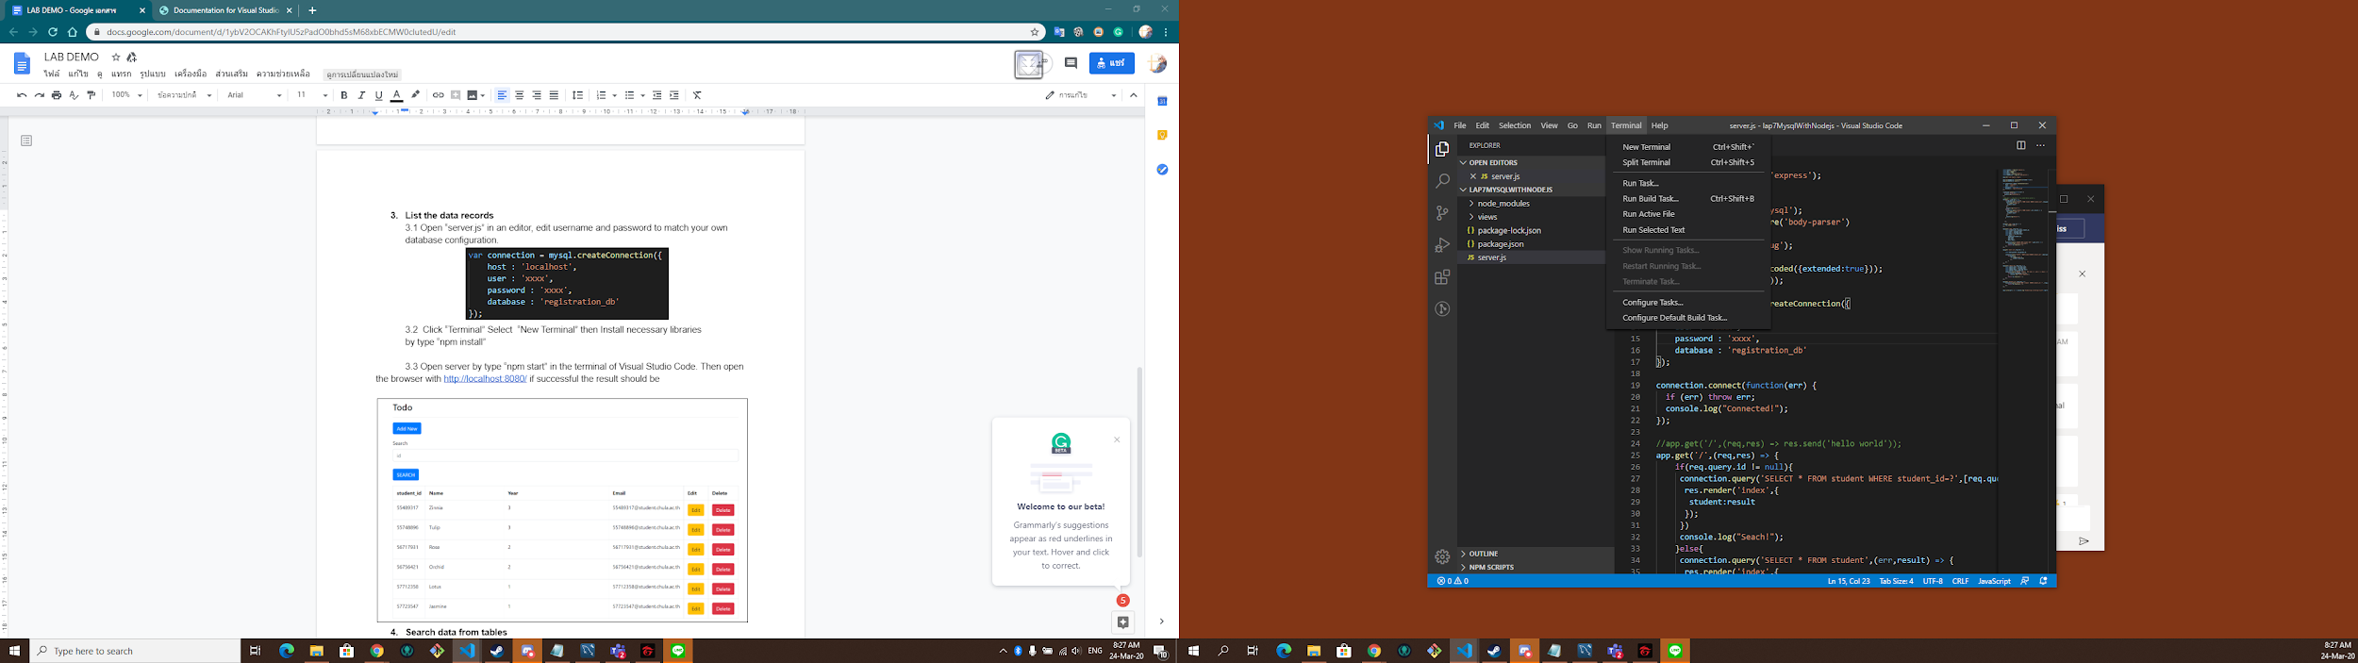

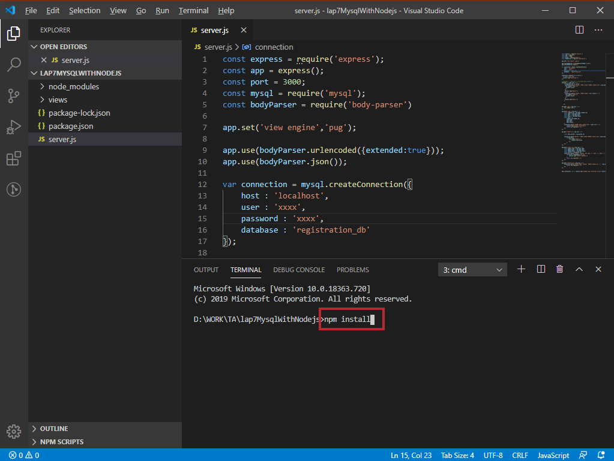

3.3 Start a web server using “npm start” command in the terminal of Visual Studio Code. Then open the web browser with URL [http://localhost:3000/](http://localhost:8080/)

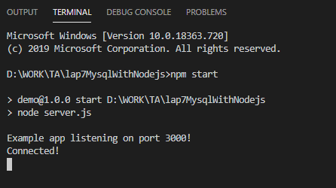

The results should look like this.

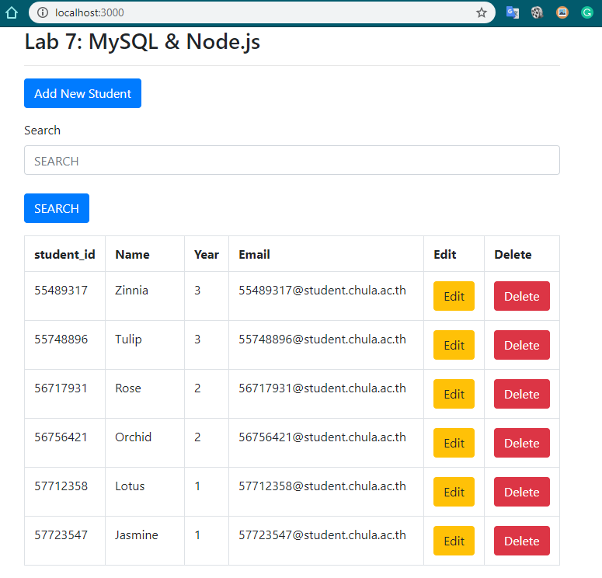

3.4 List of data

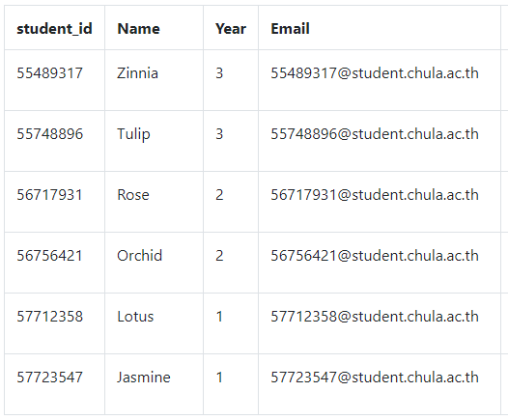

3.5 Search data from tables

Type a keyword in the text box then click search button.

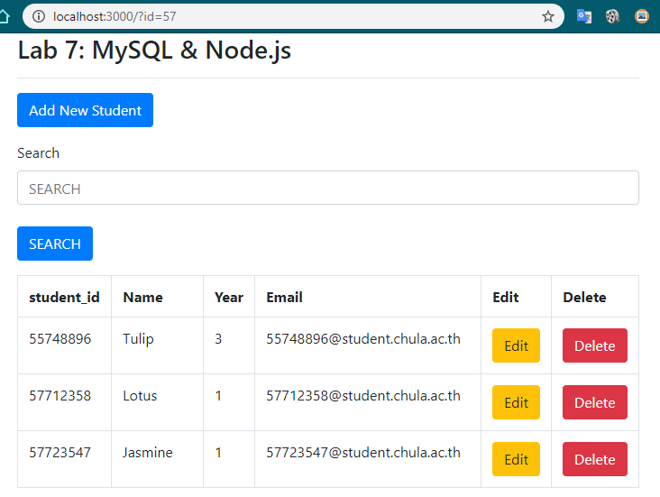

3.6 Insert a data record >> Click “Add New Student” button.

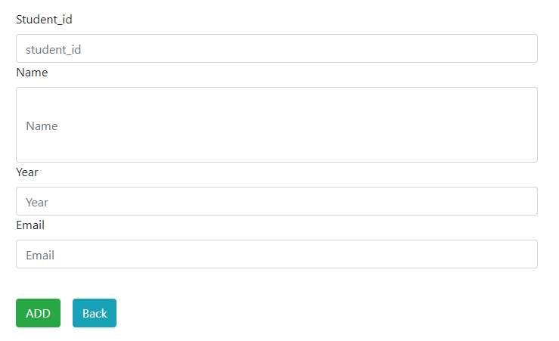

Insert your information (1 record) and your friends' information (3 records).

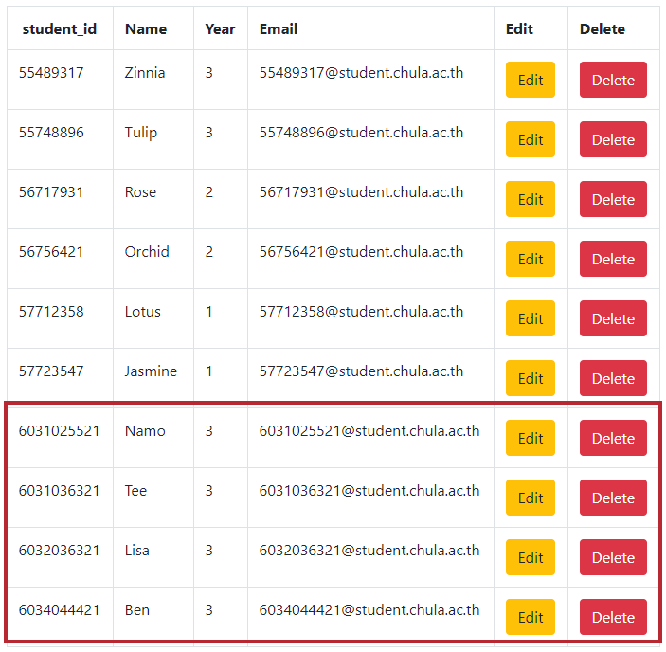

3.7 Edit and update data record(s) >> Click Edit button

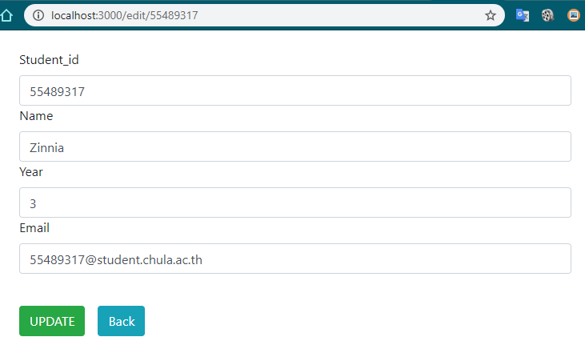

Change the Name to “John Wick” then click UPDATE

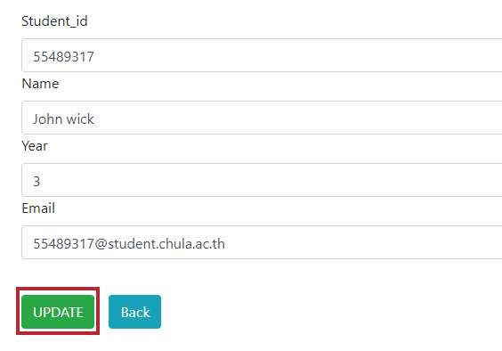

The result:

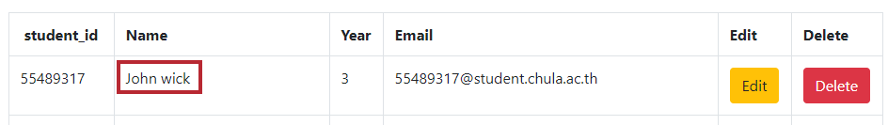

3.8 Delete a data record**>>**Click Delete button to delete one of your friend’s information

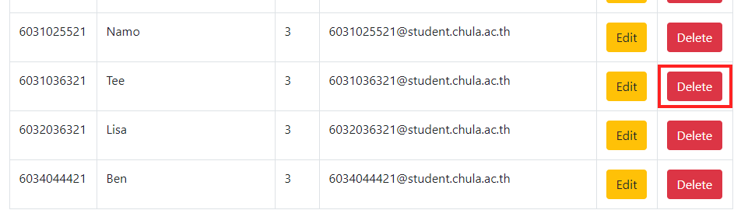

The results should look like this.

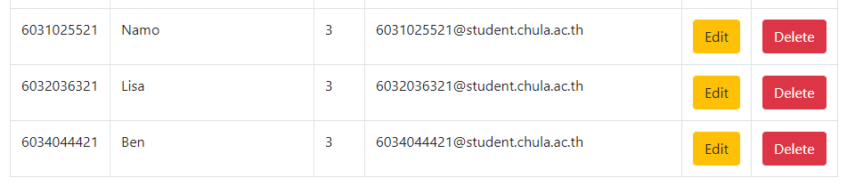

1. **Your task**s

Edit files server.js, index.pug, edit.pug, and add.pug to show, search, insert, edit, and delete the data records in the Takes table (Student ID, course id, sect_id, semester, year, and grade). Complete tasks 4.1 – 4.5, then capture all screenshots and submit them through myCourseVille.

List of screenshots:

4.1 List

Show all student enrollments.

4.2 Search

Search with the keyword “77”.

4.3 Insert

Insert your enrollment information with your studentID and the following information:

**CourseID: 301001**

**SectionID: 2**

**Semester: 2**

**Year: 2015**

**Grade: C**

4.4 Edit

Edit student enrollment information by updating the section code from “1” to “2” of studentID 55489317.

4.5 Delete

Delete student’s enrollment information of studentID 57712358.

Samples of expected screenshots:

