Country Journeys
The Country Journeys are a component of the CHAMP Toolkit for Multilevel Climate Finance and Implementation, illustrating how national and subnational governments are developing multilevel approaches to mobilize finance and implement urban climate action. Each journey traces the evolution of a country's institutional and financing arrangements and maps relevant policies, programs and initiatives against the Toolkit's guidance, organized into five key Actions (see Table 1). The purpose of Country Journeys is to showcase the progress countries have made in developing multilevel climate finance and implementation approaches and the lessons others can draw. Country Journeys are not intended to evaluate countries' performance or identify gaps. By highlighting countries’ progress, the CHAMP Toolkit aims to inspire peer learning and provide practical ideas that other countries can adapt to their own contexts. Initial country journeys feature Brazil and Sweden.

Draft: CHAMP Toolkit for Multilevel Climate Finance and Implementation

Toolkit Content
Title: CHAMP Toolkit for Multilevel Climate Finance and Implementation
Subtitle: Practical guidance for national governments to deliver the CHAMP Investment Pledge by working with cities and subnational governments to mobilize, coordinate and scale finance for urban climate action.

PART II: COUNTRY JOURNEY: SWEDEN
- The Swedish Context: An Evolving Mission-Oriented Approach to Urban Climate Transition

Sweden’s journey illustrates two central premises – 1) no actor can deliver the climate transition alone, and 2) finance becomes more effective when governance and implementation systems are in place to organize collective action.

An Evolving, Iterative Multilevel Climate Action Model

Sweden's multilevel climate action model has evolved iteratively, as successive stages of climate action exposed new challenges and opportunities for financing, implementation, and coordination. This evolution has been shaped by strong municipal autonomy, a well-developed research and innovation system, established municipal financing capacity, and a governance culture that supports experimentation and learning across institutional boundaries.

Municipalities as a "Gathering Force"

Sweden has 290 municipalities and 21 administrative regions, with municipalities enjoying substantial autonomy over local planning, public services and investment. Municipalities also own utilities and companies responsible for services such as district heating, water, waste management and housing, giving them an important role in local climate-related infrastructure investment. Yet many regulatory, financial and infrastructure conditions are determined nationally or at the European Union level, while businesses, utilities, property owners and citizens control important assets and decisions. A central premise of the Swedish approach is therefore that no single actor or level of government can deliver the transition alone. Municipalities can instead act as a “gathering force,” connecting their own mandates with actors whose decisions are also necessary for transition. This has encouraged a shift from traditional municipal governance toward more network-based, multilevel forms of governance and coordination.

Viable Cities: A Country Platform Orchestrating the Swedish Ecosystem

Sweden's multilevel model developed through its mission-oriented innovation ecosystem. Viable Cities was established in 2017 and progressively brought municipalities, national agencies, research institutions, businesses, and civil society around the mission of climate-neutral cities by 2030. Rather than attempting national scale immediately, the program developed approaches with pioneer municipalities over time:

- 9 pioneer municipalities in 2019
- 23 municipalities in 2021
- 48 municipalities in 2024 (covering approximately half of Sweden's total population)

Climate City Contracts: Integrating Climate Action into Coordination and Planning Process

As Viable Cities developed its mission of climate-neutral cities by 2030, it recognized the need for stronger political commitments and sustained cooperation between municipalities and national agencies. This led to the introduction of Climate City Contract 2030 (CCC) as an iterative governance process, alongside the development of Transition Arenas and, later, Samordningsfunktionen (the Coordination Function). Importantly, the emerging governance process was designed to interact with municipalities' ordinary planning, budgeting, and political cycles, and to be reviewed and renewed over time, rather than becoming a parallel climate-governance structure.

System Demonstrators: Collaborative Implementation Environments

Sweden’s system demonstrator approach builds on earlier experience with innovation and pilots. It was progressively connected to the Climate City Contract process from 2021 and developed through staged funding calls from 2022. This experience also highlighted that technology alone was insufficient when policy, finance, business models and other conditions shaped implementation.

Viable Cities developed System Demonstrators to bring multiple actors and interventions together around bounded, real-world transition challenges and coordinated portfolios of action. Examples in Lund and Stockholm demonstrate this approach across areas including energy, mobility and transport. From 2021 onwards, System Demonstrators were progressively connected to the wider CCC process.

Bridging the Financing Gap: Local Investment Structures & Viability Fund

As these governance and delivery approaches matured and accelerated action, new challenges emerged for matching finance with climate transition priorities. Urban transition portfolios can involve multiple owners, different risk and maturity profiles, and may require enabling interventions that are not themselves investable. These challenges prompted emerging work on Local Investment Structures to better connect local transition priorities with investment and finance.

This evolution reflects a second core principle emphasized by Viable Cities: finance follows governance. This does not mean that finance only enters after governance is complete. Rather, political direction, local ownership, coordination and portfolios create the conditions for financing needs to become clearer and for finance actors to engage. The financing challenge is therefore also a governance and implementation challenge: connecting actors, priorities, investment planning, finance, and procurement into a coherent system.

This thinking has also informed the emerging Viability Fund for Cities, reflecting Sweden's growing emphasis on connecting its established governance and implementation approaches with new financing and market-shaping arrangements.

Part B examines Sweden’s multilevel climate action model, including the mechanisms that emerged through this evolution and how they interact across the toolkit's five Actions.

- Sweden’s Multilevel Climate Action Model

Sweden's experience brings together mechanisms at different stages of maturity. Viable Cities, Climate City Contract 2030, the Coordination Function and System Demonstrators are established components, while Local Investment Structures, the Viability Fund for Cities and stronger aggregated-demand and financing interfaces are being developed. The diagram above illustrates how these arrangements connect within Sweden's multilevel climate action model.

Together, these mechanisms illustrate how the Toolkit's five reinforcing Actions contribute to CHAMP's three Implementation Roadmap pillars: strengthening multilevel climate governance (Pillar 1), catalyzing partnerships for local delivery (Pillar 2), and unlocking finance and investment at the subnational level (Pillar 3). In particular, Sweden demonstrates how country-level coordination and partnerships can connect local climate priorities with investment planning, financing and implementation, supported by continuous learning and institutional development.

This section examines how Sweden's established and emerging mechanisms interact across the Toolkit's five Actions (see Table below for the summary policies that are detailed below).
Implementation Pathway | Swedish Programmes and Initiatives
Action 1. Establish Multilevel Commitments and Platforms for Climate Investment

1.1 Multilevel Climate Commitments | Climate City Contract 2030 (CCC) – joint multilevel commitments between municipalities, Viable Cities and National Agencies
1.2 National Coordination Mechanisms | Viable Cities
1.3 Urban-Inclusive Country Platforms | Viable Cities
Action 2. Strengthen Enabling Environments for Climate Investment

2.1 Enabling Framework Conditions Assessments | Analysis of city-level implementation barriers through the Coordination Function of Viable Cities (not a full EFC assessment)
2.2 Reform Roadmaps for Urban Climate Investment | Not identified
Action 3. Plan and Prepare Climate Investments

3.1 Local Climate Budgeting and Investment Planning | CCC-linked municipal investment planning and budgeting
3.2 Climate Portfolios and Pipelines | CCC transition portfolios; coordinated local portfolios across infrastructure, policy, governance and procurement
3.3 Project Preparation | Emerging Local Investment Structures; established dedicated national project preparation facility not identified
Action 4. Mobilize Finance and Shape Markets

4.1 Local Climate Funds | Emerging Local Investment Structures
4.2 Financial Instruments and Mechanisms | Kommuninvest pooled municipal borrowing; emerging Local Investment Structures; emerging Viability Fund
4.3 Financial Aggregation and Market Shaping | Kommuninvest’s aggregated municipal borrowing; Stockholm’s participation in First Mover Cities Cohort; emerging intra-city aggregated procurement models
Action 5. Learn, Strengthen Capacities and Scale Implementation

5.1 Institutional Capacity Building | Peer learning through CCC processes and Transition Arenas (not a standalone national training programme)
5.2 System Demonstrators | Swedish System Demonstrator programme - CoAction Lund; Stockholm STOLT
5.3 International Networks and Partnerships | Viable Cities international collaboration on System Demonstrator methods and shared programme principles; First Mover Cities cohort

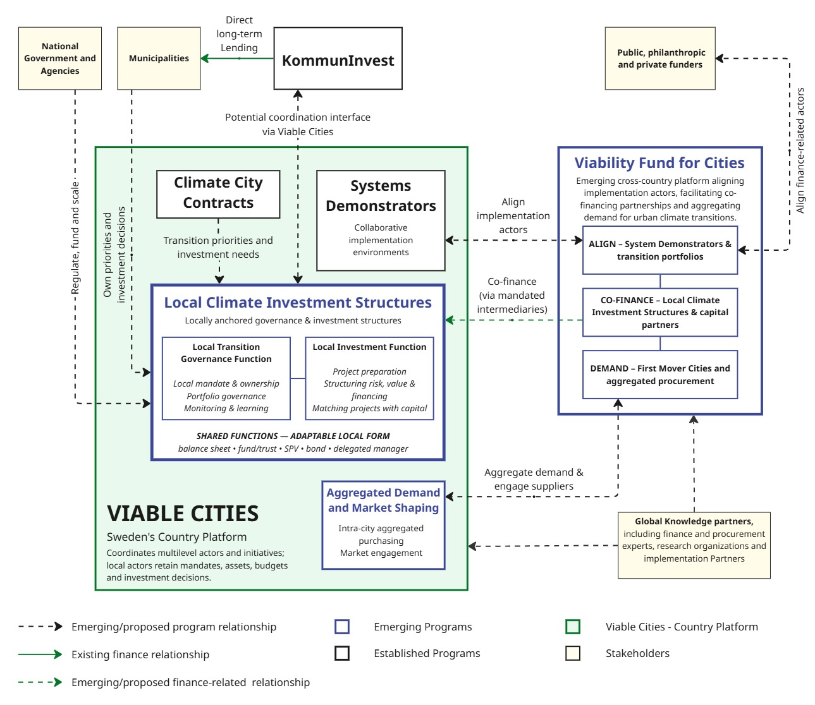

Action 1. Establish Multilevel Commitments and Platforms for Climate Investment

At the centre of Sweden's multilevel coordination model is the annual Climate City Contract 2030 (CCC) process, through which municipalities, national agencies and Viable Cities establish and renew complementary commitments. As part of this process, Transition Arenas mobilize local stakeholders, including businesses, academia and civil society, around shared priorities, while Joint Commitments enable groups of municipalities to collaborate on common governance and implementation challenges.

Viable Cities serves as Sweden's national coordination platform, connecting municipalities, six national agencies and wider transition actors. Its dedicated Coordination Function (discussed in Action 2) supports the CCC process and facilitates ongoing national–local collaboration. National agencies also use joint action planning to connect their commitments with national programmes, policy instruments and municipal implementation priorities.

Building on this experience, the emerging Viability Fund for Cities seeks to support urban climate transitions across countries by aligning implementation partners, facilitating financing partnerships and strengthening aggregated demand. Its architecture comprises three complementary segments:

- ALIGN, focused on aligning funders, programs, and implementation partners around common System Demonstrators principles;
- CO-FINANCE, mobilizing catalytic capital to help scale opportunities emerging from System Demonstrators, transition portfolios and local investment structures; and
- DEMAND, connecting these efforts with aggregated demand and market shaping.

What this has enabled: Sweden has established recurring mechanisms for shared commitments and national-local coordination, while developing new arrangements to connect these governance foundations with financing and market actors. The opportunity is to strengthen how these interconnected mechanisms translate local transition priorities into coordinated investment and implementation.

Action 2. Strengthen Enabling Environments for Climate Investment

Sweden's Coordination Function (Samordningsfunktionen) plays an intermediary role in identifying institutional, governance and financing challenges affecting local climate action. Through analysis of municipal needs, dialogue and ongoing review, it identifies recurring challenges and areas where additional support or changes beyond the municipal level may be needed.

These insights can inform national agency discussions on how existing mandates, policy instruments and funding programmes could better support local implementation. This provides a channel for municipal experience to inform national-level coordination and identify opportunities to strengthen enabling conditions for climate investment. While Sweden’s Coordination Function does not integrate local priorities into NDCs or NAPs, such mechanisms could help countries bring subnational priorities into national climate planning and implementation, supporting the CHAMP Roadmap’s priorities under Pillars 1.2 and 2.1.

What this has enabled: Sweden has established an intermediary mechanism for bringing local implementation challenges into multilevel policy discussions. The opportunity is to use these insights to inform more targeted national support and improvements to the policy, institutional and financing conditions for local climate investment.

Action 3. Plan and Prepare Climate Investments

Through the Climate City Contract (CCC) process, Swedish municipalities and their partners work to connect shared commitments with implementation portfolios, climate action plans and investment planning. The portfolio approach brings together interconnected interventions across infrastructure, policy, governance, procurement and capacity development. Climate investment planning helps to identify associated investment needs, indicative costs, financing sources and responsible actors.

Looking ahead, country-level coordination could connect locally owned investment portfolios with national climate finance strategies and investment plans (Roadmap 3.1). It could also connect these portfolios with coordinated project preparation support and finance partners (Roadmap 3.2), while investment decisions remain with the responsible owners and financiers.

Swedish municipalities participating in CCCs are working to integrate climate investment planning into ordinary planning and budgeting processes. Stockholm, for example, examines how existing municipal expenditure, procurement and investment decisions can contribute to climate objectives, alongside identifying additional climate-specific investments. However, the maturity of climate investment planning varies across participating municipalities, and extending its scope to encompass the wider public and private actors involved in urban transitions remains an area for further development.

What this has enabled: Sweden is progressively connecting climate commitments and implementation priorities with investment needs and municipal budgeting processes. The opportunity is to strengthen project preparation and coordination of investment portfolios across government levels, particularly for investments involving actors beyond municipal government.

Action 4. Mobilize Finance and Shape Markets

Sweden is exploring Local Investment Structures to coordinate, prepare and finance investments within wider climate transition portfolios. The proposed model of these structures combines two complementary functions:

- Local Governance Function: Establishes the structure's mandate and accountability, coordinates participating investment owners, and agrees how responsibilities, costs, benefits, risks and investment decisions are shared.
- Local Investment Function: Prepares investment portfolios, structures financing and risks, and connects investments with suitable capital. Where appropriately mandated, it may also receive, manage and deploy capital, including managing repayments and reinvestment.

These structures require clear arrangements for ownership, investment decision-making, capital management and connections to national and international finance. Their functions can be delivered through different institutional arrangements, including municipal balance sheets, public banks, funds or dedicated investment vehicles, depending on local mandates and legal conditions.

EnergyNet is an open-protocol approach to local energy systems, allowing different providers to develop compatible solutions and services using a shared Energy Protocol. Its first application in Brunnshög was developed through CoAction Lund, involving municipal property owners and ViaEuropa as an early technology developer. EnergyNet is being explored as a use case for Local Investment Structures to coordinate investment preparation and financing across multiple owners, including agreements on responsibilities and the sharing of costs, benefits and risks. The proposed co-financing arrangements remain under development.

Alongside financing, Sweden is developing approaches to intra-city aggregated purchasing and market shaping, where cities convene public and private buyers around shared climate outcomes while each participating buyer retains its own budget and purchasing decisions. By coordinating purchasing requirements, anticipated volumes and timelines, cities can create credible demand signals that encourage suppliers to invest in low-carbon solutions, helping mobilize additional investment for climate action. Sweden, through Viable Cities, supports the World Economic Forum’s development of the First Mover Cities cohort, with Stockholm participating as one of the cities. The cohort initially focuses on coordinating demand for low-carbon cement and concrete.

What this is enabling: Sweden is strengthening the foundations for connecting local climate investments with suitable financing and coordinated market demand. The opportunity is to further develop these emerging arrangements to mobilize capital, support implementation and create stronger markets for climate solutions.

Action 5. Learn, Strengthen Capacities and Scale Implementation

System Demonstrators generate practical learning about the governance arrangements, institutional capabilities and partnerships needed to implement and scale systemic urban transitions. Experiences from Lund and Stockholm can inform subsequent interventions and help other municipalities adapt effective approaches to their own contexts.

Learning is also embedded in the annual Climate City Contract (CCC) renewal process, through which municipalities and national agencies review commitments, progress and implementation experience to inform subsequent cycles. While this is not a formal national reporting mechanism, similar approaches could inform voluntary country-led reviews of multilevel climate action, as envisaged under the CHAMP Implementation Roadmap (1.3).

Sweden is also working to extend this learning internationally through collaborations aimed at developing shared principles and methodologies for System Demonstrator programs (see Further Resources). These efforts seek to connect cities, funders and implementation partners around common approaches to programme design, experimentation and evaluation, while enabling lessons to be adapted across different institutional and country contexts.

What this has enabled: Sweden has established practical environments for collaborative experimentation and learning, generating insights that can inform wider implementation. The opportunity is to translate this experience into stronger institutional capacities, sustained funding and approaches that can be replicated and adapted across cities and countries.

Further Resources

The Viability Fund for Cities has developed four complementary resources providing practical guidance on system demonstrator programmes, local investment structures, aggregated purchasing power and country-level coordination.

- System demonstrators – a programme design guide
- Local investment structures – design considerations
- Aggregated purchasing power framework
- Country platform functions

Brazil Journey
Central Premise: Strengthening climate federalism to connect national climate priorities, subnational investment capacities and financing institutions across three tiers of government.
- The Brazil Context: Climate Federalism

Decentralized Urban Responsibilities and Federal Investments

Brazil's multilevel climate investment system builds on its longstanding federal structure. The 1988 Constitution established municipalities as autonomous federative entities alongside the federal government and states, assigning them substantial responsibilities for urban planning, infrastructure and public services. However, municipal fiscal capacities remain highly uneven; larger municipalities have stronger own-source revenues and borrowing capacities, while smaller municipalities often depend more heavily on intergovernmental transfers and face greater technical and financial constraints.
Brazil has established federal institutions and programmes to support urban infrastructure investment. The Ministry of Cities was established in 2003, while the Growth Acceleration Programme (PAC), launched in 2007, strengthened federal support for state and municipal investments. Additionally, established public financial institutions, including BNDES and CAIXA, also play an important role in Brazil's urban investment architecture.

Developing Climate Policy and Subnational Leadership

Alongside this urban investment architecture, Brazil progressively developed national climate policy and dedicated financing mechanisms. The National Policy on Climate Change, established a framework for mitigation and adaptation, while the creation of the National Climate Fund (Fundo Clima), both adopted in 2009, introduced a dedicated source of climate financing. Brazil's first National Adaptation Plan followed in 2016.
States and municipalities also exercised climate leadership. For example, the city and state of São Paulo adopted climate legislation in 2009, while cities including Recife, Belo Horizonte and Curitiba developed their own climate policies and coordination mechanisms. These developments reflected the scope for subnational climate action within Brazil's federal system.

Renewing Multilevel Coordination and Formalizing Climate Federalism

Brazil's renewed climate agenda in 2023, with the creation of interministerial coordination bodies for climate action and multilevel governance coordination mechanisms, placed greater emphasis on coordinating climate action across government levels. The Ministry of Cities was re-established, alongside the relaunch of the Growth Acceleration Programme as Novo PAC.

A significant milestone followed in July 2024, when federal, state and municipal governments adopted the Commitment to Climate Federalism through the Federation Council, building on Brazil's endorsement of CHAMP. Plano Clima 2024–2035, formally launched in 2026, further developed Brazil's national framework for mitigation and adaptation. It includes Cities Sector Plans for mitigation and adaptation, linking national climate priorities with urban planning, sustainable mobility and resilient infrastructure.
- Brazil's Multilevel Climate Finance and Implementation Model

This section examines how Brazil's institutions and programmes align with the Toolkit's five Actions and where stronger connections could support urban climate investment and implementation (see Table 1 for the summary policies that are detailed below).

Table 1: Mapping Brazil’s Initiatives to the CHAMP Toolkit Actions

Actions | Brazilian Programmes and Initiatives
Action 1. Establish Multilevel Commitments and Platforms for Climate Investment

1.1 Multilevel Climate Commitments | Commitment to Climate Federalism (2024); Brazil's NDC (2024)
1.2 National Coordination Mechanisms | Interministerial Committee on Climate Change (CIM) and Interfederative Coordination Chamber; Green and Resilient Cities Programme (PCVR); Brazil CHAMP Finance Working Group
1.3 Urban-Inclusive Country Platforms | Brazil Investment Platform (BIP) – with opportunity to integrate municipal investment priorities
Action 2. Strengthen Enabling Environments for Climate Investment

2.1 Enabling Framework Conditions Assessments | CAPAG municipal creditworthiness assessments
2.2 Reform Roadmaps for Urban Climate Investment | Fiscal Balance Promotion Plan (PEF); National Programme for Administrative and Fiscal Management of Brazilian Municipalities (PNAFM)
Action 3. Plan and Prepare Climate Investments

3.1 Local Climate Budgeting and Investment Planning | Brazil Mutirão Programme (C40/GCoM) — climate budgeting support
3.2 Climate Portfolios and Pipelines | PCVR Project Bank; Novo PAC Seleções
3.3 Project Preparation | Brazil Mutirão Programme (C40/GCoM); ICLEI Transformative Actions Program (TAP Brasil)
Action 4. Mobilize Finance and Shape Markets

4.1 Local Climate Funds | Not identified
4.2 Financial Instruments and Mechanisms | Novo PAC; BNDES and CAIXA credit lines; National Climate Fund (Fundo Clima); Eco Invest Brasil; Brazil Investment Platform (BIP);
4.3 Financial Aggregation and Market Shaping | Belém Declaration on Sustainable Public Procurement; National Strategy for Public Procurement for Sustainable Development (ENCP)
Action 5. Learn, Strengthen Capacities and Scale Implementation

5.1 Institutional Capacity Building | AdaptaCidades
5.2 System Demonstrators/Pilots | CITinova I (Brasília and Recife urban sustainability pilots); CITinova II (metropolitan demonstration programmes in Belém, Florianópolis and Greater Teresina).
5.3 International Networks and Partnerships | C40 Cities; ICLEI; UNEP; Global Covenant of Mayors; CCFLA Brazil Local Hub, Global Innovation Lab for Climate Finance — Brazil

Brazil's multilevel model combines established federal urban-financing institutions, national climate coordination mechanisms, subnational initiatives and newer partnerships supporting climate investment. These arrangements operate across several ministries, public financial institutions, state and municipal governments, and development partners.
The sections below examine how these mechanisms contribute to the Toolkit’s five Actions:

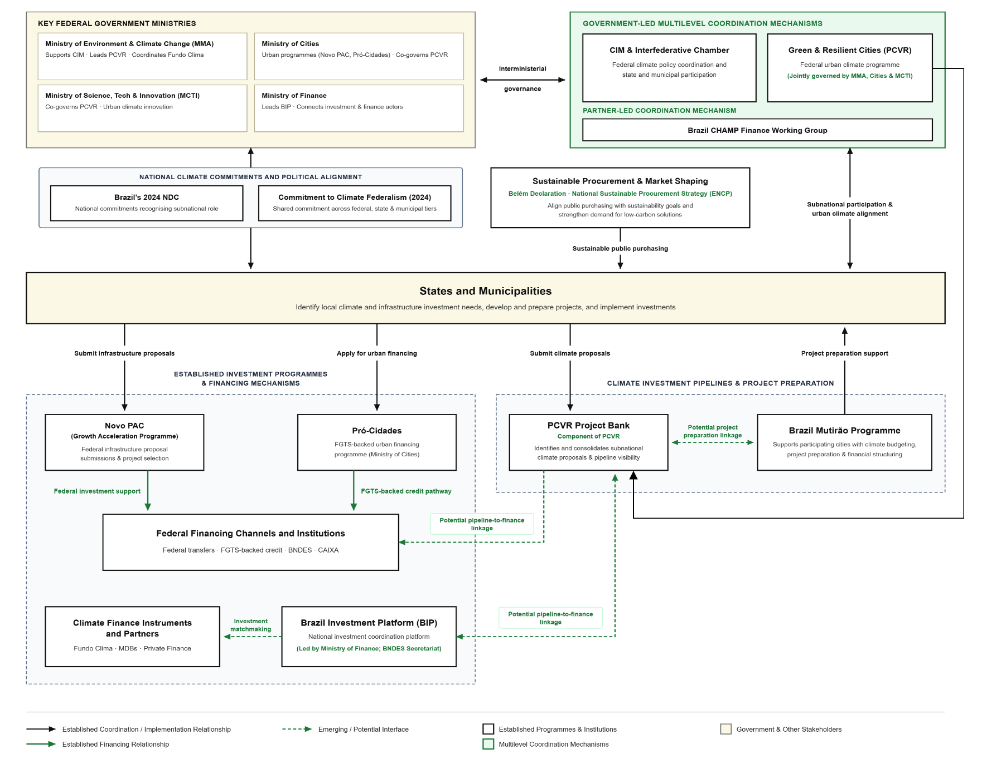
Figure 1: Brazil’s Multilevel Climate Finance and Implementation Model

Action 1. Establish Multilevel Commitments and Platforms for Climate Investment

Brazil has strengthened national–subnational climate coordination through its Commitment to Climate Federalism, adopted in 2024, and its Nationally Determined Contribution (NDC), which recognizes states and municipalities as essential implementation partners. The Interministerial Committee on Climate Change (CIM), supported by the Ministry of Environment and Climate Change (MMA), coordinates federal climate policy, while its Interfederative Coordination Chamber provides a mechanism for state and municipal participation. The Green and Resilient Cities Programme (PCVR), jointly governed by MMA, the Ministry of Cities and the Ministry of Science, Technology and Innovation (MCTI), provides a dedicated framework for coordinating urban climate action across federal institutions and government levels.
Brazil is also developing broader national investment coordination and investments mechanisms. The Brazil Investment Platform (BIP), led by the Ministry of Finance with BNDES as Secretariat, brings national institutions and financing partners together around climate-aligned investment opportunities. While it provides an important national coordination and finance-mobilization function, systematic municipal participation and links with urban project pipelines remain to be established. Complementary arrangements, including the Brazil CHAMP Finance Working Group, provide further opportunities to connect institutions working on local climate finance.
What this has enabled: Brazil has established political commitments and institutional mechanisms for multilevel climate coordination, alongside emerging national investment platforms. The opportunity is to strengthen connections between municipal investment priorities and national financing decisions.

Action 2. Strengthen Enabling Environments for Climate Investment

Brazil has established national mechanisms to assess and improve the fiscal conditions affecting municipal investment. The National Treasury's CAPAG framework assesses municipal creditworthiness based on indebtedness, current savings and liquidity, influencing eligibility for federally guaranteed borrowing. Building on these assessments, the Fiscal Balance Promotion Plan (PEF) enables eligible states and municipalities with weaker creditworthiness to undertake agreed fiscal reforms and meet performance targets in exchange for access to federally guaranteed loans.
Brazil also supports municipal institutional strengthening through the National Programme for Administrative and Fiscal Management of Brazilian Municipalities (PNAFM), which provides financing for improvements in local revenue administration, budgeting and financial management. While these programmes are not specifically designed for climate investment, they address underlying fiscal and institutional barriers affecting municipalities' ability to finance and implement infrastructure projects. Additionally, the Brazil CHAMP Finance Working Group is a partner-led coordination forum bringing together international and national partners to align programmes, exchange knowledge and strengthen coordination of support for municipal climate finance and implementation.
What this has enabled: Brazil has established fiscal assessment, reform incentives and institutional strengthening mechanisms that can improve municipal investment conditions. The opportunity is to connect these mechanisms more explicitly with urban and subnational climate finance needs.

Action 3. Plan and Prepare Climate Investments

Brazil has established federal infrastructure investment programmes along with newer mechanisms for identifying municipal climate investment needs. Through Novo PAC, states and municipalities can submit infrastructure investment proposals for federal support, including projects in sustainable mobility, sanitation and disaster prevention. More recently, the PCVR Project Bank, developed by MMA with Cities Climate Finance Leadership Alliance (CCFLA) and the University of Brasília, has begun consolidating municipal and state climate project proposals. It helps map investment demand, identify preparation gaps and improve project visibility to technical assistance and financing partners.
Complementary initiatives are strengthening municipal access to project preparation support. The Brazil Mutirão Programme, launched by C40 Cities and the Global Covenant of Mayors with support from Bloomberg Philanthropies and facilitation by the National Front of Mayors (FNP), supports cities with climate budgeting, project preparation and financial structuring. In March 2026, 34 municipalities and two states were selected for support. ICLEI's Transformative Actions Program (TAP Brasil) similarly provides technical assistance, training and mentoring to help subnational governments develop investable climate projects and engage potential funders.
What this has enabled: Brazil is improving the visibility of municipal climate investment pipelines and expanding project preparation support. The opportunity is to connect these initiatives more systematically with national financing institutions and programmes, helping projects progress from identification to investment readiness and financing.

Action 4. Mobilize Finance and Shape Markets

Brazil has an established public financing architecture for urban infrastructure, complemented by dedicated climate finance instruments. Novo PAC supports eligible state and municipal investments through federal transfers and credit, including FGTS-backed financing, while BNDES and CAIXA provide established financing channels. The National Climate Fund (Fundo Clima), coordinated by MMA and operated through BNDES for repayable financing, has expanded its support for climate-related investments, including urban resilience and mobility. Newer mechanisms include Eco Invest Brasil, which uses concessional finance and currency-risk mitigation to attract private capital. By January 2026, BIP had incorporated 17 projects representing approximately USD 25 billion in potential investment and facilitated more than 80 project–financier connections. Additionally, the Global Innovation Lab for Climate Finance's Brazil programme, supported by Climate Policy Initiative, brings public and private actors together to develop innovative financing instruments
Brazil is also developing approaches to shape markets through public purchasing. The Belém Declaration on Sustainable Public Procurement, launched at COP30 in 2025, establishes voluntary commitments by national and subnational governments to progressively integrate sustainability criteria into procurement. Brazilian states and municipalities, including Recife, Niterói and Florianópolis, have joined the initiative, creating opportunities for intergovernmental learning and stronger demand for sustainable solutions. This complements the National Strategy for Public Procurement for Sustainable Development (ENCP), established in 2025, whose implementation agenda includes extending procurement tools and piloting sustainable purchasing approaches with subnational governments.
What this has enabled: Brazil has multiple channels for mobilising public, development and private finance, alongside new frameworks for strategic sustainable procurement. The opportunity is to connect these financing and market-shaping mechanisms more closely with municipal investment pipelines, financing constraints and procurement needs.

Action 5. Learn, Strengthen Capacities and Scale Implementation

Brazil has developed experience in combining federal programmes, international partnerships and local implementation to test urban sustainability approaches. CITinova – Integrated Sustainable Cities, led by MCTI and implemented with UNEP and national and local partners, combined integrated urban planning with pilot investments in sustainable technologies in Brasília and Recife between 2018 and 2022. Supported by approximately USD 23 million in GEF grants and USD 195 million in co-financing, the programme demonstrated how national institutions, international partners and local governments could coordinate planning and implementation. Its successor, CITinova II, builds on this experience through metropolitan coordination, demonstration projects and partnerships with financing institutions.
Institutional capacity building is also advancing through AdaptaCidades, coordinated by MMA under PCVR. The initiative supports states and municipalities with climate-risk information, technical guidance, mentoring and training for local adaptation planning, alongside guidance on accessing finance. Its initial programme design prioritises support for 260 municipalities, working through state governments and, where appropriate, intermunicipal arrangements. International networks and partnerships in Brazil, including C40 Cities, ICLEI, UNEP, the Global Covenant of Mayors and CCFLA Brazil Local Hub, complement these domestic efforts through technical assistance, knowledge exchange and investment partnerships.
What this has enabled: Brazil has developed experience in federally supported urban demonstrations, municipal capacity building and international partnerships. The opportunity is to institutionalise learning from these initiatives and connect capacity development with investment planning, financing and implementation across municipalities.

