Style Guidelines for Final Year Project ReportsTITLE OF THE PROJECT
Final Year Project Proposal

Submitted by
1st Student Name
Roll Number

2nd Student Name
Roll Number

Supervised by
Supervisor Name
Academic Designation, Department

BS Cyber Security

Session 20xx-20xx

Department of Information Security
Faculty of Computing



The Islamia University of Bahawalpur
2025

Abstract
Under this heading, briefly describe the project to convey the abstract idea of the project using 250 to 300 words …….
Keywords: Cyber Security, Information security, Internet of Things, upto 5 keywords related to your project

Table of Contents
Abstract 1
Table of Contents 2
List of Figures 3
List of Tables 4
Chapter 1 Introduction 5
1.1 Background/Overview 5
1.2 Problem Statement 5
1.3 Aims and Objectives 5
1.4 Scope of the Project 5
Chapter 2 Related Work 6
Chapter 3 Methodology 7
3.1 Proposed Method 7
Chapter 4 Expected Outcomes 8
4.1 Tools and Technologies Required 8
4.1.1 Hardware 8
1.4.2 Software​​​​​​​​​​​​ 8
4.2 Expected Results: 8
4.3 Solution Application Area 8
Chapter 5 Project Planning 9
1.5 Individual Tasks/Distribution of Work (mandatory if group project) 9
2 Gantt Chart 9

A 4th Year Student

List of Figures
Figure 1. Word references tab (caption of figure 1) 6
Figure 2. Example flow diagram (caption of figure 2) 8

List of Tables
Table 1. Individual task list 9
Table2. Gantt chart illustrating the Work plan…………………………………

Chapter 1
Introduction

Background/Overview
Briefly introduce your project idea. This section will expand the title quoted for the project by explaining the background to the work you propose
The main reasons for using information from external sources are either to complement the contents of the work with relevant data or to provide a different opinion on the issue stated. In both cases, it means adding credibility to the project, making it look more trustworthy and complete. The author should create an analytical review of the previous scientific works on the topic or explore related development. Reference text should be written in quotes and indented and the references marked in [square brackets]. “Reference material”. [1]
Use IEEE referencing style available in Microsoft word as shown in Fig. 1.
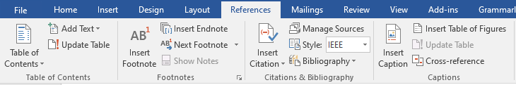
Figure 1. Word references tab

Problem Statement
Describe the purpose, motivation or relevance of the project. Describes why the problem is important. You must convey why you want to take this project and what you hope to learn from your research/development.[2]

Aims and Objectives
The goal of the project and the main focused objectives of the project are discussed in this section.

Scope of the Project
Scope defines what needs to be achieved and the work that must be done to deliver a project. It includes specific project goals, deliverables, features, functions, tasks, deadlines, and ultimately costs.

Chapter 2
Related Work
This chapter sums up the past work conducted on the similar area to specifiy that how your work is different from the existing methods.

Chapter 3
Methodology

3.1 Proposed Method
This section provides insight into what methodology you will employ in the development of the envisioned system. It is the systematic, theoretical analysis of the methods applied to your study. It can comprise step-by-step procedures, flowcharts, block diagrams or algorithms of the proposed system.
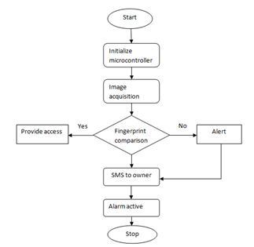
Figure 2. Example flow diagram

Chapter 4
Expected Outcomes
Mention the expected outcomes of your project in this chapter.

4.1 Tools and Technologies Required
Please describe all the HW/SW tools/technologies required for the project. For Example:

4.1.1 Hardware
Development PC: PC with MS Windows 10 or later
Minimum Display Resolution: 1024 * 768 with 16-bit color
Server PC: PC with 1TB hard drive
Body activity sensors: Fitbits (3 units)

Software​​​​​​​​​​​​
MySQL For our database
JAVA, JavaScript, PHP Programming languages
…

4.2 Expected Results:
Describe how do you expect your sytem to be working once completed.

4.3 Solution Application Area
Is your project of some real value? Which industry or application domain you are targeting? How that target domain may benefit from your solution?

Chapter 5
Project Planning

Individual Tasks/Distribution of Work (mandatory if group project)
Please mention individual tasks in the table indicating individual tasks and justify the one-year effort of two or three students. The expected individual task list with the tentative plan is given below.
Table 1 Distribution of task
Task | Group Member 1 Name | Group Member 2 Name
Do the literature survey | ○ | ●
Build the database | ○ | ●
Test the database | ● | ○
Design the methodology | ● | ○

Gantt Chart
As per individual tasks mentioned in the previous section, the Gantt chart shall graphically represent which tasks would be done in which duration, i.e., starting date, end date. What tasks shall be done in parallel, and what tasks shall be done in series? Duration of individual task. (View few samples from the internet before making your own to get ideas)
Work Packages/Milestones of our project work.
Table 2 Gantt chart illustrating the Work plan
Task | Sep | Oct | Nov | Dec | Jan | Feb | Mar | Apr | May | Jun
WP 1 – Proposal Submission
WP 2 – Evaluation Phase
WP 3 – Start implementation
WP 4 – Project Write up
WP 1 – Proposal Submission

