Freight Rate Prediction
Machine Learning Engineer Assessment: Validation Approach and December Chart

1. Summary
The task is to predict posted_rate for 12,000 loads in November and December 2025, using 48,000 labeled loads from January to October 2025. Because the final test period lies entirely in the future relative to the training data, I validated the model out of time rather than with random splits. The final model is a blend of two LightGBM regressors trained on log(posted_rate) with an L1 objective. Across five out-of-time folds it reaches a mean MAPE of 5.19% (MAE $124), against 6.36% (MAE $150) for a median rate-per-mile baseline.

2. Validation approach and train/test split
train_test.csv covers 2025-01-01 to 2025-10-31 and validation.csv covers 2025-11-01 to 2025-12-31, so the real evaluation is a forecast of the next two months. A random K-fold split would leak same-day information (market_index and quote_signal are daily series) and give overly optimistic scores. I used an expanding-window, out-of-time scheme instead:
- Folds: train on all months before month m, test on month m, for m = June to October (about 4,700 to 4,900 loads per fold).
- Leak-free preprocessing: imputation values and outlier thresholds are learned from each fold's training months only.
- Honest test folds: corrupted labels are removed from training data but kept in the test folds, so the reported error includes the noise the model will meet in production.
- Final fit: after model choices were made, the model was retrained on all of train_test.csv and applied once to validation.csv.
Mean over the five folds (MAPE %, lower is better):
Test month | Naive | No quote_signal | With quote_signal | Blend (final)
June | 8.02 | 5.19 | 4.22 | 4.59
July | 5.92 | 4.02 | 3.90 | 3.83
August | 5.89 | 5.30 | 5.98 | 5.34
September | 5.51 | 7.60 | 4.21 | 5.85
October | 6.45 | 6.43 | 6.37 | 6.36
Mean | 6.36 | 5.71 | 4.94 | 5.19

The quote_signal feature helps on average, but its relationship with price is unstable. The correlation between quote_signal and rate is positive in January to March, June and September, negative in April, May, July and October, and close to zero in August. In November and December, quote_signal has a flat daily mean (about 2.05) and lower dispersion than in training, which resembles August more than the other months. I therefore blended the model with quote_signal and the model without it. In the folds this costs about 0.25 points of MAPE compared with the quote_signal-only model, in exchange for protection against a month where the signal flips sign (as in August and October, where the quote_signal model was no better than the blend).

3. Data-quality issues and how they were handled
Issue | Train | Validation | Handling
Weight stored as negative (-47,500) | 292 | 145 | Absolute value + flag
Weight censored at 47,500 lb | 1,204 | 301 | Kept; flag feature
Missing weight | 300 | 165 | Median by equipment + flag
Missing market_index | 374 | 249 | Same-day median (daily series)
Corrupted labels (rate/mile ~4.5x or ~0.2x normal) | 677 (1.4%) | n/a | Dropped from training only
Cities not seen in training (8 cities) | 0 rows | 1,447 rows | Coordinates/distance, no city IDs
Lanes not seen in training | - | 12.2% of rows | Same as above

Two further observations shaped the design. First, market_index in validation (mean 0.93) sits lower than in training (mean 1.08), but within the training range, so tree models do not need to extrapolate. Second, 72 cities appear in validation versus 64 in training, so city names or per-city encodings would fail on 1,447 rows; the model uses coordinates, distance and haversine distance instead. The distance field is a road distance that is on average about 1.18x the straight-line distance, with a minimum of 70 miles on short hauls.

4. Model
- Target: log(posted_rate). Rate scales multiplicatively with distance, and errors are best judged in relative terms.
- Loss: L1 (median regression). It is robust to the heavy-tailed label noise and gave lower MAPE than L2 in the folds I compared.
- Features: log distance, distance, haversine distance, equipment, weight (with flags), market_index, daily median market_index and quote_signal, day of week, pickup/delivery coordinates and their differences.
- Ensemble: 3 seeds for each of the two feature sets, averaged in log space with equal weight.
- Most important inputs: quote_signal, distance, daily market conditions, weight and equipment.

5. Fixed December prediction chart
The chart below is produced by the provided score.py from the model's predictions for the fixed load (Lexington to Fort Wayne, 360 miles, Dry Van, 32,000 lb), with only the date changing. The chart inputs contain no market_index or quote_signal, so for each date I used the median of these two daily fields across the validation loads of that date (features only, no labels).
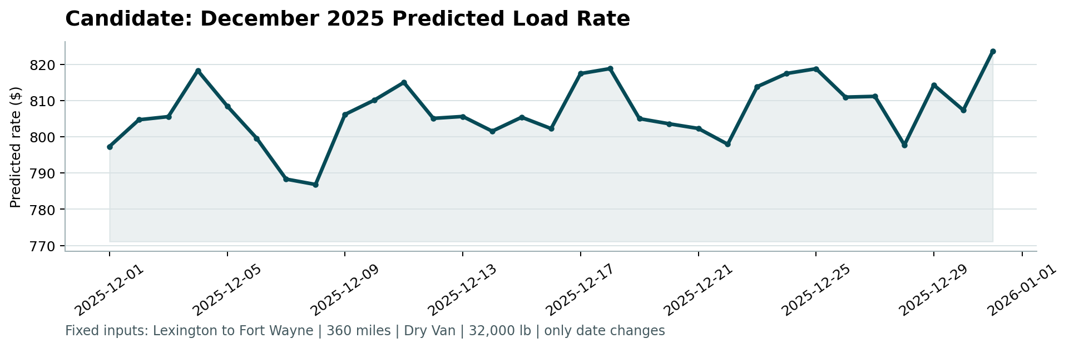
Predicted rates range from $787 (December 8) to $824 (December 31), with a mean of $807 (about $2.24 per mile). The variation of roughly 4.5% over the month comes from the daily market_index and a weekday pattern (Thursday and Wednesday are highest, Sunday and Monday lowest). The model does not predict a holiday-specific change because no December data was available to learn one.

6. Limitations and next steps
- The test months (November and December) are outside the range seen in training, so there is no seasonal evidence for them. Year-over-year data would help estimate holiday effects.
- Corrupted labels were detected with a rule based on rate per mile. A learned anomaly detector could remove them more precisely.
- The blend weight (0.5) was chosen by judgment, not tuned, to avoid overfitting to five folds. It could be tuned if more months of history were available.
- Final validation metrics are computed by Spotter after submission, so the true error on November and December is not known to me.

