1)
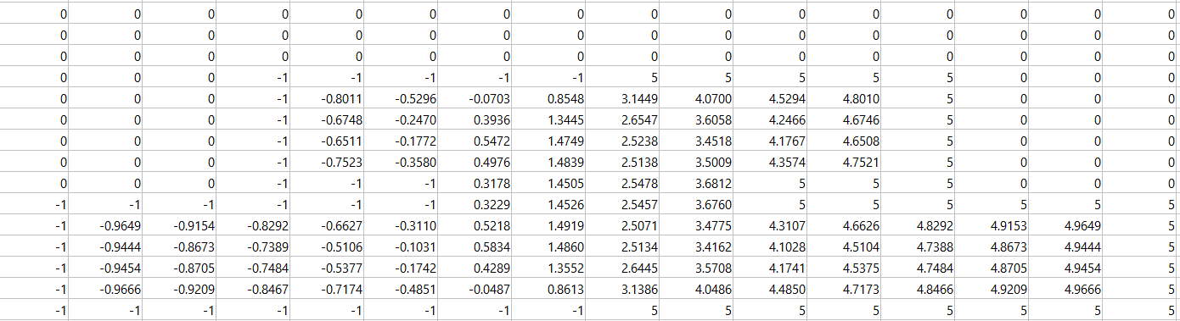
Step size2

2)

% Parameters
lengthX = 30; % cm
lengthY = 30; % cm
n1 = 0.25; % choose step size

% Discretize the grid
y = lengthY / n1;
x = lengthX / n1;

% Initialize potential matrix
stepsize025 = zeros(x, y);

-This section defines the parameters such as the dimensions of the grid (lengthX and lengthY) and the step size (n1).
-The grid is discretized, and the potential matrix ‘stepsize025’ is initialized to zeros.

% Set boundary conditions
% (top of the figure)
for i = 25:60
stepsize025(33, i) = -1;
end

% (top of the figure)
for a = 61:96
stepsize025(33, a) = 5;
end

% (left and right side of the figure)
for b = 34:71
stepsize025(b, 25) = -1;
stepsize025(b, 96) = 5;
end

% ... (similar conditions for left, right, and bottom sides)

-This section sets specific values in the matrix stepsize025 to represent boundary conditions for a given geometry.

% Iterative solution using Finite-Difference method
maxIterations = 1000;
tolerance = 1e-10;

for repeat = 1:10
for iteration = 1:maxIterations
% Update potential values using the Finite-Difference formula
V_old = stepsize025;
for i = 34:71
for j = 26:95
stepsize025(i, j) = ((stepsize025(i+1, j) + stepsize025(i-1, j) + stepsize025(i, j+1) + stepsize025(i, j-1)))/4;
end
end
% Check for convergence
if max(abs(stepsize025 - V_old)) < tolerance
break;
end
end
% ... (similar loops for different regions)
end

-This part iteratively updates the potential values in the matrix ‘stepsize025’ using the Finite-Difference method until convergence or a maximum number of iterations is reached.

% Display the results
disp('Electric Potential Distribution:');
disp(stepsize025);

% Create a meshgrid for plotting
[X, Y] = meshgrid(x, y);

% Plot the electric potential distribution using contourf
figure;
contourf(stepsize025, 50, 'LineColor', 'none');

% Add labels and title
xlabel('X-axis (cm)');
ylabel('Y-axis (cm)');
title('Electric Potential Distribution Step Size 0.25');

% Add colorbar
colorbar;

% Display grid lines
grid on;

% Show the figure
axis equal;
axis([0 lengthX 0 lengthY]);

% Optional: Customize colormap
colormap('jet');

-This part displays the electric potential distribution, creates a contour plot for visualization, and adds labels, a colorbar, and grid lines.

-These parts repeat the same structure as described above but with different step sizes (n2, n3, n4) and potential matrices (stepsize05, stepsize1, stepsize2).

T = 1;

% Calculate electric field components for each simulation
[Ex1, Ey1] = gradient(-stepsize025);
[X1, Y1] = meshgrid(1:T:120, 1:T:120);

% ... (similar calculations for other step sizes)

% Plot electric field vector plots
figure;

subplot(2, 2, 1);
quiver(X1, Y1, Ex1, Ey1);
title('Electric Field Vector Plot - Step Size 0.25 cm');
xlabel('X-axis (cm)');
ylabel('Y-axis (cm)');
axis equal;

% ... (similar subplots for other step sizes)

This part calculates the electric field components (Ex and Ey) using the gradient of the negative electric potential and creates vector plots for each step size.

sgtitle('Combined Electric Field Vector Plots');

This part adds a title to the combined vector plot figure.

3.

4.
- The contour plot for step size = 2 cm:
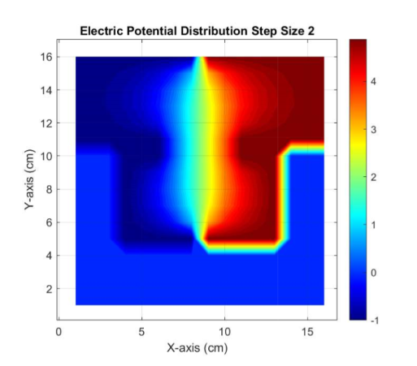

- The contour plot for step size = 1 cm:
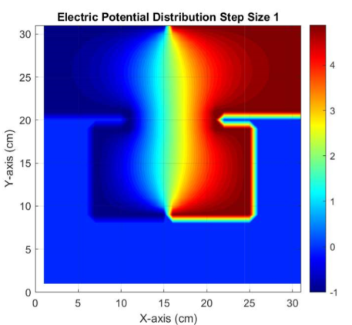
- The contour plot for step size = 0.5 cm:
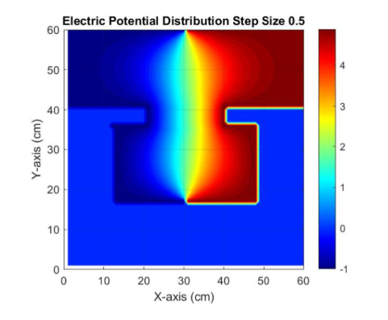

- The contour plot for step size = 0.25 cm:
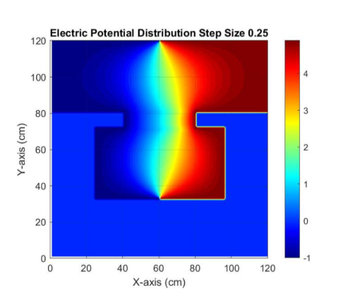
The distribution of electric potential in the system is shown by the contour plot. Contour lines indicate regions of constant potential, and the color represents the magnitude of the potential.
Places with a potential of -1 may correspond to lesser potential zones, whilst places with a potential of 5 are belong to higher potential regions.

5)
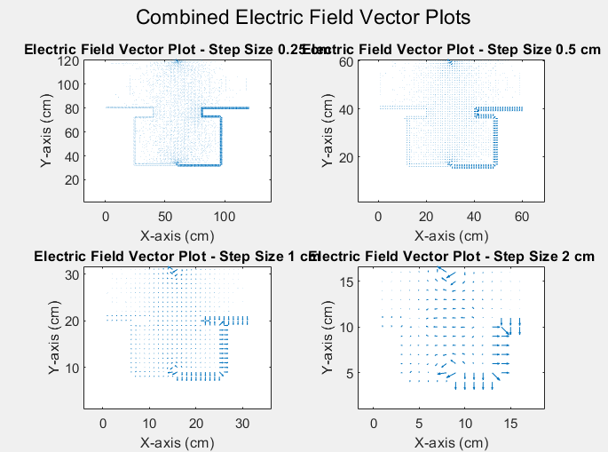
6)


