MARMARA UNIVERSITY DEPARTMANT OF ELECTRICAL AND ELECTRONICS ENGINEERING



INTRODUCTION TO DIGITAL SIGNAL PROCESSING

LABORATORY WORK REPORT 1

DFT and Its Properties

MEHMET ALİ KAMALAK
150720062

Lab Work
a. Load the image file barbara_gray_512.bmp (You would use MATLAB command ‘imread’ to load this file to a variable ‘test_image’. Use MATLAB help to learn the usage of ‘imread’, then check for ‘imwrite’). This file contains an image with several frequency components.

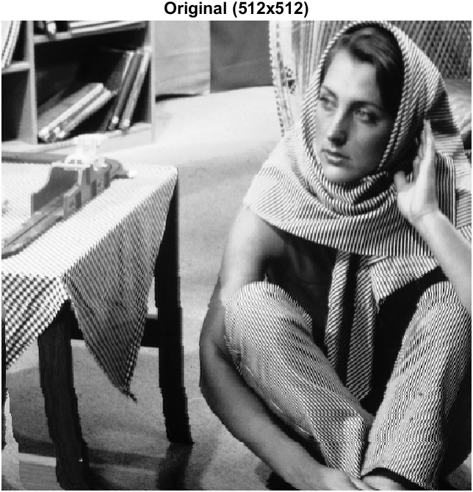

b. To observe the frequency components, use fft2 function, then calculate the magnitude of the Fourier transformed image. Afterwards, to improve the visibility of the magnitude pass it through log10 function. Diplay the result.
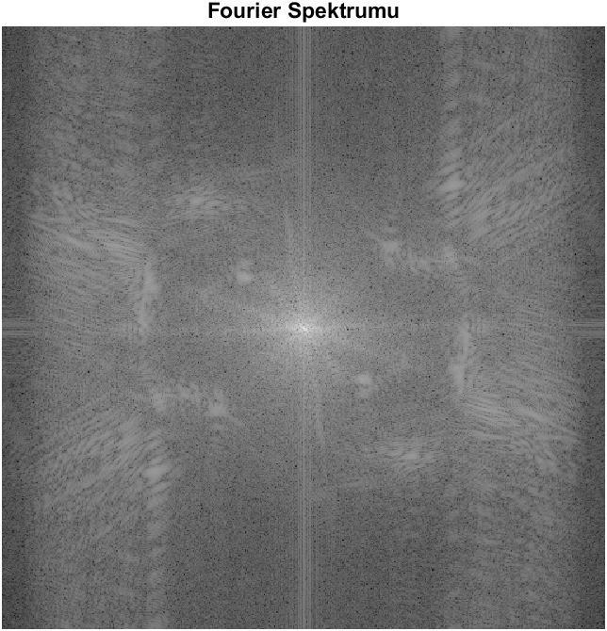
c. Downsample ‘test_image’ by 2. Therefore size of th image will be 256 by 256 at the end. Then, display it and save in bmp format. As in part (b), observe its frequency components.

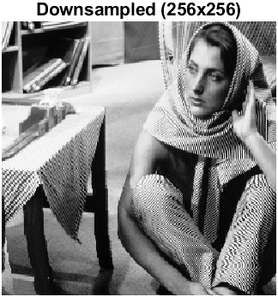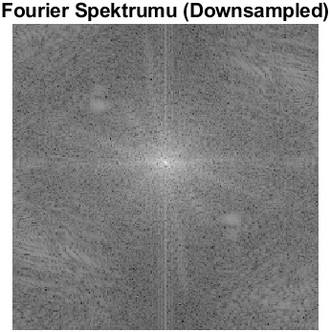

d. Upsample the image you obtain in part (c). Again, display it and save it in bmp format. Furthermore, observe its frequency compoents.
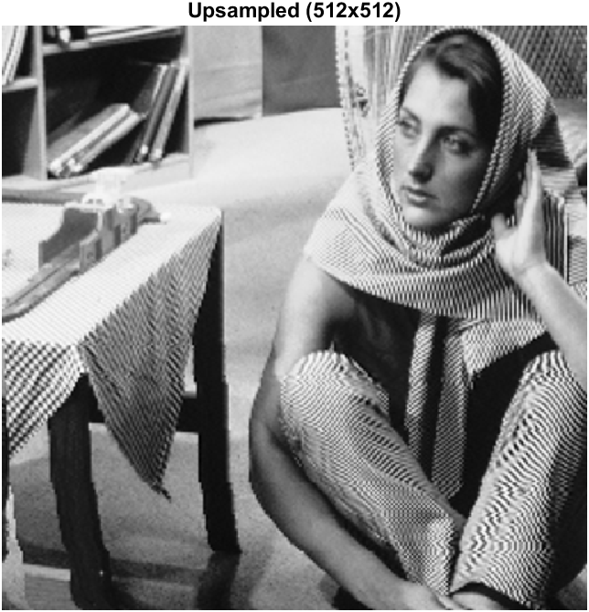
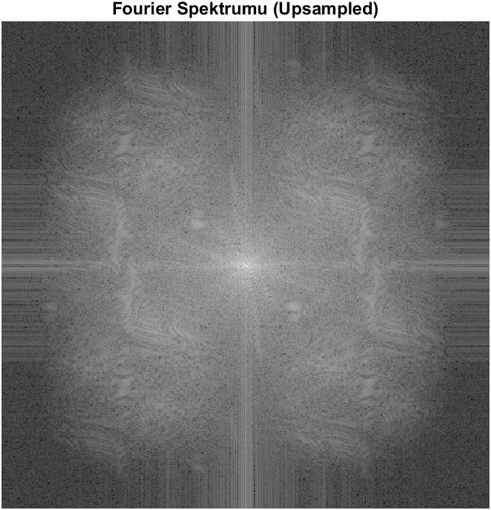

f. Discuss the result you obtain in part (e)
Downsampling reduces the number of pixels representing an image, which leads to the loss of high-frequency components. These high-frequency details include sharp edges, fine textures, and rapid changes in intensity. When the sampling rate is reduced, these details are removed, resulting in a simplified version of the image. To restore a downsampled image to its original size, upsampling is applied. For example, a 256x256 image can be resized back to 512x512 by inserting zeros between pixels. However, this approach causes blurriness since the inserted zeros do not contain actual information to reconstruct the missing details. Instead, interpolation is used to estimate the missing pixel values, allowing for smoother transitions and improved image quality. However, interpolation cannot perfectly restore the lost details, as it relies on approximation techniques. Consequently, interpolation helps produce an image that closely resembles the original, but it cannot fully recreate it with complete accuracy.

