MARMARA UNIVERSITY DEPARTMANT OF ELECTRICAL AND ELECTRONICS ENGINEERING



INTRODUCTION TO DIGITAL SIGNAL PROCESSING

LABORATORY REPORT 1

DFT and Its Properties

MEHMET ALİ KAMALAK
150720062

- Purpose
Main purpose of the experiment is to study the generation of discrete-time signals, reviewing some properties of the Discrete-Fourier transform (DFT) and using it as a tool for signal analysis. Another aim of this experiment is to study thhe effects of changing the sampling rate in discrete-time systems. Refer to the references at the end of the sheet for the required background on this topic.
2. Preliminary Work
a. Write a MATLAB function 𝑥 = 𝑔𝑒𝑛(𝐴,𝑓,𝑇,𝐹), that generates a discrete-time sinusoidal signal 𝑥[𝑛] with amplitude 𝐴. Assume that x[n] is the output of a C/D converter at sampling rate 𝐹, with a sinusoidal input of duration 𝑇 seconds, at 𝑓 𝐻𝑧.
b. Run your function gen with the following parameters:
A = 1; 𝑓 = 25 𝐻𝑧; 𝑇 = 2 𝑠𝑒𝑐; 𝐹= 100 𝐻𝑧
And obtain 𝑥[𝑛]. Using MATLAB’s fft function obtain the DFT of 𝑥[𝑛] and comment on the resulting spectra. Note on the MATLAB function fft: The fft function computes the DFT of a vector 𝒙. If the length of the vector 𝒙 is an integer power of two, then it is possible to compute the DFT using faster algorithms, which are called as Fast-Fourier Trasnform (FFT) algorithms. MATLAB has a built in function named fft, which depending on the data length, computes the DFT either directly or using the FFT algorithm.
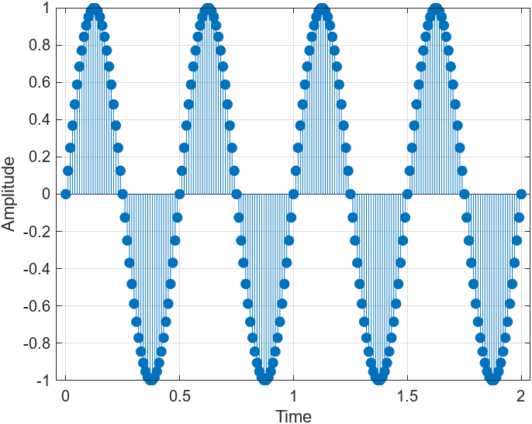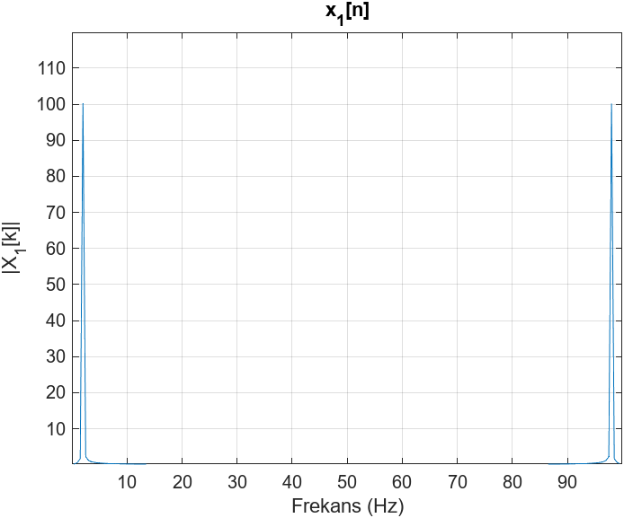
c. Use the function gen one again to generate 𝑥[𝑛], with parameters:
A = 3; 𝑓 = 10 𝐻𝑧; 𝑇 = 2 𝑠𝑒𝑐; 𝐹 = 100 𝐻𝑧 Take DFT of 𝑥[𝑛] and call it 𝑋[𝑘]. PLot the magnitude and phase spectra of 𝑥[𝑛] and comment on the resulting spectra.
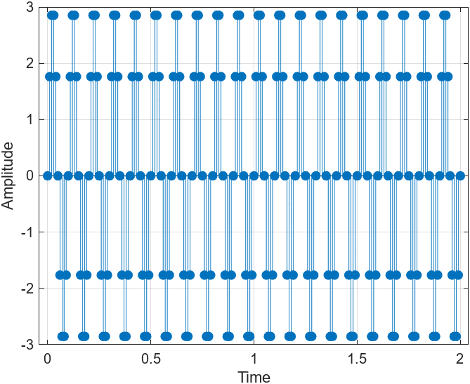
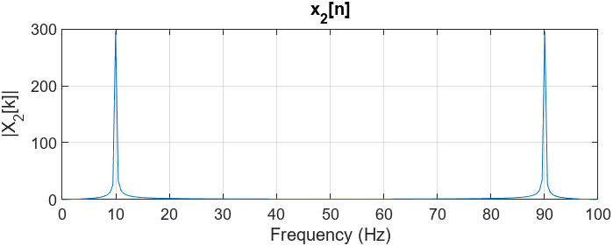

d. Now generate the signal 𝑥[𝑛] = 𝑥[𝑛] + 𝑥[𝑛]. Check numerically tht DFT is a linear transform. PLot the magnitute spectrum of 𝑥[𝑛] and comment on the resulting spectrum.
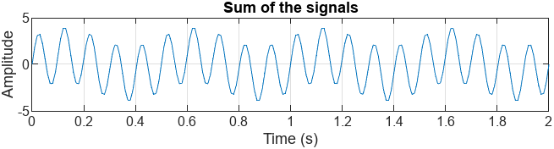
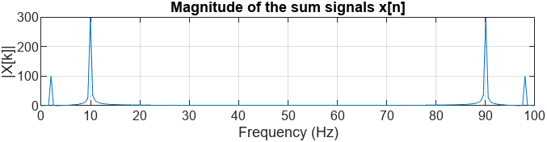
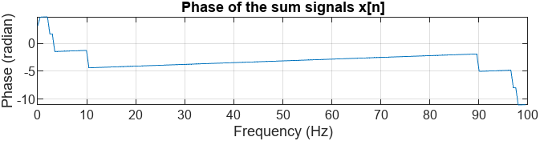
e. Generate the signal 𝑥[𝑛] = 𝑥[𝑛]𝑥[𝑛]. Plot the magnitute spectrum of 𝑥[𝑛] and comment on thhe resulting spectrum.
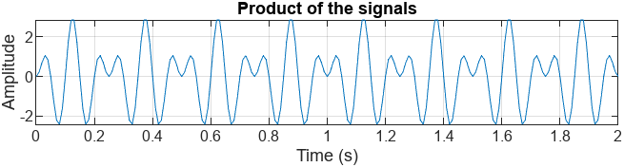
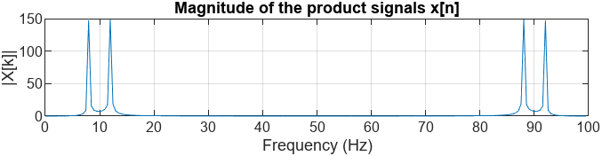

f. Generate the signal 𝑥[𝑛] = 𝑥[𝑛 −1] which is the one sample sihfted version of 𝑥[𝑛]. Assuming X₁[𝑛], 0 ≤ 𝑛 ≤ 𝑁−1, generate 𝑥[𝑛] such that 𝑥[0] = 𝑥[𝑁 −1]. Observe numarically the effect of this operation on the fft of both signals.
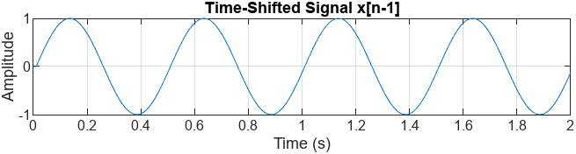
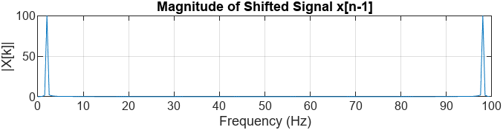
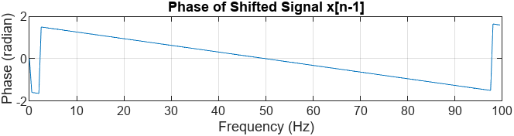

g. Load the file Television.wav (You would use MATLAB command ‘audioread’ to load this file. Use MATLAB help to learn the usage of ‘audioread’). This file contains a portion of speech waveform. Plot the waveform and its magnitude spectrum.

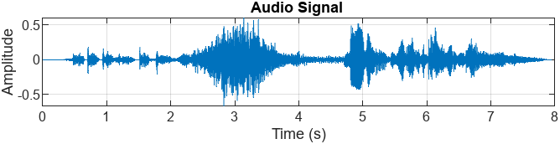
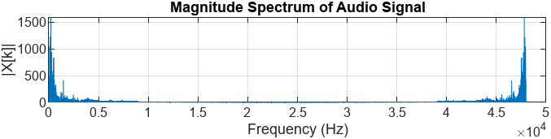
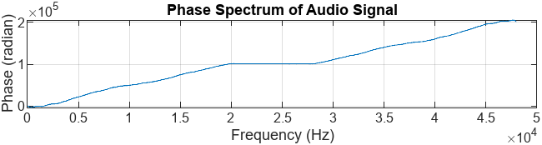

Up- and Down-Sampling

In saome cases, signals have to be processed at a sampling rate other than they have been obtained. This is the subject of Multirate-Signal Processing. Below we consider two examples oon this topic in which the effect of reducing the sampling the sampling rate is studied.

h. Generate signals:
x₁[𝑛] = 𝑠𝑖𝑛𝑐(0.2∗(𝑛−128)),𝑛 = 0,…,255
x₂[𝑛] = 𝑠𝑖𝑛𝑐(0.8∗(𝑛−128)),𝑛 = 0,…,255
i. Downsample 𝑥[𝑛] by two such that 𝑥𝑑𝑜𝑤𝑛1[0] = 𝑥[0]. Plot 𝑥[𝑛], 𝑥𝑑𝑜𝑤𝑛1[𝑛] and their magnitude spectra. Comment on the plots. Using MATLAB’s interp function interpolate 𝑥𝑑𝑜𝑤𝑛1[𝑛] by two to obtain 𝑥𝑖𝑛𝑡𝑒𝑟𝑝1. Compare the signals 𝑥[𝑛] and x𝑖𝑛𝑡𝑒𝑟𝑝1 both in time and frequency domains.

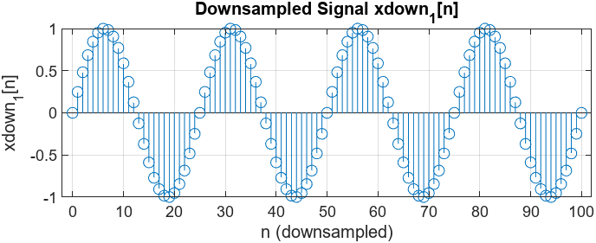

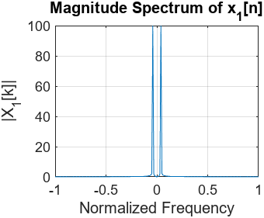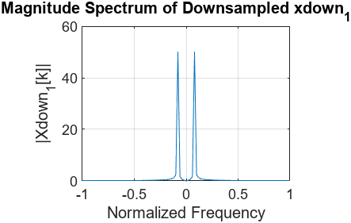

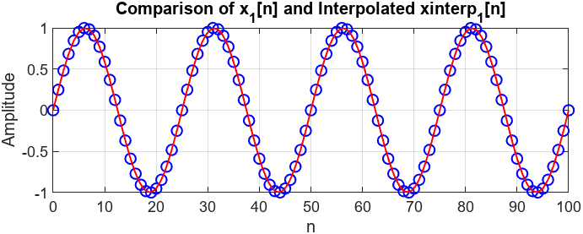

j. Downsample 𝑥[𝑛] by two such that 𝑥𝑑𝑜𝑤𝑛2[0] = 𝑥[0]. Plot 𝑥[𝑛], 𝑥𝑑𝑜𝑤𝑛2[𝑛] and their magnitude spectra. Comment on the plots. Using MATLAB’s interp function interpolate 𝑥𝑑𝑜𝑤𝑛2[𝑛] by two to obtain 𝑥𝑖𝑛𝑡𝑒𝑟𝑝2[𝑛]. Compare the signals 𝑥[𝑛] and 𝑥𝑖𝑛𝑡𝑒𝑟𝑝2[𝑛] both in time and frequency domains.

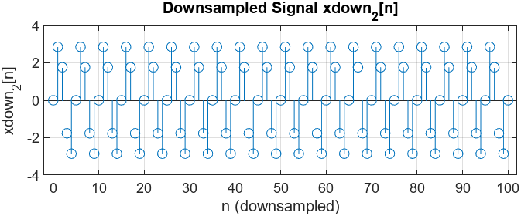

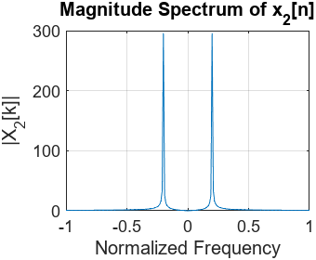

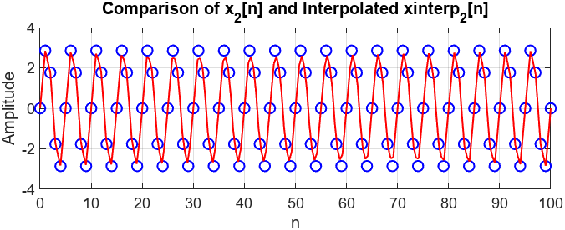

Discussion:
In this lab, we explored the effects of DFT and sampling rate changes on images and signals. When we downsampled, the image got smaller, and some details were lost. Then, we upsampled it back, but since we used interpolation, the lost details couldn’t be fully recovered. We especially noticed that high-frequency details disappeared. In conclusion, changing the sampling rate directly affects the quality of the image and signal.

