MARMARA UNIVERSITY DEPARTMANT OF ELECTRICAL AND ELECTRONICS ENGINEERING



INTRODUCTION TO DIGITAL SIGNAL PROCESSING

LABORATORY WORK REPORT 4

MEHMET ALİ KAMALAK
150720062

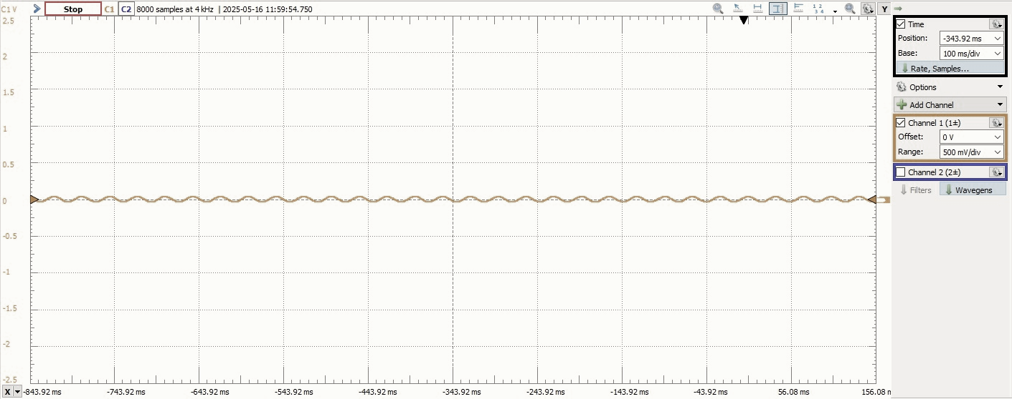
Figure 1: 15 Hz Sine Wave (Amplitude = 1 V)

This waveform represents a low-frequency sinusoid generated using STM32 DAC. It is smooth and periodic, matching the 15 Hz target.

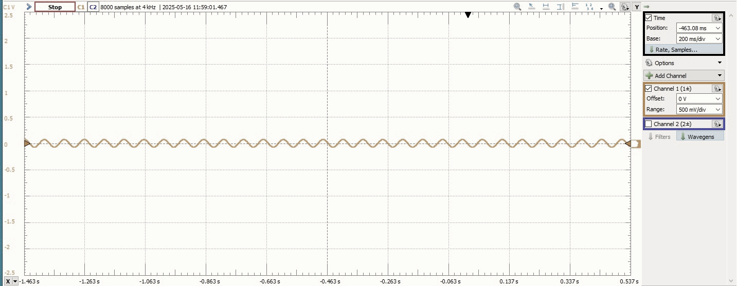
Figure 2 : 30 Hz Sine Wave (Amplitude = 0.5 V)

The waveform has a higher frequency with a visibly smaller amplitude. This confirms a successful generation of the 30 Hz sine signal.

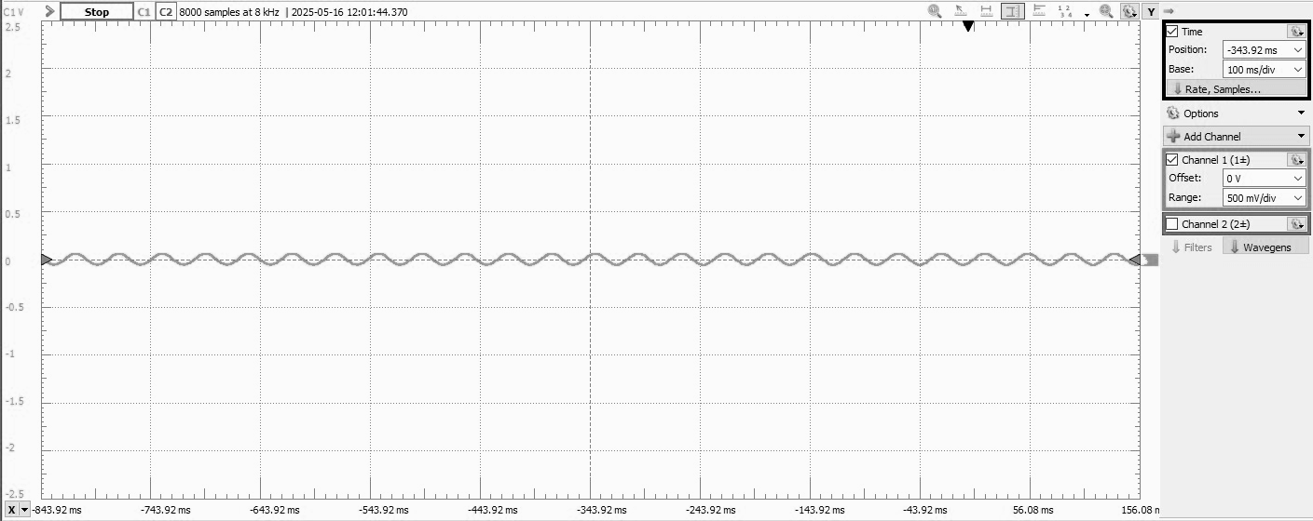
Figure 3: 25 Hz Cosine Wave (Amplitude = 0.8 V)

This cosine waveform is consistent with the expected frequency and amplitude values. It shows a phase shift compared to the sine signals.

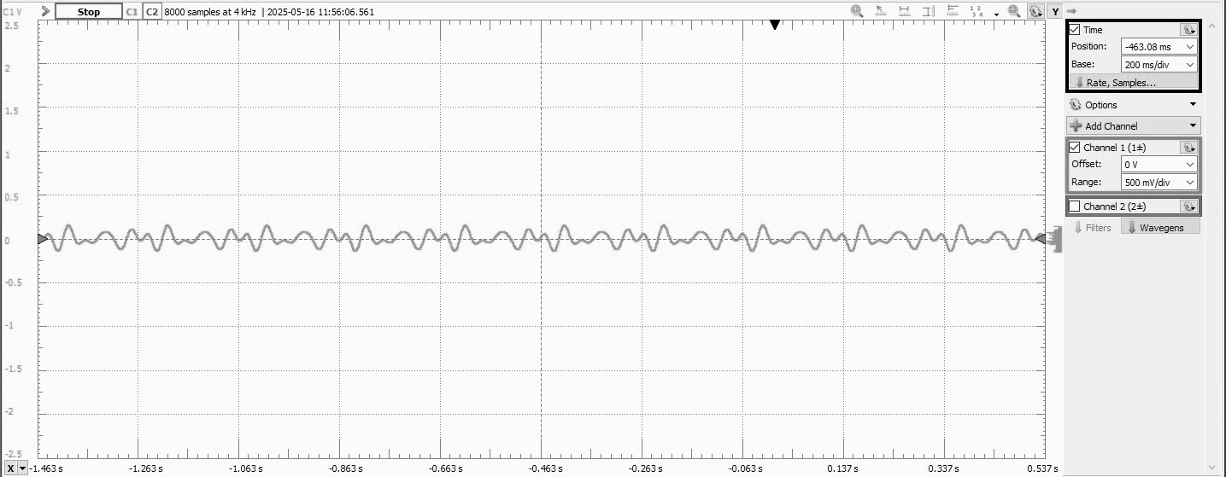
Figure 4: Composite Signal (Superposition)

This is the result of superimposing the above signals. The waveform is complex due to the interaction of different amplitudes and frequencies.

QUESTIONS:
Q1: What are the key parameters that define a sine or cosine wave?
A sine or cosine wave is defined by several key parameters. The frequency (measured in hertz) determines how many cycles the waveform completes in one second. The amplitude specifies how high or low the wave reaches from its central axis, usually in volts. The phase indicates the horizontal shift of the waveform, showing how delayed or advanced it is compared to a reference signal. Additionally, a DC offset may be included, which vertically shifts the entire waveform above or below zero. Together, these parameters uniquely shape the signal.
Q2: How can you ensure precise frequency and amplitude when using STM32 DAC?
To achieve precise frequency and amplitude with the STM32 DAC, careful control of timing and data feeding is necessary. This involves using hardware timers to maintain a consistent sampling rate, which directly influences output frequency. A lookup table (LUT) of pre-calculated sine or cosine values is typically used to generate the waveform. The values in the table must be scaled to match the DAC resolution and reference voltage to produce the correct amplitude. Consistent and accurate timing ensures the waveform is stable and true to the desired specifications.

Q3: What is signal superposition, and how is it implemented in this experiment?
Signal superposition is the process of combining multiple waveforms by summing their individual values point by point. This creates a new, composite signal that reflects the contributions of each original waveform. In this experiment, three separate signals—a 15 Hz sine wave, a 30 Hz sine wave, and a 25 Hz cosine wave—were generated individually. These signals were then added together in software, and the result was sent to the STM32 DAC output. The combined signal, observed using Analog Discovery 2, demonstrated the effect of frequency and amplitude interactions in a real-time superposition.

