MARMARA UNIVERSITY DEPARTMANT OF ELECTRICAL AND ELECTRONICS ENGINEERING



INTRODUCTION TO DIGITAL SIGNAL PROCESSING

LABORATORY REPORT 5

MEHMET ALİ KAMALAK
150720062

Introduction

In this experiment, a 25 Hz square wave was generated on the STM32F446RE board using DAC1 output. The goal was to isolate the first harmonic (25 Hz component) from this square wave using a FIR band-pass filter. The filter was designed with a passband of 20–30 Hz, implemented in C, and applied in real time. The raw and filtered signals were observed using Analog Discovery 2 with the WaveForms software. The experiment provided practical insight into digital signal processing on embedded hardware.

Components
- STM32F446RE Nucleo board (DAC1 on PA4)
- USB cable for power and programming
- Analog Discovery 2 + WaveForms software
- STM32CubeIDE
- (Optional) Breadboard and wires to route PA4 to the scope

Pre-lab
1. 25 Hz Square Wave Simulation
A 25 Hz square wave was simulated in MATLAB at a 1 kHz sampling rate (1000 samples per second). The square wave was generated using the square() function and its frequency spectrum was computed using the FFT.
The spectrum confirmed the presence of the odd harmonics (1st, 3rd, 5th, etc.), as expected from theoretical analysis of square waves.

2. FIR Band-pass Filter Design
A FIR band-pass filter of order 100 was designed in MATLAB using a Hamming window.
Since the fundamental (1st) harmonic of a 25 Hz square wave is at 25 Hz, the filter was designed with a passband of 20–30 Hz.
The filter frequency response was verified using freqz(), confirming that the passband properly captures the desired component and attenuates higher harmonics.

3. Simulation Verification
The designed filter was applied to the simulated square wave in MATLAB.
The output showed a clean sinusoidal waveform at 25 Hz, with higher harmonics effectively suppressed, validating that the filter behaves as expected before hardware implementation.

Procedure

- Raw Square Wave Generation and Visualization

To generate a 25 Hz square wave on the STM32F446RE board, the following steps were performed:
- STM32 code was written to output a 25 Hz square wave via DAC1 (PA4) using a 1 V peak-to-peak amplitude.
- The square wave was implemented as an array of 40 samples to represent one period at a 1 kHz sampling rate.
- TIM2 was configured to trigger DAC updates at 1 kHz using DMA to ensure continuous and precise waveform generation.
- The code was compiled and flashed to the Nucleo board, and PA4 was connected to Analog Discovery 2.
- In WaveForms software, the timebase was adjusted to display at least three cycles of the waveform, and the voltage scale was set to 0–1 V.
Observations:
- Peak-to-peak amplitude:
The measured amplitude was approximately 1 V, matching the expected value.
- Duty cycle and symmetry:
The waveform exhibited an approximately 50% duty cycle and good symmetry between the high and low states.
- Rise/fall time and noise or overshoot:
The transitions were sharp and well-defined, with minor noise and minimal overshoot, as expected from the DAC output.

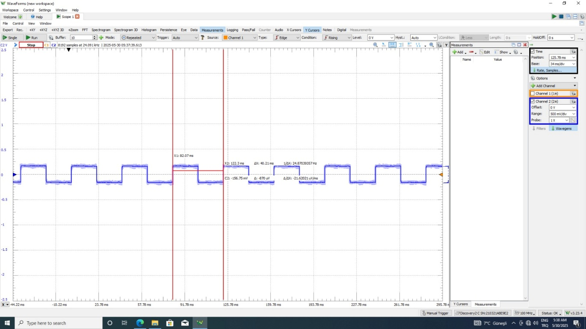
Figure 1: 25 Hz Square Wave Output (WaveForms Screenshot)

- First Harmonic Extraction via FIR Filter

To isolate the first harmonic (25 Hz) of the generated square wave, a FIR band-pass filter was designed and implemented as follows:
- A FIR band-pass filter of order 100 was designed in MATLAB using a Hamming window, with a passband of 20–30 Hz to target the 25 Hz fundamental component.
- The resulting filter coefficients were exported from MATLAB and implemented in C as an array in the STM32 firmware.
- A FIR filter function was written to perform real-time filtering.
Each new square wave sample was passed through this filter, and the filtered result was output to DAC1 (PA4) at a sampling rate of 1 kHz.
- The real-time filtering was implemented using a loop with precise timing (via Timer or wait loops), ensuring that samples were processed and output at 1 ms intervals.
- The filtered output was observed on Analog Discovery 2 using the WaveForms software.
Observations:
- The resulting waveform was a clean sinusoid centered at 25 Hz, as expected.
- The measured frequency was approximately 25.03 Hz, confirming that the first harmonic was successfully extracted.
- The higher harmonics present in the square wave were significantly suppressed by the FIR filter.
- The waveform exhibited low ripple and minimal distortion, demonstrating the effectiveness of the filter design.

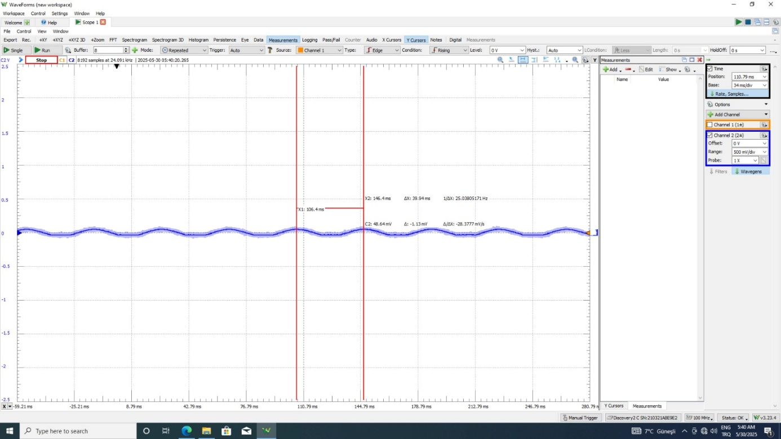
Figure 2: Filtered 25 Hz Sine Wave (WaveForms Screenshot)

Visual Analysis

Figure 1 (Square Wave): The generated square wave had an amplitude close to 1 V peak-to-peak, matching the expected value. The waveform showed a nearly perfect 50% duty cycle, with good symmetry between high and low states. The rise and fall times were sharp, and the transitions appeared clean. There was a small amount of noise on the edges, which is normal due to the DAC’s limitations.

Figure 2 (Filtered 1st Harmonic): After filtering, the output was a smooth sinusoidal waveform centered around 25 Hz. The waveform appeared clean with minimal distortion, and higher harmonics from the original square wave were not visibly present in the output. The filter effectively isolated the desired component.

Discussion
- Using a timer like TIM2 to control the DAC update speed allows the waveform to be generated at a precise and stable sampling rate. Without using a timer, the update intervals would vary due to software timing uncertainties, which would distort the signal. The timer ensures that each DAC update happens exactly every 1 ms, maintaining the correct frequency and shape of the waveform.

- When the number of FIR filter coefficients is increased, the filter’s frequency response becomes sharper, which helps to more accurately isolate the desired frequency and suppress unwanted components. However, this also introduces more delay and requires more processing. If the filter order is too low, the output may still contain remnants of other harmonics; if it is too high, the response becomes slower.

- The FIR filter was able to remove the unwanted harmonics quite well. After applying the filter, the output waveform appeared as a clean sine wave at 25 Hz, and higher harmonics from the square wave were no longer visible in the signal. This indicates that the filter effectively suppressed the extra frequencies.

- Testing the filter in MATLAB or Python is important because it allows us to verify the filter design before implementing it on the hardware. It is much easier to detect issues like an incorrect passband or insufficient attenuation in simulation. Once the filter is confirmed to work as intended in MATLAB, it is more likely to behave correctly on the STM32 as well.

Lab Questions

- Applying a window function like the Hamming window to a FIR filter helps to reduce side lobes in the frequency response. Without a window, the filter would have more leakage, meaning that frequencies outside the passband would not be fully suppressed. The Hamming window smooths out the transitions, improving the filter’s performance, especially in the stopband.

- The frequency of the square wave generated by the STM32 can be changed by adjusting how fast the DAC is updated. This can be done by modifying the period of the timer (TIM2) that triggers the DAC updates or by changing the number of samples used to represent one cycle of the square wave.

- When designing a FIR filter with more taps, the filter becomes more selective and better at rejecting unwanted frequencies. However, the main trade-off is that longer filters require more processing and introduce more delay. In real-time systems, very long filters can cause noticeable latency or exceed processing limits.

