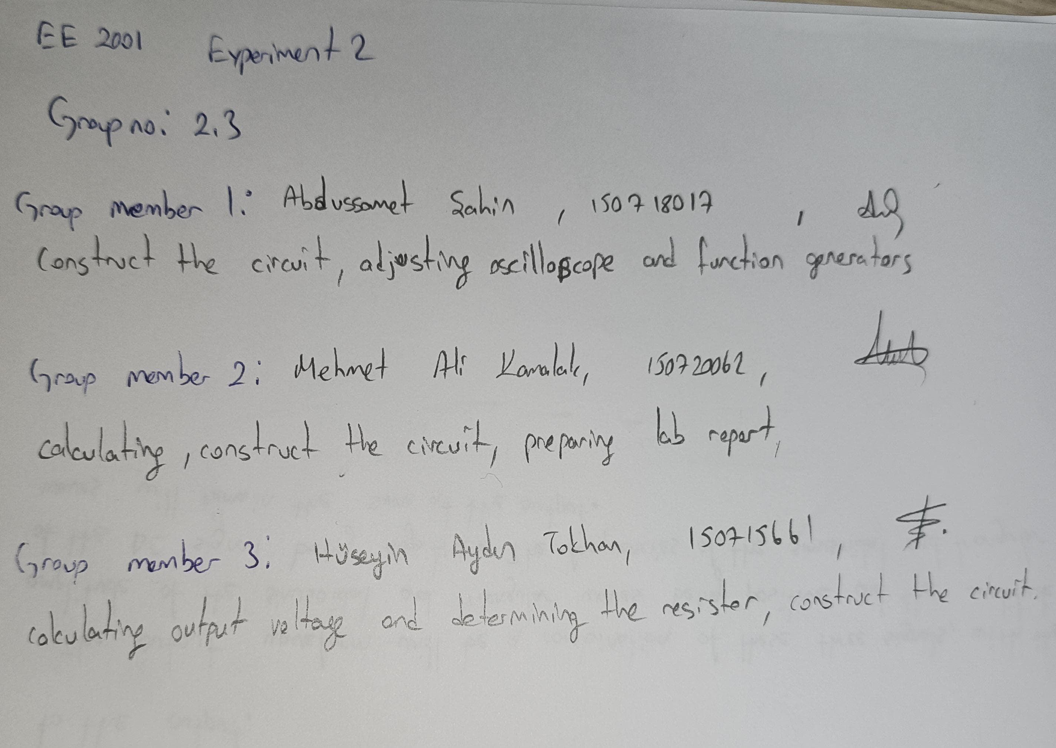

1
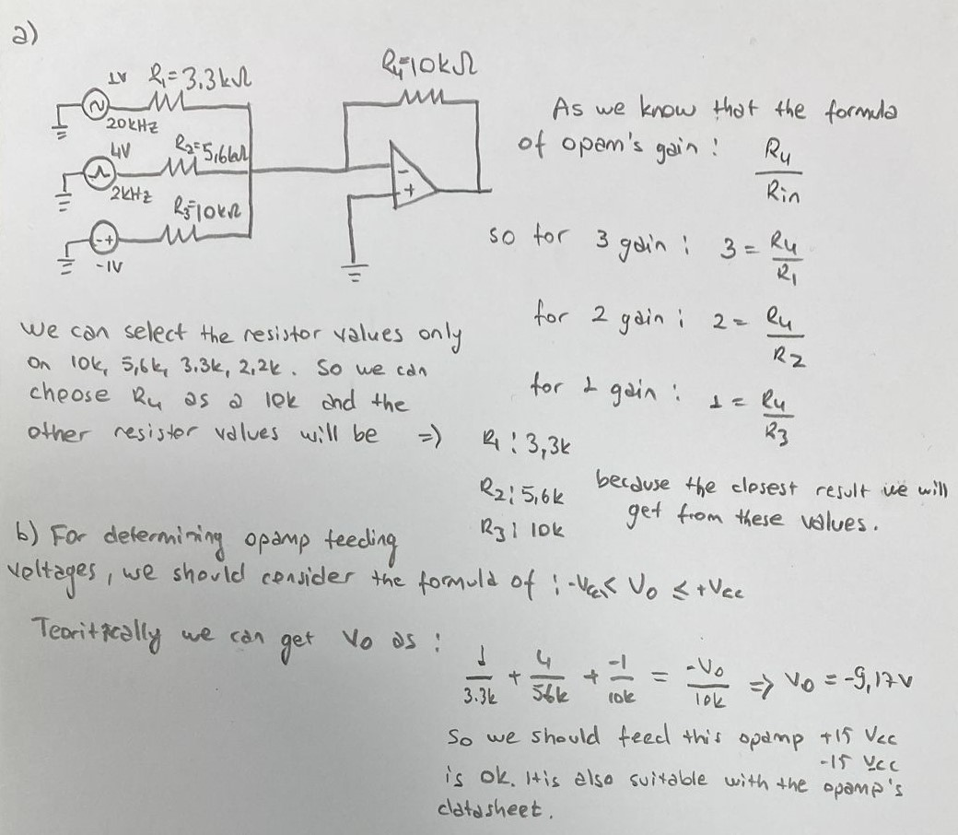
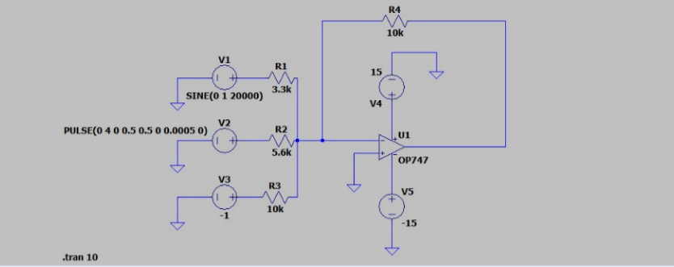
Figure 1: 1a) Determining resistor values

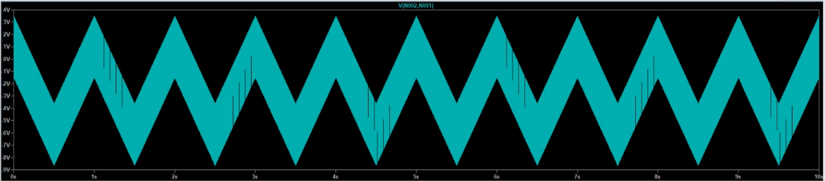
Figure 2: 1c) Guess and sketch output signal.
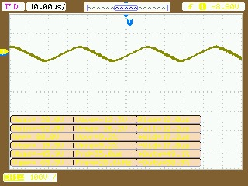
Figure 3: 1d) Construct the circuit, record input and output voltages.
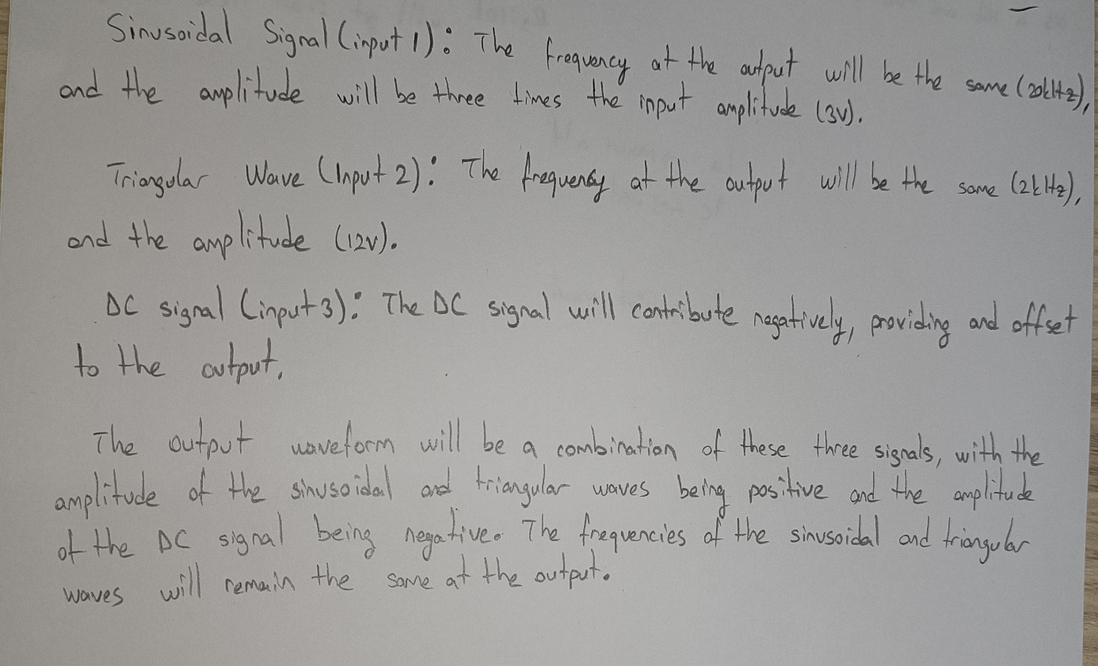
Figure 4: 1e) Show frequency and amplitude contributions of each input component at the output waveform.
2
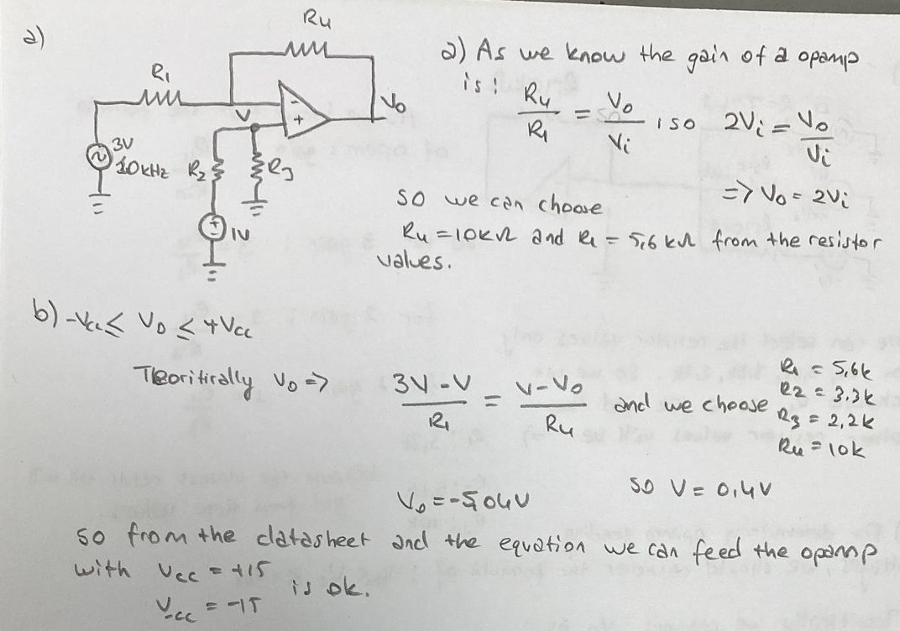
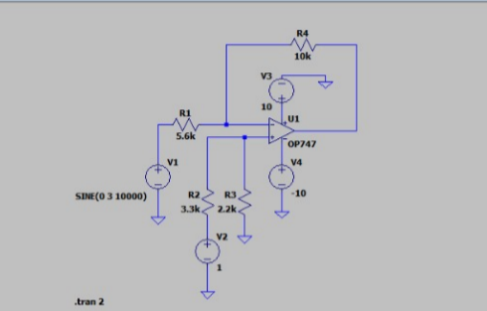
Figure 5: 2a) Determining resistor values
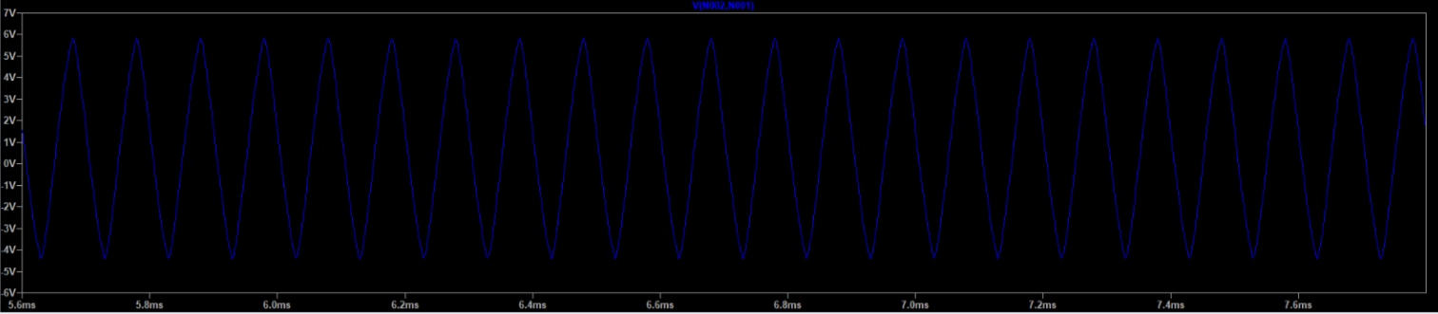
Figure 6: 2c-d) Guess and sketch output signal
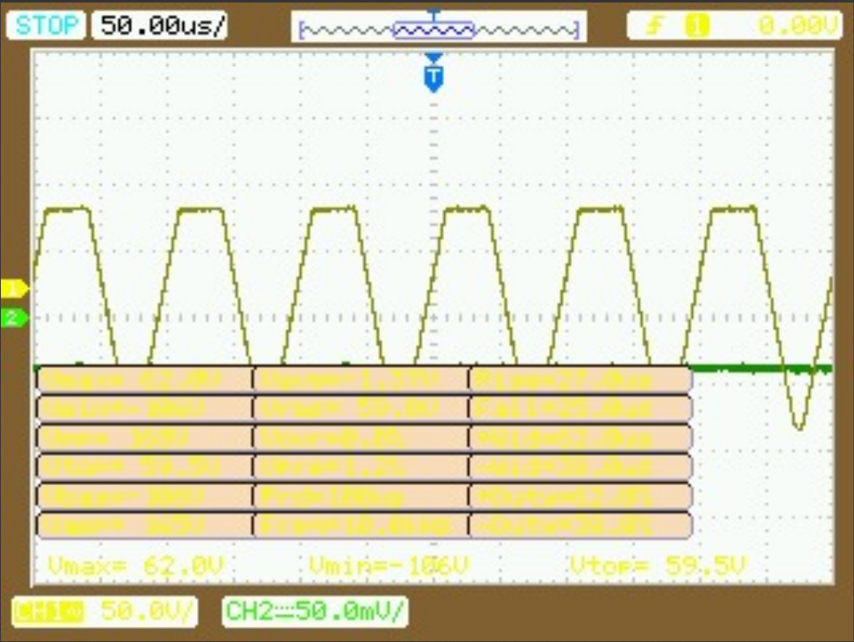
Figure 7: 2-e) Construct the circuit, record input and output voltages.

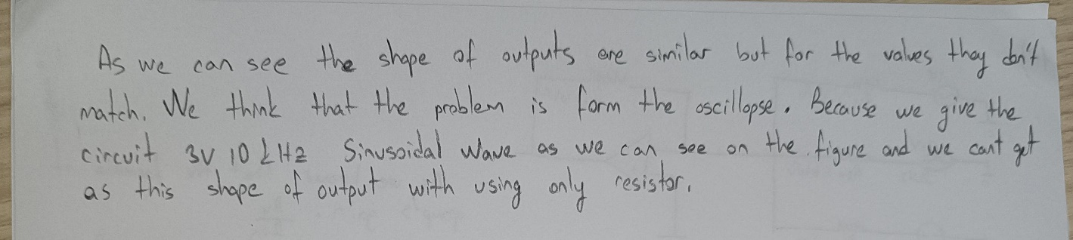
Figure 8: 2-e

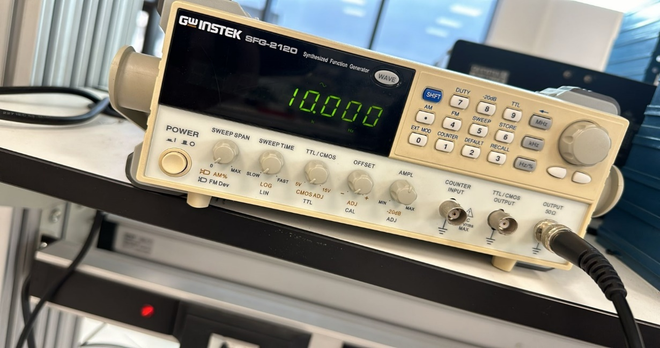
Figure 9: 2-e

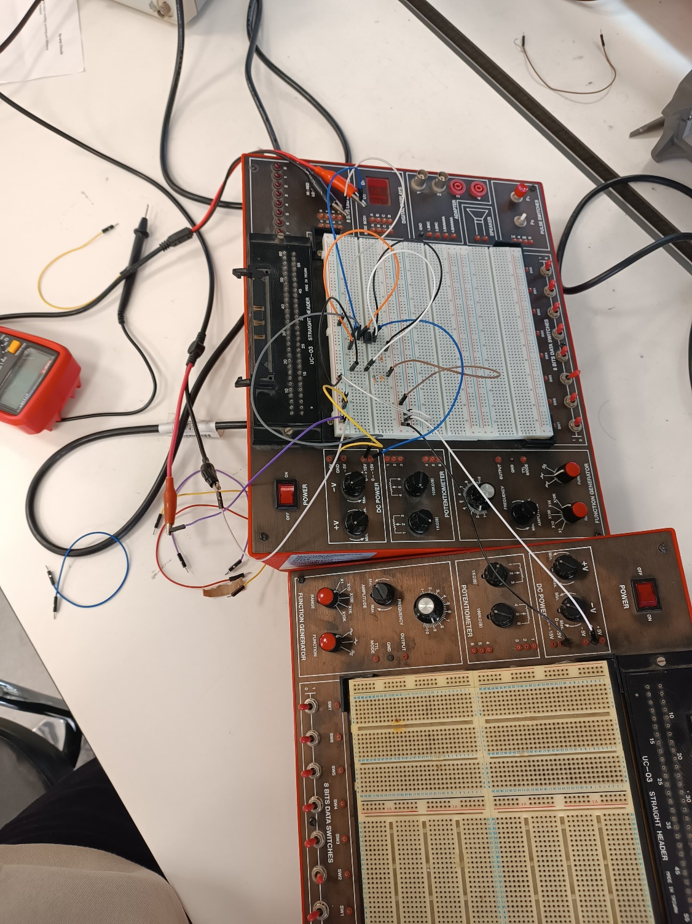
Figure 10: 2-e

