Figure 1:circuit

1.Firstly, in the Amplifier section, there is a Wheatstone bridge structure. Using this, find the missing value of R4.

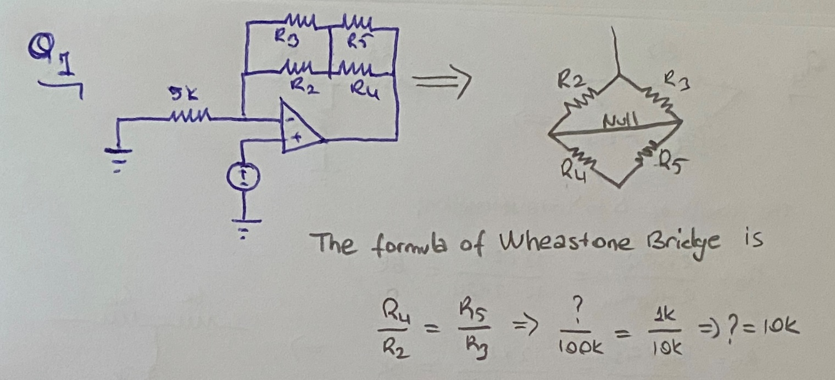

2. After finding R4 value find the current flowing through R2.3.

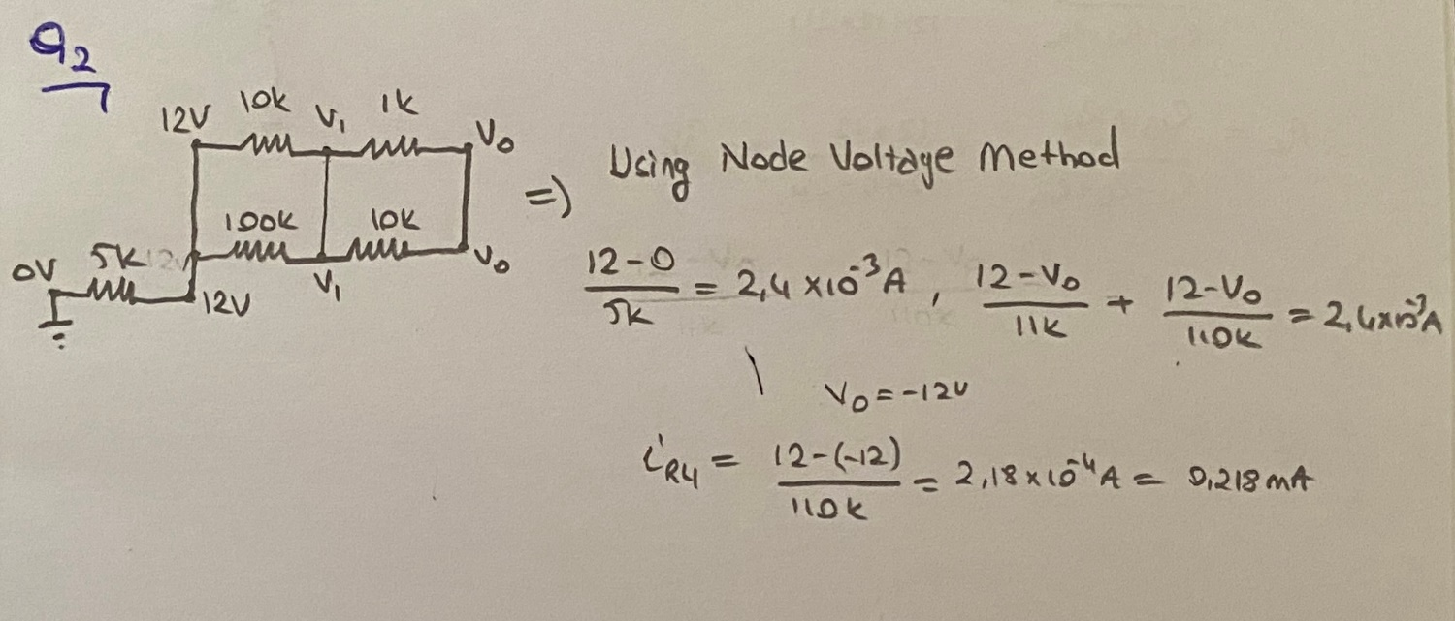

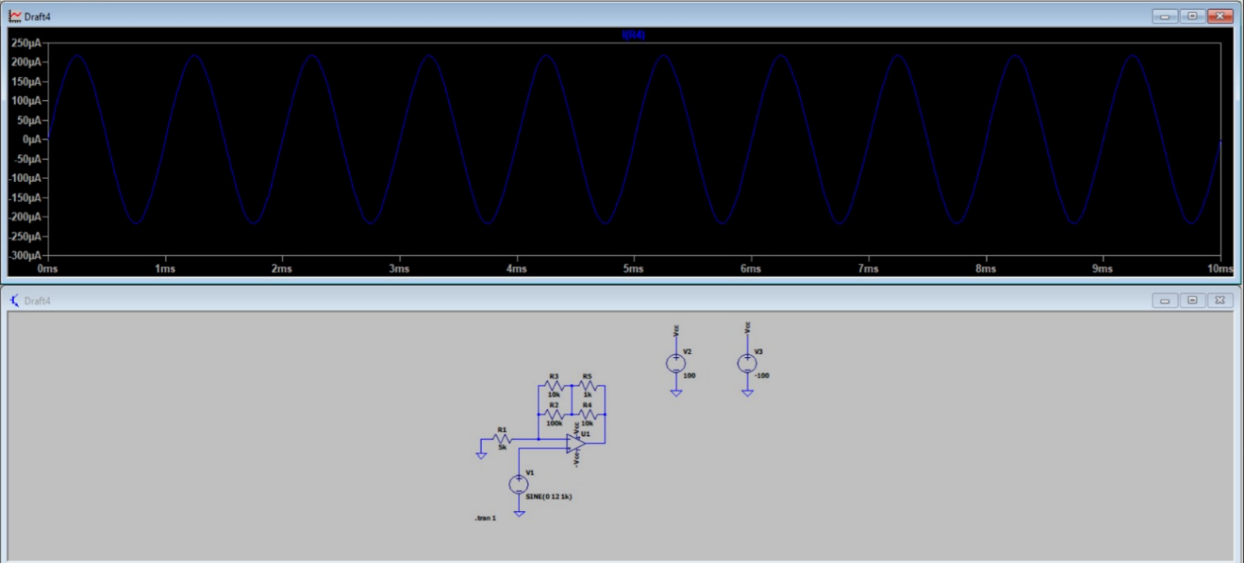

3. Afterward, in the Summing section, there is a second op-amp that inverts the negative output of the first one. Investigate ways to simplify the circuit while still obtaining a positive result and draw the final form of the circuit.

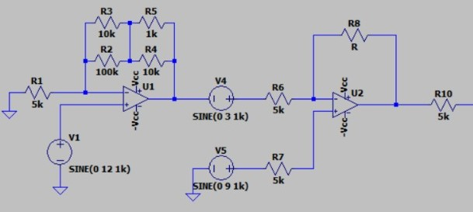

We use a Non-Inverting Operational Amplifier instead of two Inverting Amplifier not to change the voltage polarity.

4. Apply delta-wye transformation to the divider part, then apply the changes to the circuit.

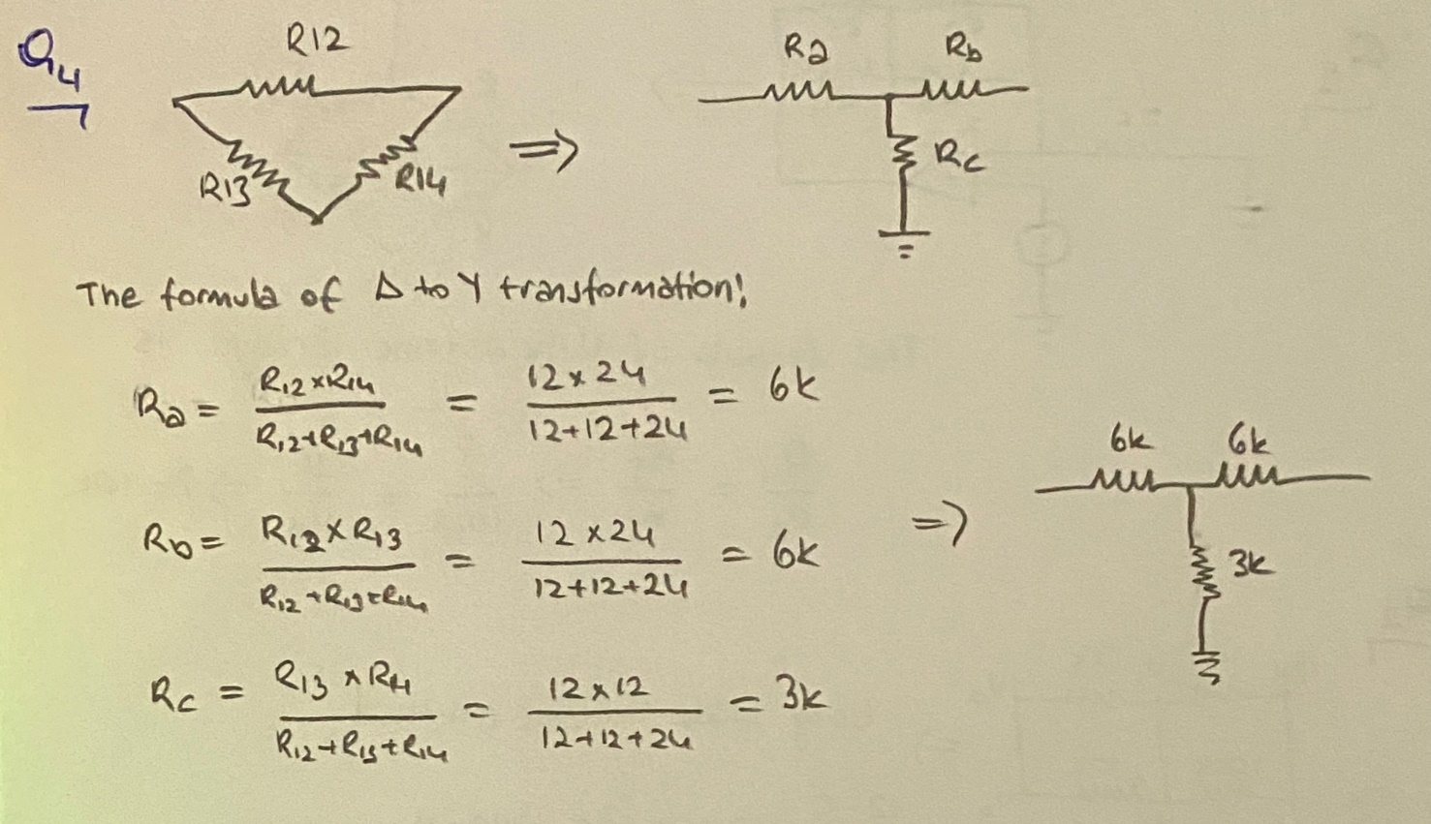
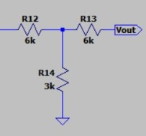

The last version of the circuit is :

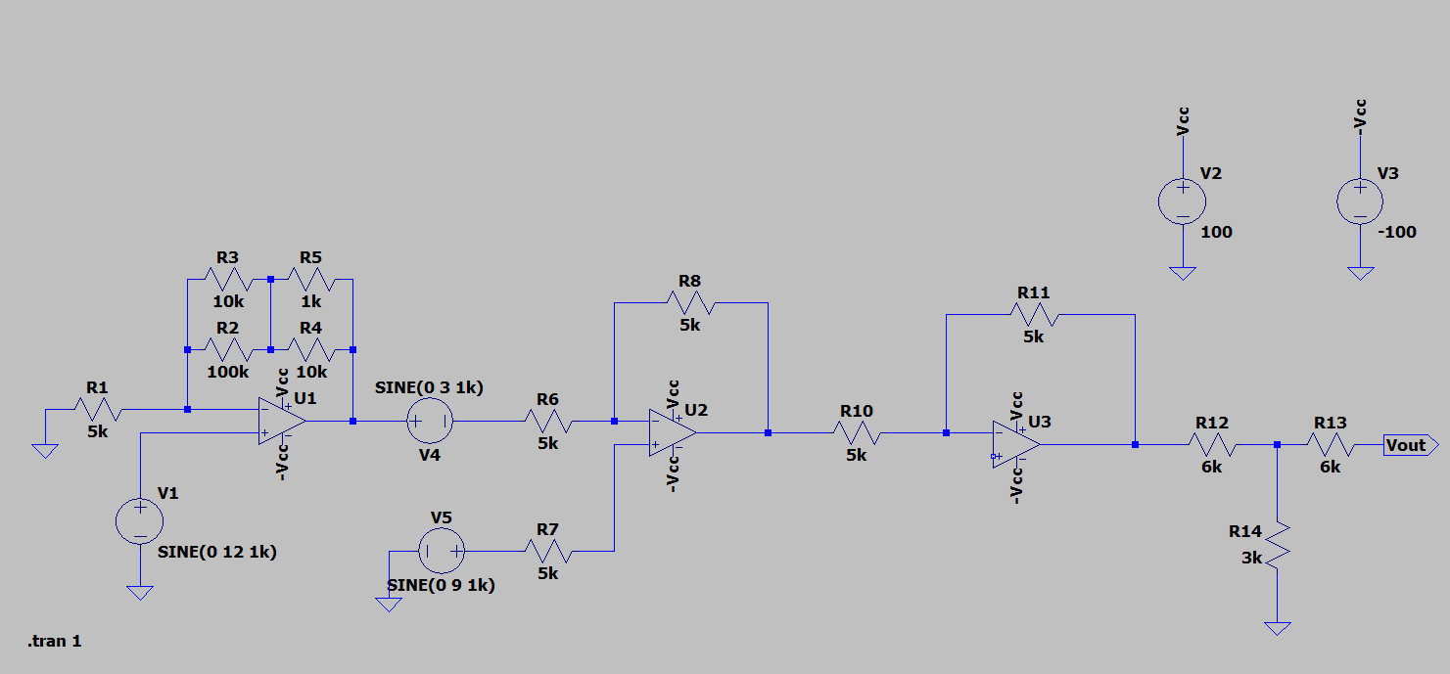

The Output of the circuit is (V_{out}) :
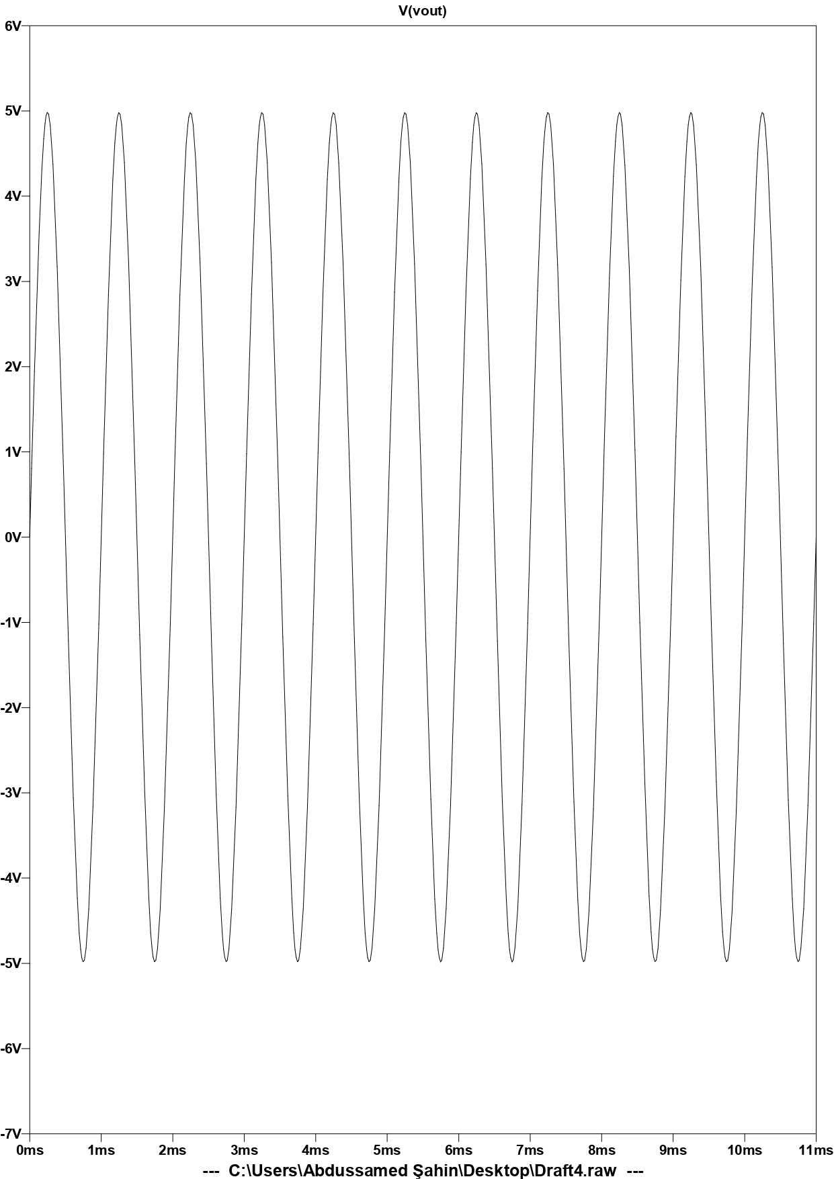

Group Member 1: Abdussamed Şahin,150718017, Analyze and draw circuit in ltspice, testing of circuit cdascdcsadccccccccccccccccccccccccccccc 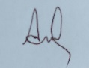

Group Member 2: Mehmet Ali Kamalak,150720062, Calculations and preparing lab report 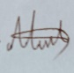

Group Member 3: Hüseyin Aydın Tokhan, 150719661,Preparing lab report and analyze 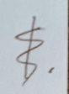

Group Member 4: Atakan Eroğlu, 150720827, Analyze and solve circuit questions 

