EXPERIMENT 4
Design of an Experiment about Fundamental Operations with Voltages GROUP NO: 11.1

Objectives:
The purpose of this experiment is to analyze the behavior of signals in a circuit using multiple sinusoidal voltage sources and examine signal gain and waveforms.
Learning Outcomes:
- - Understanding the basic use of operational amplifiers (Op-Amps).
- - Examining voltage divider circuits and resistive circuits.
- - Calculating signal gain and verifying measurements using an oscilloscope.

Materials:
The components and equipment required for the experiment are as follows:
- Signal Sources: V1, V2, V3, V4 ,V5 ,V6 (sinusoidal waves with different amplitudes and frequencies).
- Resistors:
- 10 x 1k Ω
- 8 x 2k Ω
- Op-Amps: U1, U2, U3
- Oscilloscope or voltmeter.

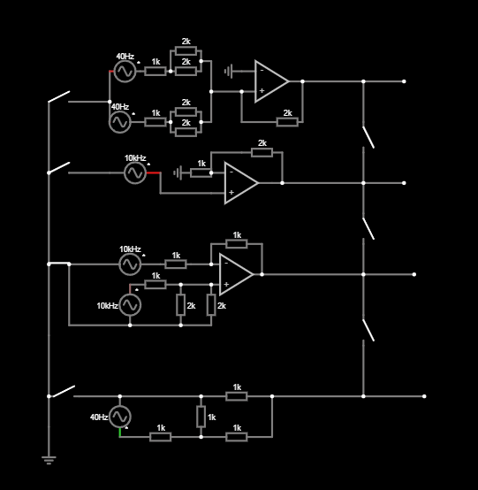
Procedure:
- Circuit Setup:
  - Using the given circuit diagram (Figure 1), place all the components correctly.
  - Adjust the parameters of signal sources V1, V2, and V3:
- V1: 5 V, 40 kHz V2: 5 V, 40 kHz V3: 5 V, 10 kHz V4: 5 V 10 kHz V5: 1 V 10kHz V6: 5 V 40kHz
- Circuit Operation:
  - Measure the input and output signals of the Op-Amps using an oscilloscope or a multimeter.

  - Analyze the voltage gains and waveforms.
- Recording Data:
  - Record the values at output voltage measurement points (S1, S2, S3).
  - Calculate the voltage drops across resistors.
- Analysis:
  - Verify the theoretical and practical results for the Op-Amps' input/output relationships.
Question 1:
Simplify the resistances in the top most circuit
Combine the resistors in the first circuit to simplify the overall resistance using series and parallel resistance formulas.

Question 2:
Find the power of 𝑹𝒇 in the second circuit from the top
Calculate the power dissipated by the feedback resistor (𝑹𝒇) in the second circuit by finding the current and voltage across it.

Question 3:
Improve the efficiency of the third circuit
Analyze the third circuit and propose modifications to make it more efficient in terms of performance or component usage.
Question 4:
Perform a node voltage analysis on the bottom circuit
Apply the node voltage method to the last circuit to calculate the voltages at each node.

    - Group Member 1: FUAT AKGÜL , 150722050 , preparing questions, writing report

    - Group Member 2: SERCAN GÖREN , 150722018 , preparing questions

    - Group Member 3: FATİH CAN DEVECİ , 150722046 , designed the all circuit, added switch, preparing questions

    - Group Member 4: MEHMET ALİ KAMALAK , 150720062 , Prepared the
report

FUAT AKGÜL | SERCAN  GÖREN | FATİH CAN DEVECİ | MEHMET ALİ  KAMALAK
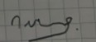 | 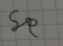 | 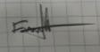 | 

