EXPERIMENT 5
GROUP NO: 11.1

Question 1: In the division part perform a Delta-to-Y transformation for the Wheatstone bridge at the top of the circuit.
Calculate the equivalent resistances for the Y configuration. Simplify the circuit using the calculated values. Simulate the original and transformed circuits to verify their equivalence.

Theoretical Calculations:

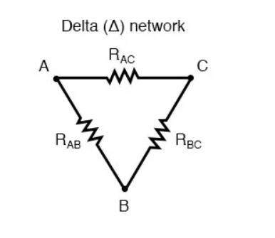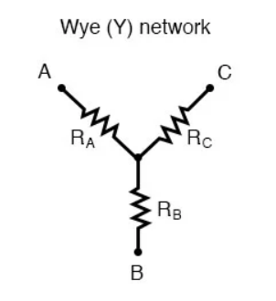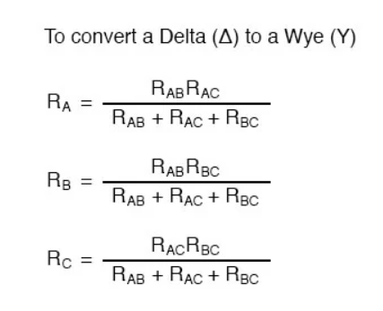

Calculations:

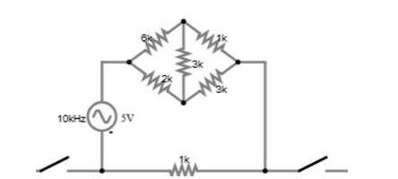

Here I have simplified the circuit as follows using delta Y transform

$\frac{6 . 2}{6 + 2 + 3} =1.1kΩ$ , $\frac{6 . 3}{6 + 2 + 3} =1.6kΩ$ , $\frac{2 . 3}{6 + 2 + 3} =O.54kΩ$

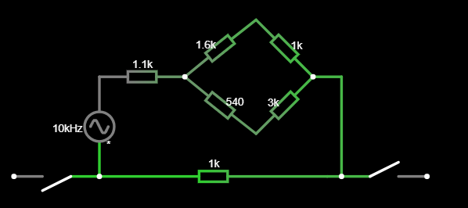

$$equivalent resistace = 1.1 +\frac{2.6 x 3.54}{2.6+3.54 } + 1$$

$$equivalent resistace = 3.6 kΩ$$

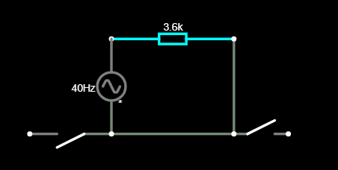

Simulation results:

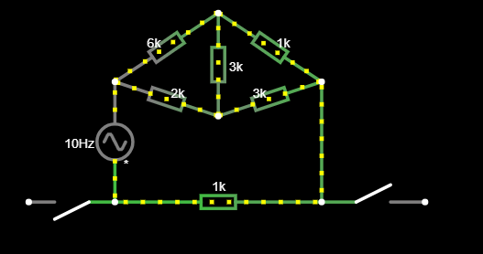

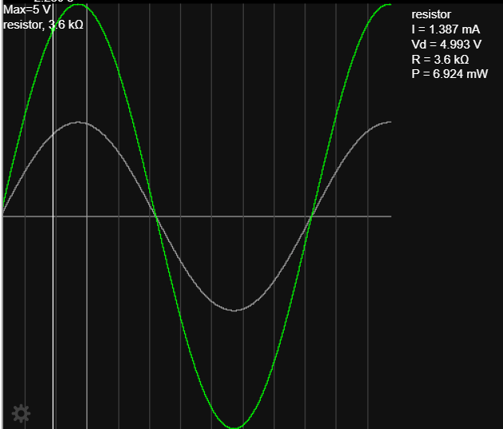

Question 2:

Output Voltage:

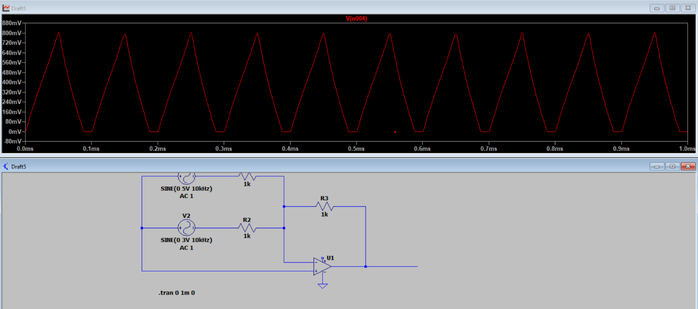
Inverting and non-inverting terminals of the operational amplifier voltages:

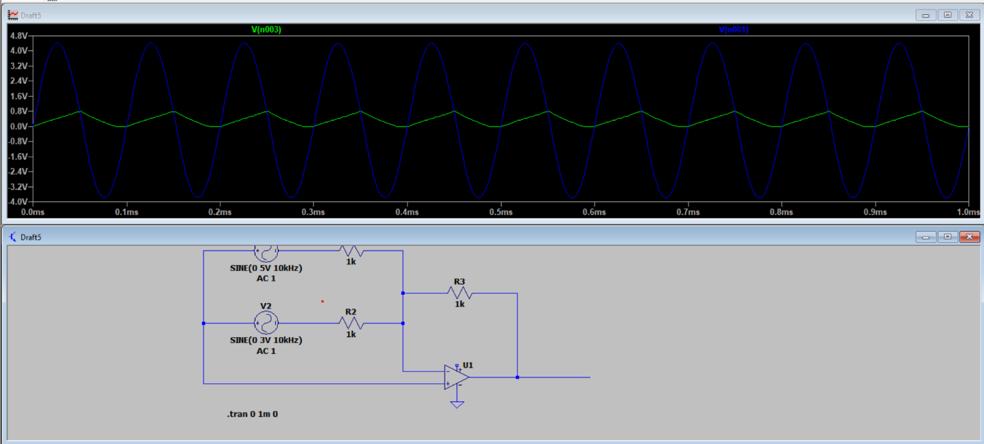

Theoretical calculations:

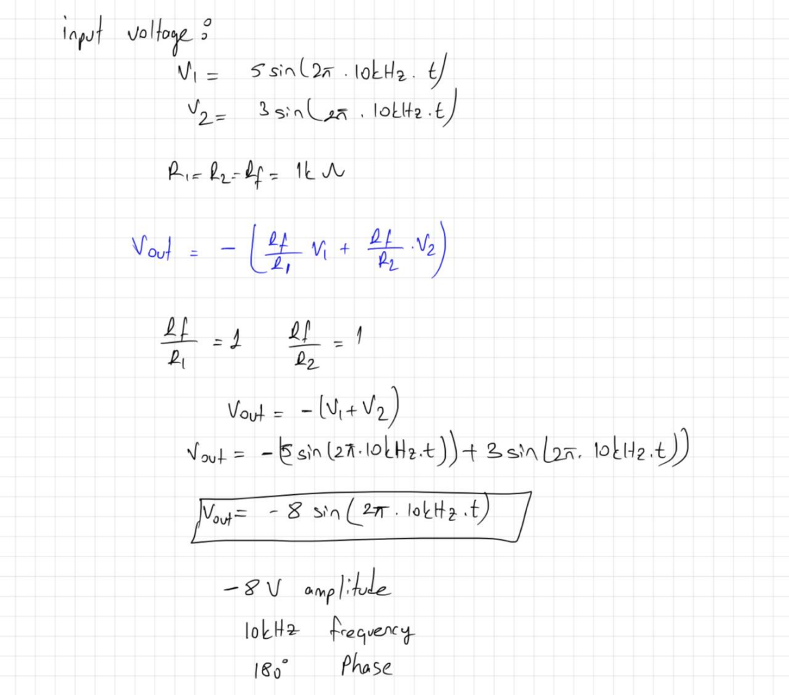

Comments for theoretical and simulation: If we compare our theoretical results and simulation results, we see that we obtain similar results even though we cannot obtain exactly the same values. The reason for these differences is that we assume that the opamp is ideal in theory. However, in the simulation, we may encounter some differences because it includes the limits of the real opamp.

Question 3:

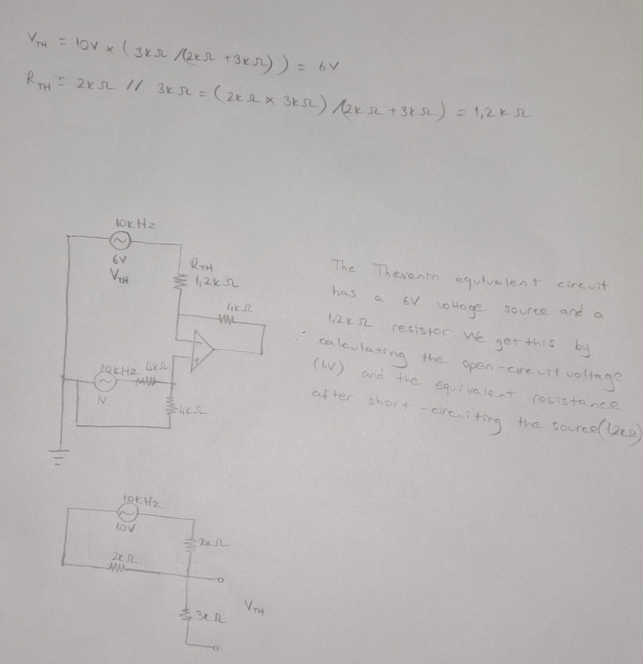

Question 4:

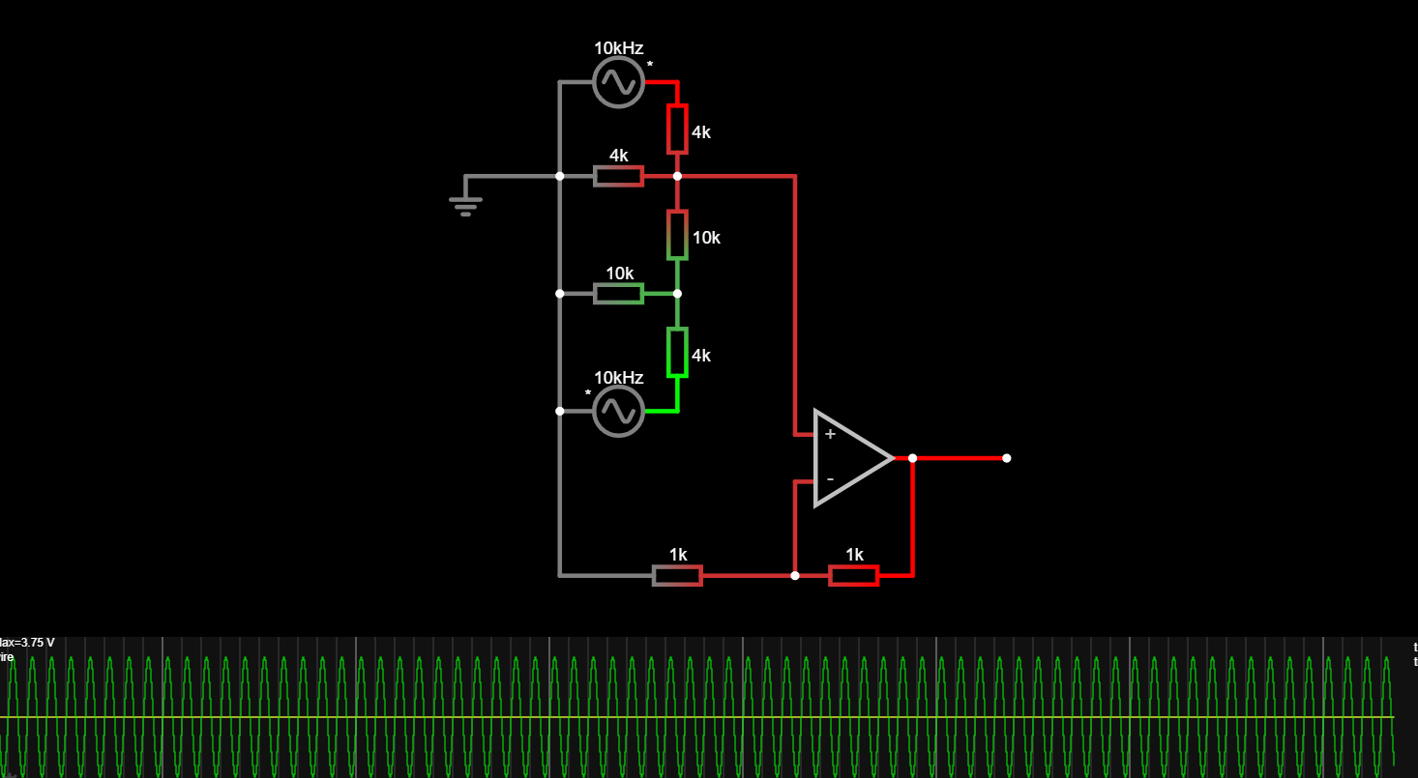
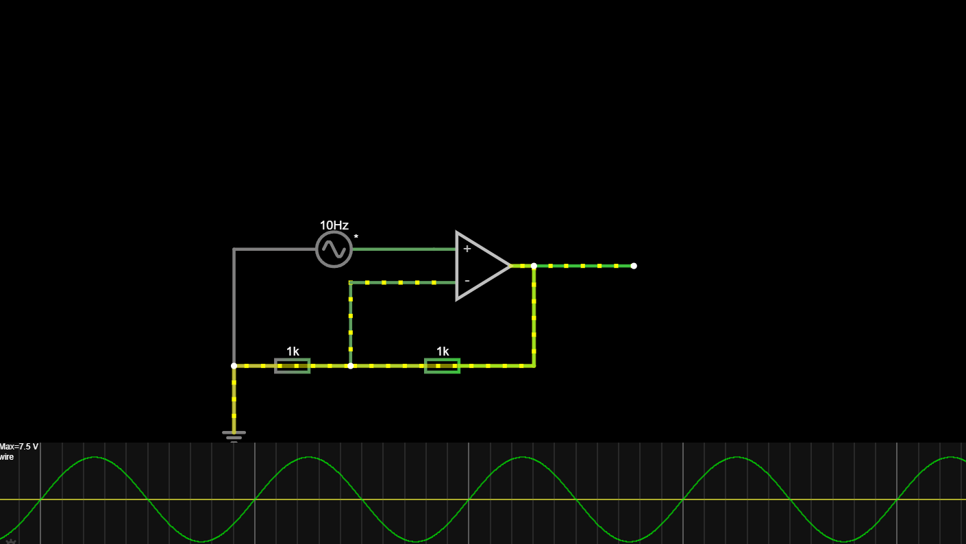
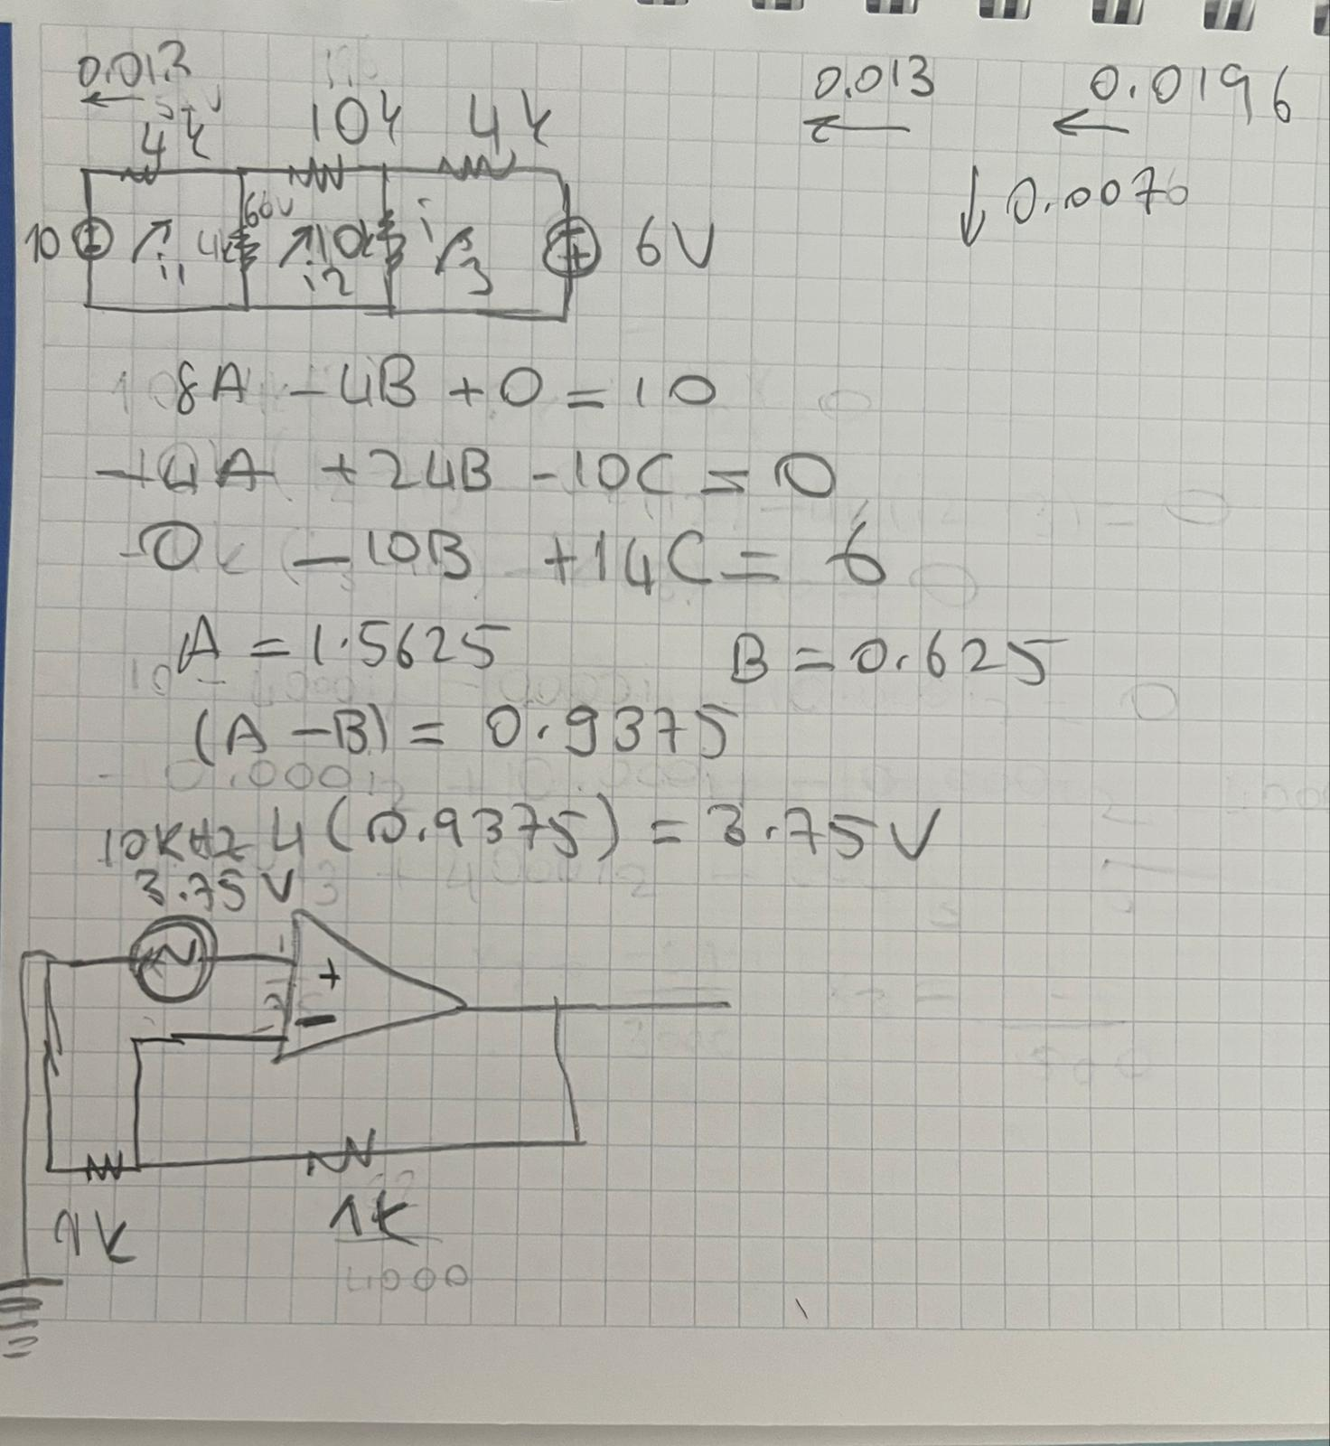

    - Group Member 1: FUAT AKGÜL , 150722050 , Writing Report, Solving the questions

    - Group Member 2: SERCAN GÖREN , 150722018 , Writing Report, Solving the questions

    - Group Member 3: FATİH CAN DEVECİ , 150722046 , Writing Report, Solving the questions

    - Group Member 4: MEHMET ALİ KAMALAK , 150720062 , Writing Report, Solving the questions

FUAT AKGÜL | SERCAN  GÖREN | FATİH CAN DEVECİ | MEHMET ALİ  KAMALAK
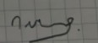 | 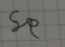 | 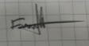 | 

