Aura Watches

*User Guide*

|  |  |  |
| --- | --- | --- |
| **Supervisor.** |  | |
| **Batch.** |  | |
| **Group.** | 1 | |
| **Serial No.** | **Enrollment Number** | **Student Name** |
| 1. |  |  |
| 2. |  |  |
| 3. |  |  |
|  |  |  |

***USER GUIDE***

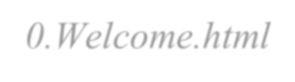

1. **E-project** (welcome to E-project.html)

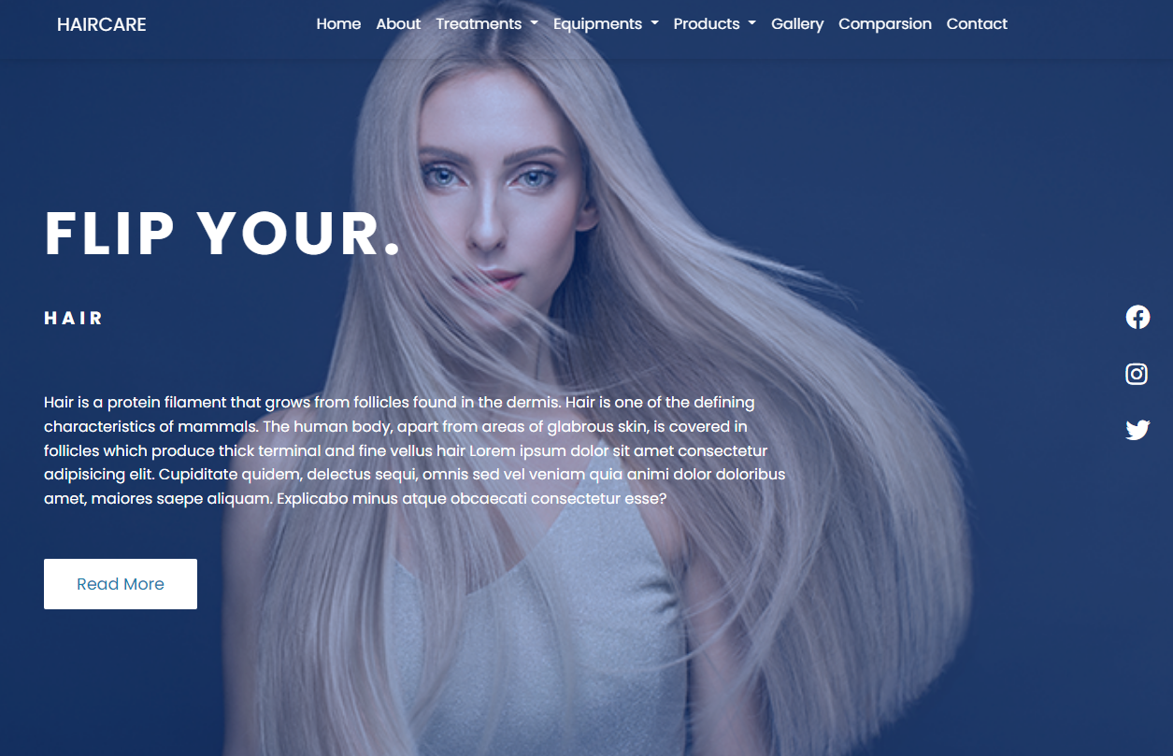



*Figure 1: Welcome Page To Aura Watches*

Used to select the language displayed on the website:

* When the user selects the American flag icon, the link to the Web page displays the English language.

* When the user selects the Vietnamese flag icon, the link to the Web page displays the Vietnamese language.



**2**





*Figure 2: Upper Frame Interface*



2.1.1 Language Section

When clicking the **Language** button, the system will lead to the page to select the language. (*0.Welcome.html*)



2.1.2 Login Section

When you click the **Sign In** button, the system will display the login window.

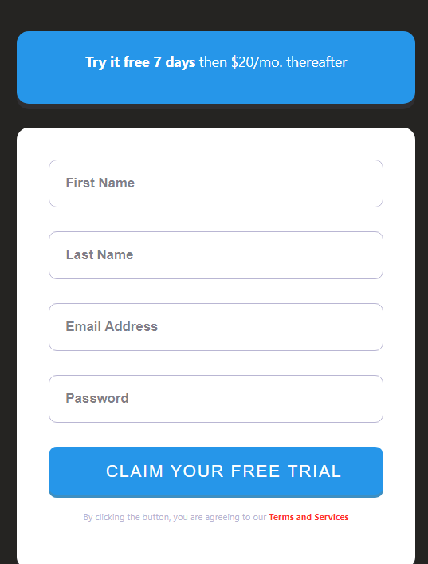



*Figure 3: Login Window*



Email:

* Start with a letter or number.
* End with a letter and number.
* Dots, hyphens, and underscores are allowed for email names but must comply with the following requirements:
  + Do not use in the start and end position.
  + Its previous and next position must be a alphanumeric character.
* The position immediately after the @ character can be a sequence of alphabetic characters or alphanumeric characters followed by one or more phrases that start with a dot and followed by a string of up to 4 letter characters.



Password:

* Start with a letter or number.
* End with a letter and number.
* Limited to 10 to 20 alphanumeric characters.

When clicking the **Login** button, the system will check the data in the fields in turn and the error message dialog box will appear if an error is detected.

* 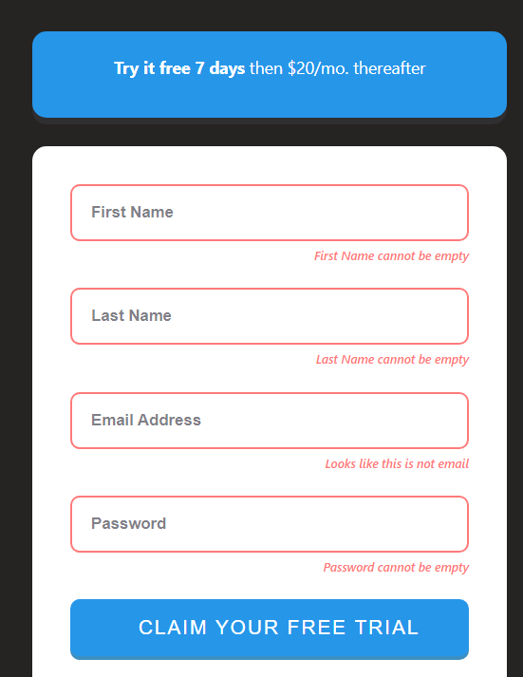You have entered the wrong email

*Figure 4:You Have Entered The Wrong Email*

* You have entered the wrong password

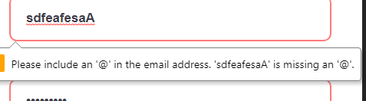

When the information in each case is valid, clicking the **Login** button will display a message confirming the information entered.

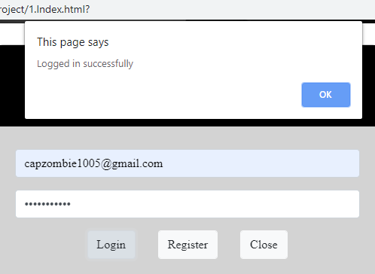



*Figure 6: Logged In Successfully*

When the **Register** button is clicked, the **Register** page interface is displayed (see description on the **Register** page).

When you click the **Close** button, the **Customer Login** window will close.



2.2 Menu Bar



*Figure 7: Menu Bar*

Used to load the remaining pages. The following is a list of those pages: * Home Page (1.Index.html)

* Products Page (2.Products.html)

* + Product Line-Up 1: Quazts Clock (2.Products.html)
    - Quazts Clock 1 (Product-Q-1.html)
    - Quazts Clock 2 (Product-Q-2.html)
    - Quazts Clock 3 (Product-Q-3.html)
    - Quazts Clock 4 (Product-Q-4.html)
  + Product Line-Up 2: Eco-Drive Clock (2.Products.html)
    - Eco-Drive Clock 1 (Product-W-1.html)
    - Eco-Drive Clock 2 (Product-W-2.html)
    - Eco-Drive Clock 3 (Product-W-3.html)
    - Eco-Drive Clock 4 (Product-W-4.html)
  + Product Line-Up 3: Automatic Clock (2.Products.html)
    - Automatic Clock 1 (Product-A-1.html)
    - Automatic Clock 2 (Product-A-2.html)
    - Automatic Clock 3 (Product-A-3.html)
    - Automatic Clock 4 (Product-A-4.html) * Technology Page (3.Technology.html)

* Store Locator Page (4.Support.html) * Register Page (5.Register.html)

Drop-down menu bar: The product tab of the **Menu** can be removed and contains submenus that lead to subpages. You can access these pages (main page or subpage) by clicking on its tab.





*Figure 8: Dropdown Menu Products*

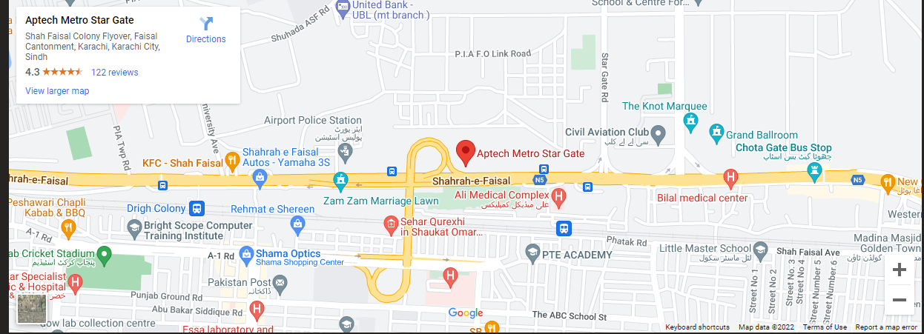

eProject: Aura Watches

Display information such as menu, operating time, store information, store location on Google Map, social networks, payment methods, support data input bar and send data button. The **Top** button is used to push to the top of the page when clicking.

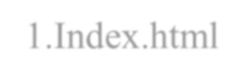

4. **Home Page** (1.Index.html)

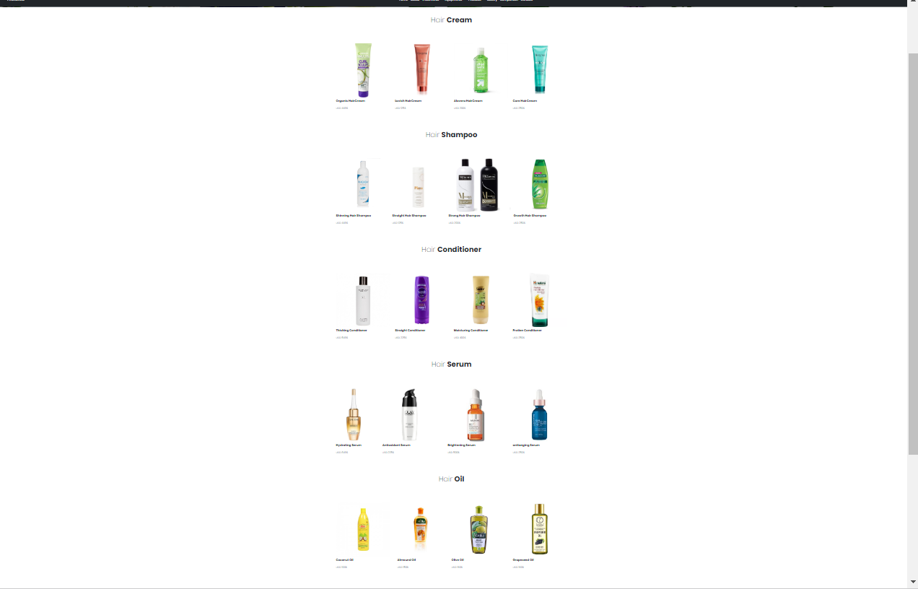

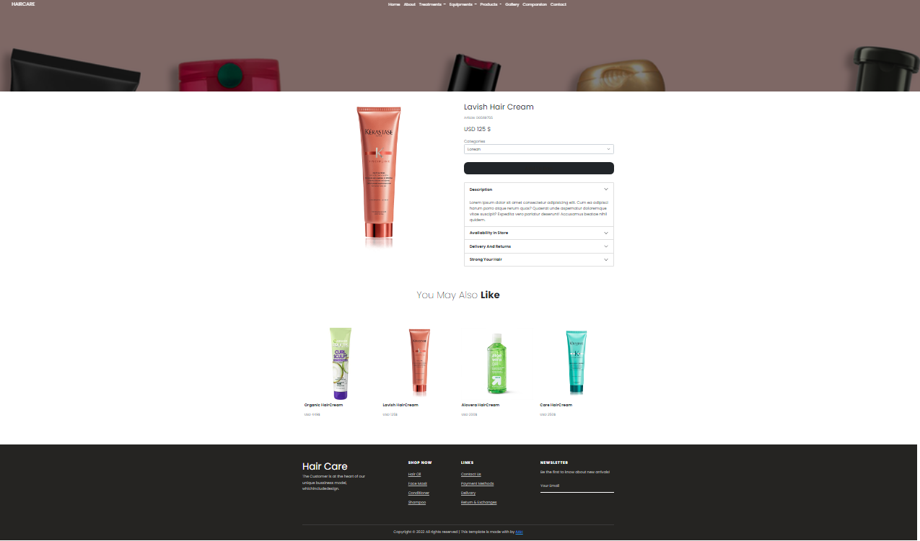



**Thank You For Reading The Documentation.**



**Please Follow The Instructions Above !!**