PARKING MANAGEMENT DATABASE SYSTEM

Project Documentation
Database: Oracle SQL
Project Type: Relational Database Management System

1. Project Overview
The Parking Management Database System is a relational database project designed to organize and manage information related to parking facilities.
The system manages important parking information such as parking areas, vehicles, parking slots, vehicle tracking records, and parking fees. The database uses separate related tables to organize the information and reduce unnecessary data duplication.
SQL queries are also used to retrieve information, perform calculations, filter records, and generate useful summaries from the database.

2. Project Objectives
The main objectives of the Parking Management Database System are:
- To store parking information in a structured relational database.
- To manage parking area information and capacity.
- To maintain vehicle records and vehicle types.
- To manage parking slot information and slot status.
- To track vehicle parking records and parking duration.
- To store and analyze parking fee information.
- To calculate total and average parking revenue and fees.
- To retrieve useful information using SQL queries.
- To demonstrate database normalization and relational database design.
- To reduce unnecessary duplication of data by separating information into appropriate tables.

3. Database Tables
The database consists of the following main tables:
Table | Purpose
AREA | Stores information about parking areas, including their capacity.
VEHICLE | Stores vehicle information, including vehicle ID and vehicle type.
SLOT | Stores parking slot information and its current status.
TRACKING | Stores vehicle parking/tracking records, including parking duration.
FEE | Stores parking fee information, including hourly rate and total fee.
PARKING_UNNORMALIZED | Contains the original unnormalized parking data used as the starting point for database organization.

4. Database Design and Relationships
The database is designed using separate tables for different categories of parking information.
The tables are connected through relevant identifiers and relationships. For example, vehicle information is maintained separately from tracking information, while parking fee information is stored in the FEE table.
This relational structure makes the database easier to manage, update, and query.

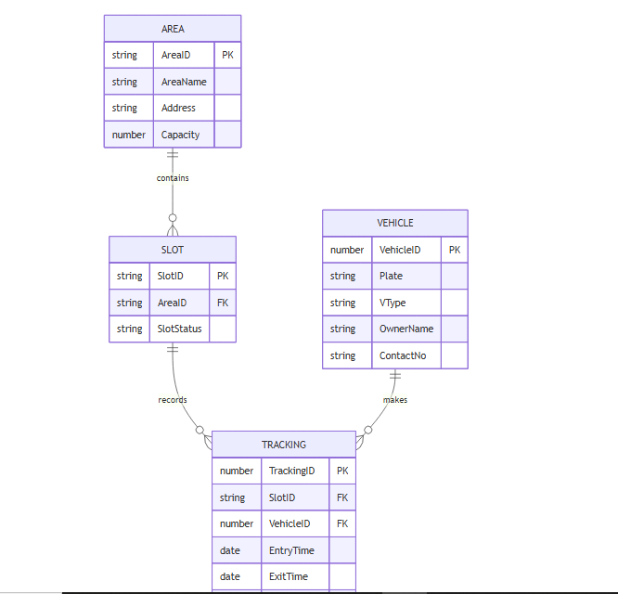
ER Diagram

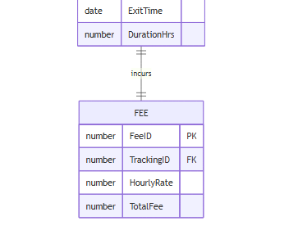

Figure 1: Entity Relationship Diagram of the Parking Management Database System

5. Database Normalization
The project begins with a table called PARKING_UNNORMALIZED, which represents the original combined parking information.
The information is then organized into separate tables such as AREA, VEHICLE, SLOT, TRACKING, and FEE.
Normalization helps organize the data, reduce unnecessary duplication, and make the database easier to maintain.

5.1 First Normal Form (1NF)
First Normal Form ensures that the data is organized into rows and columns and that each field contains a single value.
The data is structured so that individual records can be identified and accessed properly.

5.2 Second Normal Form (2NF)
Second Normal Form focuses on ensuring that attributes depend on the appropriate key.
The database separates different types of information into relevant tables so that unnecessary repetition is reduced.

5.3 Third Normal Form (3NF)
Third Normal Form further organizes the database by separating information that belongs to different entities.
The database design helps reduce redundant information and makes the data more consistent.

6. SQL Implementation
The SQL implementation of the project is divided into two main SQL files.

parking_management.sql
The parking_management.sql file contains the SQL required to set up the database and create/populate the project tables.

queries.sql
The queries.sql file contains SQL queries used to retrieve and analyze information from the database.
The queries include table checking, data retrieval, counting records, calculating parking revenue and fees, filtering records, grouping data, and sorting results.

7. SQL Queries and Analysis
The queries.sql file contains 22 SQL queries.
These queries demonstrate different SQL operations and provide useful information about the parking system.

Query 1 – Check Project Tables
Checks whether the main project tables exist in the database.

Query 2 – Display Parking Unnormalized Data
Displays all records from the PARKING_UNNORMALIZED table.

Query 3 – Display Area Data
Displays all records from the AREA table.

Query 4 – Display Vehicle Data
Displays all records from the VEHICLE table.

Query 5 – Display Slot Data
Displays all records from the SLOT table.

Query 6 – Display Tracking Data
Displays all records from the TRACKING table.

Query 7 – Display Fee Data
Displays all records from the FEE table.

Query 8 – Count Tracking Records for Each Vehicle
Counts the number of tracking records associated with each vehicle.

Query 9 – Count Total Vehicles
Calculates the total number of vehicles stored in the database.

Query 10 – Count Vehicles by Type
Groups vehicles according to their type and counts the number of vehicles in each category.

Query 11 – Count Slots by Status
Groups parking slots according to their status, such as available or occupied.

Query 12 – Calculate Total Parking Revenue
Calculates the total parking revenue using the TOTALFEE values.

Query 13 – Calculate Average Parking Fee
Calculates the average parking fee.

Query 14 – Find Highest Parking Fee
Identifies the highest parking fee recorded in the database.

Query 15 – Find Lowest Parking Fee
Identifies the lowest parking fee recorded in the database.

Query 16 – Show Parking Fees Above 100
Displays parking fee records where the total fee is greater than 100.

Query 17 – Show Vehicles of a Specific Type
Displays vehicles where the vehicle type is Car.

Query 18 – Show Available Parking Slots
Displays parking slots whose status is Available.

Query 19 – Show Occupied Parking Slots
Displays parking slots whose status is Occupied.

Query 20 – Show Tracking Records with Duration Greater Than 5 Hours
Displays tracking records where the parking duration is greater than 5 hours.

Query 21 – Show Areas with Capacity Greater Than 50
Displays parking areas with a capacity greater than 50.

Query 22 – Show Fees by Hourly Rate
Groups fee records according to hourly parking rate and counts the number of records for each rate.

8. Key SQL Operations Used
The project demonstrates several important SQL operations:
SQL Operation | Purpose
SELECT | Retrieves information from database tables.
WHERE | Filters records according to a specific condition.
GROUP BY | Groups records for summary analysis.
COUNT() | Counts the number of records.
SUM() | Calculates a total value such as total revenue.
AVG() | Calculates an average value.
MAX() | Finds the highest value.
MIN() | Finds the lowest value.
ORDER BY | Sorts query results.

9. Database Results and Screenshots
Screenshots of the database tables and SQL query results will be included in the screenshots folder of the GitHub repository.
The screenshots provide evidence that the database tables were created successfully and that the SQL queries were executed successfully.
The screenshots may include:
- Database tables
- Table records
- SQL query execution
- Query results
- Vehicle analysis
- Parking slot analysis
- Tracking analysis
- Parking fee calculations

10. Project File Structure
The GitHub repository is organized as follows:
Parking-Management-Database-System/
│
├── README.md
│
├── sql/
│ ├── parking_management.sql
│ └── queries.sql
│
├── documentation/
│ └── Parking_Management_Documentation.docx
│
└── screenshots/

File Descriptions
README.md
Provides a brief overview of the project and explains the repository contents.
parking_management.sql
Contains the SQL database setup and data required for the project.
queries.sql
Contains the 22 SQL queries used for retrieving and analyzing database information.
documentation/
Contains the detailed project documentation.
screenshots/
Contains screenshots showing database tables and query results.

11. Conclusion
The Parking Management Database System provides a structured and organized approach to managing parking-related information.
The database separates information into different related tables, including areas, vehicles, parking slots, tracking records, and fees. This improves data organization and helps reduce unnecessary duplication.
The SQL queries demonstrate how the database can be used to retrieve information, filter records, group data, calculate statistics, and analyze parking operations.
Overall, the project demonstrates the practical use of relational database concepts, normalization, Oracle SQL, and SQL-based data analysis in a Parking Management System.

