MyFitnessPlus V2
System Diagrams Document

Comprehensive Visual Documentation of System Architecture,
Database Design, Authentication, API Lifecycle, Components & Project Structure

Module: Software Engineering
Project: MyFitnessPlus V2 — Fitness Tracking Web Application
Technology: React 18 · Express 4.18 · MongoDB Atlas · Node.js
Document Type: Deliverable 6.6 — System Diagrams

Table of Contents
1. Introduction
2. Three-Tier System Architecture
3. Database Entity-Relationship Diagram
4. Authentication Flow
5. API Request / Response Lifecycle
6. React Component Hierarchy
7. Project Folder Structure
8. Technology Stack Summary
9. Diagram Cross-Reference Matrix

1. Introduction
This document provides a comprehensive visual overview of the MyFitnessPlus V2 fitness tracking web application. It contains six system diagrams that together cover every major aspect of the application: the overall three-tier architecture, the database design with all five MongoDB collections, the complete authentication flow (registration and login), the full API request/response lifecycle, the React component hierarchy with data flow patterns, and the complete project folder structure.
Each diagram is accompanied by a detailed written explanation, summary tables, and key observations that map directly to the actual codebase. No generic or theoretical content is included — every detail in this document is derived from the real source code of the MyFitnessPlus V2 project.

1.1 Document Scope
Diagram | What It Shows | Key Files Involved
System Architecture | Three-tier layout: Client, Server, Database | App.js, server.js, database.js
ER Diagram | All 5 MongoDB collections and relationships | User.js, Meal.js, Workout.js, Goal.js, WaterIntake.js
Authentication Flow | 10-step registration + 4-step login | auth.js (routes), auth.js (middleware), AuthContext.js
API Request Lifecycle | 13-step meal creation end-to-end | api.js, server.js, meals.js routes, Meal.js model
Component Hierarchy | React component tree + data flow | App.js, all pages, contexts, ProtectedRoute.js
Folder Structure | Complete client/ and server/ layout | All 25+ source files

2. Three-Tier System Architecture
The MyFitnessPlus V2 application follows a classic three-tier architecture pattern. The Presentation Tier is a React 18 single-page application running on port 3000, the Business Logic Tier is an Express 4.18 REST API server running on port 5000, and the Data Tier is a MongoDB Atlas cloud database (free M0 cluster). All communication between the client and server uses HTTP/JSON with JWT bearer tokens for authentication.
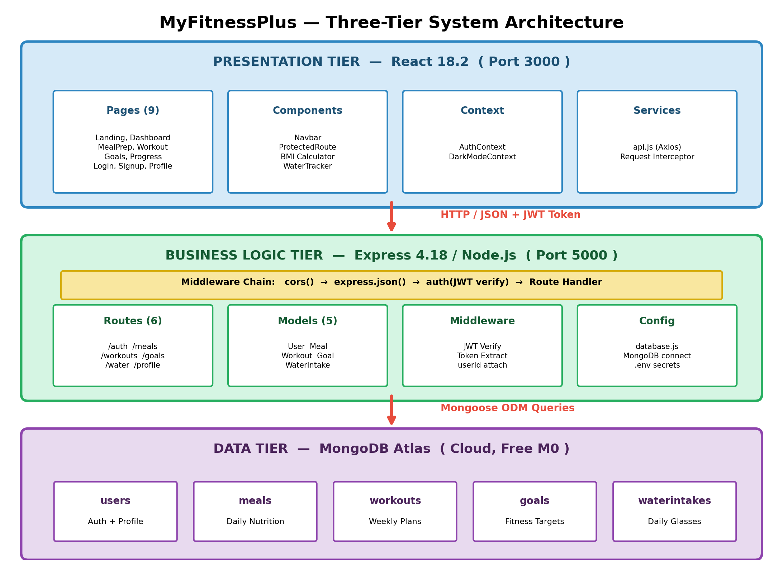
Figure: Architecture

2.1 Presentation Tier (React Frontend)
The frontend is built with React 18.2 using Create React App. It contains 9 page components, 3 shared components (Navbar, ProtectedRoute, BMI Calculator), 2 context providers (AuthContext, DarkModeContext), and a centralised API service layer (api.js). Client-side routing is handled by React Router v6 with three public routes (Landing, Login, Signup) and six protected routes that require authentication.
Sub-Module | Files | Responsibility
Pages (9) | Landing.js, Login.js, Signup.js, Dashboard.js, MealPrep.js, Workout.js, Goals.js, Progress.js, Profile.js | User-facing views with local state management
Components (3) | Navbar.js, ProtectedRoute.js, BMI Calculator | Shared UI elements used across pages
Context (2) | AuthContext.js, DarkModeContext.js | Global state: authentication + dark mode toggle
Services (1) | api.js | Axios instance with JWT interceptor + 6 API modules

2.2 Business Logic Tier (Express Backend)
The backend is an Express 4.18 server that exposes 27 RESTful API endpoints across 6 route modules. Every request passes through a middleware chain: cors() for cross-origin support, express.json() for body parsing, and the auth middleware for JWT verification on protected routes. The server uses Mongoose 7 as the ODM for MongoDB interaction.
Component | File | Purpose
Entry Point | server.js | Initialises Express, mounts middleware chain, connects routes, starts on port 5000
Database Config | config/database.js | mongoose.connect() using MONGODB_URI from .env
Auth Middleware | middleware/auth.js | Extracts JWT from Authorization header, verifies with jwt.verify(), attaches userId to req.user
Route Modules (6) | routes/*.js | auth (3), meals (5), workouts (6), goals (5), water (4), profile (4) endpoints
Data Models (5) | models/*.js | Mongoose schemas with validation, defaults, enums, and pre-save hooks

2.3 Data Tier (MongoDB Atlas)
The application uses MongoDB Atlas (cloud-hosted, free M0 tier) as its database. Data is stored in 5 collections: users, meals, workouts, goals, and waterintakes. All child collections (meals, workouts, goals, waterintakes) reference the users collection via a userId field, creating a star schema with users at the center. Connection is managed through Mongoose ODM with the connection string stored in a .env file (not committed to git for security).

2.4 Key Architecture Decisions
- Separate Ports (3000/5000): Client and server run independently, enabling independent development and deployment. CORS middleware bridges the cross-origin gap.
- JWT Stateless Authentication: No server-side sessions; the JWT token contains the userId claim and is verified on every request by the auth middleware.
- Centralised API Layer: All HTTP calls go through api.js, which auto-attaches the JWT token via an Axios request interceptor — no page needs to handle tokens directly.
- Context Providers: AuthContext and DarkModeContext wrap the entire app, making auth state and theme preference globally accessible via React hooks.
- Mongoose ODM: Schema-level validation (required fields, enums, min/max) provides a second layer of data integrity beyond the route handlers.

3. Database Entity-Relationship Diagram
The diagram below shows all five MongoDB collections and their relationships. The Users collection sits at the centre as the primary entity. Each child collection (Meals, Workouts, Goals, WaterIntakes) contains a userId field that references the parent User document, creating four one-to-many (1:N) relationships. There are no many-to-many relationships in the system.
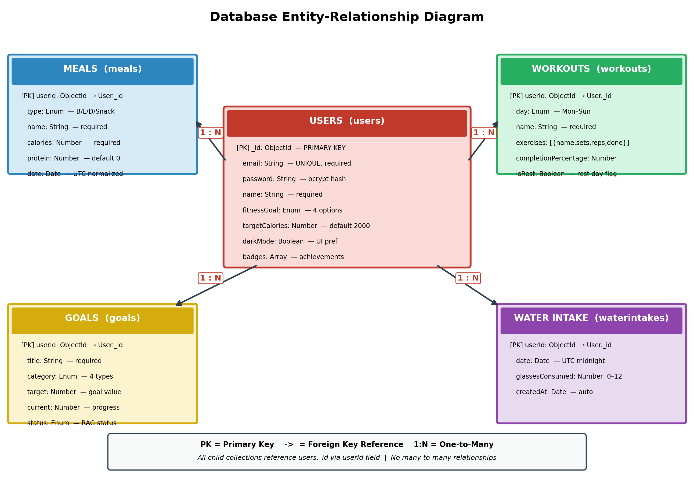
Figure: Database Er

3.1 Collection Details
Collection | Key Fields | Validation Rules | Purpose
users | _id, email, password, name, fitnessGoal, targetCalories, darkMode, badges | email: unique + required; password: min 6 chars; fitnessGoal: enum [lose_weight, build_muscle, stay_fit, improve_endurance] | Stores user credentials, profile preferences, and achievement badges
meals | userId, type, name, calories, protein, date | type: enum [Breakfast, Lunch, Dinner, Snack]; calories: required Number; date: normalised to UTC midnight | Tracks daily food intake with nutritional information per meal
workouts | userId, day, name, exercises, completionPercentage, isRest | day: enum [Monday-Sunday]; exercises: array of {name, sets, reps, done}; completionPercentage: calculated | Stores weekly workout plans with individual exercise tracking
goals | userId, title, category, target, current, status, deadline | category: enum [weight, exercise, nutrition, wellness]; status: enum [not_started, in_progress, completed] | Manages fitness goals with progress tracking and RAG status
waterintakes | userId, date, glassesConsumed, createdAt | glassesConsumed: Number 0-12; date: unique per user per day; createdAt: auto timestamp | Records daily water consumption in glasses (max 12)

3.2 Relationship Analysis
- User → Meals (1:N): One user can have many meals. Meals are queried by userId + date for daily nutrition views. Deleting a meal only removes that document.
- User → Workouts (1:N): One user has up to 7 workouts (one per day). Queried by userId + day. Each workout contains an embedded exercises array (denormalised design).
- User → Goals (1:N): One user can set multiple goals across 4 categories. Goals are independent; completing one does not affect others.
- User → WaterIntakes (1:N): One user has at most one water intake record per day (enforced by unique userId + date). Records are upserted — creating the first glass initialises the document.
- No Cascading Deletes: Deleting a user does NOT automatically remove child documents. This is by design — the app does not implement account deletion.

3.3 Schema Design Choices
The database uses a denormalised document model rather than a normalised relational approach. For example, the workouts collection embeds exercises as a sub-array instead of creating a separate exercises collection. This is the idiomatic MongoDB pattern — it reduces the number of queries needed and keeps related data together within a single document. The tradeoff is that individual exercises cannot be queried independently, but this is not required by any feature in the application.

4. Authentication Flow
Authentication in MyFitnessPlus V2 uses JSON Web Tokens (JWT). The diagram below shows the complete registration flow (10 steps from form submission to dashboard redirect) and the login flow (4 steps). Both flows result in a JWT token being stored in localStorage and used for all subsequent API requests.
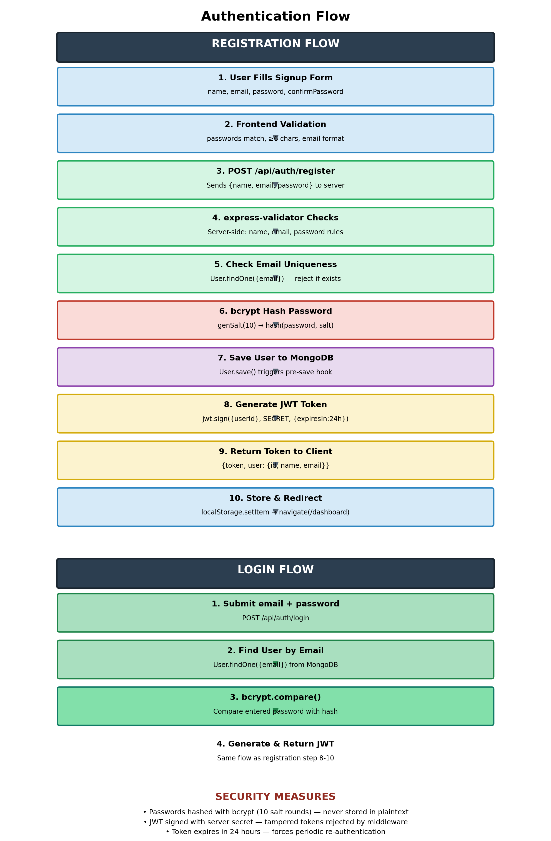
Figure: Auth Flow

4.1 Registration Flow — Step by Step
Step | Layer | Action | Code Location
1 | Client | User fills signup form with name, email, password, confirmPassword | Signup.js — form state
2 | Client | Frontend validates: passwords match, password >= 6 chars, all fields present | Signup.js — handleSubmit()
3 | Client → Server | POST /api/auth/register sends {name, email, password} via Axios | AuthContext.js — register()
4 | Server | express-validator checks: name not empty, valid email, password min 6 | routes/auth.js — validation array
5 | Server | User.findOne({email}) — if user exists, returns 400 "User already exists" | routes/auth.js — register handler
6 | Server | bcrypt.genSalt(10) then bcrypt.hash(password, salt) — hashes password | models/User.js — pre-save hook
7 | Server → DB | new User({name, email, password}).save() — persists to MongoDB | routes/auth.js — register handler
8 | Server | jwt.sign({userId: user._id}, JWT_SECRET, {expiresIn: "24h"}) — creates token | routes/auth.js — register handler
9 | Server → Client | Returns {token, user: {id, name, email}} with status 201 | routes/auth.js — response
10 | Client | Stores token in localStorage, sets user state, navigates to /dashboard | AuthContext.js — register()

4.2 Login Flow — Step by Step
Step | Layer | Action | Code Location
1 | Client → Server | POST /api/auth/login with {email, password} | AuthContext.js — login()
2 | Server → DB | User.findOne({email}) — retrieves user document from MongoDB | routes/auth.js — login handler
3 | Server | bcrypt.compare(password, user.password) — validates password against hash | routes/auth.js — login handler
4 | Server → Client | If valid: jwt.sign() → returns {token, user}. If invalid: 400 error | routes/auth.js — login handler

4.3 Token Lifecycle
Once the client receives a JWT token, it follows this lifecycle:
- Storage: Token is stored in localStorage under the key "token". This persists across page refreshes and browser restarts.
- Attachment: On every API call, the Axios request interceptor in api.js reads localStorage and adds the header: Authorization: Bearer <token>.
- Verification: The auth middleware on the server extracts the token from the Authorization header, calls jwt.verify(), and attaches {userId} to req.user.
- Expiry: Tokens expire after 24 hours (set during jwt.sign). Expired tokens cause a 401 response, which should trigger a logout on the client.
- Logout: AuthContext.logout() removes the token from localStorage and clears the user state, effectively de-authenticating the session.

4.4 Security Measures
Security Measure | Implementation | Why It Matters
Password Hashing | bcrypt with 10 salt rounds (User.js pre-save hook) | Passwords are never stored in plaintext; even if the database is compromised, passwords cannot be reversed
JWT Authentication | jsonwebtoken package, HS256 algorithm | Stateless auth — no server-side sessions; token integrity guaranteed by HMAC signature
Token Expiry | 24-hour expiration set in jwt.sign() | Limits the window of exposure if a token is stolen
Server-side Validation | express-validator on auth routes | Prevents malformed data from reaching the database even if frontend validation is bypassed
Environment Variables | JWT_SECRET and MONGODB_URI in .env (gitignored) | Secrets are not committed to version control

5. API Request / Response Lifecycle
This diagram traces a complete API request from the moment the user clicks a button to the moment the UI updates with new data. The example used is creating a new meal, which involves 13 distinct steps across the Client, Network, Server, and Database layers. This same pattern applies to all CRUD operations in the application — only the route and model change.
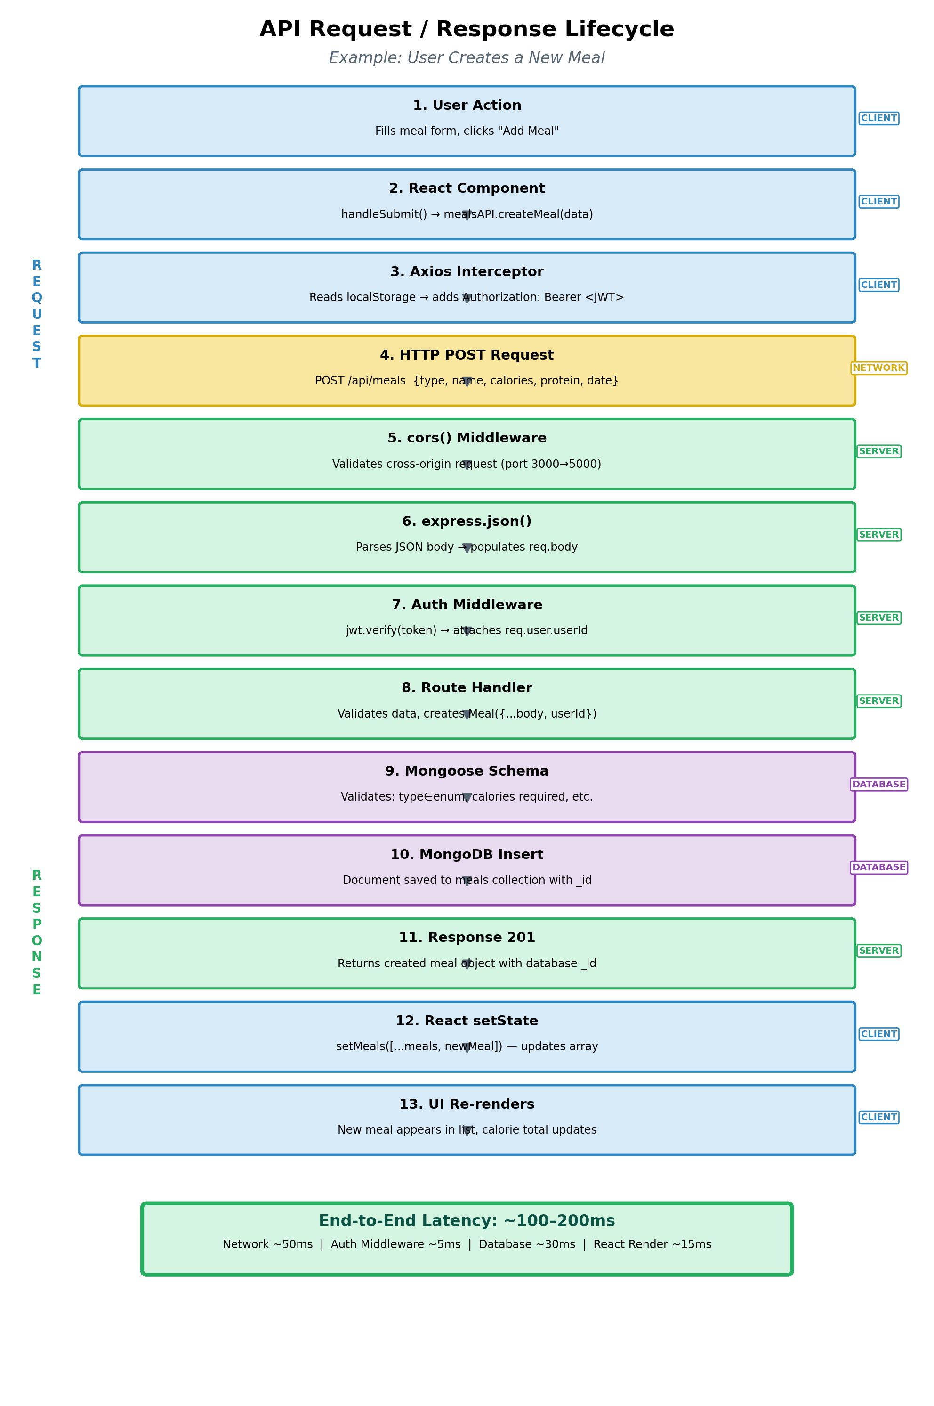
Figure: Api Flow

5.1 Request Phase (Steps 1–10)
Step | Layer | What Happens | Key Code
1. User Action | Client | User fills the meal form (type, name, calories, protein) and clicks "Add Meal" | MealPrep.js — form JSX
2. React Component | Client | handleSubmit() is called, which calls mealsAPI.createMeal(mealData) | MealPrep.js — handleSubmit()
3. Axios Interceptor | Client | The request interceptor reads the JWT from localStorage and adds Authorization: Bearer <token> header | api.js — interceptors.request.use()
4. HTTP Request | Network | POST /api/meals with JSON body: {type, name, calories, protein, date} | Axios sends HTTP request
5. CORS Middleware | Server | cors() validates the origin (port 3000) and allows the cross-origin request | server.js — app.use(cors())
6. Body Parser | Server | express.json() parses the raw JSON body into req.body object | server.js — app.use(express.json())
7. Auth Middleware | Server | jwt.verify(token, JWT_SECRET) decodes the token and attaches userId to req.user | middleware/auth.js
8. Route Handler | Server | Creates new Meal document with {...req.body, userId: req.user.userId} | routes/meals.js — POST /
9. Schema Validation | Database | Mongoose validates: type in enum, calories is Number, date is valid | models/Meal.js — schema
10. MongoDB Insert | Database | Document saved to meals collection with auto-generated _id | Mongoose .save() method

5.2 Response Phase (Steps 11–13)
Step | Layer | What Happens | Key Code
11. Response 201 | Server → Client | Express sends res.status(201).json(meal) with the complete meal object including _id | routes/meals.js
12. React setState | Client | setMeals([...meals, newMeal]) adds the new meal to the local state array | MealPrep.js — handleSubmit()
13. UI Re-renders | Client | React detects state change, re-renders the meal list, and updates the calorie total | MealPrep.js — JSX return

5.3 Error Handling Path
If any step fails, the error propagates back to the client:
- Validation Error (400): Missing required fields or invalid enum values. Returned by express-validator or Mongoose schema validation.
- Authentication Error (401): Missing, expired, or malformed JWT token. The auth middleware returns {msg: "No token, authorization denied"}.
- Server Error (500): Unexpected database connection issues or unhandled exceptions. Caught by try/catch blocks in route handlers.
- Client Error Handling: MealPrep.js catches errors in a try/catch around the API call and displays an alert() to the user.

5.4 All API Endpoints
The table below lists all 27 API endpoints in the application. Every endpoint except the first three (auth routes) requires a valid JWT token.
Route Module | Method | Endpoint | Auth Required | Purpose
Auth | POST | /api/auth/register | No | Create new user account
Auth | POST | /api/auth/login | No | Authenticate and get token
Auth | GET | /api/auth/user | Yes | Get current user profile
Meals | GET | /api/meals | Yes | Get all meals for user
Meals | GET | /api/meals?date=YYYY-MM-DD | Yes | Get meals filtered by date
Meals | POST | /api/meals | Yes | Create a new meal
Meals | PUT | /api/meals/:id | Yes | Update a meal
Meals | DELETE | /api/meals/:id | Yes | Delete a meal
Workouts | GET | /api/workouts | Yes | Get all workouts for user
Workouts | GET | /api/workouts/:day | Yes | Get workout for a specific day
Workouts | POST | /api/workouts | Yes | Create a new workout
Workouts | PUT | /api/workouts/:id | Yes | Update a workout
Workouts | PATCH | /api/workouts/:id/exercise/:idx | Yes | Toggle exercise done status
Workouts | DELETE | /api/workouts/:id | Yes | Delete a workout
Goals | GET | /api/goals | Yes | Get all goals for user
Goals | POST | /api/goals | Yes | Create a new goal
Goals | PUT | /api/goals/:id | Yes | Update a goal
Goals | PATCH | /api/goals/:id/progress | Yes | Update goal progress only
Goals | DELETE | /api/goals/:id | Yes | Delete a goal
Water | GET | /api/water?date=YYYY-MM-DD | Yes | Get water intake for a date
Water | POST | /api/water/add | Yes | Add one glass of water
Water | POST | /api/water/remove | Yes | Remove one glass of water
Water | PUT | /api/water/set | Yes | Set exact glass count
Profile | GET | /api/profile | Yes | Get user profile data
Profile | PUT | /api/profile | Yes | Update profile fields
Profile | PUT | /api/profile/darkmode | Yes | Toggle dark mode
Profile | PUT | /api/profile/badges | Yes | Update achievement badges

6. React Component Hierarchy
The component hierarchy diagram shows how React components are organised in the application. App.js sits at the root and wraps everything in AuthProvider and DarkModeProvider context providers. React Router v6 then distributes traffic to 9 page components — 3 public and 6 protected (guarded by ProtectedRoute).
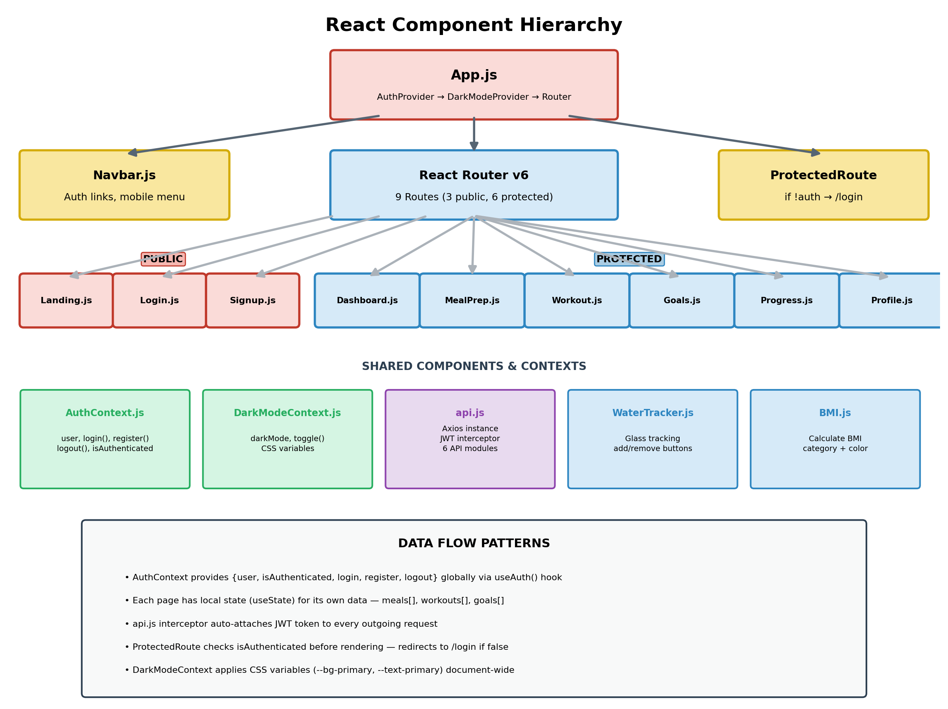
Figure: Component Tree

6.1 Component Breakdown
Component | Type | State Management | Key Features
App.js | Root | Wraps children in AuthProvider + DarkModeProvider | Defines all 9 routes, applies global layout
Navbar.js | Shared | Reads auth state via useAuth() | Shows different links for logged-in vs guest users, hamburger menu for mobile
ProtectedRoute.js | Guard | Reads isAuthenticated from AuthContext | Redirects to /login if user is not authenticated
Landing.js | Public Page | No state | Hero section, feature cards, call-to-action buttons
Login.js | Public Page | useState for email, password, error | Calls AuthContext.login() on submit
Signup.js | Public Page | useState for name, email, password, confirmPassword | Validates passwords match, calls AuthContext.register()
Dashboard.js | Protected Page | useState for meals, workouts, goals, water, loading | Aggregates data from all 4 API modules, shows daily summary cards
MealPrep.js | Protected Page | useState for meals, form fields, selectedDate | Full CRUD for meals, filter by date, calorie counting
Workout.js | Protected Page | useState for workouts, selectedDay, form fields | Weekly planner, exercise toggle, completion percentage
Goals.js | Protected Page | useState for goals, form fields, editingGoal | Goal CRUD with 4 categories, progress tracking
Progress.js | Protected Page | useState for goals | Reads goals and displays RAG traffic-light status indicators
Profile.js | Protected Page | useState for profile, editing flags | Edit name, targetCalories, fitnessGoal, toggle dark mode

6.2 Data Flow Patterns
- Global State via Context: AuthContext provides {user, isAuthenticated, login, register, logout} to every component via the useAuth() custom hook. DarkModeContext provides {darkMode, toggleDarkMode}.
- Local State per Page: Each page uses useState() for its own data (e.g., MealPrep.js has meals[], formData, selectedDate). This keeps each page self-contained.
- API Calls in useEffect: Protected pages fetch data in a useEffect(() => { fetchData() }, []) on mount. The API response populates the local state.
- Optimistic UI Updates: After a successful POST/PUT/DELETE, the local state is updated immediately without refetching from the server (e.g., setMeals([...meals, newMeal])).
- Token Auto-Injection: The api.js Axios interceptor reads the JWT from localStorage before every request, so no page component needs to handle authentication headers.

7. Project Folder Structure
The project is organised into two top-level directories: client/ (React frontend) and server/ (Express backend). This separation makes the codebase modular — the client and server have independent package.json files and can be developed, tested, and deployed independently.
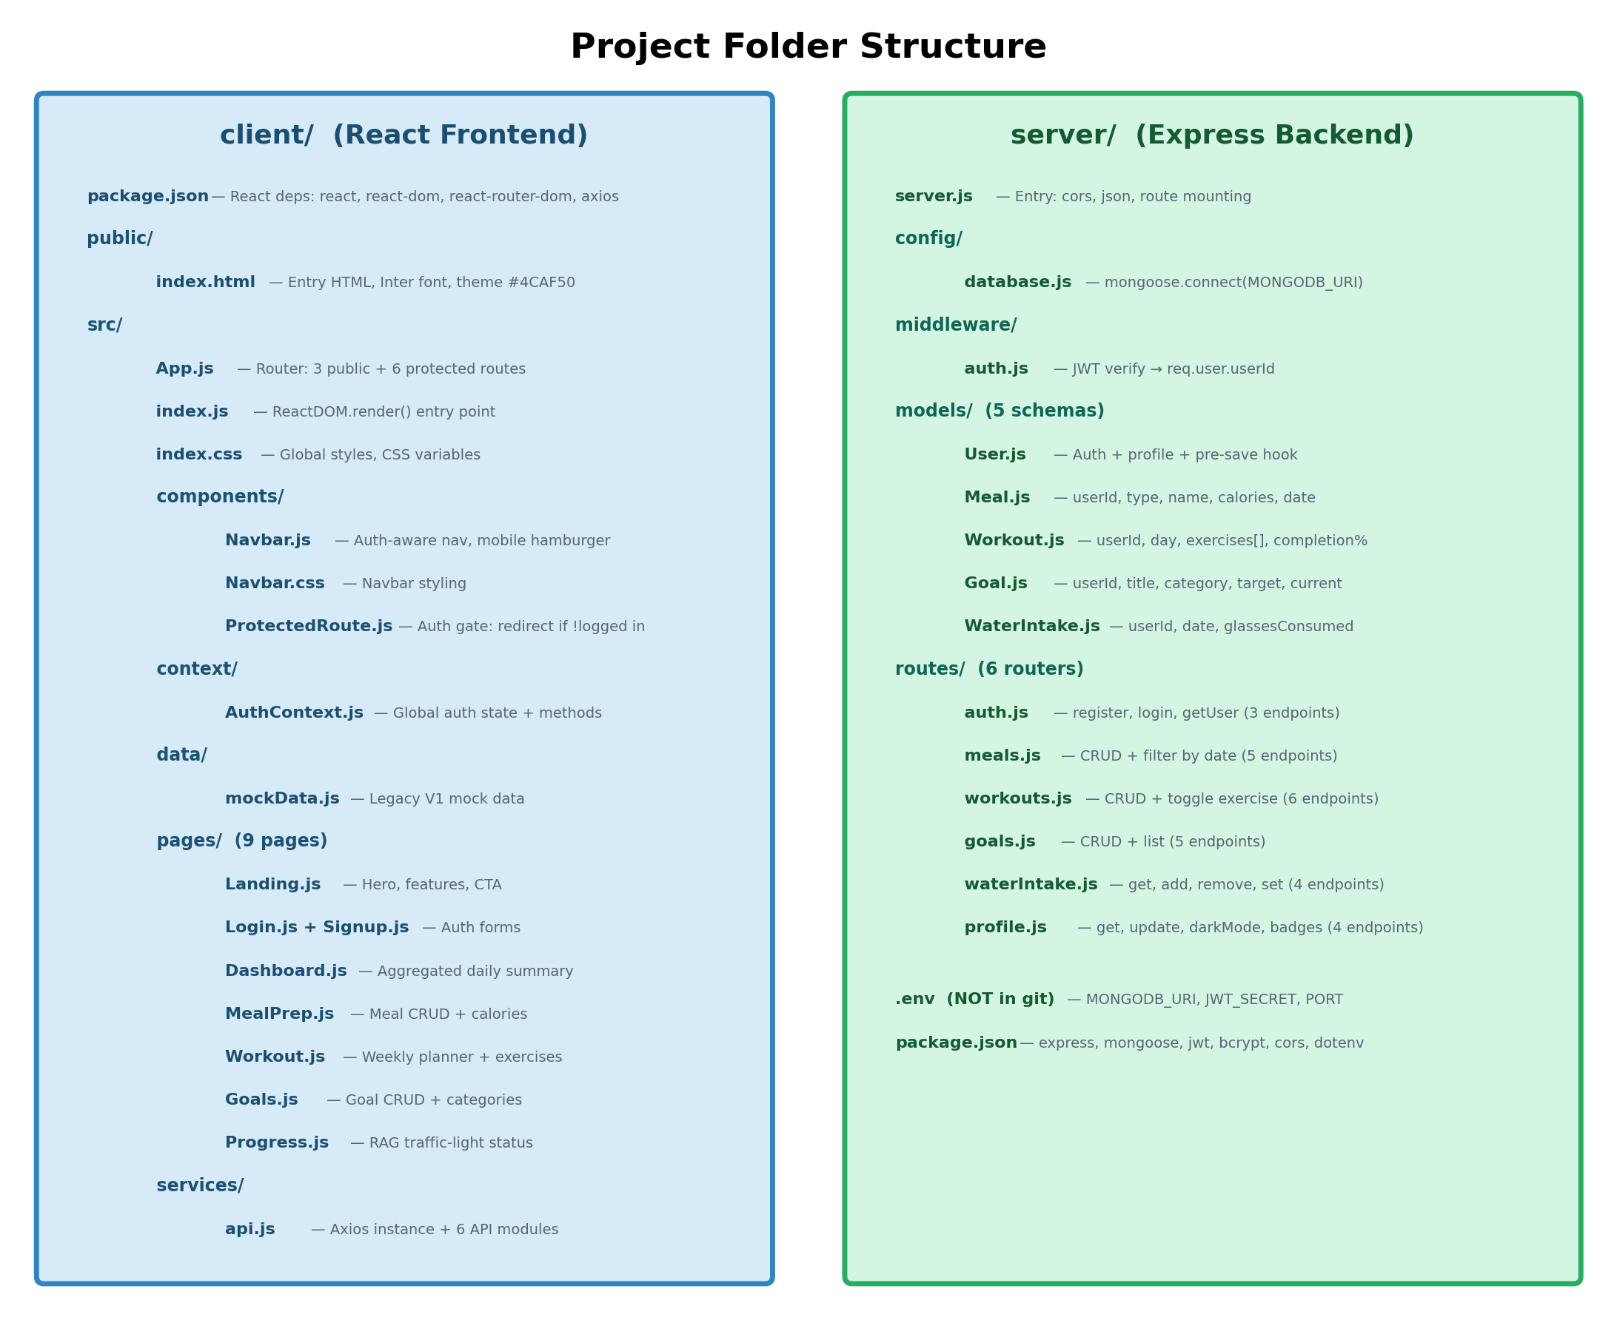
Figure: Folder Structure

7.1 Client Directory — File Inventory
Path | File Count | Purpose
client/public/ | 1 file | index.html with Inter font and green theme colour
client/src/components/ | 3 files | Navbar.js, Navbar.css, ProtectedRoute.js
client/src/context/ | 1 file | AuthContext.js — global auth state
client/src/data/ | 1 file | mockData.js — legacy V1 test data
client/src/pages/ | 14 files | 9 JS pages + 5 CSS files (Landing, Dashboard, MealPrep, Workout, Goals, Progress, Auth)
client/src/services/ | 1 file | api.js — Axios instance + 6 API modules
client/src/ | 3 files | App.js, index.js, index.css

7.2 Server Directory — File Inventory
Path | File Count | Purpose
server/ | 1 file | server.js — entry point, middleware chain, route mounting
server/config/ | 1 file | database.js — MongoDB Atlas connection via Mongoose
server/middleware/ | 1 file | auth.js — JWT verification middleware
server/models/ | 5 files | User.js, Meal.js, Workout.js, Goal.js, WaterIntake.js
server/routes/ | 6 files | auth.js, meals.js, workouts.js, goals.js, waterIntake.js, profile.js

7.3 Root-Level Configuration Files
File | Purpose
package.json (root) | Workspace-level scripts: concurrently runs client + server
client/package.json | React 18 dependencies: react, react-dom, react-router-dom, axios, react-icons
server/package.json | Backend dependencies: express, mongoose, jsonwebtoken, bcryptjs, cors, dotenv
.env (server, gitignored) | MONGODB_URI, JWT_SECRET, PORT=5000
.gitignore | Excludes node_modules/, .env, build outputs

8. Technology Stack Summary
The following table provides a complete inventory of every technology, library, and tool used in the MyFitnessPlus V2 application, grouped by layer.
Layer | Technology | Version | Role in Project
Frontend | React | 18.2 | Component-based UI library for building interactive pages
Frontend | React Router | v6 | Client-side routing: public routes + protected routes
Frontend | Axios | 1.6+ | HTTP client with request/response interceptors for JWT
Frontend | React Icons | 4.x | Icon components (FontAwesome, Material) used in Navbar
Frontend | CSS (custom) | — | Hand-written CSS with CSS variables for dark mode
Backend | Node.js | 18+ | JavaScript runtime for the server
Backend | Express | 4.18 | Web framework for REST API routing and middleware
Backend | Mongoose | 7.x | ODM for MongoDB — schemas, validation, queries
Backend | jsonwebtoken | 9.x | JWT creation (sign) and verification (verify)
Backend | bcryptjs | 2.x | Password hashing with salt (10 rounds)
Backend | cors | 2.x | Cross-origin resource sharing middleware
Backend | dotenv | 16.x | Loads .env variables into process.env
Backend | express-validator | 7.x | Request body validation on auth routes
Database | MongoDB Atlas | M0 Free | Cloud-hosted NoSQL document database
Dev Tools | concurrently | 8.x | Runs client + server simultaneously with one command
Dev Tools | nodemon | 3.x | Auto-restarts server on file changes during development

9. Diagram Cross-Reference Matrix
The matrix below maps each diagram to the source code files that it documents. This helps readers navigate from a visual diagram to the corresponding code.
Source File | Architecture | ER Diagram | Auth Flow | API Lifecycle | Components | Folder
App.js | Yes | — | — | — | Yes | Yes
server.js | Yes | — | — | Yes | — | Yes
database.js | Yes | — | — | — | — | Yes
auth.js (middleware) | Yes | — | Yes | Yes | — | Yes
auth.js (routes) | — | — | Yes | — | — | Yes
User.js | — | Yes | Yes | — | — | Yes
Meal.js | — | Yes | — | Yes | — | Yes
Workout.js (model) | — | Yes | — | — | — | Yes
Goal.js | — | Yes | — | — | — | Yes
WaterIntake.js | — | Yes | — | — | — | Yes
meals.js (routes) | — | — | — | Yes | — | Yes
api.js | Yes | — | — | Yes | Yes | Yes
AuthContext.js | — | — | Yes | — | Yes | Yes
ProtectedRoute.js | — | — | — | — | Yes | Yes
Navbar.js | — | — | — | — | Yes | Yes
MealPrep.js | — | — | — | Yes | Yes | Yes
Dashboard.js | — | — | — | — | Yes | Yes

This cross-reference confirms that every source file in the project is represented in at least one diagram, and that the six diagrams together provide complete coverage of the system from architecture down to individual file level.

