University Of Michigan
Digital Voice Transmission System Using BPSK
ECE550 - Project 2 Report – Winter 2026

Student Name: Hamza AL-Zakarneh
Date: 04/27/2026

Objective
This project presents the design and simulation of a digital communication system for transmitting a voice signal using Binary Phase Shift Keying (BPSK). The system converts an analog audio signal into digital form through sampling and quantization, then encodes and modulates it for transmission over a noisy channel that includes both additive noise and intersymbol interference (ISI).
At the receiver, the signal is demodulated and processed using a Zero-Forcing Equalizer to mitigate channel distortion and recover the original information. The system performance is evaluated using Bit Error Rate (BER) analysis, including comparison with theoretical BPSK performance. Additionally, the effects of ideal and non-ideal sampling are examined.

Introduction

Digital communication systems form the backbone of modern wireless technologies, enabling reliable transmission of information over noisy and imperfect channels. Among the various digital modulation techniques, Binary Phase Shift Keying (BPSK) is widely used due to its simplicity, robustness, and strong performance in the presence of noise. It serves as a fundamental scheme for understanding more advanced modulation and detection methods in practical communication systems.
In real-world scenarios, transmitted signals are affected by multiple impairments, including additive noise and channel-induced distortion such as intersymbol interference (ISI). Additive White Gaussian Noise (AWGN) spreads across the entire frequency spectrum and degrades signal quality, while ISI arises from multipath propagation or channel memory, causing overlap between consecutive symbols. These effects make accurate signal recovery a challenging task and necessitate the use of appropriate receiver design and equalization techniques.
The transmission process begins with converting an analog voice signal into digital form through sampling and quantization. The resulting bitstream is then encoded and mapped into BPSK symbols, which are modulated onto a carrier signal for transmission. At the receiver, coherent demodulation is used to recover the transmitted symbols, followed by a Zero-Forcing Equalizer to mitigate ISI and improve detection accuracy.
System performance is evaluated using Bit Error Rate (BER), which measures the reliability of the communication link. The measured BER is compared with theoretical BPSK performance to assess the impact of channel impairments and equalization. Additionally, the effects of ideal and non-ideal sampling are analyzed to understand how practical limitations influence signal quality.
This project demonstrates the complete design and analysis of a digital communication system, highlighting the impact of noise and ISI, and emphasizing the importance of equalization techniques in improving signal recovery and overall system performance.

System block diagram

Analog Voice Input
Analog-to-Digital Conversion (Sampling + Quantization)
Line Coding (Polar NRZ)
Channel (Noise + ISI + Multipath Effects)
BPSK Modulation
Pulse Shaping
Receiver & Demodulation
Zero-Forcing Equalizer
Signal Recovery (Digital → Analog)
The system consists of a transmitter, channel, and receiver. The transmitter includes ADC, line coding, pulse shaping, and BPSK modulation. The signal then passes through a noisy channel with ISI. At the receiver, demodulation and Zero-Forcing Equalization are applied, followed by signal recovery.

Description and Analysis

Analog Voice Input
The system begins with an analog voice signal, which represents a continuous-time waveform containing speech information. In this project, the signal is recorded and loaded into MATLAB as a discrete representation of the analog waveform. The signal is converted to a single channel (mono) and normalized to ensure its amplitude lies within a suitable range for further processing. This step prevents clipping and ensures consistent scaling across all stages.

Analog-to-Digital Conversion (ADC)
- Sampling
The continuous-time signal is first converted into a discrete-time signal through sampling. The sampling process captures the signal amplitude at uniform time intervals. The sampling frequency is selected based on the Nyquist criterion:

where is the bandwidth of the signal. For speech signals, , therefore:

This ensures that the signal can be reconstructed without aliasing.

- Quantization
After sampling, the signal amplitude is discretized into a finite number of levels. In this project, uniform quantization with 8 bits is used:

The quantization step size is given by:

Since the signal is normalized between -1 and 1:

Quantization introduces an error known as quantization noise, defined as:

This error is unavoidable in digital systems and affects signal quality.

Line Coding (Polar NRZ)
The quantized samples are converted into binary data and then mapped into a polar Non-Return-to-Zero (NRZ) format. In this representation:

This mapping produces a signal suitable for phase modulation. Polar signaling is preferred over unipolar signaling because it has zero DC components and better noise immunity.

Pulse Shaping
Pulse shaping is applied to control the time-domain structure and frequency content of the transmitted signal. In this project, a rectangular pulse is used by repeating each symbol over a fixed number of samples (samples per symbol, SPS).
If represents the symbol sequence, the shaped signal is:

where:
- is the pulse shape (rectangular in this case)
- is the symbol duration
Pulse shaping reduces abrupt transitions and defines the bandwidth of the signal. Improper pulse shaping can lead to increased spectral spreading and ISI.

BPSK Modulation
The baseband signal is modulated using Binary Phase Shift Keying (BPSK). Each symbol is transmitted by shifting the phase of a carrier signal.
The carrier is defined as:

The modulated signal is:

where:

A symbol of +1 corresponds to a 0° phase, while -1 corresponds to a 180° phase shift.

Channel Model
The transmitted signal passes through a channel that introduces both noise and intersymbol interference (ISI).
The channel is modeled as:

where:
- is the ISI coefficient (echo strength)
- represents delayed interference from previous symbols
- is additive white Gaussian noise (AWGN)
AWGN is modeled as:

The noise power is related to the signal-to-noise ratio (SNR):

The presence of ISI makes symbol detection more difficult because symbols overlap in time.

Receiver and Demodulation
At the receiver, coherent demodulation is performed. The received signal is multiplied by the same carrier used in transmission:

This shifts the signal back to baseband. After low-pass filtering, the baseband signal is recovered. The resulting signal is then sampled at symbol intervals to estimate the transmitted symbols.

Zero-Forcing Equalizer
To mitigate ISI, a Zero-Forcing Equalizer is applied. The goal is to remove the effect of the channel by canceling the delayed component.
The equalized signal is:

This method subtracts the estimated interference caused by the previous symbol.
While effective in removing ISI, Zero-Forcing can amplify noise, especially when the channel response is weak.

Signal Recovery
After equalization, the symbols are detected using a decision rule:

The recovered bitstream is then converted back into quantized samples and reconstructed into an audio waveform.
Equations Used

- Nyquist Sampling:

- Quantization:

- Pulse Shaping:

- BPSK Modulation:

- Channel Model:

- Noise Model:

- Zero-Forcing Equalizer:

- Bit Detection:

- BER:

- Theoretical BPSK BER:

Plots and Figures

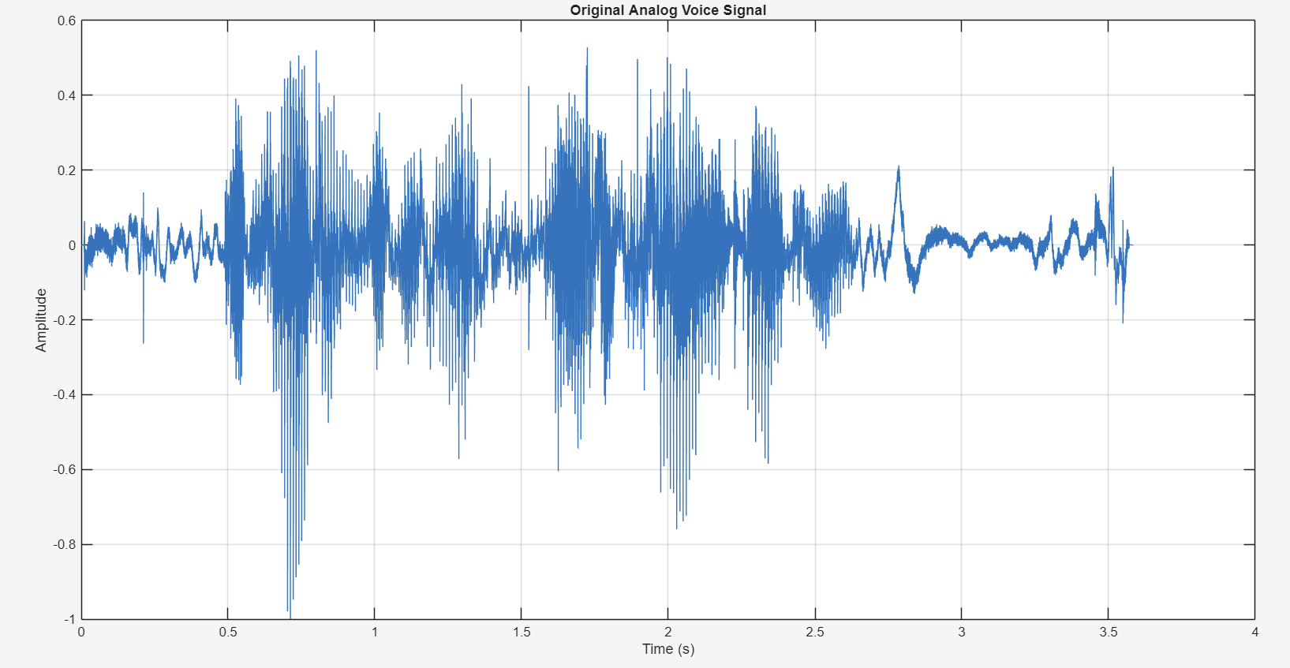
Figure1: Audio Signal vs Time
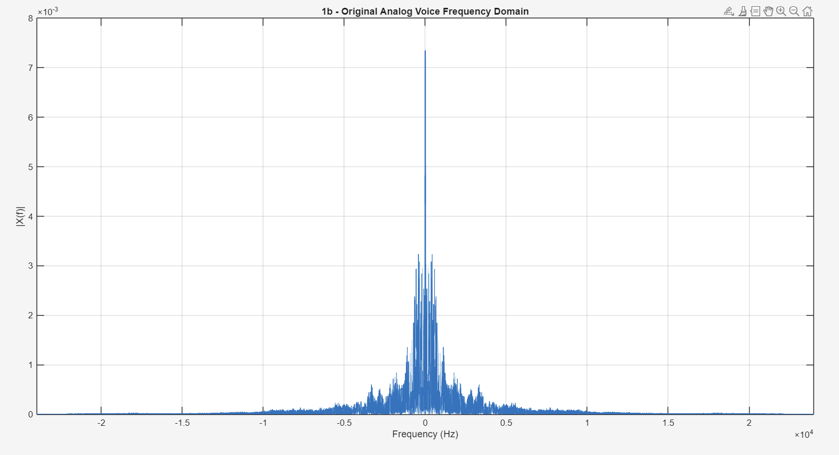
Figure2: Audio Signal vs Frequency
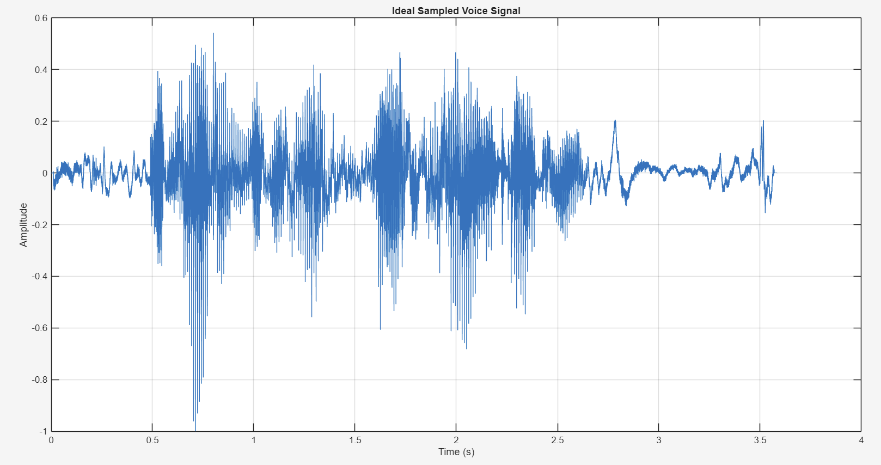
Figure3: Ideal Sampled Signal

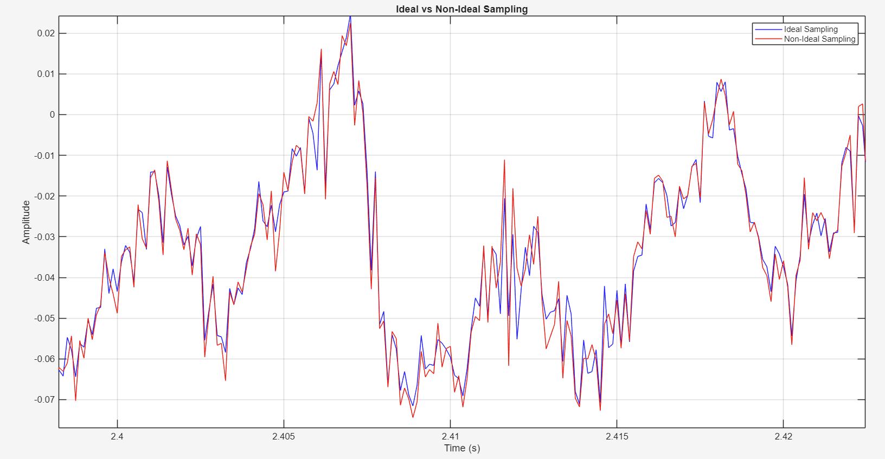
Figure4: Ideal vs Non-Ideal Sampled Signal

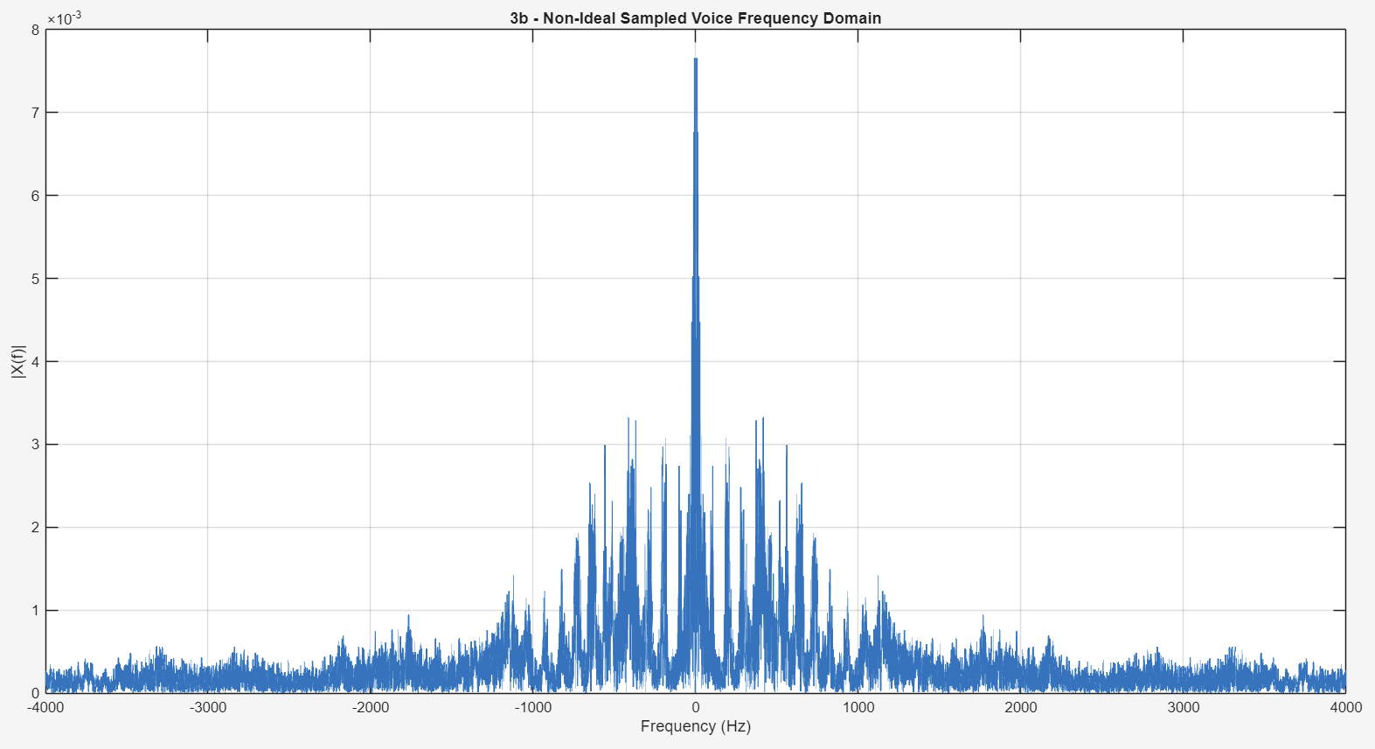
Figure5: Non-Ideal Sampled Signal vs Frequency

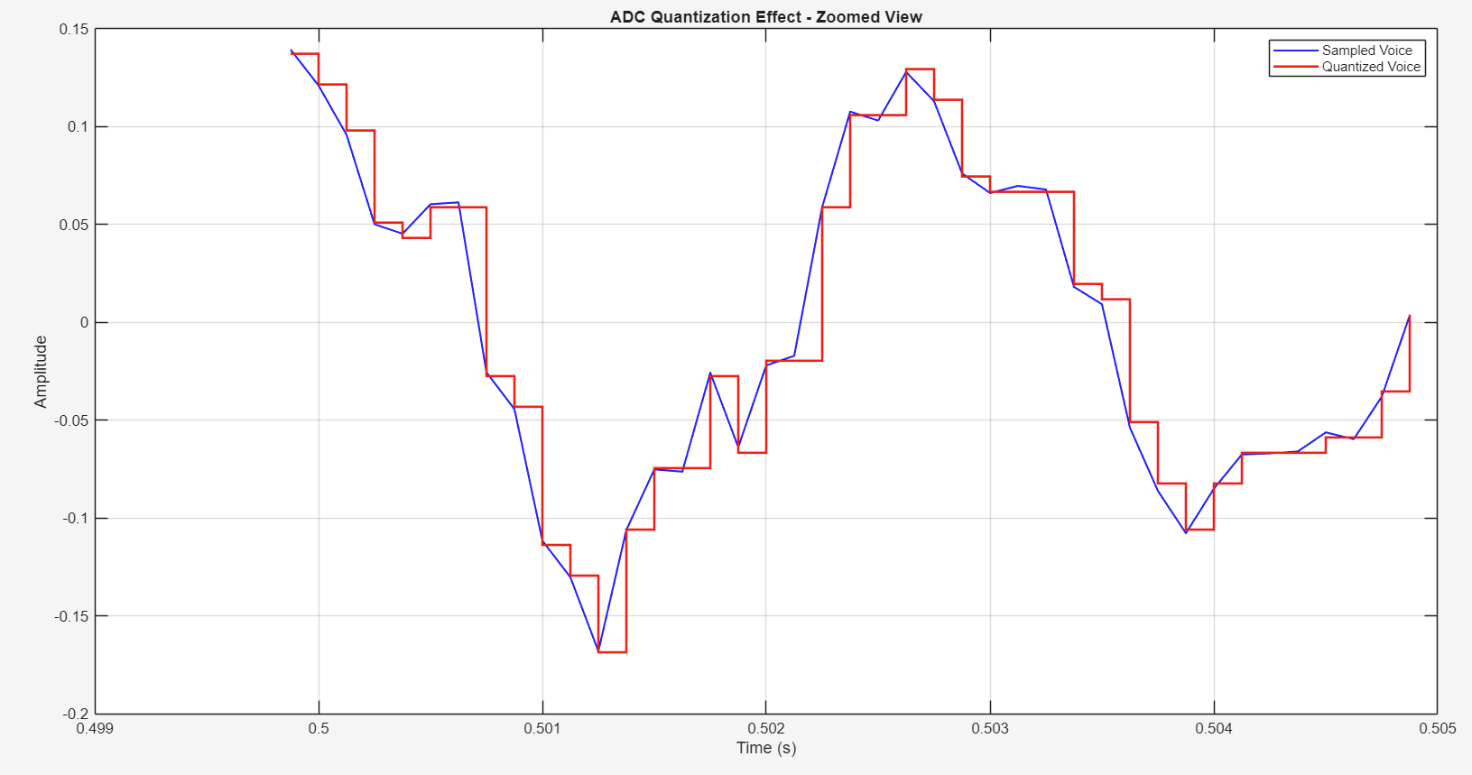
Figure6: Quantized Signal

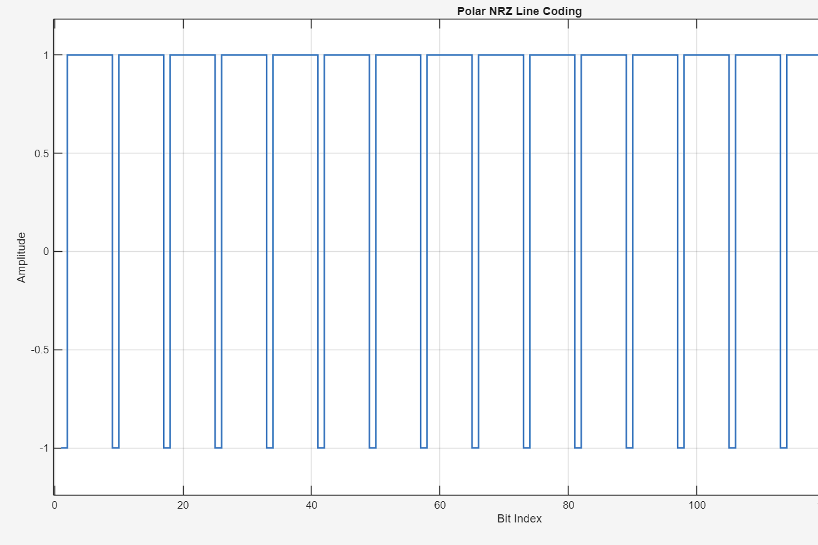
Figure7: Polar NRZ Line Coding
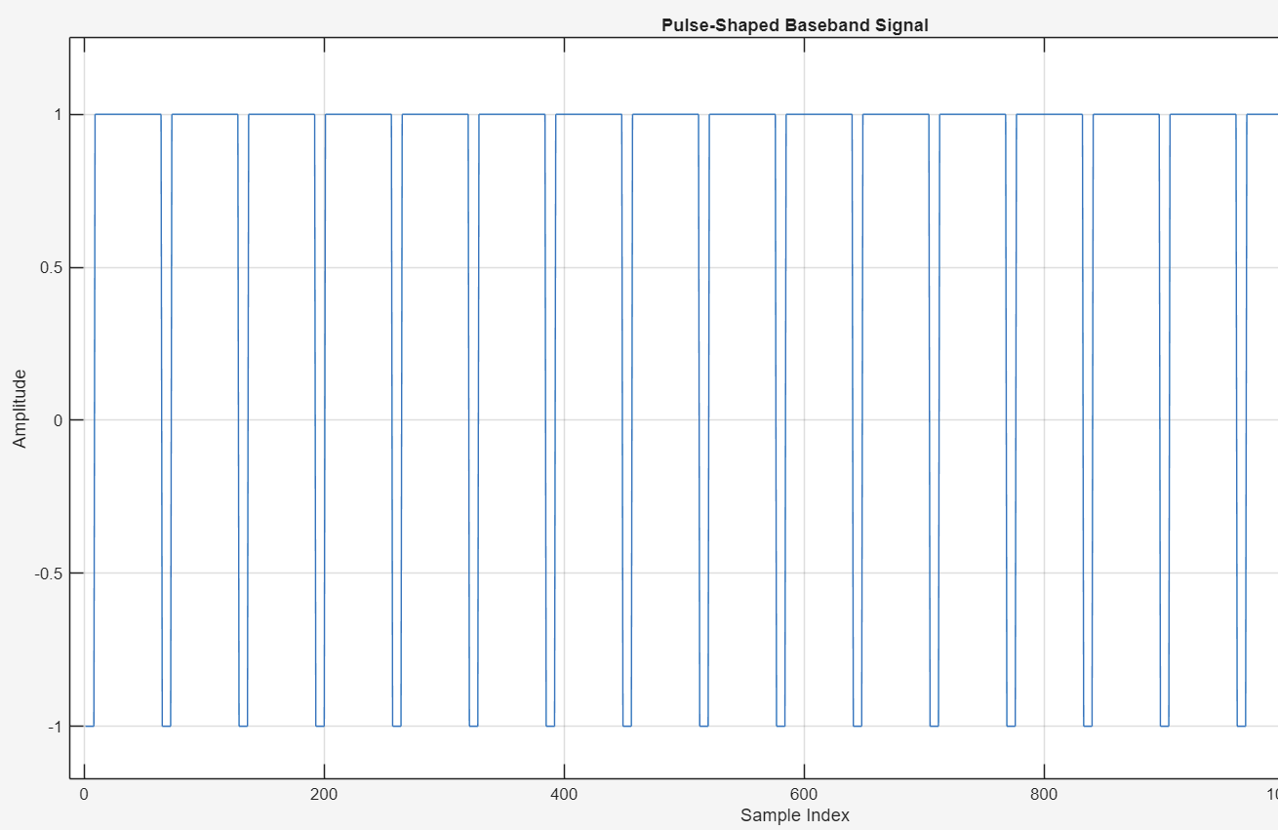
Figure8: Pulse-Shaped Baseband Signal
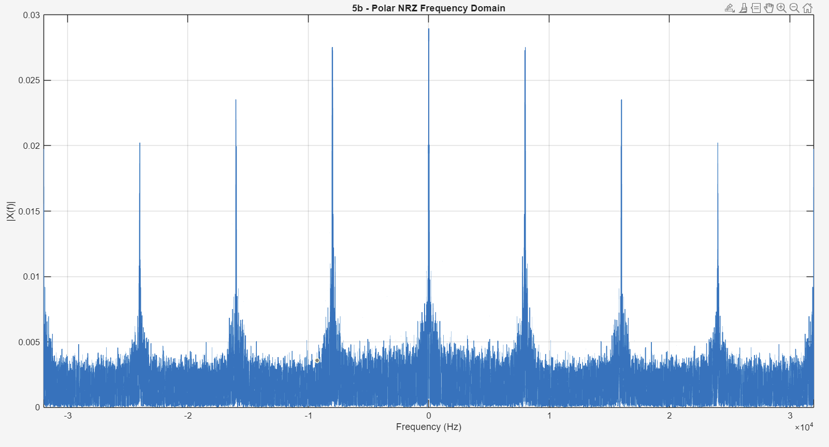
Figure9: Polar NRZ Line Coding vs Frequency

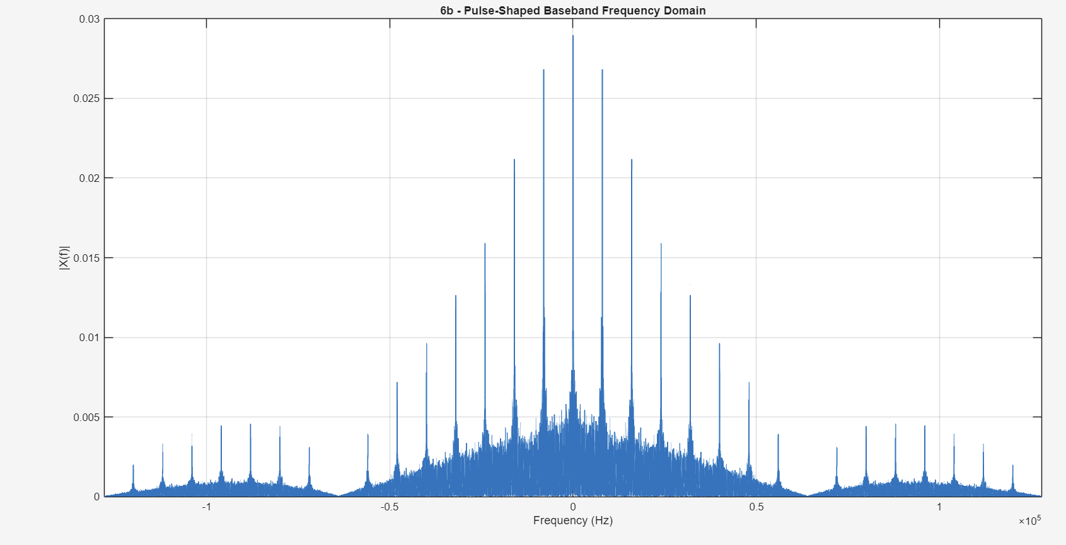
Figure10: Pulse-Shaped Baseband Signal vs Frequency

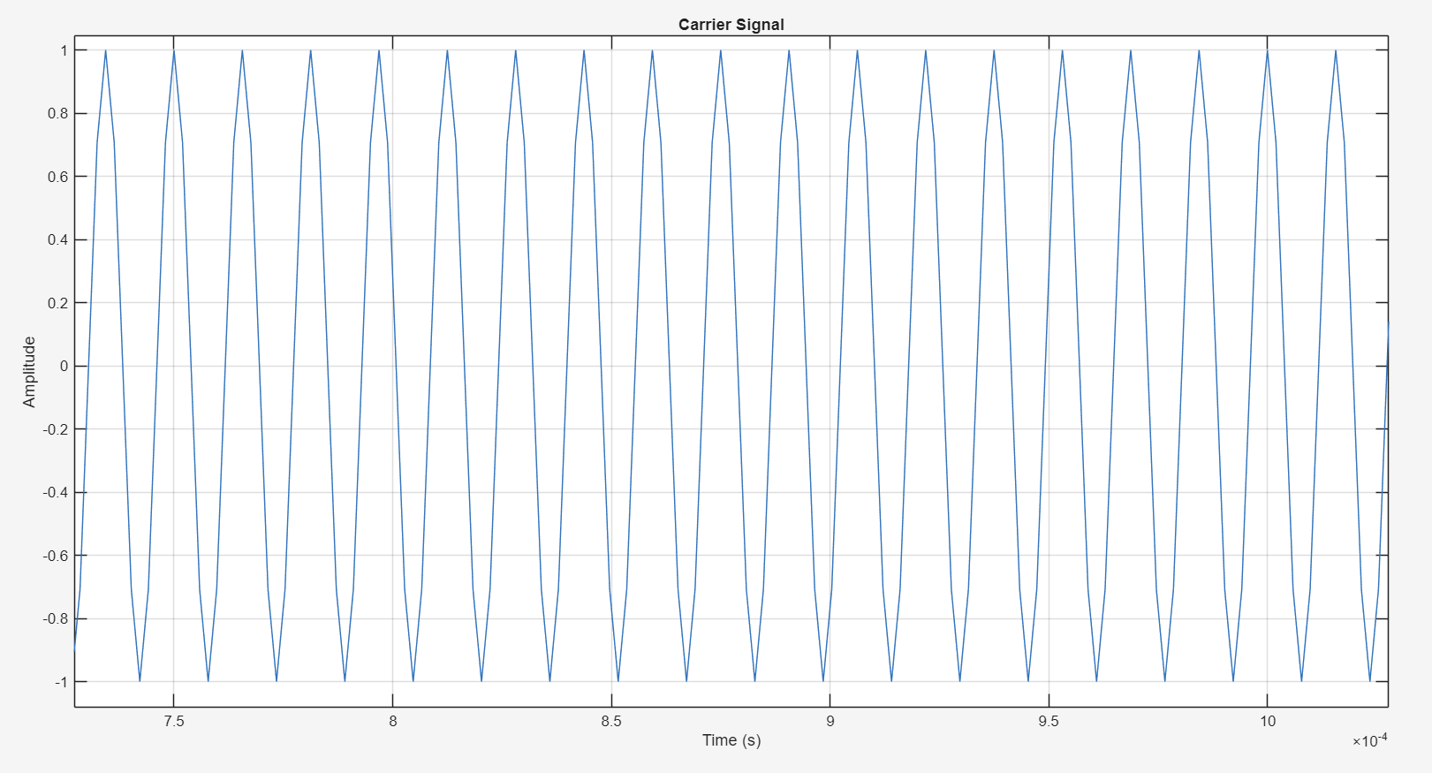
Figure11: Carrier Signal

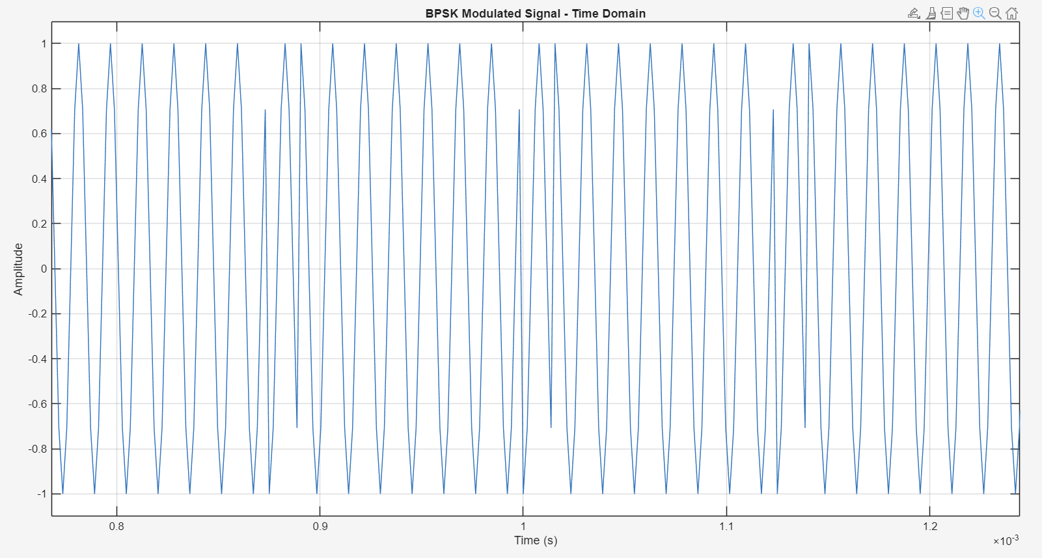
Figure11: BPSK Modulated Signal vs Time

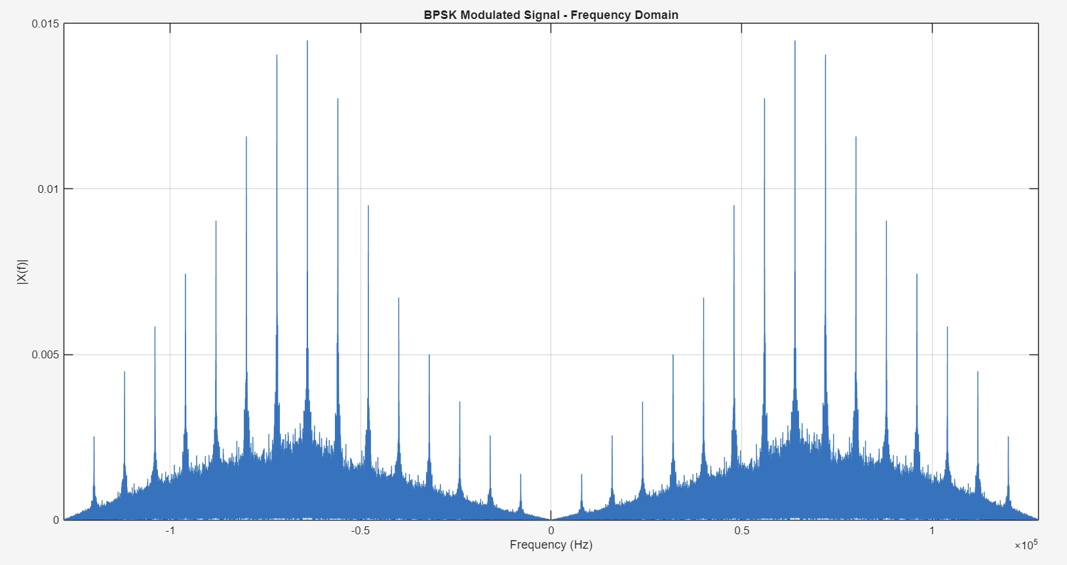
Figure12: BPSK Modulated Signal vs Frequency

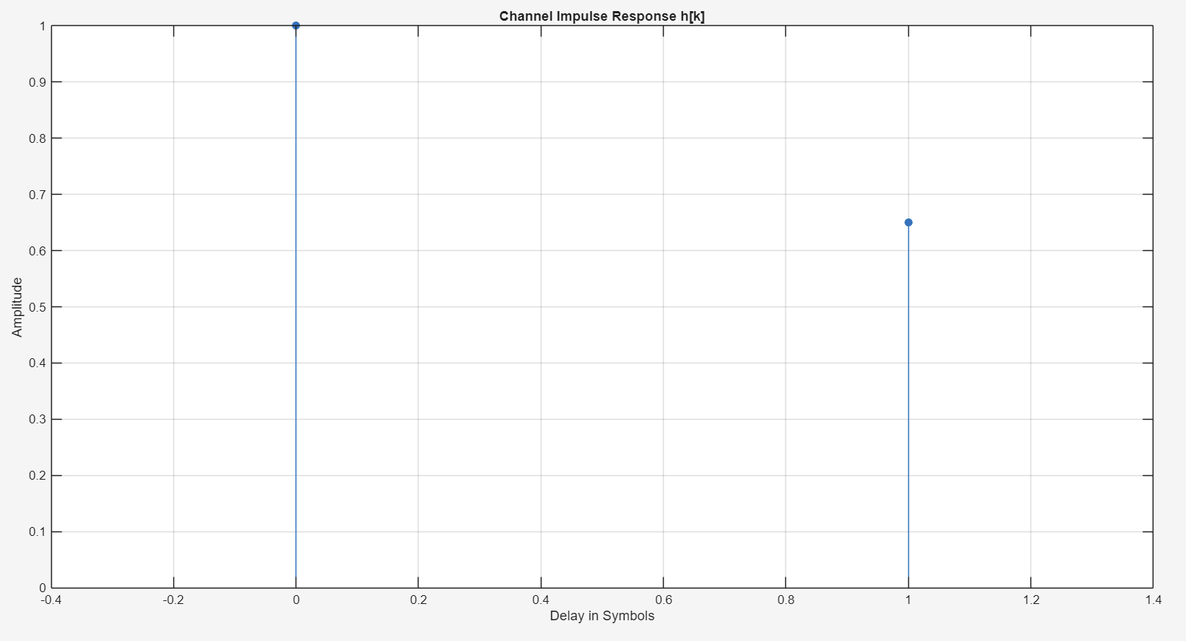
Figure13: Channel Impulse Response

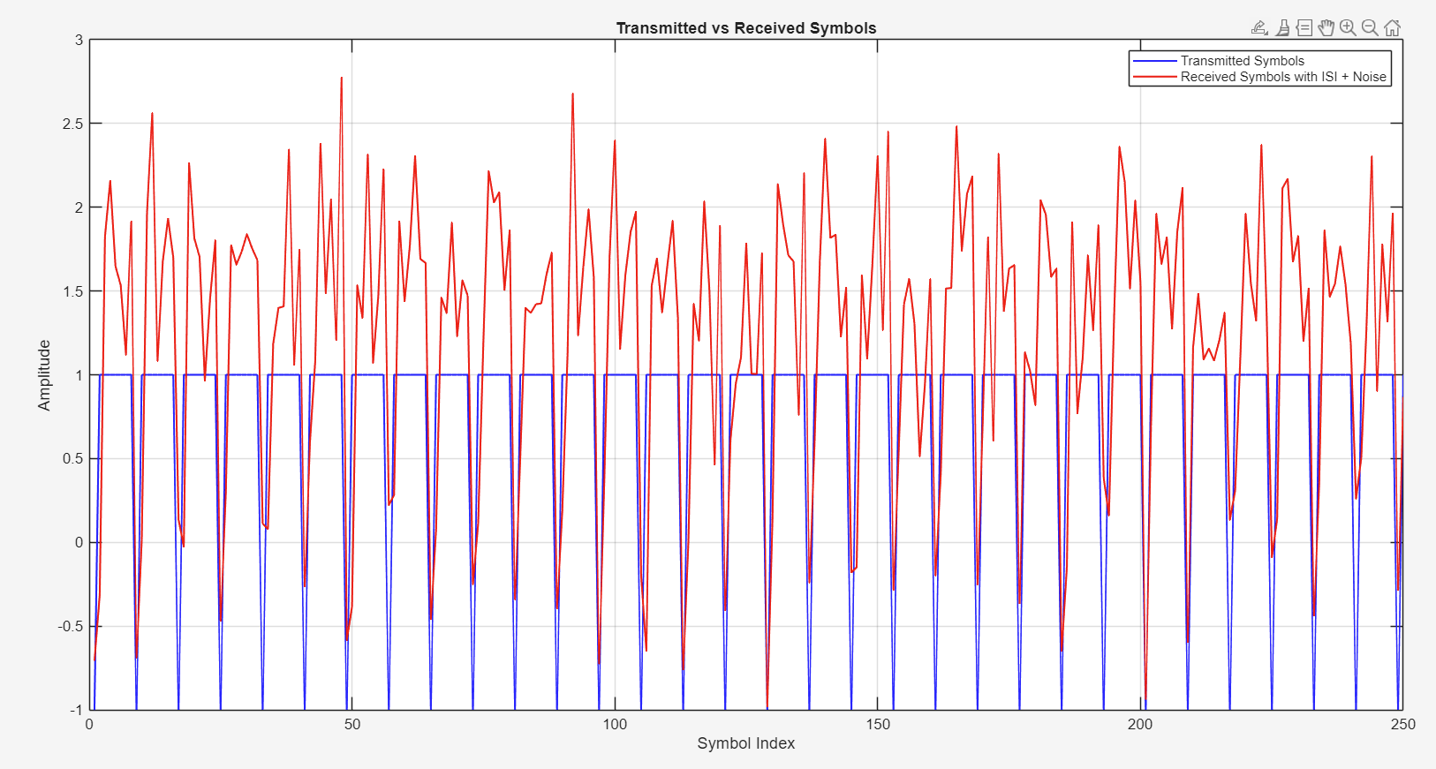
Figure14: Transmitted vs Receiver Symbols

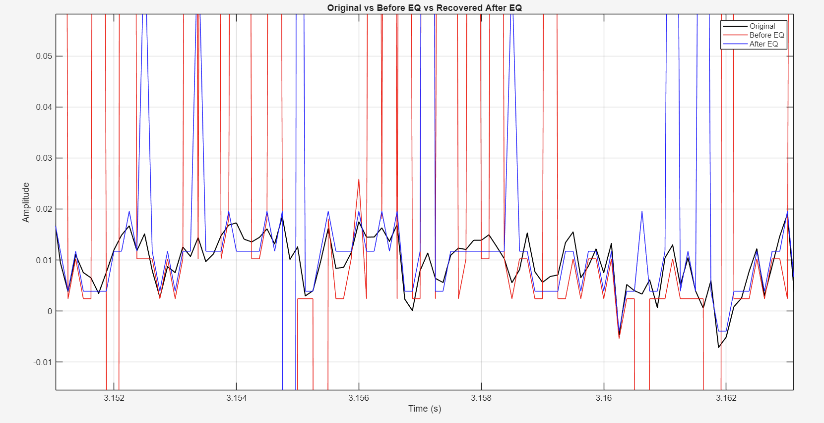
Figure15: Before and after equalization vs Time

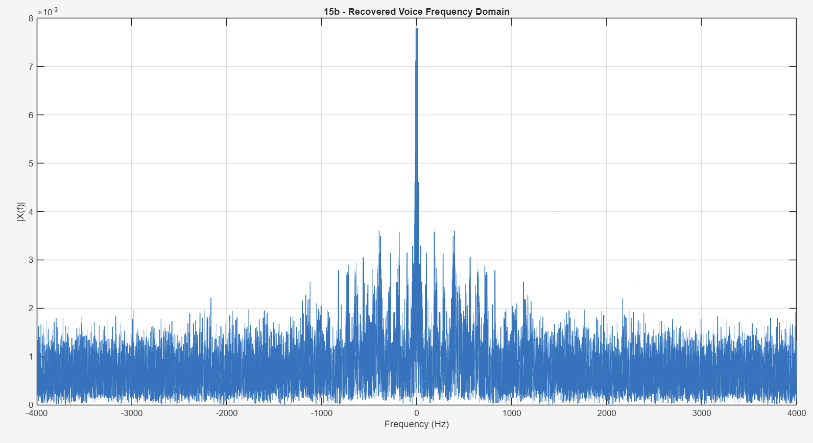
Figure16: Recovered Signal vs frequency

Bit Error Rate (BER) analysis
The performance of the communication system is evaluated using the Bit Error Rate (BER), which measures the reliability of data transmission over the channel. BER is defined as the ratio of incorrectly received bits to the total number of transmitted bits:

BER Before Equalization
Before applying the equalizer, the received signal is affected by both additive noise and intersymbol interference (ISI). The channel introduces a delayed version of the signal, which causes overlapping between consecutive symbols. As a result, symbol detection becomes inaccurate, leading to a higher error rate.
The BER before equalization is computed as:

From the simulation results:

This relatively high error rate indicates that the channel distortion significantly degrades the signal quality.
BER After Equalization
To mitigate the effect of ISI, a Zero-Forcing Equalizer is applied at the receiver. The equalizer removes the interference caused by the delayed signal component by subtracting the estimated contribution of the previous symbol:

After equalization, the detected bits are compared with the original transmitted bits to compute the BER:

From the results:

This demonstrates a significant improvement in system performance.

BER Improvement
The effectiveness of the equalizer can be quantified by comparing the BER values before and after equalization. The percentage improvement is calculated as:

Substituting the values:

This confirms that the equalizer successfully reduces the impact of ISI.

BER vs SNR Analysis
To further evaluate system performance, BER is analyzed as a function of the Signal-to-Noise Ratio (SNR). As the SNR increases, the noise power decreases, leading to more accurate symbol detection.

From the simulation:
- BER decreases as SNR increases
- Equalized system consistently outperforms the non-equalized system
Additionally, the theoretical BER for BPSK in an AWGN channel is given by:

The simulated BER is higher than theoretical value because the theoretical expression assumes an ideal channel without ISI, while the implemented system includes both noise and channel distortion.

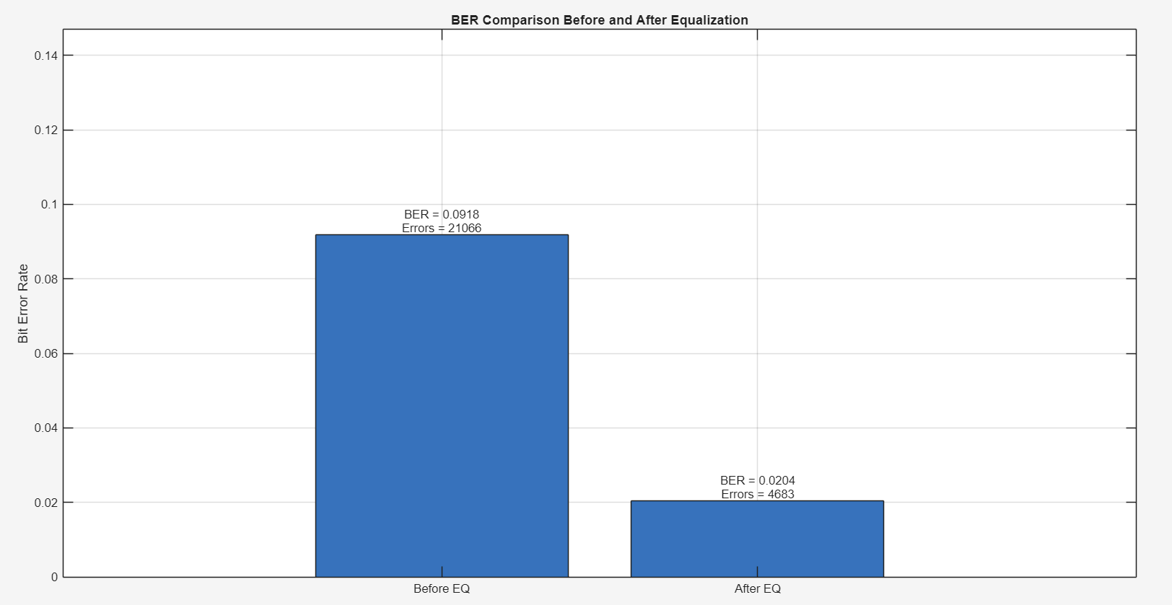
Figure16: BER values

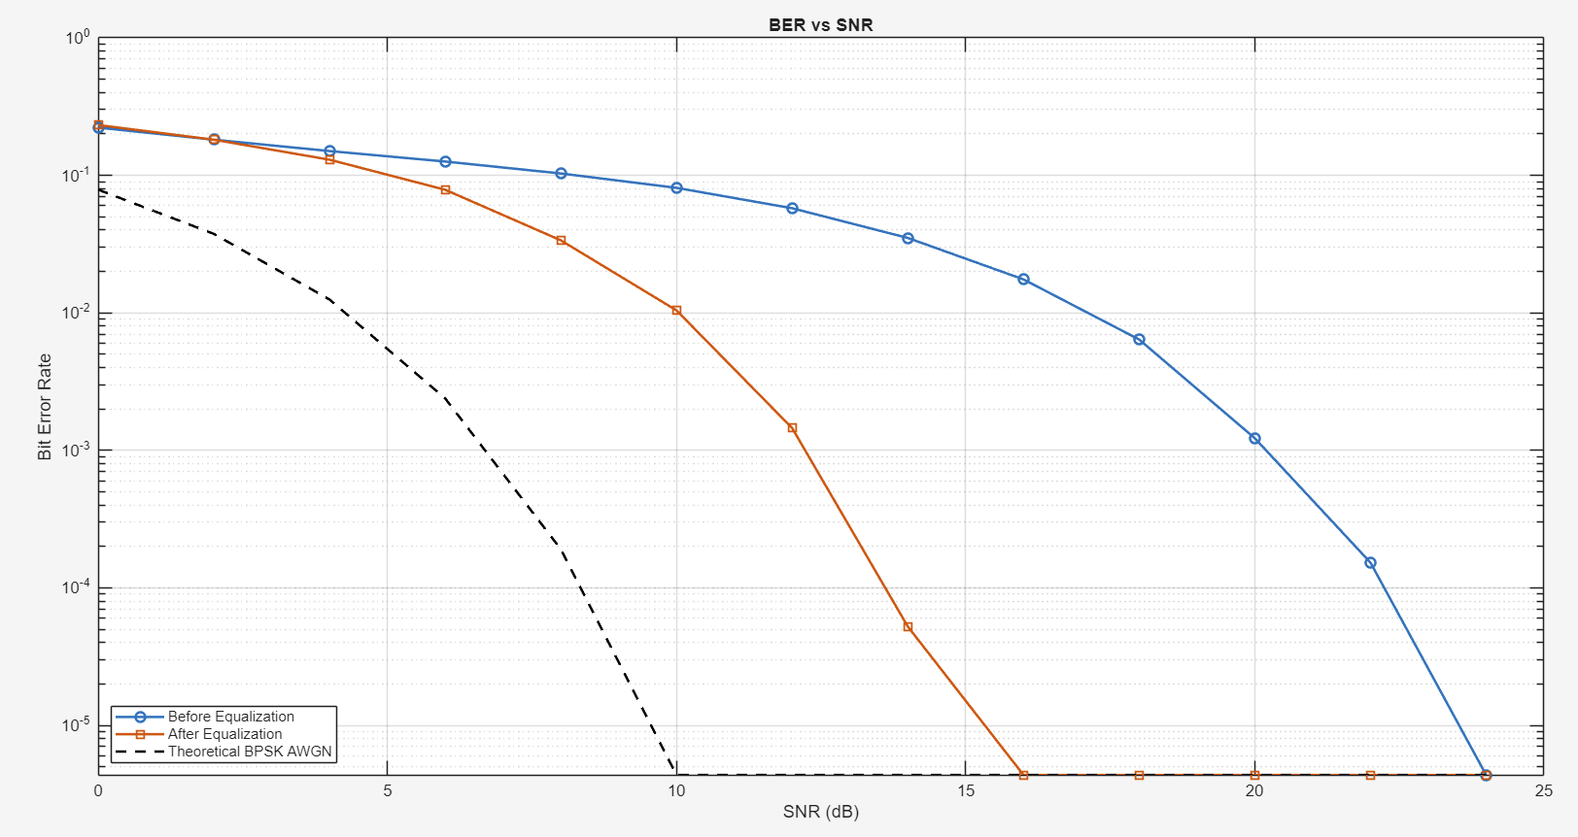
Figure17: BER analysis

Comparison between ideal and non-ideal sampling
Ideal sampling assumes that the signal is sampled at perfectly uniform time intervals without any timing error. Mathematically, the sampled signal can be represented as:

where:
- is the sampling period
- is the sampling frequency
In this project, the sampling frequency is chosen as:

which satisfies the Nyquist criterion for speech signals with bandwidth approximately 4 kHz. Under ideal sampling, the discrete-time signal accurately represents the original analog waveform, with no distortion introduced during the sampling process.
From the time-domain plot, the ideal sampled signal closely follows the shape of the original voice signal, preserving both amplitude and waveform characteristics.

In practical systems, sampling is not perfectly uniform due to hardware limitations such as clock instability. This introduces timing jitter, where the sampling instants deviate slightly from their ideal positions.
The non-ideal sampling can be modeled as:

where:
- represents a small random timing error
In this project, jitter is introduced as a random variation in the sampling time:

where is a small random noise term.

Although non-ideal sampling introduces distortion, its effect on overall system performance is relatively minor compared to:
- channel noise (AWGN)
- intersymbol interference (ISI)
Therefore:
- ADC imperfections contribute to degradation
- but are not the dominant source of errors in this system

Comparison before and after equalization

Before applying equalization, the received signal is significantly distorted due to the combined effects of additive noise and intersymbol interference (ISI) introduced by the channel. The channel can be modeled as:

where is the transmitted symbol, represents the interference from the previous symbol, and is additive white Gaussian noise. The presence of the delayed term
causes overlap between consecutive symbols, making the received waveform appear spread and less structured. In addition, the noise component introduces random fluctuations in amplitude. As a result, the received signal deviates significantly from the ideal symbol levels , leading to incorrect symbol decisions. This degradation is reflected in the Bit Error Rate (BER), which is computed as:

Before equalization, the BER was relatively high due to the combined impact of ISI and noise.
After applying the Zero-Forcing Equalizer, the effect of ISI is significantly reduced. The equalizer operates by subtracting the estimated contribution of the previous symbol from the current received signal, according to:

By substituting the channel model into this expression, the ISI term is effectively canceled:

This shows that the equalizer forces the ISI component to zero, leaving only the desired signal and the noise. Consequently, the waveform becomes more concentrated around the ideal symbol levels, and the overlap between adjacent symbols is reduced. Although noise remains present, the reduction of ISI allows for more accurate symbol detection.
This improvement is clearly observed in the BER results. Before equalization, the BER is:

After equalization, the BER is reduced to:

This represents a significant improvement in system performance. The reduction in BER confirms that ISI was a dominant source of errors and that the equalizer successfully mitigates its effect.
Overall, this comparison demonstrates that equalization plays a critical role in digital communication systems. By removing the deterministic distortion introduced by the channel, the Zero-Forcing Equalizer improves signal quality and enhances detection accuracy. However, since the noise component is not removed, the recovered signal is not perfectly identical to the original. Despite this limitation, the equalization process substantially improves the reliability of data transmission.

Conclusion
This project demonstrated the design and implementation of a digital communication system for transmitting and recovering a voice signal using Binary Phase Shift Keying (BPSK). Beginning with a baseband audio signal, the system applied analog-to-digital conversion through sampling and quantization, followed by line coding and pulse shaping to prepare the signal for transmission. The encoded data was then modulated onto a carrier signal using BPSK, shifting the signal to a higher frequency for transmission over a simulated communication channel.
The transmitted signal was corrupted by additive white Gaussian noise (AWGN) and intersymbol interference (ISI), representing realistic channel conditions. The presence of ISI caused overlap between adjacent symbols, significantly degrading signal quality and increasing the probability of detection errors. To address this, a Zero-Forcing Equalizer was implemented at the receiver to mitigate the effect of the channel by canceling the delayed interference component.
Time-domain and frequency-domain analysis provided insight into the behavior of the signal at each stage of the system. The frequency-domain representation, obtained using the Fast Fourier Transform (FFT), illustrated the bandwidth expansion due to modulation and the impact of noise and channel distortion. After equalization, the signal exhibited improved structure and reduced distortion, indicating successful mitigation of ISI.
Quantitative evaluation using Bit Error Rate (BER) demonstrated the effectiveness of the equalization process. The BER was significantly reduced after applying the Zero-Forcing Equalizer, confirming that ISI was a major source of errors in the system. Further analysis of BER as a function of Signal-to-Noise Ratio (SNR) showed that system performance improves with increasing SNR and approaches theoretical BPSK behavior under favorable conditions.
Overall, this project reinforces fundamental concepts in digital communication, including sampling theory, quantization, modulation, channel modeling, and equalization. It highlights the critical role of equalization in mitigating channel-induced distortion and improving signal reliability. The results demonstrate how practical communication systems deviate from ideal theoretical models and emphasize the importance of robust receiver design in achieving accurate signal recovery.

Future Work
Several improvements can be explored to further enhance the performance and realism of the implemented digital communication system. One important extension is the use of more advanced equalization techniques. In this project, a Zero-Forcing Equalizer was used to completely cancel intersymbol interference (ISI); however, it does not account for noise and may amplify it. Implementing a Minimum Mean Square Error (MMSE) equalizer would provide a better trade-off between ISI reduction and noise suppression, leading to improved overall performance.
Another possible improvement is refining the channel model. The current system considers a simple ISI channel with a single delayed component and additive white Gaussian noise. Future work could include more realistic channel conditions, such as multi-path propagation with multiple delayed components or time-varying channel behavior. This would allow for a more comprehensive evaluation of system robustness.
The effect of ADC parameters can also be further analyzed. In this project, an 8-bit quantization scheme was used. Future experiments could investigate the impact of different quantization levels on system performance, particularly how quantization noise affects the Bit Error Rate (BER) and recovered signal quality.
Additionally, pulse shaping can be improved. The current implementation uses a simple rectangular pulse, which introduces sharp transitions and wider spectral spreading. Using more advanced pulse shaping filters, such as raised cosine filters, could reduce bandwidth usage and minimize ISI at the transmitter.
Finally, the system can be extended by comparing performance under different signal-to-noise ratio (SNR) conditions in more detail, or by evaluating the impact of synchronization errors in the carrier or sampling process. These extensions would provide deeper insight into the limitations of the system and the practical challenges in real-world digital communication.

References
- Textbooks: Rodger E. Ziemer and William Tranter, Principles of Communications
- Systems, Modulation and Noise, Sixth Edition
- Simon Haykin and Michael Moher, Introduction to Analog & Digital Communications,
- Second Edition, Wiley

