**The National University of Computer and Emerging Sciences**

**Islamabad Campus**



**Deep Learning**

**Assignment # 1**

**Hamza Asad 22i-1908 DS-C**

**27th September 2025**

**Architecture**

**VGGFace2Net**

* **Architecture:** VGGFace2 backbone (VGG16-like)
* **Parameters:** ~138M (VGG16 base) + task-specific heads
* **Training Settings:**
  + Optimizer: Adam
  + Learning Rate: 1e-4
  + Loss: Cross-Entropy for classification, MSE for regression
  + Backbone frozen for first 5 epochs, then fine-tuned
  + Early stopping based on validation accuracy
* **Epochs:** 14 (early stopping triggered)
* **Training Time:** ~45s per validation run, total depends on machine
* **Input Size:** 224x224 RGB

**ResNet**

* **Architecture:** ResNet (likely ResNet-18 or ResNet-34) backbone
* **Parameters:** ~11M (ResNet-18) or ~21M (ResNet-34) + task-specific heads
* **Training Settings:**
  + Optimizer: Adam
  + Learning Rate: 1e-4
  + Loss: Cross-Entropy for classification, MSE for regression
  + Fully fine-tuned from the start
  + Early stopping triggered at epoch 8
* **Epochs:** 8 (early stopping triggered)
* **Training Time:** ~15s per validation run
* **Input Size:** 224x224 RGB

**Dataset Splits**

* **Total usable samples:** 3999 / 3999
* **Train:** 2889 samples
* **Validation:** 510 samples
* **Test:** 600 samples
* **Batches:**
  + Train: 91
  + Validation: 16
  + Test: 19

**Training Graphs**

**VGGFace2Net**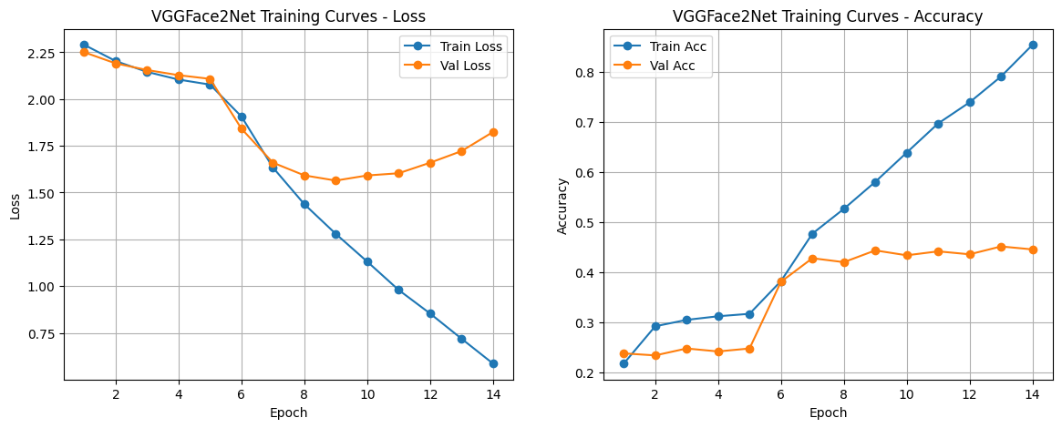

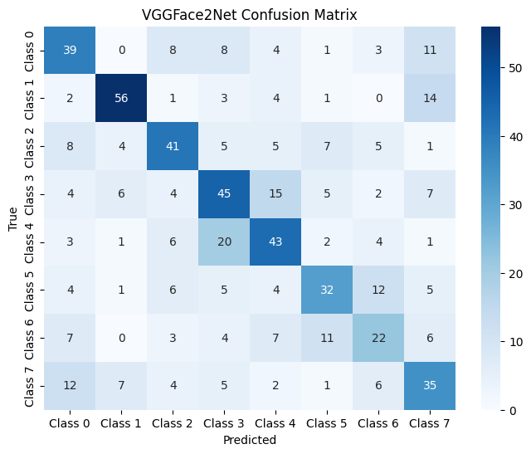

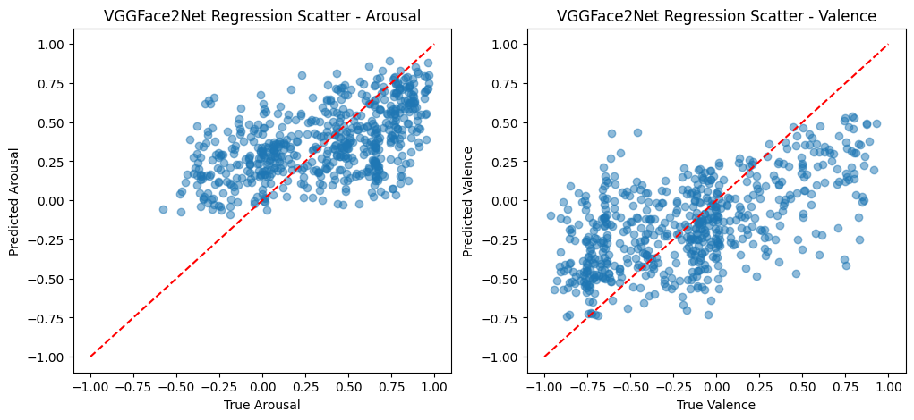

**ResNet18**

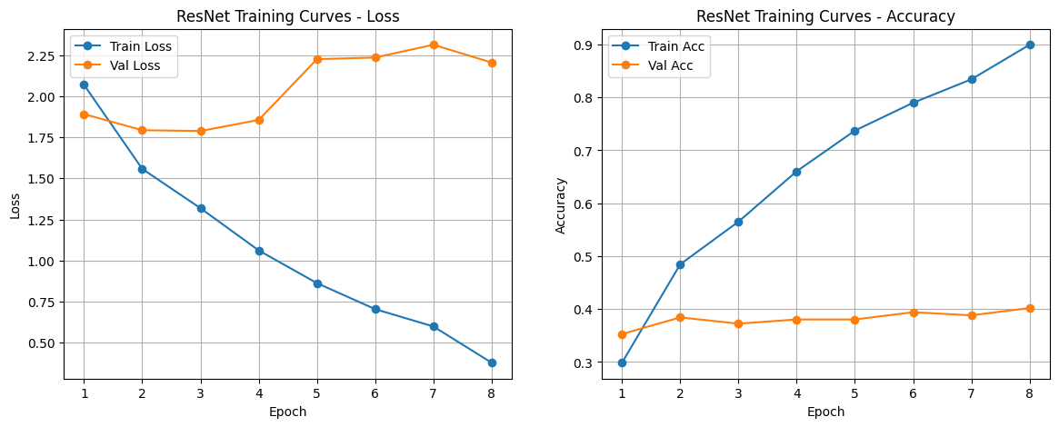

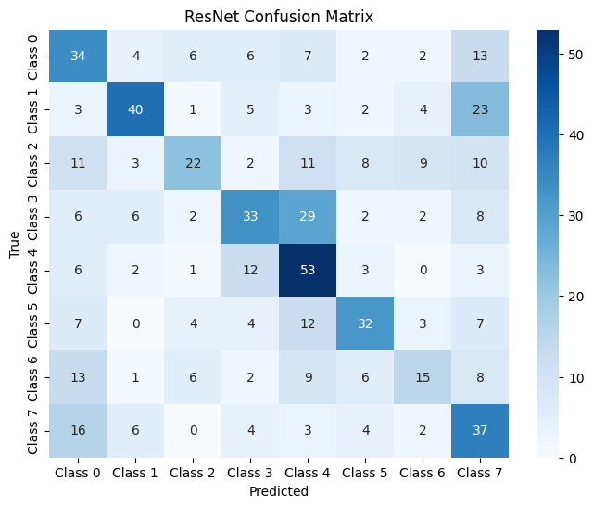

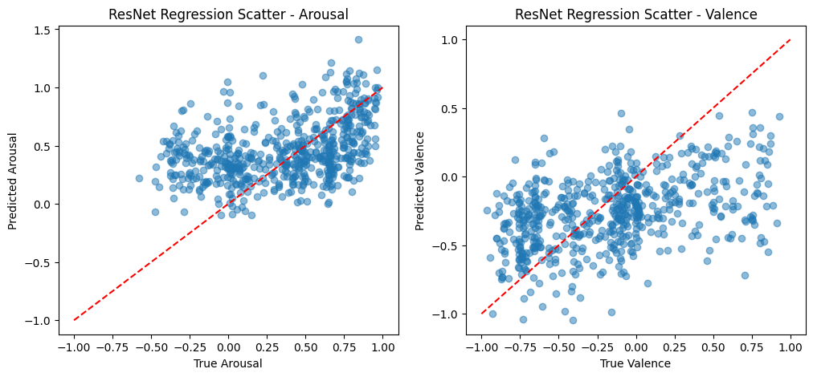

**Performance Measures**

**VGGFace2Net**

| **Metric** | **Value** |
| --- | --- |
| Accuracy | 0.5217 |
| F1-Score | 0.5225 |
| Cohen’s Kappa | 0.4521 |
| Krippendorff’s Alpha | 0.4525 |
| AUC | 0.8630 |
| PR-AUC | 0.5208 |
| **Arousal RMSE** | 0.3342 |
| Arousal CORR | 0.5194 |
| Arousal SAGR | 0.7850 |
| Arousal CCC | 0.4410 |
| **Valence RMSE** | 0.3814 |
| Valence CORR | 0.5889 |
| Valence SAGR | 0.7583 |
| Valence CCC | 0.5129 |

**ResNet**

| **Metric** | **Value** |
| --- | --- |
| Accuracy | 0.4433 |
| F1-Score | 0.4399 |
| Cohen’s Kappa | 0.3626 |
| Krippendorff’s Alpha | 0.3598 |
| AUC | 0.8256 |
| PR-AUC | 0.4564 |
| **Arousal RMSE** | 0.3835 |
| Arousal CORR | 0.4071 |
| Arousal SAGR | 0.7667 |
| Arousal CCC | 0.3555 |
| **Valence RMSE** | 0.4391 |
| Valence CORR | 0.4317 |
| Valence SAGR | 0.7150 |
| Valence CCC | 0.3528 |