**Facial Analysis System for Age, Emotion and Gender Classification**

**1. Dataset Acquisition and Preparation**

**1.1. Primary Datasets**

* UTKFace
* IMDB-WIKI
* Adience Benchmark
* MORPH Dataset

**1.2. Emotion detection datasets**

* FER2013: 35,887 grayscale 48x48 facial images with 7 emotion categories (anger, disgust, fear, happiness, sadness, surprise, neutral)

**1.3. Data Preprocessing Pipeline**

1. **Face Detection and Extraction:**
   1. Implement Haar Cascade, HOG + SVM, or MTCNN for initial face detection .
   2. Crop and align detected faces
2. **Data Cleaning:**
   1. Remove low-quality images
   2. Eliminate duplicate entries
   3. Balance dataset across age groups, gender, and emotion categories.
3. **Data Augmentation:**
   1. Random rotations (±10°)
   2. Horizontal flips
   3. Brightness and contrast variations
   4. Slight zoom in/out
   5. Random crops
4. **Normalization:**
   1. Resize all images to 224×224 pixels (standard for many CNNs)
   2. Convert to RGB format
   3. Normalize pixel values to range [0,1] or [-1,1]
5. **Train-Validation-Test Split:**
   1. 70% training, 15% validation, 15% testing.
   2. Ensure stratified sampling across age, gender, and emotion categories

**2. Digital Image Processing and Computer Vision (OpenCV)**

**2.1. Face Detection Methods**

* **HOG (Histogram of Oriented Gradients) + SVM:**
  1. More robust to lighting variations
* **MTCNN (Multi-task Cascaded Convolutional Networks):**
  1. Three-stage cascaded structure
  2. Detects faces and facial landmarks simultaneously
  3. Higher accuracy but more computationally intensive
* **RetinaFace:** State-of-the-art face detector . Useful for Joint face detection and alignment.

**2.2. Image Enhancement Techniques**

* **Illumination Correction:**
  1. Histogram equalization
  2. Adaptive histogram equalization (CLAHE)
  3. Gamma correction
* **Noise Reduction:**
  1. Gaussian filtering
  2. Median filtering
  3. Bilateral filtering
* **Edge Enhancement:**
  1. Unsharp masking
  2. Sobel and Canny edge detectors for feature enhancement

**2.3. Feature Extraction**

* **Traditional Features:**
  1. HOG (Histogram of Oriented Gradients)
  2. LBP (Local Binary Patterns)
  3. Gabor filters
  4. SIFT (Scale-Invariant Feature Transform)

• **Facial Landmark Detection**:

* Dlib's 68-point facial landmark detector
* MediaPipe Face Mesh (468 points)
* OpenFace facial landmark detection

• **Facial Action Units (FAUs)**:

* FACS (Facial Action Coding System) based feature extraction
* Muscle movement tracking for emotion inference

**3. Ready-to-Use Frameworks and APIs**

**3.1. MediaPipe Integration**

* **MediaPipe Face Mesh**:
  + Real-time 468 3D facial landmark tracking
  + On-device ML pipeline optimized for mobile and desktop
  + Facial landmark tracking for emotion detection
  + Integration modes:
    - Python API with TensorFlow
    - C++ API
    - Android/iOS SDK
* **MediaPipe Holistic**:
  + Combines face, pose, and hand tracking
  + Useful for contextual understanding of emotions
* **Implementation Strategy**:
  + Use MediaPipe for fast, accurate facial landmark extraction
  + Extract geometric features from landmarks for emotion analysis
  + Calculate distance metrics and angles between key points for expression detection
  + Track temporal changes in landmark positions for dynamic emotion analysis

**3.2. Py-FEAT Integration**

* **Python Facial Expression Analysis Tool (Py-FEAT)**:
  + Comprehensive toolkit for emotion detection
  + Automated facial expression coding
  + Detection of 8 emotions plus neutral
  + Facial Action Unit (FAU) intensity estimation
* **Core Components**:
  + Face detection and registration
  + Pose estimation
  + Action Unit detection
  + Emotion classification
  + Temporal filtering
* **Implementation Strategy**:
  + Use Py-FEAT as high-level API for emotion detection
  + Leverage pre-trained models for Action Unit detection
  + Combine with custom age and gender models
  + Extract intermediate features for multi-task learning

**3.3. Hybrid Approach**

* **MediaPipe + PyFEAT Pipeline**:
  + Use MediaPipe for fast, accurate face detection and landmark localization
  + Feed landmarks to PyFEAT for emotion analysis
  + Integrate with custom age/gender CNN
  + Benefits:
    - Real-time performance from MediaPipe
    - Research-grade emotion analysis from PyFEAT
    - Reduced training requirements

**4. Deep Learning Models**

**4.1. Pre-trained Models for Transfer Learning**

* **VGG-16/19**: Good feature extraction but larger model size
* **ResNet-50**: Better performance with residual connections
* **MobileNetV2**: Lightweight, suitable for mobile deployments
* **EfficientNet**: Balanced accuracy and efficiency
* **DenseNet**: Good feature propagation

**4.2. Custom CNN Architectures**

* **LightFaceNet**: A lightweight custom CNN designed specifically for facial analysis
* **AgeGenderNet**: Multi-task learning architecture for joint age and gender prediction
* **EmotionNet**: Specialized architecture for emotion recognition with attention to facial regions
* **UnifiedFaceNet**: Multi-task architecture for joint age, gender, and emotion prediction

**4.3. Advanced Techniques**

* **Attention Mechanisms**: To focus on important facial regions for each task
* **Multi-task Learning**: Joint optimization of age, gender, and emotion classification
* **Ensemble Methods**: Combining predictions from multiple models
* **Age Regression vs. Classification**: Testing both approaches for age estimation
* **Temporal Analysis**: For video-based emotion recognition to capture micro-expressions
* **Transfer Learning from Large Face Recognition Models**: Using face recognition feature extractors

**4.4. Hyperparameter Optimization**

* **Grid Search**
* **Random Search**
* **Bayesian Optimization**
* **Parameters to tune**:
  + Learning rate
  + Batch size
  + Dropout rates
  + Network depth and width
  + Regularization strength

**Model Evaluation and Benchmarking**

**Evaluation Metrics**

* **For Gender Classification:**
  1. Accuracy
  2. Precision
  3. Recall
  4. F1-score
  5. ROC curve and AUC
* **For Age Estimation:**
  1. Mean Absolute Error (MAE)
  2. Cumulative Score (CS) at different thresholds
  3. Accuracy within age groups
* **For Emotion Recognition**:

1. Confusion Matrix
2. Per-class accuracy, precision, recall
3. F1-score for each emotion
4. Mean accuracy across all emotions
5. Cohen's Kappa to account for class imbalance

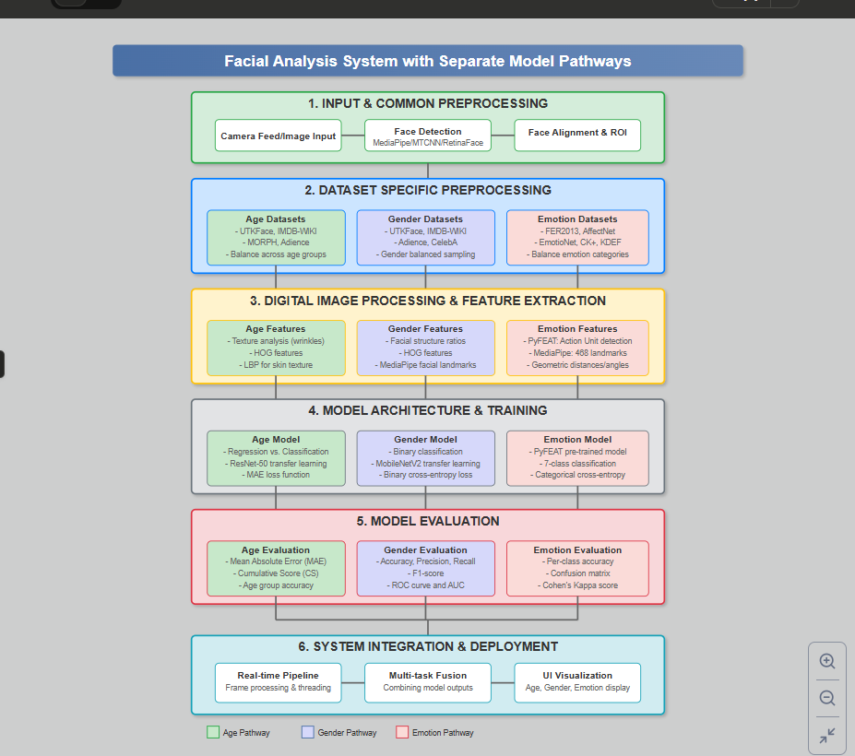

**Suggested models**

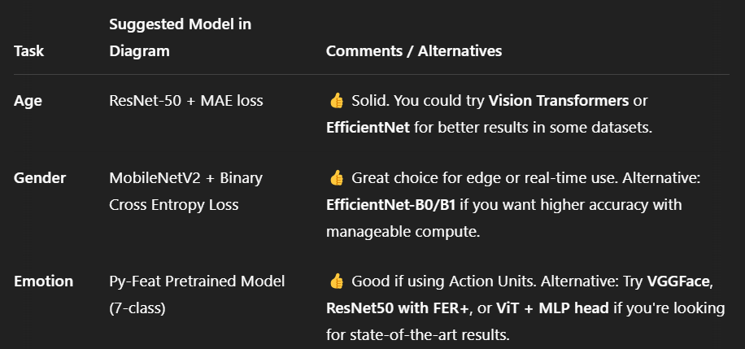

| **Stage** | **Age Detection** | **Gender Detection** | **Emotion Detection (Py-Feat + FER-2013 Fine-tune)** |
| --- | --- | --- | --- |
| **1. Dataset Collection** | UTKFace, IMDB-WIKI, MORPH | UTKFace, CelebA, Adience | FER2013, AffectNet, CK+, RAF-DB |
| **2. Preprocessing** | - **Face detection** using MediaPipe / MTCNN  - **Face alignment**  - Resize & grayscale conversion  - Balance age group samples | - **Face detection**  - Face alignment  - Resize to uniform shape  - Gender-balanced samples | - Face detection  - Face alignment  - Resize, grayscale  - Emotion class balancing |
| **3. Digital Image Processing** | - **Histogram Equalization** (enhance wrinkle contrast)  - **LBP (Local Binary Patterns)** for skin texture  - **HOG** features for structure | - **Histogram Equalization**  - **Facial symmetry ratios**  - **HOG** features  - **MediaPipe landmarks** | - **Py-Feat AUs** (Action Units)  - **Facial landmark distances** (geometric)  - **Emotion-intensity histograms**  - Optional Gabor filtering |
| **4. Data Splitting** | Train / Val / Test – 70 / 15 / 15 | Same | Same |
| **5. Model Architecture** | - CNN (e.g., ResNet-50)  - Regression / Classification head  - Loss: **MAE** | - CNN (MobileNetV2)  - Binary classifier head  - Loss: **Binary Cross-Entropy** | - Pre-trained **Py-Feat** model  - Fine-tune on FER-2013  - Loss: **Categorical Cross-Entropy** |
| **6. Training** | - Optimizer: Adam  - Epochs: 25–50 | Optimizer: Adam  Epochs: 10–30 | Freeze base, fine-tune classifier  Epochs: 15–30  Data Augmentation (shift, zoom, flip) |
| **7. Evaluation** | - **MAE**, Cumulative Score (CS)  - Age group accuracy | - Accuracy, Precision, Recall  - ROC-AUC, F1-score | - Per-class accuracy  - Confusion matrix  - Cohen's Kappa Score  - **Emotion heatmaps**, class-wise F1, recall |
| **8. Deployment** | - Real-time webcam inference  - Overlay predicted age | - Lightweight model deployment  - Show predicted gender on UI | - Real-time emotion prediction  - Optional: visualize using emoji, emotion graphs |