NLP-Powered BI vs Tableau Analysis

Tableau
Working of Tableau:
- Connecting to a dataset.
- Establishing relationship between tables.
- Creating sheets for insight by dragging and dropping table attributes to create data visualization.
- Creating dashboard by adding sheets.
Required Expertise for Tableau:
- Data concepts
- SQL knowledge
- Visualization skills
- Storytelling skills*
Tableau Pricing:
- Tableau Creator (create and publish dashboards): 70usd/month per user.
- Tableau Explorer (view and interact with dashboards, includes Tableau Desktop and Viewer): 40usd/month per user.
- Tableau Viewer (view dashboards): 15usd/month per user.
- Tableau addons are also paid.

Tableau GPT and Tableau Pulse
Tableau GPT:
- Mission statement: to simplify and democratize the process of data analysis.
- Tableau GPT will simplify and streamline existing analyst workflows, lowering the technical barrier to entry and reducing repetitive tasks.
- Tableau GPT is NOT AVAILABLE yet.
- Expected release: Spring 2024 or available for pilot later this year.
- Powered by Einstein generative AI technology (for CRM) (launched in May, 23).
- Einstein GPT will integrate with OpenAI (owned by Salesforce/not opensource).
- Tableau GPT and Tableau Pulse are expected to be paid features (no pricing info yet).
Expected Capabilities of Tableau GPT:
- Generate insights through a conversational way, e.g. "What are the top 10 products that are selling the most?" or "What are the trends in customer behavior?
- Give personalized recommendations for data visualization based on user interests.
Tableau Pulse:
- Will provide data digests, and curated newsfeed of selected KPIs.
- Will provide shareable insights across multiple platforms.
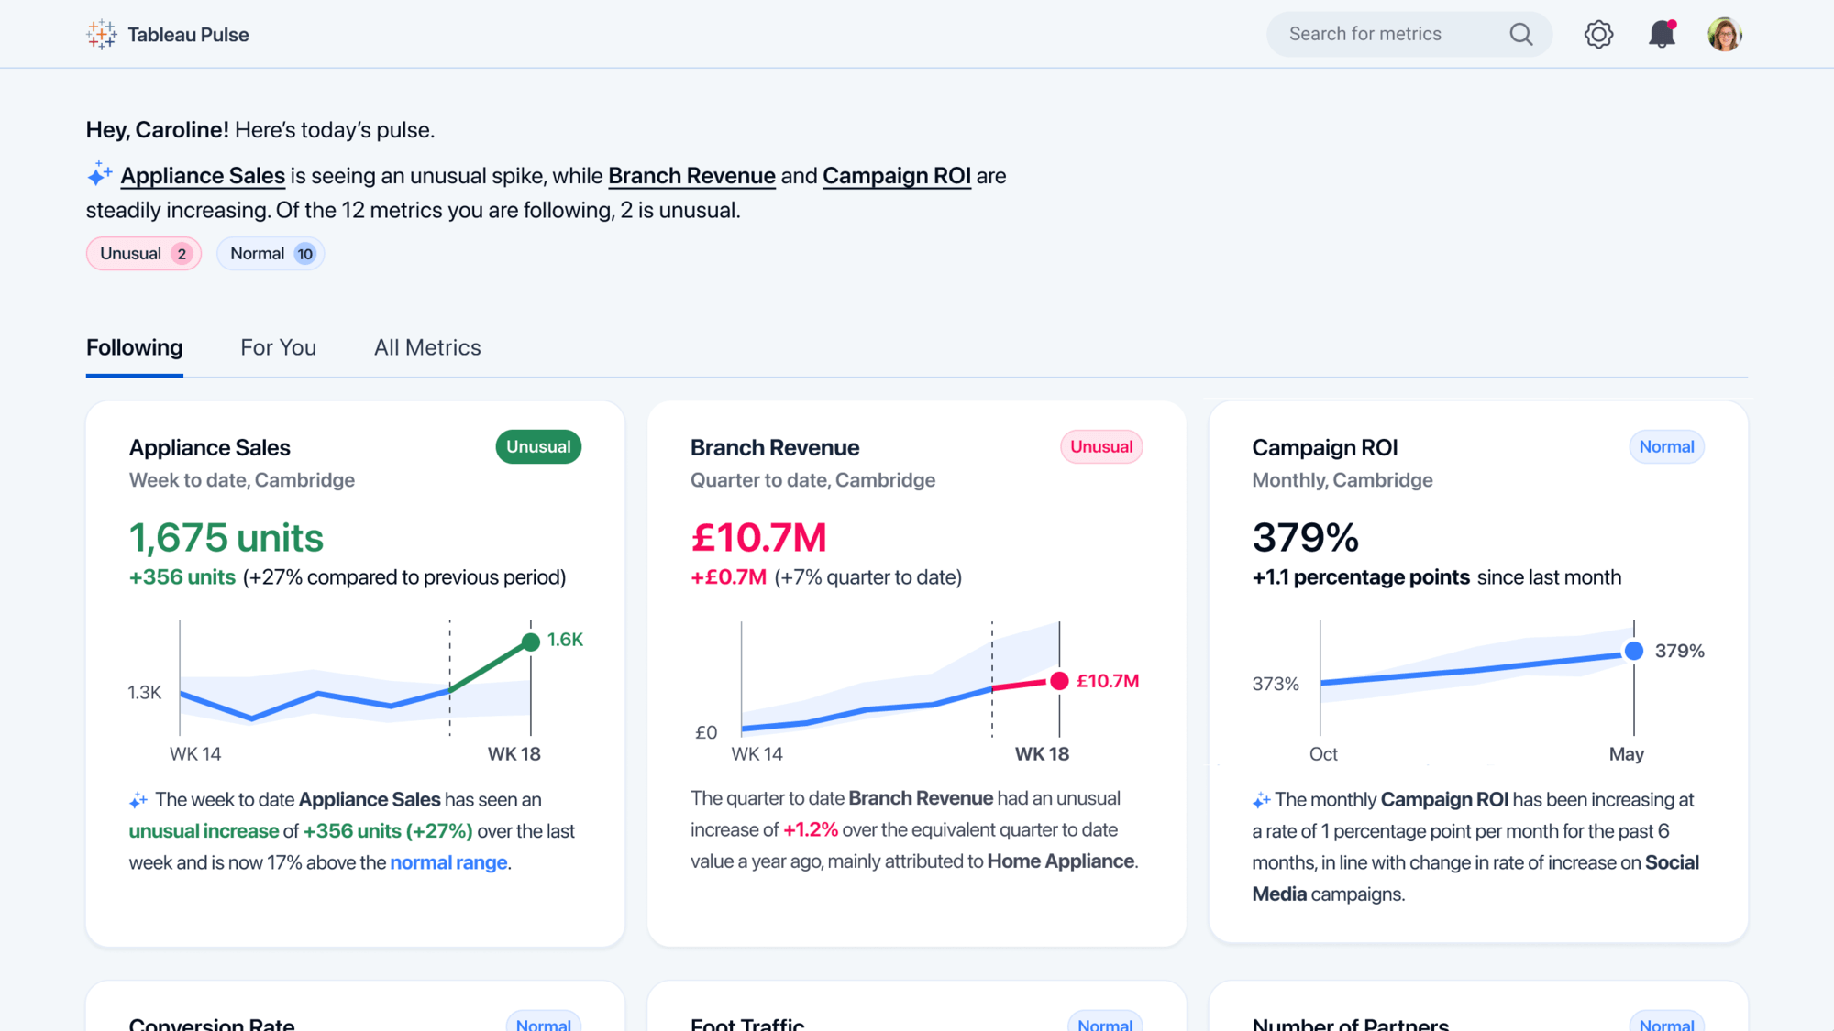



- Pulse automatically detects and generates insights, anticipates questions you might ask, and even suggests questions you might not have thought of.
- From there, Tableau GPT summarizes those insights conversationally.
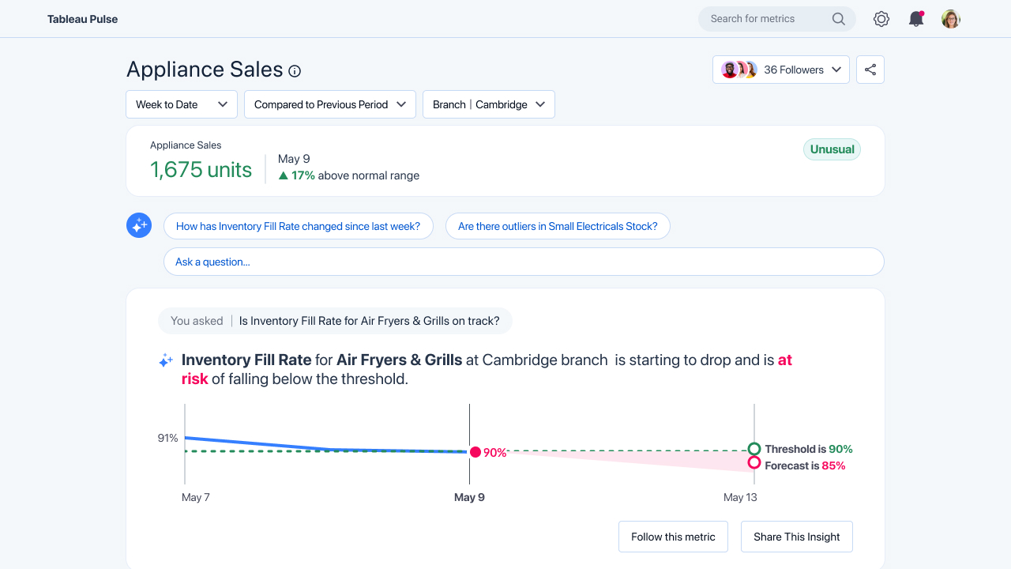

NOTE: no information available on whether user will be able to add insights generated by Tableau GPT to their dashboards.

