**GROUP 4 – Relational Model**

**2020147, 2020376, 2020091**

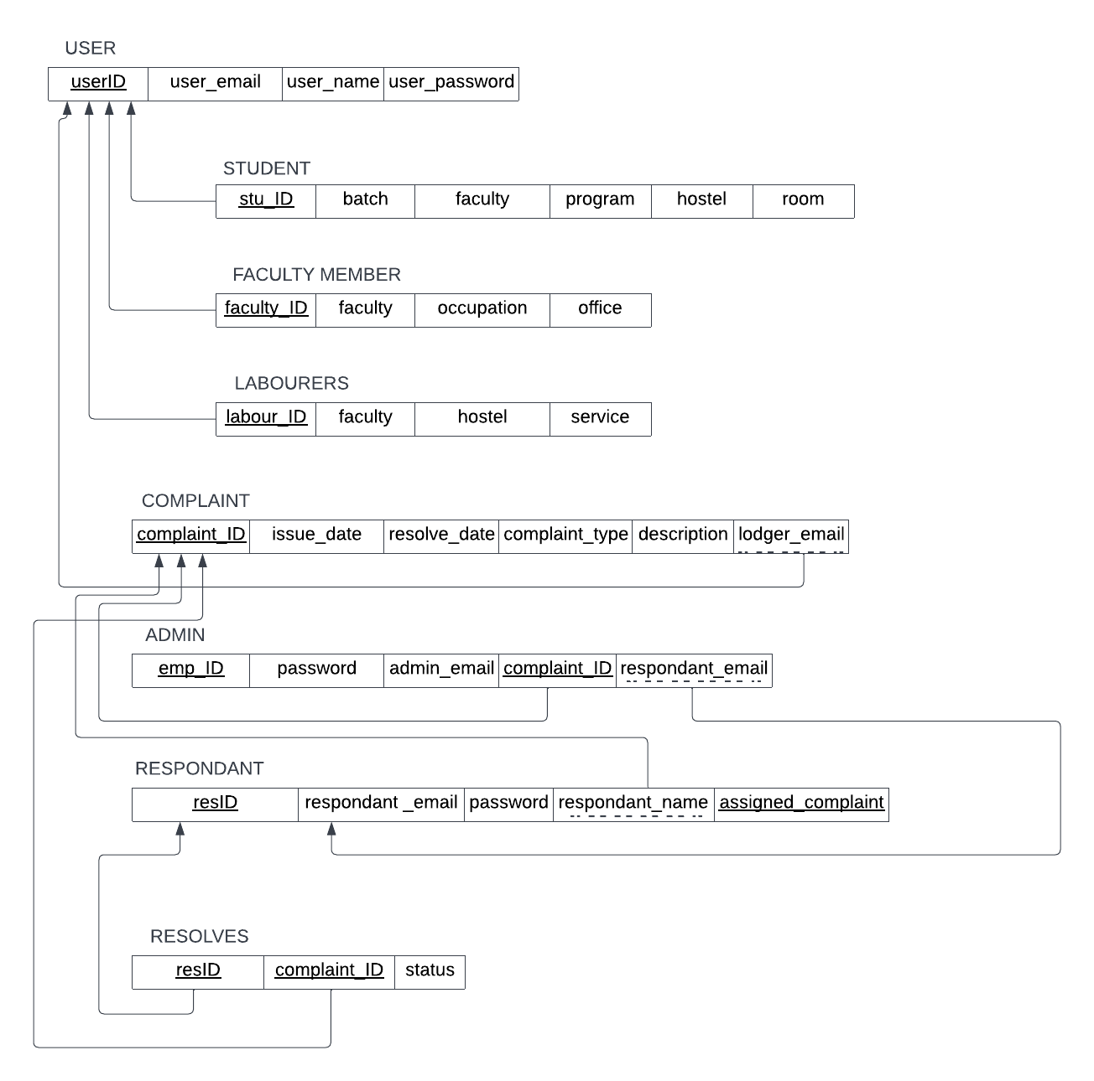

|  |  |  |  |
| --- | --- | --- | --- |
| **userID** | **user_email** | **user_name** | **user_password** |
| 2020376 | u2020376@giki.edu.pk | Zaeem Tauqir | Apple321 |
| 2020147 | [U2020147@giki.edu.pk](mailto:U2020147@giki.edu.pk) | Hamza Siddiqui | Apple321 |
| 2020019 | [u2020019@giki.edu.pk](mailto:u2020019@giki.edu.pk) | Abdul Wahab | Apple321 |
| 800 | [fida@giki.ed.pk](mailto:fida@giki.ed.pk) | Fida Muhammad | Apple321 |
| 822 | [arsalan@giki.edu.pk](mailto:arsalan@giki.edu.pk) | Arsalan Khan | Apple321 |
| 911 | [zaheer@giki.edu.pk](mailto:zaheer@giki.edu.pk) | Zaheer Lodhi | Apple321 |

**Dummy Data**

**USER**

**STUDENT**

|  |  |  |  |  |  |
| --- | --- | --- | --- | --- | --- |
| **Stu_ID** | **Batch** | **Faculty** | **Program** | **Hostel** | **Room** |
| 2020376 | 29 | FME | Mechanical Eng | 9 | 43 |
| 2020147 | 28 | FCSE | Computer Eng | 3 | 12 |
| 2020019 | 30 | FMCE | Chemical Eng | 10 | 34 |

**FACULTY MEMBER**

|  |  |  |  |
| --- | --- | --- | --- |
| **Faculty_ID** | **Faculty** | **Occupation** | **Office** |
| 800 | FME | Professor | G-35 |
| 822 | FCSE | Professor | F-45 |

**LABOURERS**

|  |  |  |  |
| --- | --- | --- | --- |
| **Labour_ID** | **Faculty** | **Hostel** | **Service** |
| 911 |  | 10 | Room cleaning |

**COMPLAINT**

|  |  |  |  |  |  |
| --- | --- | --- | --- | --- | --- |
| **Complaint_ID** | **Issue_date** | **Resolve_date** | **Complaint_type** | **Description** | **Lodger_email** |
| 1002 | 12/12/21 | 18/01/22 | Hostel |  | u2020376@giki.edu.pk |
| 1003 | 01/02/22 | 21/02/22 | Academic |  | [U2020147@giki.edu.pk](mailto:U2020147@giki.edu.pk) |
| 1004 | 02/02/22 |  | Medical |  | [u2020019@giki.edu.pk](mailto:u2020019@giki.edu.pk) |
| 1005 | 02/02/22 | 21/02/22 | Academic |  | [fida@giki.ed.pk](mailto:fida@giki.ed.pk) |
| 1006 | 27/02/22 | 09/03/22 | Food & Utility |  | [arsalan@giki.edu.pk](mailto:arsalan@giki.edu.pk) |
| 1007 | 11/03/22 |  | Others |  | [zaheer@giki.edu.pk](mailto:zaheer@giki.edu.pk) |

**ADMIN**

|  |  |  |  |  |
| --- | --- | --- | --- | --- |
| **Emp_ID** | **Password** | **Admin_email** | **Complaint_ID** | **Respondent_email** |
| 123 | Apple321 | [123@giki.edu.pk](mailto:123@giki.edu.pk) | 1002 | 667@giki.edu.pk |
| 124 | Apple321 | 124@giki.edu.pk | 1003 | [667@giki.edu.pk](mailto:667@giki.edu.pk) |
| 123 | Apple321 | [123@giki.edu.pk](mailto:123@giki.edu.pk) | 1004 | [667@giki.edu.pk](mailto:667@giki.edu.pk) |
| 123 | Apple321 | [123@giki.edu.pk](mailto:123@giki.edu.pk) | 1005 | [456@giki.edu.pk](mailto:456@giki.edu.pk) |
| 124 | Apple321 | 124@giki.edu.pk | 1006 | [456@giki.edu.pk](mailto:456@giki.edu.pk) |
| 124 | Apple321 | 124@giki.edu.pk | 1007 | [456@giki.edu.pk](mailto:456@giki.edu.pk) |

**RESPONDANT**

|  |  |  |  |  |
| --- | --- | --- | --- | --- |
| **ResID** | **Respondent_email** | **Password** | **Respondent_name** | **Assigned_complaint** |
| 667 | 667@giki.edu.pk | Apple321 | Zahir Ahmed | 1002 |
| 667 | [667@giki.edu.pk](mailto:667@giki.edu.pk) | Apple321 | Zahir Ahmed | 1003 |
| 667 | [667@giki.edu.pk](mailto:667@giki.edu.pk) | Apple321 | Zahir Ahmed | 1004 |
| 456 | [456@giki.edu.pk](mailto:456@giki.edu.pk) | Apple321 | Amir Ali | 1005 |
| 456 | [456@giki.edu.pk](mailto:456@giki.edu.pk) | Apple321 | Amir Ali | 1006 |
| 456 | [456@giki.edu.pk](mailto:456@giki.edu.pk) | Apple321 | Amir Ali | 1007 |

**RESOLVES**

|  |  |  |
| --- | --- | --- |
| **resID** | **Complaint_ID** | **status** |
| 667 | 1002 | Resolved |
| 667 | 1003 | Resolved |
| 667 | 1004 | Unresolved |
| 456 | 1005 | Resolved |
| 456 | 1006 | Resolved |
| 456 | 1007 | Unresolved |