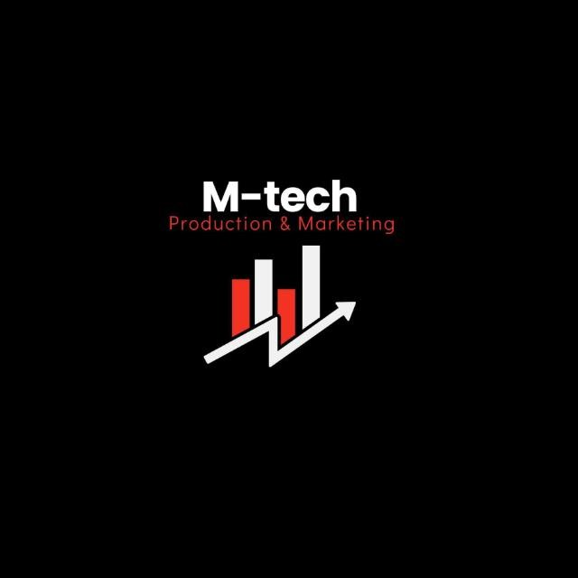

M-Tech Production & Marketing
Technology | Training | Marketing | Projects
TASK 1 REPORT
Internship Program — Batch 2026

Submitted By:
Hamza Badshah / Mtech-AI26028
Department:
AI / ML
Submitted To:
Ma’am Fatima
_______________________ | Supervisor:

Date:
29 June, 2026
Haripur Main Bazar, Khyber Pakhtunkhwa, Pakistan
mtechproductionandmarketing@gmail.com | +92 336 2222480

Introduction

This report presents the work completed for Task 1 of the M-Tech Production & Marketing AI/ML
Internship Program, Batch 2026. The internship focuses on practical exposure to core concepts in Artificial Intelligence and Machine Learning, equipping interns with skills applicable to real-world technology and marketing challenges.
M-Tech Production & Marketing is a forward-looking company based in Haripur, KPK, specializing in Technology, Training, Marketing, and Projects. The internship is structured in a 9-Phase roadmap designed to progressively build theoretical knowledge and hands-on project experience.

Objectives

- Bridge the gap between university learning and real-world software development through practical projects.
- Develop technical skills in AI, Machine Learning, Python, Full-Stack Development, and other emerging technologies.
- Improve analytical thinking, problem-solving, and logical programming abilities.
- Learn to use AI tools responsibly to enhance productivity while maintaining independent technical skills.
- Build professional skills such as communication, teamwork, documentation, and time management.
- Maintain a strong GitHub portfolio and professional LinkedIn profile to showcase completed work.

Task Description

The assigned task was to attend the official M-Tech Production & Marketing AI/ML Internship Orientation Session conducted by Abdullah Sajid. The session introduced interns to the internship's vision, objectives, learning methodology, and overall roadmap for the six-week program.
It also explained the assignment submission process, evaluation criteria, communication platforms, documentation standards, and professional expectations. The orientation provided a clear understanding of the internship structure and prepared interns for the practical learning journey ahead.

Work Done

- Attended the Orientation Session: Learned about the internship structure, objectives, and expectations for becoming an industry-ready professional.
- Understood the Learning Roadmap: Reviewed the internship phases and how each task contributes to practical skill development.
- Learned the Training Methodology: Explored pre-learning resources, live sessions, recorded lectures, practical assignments, and mentor guidance.
- Explored Communication Platforms: Understood how Google Classroom and Microsoft Teams will be used for learning, discussions, and assignment submissions.
- Defined Professional Goals: Planned to maintain a GitHub portfolio, improve my LinkedIn profile, and complete projects with proper documentation.
- Learned Responsible AI Usage: Understood the importance of using AI as a learning assistant while continuing to build personal coding and problem-solving skills.

Challenges Faced

- Adapting from academic learning to an industry-focused project environment.
- Managing internship tasks alongside university studies and personal learning.
- Understanding how to balance AI-assisted learning with independent coding and problem-solving.
- Preparing to maintain consistent documentation and project updates throughout the internship.

Key Learnings

- Consistency, discipline, and continuous learning are essential for professional growth.
- Practical implementation is more valuable than memorizing theoretical concepts.
- Maintaining an active GitHub portfolio helps demonstrate technical skills and project experience.
- Building a professional LinkedIn profile supports networking and career opportunities.
- Collaboration, teamwork, and mentor guidance contribute to better learning and project outcomes.
- AI should be used responsibly to improve productivity without replacing independent thinking.

Conclusion

The orientation session provided a strong foundation for the internship by clearly explaining the program's objectives, expectations, and learning process. It helped me understand the importance of practical learning, professional documentation, teamwork, and continuous skill development.
I am committed to actively participating in all internship activities, completing every assigned task with dedication, and improving my knowledge of Artificial Intelligence and Machine Learning. I look forward to applying the skills and experience gained during this internship to future academic and professional projects.

Intern Signature: | ___Hamza Badshah ___ | Supervisor: | _______________________
Name: | Hamza Badshah | Name:
Date: | 29 June, 2026 | Designation:

