

M-Tech Production & Marketing
Technology | Training | Marketing | Projects
TASK 1 REPORT
Internship Program — Batch 2026

Submitted By:
Hamza Badshah / Mtech-AI26028
Department:
AI / ML
Submitted To:
Ma’am Fatima
Date:
30 June, 2026
Haripur Main Bazar, Khyber Pakhtunkhwa, Pakistan
mtechproductionandmarketing@gmail.com | +92 336 2222480

Introduction

This report presents the work completed for Task 2 of the M-Tech Production & Marketing AI/ML Internship Program, Batch 2026. The internship focuses on practical exposure to core concepts in Artificial Intelligence and Machine Learning, equipping interns with skills applicable to real-world technology and marketing challenges.

M-Tech Production & Marketing is a forward-looking company based in Haripur, KPK, specializing in Technology, Training, Marketing, and Projects. The internship is structured in a 9-Phase roadmap designed to progressively build theoretical knowledge and hands-on project experience.

Objectives

- Successfully install Anaconda Navigator on a local system and verify its proper setup.
- Gain a foundational understanding of the Anaconda Navigator interface and its core features.
- Learn how to launch and work with Jupyter Notebook and Spyder for Python development.
- Understand how to manage Python environments and packages using Anaconda.
- Compare the functionality of a local development environment with cloud-based platforms such as Google Colab.
- Develop a clear understanding of the advantages, limitations, and appropriate use cases of both platforms.

Task Description

The assigned task involved installing Anaconda Navigator on my local computer and exploring its features as a Python development environment. After completing the installation, I learned how to launch Jupyter Notebook and Spyder, create and manage notebooks, and work with datasets in a local environment.
The task also required comparing Anaconda Navigator with Google Colab by evaluating their execution environment, hardware resource usage, internet requirements, data privacy, and setup process. This activity provided practical experience with local development tools and helped me understand when to use local or cloud-based platforms for different types of projects.

Work Done

- Installation: Successfully downloaded, installed, and configured Anaconda Navigator on my local system.

- Environment Exploration: Explored the Anaconda Navigator interface and became familiar with its available development tools.

- Launched Jupyter Notebook: Opened Jupyter Notebook, created a new Python notebook, and understood its basic workflow for writing and executing Python code.

- Explored Spyder IDE: Launched Spyder and observed its integrated development environment for Python programming and debugging.

- Platform Comparison: Performed a detailed comparison between Anaconda Navigator and Google Colab, focusing on execution, hardware dependency, internet requirements, data privacy, and setup

- Understanding Local Development: Learned how local environments provide greater control over installed libraries, files, and project resources.

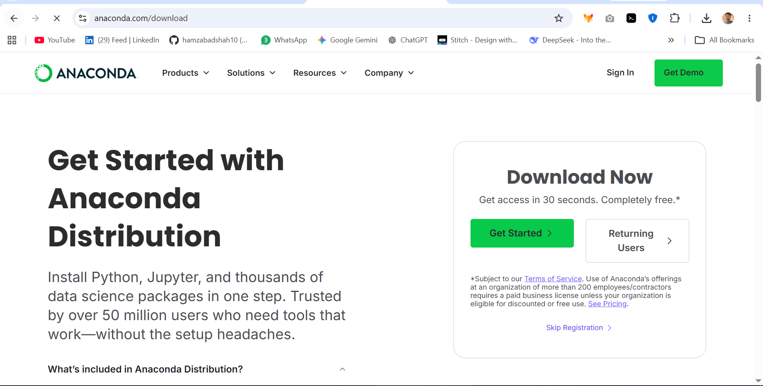

Launch Jupyter Notebook
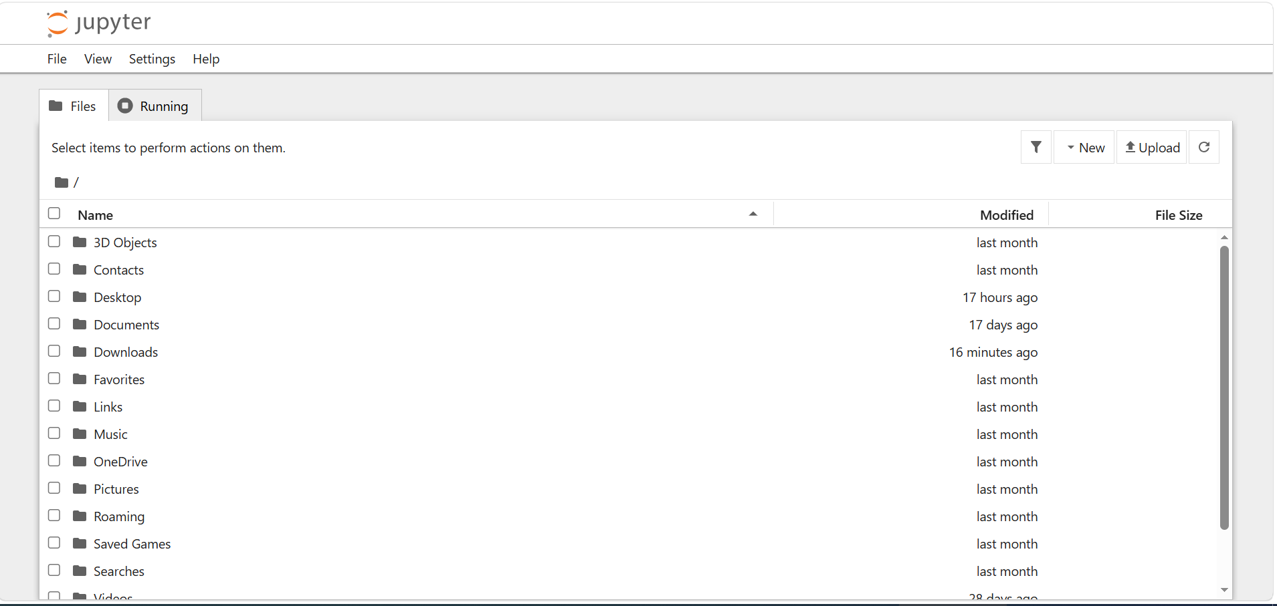

Comparison: Anaconda Navigator vs. Google Colab

Feature | Anaconda Navigator | Google Colab
Execution | Local (runs on your hardware) | Cloud-based (runs on Google servers)
Resource Dependency | Depends on your CPU/GPU/RAM | Uses Google’s cloud resources (free GPU/TPU)
Internet Requirement | No internet required for execution | Requires constant internet connection
Data Privacy | High (data stays on your machine) | Data is uploaded to Google Drive/Cloud
Setup | Requires manual installation/updates | Zero configuration; runs in a browser

Challenges Faced

- Ensuring that Anaconda Navigator was installed correctly without conflicting with existing Python installations.
- Verifying that the required environment variables and system paths were configured properly.
- Understanding the differences between package management in a local environment and cloud-based platforms.
- Learning the overall workflow and navigation of Anaconda Navigator for the first time.

Key Learnings

- Learned how to install and configure Anaconda Navigator as a complete Python development environment.
- Understood how to launch and use Jupyter Notebook and Spyder for Python programming.
- Learned the advantages of working in a local development environment, including offline access, better data privacy, and greater control over installed libraries.
- Understood that Google Colab is suitable for quick experimentation and GPU-intensive tasks, while Anaconda Navigator is ideal for long-term local project development.
- Gained practical knowledge of selecting the appropriate platform based on project requirements and available resources.

Conclusion

This task was successfully completed by installing and exploring Anaconda Navigator as a local Python development environment. Through this activity, I gained practical experience using Jupyter Notebook and Spyder while understanding the advantages of local development for offline work, data privacy, and package management.
Comparing Anaconda Navigator with Google Colab also helped me identify the strengths of both platforms and understand when each should be used. This task has provided a solid foundation for completing future AI/ML assignments and projects throughout the internship

Intern Signature: | ___Hamza Badshah___ | Supervisor: | _______________________
Name: | Hamza Badshah | Name:
Date: | 30 June, 2026 | Designation:

