Exploratory Data Analysis (EDA) Report - Fake News Detection

This is an exploratory data analysis (EDA) report for the Fake News Detection dataset. The dataset contains news articles labeled as either fake (0) or real (1). We aim to understand the distribution, relationships, and characteristics of the data.

# 1. Basic Information

Number of Rows: 44898

Number of Columns: 5

Column Names: title, text, subject, date, label

Data Types:  
title object  
text object  
subject object  
date object  
label int64  
dtype: object

# 2. Descriptive Statistics

label  
count 44898.000000  
mean 0.477015  
std 0.499477  
min 0.000000  
25% 0.000000  
50% 0.000000  
75% 1.000000  
max 1.000000

# 3. Visualizations

Figure 1: Distribution of Real vs Fake News

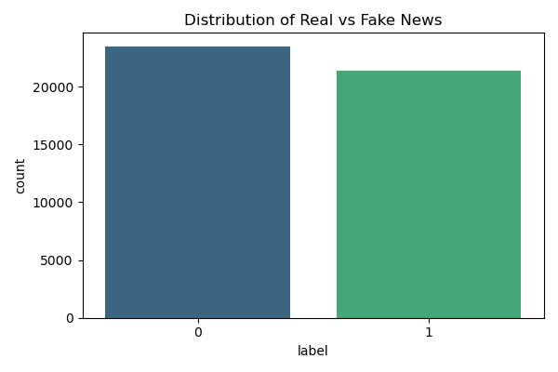

# 4. Profiling Report

For more detailed insights, please refer to the automated profiling report: 'eda_report.html'.