**LAB MANUAL 4**

**HomeTask # 4**

**ME-XXX: Computer Systems And Programming**



# Submitted by:

# Muhammad Hamza(467023)

**DEPARTMENT OF MECHANICAL ENGINEERING**

**NATIONAL UNIVERSITY OF SCIENCES AND TECHNOLOGY,H12**

# TASK 1:

## Write a C++ that prints the numbers from 1 to 150 except multiples of 10.

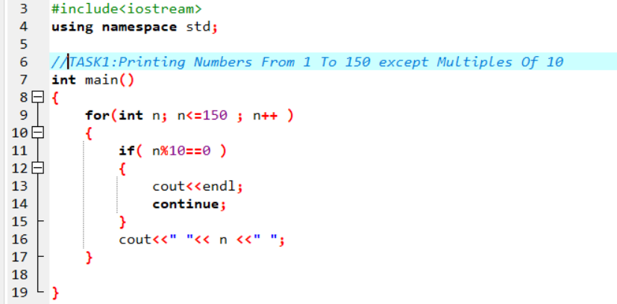

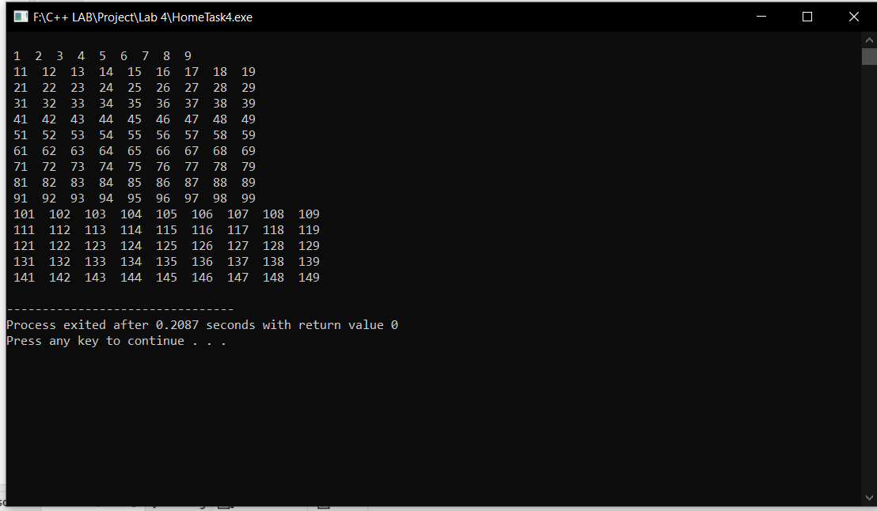

# TASK 2:

## Write a C++ program to find sum of digits of a number.



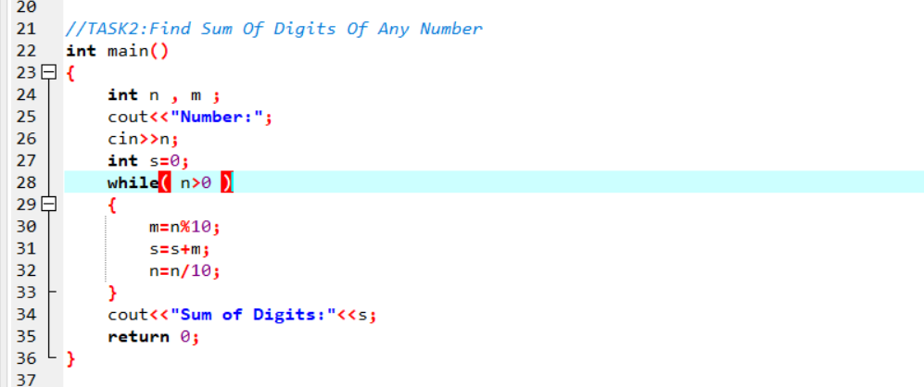

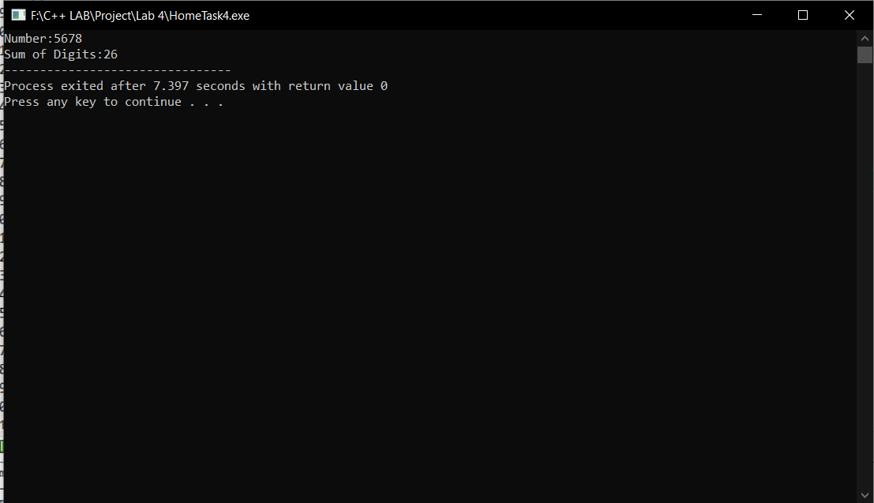

# TASK 3:

## Write aC++ program to check whether a number is prime number or not.



