**Loops**

**Lab Assignment # 5**

**ME-XXX Computer Systems And Programming**



## Submitted by:

**Muhammad Hamza (467023)**

**DEPARTMENT OF MECHANICAL ENGINEERING**

**NATIONAL UNIVERSITY OF SCIENCES AND TECHNOLOGY,H12**

## Convert the following while loop to a do-while loop:

## int x = 1; while (x > 0) { cout << "enter a number: "; cin >> x; }

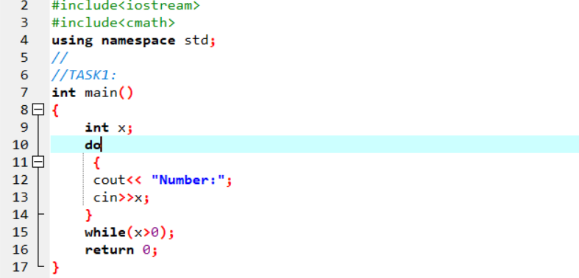

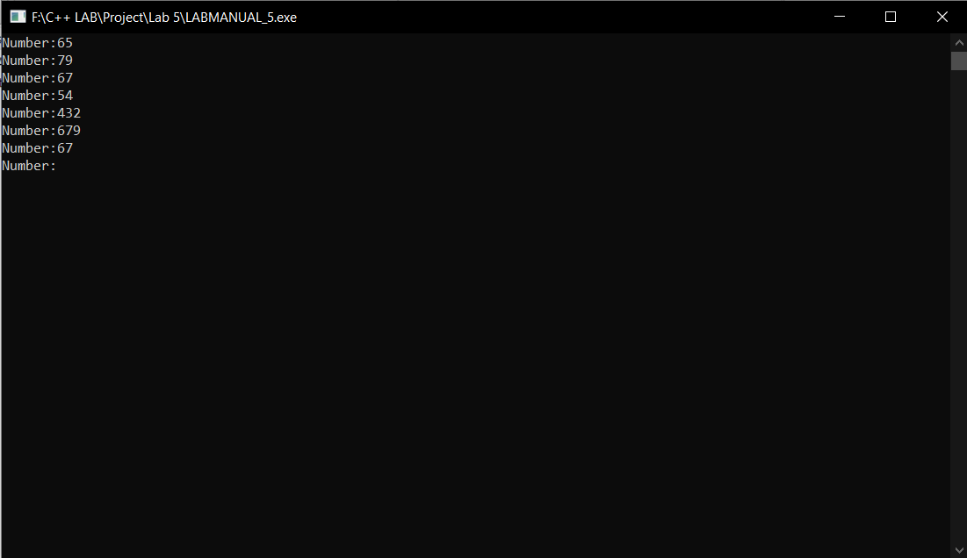

## Use a do while loop to make a simple calculator for two numbers. Insert buttons for it to ask again and for termination.



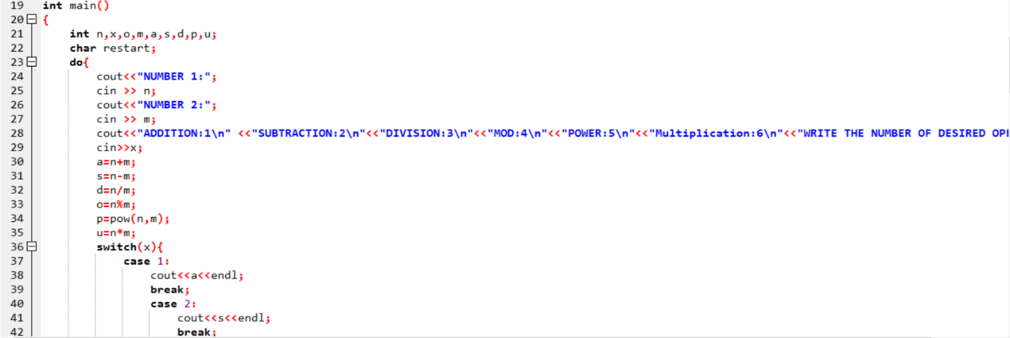

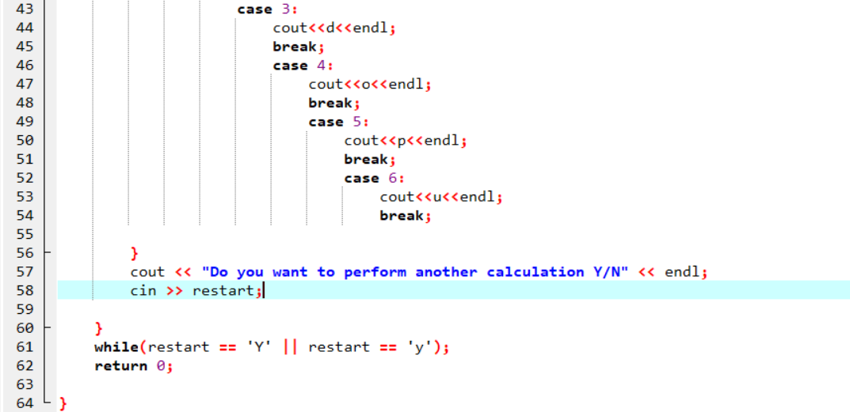

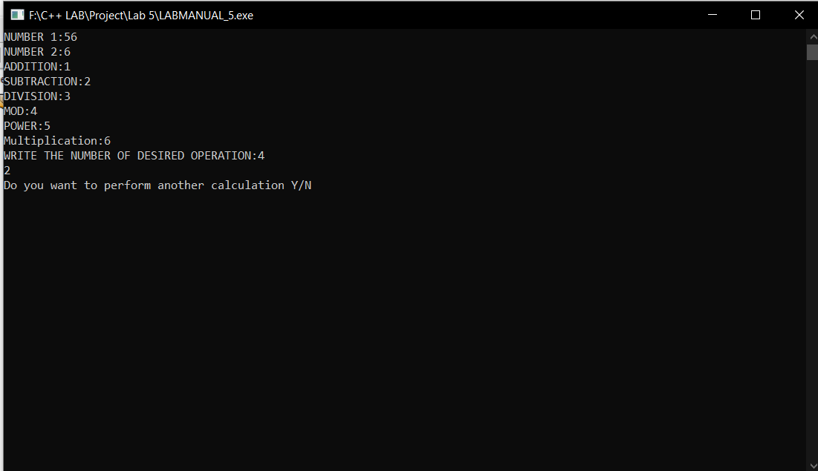

## 3. Write programs with while or do while loops that compute:

## a. The sum of all even numbers between 2 and 100 (inclusive).



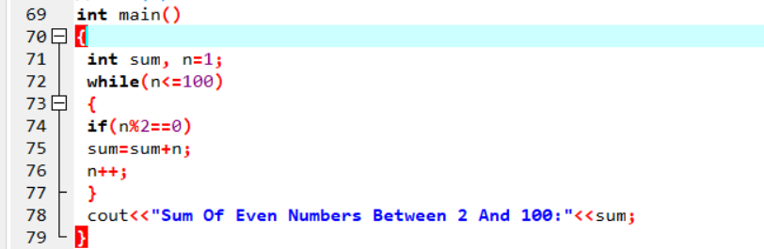

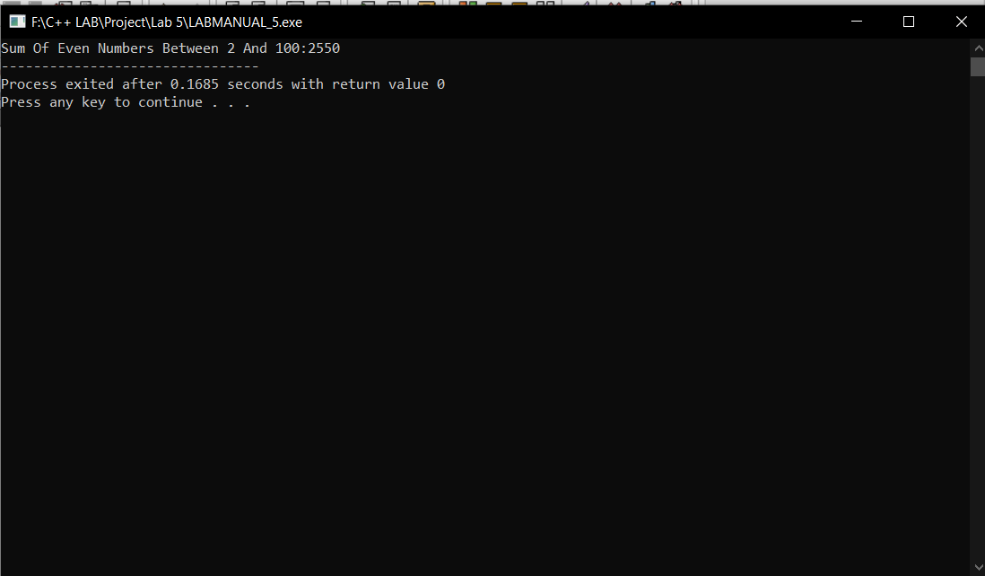

## b. The sum of all squares between 1 and 100 (inclusive)



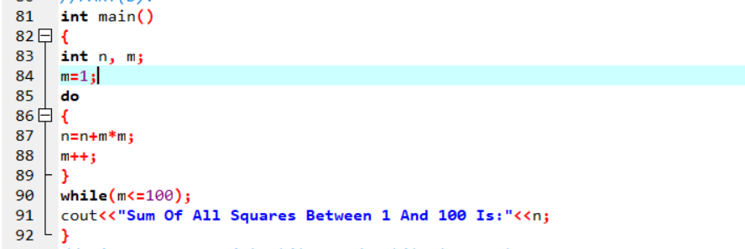

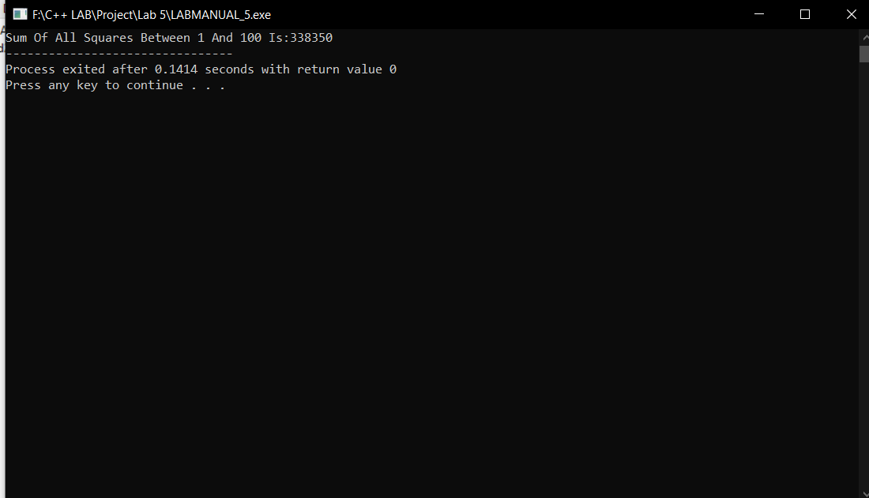

## 4. Write programs with while or do while loops that compute:

## a. All powers of 2 from 20 up to 220.



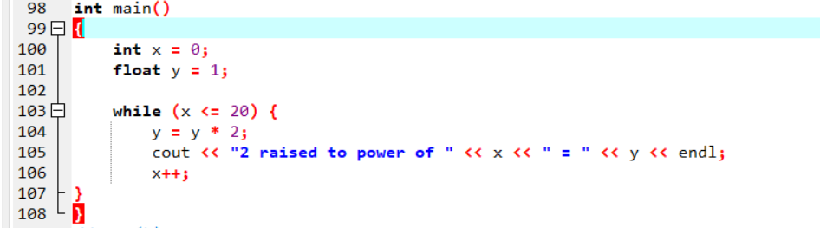

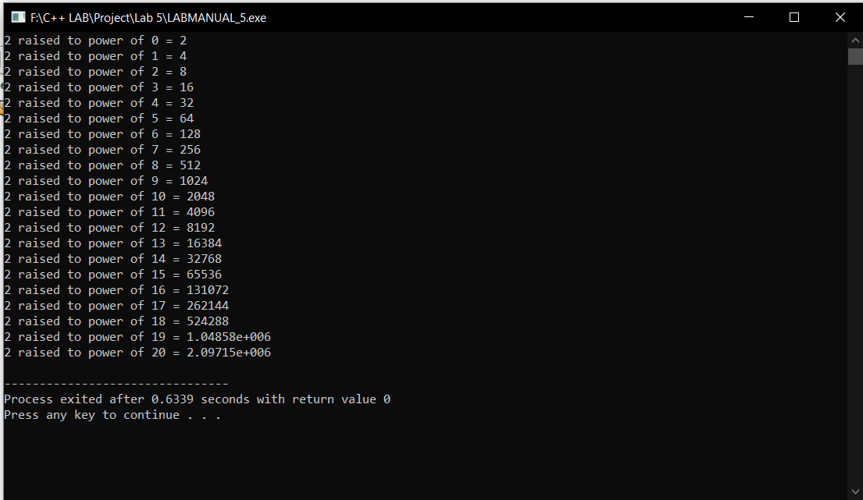

## b. The sum of all odd numbers between a and b (inclusive), where a and b are inputs

