**ARRAYS**

**LAB MANUAL # 7**

**ME XXX: COMPUTER SYSTEMS AND PROGRAMMING**



## Submitted by:

**Muhammad Hamza (467023)**

**DEPARTMENT OF MECHANICAL ENGINEERING**

**NATIONAL UNIVERSITY OF SCIENCES AND TECHNOLOGY,H12**

# LAB TASK 1

Take 10 integer inputs from user and store them in an array and print them on screen



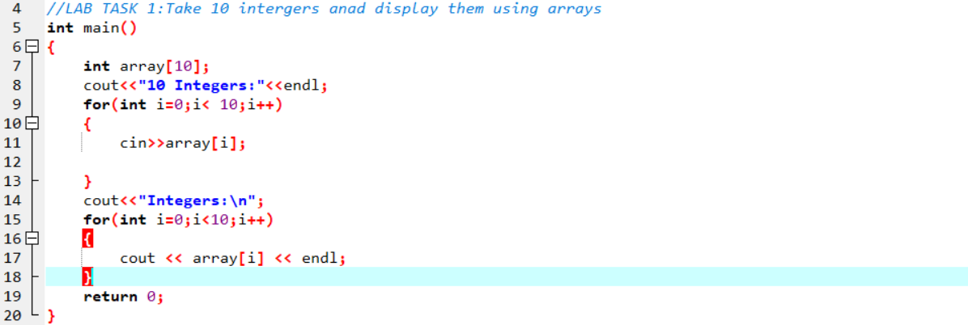

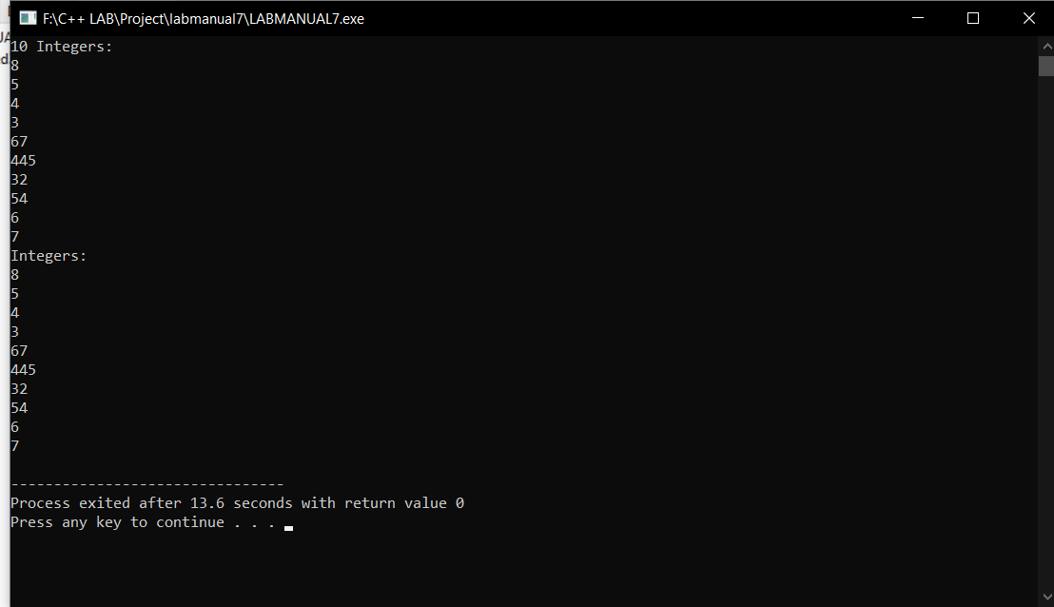

# LAB TASK 2

Write a program to find the sum and product of all elements of an array with 5 integer elements



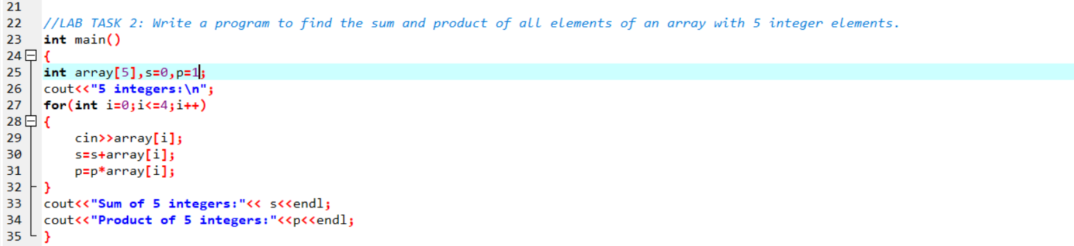

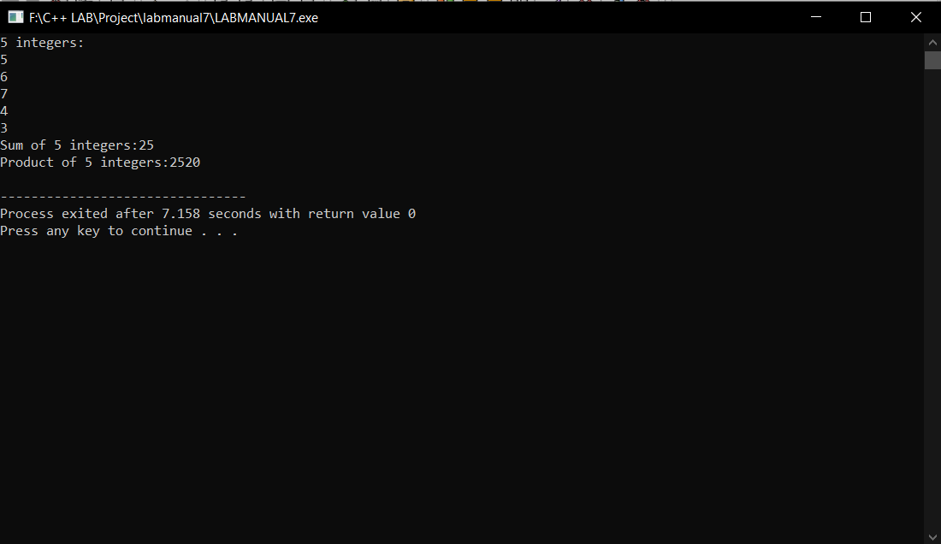

# LAB TASK 3

Print diamond pattern using a single array



