**HOMETASK**

**LAB # 8**

**ME-XXX:Computer Systems and Programming**



## Submitted by:

**Muhammad Hamza (467023)**

**DEPARTMENT OF MECHANICAL ENGINEERING**

**NATIONAL UNIVERSITY OF SCIENCES AND TECHNOLOGY,H12**

Take an array and find the most repeated element in that array.



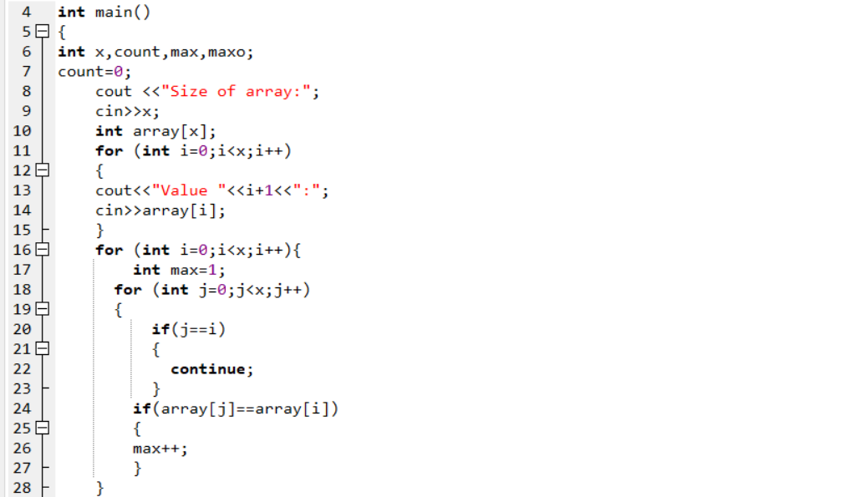

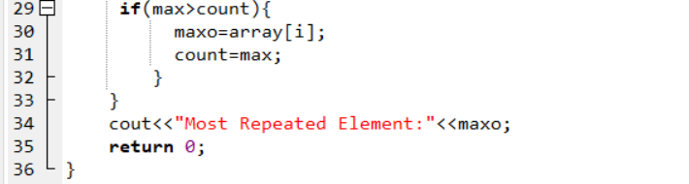

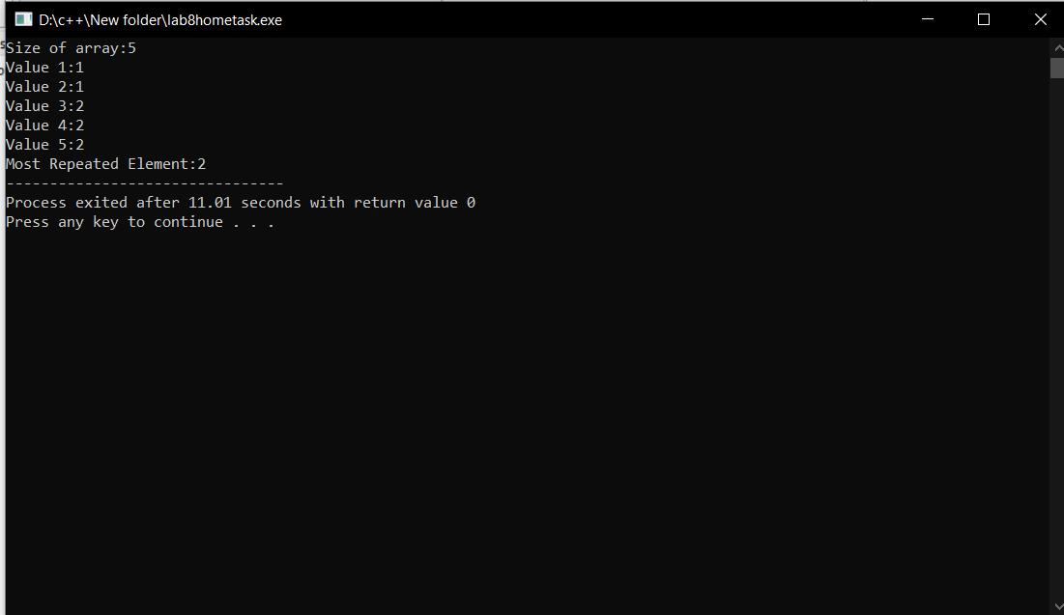

**Let’s say an array is a[8] = {13, 15, 17, 9, 99, 77, 65, 43}. Find largest and smallest element.**



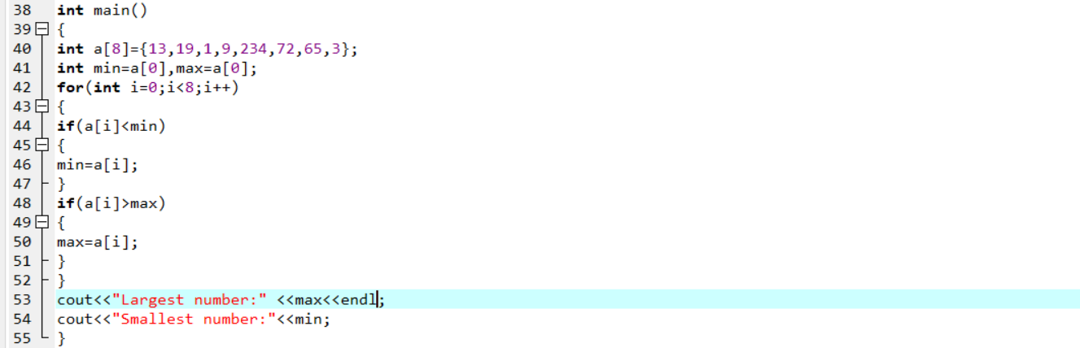

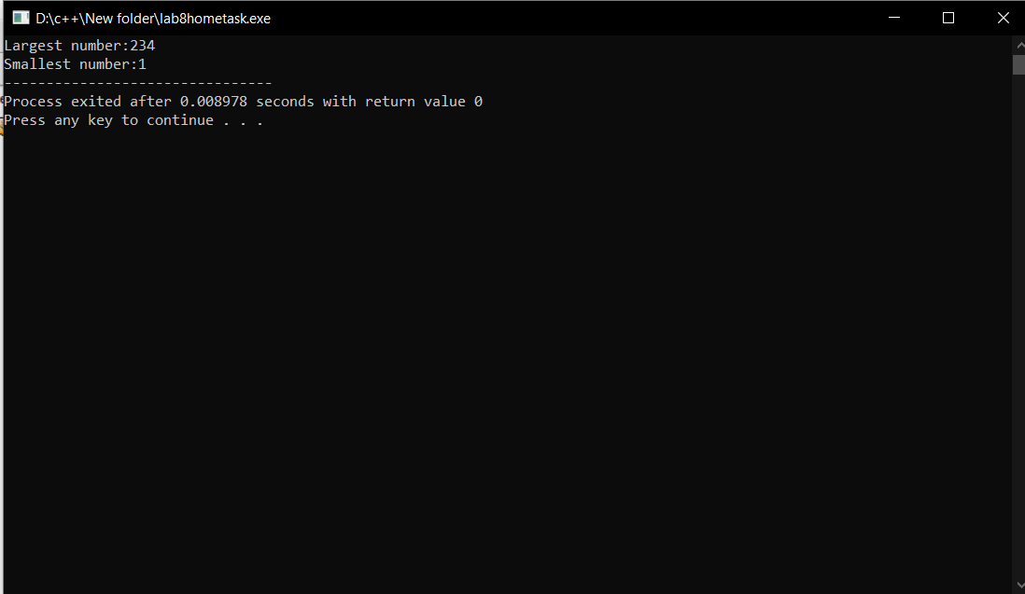

**3. Develop a program that takes 5 array elements from user. Swap position [2] element with position [4] element.**



