Quiz3

Name: MERIEM GUADDA

ID: 213J14

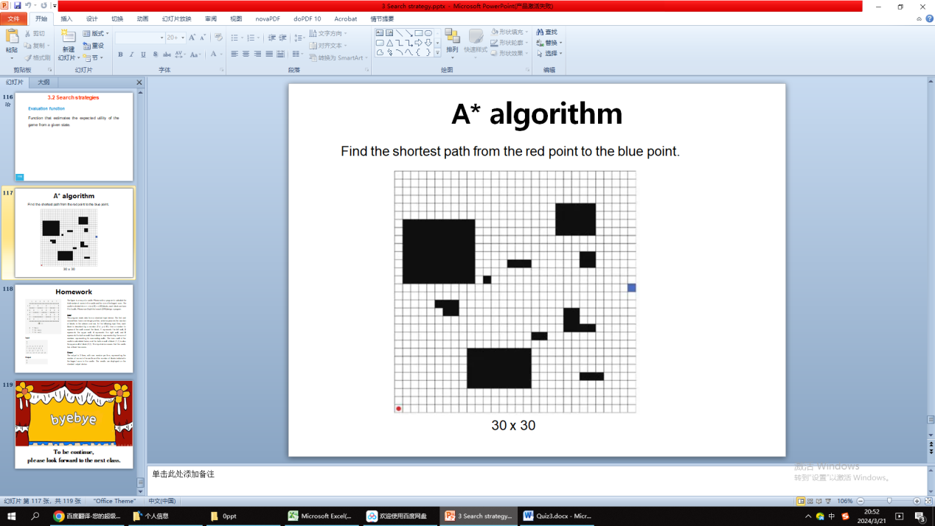

FFFFFFFFFFFFFFFFFFFFFFF

THE CODE:

def get_neighbors(grid, row, col):

"""

This function retrieves all valid neighbors for a given cell on the grid.

"""

neighbors = []

rows, cols = len(grid), len(grid[0])

for dx, dy in [(0, 1), (1, 0), (0, -1), (-1, 0)]:

new_row, new_col = row + dx, col + dy

if 0 <= new_row < rows and 0 <= new_col < cols and grid[new_row][new_col] != '1':

neighbors.append((new_row, new_col))

return neighbors

def find_shortest_path(grid, start, goal):

"""

This function implements BFS to find the shortest path between start and goal points.

"""

rows, cols = len(grid), len(grid[0])

queue = [(start[0], start[1], 0, [(start[0], start[1])])] # (row, col, distance, path)

visited = set()

while queue:

row, col, distance, path = queue.pop(0)

if (row, col) == goal:

return distance, path # Path found, return distance and path

if (row, col) in visited:

continue

visited.add((row, col))

for neighbor in get_neighbors(grid, row, col):

queue.append((*neighbor, distance + 1, path + [neighbor])) # Add neighbor with updated distance and path

return -1, [] # No path found

# Example usage

grid = [ [0, 0, 0, 0, 0, 0, 0, 0, 0, 0, 0, 0, 0, 0, 0, 0, 0, 0, 0, 0, 0, 0, 0, 0, 0, 0, 0, 0, 0, 0],

[0, 0, 0, 0, 0, 0, 0, 0, 0, 0, 0, 0, 0, 0, 0, 0, 0, 0, 0, 0, 0, 0, 0, 0, 0, 0, 0, 0, 0, 0],

[0, 0, 0, 0, 0, 0, 0, 0, 0, 0, 0, 0, 0, 0, 0, 0, 0, 0, 0, 0, 0, 0, 0, 0, 0, 0, 0, 0, 0, 0],

[0, 0, 0, 0, 0, 0, 0, 0, 0, 0, 0, 0, 0, 0, 0, 0, 0, 0, 0, 0, 0, 0, 0, 0, 0, 0, 0, 0, 0, 0],

[0, 0, 0, 0, 0, 0, 0, 0, 0, 0, 0, 0, 0, 0, 0, 0, 0, 0, 0, 1, 1, 1, 1, 1, 1, 0, 0, 0, 0, 0],

[0, 0, 0, 0, 0, 0, 0, 0, 0, 0, 0, 0, 0, 0, 0, 0, 0, 0, 0, 1, 1, 1, 1, 1, 1, 0, 0, 0, 0, 0],

[0, 1, 1, 1, 1, 1, 1, 1, 1, 1, 0, 0, 0, 0, 0, 0, 0, 0, 0, 1, 1, 1, 1, 1, 1, 0, 0, 0, 0, 0],

[0, 1, 1, 1, 1, 1, 1, 1, 1, 1, 0, 0, 0, 0, 0, 0, 0, 0, 0, 1, 1, 1, 1, 1, 1, 0, 0, 0, 0, 0],

[0, 1, 1, 1, 1, 1, 1, 1, 1, 1, 0, 0, 0, 0, 0, 0, 0, 0, 0, 1, 1, 1, 1, 1, 1, 0, 0, 0, 0, 0],

[0, 1, 1, 1, 1, 1, 1, 1, 1, 1, 0, 0, 0, 0, 0, 0, 0, 0, 0, 0, 0, 0, 0, 0, 0, 0, 0, 0, 0, 0],

[0, 1, 1, 1, 1, 1, 1, 1, 1, 1, 0, 0, 0, 0, 0, 0, 0, 0, 0, 0, 0, 0, 0, 0, 0, 0, 0, 0, 0, 0],

[0, 1, 1, 1, 1, 1, 1, 1, 1, 1, 0, 0, 0, 0, 0, 0, 0, 0, 0, 0, 0, 0, 1, 1, 0, 0, 0, 0, 0, 0],

[0, 1, 1, 1, 1, 1, 1, 1, 1, 1, 0, 0, 0, 0, 1, 1, 1, 0, 0, 0, 0, 0, 1, 1, 0, 0, 0, 0, 0, 0],

[0, 1, 1, 1, 1, 1, 1, 1, 1, 1, 0, 1, 0, 0, 0, 0, 0, 0, 0, 0, 0, 0, 0, 0, 0, 0, 0, 0, 0, 0,],

[0, 0, 0, 0, 0, 0, 0, 0, 0, 0, 0, 0, 0, 0, 0, 0, 0, 0, 0, 0, 0, 0, 0, 0, 0, 0, 0, 0, 0, 'E'],

[0, 0, 0, 0, 0, 0, 0, 0, 0, 0, 0, 0, 0, 0, 0, 0, 0, 0, 0, 0, 0, 0, 0, 0, 0, 0, 0, 0, 0, 0],

[0, 0, 0, 0, 0, 1, 1, 1, 0, 0, 0, 0, 0, 0, 0, 0, 0, 0, 0, 0, 0, 0, 0, 0, 0, 0, 0, 0, 0, 0],

[0, 0, 0, 0, 0, 0, 1, 1, 0, 0, 0, 0, 0, 0, 0, 0, 0, 0, 0, 0, 1, 1, 0, 0, 0, 0, 0, 0, 0, 0],

[0, 0, 0, 0, 0, 0, 0, 0, 0, 0, 0, 0, 0, 0, 0, 0, 0, 0, 0, 0, 1, 1, 0, 0, 0, 0, 0, 0, 0, 0],

[0, 0, 0, 0, 0, 0, 0, 0, 0, 0, 0, 0, 0, 0, 0, 0, 0, 0, 0, 0, 1, 1, 1, 1, 0, 0, 0, 0, 0, 0],

[0, 0, 0, 0, 0, 0, 0, 0, 0, 0, 0, 0, 0, 0, 0, 0, 0, 1, 1, 0, 0, 0, 0, 0, 0, 0, 0, 0, 0, 0],

[0, 0, 0, 0, 0, 0, 0, 0, 0, 1, 1, 1, 1, 1, 1, 1, 1, 0, 0, 0, 0, 0, 0, 0, 0, 0, 0, 0, 0, 0],

[0, 0, 0, 0, 0, 0, 0, 0, 0, 1, 1, 1, 1, 1, 1, 1, 1, 0, 0, 0, 0, 0, 0, 0, 0, 0, 0, 0, 0, 0],

[0, 0, 0, 0, 0, 0, 0, 0, 0, 1, 1, 1, 1, 1, 1, 1, 1, 0, 0, 0, 0, 0, 0, 0, 0, 0, 0, 0, 0, 0],

[0, 0, 0, 0, 0, 0, 0, 0, 0, 1, 1, 1, 1, 1, 1, 1, 1, 0, 0, 0, 0, 0, 0, 1, 1, 1, 0, 0, 0, 0],

[0, 0, 0, 0, 0, 0, 0, 0, 0, 1, 1, 1, 1, 1, 1, 1, 1, 0, 0, 0, 0, 0, 0, 0, 0, 0, 0, 0, 0, 0],

[0, 0, 0, 0, 0, 0, 0, 0, 0, 0, 0, 0, 0, 0, 0, 0, 0, 0, 0, 0, 0, 0, 0, 0, 0, 0, 0, 0, 0, 0],

[0, 0, 0, 0, 0, 0, 0, 0, 0, 0, 0, 0, 0, 0, 0, 0, 0, 0, 0, 0, 0, 0, 0, 0, 0, 0, 0, 0, 0, 0],

[0, 0, 0, 0, 0, 0, 0, 0, 0, 0, 0, 0, 0, 0, 0, 0, 0, 0, 0, 0, 0, 0, 0, 0, 0, 0, 0, 0, 0, 0],

[0, 0, 0, 0, 0, 0, 0, 0, 0, 0, 0, 0, 0, 0, 0, 0, 0, 0, 0, 0, 0, 0, 0, 0, 0, 0, 0, 0, 0, 0],

['S', 0, 0, 0, 0, 0, 0, 0, 0, 0, 0, 0, 0, 0, 0, 0, 0, 0, 0, 0, 0, 0, 0, 0, 0, 0, 0, 0, 0, 0]

]

def visualize_path(grid, path):

"""

Visualizes the path on the grid.

"""

for row in range(len(grid)):

for col in range(len(grid[0])):

if (row, col) in path:

print("*", end=" ")

else:

print(grid[row][col], end=" ")

print()

start = (30, 0) # Replace with your starting coordinates (row, col)

goal = (14, 29) # Replace with your goal coordinates (row, col)

distance, path = find_shortest_path(grid, start, goal)

if distance != -1:

print(f"Shortest path length: {distance}")

visualize_path(grid, path)

else:

print("No path found between start and goal points.")

Result:

