Consider the DNA sequence GCAAGCG. Draw the suffix tree corresponding to this sequence. Also, label the internal nodes with their string depths.

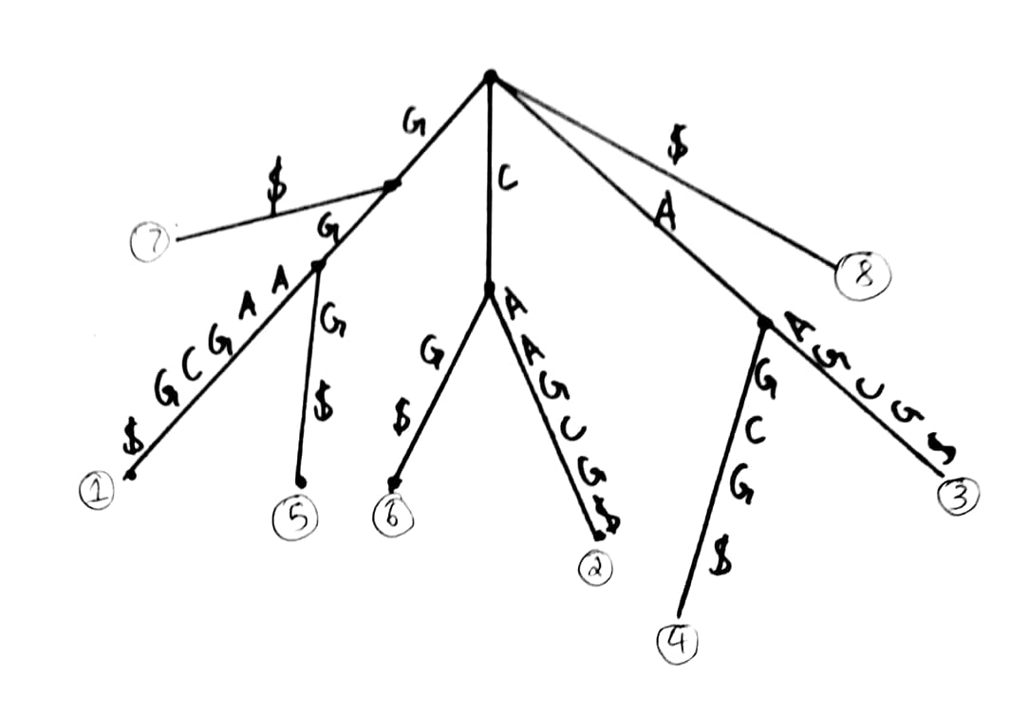Draw the generalised suffix tree using the sequences GC AAGCG, AAG and TGC.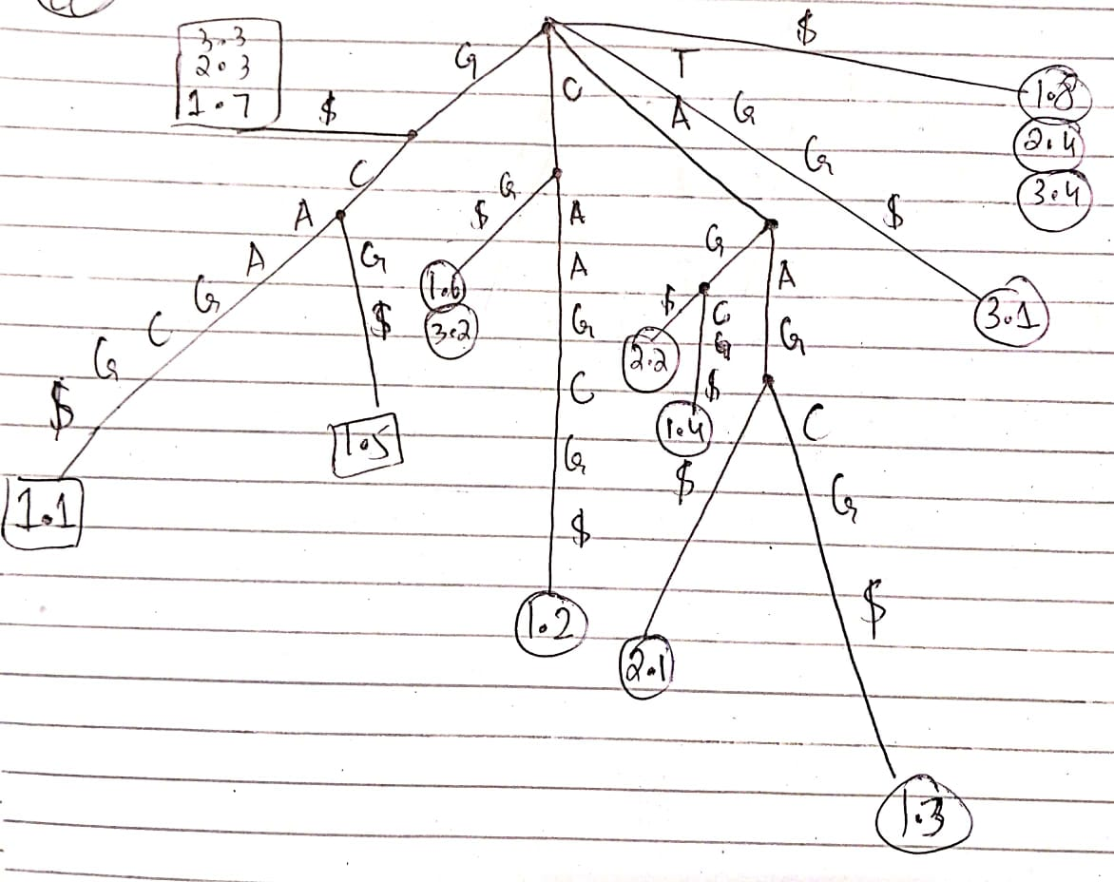

1

1

1

2

Globally align the protein sequences HEAGAWGHEE and PAWHEAE using dynamic programming. Use BLOSUM50 matrix to calculate the match/mismatch scores. The gap penalty is -8. What is the score of your alignment?

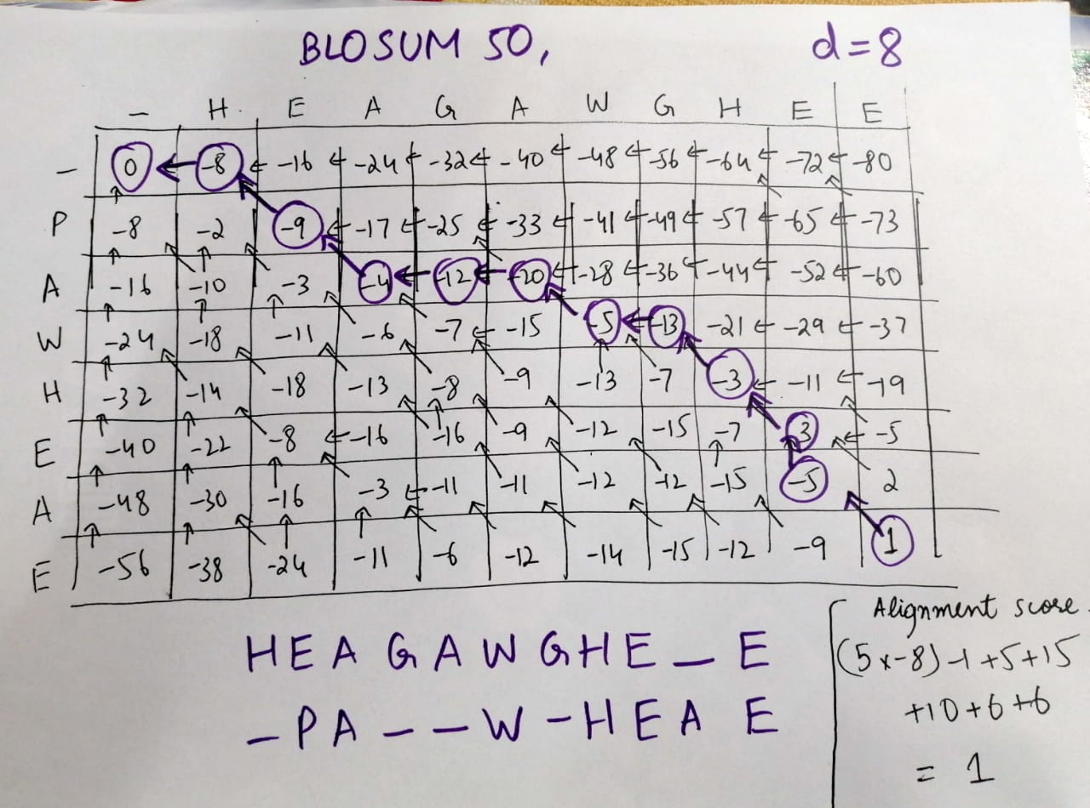

Globally align the sequences GA and GCA using the affine gap penalty model where the scoring scheme is d = −7, e = −2, match = 1 and mismatch = −3

