Article

AI and Machine Learning Methods for n-Colorant Printer Characterization
Muhammad Hamza Zafar 1,∗ and Phil Green 1

Colourlab, Department of Computer Science, Norwegian University of Science and Technology (NTNU), 2815 Gjøvik, Norway
* Correspondence: muhammad.h.zafar@ntnu.no

Abstract 1
- Printer color characterization maps colorant amounts to colorimetry; the 2
classical toolchain strains beyond four inks. We compare 14 machine learning methods 3
against polynomial regression on nine datasets spanning three- to seven-colorant datasets, 4
under cross-validation with CIEDE2000 (∆E₀₀).

Gaussian process regression 11
remains the best-median model on all nine datasets, but at seven inks its margin over 12
a degree-4 CIELAB polynomial is a factor of 1.7. An exploratory probe finds 13
the best unaided large-language-model equation 13 times worse than a least-squares 14
cubic. Machine learning characterizes n > 4 colorant systems well, and so does classical 15
polynomial regression, given the fitting space and degree it needs. 16
Keywords: printer characterization; color; machine learning; CIEDE2000; n-color; printing 17
industry 18

Received:
Revised:
Accepted:
Published:
Copyright: © 2026 by the authors. Submitted to Technologies for possible open access publication under the terms and conditions of the Creative Commons Attribution (CC BY) license.
- Introduction 19
The forward model in printer color characterization is the problem of predicting the
colorimetry (normally CIE XYZ or CIE Lab) that a printer produces for a given combination of colorant 21
inputs.Cyan, magenta, yellow, and black (CMYK) process colours are the most common, but larger 22
colorant sets (e.g., adding orange, green, violet, or blue) are also used in commercial and packaging and 23
printing. Two approaches are widely used, often in combination: a dense 24
look-up table (LUT) is built over the colorant space, interpolated at print time, or a 25
polynomial regression is fitted. . Both approaches require training data from the printing and measurement of test charts; however, they scale poorly 26
as the number of colorants n grows:.A LUT’s node count grows exponentially with n 27
[1], and a fixed-order polynomial’s term count also grows combinatorially (e.g. 20 terms 28
for a 3rd-order expansion of 3 inputs, 35 for 4 inputs), while offering no principled way 29
to add higher-order interaction terms only where the data need them. This has made 30
n > 4 colorant printing (CMYKOGV, CMYKOGB, and similar seven-channel systems used 31
commercially to extend gamut and reduce spot-color dependence [2,3]) a case where the 32
standard characterization toolchain is structurally strained, independent of how much 33
calibration data is available. 34

Machine learning methods that fit a function directly from data, rather than a fixed- 35 degree polynomial basis or a discretized LUT, are an obvious candidate to close this gap, and 36 have been proposed for color device characterization since at least the early 1990s [4,5], and 37 a continuing literature applies neural and ensemble models to CMYK-to-CIELAB printer 38 characterization [6,7]. That literature is fragmented across devices and protocols, however, 39 and rarely evaluates a broad model set under a single corrected, perceptually uniform 40 error metric across colorant counts. This paper is organized around two questions: (a) can AI and machine learning match or beat classical polynomial regression at 43 n ≤ 4 colorants, potentially avoiding gray-component-replacement-style handling of the 44 K channel; and (b) can they handle n > 4 colorant systems, where classical polynomial and 45 LUT-based methods are not designed to scale gracefully. Question (a) is answered with 46 corrected, cross-validated results on three printer datasets at n = 3 and n = 4 (Section 4); 47 question (b) in Section 4.7, with full model comparisons on a five-ink KCMYG set and two 48 independent seven-ink sets (CMYKOGV, CMYKOGB). 49

64
- Related Work 65
Device characterization, mapping a device’s control values to a device-independent 66
color space, is a long-standing problem in color science, surveyed for example in Bala [9] and Green [xx]. The classical 67
solutions are LUT-based interpolation and low-order polynomial regression fit by ordinary 68
least squares, often used in combination.. 69
Neural networks were proposed for printer and scanner characterization as early as Kang 70
and Anderson [4] and Tominaga [5], and later work compared them against polynomial 71
transforms for camera characterization [10], finding approximately equal accuracy and 72
recommending the polynomial on practical grounds: it is simpler to fit, and its parameter 73
set is smaller and easier to audit. The line has continued since: wavelet neural networks [6] 74
and stacking ensembles [7] map CMYK to CIELAB directly, and Gaussian process regression 75
has been applied to camera characterization [11]. This paper revisits that comparison with 76
a much larger model set (14 methods spanning linear, kernel, tree-ensemble and neural 77
architectures), a perceptually uniform error metric (Section 3.3), a direct 78
test of n > 4 colorant generalization against a properly fitted classical baseline, and an 79
exploratory test of a large language model as a zero-shot color predictor. 80

Printer characterization and calibration models conventionally 82
take CIELAB as their output space, but evaluating error using a more perceptually uniform metric such as CIEDE2000 83

is preferred He et al. [14] compare XYZ, 90 log-XYZ and CIELAB regression targets for third-order polynomial and neural models 91 on a CMYK 3D printer and found raw XYZ the worst of the three. 98
Characterizing an n > 4 colorant process is not itself a new problem. The analytical 99
line runs from the seven-ink color-to-colorant transforms of Boll [2], through Neugebauer- 100
family models generalized to n inks by barycentric subdivision [15], to the spot color 101
overprint model of Deshpande et al. [16]

Shi et al. [17] train a neural spectral predictor for ten-ink 104
multilayer printing, and Chen and Urban [18] learn deep forward and backward models 105
for a six-material 3D printer.

110
Large language models have been shown to act as capable in-context regressors on 111
numerical data [19] and, when allowed to write and execute code, to discover scientific 112
equations by proposing skeletons whose parameters are fitted numerically [20]. The ex- 113
ploratory probe of Section 4.8 asks the domain-specific form of that question, whether 114
a language model can write a usable CMY→XYZ characterization equation from mea- 115
surement pairs in its prompt, for which the authors have found no published attempt; its 116
code-execution condition reproduces exactly the division of labor that Shojaee et al. [20] 117
formalize. 118
The regression methods compared in Section 3.2 draw on standard machine learning 119
literature: ridge regression [21], the lasso and elastic net [22,23], principal component 120
regression [24], partial least squares [25], support vector regression [26], k-nearest neighbors 121
[27], classification and regression trees [28], random forests [29], gradient boosting [30], 122
and Gaussian process regression [31]. Color differences throughout use the CIEDE2000 123
formula [32], the current standard perceptual color-difference metric.

127
- Materials and Methods 128
  - Datasets 129
This paper is structured around the full n = 3 → 4 → 5 → 7 colorant ladder 130
summarized in Table 1. Three printer characterization datasets (PC10, PC11, FOGRA51) 131
consist of 1,617 measured CMYK combinations under a shared measurement 132

protocol (spectrophotometric CIE Lab and CIE XYZ, D50 illuminant, 2° standard observer), 133 and each were evaluated twice: once restricted to the K = 0 subset with only C, M, Y as 134 inputs (818 measured rows, the n = 3/CMY condition), and once using the full sample 135 set with C, M, Y, K as four inputs (1,617 measured rows, the n = 4/CMYK condition). 136 Two row counts were kept apart throughout, and both are given in Table 1: the counts 137 as received, just quoted, and the counts as analyzed after duplicate rows in CMYK space were 138 removed (Section 3.3), giving 795 for every CMY condition and 1,588 for every 139 CMYK condition, the latter comprising 795 rows with K = 0 plus 793 with K > 0. Every 140
∆E₀₀ statistic in this paper is computed over the analyzed rows; the as-received counts 141 appear only where the datasets themselves are being described. A fourth, n = 4 dataset serves the cross- 145 printer generalization experiments of Section 4.6 rather than the model-comparison tables: 146 13 newsprint press runs, 1,485 CMYK samples per run, 147 measured as 36-band spectral reflectance (380–730 nm) and converted to CIE XYZ (D50/2°) 148 via the colour-science library [35]. Registered characterization data sets such as FOGRA52 and APTECH are usually derived from multiple press runs and subject to smoothing, as opposed to the newsprint datasets which are individual measured press runs and subject to greater noise from print and measurement variability. It has previously been noted (Green 2006) that averaging and smoothing lead to smaller model errors. 151
Three further datasets extend the ladder to n = 5 and n = 7 (Section 4.7). KCMYG 152
is a five-ink (black, cyan, magenta, yellow, green) chart of 2,214 patches, measured as 153
36-band spectral reflectance and converted to XYZ. CMYKOGV is the 154
APTEC seven-ink (CMYK plus orange, green, violet) coated chart published through the 155
ICC characterization-data registry [36], measurements in XYZ and Lab (D50/2°, M1) 156
with 3,534 patches; 232 of these are duplicates
which were removed by the 158
same exact-duplicate policy applied to every dataset compared in this paper (Section 3.3), 159
leaving 3,302 analyzed samples. CMYKOGB is a seven-ink (CMYK plus orange, 160
green, blue) chart of 2,000 spectral patches. The two 161
seven-ink sets differ in their seventh colorant (violet vs. blue) and come from different 162
providers.
164
Table 1. Datasets across the full n = 3 → 4 → 5 → 7 colorant ladder. Rows are given as received, with the analyzed count in parentheses where byte-identical duplicate rows are removed (Section 3.3);. Analyzed rows are pooled across all 5 cross-validation folds, so every one of them is predicted exactly once.

Dataset | Substrate | Colorants | n | Rows | Source
PC10 | CCNB 250 g/m2 (PS 11) | CMY | 3 | 818 (795) | APTEC PC10 [34]
PC10 | CCNB 250 g/m2 (PS 11) | CMYK | 4 | 1,617 (1,588) | APTEC PC10 [34]
PC11 | CCNB 250 g/m2 (PS 11) | CMY | 3 | 818 (795) | APTEC PC11 [34]
PC11 | CCNB 250 g/m2 (PS 11) | CMYK | 4 | 1,617 (1,588) | APTEC PC11 [34]
FOGRA51 | Reference (ISO 12647-2) | CMY | 3 | 818 (795) | Fogra Research Institute [33]
FOGRA51 | Reference (ISO 12647-2) | CMYK | 4 | 1,617 (1,588) | Fogra Research Institute [33]
News | Newsprint, 13 press runs | CMYK | 4 | 1,485 / run | Newspaper industry
KCMYG | Coated (5-ink) | CMYK+G | 5 | 2,214 | Commercial printer
CMYKOGV | Coated (7-ink) | CMYK+OGV | 7 | 3,534 (3,302) | APTEC, ICC registry [36]
CMYKOGB | Coated (7-ink) | CMYK+OGB | 7 | 2,000 | Commercial printer

  - Models 165
Fourteen regression methods are compared (Table 2)

All models are implemented input-dimension-agnostically, so the 170
same code path serves the n = 3, n = 4, n = 5, and n = 7 conditions. Every stochastic 171
model is seeded (fixed seed 42) for reproducibility. 172
Four further variants are added for Section 4.5 and appear in the same tables, 173
listed at the foot of Table 2. Two of them lift the third-order cap (poly4) and the 174
XYZ fitting space (poly3_cbrt) separately, one lifts both (poly4_cbrt), and the fourth 175
(gaussian_process_cbrt) offers the same change of fitting space to the polynomial’s 176
strongest competitor.

The _cbrt variants differ from their plain counterparts in one respect: 180
the estimator is fitted against √3 XYZ (physical XYZ, clipped at zero) and its prediction is 181
cubed on the way out. 182

Table 2. Methods implemented.

Model Configuration

Polynomial regression (degree 3) Full 3rd-order feature expansion + ordinary least squares Ridge regression [21] α = 0.5
Lasso regression* [22] α = 10−3
Elastic Net* [23] α = 10−3, ℓ₁ ratio = 0.5
Principal component regression [24] All components retained + Ridge (α = 0.5)
Partial least squares regression [25] 3 components
k-nearest neighbors [27] k = 5, uniform weights
Support vector regression* [26] RBF kernel, C = 10, γ = scale, ε = 0.01 Decision tree [28] Unconstrained depth
Random forest [29] 200 trees, max depth 15
Gradient boosting [30] 200 estimators, learning rate 0.05, max depth 5
Gaussian process regression [31] Const RBF + WhiteKernel(10−3, bounds 10−9–105), y-normalized, 15 opti-
×
mizer restarts
MLP (shallow) 1 hidden layer, 64 units, L-BFGS
MLP (deep) 3 hidden layers, 64 units each, L-BFGS

Fitting-space and degree variants (Section 4.5)
√
poly3_cbrt Degree-3 expansion + OLS, fitted against ³

XYZ; prediction cubed back

poly4 Full 4th-order feature expansion + ordinary least squares, fitted on XYZ
√
poly4_cbrt Degree-4 expansion + OLS, fitted against ³ XYZ; prediction cubed back Gaussian process as configured above, fitted against ³ XYZ; prediction cubed
√

gaussian_process_cbrt
back

Evaluation Protocol 183
Each (dataset, model) pair is evaluated with 5-fold cross-validation (fixed seed 42, 184
shuffled). Duplicate rows

were removed. 187

191
The newsprint runs are deliberately not de-duplicated: 205 their repeated colorant entries carry differing measurements (roughly 0.4–1.9 ∆E₀₀ of 206 press repeatability, Section 4.6), which is signal about the press rather than an artifact, so 207 those repeats are retained and made to co-travel into one fold by grouped cross-validation 208 instead. Within each fold: 209
- A MinMax scaler is fit on the training fold’s inputs and, separately, on the training 210
fold’s XYZ targets; scaling parameters are never estimated from the held-out fold. 211
- The model is fit in the normalized (0–1) input/output space. 212
- Predictions are generated in normalized space, then inverse-transformed back to 213
XYZ using the training fold’s target scaler. 214
- Predicted XYZ values are clipped at zero (tristimulus values cannot be negative). 215
- Both predicted and ground-truth XYZ are converted to CIE Lab under the D50 illumi- 216
nant and 2° standard observer, and the per-sample color difference is computed with 217
the CIE 2000 formula [32]. 218
Every sample in a dataset is held out exactly once across the 5 folds, so the reported 219
statistics pool over the entire dataset rather than a single train/test split. Summary statistics 220
are the median, 95th percentile, and maximum of the per-sample ∆E₀₀ distribution, not 221
the mean or standard deviation, since color-difference errors are not normally distributed 222
and a small number of large outliers can otherwise dominate a mean-based summary. 223
Two further protocol details are specific to the n = 5 and n = 7 datasets. First, 224
their folds are assigned with scikit-learn’s GroupKFold, keyed on the distinct input recipe 225
(rounded to 6 decimal places). KCMYG and CMYKOGB contain repeated recipes whose 226
measurements genuinely differ (CMYKOGB’s 20 repeated paper-white patches spread 227
by 0.348 ∆E₀₀), so, as with the newsprint data, those repeats are kept as measured and forced into a 228
single fold rather than removed; CMYKOGV-7’s duplicates are byte-identical and are 229
removed by the policy above
. GroupKFold’s assignment is deterministic and unshuffled, in contrast to the 231
seeded shuffled k-fold used for the coated n ≤ 4 sets. Second, Gaussian process training 232
folds are subsampled to at most 2,000 rows (fixed seed 42) to bound the method’s O(N3) fit 233
cost, a cap that only CMYKOGV-7 (3,302 analyzed rows) actually reaches. 234

239
Reproducibility. 240
All models use fixed seeds and a pinned dependency set (Python 3.12.11, scikit-learn 241
1.7.2, NumPy 2.3.3, SciPy 1.16.2)
.
The Gaussian process 244
uses the single dataset-agnostic kernel configuration of Table 2 (WhiteKernel initialized 245
at 10−3, bounds 10−9–105, 15 optimizer restarts), with no per-dataset tuning
. Two checks bound how far the numbers travel, and both were re-run on 247
the de-duplicated data used throughout this paper. Re-running the 16 models then in 248
the registry on the six coated datasets (96 model/dataset cells) on a second machine 249
(Linux/x86-64, OpenBLAS) under an identical pinned environment, same code, data and 250
seeds, reproduces the macOS/arm64 (Apple Accelerate) values on 58 of 96 cells exactly 251
and on 76 of 96 to within 0.01 ∆E₀₀, with a worst case of 0.108; each of the largest 252
divergences is an iteratively optimized neural net, while the closed-form, kernel and tree 253
methods all agree exactly or to within 0.01. Pinned dependencies alone therefore do not 254
give cross-platform bit-reproducibility, and the reported values are additionally pinned to 255
one platform (macOS/arm64). The Gaussian process is the least platform-sensitive of the 256
family: its final configuration reproduces exactly on seven of the nine non-newsprint datasets and 257
to within 0.016 on the other two, and all 182 newsprint Gaussian process results (13 within-run, 258
156 cross-run, 13 leave-one-out) are bit-exact across the two platforms. Varying the cross- 259
validation shuffle seed over 0/1/2/3/42 on the six coated datasets moves each model’s 260
median by a standard deviation of at most 0.001 (Gaussian process), 0.009 (polynomial), 261
0.023 (SVM), 0.044 (k-NN) and 0.091 (deep MLP), so fold assignment is not a meaningful 262
source of variance at the precision reported here, the MLPs excepted.

A 265
third and stronger check is independent of this implementation entirely: a clean-room 266
re-implementation, carried out by an independently tasked AI coding agent in a separate 267
workspace, built from the raw measurement files and a prose specification alone (with 268
no access to our code, configuration or results), wrote its own CGATS parser, Lab/XYZ 269
and spectral-to-XYZ conversions, cross-validation and ∆E₀₀ path, and reproduced our 270
Gaussian process medians to within 0.003 ∆E₀₀ and the third-order polynomial’s to within 271
0.001 on every coated dataset.

276
Use of generative AI in conducting this study. 277
Generative AI assisted the implementation of the pipeline, the figure-plotting code 278
and the manuscript prose, as declared in the Acknowledgments. No reported quantity orig- 279
inates with an assistant: every number in this paper is produced by the committed pipeline 280
from the committed data, written to a version-controlled results CSV and checked against 281
it, with the clean-room reimplementation above as a further check on the implementation 282
itself. This use of AI as an instrument is distinct from Section 4.8, where large language 283
models are the object of study; no model evaluated there had any role in producing the rest 284
of the paper. 285

Correction to the AIC 2025 conference results. 286
We note that a previous version of this analysis [8] computed ∆E₀₀ on normalized 287
(0–1 scaled) XYZ values rather than on the physical 0–100 XYZ scale, which understated 288
the reported color differences by approximately a factor of five. All results reported in this 289
paper are corrected and supersede the previous published results. 290
- Results 291
  - n = 3 (CMY) 292
Table 3 reports median, 95th-percentile, and maximum ∆E₀₀ for all 14 registry models 293
plus the four fitting-space variants on the three n = 3 (CMY) datasets, pooled across 294
the 5 cross-validation folds so that every one of the 795 analyzed K = 0 samples per 295
dataset is predicted exactly once. Figure 1 ranks the 14 registry medians on a log scale 296
against ∆E₀₀ = 1. Gaussian process 297
regression is the best-median model on all three datasets by a wide margin, fitted in 298
cube-root space (0.041, 0.043, 0.053) slightly ahead of fitted in XYZ (0.046, 0.046, 0.057). 299
Polynomial regression is a clear second, but results vary according to its 300
degree and its fitting space

306
Table 3. Median, 95th-percentile, and maximum ∆E₀₀ per model for the n = 3 (CMY) condition on the three printer datasets, 795 analyzed K = 0 samples each (818 as received, less 23 byte-identical duplicates; Section 3.3). All values from 5-fold cross-validation with every sample predicted exactly once; ∆E₀₀ computed on denormalized XYZ (D50 illuminant, 2° standard observer), per Section 3.3. Models are sorted by PC10 median; the four fitting-space variants of Section 4.5 are marked †. Source: journal/results/{PC10,PC11,FOGRA51}-CMY/summary.csv.
PC10 PC11 FOGRA51
Model | Median | P95 | Max |  | Median | P95 | Max |  | Median | P95 | Max
Gaussian Process (cbrt)† | 0.041 | 0.148 | 2.270 |  | 0.043 | 0.131 | 1.749 |  | 0.053 | 0.165 | 0.458
Gaussian Process | 0.046 | 0.153 | 2.274 |  | 0.046 | 0.139 | 1.747 |  | 0.057 | 0.182 | 0.679
Polynomial (4th order, cbrt)† | 0.085 | 0.255 | 2.171 |  | 0.084 | 0.226 | 1.789 |  | 0.156 | 0.341 | 1.168
Polynomial (4th order)† | 0.101 | 0.340 | 2.331 |  | 0.097 | 0.325 | 1.680 |  | 0.125 | 0.410 | 1.846
Polynomial (3rd order, cbrt)† | 0.148 | 0.454 | 2.048 |  | 0.140 | 0.341 | 1.653 |  | 0.432 | 0.916 | 1.958
Polynomial (3rd order) | 0.268 | 0.982 | 6.795 |  | 0.238 | 0.855 | 7.838 |  | 0.369 | 1.135 | 8.251
SVM | 0.730 | 1.835 | 7.489 |  | 0.693 | 1.831 | 5.466 |  | 0.796 | 1.913 | 6.107
Gradient Boosting | 0.901 | 3.011 | 25.767 |  | 0.801 | 2.600 | 11.474 |  | 0.834 | 3.491 | 16.821
MLP (Deep) | 1.134 | 4.072 | 15.654 |  | 1.132 | 3.767 | 22.840 |  | 1.083 | 4.223 | 13.447
MLP (Shallow) | 1.265 | 4.777 | 20.787 |  | 1.137 | 4.020 | 9.511 |  | 1.304 | 4.934 | 20.615
Random Forest | 1.731 | 4.040 | 10.446 |  | 1.710 | 4.181 | 10.425 |  | 1.887 | 4.316 | 10.982
k-NN | 1.998 | 4.210 | 13.466 |  | 1.923 | 4.087 | 15.360 |  | 1.905 | 4.180 | 13.354
Decision Tree | 4.410 | 9.723 | 16.067 |  | 4.327 | 9.040 | 15.703 |  | 4.412 | 9.425 | 18.467
Lasso | 6.478 | 24.696 | 44.001 |  | 6.151 | 23.682 | 45.374 |  | 6.642 | 25.267 | 42.222
PLSR | 6.520 | 24.734 | 43.855 |  | 6.161 | 23.939 | 45.211 |  | 6.650 | 25.305 | 42.061
Elastic Net | 6.532 | 24.777 | 43.927 |  | 6.143 | 23.591 | 45.294 |  | 6.640 | 25.312 | 42.144
Ridge | 6.545 | 24.698 | 43.854 |  | 6.148 | 23.799 | 45.213 |  | 6.658 | 25.175 | 42.065
PCR | 6.545 | 24.698 | 43.854 |  | 6.148 | 23.799 | 45.213 |  | 6.658 | 25.175 | 42.065

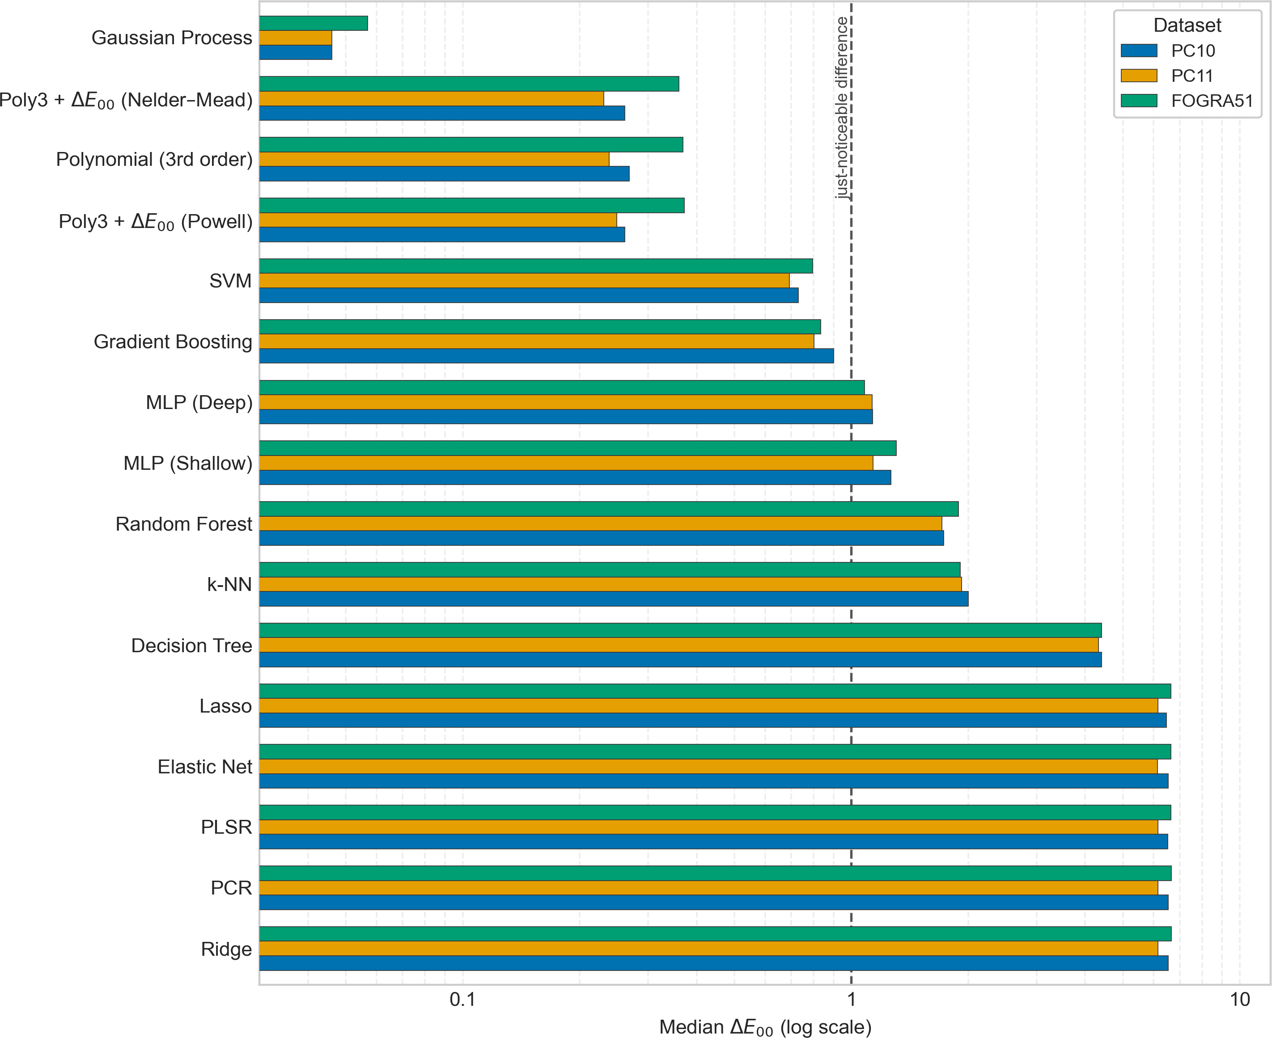

Figure 1. Median ∆E₀₀ per model across the three CMY datasets (795 analyzed K = 0 samples each, 5-fold cross-validation), ranked by mean median across datasets; the two ∆E₀₀-refined polynomial variants of Section 4.4 are shown alongside the 14 registry models. Log scale;).
  - n = 4 (CMYK) and the n=3 → n=4 Comparison 307
Table 4 reports the same statistics for the n = 4 (CMYK) condition, using the full 308
sample set of 1,588 analyzed rows, the 795 K = 0 rows of Table 3 plus 793 rows with 309
K > 0, with K retained as a fourth input rather than dropped. Gaussian process regression 310
remains the best-median model on all three datasets.

The relative ordering of the remaining models 314
is otherwise stable between n = 3 and n = 4 (SVM third, gradient boosting fourth, on all 315
three datasets)
. 317

Table 4. Median, 95th-percentile, and maximum ∆E₀₀ per model for the n = 4 (CMYK) condi-tion on the three printer datasets, 1,588 analyzed samples each (795 with K = 0 plus 793 with K > 0; 1,617 as received, less 29 byte-identical duplicates). Same protocol as Table 3. Models are sorted by PC10 median; the four fitting-space variants of Section 4.5 are marked †. Source: journal/results/{PC10,PC11,FOGRA51}-CMYK/summary.csv.
PC10 PC11 FOGRA51
Model | Median | P95 | Max |  | Median | P95 | Max |  | Median | P95 | Max
Gaussian Process (cbrt)† | 0.050 | 0.229 | 2.723 |  | 0.052 | 0.216 | 1.766 |  | 0.070 | 0.213 | 1.412
Gaussian Process | 0.056 | 0.471 | 7.227 |  | 0.057 | 0.383 | 7.684 |  | 0.069 | 0.267 | 3.153
Polynomial (4th order, cbrt)† | 0.112 | 0.387 | 2.625 |  | 0.112 | 0.380 | 2.709 |  | 0.167 | 0.484 | 3.642
Polynomial (3rd order, cbrt)† | 0.219 | 0.759 | 3.506 |  | 0.216 | 0.752 | 3.511 |  | 0.437 | 1.097 | 5.786
Polynomial (4th order)† | 0.246 | 2.811 | 25.385 |  | 0.227 | 2.464 | 23.535 |  | 0.213 | 1.772 | 19.665
Polynomial (3rd order) | 0.942 | 8.310 | 33.978 |  | 0.869 | 7.500 | 33.070 |  | 0.816 | 6.733 | 29.287
SVM | 1.017 | 5.387 | 23.175 |  | 0.994 | 4.731 | 19.743 |  | 0.996 | 4.872 | 13.246
Gradient Boosting | 1.541 | 6.959 | 29.019 |  | 1.410 | 5.721 | 25.210 |  | 1.508 | 6.578 | 30.742
MLP (Deep) | 1.729 | 11.800 | 48.645 |  | 1.633 | 9.516 | 29.132 |  | 1.658 | 9.675 | 37.063
MLP (Shallow) | 2.002 | 10.385 | 29.829 |  | 1.879 | 11.921 | 27.502 |  | 1.957 | 9.850 | 29.364
k-NN | 2.229 | 5.839 | 12.798 |  | 2.132 | 5.585 | 11.064 |  | 2.216 | 5.999 | 22.229
Random Forest | 2.376 | 4.980 | 10.499 |  | 2.349 | 4.791 | 12.587 |  | 2.635 | 5.630 | 10.592
Decision Tree | 4.611 | 9.648 | 24.345 |  | 4.413 | 9.098 | 22.321 |  | 4.493 | 10.048 | 22.887
Ridge | 8.876 | 24.436 | 42.282 |  | 8.443 | 23.337 | 41.640 |  | 8.788 | 24.822 | 40.642
PCR | 8.876 | 24.436 | 42.282 |  | 8.443 | 23.337 | 41.640 |  | 8.788 | 24.822 | 40.642
Elastic Net | 8.876 | 24.373 | 42.449 |  | 8.446 | 23.364 | 41.816 |  | 8.780 | 25.045 | 41.056
Lasso | 8.886 | 24.479 | 42.589 |  | 8.394 | 23.617 | 41.195 |  | 8.699 | 25.264 | 41.372
PLSR | 8.887 | 25.113 | 42.276 |  | 8.476 | 23.647 | 41.592 |  | 8.596 | 25.176 | 42.190

Figure 2 compares median ∆E₀₀ at n = 3 (CMY) versus n = 4 (CMYK) for every 318 registry model on PC10, the full 1,588-sample set now including the K > 0 rows. Adding 319 the fourth input channel is not uniformly costly: third-order polynomial regression fitted on 320 XYZ, which has no mechanism to represent the extra channel’s interaction terms beyond its 321 fixed cubic expansion, degrades from a median of 0.268 to 0.942 (×3.5), whereas Gaussian 322 process regression is comparatively robust, degrading only from 0.046 to 0.056 (×1.2). 323

332

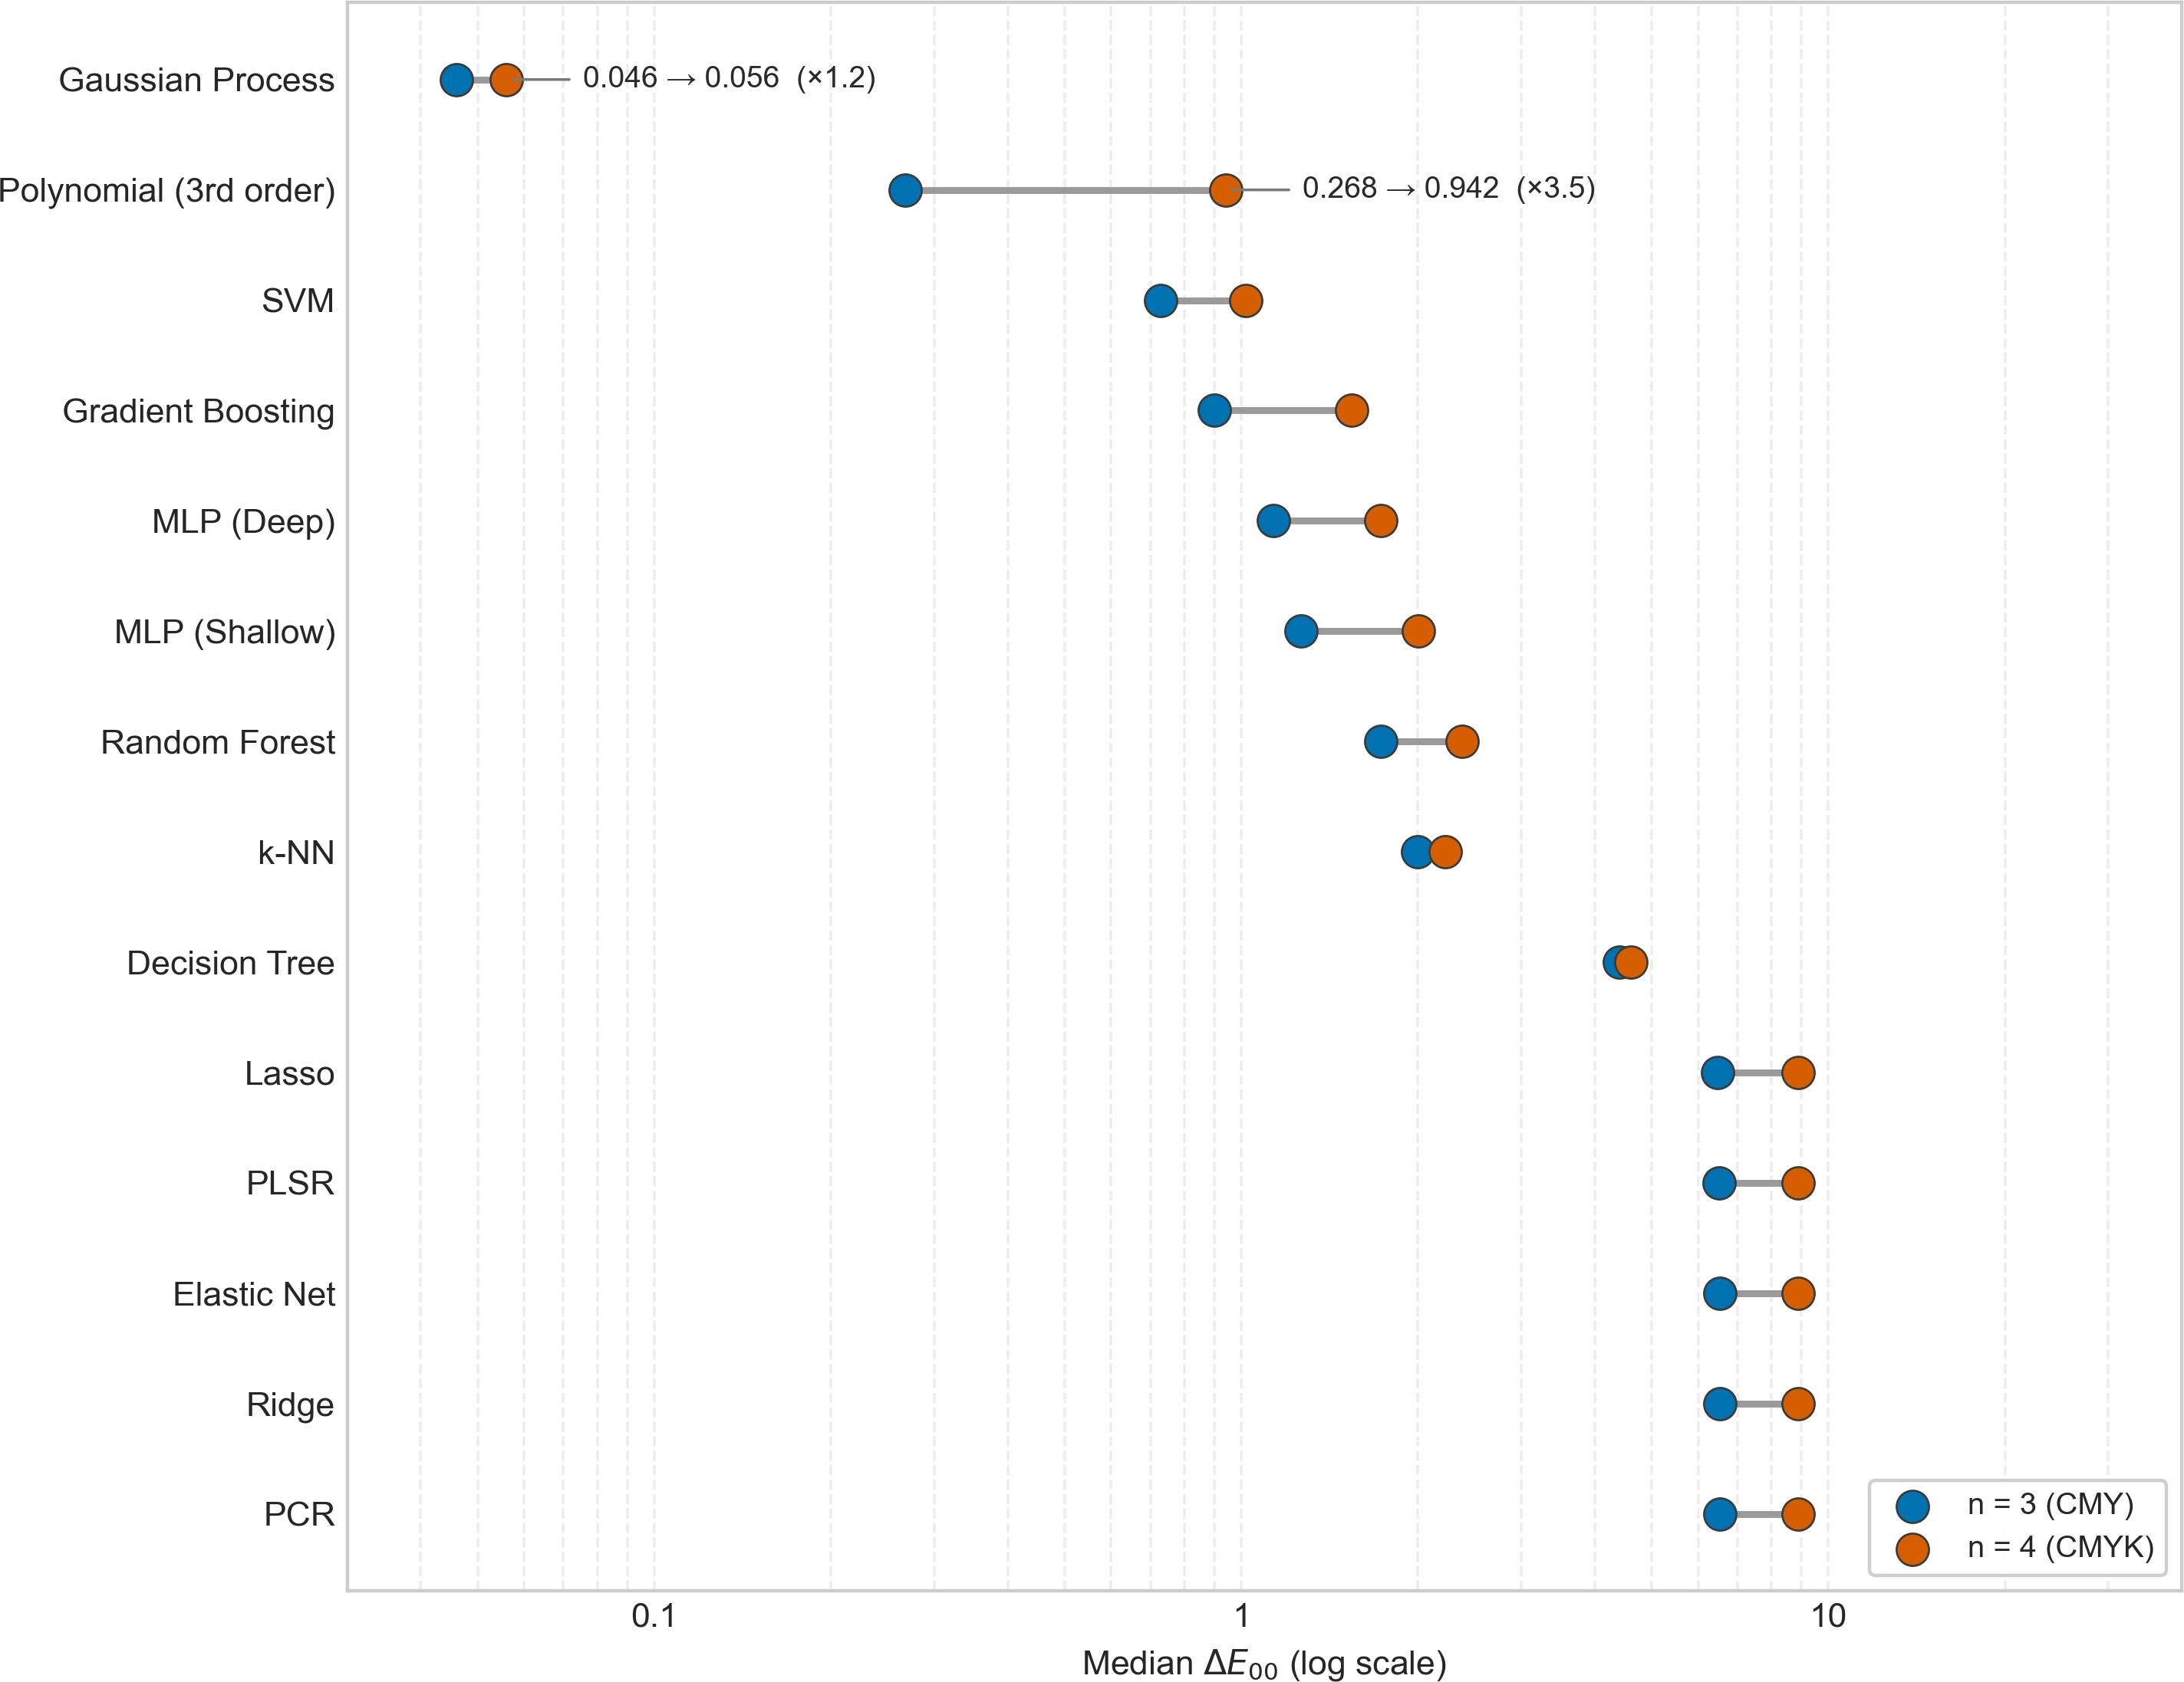

Figure 2. Median ∆E₀₀ per registry model on PC10 at n = 3 (CMY, 795 analyzed samples) versus
n = 4 (CMYK, 1,588 analyzed samples). Third-order polynomial regression fitted on XYZ degrades
×3.5 with the added K channel, while Gaussian process regression degrades only ×1.2, the two highlighted comparisons.

Fold Assignment and the Measurement Noise Floor 333
Gaussian process regression is the best-median model in every dataset/condition 334
combination reported above, and, anticipating Section 4.7, on all nine datasets in this paper: 335
fitted in cube-root space on eight of them and in XYZ on the ninth (FOGRA51-CMYK, by 336
0.001 ∆E₀₀). That makes it the one most worth stress-testing. Two checks bear on it, both 337
read from journal/results/gp_verification.csv, whose k-fold column reproduces the 338
gaussian_process and poly3 rows of Tables 3–4 exactly. 339
Fold assignment. Repeating the six coated conditions with GroupKFold’s deterministic, 340
unshuffled assignment in place of the seeded shuffled split moves GP’s median by at most 341
0.003 ∆E₀₀ (grouped 0.043–0.066 vs. k-fold 0.046–0.069) and third-order polynomial regres- 342
sion’s by at most 0.008 (grouped 0.233–0.938 vs. k-fold 0.238–0.942).

349
Noise floor. The coated sets no longer support a repeatability estimate, because their 350
duplicate pairs were byte-identical: a repeatability of 0.000 measures the export, not the 351
press, and such rows are removed rather than reported. Where repeated patches genuinely 352
differ the estimate is meaningful, and there the Gaussian process sits on it: 0.348 ∆E₀₀ 353
across CMYKOGB-7’s 20 paper-white repeats, and 0.38–1.93 per newsprint press run, against 354
per-run GP medians of 0.674–2.141 (Section 4.6). 355
  - Direct ∆E₀₀ Loss 356
The plain polynomial fits reported so far minimize ordinary least squares on normal- 357
ized XYZ, a proxy for the more perceptually-uniform ∆E₀₀ metric the paper actually evaluates on. This 358

experiment tests whether refining the third-order polynomial’s coefficients directly on 359 mean ∆E₀₀ closes any of that gap. Starting from the 363 least-squares solution, the coefficients are refined with a derivative-free optimizer whose 364 objective is mean ∆E₀₀ on the training fold, evaluated in XYZ; there 365 are 60 coefficients at n = 3 (20 third-order terms × 3 output channels) and 105 at n = 4. 366 The refined model is then evaluated with the same seeded 5-fold cross-validation as every 367 other model. Two optimizers are compared: Nelder–Mead (poly3_de00_nm, budget 2,000 368 iterations) and Powell (poly3_de00_powell, budget 200 iterations). Both are reported at 369 n = 3 and n = 4 (Table 5). 370
Table 5. Median, 95th-percentile, and maximum ∆E₀₀ for the least-squares polynomial (poly3) versus its two ∆E₀₀-refined variants, at n = 3 (CMY, 795 analyzed samples) and n = 4 (CMYK, 1,588 analyzed samples) on the three printer datasets. Source: journal/results/{PC10,PC11,FOGRA51}-{CMY,CMYK}/summary.csv.
PC10 PC11 FOGRA51
Model | Median | P95 | Max |  | Median | P95 | Max |  | Median | P95 | Max
n = 3 (CMY)
Poly3 (least squares) | 0.268 | 0.982 | 6.795 |  | 0.238 | 0.855 | 7.838 |  | 0.369 | 1.135 | 8.251
Poly3 + ∆E₀₀ (Nelder–Mead) | 0.261 | 1.019 | 5.783 |  | 0.231 | 0.861 | 6.564 |  | 0.360 | 1.156 | 6.198
Poly3 + ∆E₀₀ (Powell) | 0.261 | 0.861 | 5.699 |  | 0.249 | 0.720 | 5.391 |  | 0.372 | 1.041 | 4.018
n = 4 (CMYK)
Poly3 (least squares) | 0.942 | 8.310 | 33.978 |  | 0.869 | 7.500 | 33.070 |  | 0.816 | 6.733 | 29.287
Poly3 + ∆E₀₀ (Nelder–Mead) | 0.894 | 6.896 | 31.639 |  | 0.843 | 6.127 | 31.084 |  | 0.768 | 6.126 | 31.022
Poly3 + ∆E₀₀ (Powell) | 0.867 | 6.075 | 32.666 |  | 0.789 | 5.987 | 28.569 |  | 0.785 | 5.471 | 31.234

At n = 3 the effect is confined to the tail. Powell reduces max error by 371 16–51% relative to least squares (PC10 −16%, PC11 −31%, FOGRA51 −51%) and improves 372 P95 on all three datasets, while leaving the median unchanged to within 0.011 ∆E₀₀ in either 373 direction. Nelder–Mead also cuts max error on all three (15–25%) but is marginally worse 374 than least squares at P95 on all three, on a training budget an order of magnitude larger 375 (2,000 vs. 200 iterations); Powell is therefore the preferred variant. At n = 4, where the 376 least-squares polynomial starts out roughly 3.5× worse (Section 4.2), the same refinement is 377 no longer tail-only: Powell lowers the median by 4–9% (0.942 → 0.867, 0.869 → 0.789, 0.816 378
→ 0.785) and P95 by 19–27%, while its effect on the single worst sample turns inconsistent 379 (−4% on PC10, −14% on PC11, +7% on FOGRA51); Nelder–Mead improves the median 380 by 3–6% and P95 by 9–18% there. The refinement buys accuracy in the upper tail while the 381 cubic basis still fits the data comfortably at n = 3, and across the bulk of the distribution 382 once that basis is under real strain at n = 4 (Figure 3). 383
The natural reading of that pattern (that least squares on XYZ is misweighted relative 384
to the perceptual metric, and that optimizing the metric directly repairs the mismatch) is 385
tempting, and Section 4.5 shows it to be wrong. Every improvement recorded in Table 5 386
is smaller than the improvement obtained by leaving the objective alone and changing 387
only the space the least-squares fit is carried out in (compare Powell’s PC10-CMYK median 388
of 0.867 with the same cubic’s 0.219 fitted in cube-root space), and the explicit control 389
for metric alignment in Section 4.5 fails. Direct ∆E₀₀ refinement is best read as a small, 390
expensive correction that a well-chosen fitting space largely subsumes. 391

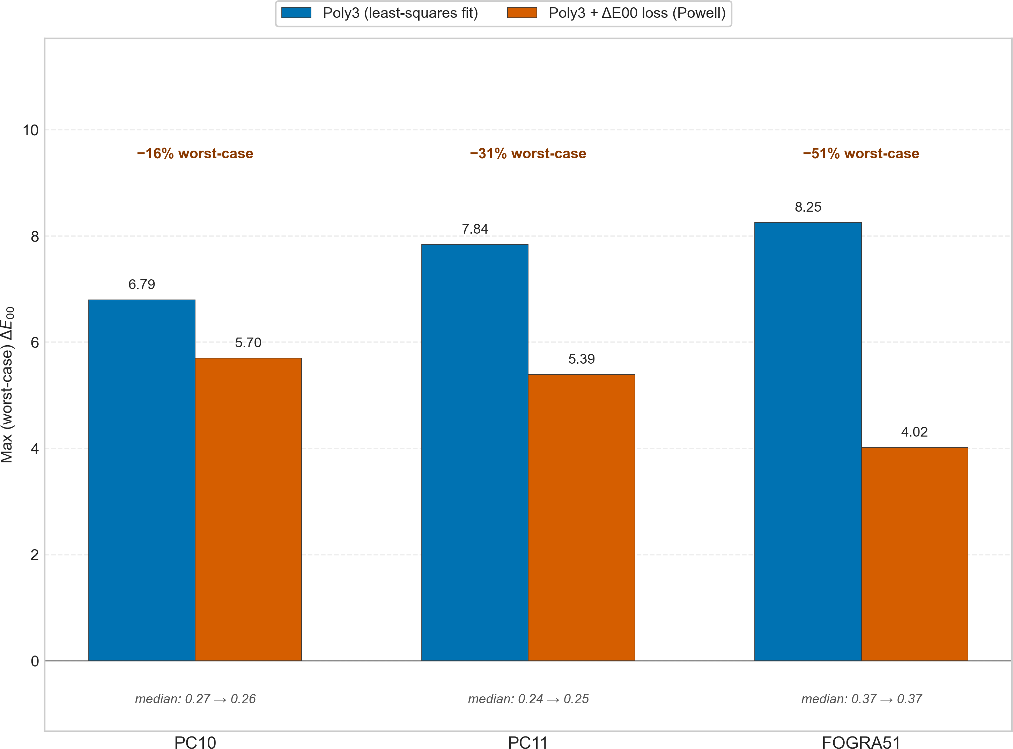

Figure 3. Maximum (worst-case) ∆E₀₀ for the least-squares polynomial versus its Powell-refined variant across the three n = 3 (CMY) datasets, with each pairing’s medians annotated below the bars. The full median/P95/max statistics for both optimizers, at n = 3 and n = 4, are in Table 5.

The Fitting Space: A Correction to the Classical Baseline 392
Every polynomial result reported above
was obtained by minimizing squared error on XYZ. That fitting space is a model- 394
ing choice rather than a neutral default; this section measures its cost, establishes the 395
mechanism, and states what the correction changes about the paper’s argument. 396
What was changed, and why it is the same as fitting in CIELAB. 397
The variant poly3_cbrt differs from poly3 in one respect:
the regression 399
target is √3 XYZ instead of XYZ, and the prediction is cubed 400
before scoring. This is not an arbitrary transform. CIELAB is an invertible linear map of 401
the triple ( f (X/X_{n}), f (Y/Y_{n}), f (Z/Z_{n})), where f is a cube root above a small threshold; 402
ordinary least squares with a shared design matrix is equivariant under an invertible linear 403
map of the target. (In fact the linear segment has the effect of making the power function approximately 2.4 rather than 3.0 over the domain). Thus fitting to √3 XYZ and fitting in CIELAB are very similar estimators,

Fitting directly in 406
CIELAB confirms this numerically: median ∆E₀₀ 0.148 by both routes on PC10-CMY, and 407
0.830 (cube root) against 0.832 (CIELAB) on CMYKOGV-7
. 409
The size of the effect. 410
Table 6 gives the medians and maxima for both polynomial degrees and for the 411
Gaussian process, each fitted both ways, on all nine datasets. Refitting the degree-3 412
polynomial in cube-root space improves its maximum error on 9 of 9 datasets, by 38–90%, 413
and its median on 8 of 9; the exception is FOGRA51-CMY, where the median rises from 414
0.369 to 0.432 while the maximum still falls from 8.251 to 1.958. The effect grows with 415
ink count, from a factor of 1.8 in the median at n = 3 on PC10 to a factor of 6.5 at n = 7 416
on CMYKOGV. The degree-4 polynomial and the Gaussian process each improve their 417
median on 8 of 9 datasets under the same change, so this is a property of the data rather 418

than of the polynomial, and the correction must be offered to every model before any two 419
are compared. 420
Table 6. Fitting space, all nine datasets: median and maximum ∆E₀₀ for the degree-3 polynomial, the degree-4 polynomial and the Gaussian process, each fitted on XYZ and on √3 XYZ (equivalently, in
CIELAB). Folds, seeds, term counts and the ∆E₀₀ path are identical within each pair. Best median per dataset in bold. Source: journal/results/*/summary.csv.
Polynomial, degree 3 Polynomial, degree 4 Gaussian process
Dataset | XYZ | cbrt |  | XYZ | cbrt |  | XYZ | cbrt
Median ∆E₀₀
PC10-CMY | 0.268 | 0.148 | 0.101 |  | 0.085 | 0.046 |  | 0.041
PC11-CMY | 0.238 | 0.140 | 0.097 |  | 0.084 | 0.046 |  | 0.043
FOGRA51-CMY | 0.369 | 0.432 | 0.125 |  | 0.156 | 0.057 |  | 0.053
PC10-CMYK | 0.942 | 0.219 | 0.246 |  | 0.112 | 0.056 |  | 0.050
PC11-CMYK | 0.869 | 0.216 | 0.227 |  | 0.112 | 0.057 |  | 0.052
FOGRA51-CMYK | 0.816 | 0.437 | 0.213 |  | 0.167 | 0.069 |  | 0.070
KCMYG-5 | 1.457 | 1.024 | 1.057 |  | 0.853 | 0.867 |  | 0.764
CMYKOGV-7 | 5.386 | 0.830 | 2.080 |  | 0.272 | 0.249 |  | 0.160
CMYKOGB-7 | 3.332 | 1.611 | 1.698 |  | 1.132 | 1.280 |  | 0.977
Maximum ∆E₀₀
PC10-CMY | 6.795 | 2.048 | 2.331 |  | 2.171 | 2.274 |  | 2.270
PC11-CMY | 7.838 | 1.653 | 1.680 |  | 1.789 | 1.747 |  | 1.749
FOGRA51-CMY | 8.251 | 1.958 | 1.846 |  | 1.168 | 0.679 |  | 0.458
PC10-CMYK | 33.978 | 3.506 | 25.385 |  | 2.625 | 7.227 |  | 2.723
PC11-CMYK | 33.070 | 3.511 | 23.535 |  | 2.709 | 7.684 |  | 1.766
FOGRA51-CMYK | 29.287 | 5.786 | 19.665 |  | 3.642 | 3.153 |  | 1.412
KCMYG-5 | 65.742 | 29.230 | 55.860 |  | 39.488 | 31.738 |  | 16.172
CMYKOGV-7 | 59.833 | 27.979 | 57.988 |  | 18.612 | 49.757 |  | 5.713
CMYKOGB-7 | 48.974 | 30.274 | 48.974 |  | 24.096 | 44.305 |  | 14.270

The mechanism is approximability, not the perceptual metric. 421
The tempting explanation is that a cube root brings least squares into line with 422
CIEDE2000, since ∆E₀₀ is computed in a space whose lightness axis is essentially a cube 423
root. That explanation is testable and it fails. To first order, fitting √3 y by unweighted 424
least squares is equivalent to fitting y with sample weights y−4/3; running exactly that 425
weighted fit in XYZ, at the same degree and folds and with each channel weighted 426
by its own y_{c}^{−4/3}, makes the median worse than the unweighted XYZ fit on 8 of the 9 427
datasets (PC10-CMYK 0.942 → 1.551, PC11-CMYK 0.869 → 1.400, FOGRA51-CMYK 0.816 428
→ 1.315), and on all nine it is far worse than the cube-root fit it was meant to imitate 429
(journal/results/weighting_control.csv). Metric alignment is therefore not what is 430
happening. 431
What is happening is that the ink-to-color response is much closer to a low-order 432
polynomial after a compressive transform than before it. Measured as degree-3 residual 433
RMS expressed as a percentage of the target’s standard deviation, on PC10-CMY the per- 434
channel figures fall from 0.99/1.05/1.58 (X/Y/Z) in XYZ to 0.65/0.62/0.75 under a cube 435
root, and on CMYKOGV-7 from 11.88/13.29/15.87 to 3.15/3.02/3.59 (journal/results/ 436
residual_rms.csv). The transform is doing approximation-theoretic work, not perceptual 437
work. This also explains the single median regression: FOGRA51-CMY is the one dataset 438
where the cube root makes the polynomial fit worse on every channel (0.95/1.05/1.56 → 439
1.30/1.28/1.65), so there the transform reallocates error from the dark patches, where it 440
wins, to the light ones. 441
The cube root is not privileged. 442
If the mechanism is variance stabilization rather than perceptual alignment, then 443
other compressive transforms should work too, and they do. Table 7 sweeps five target 444
transforms at degree 3. A square root gives a better median than the cube root on 4 of 445

the 9 datasets, and taken across the whole sweep the cube root is the outright winner on 446
only 2, against 3 each for √y and y0.25. Each of the four non-identity transforms beats the 447
identity on 8 of 9 datasets, all four failing on the same one, FOGRA51-CMY. The practical 448 recommendation is therefore not “use a cube root” but “do not fit in XYZ”; the cube root 449 has the incidental advantage of being the one whose fit is exactly the CIELAB fit, which is 450 what makes it reportable as an equivalence rather than as a tuned hyperparameter. This 451 output-side transform should not be confused with root-polynomial regression [37], which 452 takes fractional powers of the input monomials to obtain exposure invariance in camera 453 color correction; here the monomial basis is untouched and the transform is applied to the 454 regression target. 455
Table 7. Median ∆E₀₀ of the degree-3 polynomial fitted against five different target transforms, identical folds and term counts throughout. Best per row in bold. The identity and cube-root columns reproduce the poly3 and poly3_cbrt rows of Table 6 exactly, which is the sweep’s internal control. Source: journal/results/transform_sweep.csv.

Dataset identity √y |  |  | √3 y | y0.25 log(1 + y)
PC10-CMY | 0.268 | 0.127 | 0.148 | 0.166 | 0.234
PC11-CMY | 0.238 | 0.124 | 0.140 | 0.154 | 0.206
FOGRA51-CMY | 0.369 | 0.376 | 0.432 | 0.467 | 0.562
PC10-CMYK | 0.942 | 0.252 | 0.219 | 0.250 | 0.385
PC11-CMYK | 0.869 | 0.243 | 0.216 | 0.251 | 0.379
FOGRA51-CMYK | 0.816 | 0.386 | 0.437 | 0.490 | 0.679
KCMYG-5 | 1.457 | 1.045 | 1.024 | 1.023 | 1.112
CMYKOGV-7 | 5.386 | 1.253 | 0.830 | 0.811 | 1.126
CMYKOGB-7 | 3.332 | 1.821 | 1.611 | 1.560 | 1.592

Degree is the second lever, and it does not overfit. 456
The polynomial baseline in this comparison was also capped at third order, following 457
standard practice for device characterization: Bala [9] works its regression example at third 458
order and recommends the smallest term count that fits the curvature, and the systematic 459
polynomial study of Hong et al. [38] likewise recommends third-order models. At seven 460
inks that cap is doing a great deal of the work. Table 8 sweeps degrees 2 to 5 on CMYKOGV- 461
7 in both spaces. A degree-4 polynomial fitted in CIELAB reaches a median of 0.272 ∆E₀₀, 462
against 5.386 for the degree-3 XYZ fit that the uncorrected comparison used: a factor of 20 463
attributable entirely to two modeling choices and none of it to the data or to the method’s 464
expressive limits. 465
The obvious objection is overfitting: 330 terms per channel is 990 coefficients against 466
3,302 samples, or 2.7 training rows per fitted coefficient under 5-fold cross-validation. The 467
evidence is against it. The gap between the in-fold training median and the held-out 468
median, averaged over the five folds, is +0.029 ∆E₀₀ at degree 4, unchanged from +0.029 469
at degree 3 and still only +0.036 at degree 5. It is the XYZ-fitted column that shows the 470
overfitting signature, its gap widening from +0.121 at degree 3 to +0.226 at degree 4. Every 471
value reported here is out-of-sample in any case; the train/test gap is quoted only to show 472
that the degree-4 fit is not being propped up by memorization. 473

Table 8. Degree sweep on CMYKOGV-7 (7 inks, 3,302 analyzed samples, grouped 5-fold cross-validation). “Rows/coefficient” is the training-fold size divided by the 3× terms-per-channel co-efficients actually fitted. “Gap” is the held-out median minus the in-fold training median, av-eraged over the five folds, for the cube-root column. The Gaussian process fitted in the same space scores 0.160 on this dataset. The degree-3 and degree-4 medians reproduce the poly3, poly3_cbrt, poly4 and poly4_cbrt entries of journal/results/CMYKOGV-7/summary.csv. Source: journal/results/CMYKOGV-7/degree_sweep.csv.

Degree | Median, XYZ | Median, cbrt | Terms/channel | Rows/coefficient | Gap (cbrt)
2 | 9.953 | 2.656 | 36 | 24.5 | +0.013
3 | 5.386 | 0.830 | 120 | 7.3 | +0.029
4 | 2.080 | 0.272 | 330 | 2.7 | +0.029
5 | 0.506 | 0.126 | 792 | 1.1 | +0.036

487

Newsprint: Within-Run, Cross-Run, and Leave-One-Out 488
Three experiments probe how well a model characterizing one printer generalizes to 489
another, using the 13 nnewsprint press runs described in Section 3.1 490
(1,485 CMYK samples per run). Three training conditions are compared: (A) within-run, 491
5-fold cross-validation on a single press run (the best case, a model fitted to that specific 492
press, and the only condition run for the full 14-model registry); (B) cross-run, trained on one 493
run and tested on another with no shared training data (all 13 × 12 = 156 ordered pairs); 494
and (C) leave-one-run-out, trained on 12 pooled runs and tested on the 13th. Conditions (B) 495
and (C) use a four-model subset of Gaussian process, third-order polynomial, SVM and 496
deep MLP: winner, classical baseline and two mid-field representatives from Table 4.
In condition (C) only, the 2,000-row cap on Gaussian process training folds 498
(Section 3.3)

significantly reduced the amount of data seen by the model. 502

Table 9. Median ∆E₀₀ per model across the three newsprint generalization experiments (13 press runs). Within-run and leave-one-out values are the median of each run’s own median ∆E₀₀ across the 13 runs, and are therefore individual CSV entries; cross-run values are the median across the 156 ordered train/test press pairs, an even count, so each is the midpoint of the two central entries. All models are fitted on XYZ; the fitting-space correction of Section 4.5 has not been applied to this experiment. Source: journal/results/ifra/{within_run,cross_run,leave_one_out}.csv.

Model | Within-run (A) | Cross-run (B) | Leave-one-out (C)
Gaussian Process | 0.899 | 3.844 | 3.155
SVM | 1.073 | 3.874 | 3.008
Polynomial (3rd order) | 1.416 | 4.167 | 3.301
MLP (Deep) | 1.614 | 4.132 | 3.625

Within-run (A), Gaussian process regression is the best of the 14 504 models on 12 of the 13 runs. One failure mode is worth recording: 506 initialized with a near-zero WhiteKernel (10−5, two orders of magnitude below newsprint’s 507 measured noise), the kernel’s marginal-likelihood optimization enters a local optimum 508 in which the fitted RBF length-scale collapses to its lower bound and the model reverts 509 to predicting close to the training-set mean color, putting GP’s within-run median near 510 18.8, an order of magnitude worse than every other model. That is a property of the 511 optimization, not of Gaussian processes: the neutral initialization, widened bounds and 512 restarts of Section 3.2 find the healthy optimum on every dataset, with fitted noise levels 513 matching each dataset’s measured duplicate-pair repeatability. 514
The substantive story is that press-to-press variation dominates model choice: ev- 515
ery model’s cross-run error (B, 3.844–4.167 median regardless of model) is 2.6–4.3× its 516
own within-run error (A), and no amount of model sophistication closes that gap. This 517
corroborates, from the modeling side, what Nussbaum and Hardeberg [39] found from 518
the process-control side on eight coldset newspaper presses, where inter-press variation 519
exceeded the difference between custom and standard ICC profiles.

532

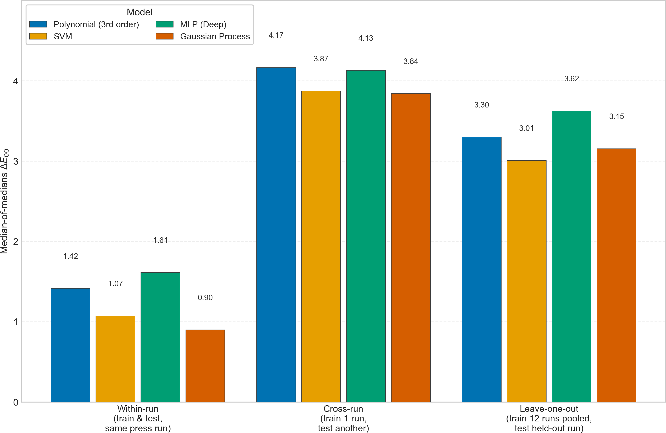

Figure 4. Median-of-medians ∆E₀₀ under the three newsprint generalization conditions (within-run, cross-run, leave-one-run-out) for third-order polynomial regression, SVM, deep MLP, and Gaussian process regression. Within-run values are per-press-run 5-fold cross-validation; cross-run pools the 156 ordered press pairs. Generated from the results CSVs by fig_ifra_generalization.py.

Scaling to n > 4 Colorants 533
This section answers question (b) of Section 1 (whether machine learning can handle 534
n > 4 colorant systems, where classical polynomial and LUT-based methods do not scale) 535
on the three datasets extending the ladder to n = 5 and n = 7 (Table 1): the five-ink KCMYG 536
set and the two independent seven-ink sets, CMYKOGV and CMYKOGB (Section 3.1). 537
Table 10 reports median, 95th-percentile, and maximum ∆E₀₀ for the full model registry, 538
the two ∆E₀₀-refined polynomial variants of Section 4.4, and the four fitting-space variants 539
of Section 4.5, under the grouped, deterministic cross-validation protocol of Section 3.3. 540
Because Section 4.5 showed both the fitting space and the degree cap of the classical baseline 541
to be costly, the result below is stated twice, against the uncorrected and the corrected 542
baseline; the two differ by an order of magnitude. 543

Table 10. Median, 95th-percentile, and maximum ∆E₀₀ per model for the n = 5 (KCMYG, 2,214 sam-ples) and n = 7 (CMYKOGV, 3,302 analyzed samples; CMYKOGB, 2,000 samples) datasets. Grouped 5-fold cross-validation with every sample predicted exactly once (Section 3.3); ∆E₀₀ on denormalized XYZ (D50, 2°). Models sorted by KCMYG-5 median; the four fitting-space variants of Section 4.5 are marked †. Source: journal/results/{KCMYG-5,CMYKOGV-7,CMYKOGB-7}/summary.csv.
KCMYG-5 CMYKOGV-7 CMYKOGB-7
Model | Median | P95 | Max |  | Median | P95 | Max |  | Median | P95 | Max
Gaussian Process (cbrt)† | 0.764 | 2.067 | 16.172 |  | 0.160 | 0.677 | 5.713 |  | 0.977 | 2.996 | 14.270
Polynomial (4th order, cbrt)† | 0.853 | 2.118 | 39.488 |  | 0.272 | 1.189 | 18.612 |  | 1.132 | 3.843 | 24.096
Gaussian Process | 0.867 | 2.267 | 31.738 |  | 0.249 | 4.497 | 49.757 |  | 1.280 | 8.066 | 44.305
Polynomial (3rd order, cbrt)† | 1.024 | 2.389 | 29.230 |  | 0.830 | 2.982 | 27.979 |  | 1.611 | 7.091 | 30.274
Polynomial (4th order)† | 1.057 | 3.289 | 55.860 |  | 2.080 | 13.800 | 57.988 |  | 1.698 | 19.662 | 48.974
SVM | 1.185 | 6.275 | 38.741 |  | 2.138 | 11.259 | 27.735 |  | 1.776 | 13.228 | 42.827
Poly3 + ∆E₀₀ (Powell) | 1.405 | 5.293 | 59.035 |  | 3.104 | 12.482 | 48.585 |  | 2.979 | 19.324 | 49.052
Polynomial (3rd order) | 1.457 | 7.928 | 65.742 |  | 5.386 | 25.150 | 59.833 |  | 3.332 | 24.845 | 48.974
Poly3 + ∆E₀₀ (Nelder–Mead) | 1.464 | 7.239 | 65.888 |  | 5.375 | 21.828 | 52.271 |  | 3.324 | 22.758 | 47.049
k-NN | 1.871 | 4.935 | 54.927 |  | 3.669 | 9.213 | 28.874 |  | 2.560 | 8.022 | 42.641
MLP (Deep) | 1.970 | 9.030 | 35.677 |  | 3.579 | 14.126 | 38.548 |  | 2.536 | 15.106 | 39.321
MLP (Shallow) | 2.013 | 11.520 | 34.424 |  | 3.380 | 14.761 | 43.884 |  | 2.985 | 18.080 | 37.836
Random Forest | 2.237 | 6.925 | 37.295 |  | 3.774 | 9.512 | 29.535 |  | 2.322 | 8.197 | 69.308
Gradient Boosting | 2.825 | 9.941 | 40.629 |  | 3.828 | 16.099 | 35.012 |  | 3.916 | 16.899 | 44.962
Decision Tree | 4.780 | 14.196 | 40.780 |  | 5.337 | 15.833 | 38.032 |  | 5.038 | 15.471 | 85.477
Lasso | 10.681 | 26.169 | 50.045 |  | 14.937 | 27.875 | 50.410 |  | 11.529 | 30.845 | 49.111
Elastic Net | 10.709 | 25.476 | 50.057 |  | 14.967 | 27.829 | 48.606 |  | 11.440 | 31.143 | 49.817
Ridge | 10.730 | 24.982 | 50.271 |  | 15.009 | 27.530 | 44.107 |  | 11.244 | 31.188 | 50.696
PCR | 10.730 | 24.982 | 50.271 |  | 15.009 | 27.530 | 44.107 |  | 11.244 | 31.188 | 50.696
PLSR | 13.572 | 31.858 | 52.912 |  | 18.327 | 37.555 | 63.530 |  | 17.615 | 37.903 | 59.849

The uncorrected comparison. 544
Figure 5 gives the registry results on the full n = 3 → 4 → 5 → 7 ladder. Third-order 545
polynomial regression fitted on XYZ
degrades from a median of 0.268 at 547
n = 3 (PC10, Table 3) through 0.942 at n = 4 and 1.457 at n = 5 to 5.386 (CMYKOGV-7) and 548
3.332 (CMYKOGB-7) at n = 7: roughly an order of magnitude over the ladder. Gaussian 549
process regression fitted on XYZ stays at or below a median of 1.280 on every rung.
This suggests the classical method collapses at high ink counts while the machine 551
learning method holds, with a factor of 21.6 between them at seven inks on CMYKOGV 552
(5.386 against 0.249).

555

568

Key points 569
1) A Gaussian process is still the best-median model on all three 570
n > 4 datasets and, fitted in cube-root space, on 8 of the 9 datasets in this paper (in XYZ 571
on the ninth, FOGRA51-CMYK, by 0.001 ∆E₀₀).
2) Its advantage in the error tail 572
at high ink count is much larger than its advantage in the median and does not shrink 573
under the correction: on CMYKOGV-7 it holds P95 0.677 and maximum 5.713 against the 574
corrected polynomial’s 1.189 and 18.612, and on CMYKOGB-7 2.996 and 14.270 against 575
3.843 and 24.096. For a characterization model the worst patch often matters more than the 576
typical one, and that is where the gap remains.
3) Most usefully to a practitioner, 577
the Gaussian process reaches those numbers with no choices to make: the polynomial’s 578
competitiveness at n = 7 depends on selecting a degree and a fitting space, and getting 579
either wrong is expensive.

584
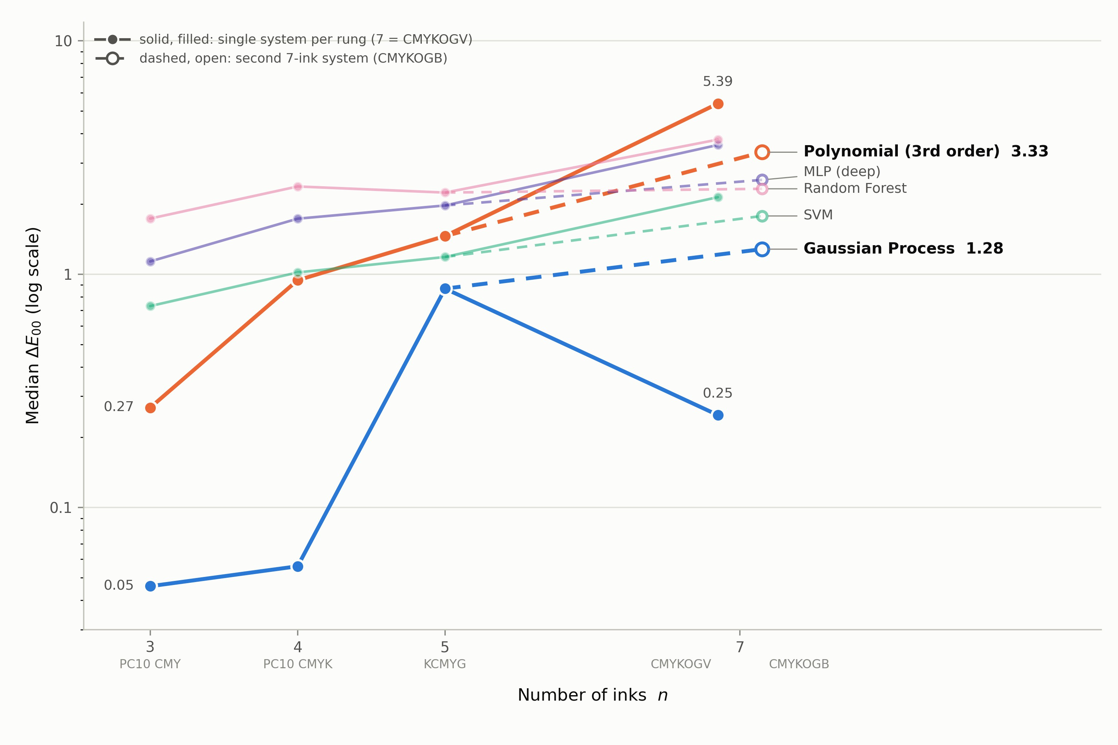
Figure 5. Median ∆E₀₀ versus number of inks n ∈ {3, 4, 5, 7} for Gaussian process regression, third-order polynomial regression, and three mid-field models (log scale), all fitted on XYZ. Each rung is an independent dataset and printing system, so each model’s own trend, not levels across rungs, is the meaningful comparison; the second seven-ink system (CMYKOGB) is drawn as a dashed branch. Linear-family models are omitted (medians 6.5–18.3 across these datasets). This figure shows the uncorrected comparison: the polynomial curve is the degree-3 XYZ fit, and Section 4.5 shows that most of its rise between n = 4 and n = 7 is attributable to the fitting space and the degree cap. At degree 4 in CIELAB the same curve would read 0.085 (n = 3, PC10), 0.112 (n = 4, PC10), 0.853 (n = 5), and 0.272 and 1.132 at n = 7, i.e. essentially flat across the ladder. Generated from the results CSVs by fig_ncolor_ladder.py.

595
One number in Table 10 demands a caveat rather than a headline: Gaussian process 596
regression’s median on CMYKOGV-7 is better than its median on the five-ink KCMYG set, in 597
both fitting spaces (0.249 against 0.867 in XYZ; 0.160 against 0.764 in cube-root space). This 598
is not evidence that seven inks are easier than five. In the CMYKOGV chart, 84% of patches 599
use at most four nonzero inks, so the chart is a union of densely sampled low-dimensional 600
wedges that an RBF-kernel GP interpolates extremely well, and it is also the largest of the 601
three datasets (3,302 analyzed samples).
603

613

Large Language Models as Equation Writers: An Exploratory Probe 614
Scope. 615
This subsection is an exploratory probe, not a benchmark, and it should not be 616
read as one. Each row of Table 11 is a single query to a single model (n = 1); the 617
conditions differ from row to row in ways that demonstrably matter more than the 618
model identity, including whether the model was given a code interpreter and whether 619
its reasoning mode was enabled; and every row concerns one three-ink chart, PC10- 620 CMY, so nothing here bears on the n > 4 question that motivates the rest of the paper. 621 Model identifiers, providers, temperature, token usage and cost are recorded per row in 622
journal/results/llm/equation_summary.csv, and the verbatim prompt and every raw 623
response are archived, so the probe is reproducible even though it is not statistically pow- 624
ered. We report it because the effect sizes are large enough to be informative in spite of that, 625
and because one of its findings is methodological rather than colorimetric. 626
The task. 627
For the LLMs we asked not for per-patch 628
predictions but for a portable equation: “Generate an equation that transforms any coordinate 629
in data set A into a coordinate in data set B. The equation should be as simple as possible, 630
and avoid exponents greater than 3. The success criterion is minimisation of average 631
and maximum differences between CIELAB values in data set B and those estimated 632
by the equation, as defined by the CIEDE2000 equation.” Each model was shown 150 633
(c, m, y) → (X, Y, Z) training pairs in its prompt and asked to return three expressions 634
in c, m, y. Answers were parsed by a tokenizer whitelist and sympy (model text is never 635
evaluated as code) and scored on 100 held-out patches with the same ∆E₀₀ path as every 636
classical model in this paper. The comparator, poly3-ls-local, is a least-squares cubic 637
fitted on exactly those 150 rows and scored on exactly those 100 patches, so the LLM and 638
the classical method see identical data. 639

Table 11. Large language models asked to write a CMY→XYZ characterization equation, PC10-CMY, 150 in-prompt training pairs, scored on 100 held-out patches with this paper’s ∆E₀₀ path. “Degree” is the total degree of the expanded expression; the brief asked for exponents no greater than 3. Source: journal/results/llm/equation_summary.csv; the web/code-execution row is scored from the archived answer in journal/llm/raw/equation_harness/ by the same parser and metric.

Model | Condition | Median | P95 | Max | Terms | Degree
Claude Fable 5 | web UI, with code execution | 0.082 | 0.241 | 0.752 | 2,542 | 27
Least-squares cubic (ours) | not an LLM; same 150 rows | 0.234 | 0.917 | 3.052 | 57 | 3
GPT-5.6 Sol | API, reasoning enabled | 3.070 | 7.312 | 10.318 | 192 | 9
Claude Opus 5 | API, reasoning disabled | 14.291 | 24.081 | 39.999 | 192 | 9
DeepSeek V4 Pro | API, reasoning disabled | 23.764 | 42.444 | 49.739 | 39 | 3
Claude Haiku 4.5 | API, reasoning enabled | 28.781 | 46.822 | 57.556 | 33 | 3
Claude Fable 5 | API, reasoning enabled | no equation returned (1,600 and 78,000 completion tokens)
DeepSeek V4 Pro | API, reasoning enabled | no equation returned (2,400 and 8,000 completion tokens)

Unaided, no model is competitive. 640
The best equation produced by a model reasoning from the numbers alone is GPT-5.6 641
Sol’s, at median 3.070 ∆E₀₀, 13× worse than the least-squares cubic fitted on the same 642
150 rows (0.234), with a maximum of 10.318 against 3.052. The brief’s success criterion, 643
minimizing both average and maximum difference, is not met by any unaided model. The 644
remaining three unaided answers are worse by a further order of magnitude, and inspection 645
shows why: DeepSeek V4 Pro’s cubic has near-proportional coefficients across the three 646
channels, so it cannot produce chroma at all and predicts a mid gray for a saturated yellow 647
patch. Asking a language model to write a characterization transform is not a substitute for 648
fitting one, and the gap is not marginal. 649
Given a code interpreter, one model beat the cubic: an automation result, not a 650
color-science one. 651
The top row of Table 11 was produced by Claude Fable 5 in a browser session with 652
code execution available. It returned per-channel expressions of the form (cubic in c, m, y)3 653
carrying coefficients such as 4.40094852422, and it scores median 0.082 ∆E₀₀, roughly three 654
times better than our own cubic. That precision is the signature of a numerical fit, and 655
the archived session confirms it: the model wrote and ran code, fitted the coefficients 656
numerically, and reported the result. What the row measures is therefore an agent with 657
a least-squares library, not a language model’s colorimetric reasoning, and it is reported 658
here only to make the point that the two are indistinguishable from the answer text alone. 659
Attempts to obtain a clean tool-free answer through a command-line agent instead of a 660
browser failed repeatedly: with successive tool categories disabled, the agent found a 661
computation channel each time (187 and 74 tool invocations in the first two attempts) 662
and fitted the coefficients numerically rather than reasoning them out. Any evaluation 663
of language models on quantitative tasks that queries them through an agentic harness, 664
without auditing the transcript for tool calls, is measuring the harness; that is the probe’s 665
methodological finding. 666
Accuracy was bought by breaking the constraint. 667
The brief asked for an equation “as simple as possible” with no exponent above 3, 668
and the ranking in Table 11 is almost inverse to compliance with it. The two answers that 669
respect the letter and the spirit of the constraint (DeepSeek’s 39-term cubic, and Haiku’s 670
33-term expression of total degree 3 with no single variable raised above the square) are 671
the two worst. GPT-5.6 Sol and Claude Opus 5 keep every single-variable exponent at 3 672
but multiply three per-ink cubics together, giving an expanded total degree of 9 and 192 673

terms. The code-execution answer nests a cubic inside a cube: per-variable exponent 9, 674 total degree 27, 2,542 terms once expanded, which is neither simple nor portable in any 675 useful sense. The more accurate the answer, the more thoroughly the simplicity constraint 676 was circumvented. 677
Reasoning budget is the binding constraint, and it is not uniform across providers. 678
Two of the models never returned an equation at all. Claude Fable 5, with reasoning 679
enabled, returned no equation at either completion budget: at 1,600 tokens the response hit 680
the length limit mid-derivation with no visible content (238 archived reasoning tokens), 681
and at 78,000 tokens it spent essentially the entire allowance on reasoning (77,999 reasoning 682
tokens) and again returned empty content; DeepSeek V4 Pro did the same at 2,400 and 683
8,000 before returning an answer only once reasoning was disabled, which is why its 684
row is labeled as such and why its coefficients read as recalled rather than fitted. GPT- 685
5.6 Sol, by contrast, converged and answered within 2,747 completion tokens, of which 686
2,358 were reasoning. On a task with a well-defined stopping point, one frontier model 687
terminated inside 3,000 tokens while another had not terminated inside 78,000. With n = 1 688
per condition this is an observation rather than a measurement, but on this task completion 689
cost was dominated by whether the model terminated, not by whether it was right. 690
Relation to the earlier direct-prediction pilot. 691
An earlier pilot on the same 100 held-out patches asked two OpenAI models to 692
predict XYZ directly rather than to write an equation, with 400 in-context examples 693
and temperature-0 decoding (journal/results/llm/PC10-CMY_summary.csv). GPT-4o 694
reached a median of 3.034 ∆E₀₀ (P95 10.642, max 14.621) and GPT-4o-mini 9.445 (P95 29.928, 695
max 44.792); all 200 responses parsed. GPT-4o’s per-patch prediction and GPT-5.6 Sol’s 696
portable equation therefore land in the same place, 3.034 against 3.070, and both are an 697
order of magnitude behind least squares on the same rows. That pilot’s holdout predates 698
the de-duplication policy of Section 3.3 and was drawn from a recipe-de-duplicated pool 699
of the as-received 818 rows (its split code drops repeated recipes, a stricter rule than the 700
byte-identical policy adopted later) and has not been re-drawn, so its numbers are quoted 701
for context only and are not comparable in protocol to the cross-validated tables above 702
(Figure 6). 703

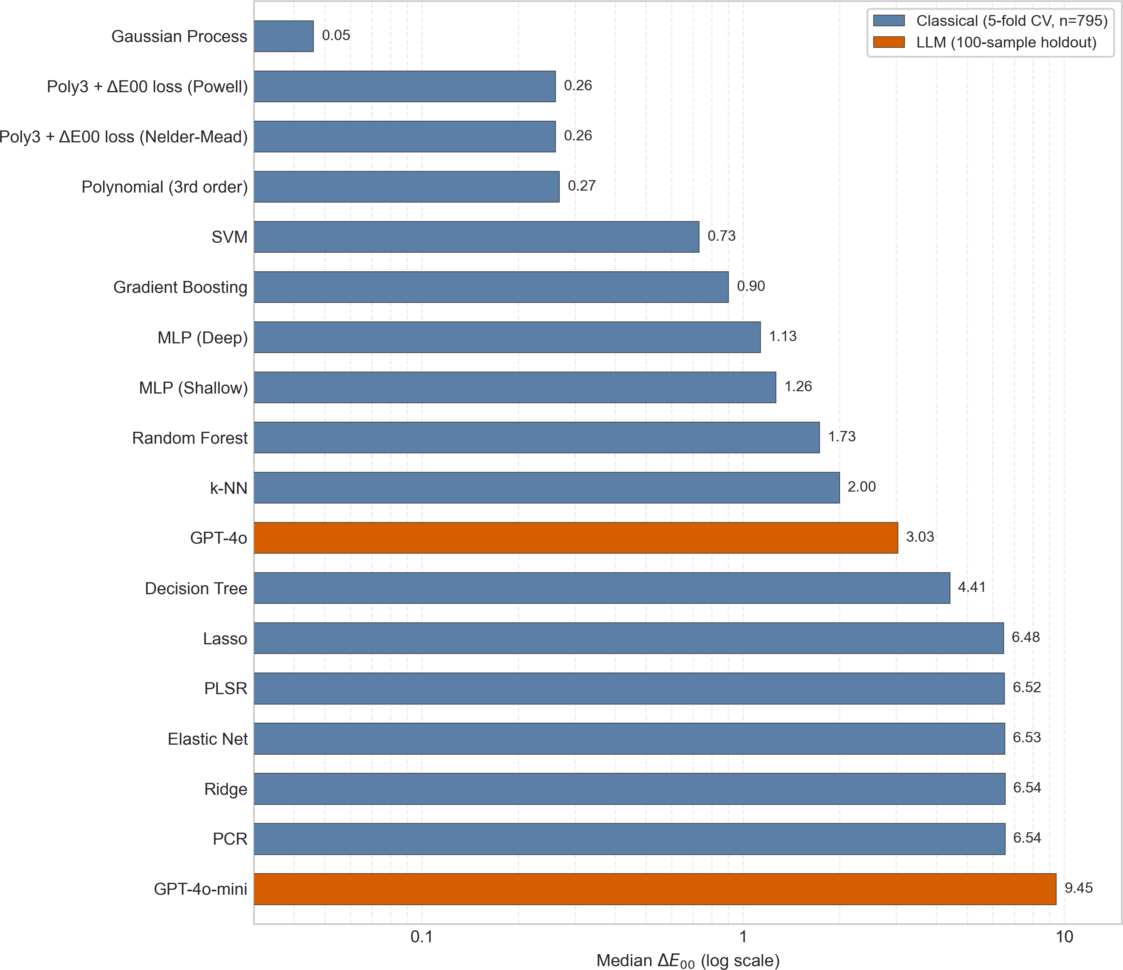

Figure 6. The earlier direct-prediction pilot: median ∆E₀₀ for GPT-4o and GPT-4o-mini predicting XYZ per patch (single 100-sample holdout, 400 in-context examples) alongside the classical/ML model set and the two ∆E₀₀-refined polynomial variants (5-fold cross-validation, 795 analyzed samples), PC10-CMY. The two evaluation protocols differ as described in the text; log scale, dashed line at ∆E₀₀ = 1.

External Validation Against an Independent Tool 704
CharData Viewer [40] (v1.18.0), a public browser-resident characterization-data ex- 705
plorer, ships the same standard datasets this study uses and reports its own polynomial 706
fit statistics, which makes an external cross-check possible on identical data.

Results are shown in Figure 7, where it can be seen our polynomial and cube-root GP methods perform better than CharData and our XYZ GP methods. 712

728

743
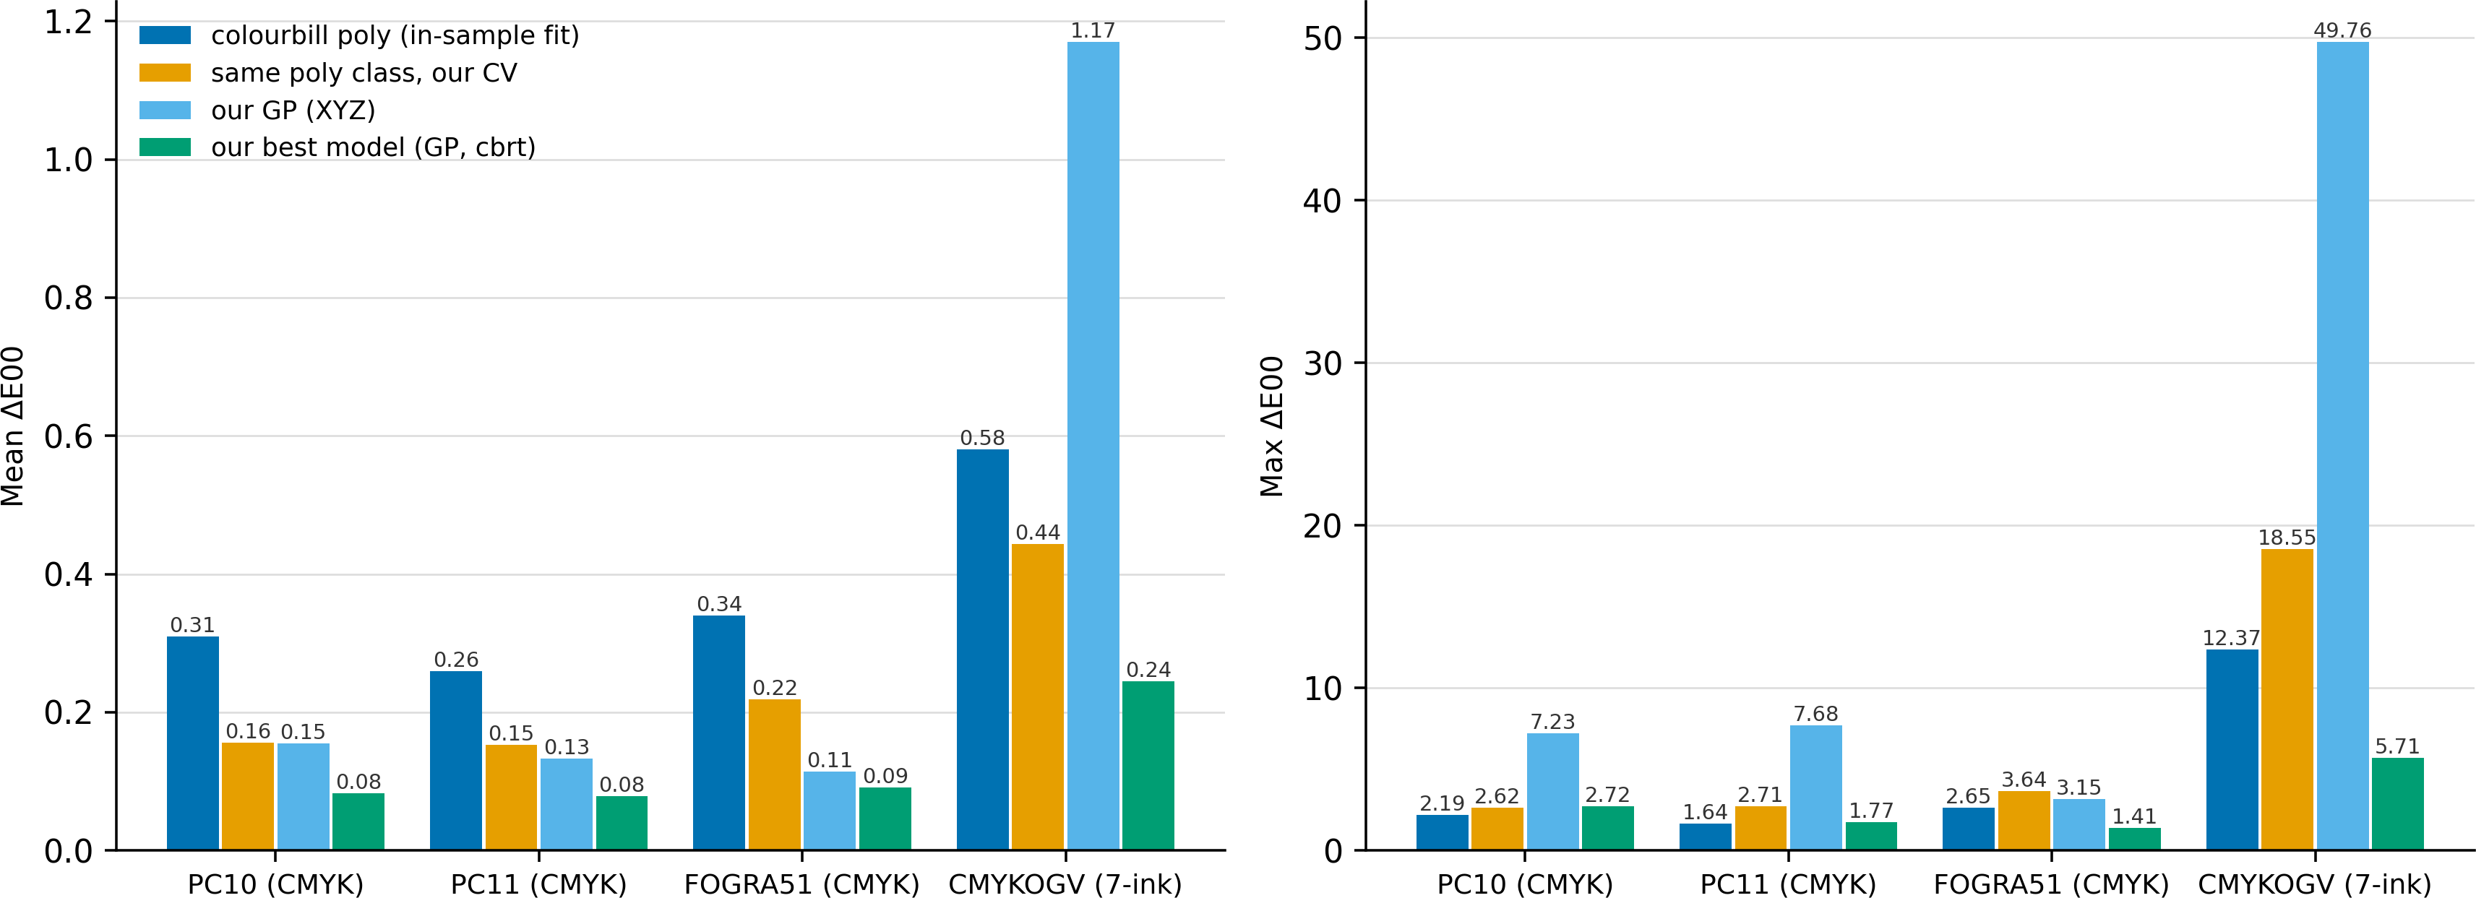
Figure 7. Mean and maximum ∆E₀₀ on identical data: CharData Viewer’s degree-4 polynomial fit versus this work. The protocols differ and are not interchangeable: the external tool’s statistics are resubstitution (the model is fitted on all loaded rows and evaluated on the same rows, which is systematically optimistic), whereas ours are 5-fold cross-validated out-of-sample errors. The comparison is meaningful only as a floor: our numbers are produced under the harder protocol. Source: journal/results/colourbill/{colourbill_fit_stats,poly_lab_cv,comparison}.csv.
- Discussion 744
The baseline, before either question.
Section 4.5 establishes 746
that the classical polynomial
was fitted on XYZ and capped at third order, and that both 748
restrictions are costly: correcting the space alone improves the polynomial’s maximum 749
error on 9 of 9 datasets and its median on 8 of 9, and correcting both takes its median 750
on the seven-ink CMYKOGV chart from 5.386 to 0.272 ∆E₀₀. Section 4.5 establishes the 751
mechanism and shows the cube root not to be privileged among compressive transforms; 752
none of this is new as technique (Section 2), and its consequence is that both answers below 753
are narrower than an uncorrected comparison would suggest. 754

Question (a): does machine learning match or beat classical polynomial regression 755
at n ≤ 4? Yes, but by about a factor of two rather than the order of magnitude the 756
uncorrected comparison suggested. Gaussian process regression is the best-median model 757
on all three printer datasets at both n = 3 and n = 4 (Tables 3–4); against the best 758
polynomial available at any degree and fitting space it is 2.0–2.4× better in median, and 759
against the corrected degree-3 CIELAB polynomial 3.3–8.2× better. The 6× and 12–17× 760
margins over the degree-3 XYZ fit reflect the baseline’s fitting space as much as the model’s 761

merit. The result is insensitive to the fold-assignment scheme (Section 4.3), survives an 762 independent external cross-check (Section 4.9), and was reproduced to within 0.003 ∆E₀₀ 763 by a clean-room reimplementation, on the pre-deduplication results set (Section 3.3). On 764 the gray-component-replacement motivation behind the question, the reading is likewise 765 narrower: the Gaussian process handles the added K channel as a fourth input dimension 766 with no special-casing, degrading ×1.2 in median error, but so does the polynomial once it 767 is fitted in the same space (×1.5 at degree 3, ×1.3 at degree 4), against ×3.5 for the XYZ fit 768 (Figure 2). The claim that a fixed-degree basis cannot absorb K’s interaction terms while 769 a kernel adapts is not supported once the fitting space is controlled for; what remains 770 is a level difference. A second, narrower result refines rather than replaces the classical 771 polynomial: optimizing its coefficients directly on ∆E₀₀ (Section 4.4) cuts worst-case error 772 16–51% at n = 3 at essentially unchanged median, and at n = 4 improves the median by 773 4–9% and the 95th percentile by 19–27%, though a change of fitting space, which is free, 774 does more (0.942 → 0.219 on PC10-CMYK, against Powell’s 0.867). One caveat: the newsprint 775 results (Section 4.6) show press-to-press variation, not model choice, dominating error 776 once training and test data come from different presses. GP is the best within-run model 777 on newsprint too (median-of-medians 0.899, at the press noise floor), but that advantage 778 vanishes under cross-run and leave-one-out evaluation, where it is indistinguishable from 779 SVM, polynomial regression and a deep MLP. 781 Question (b): can machine learning handle n > 4 colorant systems where classical 782 methods do not scale? Yes; and so can classical polynomial regression, given a perceptual 783 fitting space and a fourth degree. Gaussian process regression remains the best-median 784 model on the five-ink KCMYG set and both seven-ink systems, at 0.764, 0.160 and 0.977 785
∆E₀₀ fitted in cube-root space. But the corrected polynomial follows at 0.853, 0.272 and 786 1.132, factors of 1.1, 1.7 and 1.2 rather than the factor of 21.6 that the degree-3 XYZ baseline 787 implied on CMYKOGV-7; on KCMYG-5 and CMYKOGB-7 it beats the XYZ-fitted Gaussian 788 process (0.853 against 0.867; 1.132 against 1.280). The claim is therefore not 789 that classical methods fail beyond CMYK, but that they need two things in order not to (a 790 fitting space and a degree), and that both must be chosen, whereas the Gaussian process 791 requires neither and additionally keeps a substantial margin in the error tail, where a 792 characterization model is often judged (CMYKOGV-7: P95 0.677 and maximum 5.713 793 against 1.189 and 18.612). The classical route does still fail on a third axis, feasibility of 794 direct metric optimization: Nelder–Mead stalls barely off its least-squares initialization 795 at n = 7, silently returning a model no better than the baseline, while Powell improves 796 worst-case behavior but at 41–62 minutes per dataset versus seconds at n ≤ 4. Two caveats 797 bound everything above: the rungs are independent datasets and printing systems, so only 798 each model’s own trend across n is meaningful, not absolute levels between rungs; and the 799 GP’s low CMYKOGV-7 median partly reflects that chart’s structure (84% of patches use ≤4 800 inks) rather than intrinsic seven-ink ease (Section 4.7). 801
Limitations. Every model comparison here (Sections 4.1–4.5 and 4.7) is trained and 802
evaluated within a single substrate per dataset; the newsprint experiments (Section 4.6) are 803
the paper’s only cross-printer evidence, and they cover one substrate class (newsprint) 804
at one colorant count (n = 4). The fitting-space and degree corrections of Section 4.5 805
were applied to the polynomial and to the Gaussian process, the two models the paper’s 806
argument rests on, but not to the remaining twelve; their positions in Tables 3, 4 and 10 807
should be read as XYZ-space results and may improve under the same treatment, so the 808
mid-field ordering is not a settled ranking. Nor has the degree sweep been repeated on 809
datasets other than CMYKOGV-7, so degree 4 is demonstrated not to overfit at 2.7 rows 810
per coefficient on one 3,302-row chart rather than in general. Gaussian process regression’s 811

O(N3) training cost in the number of samples is a deployment concern as datasets grow 812 (the newsprint leave-one-out condition pools ∼17,800 samples), separate from its accuracy 813 advantage; the corrected polynomial’s 0.1 s fit is the relevant counterweight. The language- 814 model probe of Section 4.8 is n = 1 per condition on one three-ink chart and supports no 815 ranking of models. 819
- Conclusions 820

Fitted against the cube root of 824
XYZ (a similar estimator to fitting in CIELAB), the degree-3 polynomial
gives good results, while raised to degree 4 in that 826
space it reaches a median of 0.272 ∆E₀₀ on a seven-ink chart
. Section 4.5 establishes the mechanism and shows the cube root to be merely the 828
transform that coincides with CIELAB, not the best one on most datasets. 829
Against that baseline, Gaussian process regression remains the best-median 830
model on 8 of the 9 datasets, at n = 3, 4, 5 and 7 alike

; on two of the three n > 4 datasets a degree-4 CIELAB polynomial beats the 833
XYZ-fitted Gaussian process. What the Gaussian process retains, and what a practitioner 834
should weigh, is that it requires no choice of degree or fitting space, and that it holds 835
a clear margin in the error tail at high ink count. Refining the polynomial’s coefficients 836
directly on ∆E₀₀ helps at the margins but is largely subsumed by choosing the fitting space 837
correctly, and at n = 7 it either stalls (Nelder–Mead) or becomes hour-scale (Powell). Cross- 838
printer generalization, tested on 13 newsprint press runs, is dominated by press-to-press 839
variation rather than model choice, and pooling training data across presses recovers only 840
20–32% of the gap. An independent public tool, run on byte-identical data, confirms both 841
our ∆E₀₀ arithmetic and that these cross-validated errors match or beat its in-sample fit; 842
by fitting its own polynomial in CIELAB, it also independently corroborates the space 843
correction above. Finally, an exploratory probe of large language models asked to write a 844
characterization equation finds the best unaided answer 13× worse than a least-squares 845
cubic on the same 150 rows; the one model that beat the cubic did so by writing and running 846
code, which measures an agent rather than a language model. The answer to the paper’s 847
central question is therefore affirmative but narrower than expected: machine learning 848
does characterize n > 4 colorant systems well, and so does classical polynomial regression, 849
provided it is given the fitting space and the degree it needs. 850
Author Contributions: Conceptualization, M.H.Z. and P.J.G.; methodology, M.H.Z.; software, M.H.Z.; 851
validation, M.H.Z. and P.J.G.; formal analysis, M.H.Z.; investigation, M.H.Z.; resources, P.J.G.; data 852
curation, M.H.Z.; writing (original draft preparation), M.H.Z.; writing (review and editing), M.H.Z. 853
and P.J.G.; visualization, M.H.Z.; supervision, P.J.G.; project administration, P.J.G.; funding acquisition, 854
P.J.G. All authors have read and agreed to the published version of the manuscript. 855
Funding: This research received no external funding. 856
Institutional Review Board Statement: Not applicable. 857
Informed Consent Statement: Not applicable. 858

Data Availability Statement: The analysis code, experiment scripts and every results CSV under- 859 lying the tables and figures of this study are publicly available at https://github.com/hamzafer/ 860 Evaluating-Machine-Learning-Methods. The characterization datasets themselves are third-party 861 data and are not redistributed there. Three of them are publicly available from their origina- 862 tors: FOGRA51 from the Fogra Research Institute, https://fogra.org/en/downloads/work-tools/ 863 characterisation-data [33]; and the APTEC PC10 and PC11 charts [34] together with the APTEC 864 CMYKOGV seven-ink chart, from the ICC characterization data registry, https://registry.color.org/ 865 [36]. Restrictions apply to the availability of the remaining datasets. The IFRA 2005 newsprint charts 866 are licensed research data, used here under that license; the KCMYG five-ink chart and the Apex 867 CMYKOGB seven-ink chart were obtained from third parties through the second author. These three 868 are not the authors’ to redistribute and are available from the respective providers on reasonable 869 request and with their permission. 870
Acknowledgments: The authors thank William Li and the providers of the five- and seven-colorant 871
characterization data used in Section 4.7. During the preparation of this manuscript/study, the 872
authors used Anthropic Claude (Claude Code command-line agent; Claude Sonnet 5, Claude Opus 873
4.6, Claude Opus 5 and Claude Fable 5 models) for the purposes of implementing the characteriza- 874
tion pipeline and analysis scripts, generating figure-plotting code, and drafting and copy-editing 875
manuscript prose. The authors have reviewed and edited the output and take full responsibility for 876
the content of this publication. This statement concerns AI used as a tool in preparing the work, and 877
is separate from Section 4.8, in which large language models are themselves the object of study. 878
Conflicts of Interest: The authors declare no conflicts of interest. 879
Abbreviations 880
The following abbreviations are used in this manuscript: 881
882

CMY Cyan, Magenta, Yellow
CMYK Cyan, Magenta, Yellow, Key (Black)
CMYKOGV Cyan, Magenta, Yellow, Key, Orange, Green, Violet CMYKOGB Cyan, Magenta, Yellow, Key, Orange, Green, Blue CV Cross-Validation
GP Gaussian Process
ICC International Color Consortium
LLM Large Language Model
LUT Look-Up Table
MLP Multilayer Perceptron
NTNU Norwegian University of Science and Technology
SVM Support Vector Machine (used here as support vector regression, SVR)
∆E00 CIEDE2000 color-difference formula

883

References 884
- Bala, R.; Klassen, R.V. Efficient Color Transformation Implementation. In Digital Color Imaging Handbook; Sharma, G., Ed.; CRC 885
Press: Boca Raton, FL, 2003; pp. 687–725. https://doi.org/10.1201/9781420041484-11. 886
- Boll, H. Color-to-Colorant Transformation for a Seven Ink Process. In Proceedings of the Device-Independent Color Imaging, 887
Proc. SPIE, 1994, Vol. 2170, pp. 108–118. https://doi.org/10.1117/12.173839. 888
- Deshpande, K.; Green, P.; Pointer, M.R. Gamut Evaluation of an n-Colour Printing Process with the Minimum Number of 889
Measurements. Color Research & Application 2015, 40, 408–415. https://doi.org/10.1002/col.21909. 890
- Kang, H.R.; Anderson, P.G. Neural Network Applications to the Color Scanner and Printer Calibrations. Journal of Electronic 891
Imaging 1992, 1, 125–135. https://doi.org/10.1117/12.57526. 892
- Tominaga, S. A Neural Network Approach to Color Reproduction in Color Printers. In Proceedings of the IS&T/SID Color 893
Imaging Conference, Springfield, VA, 1993; Vol. 1993, pp. 173–177. https://doi.org/10.2352/CIC.1993.1.1.art00043. 894
- Su, Z.; Yang, J.; Li, P.; Zhang, H.; Jing, J. Colour Space Conversion Model from CMYK to CIELab Based on CS-WNN. Coloration 895
Technology 2021, 137, 272–279. https://doi.org/10.1111/cote.12529. 896

- Zhan, H.; Zou, Y.; Zhang, Y.; Gong, W.; Xu, F. Color Space Conversion Model from CMYK to CIELab Based on Stacking Ensemble 897
Learning. Color Research & Application 2025, 50, 314–326. https://doi.org/10.1002/col.22971. 898
- Zafar, M.H.; Green, P. Comparison of AI Based Machine Learning Methods with Basic Polynomial Regression for Cross Media 899
Color Reproduction. In Proceedings of the 16th Congress of the International Colour Association (AIC) 2025: Color for Future, 900
Color Association of Taiwan, Taipei, Taiwan, 19–24 October 2025; pp. 59–64. ISBN 978-0-6484724-7-6. 901
- Bala, R. Device Characterization. In Digital Color Imaging Handbook; Sharma, G., Ed.; CRC Press: Boca Raton, FL, 2003; pp. 269–384. 902
https://doi.org/10.1201/9781420041484-5. 903
- Cheung, V.; Westland, S.; Connah, D.; Ripamonti, C. A Comparative Study of the Characterisation of Colour Cameras by Means 904
of Neural Networks and Polynomial Transforms. Coloration Technology 2004, 120, 19–25. https://doi.org/10.1111/j.1478-4408.20 905
04.tb00201.x. 906
- Molada-Tebar, A.; Riutort-Mayol, G.; Marqués-Mateu, Á.; Lerma, J.L. A Gaussian Process Model for Color Camera Characteriza- 907
tion: Assessment in Outdoor Levantine Rock Art Scenes. Sensors 2019, 19, 4610. https://doi.org/10.3390/s19214610. 908
- Hung, P.C. Colorimetric Calibration in Electronic Imaging Devices Using a Look-Up-Table Model and Interpolations. Journal of 909
Electronic Imaging 1993, 2, 53. https://doi.org/10.1117/12.132391. 910
- Vrhel, M.J.; Trussell, H.J. Color Device Calibration: A Mathematical Formulation. IEEE Transactions on Image Processing 1999, 911
8, 1796–1806. https://doi.org/10.1109/83.806624. 912
- He, R.; Xiao, K.; Pointer, M.; Bressler, Y.; Liu, Q. Investigation on Color Characterization Methods for 3D Printer. In Proceedings 913
of the London Imaging Meeting, 2023, Vol. 4, pp. 71–75. https://doi.org/10.2352/lim.2023.4.1.18. 914
- Babaei, V.; Hersch, R.D. N-Ink Printer Characterization With Barycentric Subdivision. IEEE Transactions on Image Processing 2016, 915
25, 3023–3031. https://doi.org/10.1109/TIP.2016.2560526. 916
- Deshpande, K.; Green, P.; Pointer, M.R. Characterisation of the n-colour printing process using the spot colour overprint model. 917
Optics Express 2014, 22, 31786–31800. https://doi.org/10.1364/OE.22.031786. 918
- Shi, L.; Babaei, V.; Kim, C.; Foshey, M.; Hu, Y.; Sitthi-Amorn, P.; Rusinkiewicz, S.; Matusik, W. Deep Multispectral Painting 919
Reproduction via Multi-Layer, Custom-Ink Printing. ACM Transactions on Graphics 2018, 37, 1–15. https://doi.org/10.1145/3272 920
127.3275057. 921
- Chen, D.; Urban, P. Deep Learning Models for Optically Characterizing 3D Printers. Optics Express 2021, 29, 615. https: 922
//doi.org/10.1364/OE.410796. 923
- Vacareanu, R.; Negru, V.A.; Suciu, V.; Surdeanu, M. From Words to Numbers: Your Large Language Model Is Secretly a Capable 924
Regressor When Given In-Context Examples. In Proceedings of the First Conference on Language Modeling (COLM), 2024. 925
https://doi.org/10.48550/arXiv.2404.07544. 926
- Shojaee, P.; Meidani, K.; Gupta, S.; Barati Farimani, A.; Reddy, C.K. LLM-SR: Scientific Equation Discovery via Programming 927
with Large Language Models. In Proceedings of the International Conference on Learning Representations (ICLR), 2025. 928
https://doi.org/10.48550/arXiv.2404.18400. 929
- Hoerl, A.E.; Kennard, R.W. Ridge Regression: Biased Estimation for Nonorthogonal Problems. Technometrics 1970, 12, 55–67. 930
https://doi.org/10.1080/00401706.1970.10488634. 931
- Tibshirani, R. Regression Shrinkage and Selection via the Lasso. Journal of the Royal Statistical Society: Series B (Methodological) 932
1996, 58, 267–288. https://doi.org/10.1111/j.2517-6161.1996.tb02080.x. 933
- Zou, H.; Hastie, T. Regularization and Variable Selection via the Elastic Net. Journal of the Royal Statistical Society: Series B 934
(Statistical Methodology) 2005, 67, 301–320. https://doi.org/10.1111/j.1467-9868.2005.00503.x. 935
- Massy, W.F. Principal Components Regression in Exploratory Statistical Research. Journal of the American Statistical Association 936
1965, 60, 234–256. https://doi.org/10.1080/01621459.1965.10480787. 937
- Geladi, P.; Kowalski, B.R. Partial Least-Squares Regression: A Tutorial. Analytica Chimica Acta 1986, 185, 1–17. https: 938
//doi.org/10.1016/0003-2670(86)80028-9. 939
- Cortes, C.; Vapnik, V. Support-Vector Networks. Machine Learning 1995, 20, 273–297. https://doi.org/10.1007/BF00994018. 940
- Cover, T.M.; Hart, P.E. Nearest Neighbor Pattern Classification. IEEE Transactions on Information Theory 1967, 13, 21–27. 941
https://doi.org/10.1109/TIT.1967.1053964. 942
- Breiman, L.; Friedman, J.H.; Olshen, R.A.; Stone, C.J. Classification and Regression Trees; Wadsworth: Monterey, CA, 1984. 943
- Breiman, L. Random Forests. Machine Learning 2001, 45, 5–32. https://doi.org/10.1023/A:1010933404324. 944
- Friedman, J.H. Greedy Function Approximation: A Gradient Boosting Machine. Annals of Statistics 2001, 29, 1189–1232. 945
https://doi.org/10.1214/aos/1013203451. 946
- Rasmussen, C.E.; Williams, C.K.I. Gaussian Processes for Machine Learning; MIT Press: Cambridge, MA, 2006. https://doi.org/10.7 947
551/mitpress/3206.001.0001. 948
- Sharma, G.; Wu, W.; Dalal, E.N. The CIEDE2000 Color-Difference Formula: Implementation Notes, Supplementary Test Data, 949
and Mathematical Observations. Color Research & Application 2005, 30, 21–30. https://doi.org/10.1002/col.20070. 950

- Fogra Research Institute. FOGRA51 and FOGRA52 Characterisation Data (Version 1.0) [Data set]. https://fogra.org/en/ 951
downloads/work-tools/characterisation-data, 2020. Accessed on 29 August 2026. 952
- Advanced Printing Technology Centre Limited (APTEC). APTEC PC10 Cardboard and APTEC PC11 CCNB Characterization 953
Data, 2023 v1. ICC Characterization Data Registry, 2023. Available online: https://registry.color.org/cmyk-registry/aptec_ 954
coated_cardboard and https://registry.color.org/cmyk-registry/aptec_ccnb (accessed on 29 August 2026). 955
- Mansencal, T.; Mauderer, M.; Parsons, M.; Shaw, N.; Wheatley, K.; Cooper, S.; Vandenberg, J.D.; et al. Colour 0.4.6, 2024. Python 956
library. Available online: https://www.colour-science.org/ (accessed on 29 August 2026), https://doi.org/10.5281/zenodo.1391 957
7514. 958
- International Color Consortium. ICC Characterization Data Registry, 2025. Available online: https://registry.color.org/ (accessed 959
on 29 August 2026). APTEC CMYKOGV coated chart: https://registry.color.org/cmyk-registry/aptec_cmykogvcoated. 960
- Finlayson, G.D.; Mackiewicz, M.; Hurlbert, A. Color Correction Using Root-Polynomial Regression. IEEE Transactions on Image 961
Processing 2015, 24, 1460–1470. https://doi.org/10.1109/TIP.2015.2405336. 962
- Hong, G.; Luo, M.R.; Rhodes, P.A. A Study of Digital Camera Colorimetric Characterization Based on Polynomial Modeling. 963
Color Research & Application 2001, 26, 76–84. https://doi.org/10.1002/1520-6378(200102)26:1<76::AID-COL8>3.0.CO;2-3. 964
- Nussbaum, P.; Hardeberg, J.Y. Print Quality Evaluation and Applied Colour Management in Coldset Offset Newspaper Print. 965
Color Research & Application 2012, 37, 82–91. https://doi.org/10.1002/col.20674. 966
- Li, W. CharData: ICC Profile and CGATS/IT8 Characterisation Viewer in the Browser, 2026. Available online: https://chardata. 967
colourbill.com/ (accessed on 29 August 2026).
Green, P. "Accuracy of colour transforms", Proc. SPIE 6058, Color Imaging XI: Processing, Hardcopy, and Applications, 605802 968

