Locavore - Midterm Portfolio Refinements
Portfolio Link: https://hamzagame123.github.io/portfolio/Locavore/case-study.html
Hero / Intro Section
Before | After
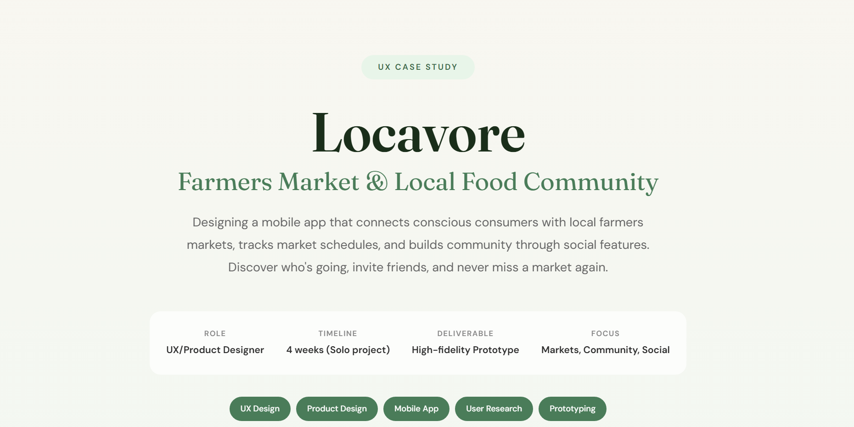 | 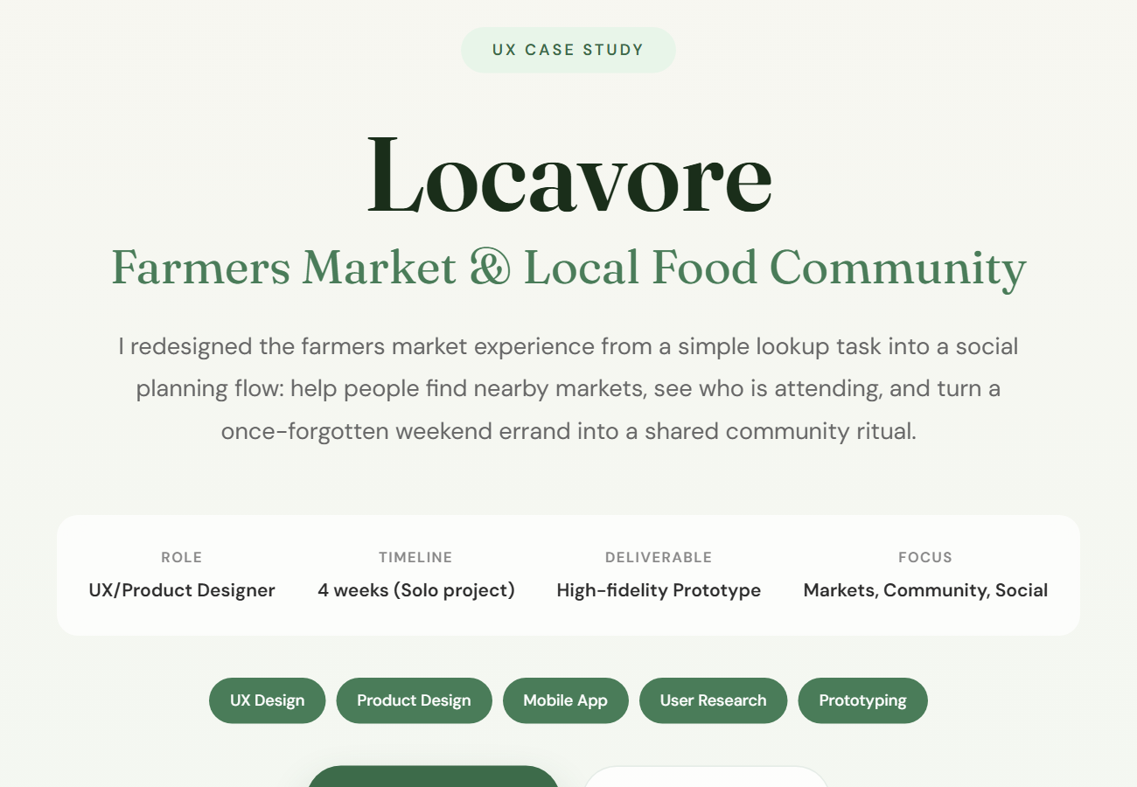

Process / Research Section
Before | After
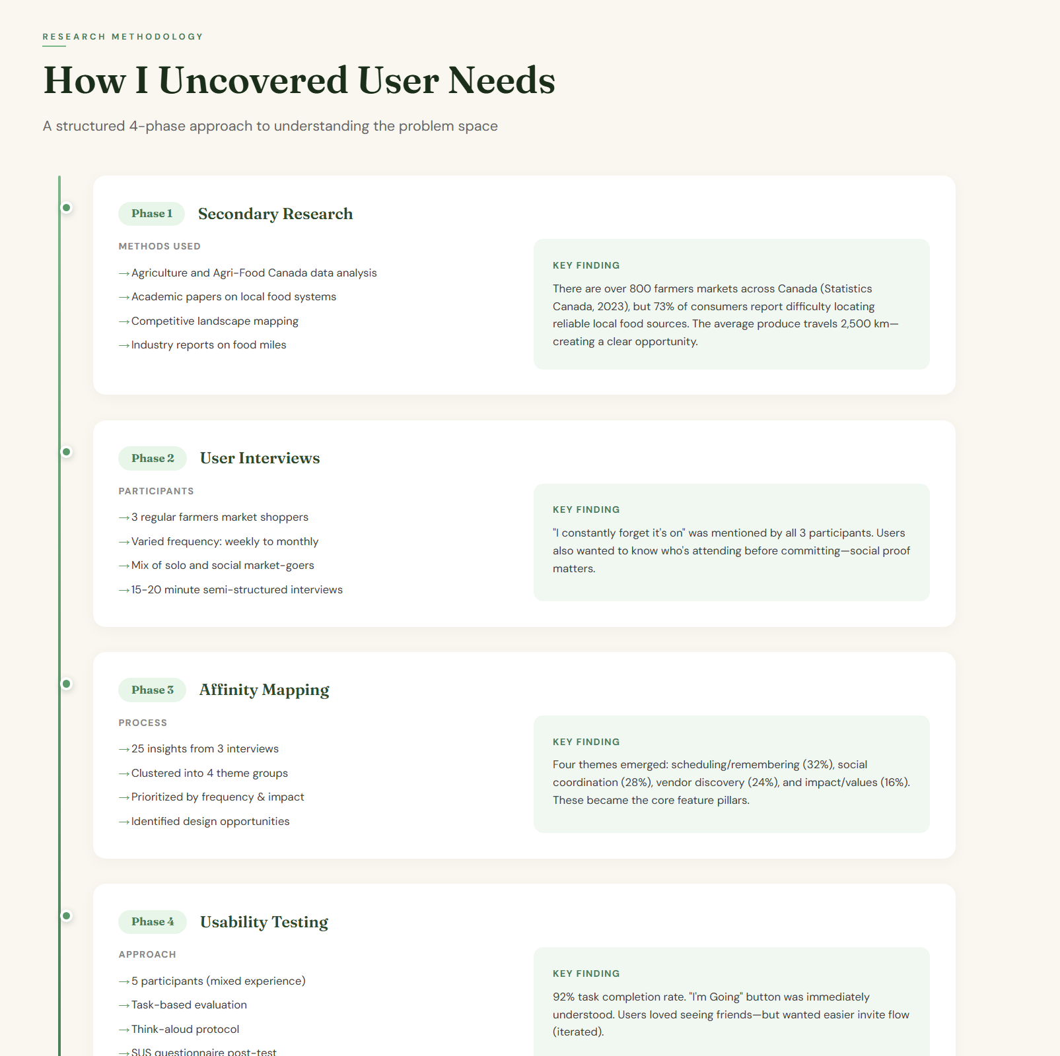 | 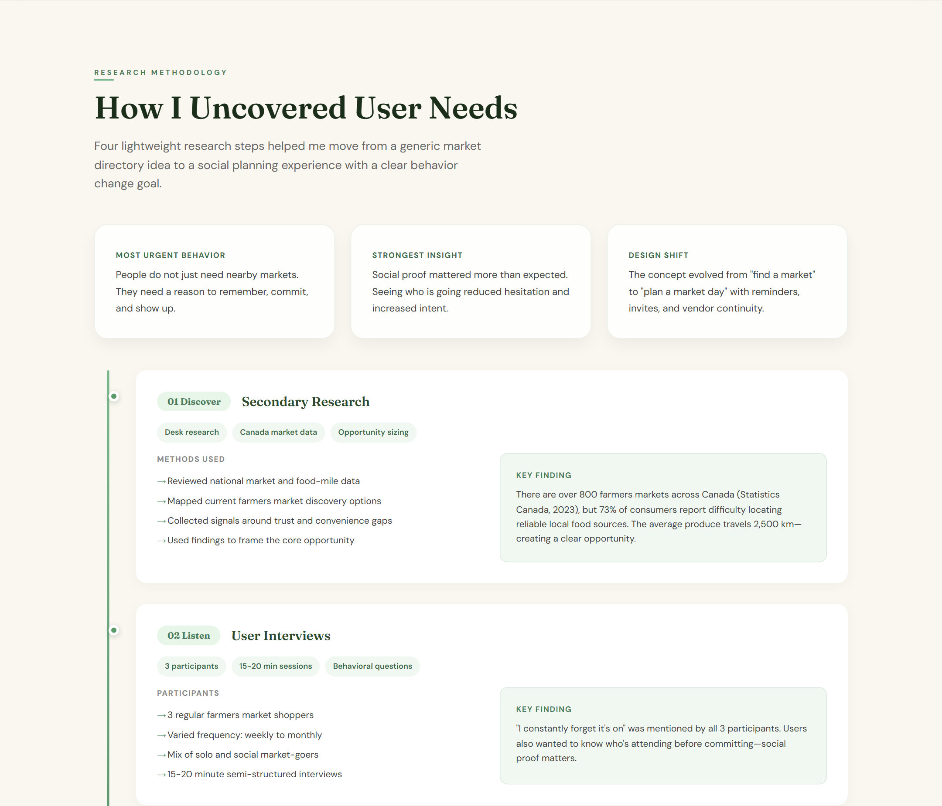

Final Prototype Section
Before | After
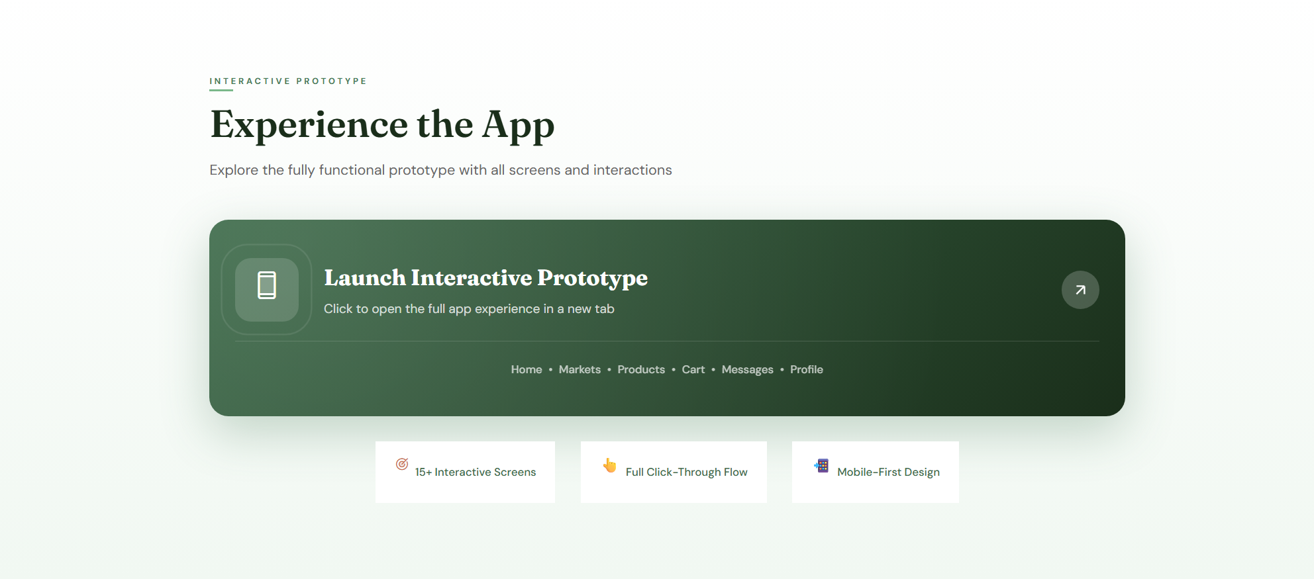 | 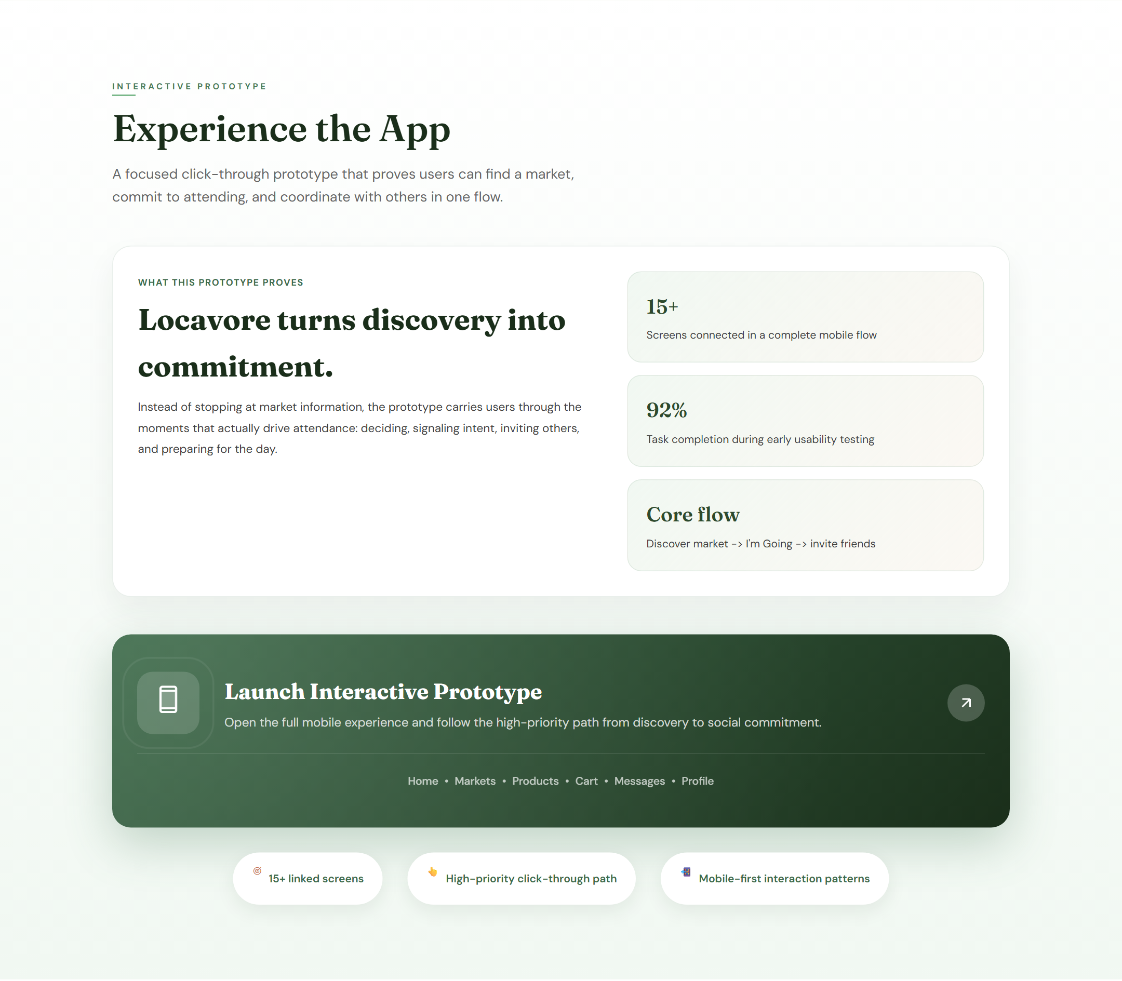

Change List
- Change: Added clearer hero framing and CTA buttons
Why: Make the project value and key navigation obvious immediately.
- Change: Reworked the top summary into problem, solution, and outcome blocks
Why: Improve first-scan clarity for recruiters and instructors.
- Change: Updated the summary details to show role, timeline, tools, research, deliverable, and outcome
Why: Make the case study easier to evaluate quickly.
- Change: Added research highlight cards and phase metadata chips
Why: Make the process section more scannable and readable.
- Change: Strengthened the prototype section with a proof-focused spotlight
Why: Make the main interaction and product value more obvious.
- Change: Refined the results section with an outcome snapshot and clearer metrics
Why: Show stronger progression from design work to evidence-backed learning.
What's Next
If I had more time, I would run another round of usability testing with actual farmers market shoppers and use it to refine the invite flow and market comparison experience. That would turn the current concept validation into stronger evidence-backed iteration.

