**PART 1**

**Executive Summary**  
Designing a database for the nurses working at Green Apple Healthcare, which would contain information about their shifts, department assignments and pay slip. The purpose of making such a database is to make good use of the hospital’s new enterprise system and improve the overall efficiency of managing the nurses’ roster.  
  
**Business Rules**

1. Each nurse has first name, last name, employ ID, phone number and address.
2. Nurses will be assigned a shift, patients and a department only after they have completed a 2-month mandatory training period.
3. One shift has atleast one nurse working in it.
4. One nurse can do zero or multiple shifts.
5. Each shift comprises of a shift code, day and timeslot.
6. Each nurse can work in only 1 timeslot per day.
7. Each nurse’s shift will be changed after 1 week.
8. One department has atleast one nurse working in it.
9. One nurse can work in zero or one department.
10. Each department will be headed by one doctor.
11. Each Doctor will be the head of a department.
12. Each Doctor should have first name, last name, employ ID, phone number and address.
13. Each department must have a name, department number and location within the hospital.
14. Each nurse’s department will be changed after every 2 weeks.
15. Nurses cannot exchange shifts with other nurses without the Hospital’s permission.
16. Nurses cannot exchange departments with other nurses without the Hospital’s permission
17. One nurse can look after zero or multiple patients.
18. Each patient will be looked after by atleast 1 nurse.
19. Each patient will have a Patient ID, name, date admitted, room number.
20. No two patients can have the same ID or room number
21. In case of overtime, pay rate for nurses will be one and one-half (1.5) times their regular working hour rate of pay.
22. Every nurse will get a payslip on the 10th of each month.
23. Every payslip must have a payslip number, salary deposit date, bonus awarded, salary deposited and bank account number.

**ERD Components  
Entity 1:** Nurses  
**Attributes:** N_EmployID, N_FirstName, N_LastName, N_PhoneNum, N_Address

**Entity 2:** Shift  
**Attributes:** ShiftCode, Timeslot, Days

**Entity 3:** Department  
**Attributes:** Dept_Number, Dept_Name, Dept_Location

**Entity 4:** Patient  
**Attributes:** P_ID, P_FullName, P_DateAdmitted, P_RoomNumber

**Entity 5:** Payslip  
**Attributes:** PayslipNumber, SalaryDepositDate, BonusAwarded, SalaryDeposited, BankAccountNumber

**Entity 6:** Doctor  
**Attributes:** D_EmployID, D_FirstName, D_LastName, D_PhoneNum, D_Address

**Entity 7:** Nurses_Shift (Intermediary table created to break many to many relationship between Nurses and Shift)   
**Attributes:** N_EmployID, ShiftCode

**Entity 8:** Nurses_Patients (Intermediary table created to break many to many relationship between Nurses and Patients)   
**Attributes:** N_EmployID, P_ID

**Relationships**

1. One shift has atleast one nurse working in it and one nurse can do zero or multiple shifts.
2. One department has atleast one nurse working in it and one nurse can work in zero or one department.
3. One nurse can look after zero or multiple patients and one patient will be looked after by atleast one nurse.
4. One nurse will get one payslip and one payslip is generated for one nurse.
5. One department is headed by one doctor and one doctor can only head one department.

**Cardinality**

1. Nurses (0:M) – Shift (1:N) -> Nurses (0:M) – Nurses_Shift (1:1) and Nurses_Shift (1:1) – Shift (1:N)
2. Nurses (0:1) – Department (1:N)
3. Nurses (0:M) – Patient (1:N) -> Nurses (0:M) – Nurses_Patients (1:1) and Nurses_Patients (1:1) – Patient (1:N)
4. Nurses (1:1) – Payslip (1:1)
5. Department (1:1) – Doctor (1:1)

**Keys**

**Nurses:** N_EmployID (PK), Dept_Number (FK), PayslipNumber (FK)  
**Shift:** ShiftCode (PK)  
**Department:** Dept_Number (PK), D_EmployID (FK)  
**Patient:** P_ID (PK)  
**Payslip:** PayslipNumber (PK)  
**Doctor:** D_EmployID (PK)  
**Nurses_Shift**: N_EmployID and ShiftCode (Composite Primary Key). Both individually are also foreign keys.  
**Nurses_Patients:** N_EmployID and P_ID (Composite Primary Key). Both individually are also foreign keys.

**Two Dimensional Flat File**



**ERD Diagram**

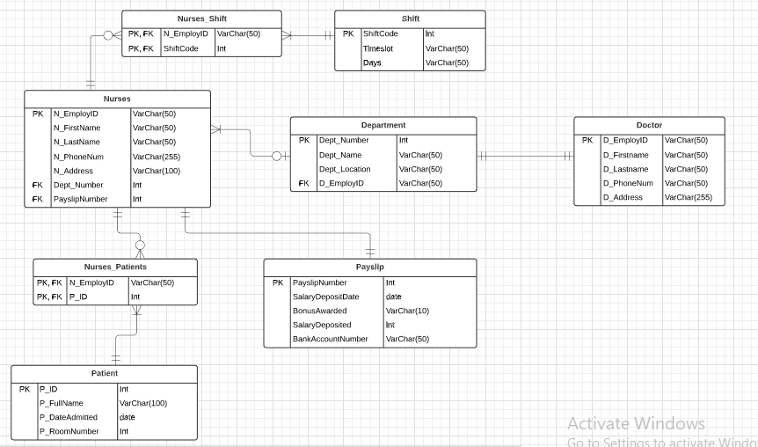

**PART 2**

**UNF Table**

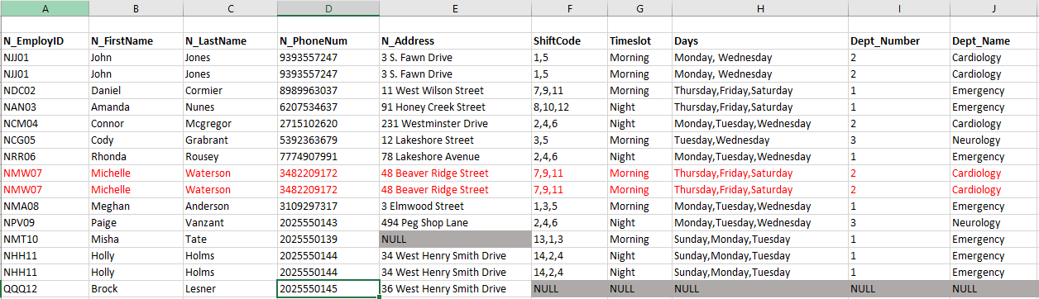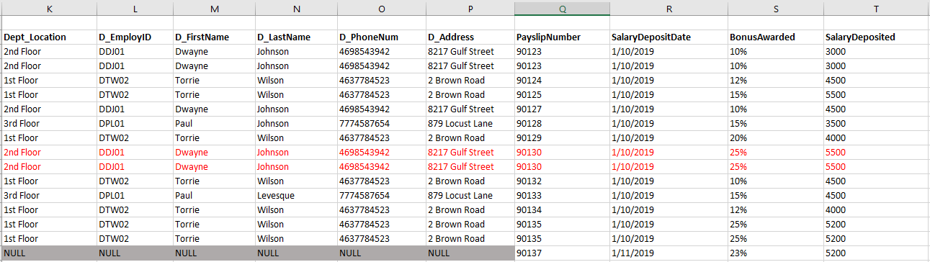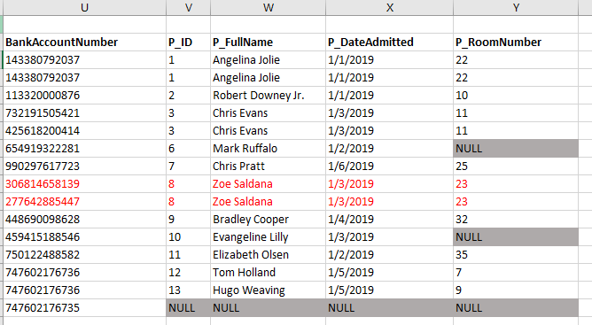

**Dependencies**

|  |  |  |  |  |
| --- | --- | --- | --- | --- |
| **N_EmployID** | **N_FirstName** | **N_LastName** | **N_PhoneNum** | **N_Address** |

|  |  |  |
| --- | --- | --- |
| **ShiftCode** | **Timeslot** | **Days** |

|  |  |  |  |
| --- | --- | --- | --- |
| **Dept_Number** | **Dept_Name** | **Dept_Location** | **HOD_Name** |

|  |  |  |  |  |
| --- | --- | --- | --- | --- |
| **D_EmployID** | **D_FirstName** | **D_LastName** | **D_PhoneNum** | **D_Address** |

|  |  |  |  |  |
| --- | --- | --- | --- | --- |
| **PayslipNumber** | **SalaryDepositDate** | **BonusAwarded** | **SalaryDeposited** | **BankAccountNumber** |

|  |  |  |  |
| --- | --- | --- | --- |
| **P_ID** | **P_FullName** | **P_DateAdmitted** | **P_RoomNumber** |

**Primary Keys:** N_EmployID, ShiftCode, Dept_Number, D_EmployID, PayslipNumber, P_ID

**Tables Separated Below**









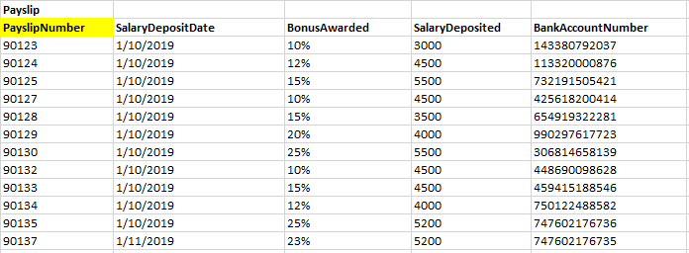



Since there are no transitive dependencies, above tables satisfy 3NF condition.

**Foreign Keys**



PayslipNumber and Dept_Number are foreign keys in Nurses table



D_EmployID is foreign key in Department table

Below tables were made in order to break the many to many relationship between Nurses and Patient (Nurses_Patient), Nurses and Shift (Nurses_Shift)

 

**Nurses_Shift**: N_EmployID and ShiftCode (Composite Primary Key). Both individually are also foreign keys.  
**Nurses_Patients:** N_EmployID and P_ID (Composite Primary Key). Both individually are also foreign keys.

Relationships and cardinalities already the same as in in Part 1.

**PART 3 (Script)**

**Creating database and tables**

create database Nurses_DB

use Nurses_DB;

create table Nurses_DB.Nurses_OP.Doctor (

D_EmployID VARCHAR (50) PRIMARY KEY,

D_FirstName VARCHAR (50) NOT NULL,

D_LastName VARCHAR (50) NOT NULL,

D_PhoneNum VARCHAR (50) NOT NULL,

D_Address VARCHAR (255) NOT NULL

);

create table Nurses_DB.Nurses_OP.Patient (

P_ID INT PRIMARY KEY IDENTITY (1, 1),

P_FullName VARCHAR (100) NOT NULL,

P_DateAdmitted DATE NOT NULL,

P_RoomNumber INT NULL

);

create table Nurses_DB.Nurses_OP.Payslip (

PayslipNumber INT PRIMARY KEY,

SalaryDepositDate DATE NOT NULL,

BonusAwarded VARCHAR(10) NOT NULL,

SalaryDeposited INT NOT NULL,

BankAccountNumber VARCHAR(50) NOT NULL

);

create table Nurses_DB.Nurses_OP.Department (

Dept_Number INT PRIMARY KEY IDENTITY (1, 1),

Dept_Name VARCHAR (50) NOT NULL,

Dept_Location VARCHAR (50) NOT NULL,

D_EmployID VARCHAR (50) NOT NULL,

FOREIGN KEY (D_EmployID) REFERENCES Nurses_DB.Nurses_OP.Doctor (D_EmployID)

);

alter table Nurses_DB.Nurses_OP.Nurses

alter column Dept_Number INT NULL;

create table Nurses_DB.Nurses_OP.Nurses (

N_EmployID VARCHAR (50) PRIMARY KEY,

N_FirstName VARCHAR (50) NOT NULL,

N_LastName VARCHAR (50) NOT NULL,

N_PhoneNum VARCHAR (255),

N_Address VARCHAR (100) NULL,

Dept_Number INT NOT NULL,

PayslipNumber INT NOT NULL,

FOREIGN KEY (Dept_Number) REFERENCES Nurses_DB.Nurses_OP.Department (Dept_Number),

FOREIGN KEY (PayslipNumber) REFERENCES Nurses_DB.Nurses_OP.Payslip (PayslipNumber)

);

create table Nurses_DB.Nurses_OP.Shifts (

ShiftCode INT PRIMARY KEY IDENTITY (1, 1),

Timeslot VARCHAR (50) NOT NULL,

Days VARCHAR (50) NOT NULL

);

create table Nurses_DB.Nurses_OP.Nurses_Shift (

N_employID VARCHAR (50) NOT NULL,

ShiftCode INT NOT NULL,

PRIMARY KEY (N_employID,ShiftCode),

FOREIGN KEY (N_employID) REFERENCES Nurses_DB.Nurses_OP.Nurses (N_EmployID),

FOREIGN KEY (ShiftCode) REFERENCES Nurses_DB.Nurses_OP.Shifts (ShiftCode),

);

create table Nurses_DB.Nurses_OP.Nurses_Patients (

N_employID VARCHAR (50) NOT NULL,

P_ID INT,

PRIMARY KEY (N_employID,P_ID),

FOREIGN KEY (N_employID) REFERENCES Nurses_DB.Nurses_OP.Nurses (N_EmployID),

FOREIGN KEY (P_ID) REFERENCES Nurses_DB.Nurses_OP.Patient (P_ID)

);

**Adding data in tables**

INSERT INTO Nurses_DB.Nurses_OP.Doctor (D_EmployID,D_FirstName,D_LastName,D_PhoneNum,D_Address)

values ('DDJ01','Dwayne','Johnson' ,'4698543942' ,'8217 Gulf Street'), ('DPL01', 'Paul', 'Johnson', '7774587654', '879 Locust Lane'),

('DTW02', 'Torrie', 'Wilson', '4637784523', '2 Brown Road');

insert into Nurses_DB.Nurses_OP.Patient (P_FullName, P_DateAdmitted, P_RoomNumber)

values ('Angelina Jolie', '1/1/2019', 22);

insert into Nurses_DB.Nurses_OP.Patient (P_FullName, P_DateAdmitted, P_RoomNumber)

values ('Robert Downey Jr.','1/1/2019',10

),('Chris Evans','1/3/2019',11

),('Mark Ruffalo','1/2/2019',NULL

),('Chris Pratt','1/6/2019',25

),('Zoe Saldana','1/3/2019',23

),('Bradley Cooper ','1/4/2019',32

),('Evangeline Lilly','1/3/2019',NULL

),('Elizabeth Olsen','1/2/2019',35

),('Tom Holland','1/5/2019',7

),('Hugo Weaving','1/5/2019',9

);

insert into Nurses_DB.Nurses_OP.Payslip (PayslipNumber, SalaryDepositDate, BonusAwarded, SalaryDeposited, BankAccountNumber)

values (90123,'1/10/2019','10%',3000,'143380792037'

),(90124,'1/10/2019','12%',4500,'113320000876'

),(90125,'1/10/2019','15%',5500,'732191505421'

),(90127,'1/10/2019','10%',4500,'425618200414'

),(90128,'1/10/2019','15%',3500,'654919322281'

),(90129,'1/10/2019','20%',4000,'990297617723'

),(90130,'1/10/2019','25%',5500,'306814658139'

),(90132,'1/10/2019','10%',4500,'448690098628'

),(90133,'1/10/2019','15%',4500,'459415188546'

),(90134,'1/10/2019','12%',4000,'750122488582'

),(90135,'1/10/2019','25%',5200,'747602176736'

);

insert into Nurses_DB.Nurses_OP.Payslip (PayslipNumber, SalaryDepositDate, BonusAwarded, SalaryDeposited, BankAccountNumber)

values (90137,'1/11/2019','23%',5200,'747602176735'

)

insert into Nurses_DB.Nurses_OP.Department (Dept_Name, Dept_Location, D_EmployID)

values ('Emergency','1st Floor','DTW02'

),('Cardiology','2nd Floor','DDJ01'

),('Neurology','3rd Floor','DPL01'

);

insert into Nurses_DB.Nurses_OP.Nurses (N_EmployID, N_FirstName, N_LastName, N_PhoneNum, N_Address, Dept_Number, PayslipNumber)

values ('NJJ01','John','Jones','9393557247','3 S. Fawn Drive',2,90123),

('NDC02','Daniel','Cormier','8989963037','11 West Wilson Street',1,90124),

('NAN03','Amanda','Nunes ','6207534637','91 Honey Creek Street',1,90125

),

('NCM04','Connor','Mcgregor','2715102620','231 Westminster Drive',2,90127

),

('NCG05','Cody','Grabrant','5392363679','12 Lakeshore Street',3,90128

),

('NRR06','Rhonda','Rousey','7774907991','78 Lakeshore Avenue',1,90129

),

('NMW07','Michelle','Waterson','3482209172','48 Beaver Ridge Street',2,90130

),

('NMA08','Meghan','Anderson','3109297317','3 Elmwood Street',1,90132

),

('NPV09','Paige','Vanzant','2025550143','494 Peg Shop Lane',3,90133

),

('NMT10','Misha ','Tate','2025550139',NULL,1,90134

),

('NHH11','Holly','Holms','2025550144','34 West Henry Smith Drive',1,90135

);

insert into Nurses_DB.Nurses_OP.Nurses (N_EmployID, N_FirstName, N_LastName, N_PhoneNum, N_Address, Dept_Number, PayslipNumber)

values ('QQQ12', 'Brock', 'Lesner', '2025550145', '36 West Henry Smith Drive', NULL, 90137);

insert into Nurses_DB.Nurses_OP.Shifts (Timeslot, Days)

values ('Morning','Monday

'),('Night','Monday

'),('Morning','Tuesday

'),('Night','Tuesday

'),('Morning','Wednesday

'),('Night','Wednesday

'),('Morning','Thursday

'),('Night','Thursday

'),('Morning','Friday

'),('Night','Friday

'),('Morning','Saturday

'),('Night','Saturday

'),('Morning','Sunday

'),('Night','Sunday

');

insert into Nurses_DB.Nurses_OP.Nurses_Shift (N_employID, ShiftCode)

values ('NJJ01',1

),('NJJ01',5

),('NDC02',7

),('NDC02',9

),('NDC02',11

),('NAN03',8

),('NAN03',10

),('NAN03',12

),('NCM04',2

),('NCM04',4

),('NCM04',6

),('NCG05',3

),('NCG05',5

),('NRR06',2

),('NRR06',4

),('NRR06',6

),('NMW07',7

),('NMW07',9

),('NMW07',11

),('NMA08',1

),('NMA08',3

),('NMA08',5

),('NPV09',2

),('NPV09',4

),('NPV09',6

),('NMT10',13

),('NMT10',1

),('NMT10',3

),('NHH11',14

),('NHH11',2

),('NHH11',4

);

insert into Nurses_DB.Nurses_OP.Nurses_Patients (N_employID,P_ID)

values ('NDC02',5

),('NAN03',6

),('NCM04',6

),('NCG05',7

),('NRR06',8

),('NMW07',9

),('NMA08',10

),('NPV09',11

),('NMT10',12

),('NHH11',13

),('NHH11',14

);

**Testing Joins and their results**

-- I chose Nurses and Departments

-- a. Show your table records

select * from Nurses_DB.Nurses_OP.Nurses;

select * from Nurses_DB.Nurses_OP.Department;

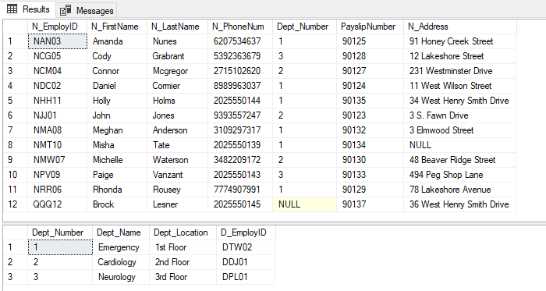

-- b. Create inner joins between two tables

select * from Nurses_DB.Nurses_OP.Nurses A

inner join Nurses_DB.Nurses_OP.Department B on A.Dept_Number = B.Dept_Number;

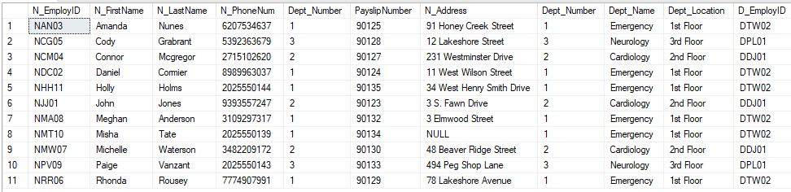

All nurses except Brock Lesner (N_EmployID=QQQ12) are shown here, since Brock did not have any Dept_Number

-- c. Create full joins between two tables

select * from Nurses_DB.Nurses_OP.Nurses A

full outer join Nurses_DB.Nurses_OP.Department B on A.Dept_Number = B.Dept_Number;

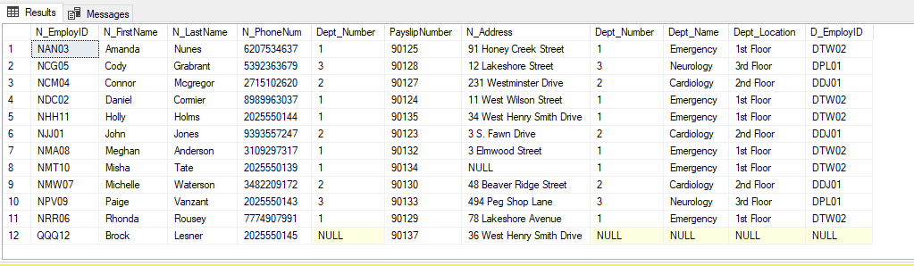

Shows all the nurses and all departments.

-- d. Create left outer joins between two tables

select * from Nurses_DB.Nurses_OP.Nurses A

left outer join Nurses_DB.Nurses_OP.Department B on A.Dept_Number = B.Dept_Number;

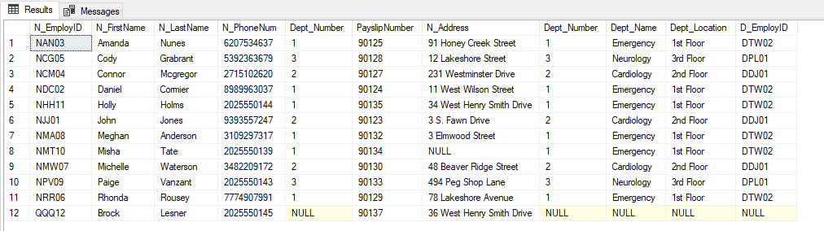

Using left outer join, the record unique to the left table is also shown. The last record of the Nurses table (12th record) with NULLs in the Department table against it.

-- e. Create right outer joins between two tables

select * from Nurses_DB.Nurses_OP.Nurses A

right outer join Nurses_DB.Nurses_OP.Department B on A.Dept_Number = B.Dept_Number;

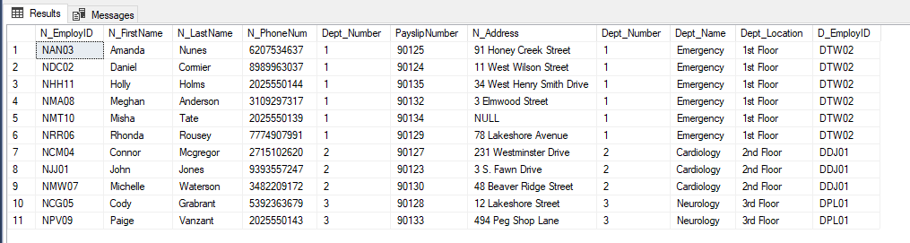

Since there is no department that has no nurses, right join would give the same result as inner join and return us 11 records. All the records in the right hand table match the records in the left hand table.

-- f. Create intersect between two tables

select Dept_Number from Nurses_DB.Nurses_OP.Nurses

intersect

select Dept_Number from Nurses_DB.Nurses_OP.Department;

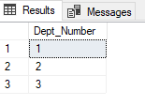

Intersection of dept number of both nurses and department table is shown.

-- g. Create union between two tables

select Dept_Number from Nurses_DB.Nurses_OP.Nurses

where Dept_Number in (1,2)

union

select Dept_Number from Nurses_DB.Nurses_OP.Department

where Dept_Number in (3);

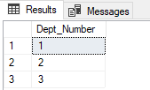

The first query fetches department 1 and 2 and the second query fetches department 3. Union joins both the results and shows us all the 3 departments.

--h. Create except between two tables

select Dept_Number from Nurses_DB.Nurses_OP.Nurses

except

select Dept_Number from Nurses_DB.Nurses_OP.Department

where Dept_Number in (3);

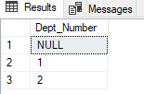

For except, the first query returns all three departments (1,2 and 3). The second query only returns department 3. Since except would remove the records from the first query that are in second query, we only see department 1 and 2 in the result.