AutiMate
An AI-assisted mobile application supporting autistic children
The complete project document — what it is, how it works, how it is built, and what it deliberately is not.
Project | AutiMate — Final Year Project, and Alibaba Cloud AI Hackathon Pakistan 2026 entry
Prepared by | Muhammad Hamza Habib — Track D3, AI · Speech · Adaptive Logic
Team | 4 people — D1 Frontend & Design · D2 Firebase & Data · D3 AI/Speech/Logic · D4 Integration & Release
Platform | Flutter — Android primary, iOS best-effort
Build window | 22–27 August 2026 (hackathon build phase); regional round 28–30 August
Document version | 1.0 · 20 August 2026
Status | Reference document for the team, the supervisor, and the judging panel

How to read this document. Sections 1–5 are the product: what AutiMate is and what it does. Sections 6–9 are the engineering: architecture, data, the intelligence, and speech. Section 10 is a standalone practical guide to checking whether your Android phone has an Urdu voice — the single riskiest unknown in the project, and the one thing that must be settled before the build starts. Sections 11–21 cover delivery, risk, quality and the demo. The appendices carry the code contracts and the probe app.
Where this comes from. This document consolidates three source documents in the project folder — AutiMate_Scope_Doc.md (the 16-week product scope), AutiMate_7Day_Sprint_Plan.md (the four-person build sprint) and AutiMate_D3_AI_Track_Plan.md (the AI track work order) — into one continuous account, with diagrams. Where the sources disagree, the sprint plan wins for what gets built and the scope document wins for what gets documented.

Contents
Contents 2
1 Executive summary 5
1.1 What AutiMate is 5
1.2 The three-sentence version 5
1.3 What makes it different 5
2 The problem 6
2.1 What the child faces 6
2.2 Why existing tools do not fit 6
2.3 What AutiMate is not 6
3 Who it is for 7
3.1 The roles 7
3.2 What a day looks like 7
4 Objectives and how success is measured 9
5 The product — eight modules 10
5.1 M1 · Communication Aid (AAC) — the flagship 10
5.2 M2 · Social Communication Training 10
5.3 M3 · Emotion and Expression Recognition 11
5.4 M4 · Routine and Flexibility Builder 11
5.5 M5 · Interest-Based Learning 11
5.6 M6 · Sensory-Friendly Environment 11
5.7 M7 · Parent and Teacher Dashboard 11
5.8 M8 · Adaptive Support Levels 11
5.9 Cross-cutting concerns 11
5.10 Explicitly out of scope 12
6 How it is built 13
6.1 The layers 13
6.2 The folder structure 14
6.3 The one rule that holds it together 14
6.4 Technology stack 14
7 The data 16
7.1 Collections 16
7.2 Who can read what 17
7.3 The grammar fields — a small detail with a large effect 17
8 The intelligence — where the AI actually is 18
8.1 The honest inventory 18
8.2 The AAC pipeline 19
8.3 Bilingual sentence realisation 19
8.4 Card ranking — recency-weighted frequency 20
8.5 The emotion activity engine 21
8.6 Adaptive difficulty 22
8.7 Expression practice — the on-device machine learning 23
8.8 What was rejected, and why 24
9 Speech — the most demo-critical service in the app 25
9.1 What the service must do 25
9.2 How the Urdu voice is resolved 25
9.3 Queue, barge-in and warm start 26
9.4 The risk this section exists to manage 26
10 Checking whether your Android phone has an Urdu voice 27
10.1 Why this is the first thing to test 27
10.2 Method 1 — the phone’s own settings, no code required 27
10.3 Method 2 — the probe app (the definitive answer) 29
10.4 Method 3 — from a laptop over adb (optional) 30
10.5 The three traps 30
10.6 If Urdu is missing — what to try, in order 30
10.7 Insurance worth buying whatever the answer is 31
10.8 The checklist to run on the demo phone 31
11 Working without a connection 33
12 Non-functional requirements 34
13 Privacy, safety and ethics 35
14 The team 36
14.1 The three rules 36
15 Delivery plan 38
15.1 The six-day build 38
15.2 The 16-week roadmap this is a slice of 39
15.3 If time runs short — the cut order 39
16 Risks 40
17 Quality — testing and the definition of done 42
17.1 What is tested, and how 42
17.2 Definition of done, per feature 42
18 What you hand over, and in what format 43
18.1 Why this question comes up at all 43
18.2 What I deliver — the D3 track 44
18.3 What the team delivers 45
18.4 Two audiences, two packages — one codebase 45
18.5 Formats, names, and the things that get lost 46
18.6 The submission package 46
18.7 If someone asks “where is your model?” 46
19 The demonstration 48
20 Open questions to settle before the build starts 49
21 Glossary 50
Appendix A Interface contracts 51
A.1 Speech 51
A.2 Sentence assembly 51
A.3 Card ranking, emotion activity, adaptive level 52
A.4 Expression practice 53
Appendix B The Urdu voice probe 54
B.1 The dependency 54
B.2 The probe 54
Appendix C Figures and sources 55
C.1 Figure index 55
C.2 Source documents 55

1 Executive summary

1.1 What AutiMate is
AutiMate is a child-friendly Android application that helps autistic children communicate, recognise emotions, follow daily routines, and stay regulated in a sensory environment they can tolerate. It also gives the adults around that child — parents, teachers, therapists — lightweight tools to set activities up and to see what is actually happening over time.
Its flagship feature is an AAC communication aid: a grid of picture cards a non-verbal or minimally verbal child taps to build a sentence, which the phone then speaks aloud in English or Urdu. Everything a child touches works fully offline, on the device, with no network call in the path between a tap and a spoken word.

1.2 The three-sentence version
A non-verbal child taps two picture cards and the phone says “I want an apple.” One toggle later, the same two taps produce grammatical Urdu — میں سیب چاہتا ہوں — with the verb agreeing with the child’s own gender, because the sentence is generated per language rather than translated. It runs in airplane mode, on a mid-range phone, with nothing about the child leaving the device.

1.3 What makes it different
Most comparable tools | AutiMate
English-only, or a machine translation bolted on | Bilingual by construction — English and Urdu are generated separately from the same structure, with full RTL layout
Require an internet connection for speech | Platform text-to-speech on the device; the core child experience never needs a network
Expensive, or subscription-gated | No payments, no subscriptions, no advertising, no third-party analytics on child data
Built for clinicians, with clinical language | Built for the child and the caregiver; makes no diagnostic or therapeutic claim anywhere
Bright, animated, noisy interfaces | A global sensory mode: reduced motion, muted palette, a volume ceiling, no flashing or sudden audio
Opaque “AI-powered” personalisation | Rule-based and explainable — a parent can be told exactly why a level changed or why a card moved

2 The problem

2.1 What the child faces
Autistic children commonly meet a set of daily obstacles that ordinary software makes worse rather than better:
- Expressing a need verbally — the want exists, the words do not arrive, and the frustration lands on both child and caregiver.
- Reading faces and emotional cues — an ability most software assumes rather than teaches.
- Unexpected change — a routine that shifts without warning can end a day.
- Generic learning material — content unrelated to the child’s actual interests gets no engagement at all.
- Sensory overload — bright colour, animation, sudden sound and visual clutter are standard app design and are actively hostile here.

2.2 Why existing tools do not fit
Established AAC and autism-support applications tend to be expensive, English-only, internet-dependent, or designed around a clinician rather than around the child and the family. In Pakistan that combination excludes most families outright: the price is prohibitive, the language is wrong, and the connectivity assumption does not hold. An Urdu-speaking child using an English-only communication aid is being asked to communicate in a language their family does not speak at home.

2.3 What AutiMate is not
AutiMate is a support and training tool. It is explicitly not a diagnostic, screening, or treatment application, and it makes no clinical claim anywhere in the interface, the documentation, or the presentation. It does not classify severity, it does not label behaviour automatically, and it never tells anyone what a child is feeling. The emotion features teach recognition; they do not report on a real person’s emotional state.

3 Who it is for
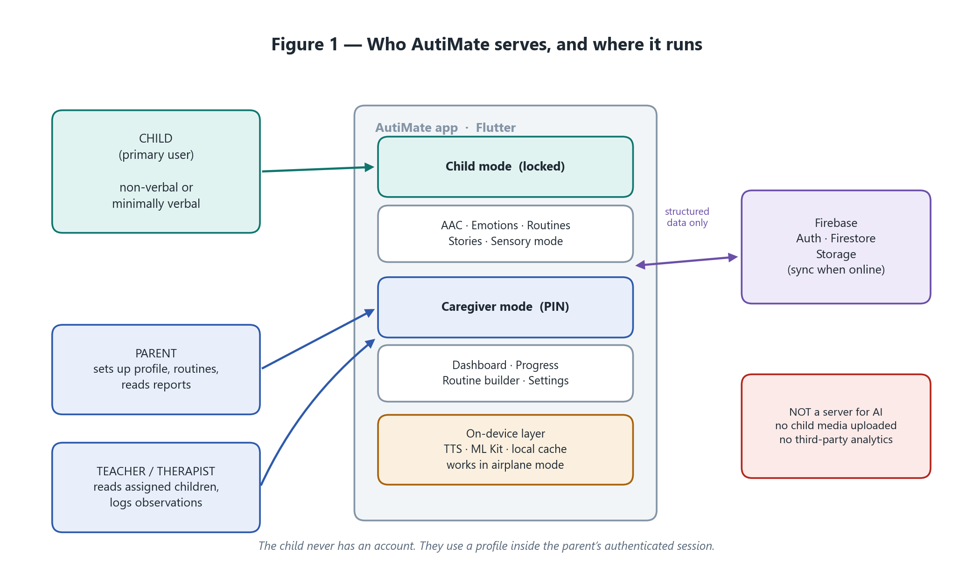
Figure 1 — The three human roles, the two modes of the app, and the strict limit on what ever leaves the device.

3.1 The roles
Role | What they do | What they can reach
Child | Uses the communication aid, emotion activities, routines and calming activities | A simplified, locked child mode. No account, no settings, no way out without a caregiver
Parent | Creates the child profile, configures routines and preferences, adds custom cards, reads reports | Full control of their own children, and nothing belonging to anyone else
Teacher / therapist | Follows progress for assigned children and logs written observations | Read access to assigned children only; write access only to observations
Supervisor / judge | Assesses the project | Not an app role — they receive the demo and this document

A child never holds an account. They use a profile inside the parent’s authenticated session — which removes an entire class of child-safety and credential problems rather than trying to manage it.

3.2 What a day looks like
Morning. The child opens the routine screen and sees five picture steps: wake, toilet, brush teeth, breakfast, shoes. Each step speaks its own label when tapped. Completing one marks it visibly done. Five minutes before the routine ends, a transition warning appears — the change is announced, not sprung.
Through the day. The child wants juice. Two taps on the communication grid — [I want] [juice] — and the phone speaks the sentence for them. Cards they use often drift to the front of the grid on their own.
Activity time. A short emotion session: five faces, two to four choices each depending on the child’s current level, spoken feedback after every answer, stars at the end.
Evening. The parent opens the dashboard: twelve activities this week, accuracy by emotion, routine completion five days out of seven, and a free-text note they wrote themselves. No automatic behavioural labels, no invented precision.

4 Objectives and how success is measured
Eight objectives, each with an indicator that can actually be checked on a device rather than asserted in a report.
# | Objective | Success indicator
O1 | Give non-verbal children a working communication aid | A child can build and speak a request in three taps or fewer
O2 | Teach emotion recognition through repeatable activities | Accuracy improves measurably across sessions
O3 | Make routines predictable and transitions less stressful | Routine completion is tracked and visualised
O4 | Personalise learning around the child’s declared interests | A learning path is generated from the interest profile
O5 | Reduce sensory overload through a configurable interface | Sensory mode measurably alters motion, sound and contrast
O6 | Give caregivers explainable progress insight | A weekly report with no fabricated precision
O7 | Work without internet for core child-facing features | Every core module functions fully in airplane mode
O8 | Support English and Urdu, including right-to-left layout | Full UI localised; zero hard-coded user-facing strings

5 The product — eight modules
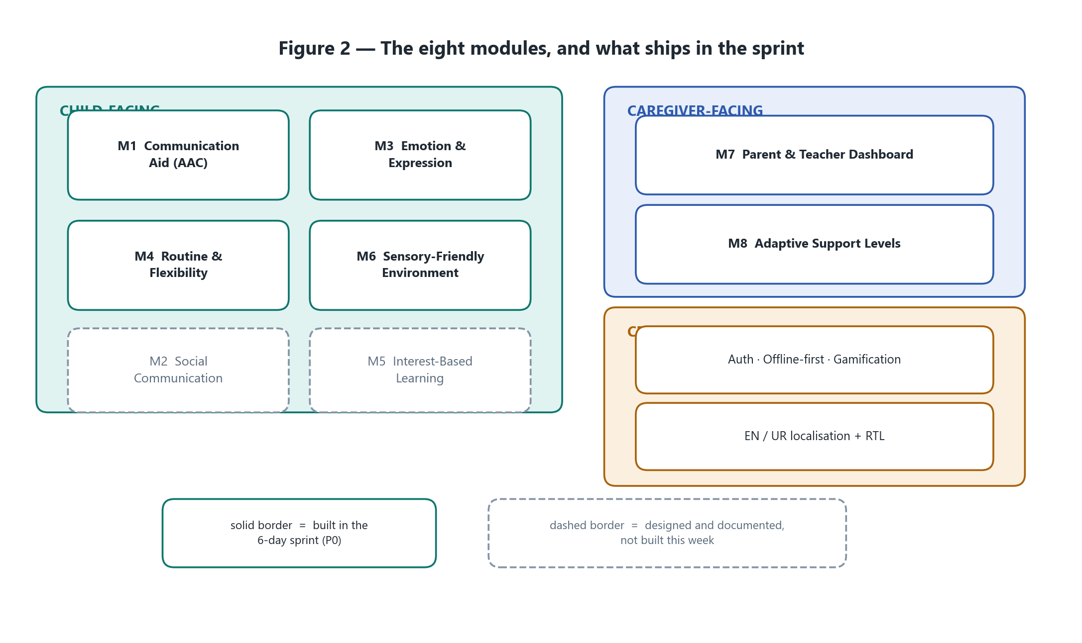
Figure 2 — The eight modules. Solid borders are built in the six-day sprint; dashed borders are designed and documented, not built this week.

5.1 M1 · Communication Aid (AAC) — the flagship
The highest-priority module and the strongest demonstration asset. A grid of large picture cards, organised into categories — food, drinks, emotions, activities, people, places, needs, objects — that a child taps to compose a phrase on a sentence strip. Tapping Speak says the whole sentence aloud.
- Every card also speaks its own label the instant it is tapped — immediate auditory feedback is a standard AAC design norm, not a nicety.
- Frequently-used and recently-used cards surface automatically, ranked by the algorithm in section 8.4.
- Parents can add custom cards: an image from the gallery or camera, a label in both languages, and optional recorded audio.
- Tap targets are at least 64 dp, text is minimal, contrast meets WCAG AA.
- The whole module works offline. This is not a stretch goal; it is the module’s identity.

5.2 M2 · Social Communication Training
Short illustrated social stories — meeting someone, asking for help, waiting for a turn, going to a shop — each narrated, each followed by a simple comprehension check. Conversation practice is scripted and branching, never open-ended generative chat, for the child-safety reasons set out in section 13.

5.3 M3 · Emotion and Expression Recognition
Two halves. Identification: the child is shown a face, an emoji or an illustrated scene and picks the emotion from six — happy, sad, angry, surprised, scared, neutral. Difficulty scales through the number of choices, the availability of a hint, and how visually confusable the wrong answers are (section 8.5).
Expression practice: the child is asked to make a face, and an on-device model reads the camera live to fill a progress meter. Camera frames are processed in memory and discarded — never written to storage, never uploaded (section 8.7).

5.4 M4 · Routine and Flexibility Builder
A visual daily schedule built from icon, label, time and optional audio. Steps can be marked complete; local notifications act as reminders; transition warnings announce a change before it happens (“play time ends in five minutes”). Flexibility training inserts a small, parent-approved change into a routine the child already knows, with positive reinforcement — practising change in a controlled way rather than only ever avoiding it.

5.5 M5 · Interest-Based Learning
The child’s interests — cars, animals, trains, space — are recorded in their profile and mapped to learning topics through a deterministic, inspectable table. Not a black-box recommender: a caregiver can see exactly why a topic appeared.

5.6 M6 · Sensory-Friendly Environment
A global mode that reduces motion, mutes the palette, lowers brightness, strips clutter and caps volume, plus calming activities: guided breathing, slow visual patterns, gentle sound. Nowhere in the application is there flashing, strobing, or sudden loud audio — including in the reward and feedback moments, which is where such things usually creep in.

5.7 M7 · Parent and Teacher Dashboard
Child profile management, activity history, emotion accuracy over time, routine adherence, and manual observation logging: free text with an optional tag, written by a human. There is no automatic behavioural labelling anywhere in the product.

5.8 M8 · Adaptive Support Levels
Three levels — beginner, intermediate, advanced — that adjust choice count, hint visibility, audio assistance, activity complexity and reward frequency. Promotion and demotion follow a simple published rule (section 8.6), and a parent can override and lock the level at any time.

5.9 Cross-cutting concerns
Concern | How it is handled
Authentication | Firebase Authentication for parents and teachers; children use profiles, not accounts
Persistence | Cloud Firestore for structured data, Firebase Storage for custom card media
Offline | Firestore offline persistence; child-facing features work with no connection at all (section 11)
Gamification | Stars, badges, streaks and progress rings — cooperative and personal, never competitive between children
Localisation | Full English and Urdu, right-to-left verified; no hard-coded user-facing strings anywhere
Security | Firestore security rules enforce data isolation server-side; client checks are treated as UX only

5.10 Explicitly out of scope
Listed so that nobody assumes otherwise halfway through the project, and so the boundary can be defended rather than apologised for.
Excluded | Reason
Clinical diagnosis, screening or severity classification | Outside the project remit; ethically and legally inappropriate
AR / VR experiences | High cost, low marginal value at this scope
Open-ended generative AI chat for children | Safety risk that cannot be adequately guardrailed at this scale
Multi-tenant school or institution management | Enterprise complexity, no project value
Video calling or messaging between users | A significant safety surface for no benefit here
Payments, subscriptions, monetisation | Not applicable
A web dashboard | Optional stretch only; not counted in core deliverables
A bidirectional sync engine with conflict resolution | Last-write-wins is sufficient for this data
Languages beyond English and Urdu | The architecture allows it; the content will not be produced
Wearable or IoT sensor integration | Out of scope
Voice-based emotion recognition | Deferred; only if a later phase finishes early

6 How it is built

6.1 The layers
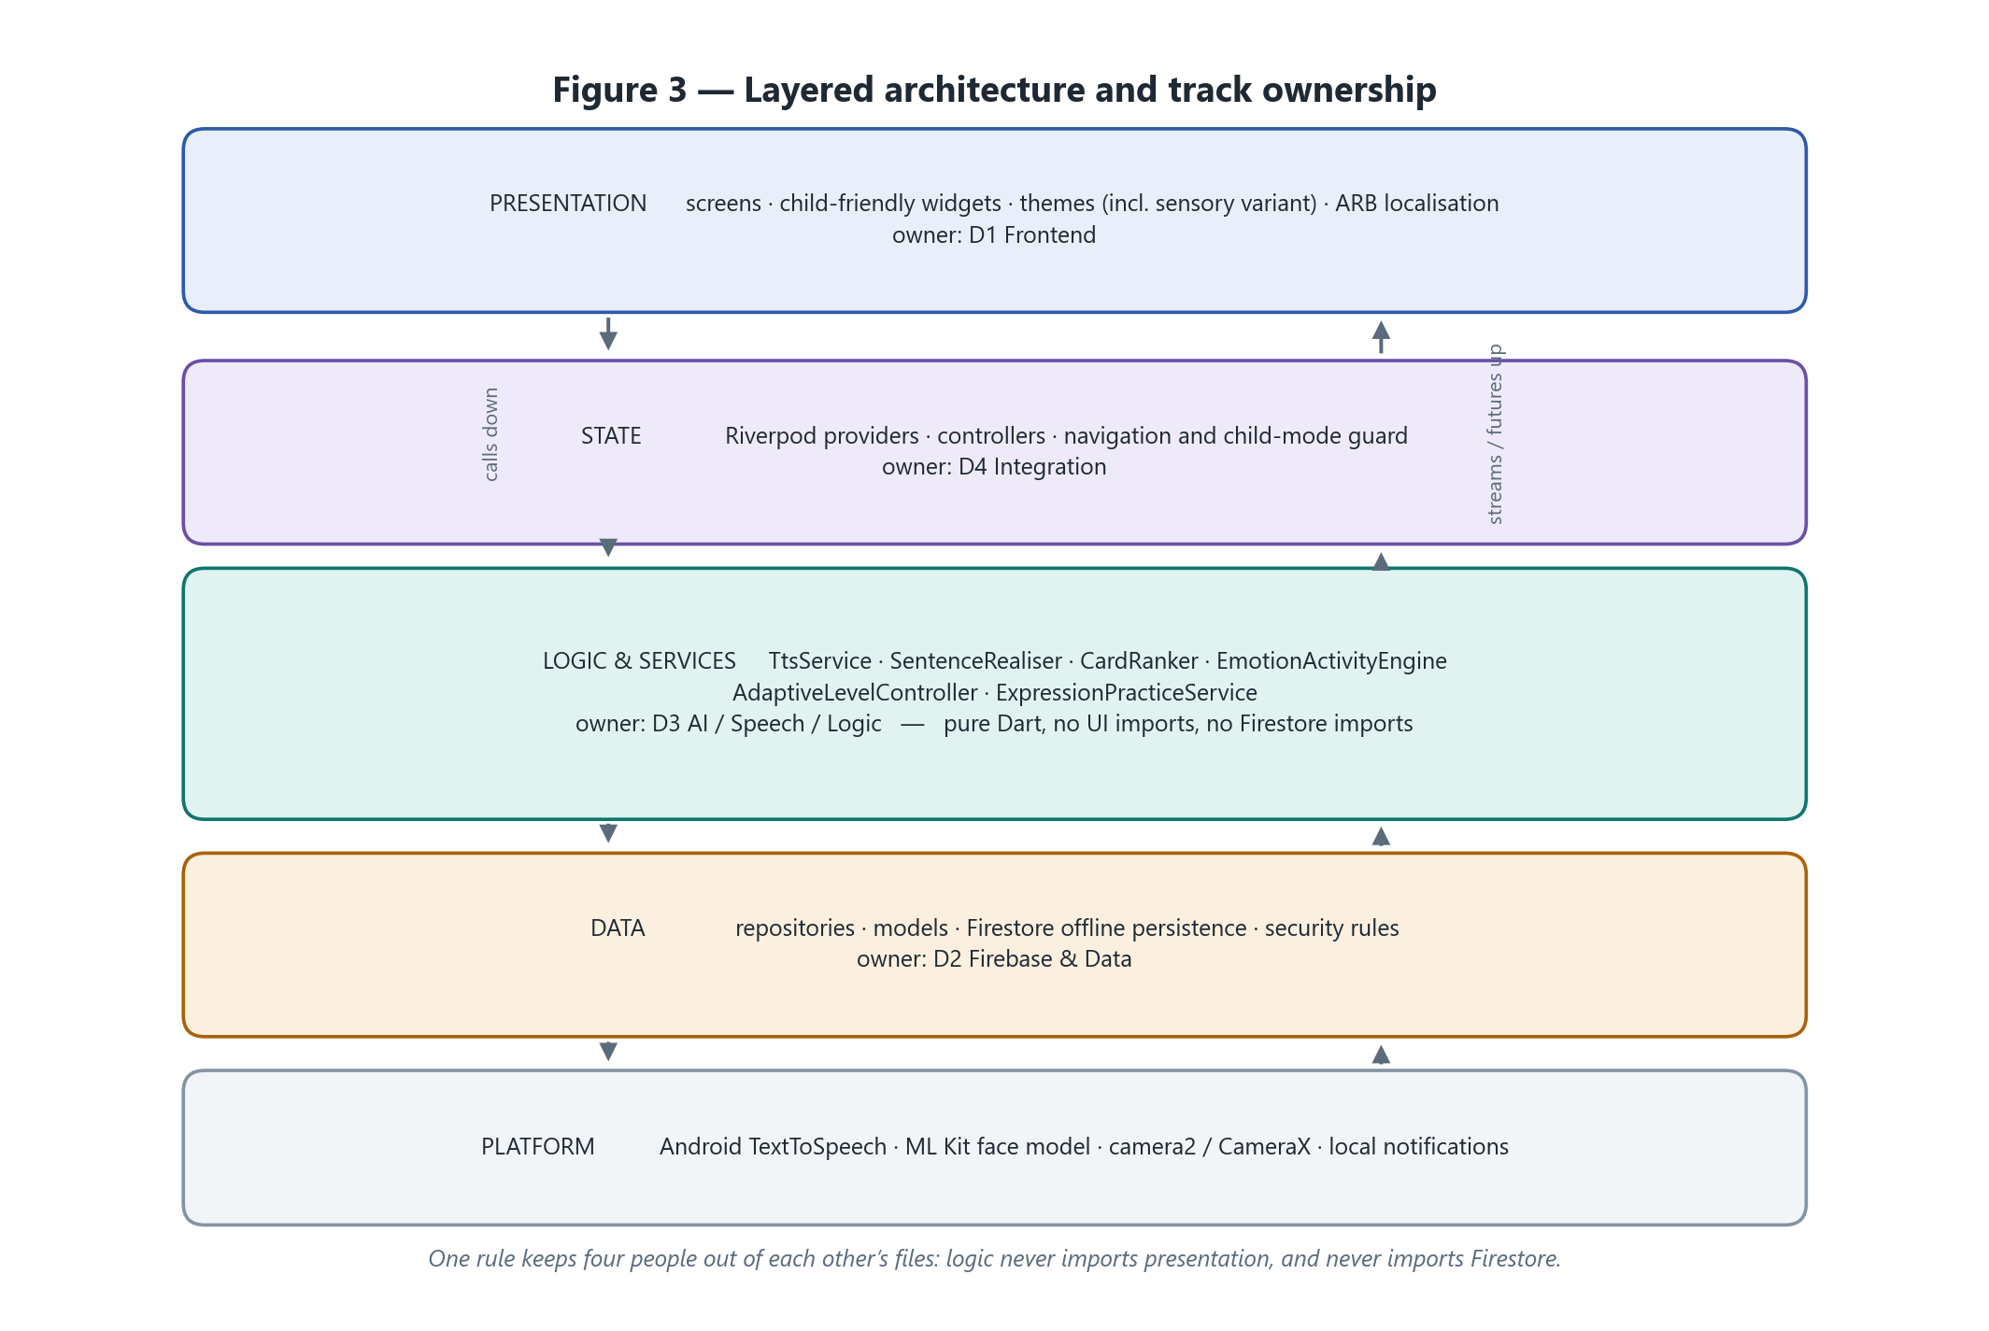
Figure 3 — Five layers, each owned by one person. The ownership boundary is what stops four people editing the same file in a six-day sprint.
The application is a feature-based Flutter project with a conventional downward dependency: presentation calls state, state calls logic and data, and results travel back up as futures and streams. The unusual part is not the shape — it is that each layer has a single named owner for the duration of the sprint.

6.2 The folder structure
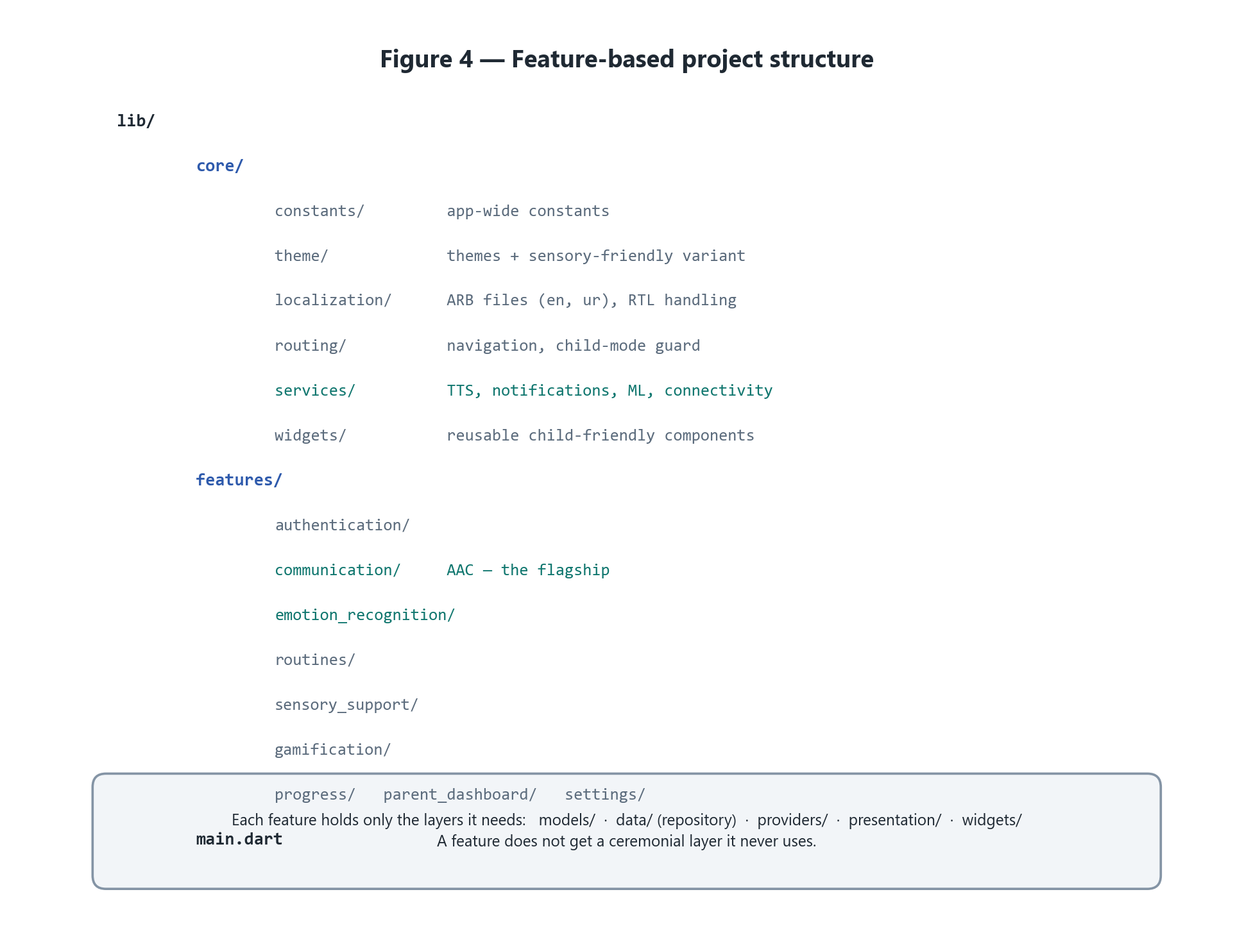
Figure 4 — Feature-based structure. Shared machinery lives in core/, each feature owns its own vertical slice.

6.3 The one rule that holds it together
Logic and services live in lib/core/services/ and lib/features/*/logic/, and depend only on Dart, their own packages, and the repository interfaces. They import nothing from presentation/, and they never touch Firestore directly. If a piece of logic needs a widget, the design is wrong. That single rule is what lets the AI track be written, tested and refactored while three other people are calling into it.

6.4 Technology stack
Layer | Technology | Why this one
App framework | Flutter (Dart) | One codebase, Android and iOS, fast UI iteration
State management | Riverpod | Compile-safe, testable, and the team standard
Authentication | Firebase Authentication | Managed and secure; no hand-rolled auth code
Database | Cloud Firestore | Offline persistence is built in, which serves the offline-first goal directly
Media storage | Firebase Storage | Custom card images and recorded audio
Notifications | Local notifications | Routine reminders are device-local; no server needed
Speech output | Platform TTS via flutter_tts | Native, offline-capable, free — see section 9
On-device ML | Google ML Kit face detection | Ships a working model, ~30–60 ms per frame, no network
Charts | fl_chart | One dashboard chart; no heavier dependency justified
Design | Figma | UI and UX planned before implementation

Dependency rule. Every package added to the project requires a one-line written justification in the pull request. If Flutter, Firebase, or an existing dependency already does the job, no new package is added. build_runner and code generation are excluded outright — in a six-day sprint a single generation failure can cost half a day, and the model classes are small enough to write by hand.

7 The data
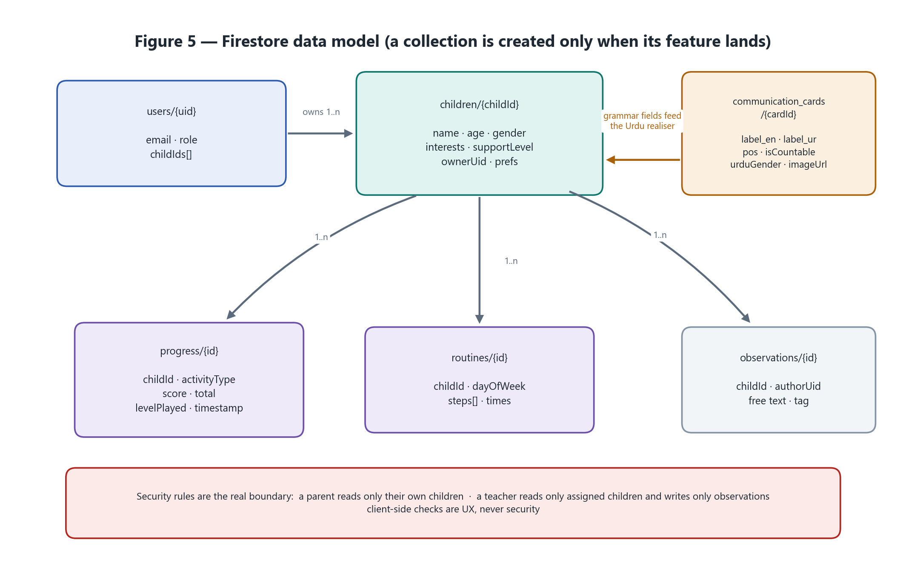
Figure 5 — The Firestore collections and how they relate. A collection is created only when the feature that needs it is implemented.

7.1 Collections
Collection | Holds | Created in
users/{uid} | Parent and teacher accounts, role, linked children | Phase 1
children/{childId} | Child profile: name, age, gender, interests, preferences, support level | Phase 1
communication_cards/{cardId} | Default and custom AAC cards, including the grammar fields | Phase 2
social_stories/{id} | Story content and steps | Phase 2
activities/{id} | Activity definitions for emotion and learning modules | Phase 2
progress/{id} | Per-child activity results and scores | Phase 2
routines/{id} | Routine templates and daily steps | Phase 3
learning_content/{id} | Interest-mapped learning items | Phase 3
observations/{id} | Manual caregiver observation logs | Phase 4

7.2 Who can read what
- A parent reads and writes only their own children’s data.
- A teacher reads only children explicitly assigned to them, and writes only observations.
- No user can read another user’s records under any circumstance.
- Client-side checks are user experience. The Firestore security rules are the actual boundary.

7.3 The grammar fields — a small detail with a large effect
Each seeded communication card carries four extra fields that most card models would not have: pos (part of speech), isCountable, startsWithVowelSound, and urduGender. They cost one line each in the seed script and they are what allow the sentence engine in section 8.3 to produce “I want an apple” rather than “I want apple”, and میں کتاب چاہتی ہوں rather than a word-for-word transliteration. Without them the bilingual engine degrades to naive word-joining, and the strongest ten seconds of the demo disappears.

8 The intelligence — where the AI actually is
This section exists because the question “where is the AI?” will be asked, by a supervisor and by a judge, and it deserves a precise answer rather than a marketing one.

8.1 The honest inventory
Capability | What actually ships | Honest label
On-device machine learning | ML Kit face detection driving live expression practice | Real ML, on-device, no network
Bilingual sentence generation | Two language-specific surface realisers over a shared structure | Rule-based NLG, not ML — and correct to say so
Personalisation | Recency-weighted frequency ranking of communication cards | Algorithmic, explainable in one line of maths
Adaptive difficulty | A pure-function state machine over recent outcomes | Rule-based, chosen deliberately over a learned policy
Speech synthesis | Platform TTS, bilingual, offline, queued | Platform capability, engineered around carefully
Deliberately not built | Custom emotion classifier · speech-to-text · generative chat | Designed and documented as future work

The rule for the room: never claim a model you cannot demonstrate. A team that says “we used machine learning only where it earned its place, and here it is running live in airplane mode” is more credible than one claiming a classifier it cannot show. Restraint is defensible; overreach is not.

8.2 The AAC pipeline
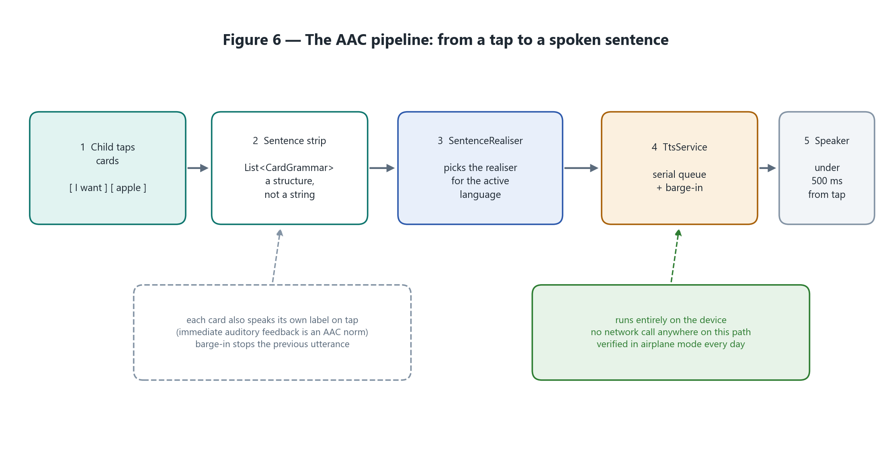
Figure 6 — Tap to speech, with nothing on the path that needs a network.
The important design decision is at step 2. The sentence strip is not a string. It is a list of card structures, which is what makes step 3 possible: switching language mid-session re-renders the same taps through a different grammar instead of translating text that has already lost its structure.

8.3 Bilingual sentence realisation
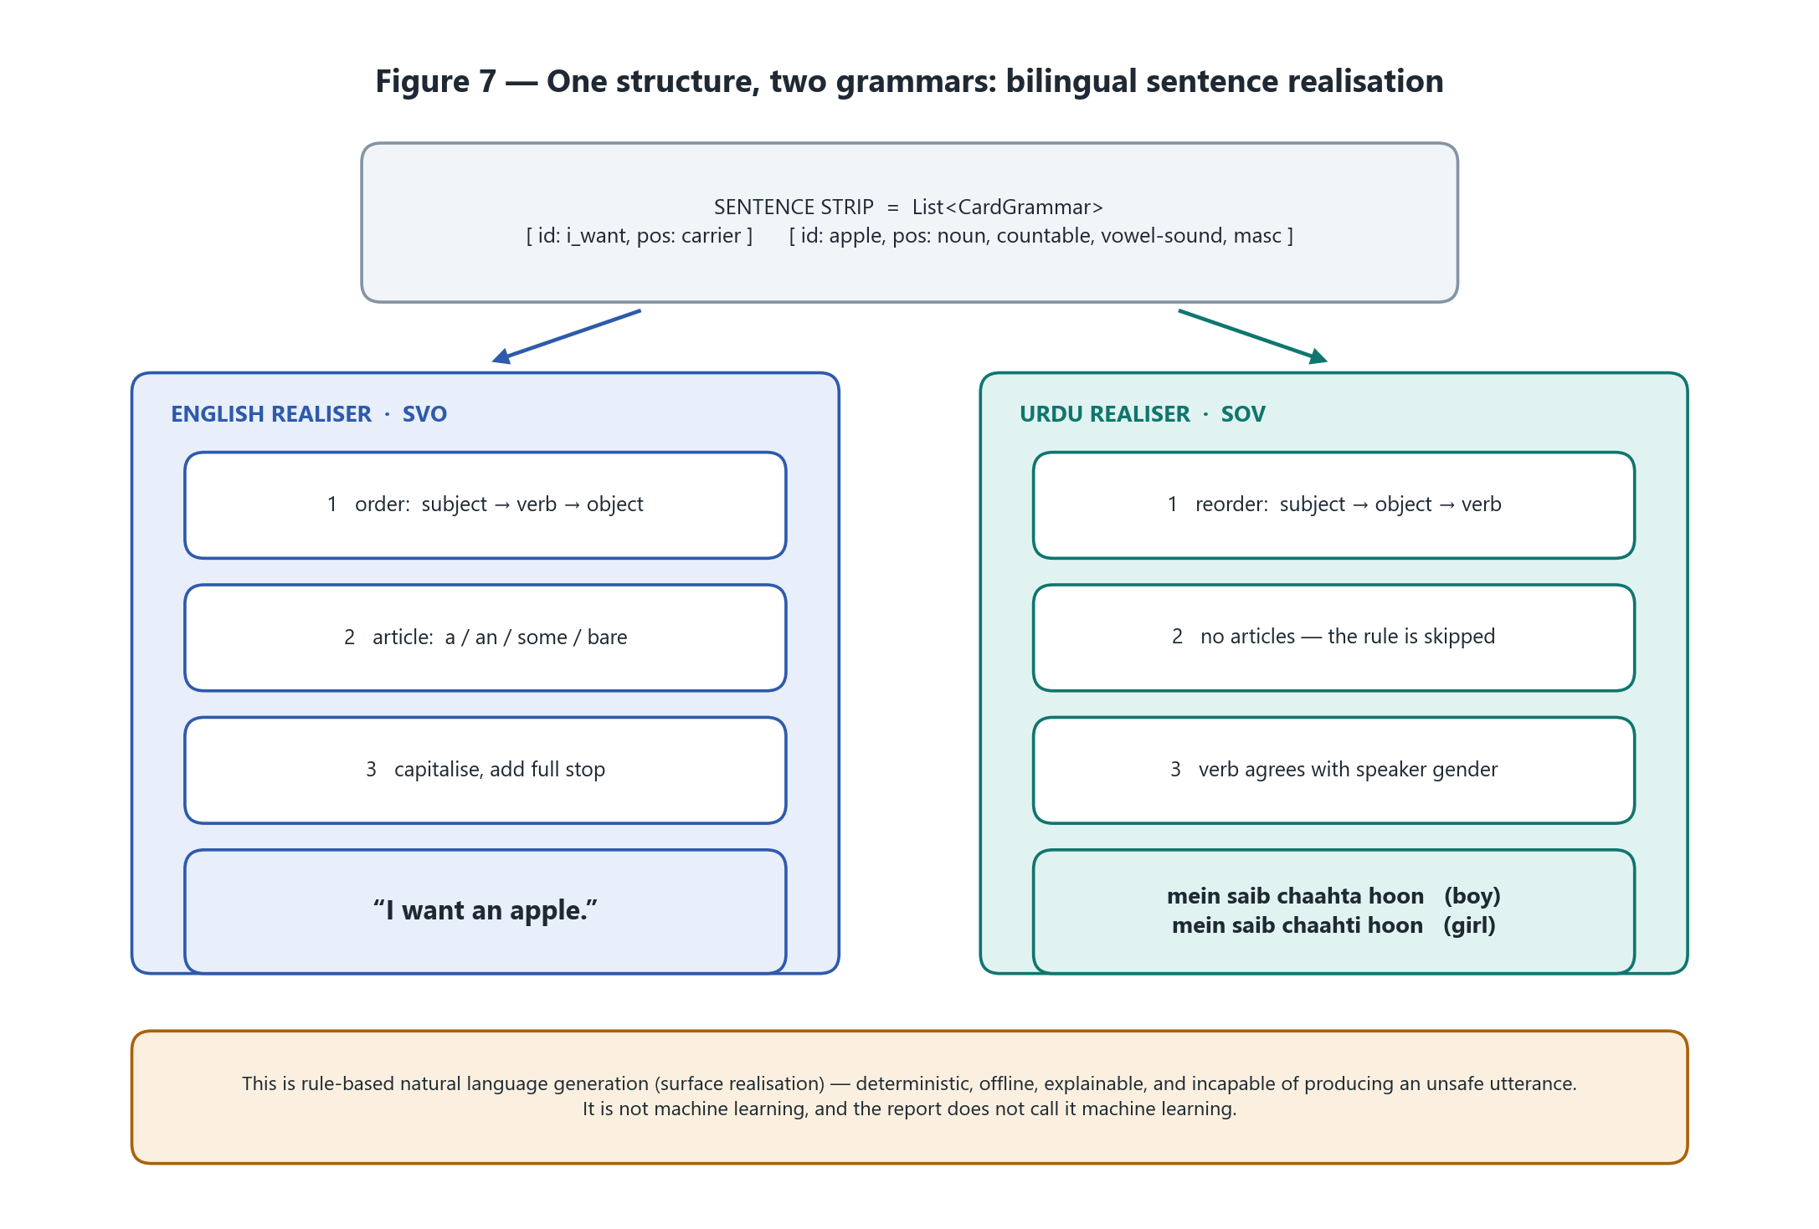
Figure 7 — One structure, two grammars. English is SVO with article selection; Urdu is SOV with speaker-gender verb agreement.
English is subject–verb–object: I want an apple. Urdu is subject–object–verb: میں سیب چاہتا ہوں — literally I apple want-am. A word-by-word translation of the English strip therefore produces broken Urdu. Two independent realisers, each consuming the same structure, produce grammatical output in both.
The Urdu verb also agrees with the speaker’s gender, taken from the child’s profile — so a boy’s app says چاہتا and a girl’s says چاہتی. That is a two-hour implementation detail that reads as real linguistic engineering, because it is.

Worked examples — the test table written on day two
Sentence strip | English output | Urdu output | Rule exercised
[I want] [apple] | I want an apple. | میں سیب چاہتا ہوں | “an” before a vowel sound; SOV reorder
[I want] [water] | I want some water. | میں پانی چاہتا ہوں | Uncountable noun takes “some”; Urdu has no article
[I want] [book] | I want a book. | میں کتاب چاہتی ہوں | Consonant article; feminine speaker agreement
[I feel] [happy] | I feel happy. | میں خوش ہوں | Adjective predicate, no object
[apple] | Apple. | سیب | Single bare noun — capitalise, no article
[ ] (empty strip) | — no speech, no crash — | — no speech, no crash — | The case that breaks live demos

Honest framing. This is rule-based natural language generation — surface realisation. It is not machine learning and the report does not call it machine learning. It is the correct tool: deterministic, offline, explainable, and structurally incapable of producing an unsafe utterance, which matters when the user is a child.

8.4 Card ranking — recency-weighted frequency
Sorting the “frequently used” row by raw usage count fails in an obvious way: a card used forty times last month outranks the card the child needs today. The fix is exponential recency decay.
score(card) = Σ over every use exp( −λ · ageInDays )

λ = ln(2) / 7 # a use is worth half as much after seven days

Sum the decayed weight of every use of a card, sort descending, take the top eight. It needs no training data, runs offline in microseconds, self-corrects when a child’s needs change, and — the property that actually matters — a caregiver can be told exactly why any given card is in the top row.

8.5 The emotion activity engine
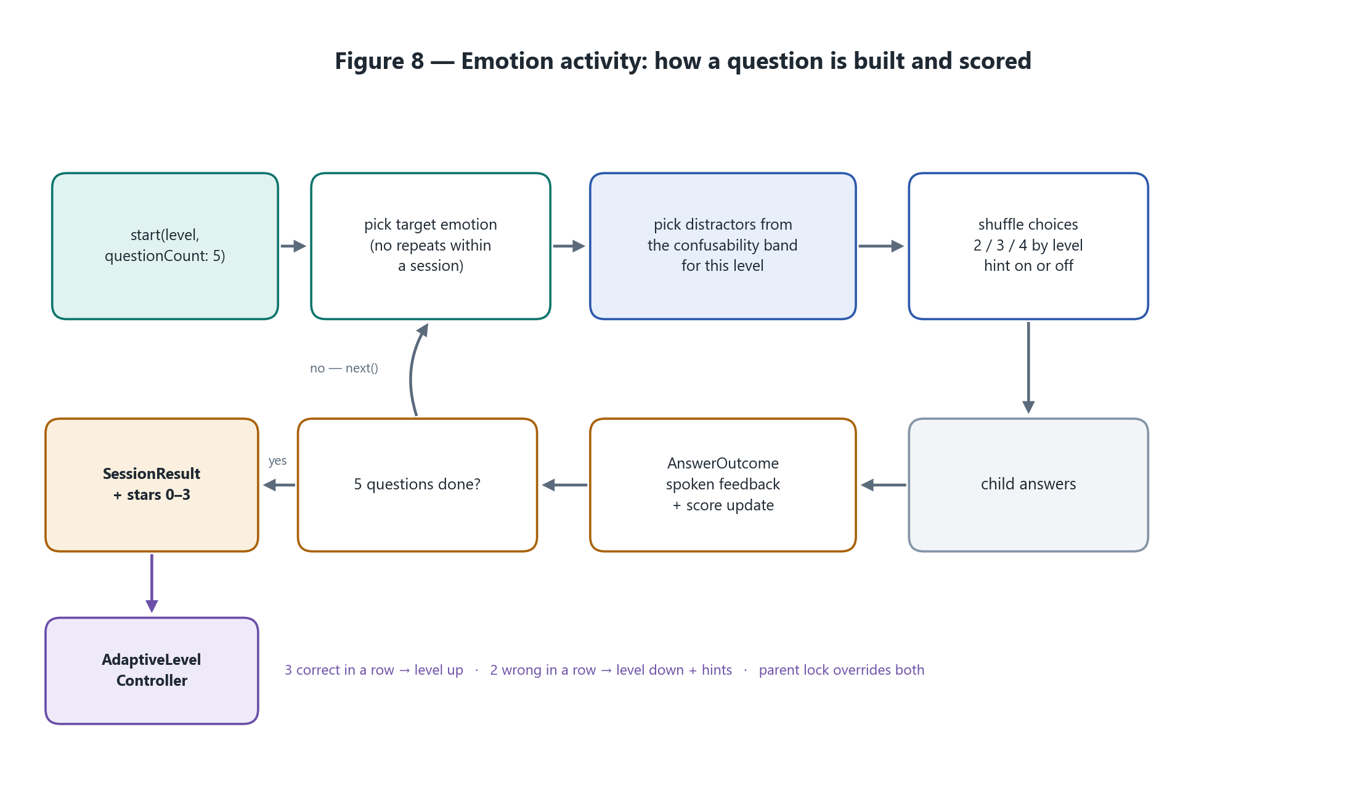
Figure 8 — A five-question session: how each question is assembled, scored, and turned into a persisted result.
Random wrong answers make a poor teaching activity. Happy against sad is trivial at every level, so the child stops learning. Instead the engine draws distractors from a hand-authored confusability matrix — how easily each pair of emotions is mistaken for the other, grounded in the visual features that separate them: mouth curvature, eyebrow angle, eye aperture.
 | happy | sad | angry | surprised | scared | neutral
happy | — | 0.1 | 0.1 | 0.3 | 0.1 | 0.4
sad | 0.1 | — | 0.5 | 0.1 | 0.6 | 0.4
angry | 0.1 | 0.5 | — | 0.2 | 0.5 | 0.3
surprised | 0.3 | 0.1 | 0.2 | — | 0.7 | 0.2
scared | 0.1 | 0.6 | 0.5 | 0.7 | — | 0.2
neutral | 0.4 | 0.4 | 0.3 | 0.2 | 0.2 | —

Level | Choices | Distractors drawn from | Goal
Beginner | 2 | The lowest confusability band — happy against sad | Success. The child needs to win
Intermediate | 3 | The middle band | Consolidation
Advanced | 4 | The highest band — scared against surprised, sad against scared | Genuine discrimination

When a judge asks how difficulty increases, “more options appear” is a weak answer. “The wrong answers become visually harder to distinguish, along a matrix I can show you” is a strong one.

8.6 Adaptive difficulty
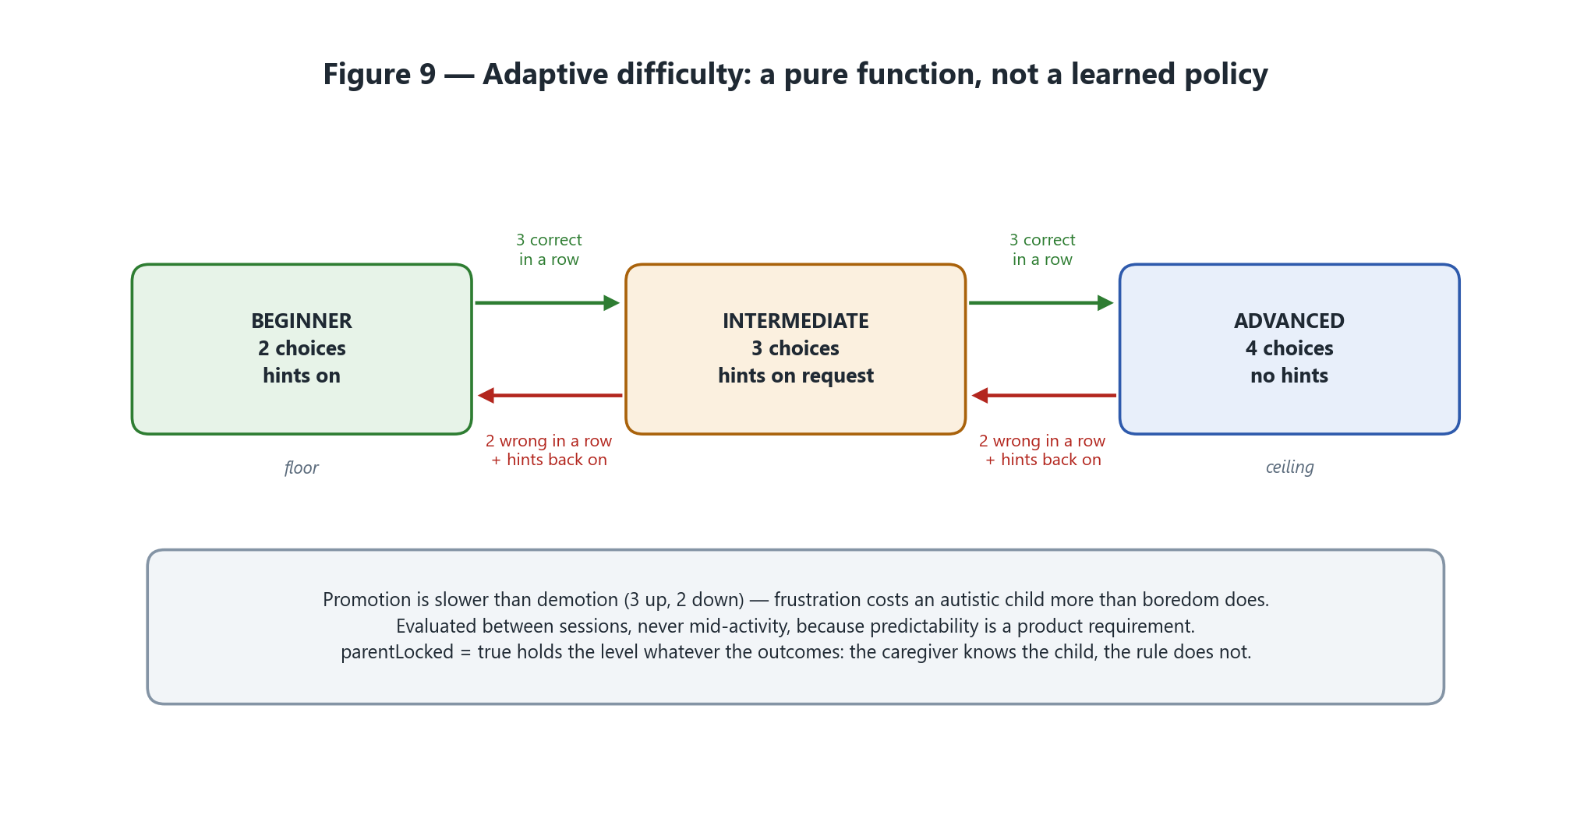
Figure 9 — Three states, four transitions, one override. Every possible transition fits on a whiteboard.
Four design choices here are deliberate, and each has an answer ready if questioned:
- Promotion is slower than demotion — three correct to go up, two wrong to come down. Frustration costs an autistic child more than boredom does, so the system errs toward success.
- Evaluation happens between sessions, never mid-activity. Difficulty shifting under a child during an activity is disorienting, and predictability is a core product requirement.
- The parent lock is absolute. The caregiver knows the child; the rule does not.
- It is a pure function — state in, state out, no hidden fields — so every transition is unit tested and enumerable.
“We chose a rule-based adaptive system deliberately. A parent can understand exactly why the level changed. A learned policy would need training data we do not ethically have, and would be unexplainable to the person who most needs to trust it.” That answer is stronger than any model that could be trained in a week.

8.7 Expression practice — the on-device machine learning
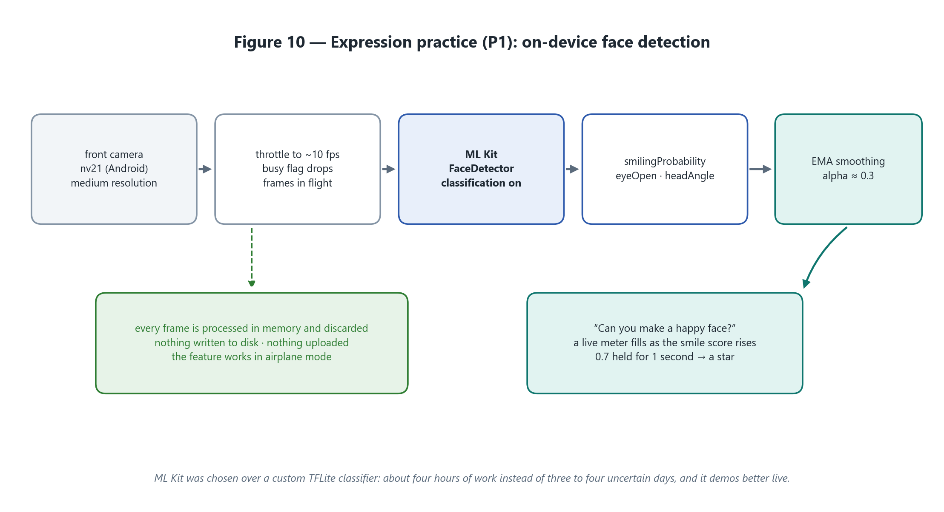
Figure 10 — The camera pipeline. Frames live for one detection pass and are then discarded.
The activity is simple: “Can you make a happy face?” A meter fills as the smile probability rises; holding above 0.7 for one continuous second awards a star. It is live, responsive, on-device, and visible from across a room — which is exactly why it must not be started before everything else is finished.

Why ML Kit rather than a custom TFLite classifier
 | Custom TFLite model | ML Kit face detection
Setup time | 3–4 days, uncertain | About four hours
Runs on device | Yes | Yes
Privacy | Frames stay local | Frames stay local
Latency | Variable | ~30–60 ms per frame
Output | Six-class emotion, if it works | Smile probability, eye-open probability, head angle
Risk | High — may end the week with nothing | Low — ships

ML Kit gives smilingProbability and leftEyeOpenProbability directly. That is enough for a genuinely strong activity with a live meter — which demonstrates better than a six-class classifier, because the evaluator can watch it respond in real time. It is still real on-device machine learning, still privacy-preserving, still zero network calls. The honest report wording is: “expression practice uses on-device ML Kit face detection to derive expression signals locally; a fine-tuned multi-class emotion classifier is documented as future work.”

Implementation notes that save hours
- Construct the camera controller with ImageFormatGroup.nv21 on Android and bgra8888 on iOS. Guessing the format is the single biggest time sink in this integration.
- FaceDetectorOptions(enableClassification: true) is required — without it smilingProbability is null. Leave contours and landmarks off; they cost latency and are not used.
- Throttle with a busy flag, not a timer: drop incoming frames while a detection is in flight, or the queue backs up and latency climbs until the app stalls.
- Smooth with an exponential moving average (α ≈ 0.3) before the value reaches the UI. Raw per-frame probability jitters and the meter looks broken even when it is working.
- Dispose the detector and stop the stream in dispose(). A live camera stream behind a navigation push is a battery drain and an obvious bug in questioning.

8.8 What was rejected, and why
Rejected | Reason
A custom-trained TFLite emotion classifier | Three to four days of uncertain work with a real chance of ending the week with nothing. Documented as future work
Cloud speech synthesis of any provider | Breaks the offline requirement, adds latency and cost, and sends a child’s utterances to a server
Open-ended LLM chat for the child | Out of scope on safety grounds; it cannot be adequately guardrailed at this scale
A learned adaptive-difficulty policy | No ethically obtainable training data, and unexplainable to the parent who must trust it
Speech-to-text | Cut from the sprint scope; designed and documented, not built
A translation API for Urdu | Would produce word-order errors exactly where they matter most. Per-language realisation is both cheaper and better

9 Speech — the most demo-critical service in the app
If the text-to-speech service fails, the flagship feature fails and the demonstration is over. It is therefore built first, on day one, and verified on physical hardware every single day thereafter.

9.1 What the service must do
Requirement | Why
Speak English and Urdu | The product claim; Urdu is the accessibility argument
Start speaking under 500 ms after a tap | Slower than that and a child loses the connection between action and sound
Work offline | The core promise; venue wifi cannot be trusted at a demo either
Never throw | A crash mid-utterance ends a demonstration. Failures surface as a state, not an exception
Queue and barge-in | Five fast taps must produce five clean utterances, not garbled overlap
Respect sensory mode | A volume ceiling and a slower rate, driven from settings — not from the theme

9.2 How the Urdu voice is resolved
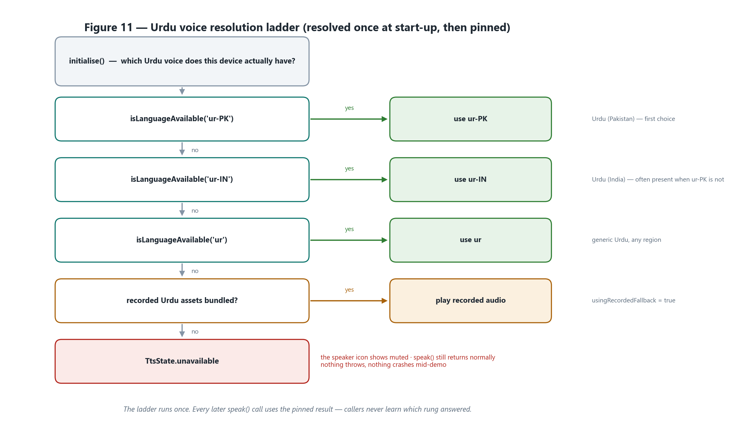
Figure 11 — The fallback ladder. It runs once at start-up; every later call uses the pinned result.
Locale resolution runs once inside initialise() and the winning locale is cached — probing on every utterance would add latency to the one path that cannot afford it. The caller never learns which rung answered: whether the audio came from a platform voice or a recorded asset is entirely the service’s business.

9.3 Queue, barge-in and warm start
- Serial queue. A single loop drains a queue of utterances, with awaitSpeakCompletion(true) so that speaking genuinely awaits — which is what makes ordering possible at all.
- speak() = clear the queue, stop, then enqueue — barge-in. enqueue() = append, used for routine step sequences.
- Warm start. The first utterance on Android pays an engine-initialisation cost that can exceed the 500 ms budget on its own. During initialise() the service sets the language and speaks a single space at zero volume. First-tap latency is then measured with a stopwatch and written down — it is a real non-functional requirement that can be quoted.
- Child-appropriate prosody. Speech rate around 0.45–0.5 on Android — the platform default is far too fast for a child — pitch 1.0, and a volume ceiling that sensory mode can lower further.

9.4 The risk this section exists to manage
Urdu text-to-speech availability varies by device, by Android version, by region and by which speech engine happens to be installed. It is the single highest-likelihood, highest-impact risk in the whole project, and it is retired before the build starts rather than discovered during it. Section 10 is the procedure for retiring it.

10 Checking whether your Android phone has an Urdu voice
This section is written to be used on its own, phone in hand. It is the procedure for Day 0 — before any application code is written — and it should be repeated on every device that will be used for the demonstration.

10.1 Why this is the first thing to test
Urdu speech is the accessibility claim the whole product rests on. Unlike English, an Urdu voice is not guaranteed to exist on an Android phone: availability depends on the manufacturer, the Android version, the region, which speech engine is installed, and whether the voice data has ever been downloaded. Two phones sitting on the same desk can give different answers.
The cost of discovering this on Day 0 is a couple of hours and a documented decision. The cost of discovering it on Day 5 is the demonstration.
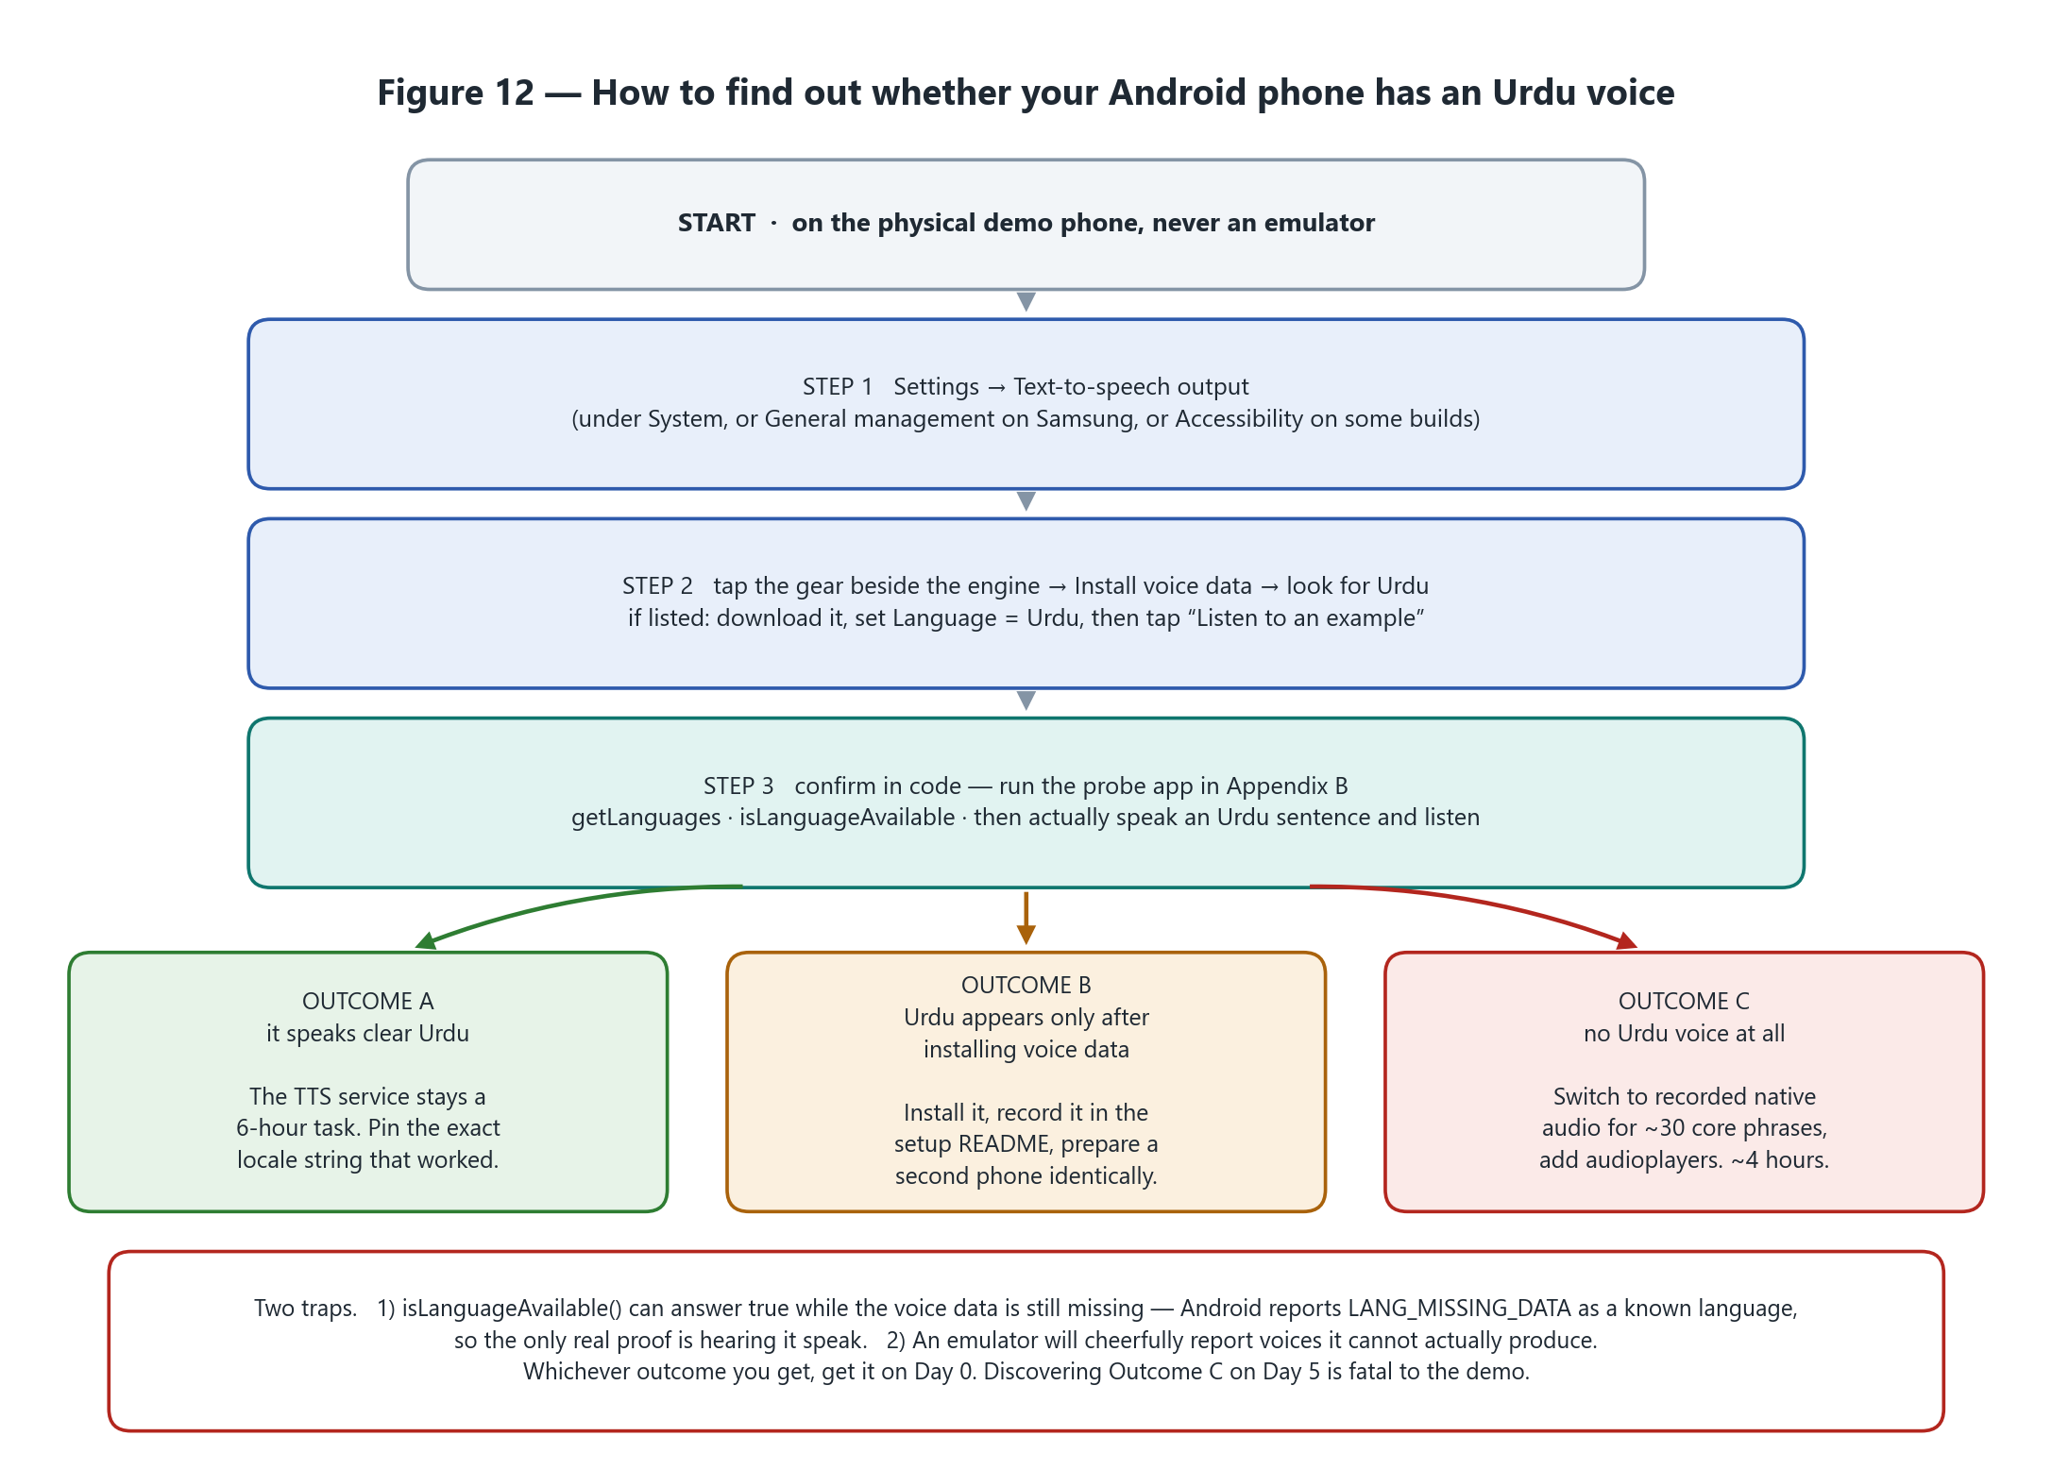
Figure 12 — The whole procedure on one page: the settings route, the probe that confirms it, three possible outcomes, and the traps that produce a false positive.

10.2 Method 1 — the phone’s own settings, no code required
Start here. It takes about five minutes and it is also how you fix the problem if the voice is simply not downloaded yet.

Step 1 — find the text-to-speech screen
The path differs by manufacturer. Find whichever of these matches your phone:
Phone | Settings path
Stock Android / Pixel / Motorola | Settings → Accessibility → Text-to-speech output (older builds: Settings → System → Languages & input → Text-to-speech output)
Samsung (One UI) | Settings → General management → Text-to-speech
Xiaomi / Redmi / POCO (MIUI, HyperOS) | Settings → Additional settings → Accessibility → Text-to-speech output
Oppo / Realme / vivo / OnePlus | Settings → Additional settings → Accessibility → Text-to-speech output
Infinix / Tecno / itel (HiOS, XOS) | Settings → System → Languages & input → Text-to-speech output
Any phone, if lost | Open Settings, use the search box, and type text-to-speech

Step 2 — note which engine is selected
At the top of that screen is Preferred engine. It will usually be one of:
- Speech Recognition & Synthesis (package com.google.android.tts) — Google’s engine, the one to prefer.
- Samsung text-to-speech engine (com.samsung.SMT) — common on Samsung devices; its language list is narrower.
- An OEM engine, or nothing at all on very stripped-down builds.
Write down which engine is selected. The answer to “does this phone have Urdu?” is really “does this engine on this phone have Urdu?” — switching engines can change the answer entirely.

Step 3 — look for Urdu in the voice data
1. Tap the gear / settings icon next to the preferred engine.
2. Tap Install voice data (on some builds this is under a Voice data or Languages entry).
3. Scroll the language list and look for Urdu. It may appear as Urdu, اردو, Urdu (Pakistan) or Urdu (India).
4. If it is there, tap it and download it. A voice is often a 20–60 MB download; some engines offer several quality variants — take the one marked for offline use if the choice is offered.
5. If it is not in the list at all, do not conclude anything yet — go to section 10.6 first, then re-check.

Step 4 — make it actually speak
1. Go back to the main text-to-speech screen.
2. Set Language to Urdu (turn off “use system language” if that switch is present).
3. Tap Listen to an example / Play.
4. Listen. Do you hear Urdu, in an intelligible voice? Not English, not silence, not a burst of noise?
A sample that plays in English while the language is set to Urdu means the engine fell back — that is a negative result, not a positive one.

Step 5 — repeat it in airplane mode
Turn airplane mode on and press Listen to an example again. Some Google voices are network-backed: they sound excellent while online and produce nothing at all offline. AutiMate’s core claim is that the child-facing features work with no connection, so a voice that only speaks online does not count as a pass. This single step catches the most expensive false positive in the whole procedure.

10.3 Method 2 — the probe app (the definitive answer)
The settings screen tells you what the phone believes. The probe tells you what the app will actually get when it calls the platform, which is the thing that matters. A complete, runnable probe is in the project at tools/urdu_tts_probe/ — see Appendix B for the core of it.
cd tools/urdu_tts_probe
flutter create . # generate android/ for this pubspec, once
flutter pub get
flutter run # with a PHYSICAL Android device connected

The probe prints, on the phone’s own screen so you can read it without a laptop:
- every text-to-speech engine installed, and which is the default;
- every locale the current engine reports, with any beginning ur highlighted;
- direct isLanguageAvailable answers for ur-PK, ur-IN and ur, in the order the real service will try them;
- every named voice that looks Urdu — including ones whose data has not been downloaded;
- and it gives you buttons to speak an Urdu sentence and hear the result.
The Urdu test sentence is السلام علیکم، میں سیب چاہتا ہوں — a greeting plus the exact phrase the AAC demonstration will produce, so the probe tests the real thing rather than an abstraction.

What a good result looks like
ENGINES INSTALLED
com.google.android.tts
default engine: com.google.android.tts

LOCALES REPORTED: 74
URDU LOCALE FOUND: ur-PK

DIRECT AVAILABILITY CHECKS
isLanguageAvailable("ur-PK") = true
isLanguageAvailable("ur-IN") = false
isLanguageAvailable("ur") = true

VOICES: 312 total, 2 look Urdu
{name: ur-pk-x-urm-local, locale: ur-PK}

The suffix -local on a voice name is a good sign: it indicates a voice that synthesises on the device rather than over the network. A voice ending -network will not work in airplane mode.

What a bad result looks like
LOCALES REPORTED: 41
NO locale starting with "ur" <-- this is the bad outcome

DIRECT AVAILABILITY CHECKS
isLanguageAvailable("ur-PK") = false
isLanguageAvailable("ur-IN") = false
isLanguageAvailable("ur") = false

10.4 Method 3 — from a laptop over adb (optional)
Useful for recording exactly what was tested, and for checking several phones quickly.
adb devices # confirm the phone is attached
adb shell settings get secure tts_default_synth # which engine is the default
adb shell pm list packages | grep -i tts # which engines are installed at all
adb shell dumpsys package com.google.android.tts | grep -i versionName

Be honest about what adb can and cannot tell you. These commands identify the engine and its version. They do not reliably reveal which voice data has been downloaded — that lives in the engine’s private storage. adb is for recording the environment; the probe and your own ears are for the verdict.

10.5 The three traps
Trap | What happens | Defence
A query says yes, the phone says nothing | Android reports language support at several levels — available, country-available, data missing, not supported — and different wrappers collapse those differently. A voice can also be listed with its data not yet installed. | Treat every query as encouraging, not conclusive. Hearing the sentence is the only proof.
The emulator lies | Emulator images happily report voices they cannot produce, and audio routing adds its own failures. | Test on the physical demo device, every time. This is why Day 0 exists.
The voice is network-backed | A high-quality Google voice may synthesise server-side. It sounds perfect in the room with wifi and silent in airplane mode. | Always run the test twice — once online, once in airplane mode. Only the offline pass counts.

10.6 If Urdu is missing — what to try, in order
# | Try this | Effort | Notes
1 | Install or update Speech Recognition & Synthesis from the Play Store, then re-check | 5 min | Some OEM builds ship an old Google engine with a much shorter language list. This alone fixes many phones
2 | Gear → Install voice data → Urdu → download, then re-run the probe | 10 min | The most common cause of a false negative is simply that nobody ever downloaded it
3 | Switch the preferred engine and re-check | 5 min | The Samsung engine and the Google engine have different language sets on the same phone
4 | Install an alternative engine — eSpeak NG or RHVoice | 15 min | eSpeak NG is open source, fully offline and does support Urdu, but it is robotic. Acceptable for development; a poor choice for a child-facing demo
5 | Try a different phone | varies | Borrow two or three. Record brand, model, Android version and engine version for whichever works
6 | Record native Urdu audio for ~30 core phrases | ~4 h | The documented fallback. Add audioplayers, bundle the assets, and route the recorded path behind the same service interface

Option 6 is not a defeat. For a child-facing accessibility application, a recorded native speaker is arguably better than a synthetic voice: clearer, warmer, and consistent every time. The honest framing is “Urdu speech uses recorded native-speaker audio for the core vocabulary, with platform text-to-speech wherever a device voice is available.” That is a design decision, not an apology — and because the fallback sits behind the same TtsService interface, no calling code changes.

10.7 Insurance worth buying whatever the answer is
- Record the top ten phrases anyway. Even with a working device voice, an overnight system update can change what the phone has. An hour of recording is cheap insurance against that.
- Set up a second phone identically and verify it the same way. One phone is a single point of failure for an in-person demonstration.
- Pin the exact locale string that worked — ur-PK and ur-IN are not interchangeable — and put it in the setup README with the engine version.
- Turn off automatic system updates on the demo device once it is verified.
- Re-verify on the morning of the demo. Sixty seconds, and it has caught worse.

10.8 The checklist to run on the demo phone
✔ | Check | Record
☐ | Physical device, not an emulator | brand / model / Android version
☐ | Text-to-speech settings screen located | path used
☐ | Preferred engine identified | package + version
☐ | Urdu appears under Install voice data | yes / no
☐ | Urdu voice data downloaded | size / variant
☐ | “Listen to an example” speaks Urdu — online | yes / no
☐ | “Listen to an example” speaks Urdu — airplane mode | yes / no
☐ | Probe app run; locale list captured | screenshot
☐ | ur-PK / ur-IN / ur availability recorded | true / false each
☐ | Probe spoke the Urdu sentence aloud — airplane mode | yes / no
☐ | Outcome decided: A, B or C | A / B / C
☐ | Result posted to the team the same day | date / time
☐ | Second device verified identically | brand / model

11 Working without a connection
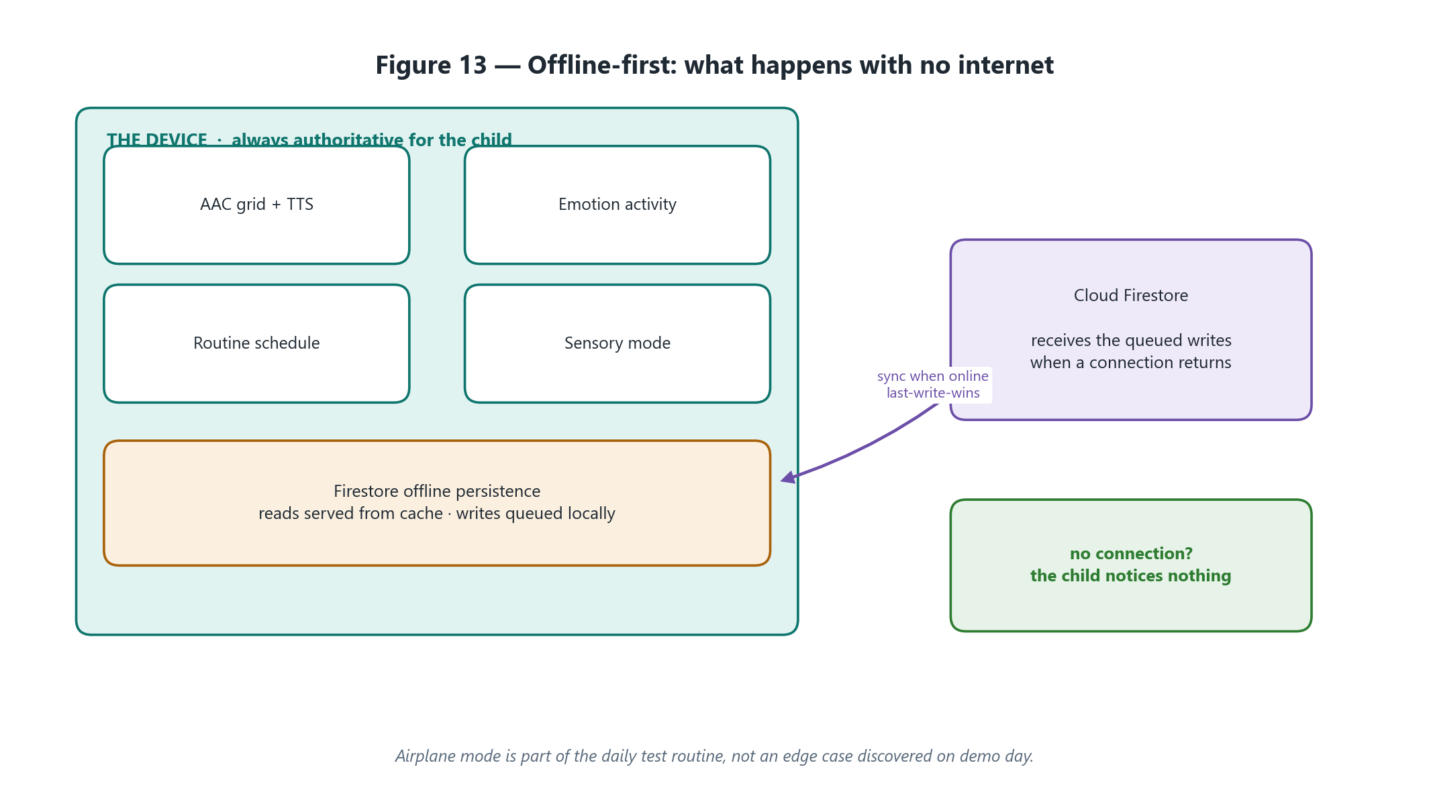
Figure 13 — With no network, the child notices nothing. Writes queue locally and reconcile later.
Offline is not a degraded mode bolted on at the end; it is the default the child-facing features are designed around. Firestore’s offline persistence serves reads from a local cache and queues writes until a connection returns. Conflicts are resolved last-write-wins — deliberately, because the data does not justify a merge engine and building one would consume days that hardening needs.
Airplane mode is part of the daily test routine for the AAC module, the emotion activity and routines — not an edge case discovered on demonstration day.

12 Non-functional requirements
Area | Requirement
Performance | Screen transitions under 300 ms; speech begins under 500 ms after a tap
Latency | On-device inference preferred; no per-frame network calls; assets preloaded
Offline | AAC, routines, downloaded stories and progress recording all work with no connection
Accessibility | Minimum 64 dp tap targets on child screens, WCAG AA contrast, audio labels throughout
Privacy | Minimum viable data collection; camera frames processed on-device and discarded; no raw audio or video stored; no third-party analytics on child data
Security | No hard-coded secrets; Firestore rules enforced server-side; authentication required for every write
Reliability | Every network or AI operation has explicit loading, success, empty, error and retry states
Error experience | Child screens show friendly non-technical messages; technical detail appears only in caregiver screens and logs
Localisation | Zero hard-coded user-facing strings; right-to-left layout verified for Urdu on every screen

13 Privacy, safety and ethics
These commitments are not decoration. They constrain the architecture — several of the technical choices in section 8 exist because of them — and they appear in the final report unchanged.
- AutiMate makes no diagnostic, clinical or therapeutic claim anywhere in the interface, the documentation or the presentation.
- Emotion features are labelled as a learning aid, never as a statement of fact about a person’s feelings.
- Camera frames are processed on-device and immediately discarded — never uploaded, never written to storage.
- Only data strictly necessary for a feature is collected at all.
- There is no automatic behavioural labelling. Caregiver observations are free text, written by a human.
- No advertising, and no third-party analytics on child data.
- A visible privacy statement is shown during onboarding, in both languages.
- Conversation practice is scripted and branching. Open-ended generative chat for a child is out of scope on safety grounds, and a guardrail that cannot be verified will not be shipped.
The privacy story is only credible because it is architectural. There is no server in the speech path, no upload in the camera path, and no field in the schema for a behavioural label. Saying it on stage while the phone is in airplane mode is the proof.

14 The team
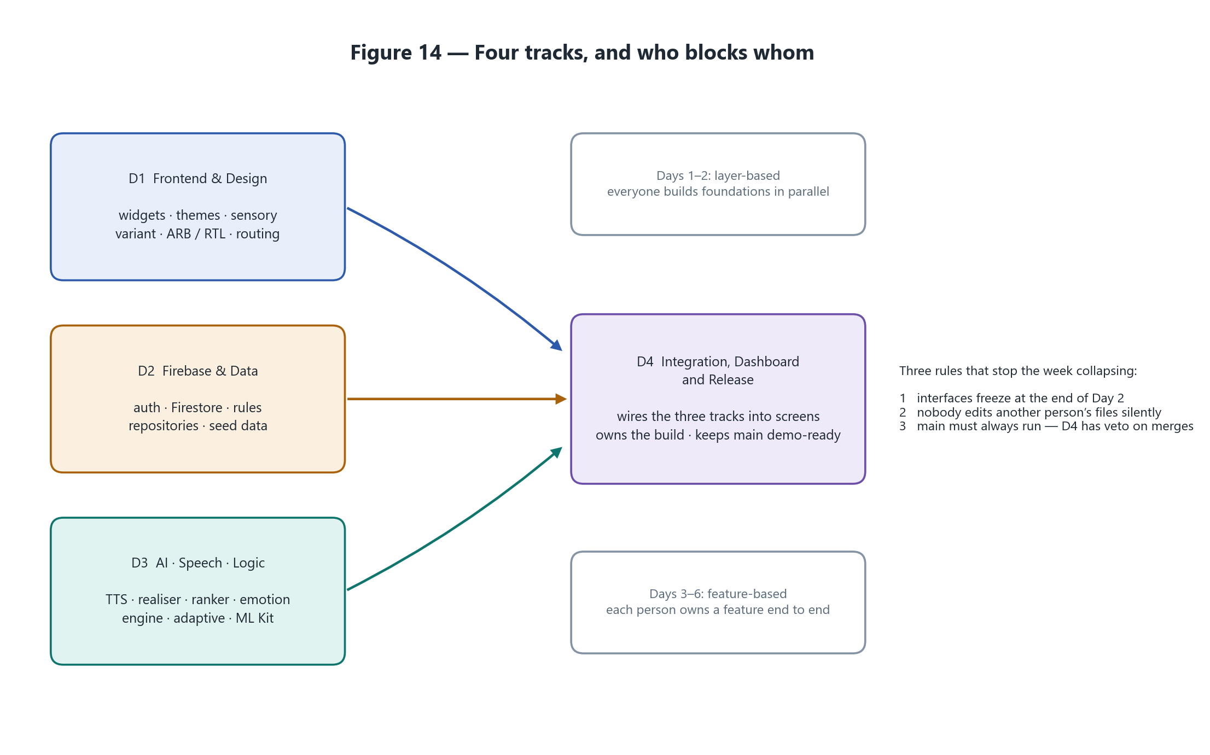
Figure 14 — Four tracks. Days one and two are layer-based so nobody is blocked; days three onward are feature-based so nobody collides.
Track | Owns | Delivers by end of day two
D1 Frontend & Design | Scaffolding, theme including the sensory variant, reusable child widgets, routing and child-mode lock, ARB localisation and RTL | Any teammate can import a child-friendly button, a loading state and a localised string, and the app switches to Urdu RTL correctly
D2 Firebase & Data | Firebase setup, authentication, Firestore schema and security rules, repositories, offline persistence, seed data | Auth works, a child profile can be created and read, and repositories return real types
D3 AI · Speech · Logic | TTS service, sentence realiser, card ranker, emotion engine, adaptive controller, ML Kit expression practice | A working bilingual TTS service on a real device, plus the activity logic with passing unit tests
D4 Integration & Release | Dashboard, progress aggregation, routine builder, gamification, integration, the build, the demo script | The app shell runs with all tabs navigable and a clean flutter analyze

14.1 The three rules
1. Interfaces freeze at the end of day two. Signatures are published on day one marked provisional, re-published on day two marked frozen, and are untouchable afterwards without everyone’s agreement.
2. Nobody edits another person’s files silently. Merge conflicts are the single largest killer of short sprints.
3. main must always run. D4 has veto power on merges, and that is not negotiable in the last 48 hours.
The reason the interface freeze matters so much: publishing the contracts on day one lets three other people write code against the AI track before the AI track exists. It is the highest-leverage single act in the whole week. The contracts themselves are in Appendix A.

15 Delivery plan

15.1 The six-day build
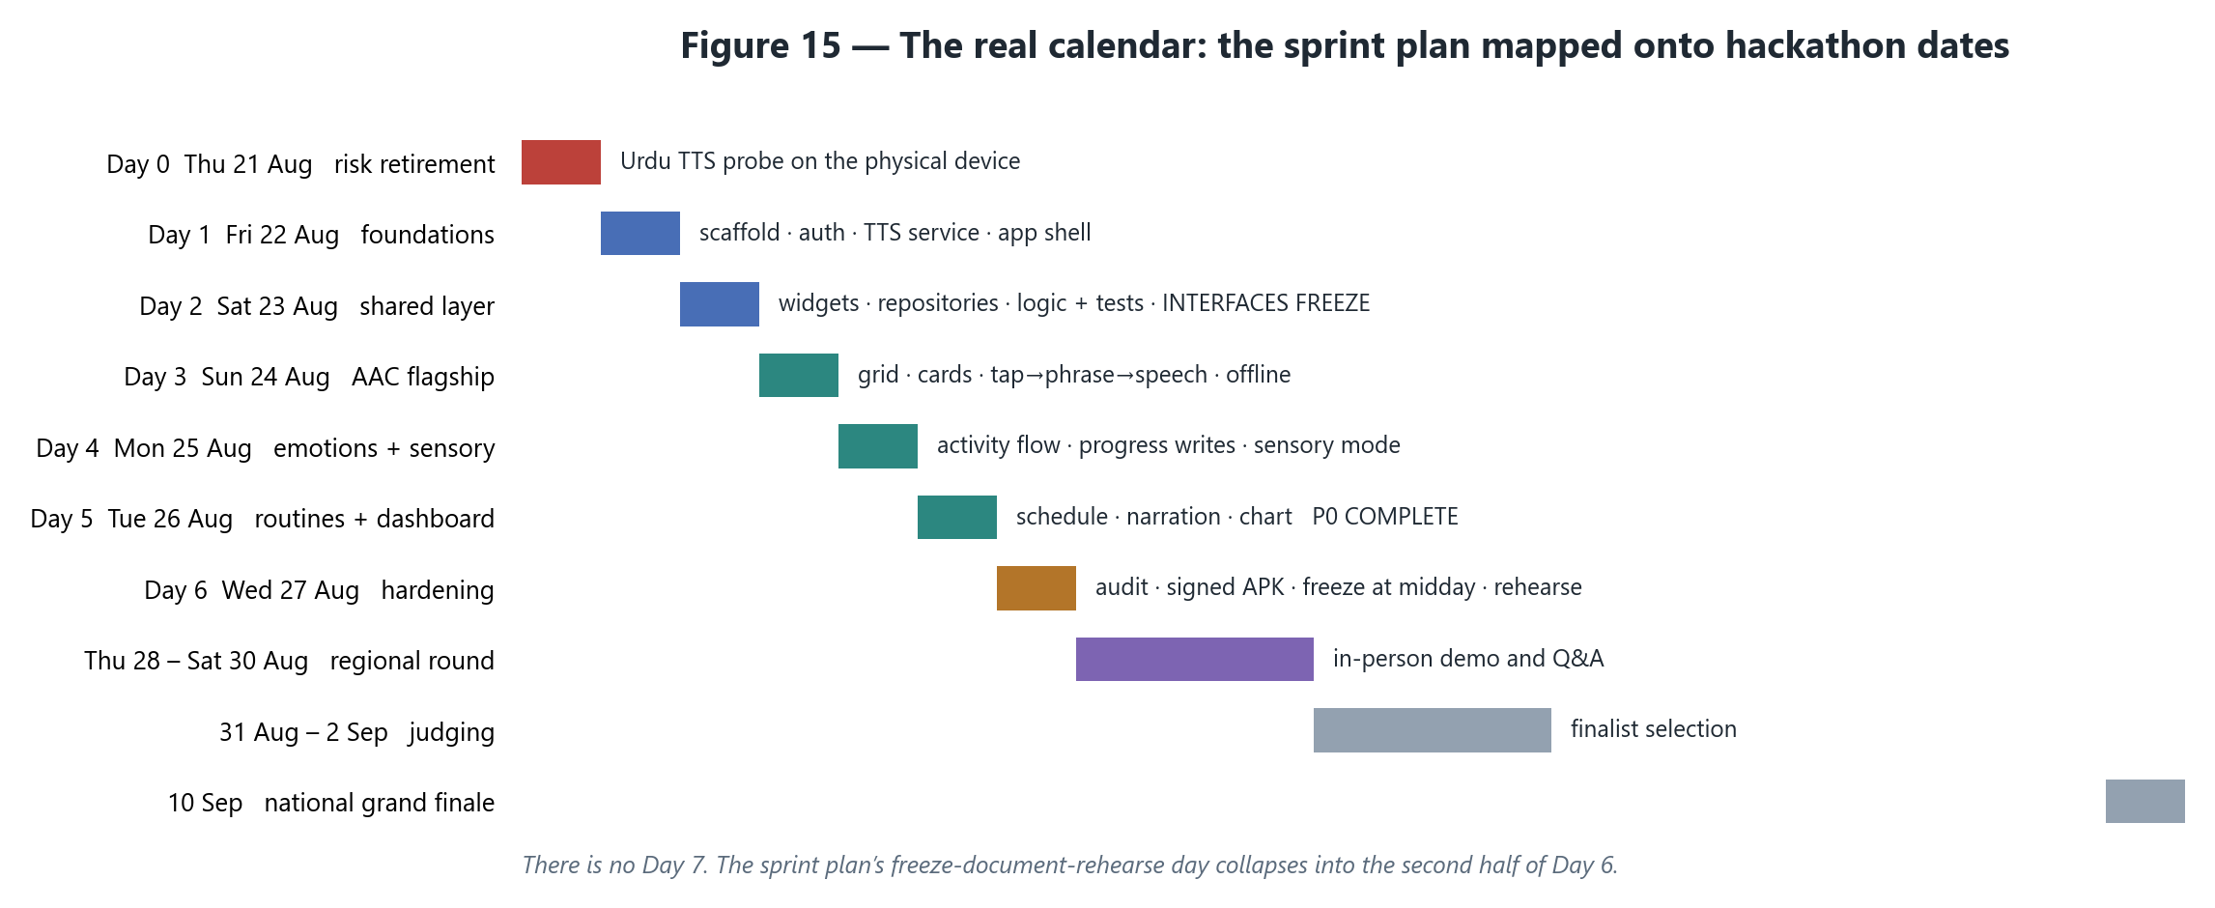
Figure 15 — The sprint mapped onto real dates. Note that the seventh day does not exist.
Day | Focus | The gate that must be true before moving on
Day 0 Thu 21 Aug | Environment and risk retirement | An Urdu voice is verified — or ruled out — on the physical demo device (section 10)
Day 1 Fri 22 Aug | Foundations, everyone in parallel | The app launches, a user can register, and a string speaks aloud in Urdu
Day 2 Sat 23 Aug | Shared layer and contracts | Nobody is blocked on anybody. Interfaces freeze. ~30 unit tests green
Day 3 Sun 24 Aug | AAC — all hands on the flagship | A child taps an apple card and the phone says “I want an apple.” In airplane mode. In Urdu
Day 4 Mon 25 Aug | Emotion activity and sensory mode | Five questions completed, stars shown, the result lands in Firestore
Day 5 Tue 26 Aug | Routines and dashboard | P0 feature-complete. Everything after this is polish and hardening
Day 6 Wed 27 Aug | Hardening, freeze at midday, rehearse | Signed APK on the demo device; two full run-throughs with no crash

Day 3 is the one that matters most. The AAC moment is the opening scene of the demonstration and it must be flawless before anything else gets attention.

15.2 The 16-week roadmap this is a slice of
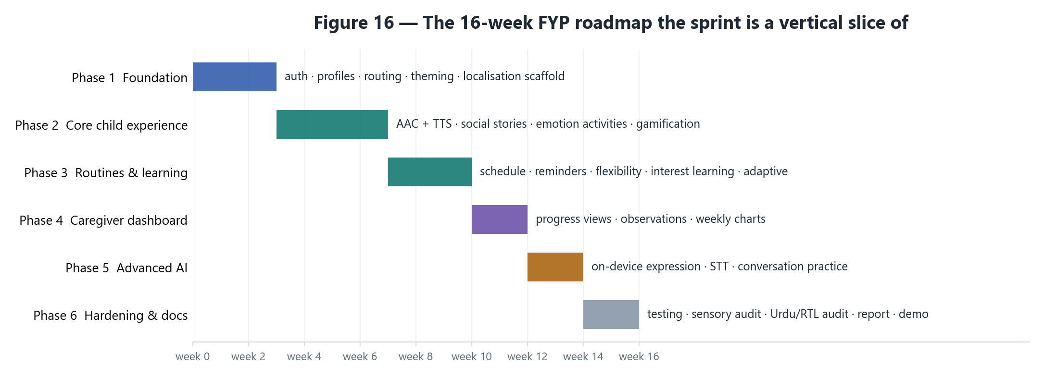
Figure 16 — The full FYP plan. The sprint builds a vertical slice through phases 1 to 4.
The sprint is not the project. The scope document describes eight modules over roughly sixteen weeks; the sprint takes a vertical slice through it — fewer features, each working end to end, offline, in both languages, with real persistence. That demonstrates far better than seven half-built tabs, and it is far easier to defend in a viva.
Say this to a supervisor or a judge up front: “We scoped a vertical slice for the build week; the remaining modules are designed and documented but not implemented.” That is a professional answer. “We ran out of time” is not.

15.3 If time runs short — the cut order
Decided in advance, in writing, so that a tired team at 2 a.m. does not have to decide it badly:
1. Expression practice (the camera feature) — cut first, without hesitation.
2. Routine reminders and notifications.
3. Custom card creation — ship with seeded cards only.
4. Urdu on the parent screens — keep Urdu on every child screen, because that is the accessibility claim.
5. The dashboard chart — replace it with a simple statistics list.
Never cut: the AAC communication aid with text-to-speech, or offline capability. Those two are the project’s identity. Everything else is negotiable.

16 Risks
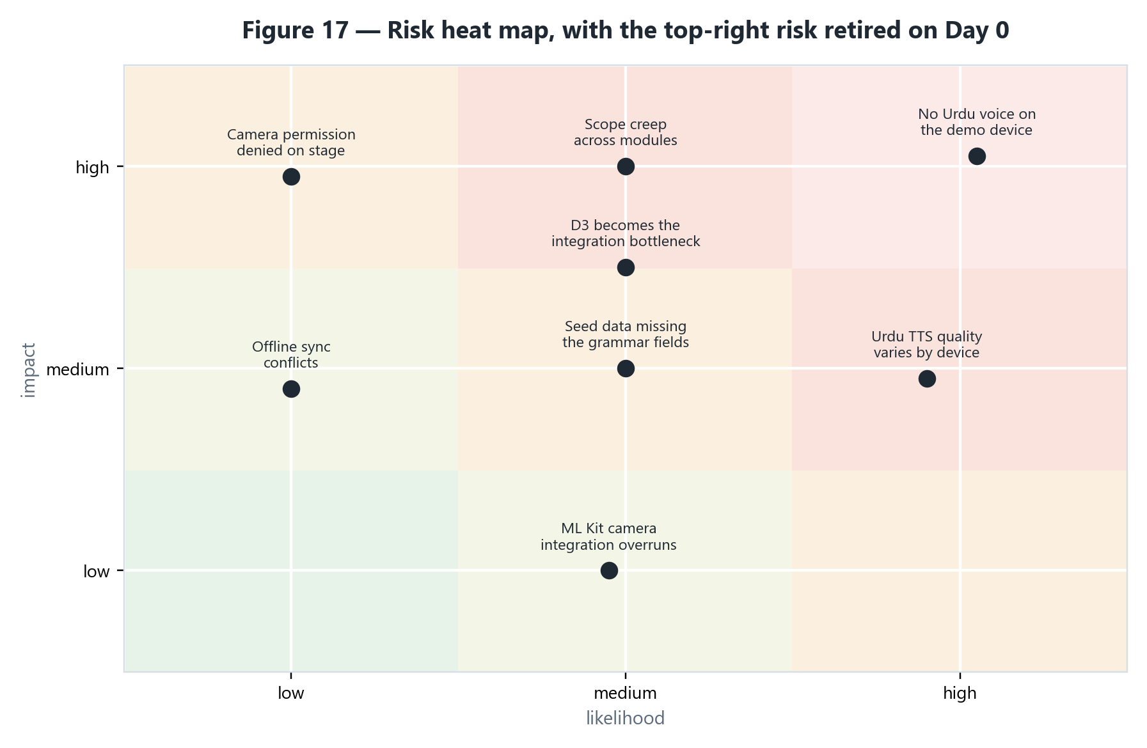
Figure 17 — The risk map. The one in the top-right corner is retired on Day 0 by the procedure in section 10.
Risk | Likelihood | Impact | Mitigation | Trigger to act
No Urdu voice on the demo device | High | High | Recorded native audio for ~30 core phrases, behind the same interface | The Day 0 probe result
Speech first-utterance latency breaches 500 ms | Medium | Medium | Warm start during initialise() | Day 1 measurement
Overlapping speech on rapid taps | High | Medium | Serial queue and barge-in, built in from day one | Built in, not deferred
Seed data lacks the four grammar fields | Medium | High | Requested in writing on Day 1 with the exact field list | Day 1 morning
Urdu realiser wrong on an unseen card | Medium | Medium | Test against the entire seeded card set, not just demo phrases | Day 6 audit
Scope creep across eight modules | High | High | Phase gates with explicit exit criteria; the out-of-scope list is binding | Any mid-sprint addition
ML Kit camera integration overruns | Medium | Low | Hard cut at midday on Day 6; nothing in P0 depends on it | Day 6 noon
Camera permission denied during the demo | Low | High | Granted before the demo; denial handled with a friendly fallback screen | Day 6 audit
The AI track becomes the integration bottleneck | Medium | Medium | Interfaces published Day 1, frozen Day 2, so others code against them early | Ongoing
No access to autistic children for testing | High | Medium | Validate against published accessibility guidance; seek a special-education teacher’s feedback | Ongoing

17 Quality — testing and the definition of done

17.1 What is tested, and how
Type | Focus | Roughly
Unit | Sentence realiser, emotion engine, adaptive controller, card ranker, progress aggregation — all pure Dart | 30+ tests
Widget | Reusable child-facing components, AAC grid, routine card, emotion activity screen | Key components
Integration | Auth → profile creation; complete-an-activity → progress-recorded | Two flows
Manual, daily | Airplane mode, Urdu and RTL layout, sensory mode audit, rapid-tap stress, first-utterance latency | Every day, on hardware

The logic track carries the team’s test-coverage claim because it is the testable one: none of it needs a device, a network or Firebase. That is also what makes it safe to refactor on day five while three other people are calling into it.

17.2 Definition of done, per feature
1. Implemented within the existing feature-based architecture.
2. All user-facing strings localised in English and Urdu, with RTL verified.
3. Loading, success, empty, error and retry states all handled.
4. Child-facing errors are friendly and non-technical.
5. Respects sensory-friendly mode — including volume ceiling and reduced motion.
6. Unit and/or widget tests written and passing.
7. flutter analyze clean.
8. Works offline wherever the offline requirement applies.
9. Firestore rules updated if new data is touched.
10. Verified on the physical demo device, not the emulator.
11. Reviewed by at least one other team member.

18 What you hand over, and in what format
The short answer: you do not deliver a model. There is no .tflite file, no .h5, no weights, no dataset and no training notebook — because nothing in AutiMate is trained. You deliver source code, tests, a signed APK, documentation and the report. The only machine-learning model in the project is Google’s face detector, which arrives bundled inside the ML Kit dependency: you consume it, you do not produce it.
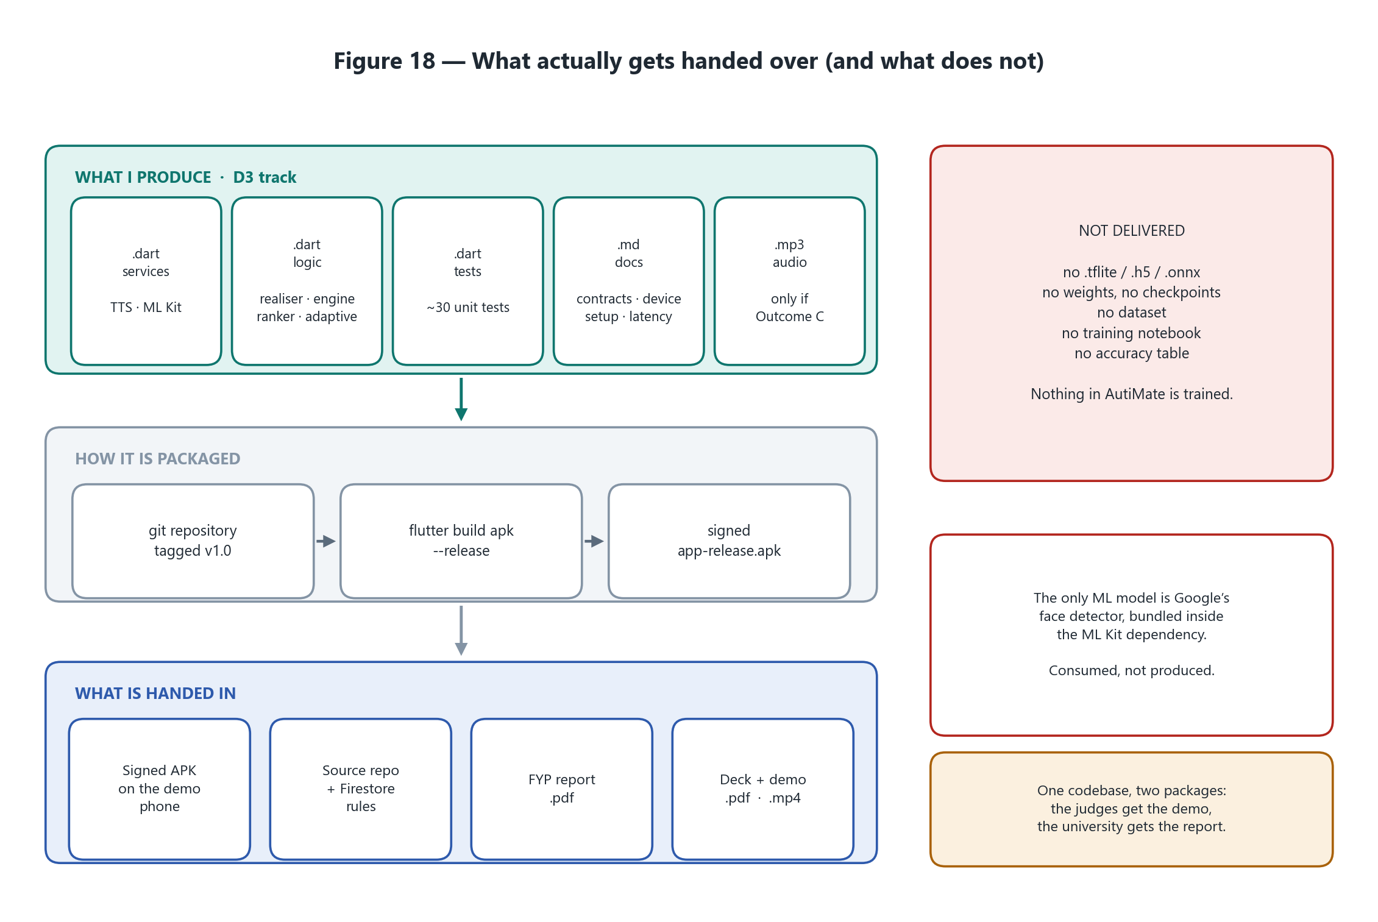
Figure 18 — Everything the AI track produces is source, tests, documents or audio. The model-shaped artefacts on the right are deliberately absent.

18.1 Why this question comes up at all
The phrase “AI project” is widely assumed to mean a trained model, a labelled dataset, a notebook and an accuracy table. That is the shape of a research project. AutiMate is a product project that uses AI where it earns its place. Both are legitimate final-year projects, and they hand over different things. Producing a model you never needed would mean you built the wrong project.
 | A model-building project | AutiMate
The central artefact | A trained model file and the notebook that produced it | A working application running on a phone
Evidence of quality | Accuracy, precision and recall, a confusion matrix on a held-out split | It runs offline, speaks grammatical Urdu, starts speaking in under 500 ms, and survives two full run-throughs without a crash
Data | A labelled dataset, cleaned and split | No dataset at all — and no child data leaves the device
Reproducibility | Re-run training and obtain comparable weights | Clone the repository, run flutter run, obtain the same application
The main risk | The model underperforms | The feature does not ship in time
What is defended | Architecture choices and hyperparameters | Engineering choices, and why machine learning was used only where it earned its place

18.2 What I deliver — the D3 track
Nine artefacts. Every one of them is source code, a test, a document, or — in a single conditional case — an audio asset.
# | Artefact | Format | Lives in | Who consumes it
1 | TtsService implementation | .dart | lib/core/services/tts/ | D4, and every screen that speaks
2 | SentenceRealiser — English and Urdu | .dart | lib/features/communication/logic/ | The AAC screen
3 | CardRanker | .dart | same folder | The “frequently used” row of the grid
4 | EmotionActivityEngine, with the confusability matrix as a const table | .dart | lib/features/emotion_recognition/logic/ | The activity screen; D4’s session summary
5 | AdaptiveLevelController | .dart | same folder | Between sessions; the parent dashboard
6 | ExpressionPracticeService — P1 only | .dart | lib/core/services/ml/ | The expression practice screen
7 | Unit test suite, roughly 30 tests | .dart, run by flutter test | test/ | The team, and the report’s quality claim
8 | Frozen interface contracts, the Day 0 device note, and the measured latency numbers | .md | docs/ | D1, D2, D4, the supervisor, the judges
9 | Recorded Urdu audio — only under Outcome C | .mp3 or .m4a, mono, 44.1 kHz | assets/audio/ur/, declared in pubspec.yaml | The fallback path inside TtsService

Notice what is not on that list. The closest thing to a “model” the AI track produces is the confusability matrix — a 6×6 table of hand-authored numbers in a Dart file. That is precisely why you can draw it on a whiteboard and defend every cell in it, which no trained classifier built in six days would let you do.

18.3 What the team delivers
Deliverable | Format | Owner
Source code repository, tagged at the code freeze | git repository, plus a .zip export as a backup | All; D4 cuts the release
Signed Android APK | .apk, release build, installed on the demo phone | D4
Firebase project with deployed security rules | firestore.rules in the repository and deployed | D2
UI/UX designs | Figma link plus a PDF export | D1
Test suite | .dart; flutter test green, flutter analyze clean | D3 leads, all contribute
Technical documentation | Markdown in docs/, plus this document | All
FYP report | .docx working copy, .pdf for submission | All
Presentation deck | .pptx plus a .pdf export | D4
Demo script and a recorded fallback video | .md plus a 1080p .mp4 | D4

18.4 Two audiences, two packages — one codebase
This is the distinction that most often goes wrong. The hackathon and the university want different artefacts from exactly the same work.
 | Hackathon regional round, 28–30 Aug | University FYP submission
What they receive | A phone with the app installed, a three-minute live demo, a short deck, a repository link | The full written report, the complete source, the documentation and the test evidence
What they judge | Does it work, is it useful, is the AI real and visible | Is the engineering sound, is the process documented, can you defend every decision
Attention available | Minutes | Hours
The centrepiece | The running APK | The report
The usual failure | A demo that crashes, or a claim that cannot be shown | Undocumented decisions and untested code

Do not hand a fifty-page document to a hackathon judge, and do not hand only an APK to a supervisor. Same work, packaged twice, with a different centrepiece each time.

18.5 Formats, names, and the things that get lost
- APK — name it autimate-v1.0-demo-20260827.apk. It must be a release build, signed with a keystore you have backed up somewhere other than the laptop. Lose the keystore and that build can never be updated.
- Repository — tag the code freeze (v1.0-hackathon) and also export a .zip. A submission that depends on GitHub being reachable at the wrong moment is a risk you do not need to take.
- Report — write it in .docx, submit .pdf. Place the diagrams from docs/diagrams/ at 220 dpi rather than screenshots of them.
- Deck — carry a .pdf export alongside the .pptx; a venue laptop will not have your fonts.
- Demo video — record a clean 1080p run on Day 6 while everything still works. If the live demo fails on stage you play the video and keep talking. It is the cheapest insurance in the entire project.
- Screenshots — take them on Day 6, in both languages, in sensory mode, and in airplane mode with the flight icon visible in the status bar. That icon is evidence, not decoration.
- Test evidence — save the actual console output of flutter test and flutter analyze to text files. A claim of thirty passing tests is worth more with the output beside it.

18.6 The submission package
autimate-submission/
├── apk/
│ └── autimate-v1.0-demo-20260827.apk signed release build
├── source/
│ └── autimate/ the repository, tagged v1.0
├── docs/
│ ├── architecture.md
│ ├── setup-guide.md
│ ├── interface-contracts.md frozen at the end of Day 2
│ ├── urdu-tts-device-notes.md the Day 0 probe result, outcome A / B / C
│ └── diagrams/ 18 figures, 220 dpi PNG
├── report/
│ ├── AutiMate_FYP_Report.pdf the submitted copy
│ └── AutiMate_FYP_Report.docx the working copy
├── presentation/
│ ├── AutiMate_Deck.pdf
│ └── AutiMate_Demo.mp4 the fallback recording
├── evidence/
│ ├── screenshots/ EN, UR, sensory mode, airplane mode
│ ├── flutter-test.txt
│ └── flutter-analyze.txt
└── README.md what everything is, and how to build it

18.7 If someone asks “where is your model?”
“There is one machine-learning model in the app: Google’s on-device face detector, which we run locally for the expression activity — and here it is, working in airplane mode. We deliberately did not train a classifier. There is no ethically obtainable dataset of autistic children’s faces or activity performance, and a parent needs to understand why the app did what it did. So the personalisation, the difficulty adaptation and the bilingual sentence generation are algorithms we can explain line by line, and the one place machine learning genuinely earned its place is the one place we used it. A fine-tuned emotion classifier is documented as future work.”

19 The demonstration
Three minutes, rehearsed at least three times on the actual demo device, in airplane mode from the first second so that nobody has to be told it works offline — they can see it.
Time | What happens | The line that goes with it
0:00 | Airplane mode is switched on, visibly, before anything else | “Everything you are about to see runs on the phone. Nothing leaves it.”
0:15 | A child profile is opened; the AAC grid appears | “This is what a non-verbal child sees. Eight categories, very large targets, almost no text.”
0:30 | Two cards are tapped: [I want] [apple] → the phone speaks | “Two taps, one sentence, spoken aloud.”
0:50 | The language toggle is switched to Urdu; the same two cards are tapped | “Same taps. The Urdu is generated, not translated — and the verb agrees with the child’s gender.”
1:15 | A card is tapped repeatedly, then the grid is reloaded and it has moved to the front | “The grid learns the child’s vocabulary, with a seven-day half-life so last month’s habits don’t crowd out today’s needs.”
1:35 | A five-question emotion session is played, deliberately getting two wrong | “Wrong answers get visually harder as the level rises — from a matrix I can show you.”
2:05 | The parent dashboard shows the session that just happened | “That result was written locally and will sync when a connection returns.”
2:20 | Sensory mode is toggled on, on camera | “Reduced motion, muted palette, a volume ceiling. No flashing anywhere in the app.”
2:35 | Expression practice, if it shipped: “make a happy face”, meter fills | “On-device machine learning. Frames are discarded after one pass — and we are still in airplane mode.”
2:50 | Close | “Support tool, not a diagnostic. Nothing about the child leaves the phone.”

Prepare for the two questions that always come: “Why isn’t module X built?” — because the week bought four modules working properly rather than eight half-working, and the rest are designed and documented. And “Where is the AI?” — answer it in the order given in section 8.1, claiming nothing that cannot be shown running.

20 Open questions to settle before the build starts
# | Question | Who answers | What it changes
1 | Which phone is the demo device, and does it have an Urdu voice? | Whoever holds the device, on Day 0 | Everything in section 9 and 10. Highest priority by a distance
2 | Is a second device available with the same voice? | The team | Whether the demo has a single point of failure
3 | Will the seeded cards carry pos, isCountable, startsWithVowelSound and urduGender? | D2, on Day 1 | Whether the Urdu realiser works properly or degrades to word-joining
4 | Does the child profile carry gender? | D2 | Urdu verb agreement. Without it, masculine is assumed and the limitation is noted
5 | Who produces the six emotion face assets — photographs or illustrations? | D1, needed by Day 3 | Illustrations avoid likeness and consent issues and suit the sensory-friendly design
6 | Is SessionResult the right shape for the chart? | D4, confirm Day 1 | It crosses three tracks; changing it on Day 4 is expensive
7 | Does everyone have a physical Android device? | The team, before Day 0 | Emulators cannot verify speech or the camera
8 | Are native Urdu recordings being made regardless of the probe result? | The team | Cheap insurance against a phone that updates itself overnight

21 Glossary
Term | Meaning
AAC | Augmentative and Alternative Communication — tools that support or replace speech, here a picture-card grid that speaks
ARB | Application Resource Bundle — the JSON-like files holding translated strings in a Flutter project
Barge-in | Interrupting speech that is already playing so a new utterance can start immediately
Confusability matrix | A table of how easily each pair of emotions is mistaken for the other; used to make wrong answers harder as level rises
EMA | Exponential moving average — smoothing applied to a jittery per-frame signal before it reaches the interface
ML Kit | Google’s on-device machine learning library; here, face detection with classification enabled
P0 / P1 | Priority zero — non-negotiable for this build. Priority one — only if P0 finishes on schedule
Realiser | The component that turns a structure into a grammatical sentence in one specific language
RTL | Right-to-left — the text and layout direction Urdu requires
Sensory mode | A global setting that reduces motion, mutes colour, caps volume and strips visual clutter
SVO / SOV | Subject–verb–object (English) and subject–object–verb (Urdu) word order
Surface realisation | The final stage of natural language generation: producing the actual words and their order
TTS / STT | Text-to-speech (the phone speaking) and speech-to-text (the phone listening). AutiMate ships the former
Vertical slice | A small set of features built end to end rather than many features built partially

Appendix A Interface contracts
These are the signatures the other three tracks write code against. They are published on day one marked provisional and frozen at the end of day two. Everything here is pure Dart: no widget, no Firestore document, no user-facing English string.

A.1 Speech
enum AppLanguage { en, ur }
enum TtsState { idle, speaking, unavailable }

/// The answer to "can this device speak this language?"
class VoiceAvailability {
final AppLanguage language;
final bool available;
final String? resolvedLocale; // 'ur-PK', 'ur-IN', or null
final bool usingRecordedFallback;
}

abstract class TtsService {
/// Call once during app start. Resolves voices and warms the engine so the
/// first real utterance is not slowed by engine initialisation.
Future<void> initialise();

/// Per-language availability — for the settings screen and for the fallback.
Future<List<VoiceAvailability>> availability();

/// Speak now, cancelling anything already speaking (barge-in).
/// Never throws — failures surface through [state].
Future<void> speak(String text, AppLanguage language);

/// Queue behind whatever is speaking. Used for routine step sequences.
Future<void> enqueue(String text, AppLanguage language);

Future<void> stop();

/// D1 binds the speaker icon to this.
Stream<TtsState> get state;
}

- speak() never throws. With no voice it emits TtsState.unavailable and returns; the interface shows a muted speaker and nothing crashes.
- initialise() must be awaited in main() before the first frame, or the first tap feels slow.
- The fallback chain is owned entirely inside the service. Callers never learn whether audio came from the platform engine or a recorded asset.

A.2 Sentence assembly
enum PartOfSpeech { carrier, pronoun, verb, noun, adjective, quantifier }
enum UrduGender { masculine, feminine }

/// The grammar-relevant subset of a card. D2 owns the full Firestore model
/// and maps into this; the logic never sees a Firestore document.
class CardGrammar {
final String id;
final String labelEn;
final String labelUr;
final PartOfSpeech pos;
final bool isCountable; // drives a / an / some in English
final bool startsWithVowelSound; // 'apple' true, 'university' false
final UrduGender urduGender; // drives Urdu agreement
}

/// Grammatical facts about the child, from their profile.
class SpeakerProfile {
final UrduGender gender; // چاہتا vs چاہتی
}

class RealisedSentence {
final String text;
final AppLanguage language;
}

abstract class SentenceRealiser {
RealisedSentence realise(List<CardGrammar> strip, SpeakerProfile speaker);
}

A.3 Card ranking, emotion activity, adaptive level
class CardUsageEvent { final String cardId; final DateTime usedAt; }

abstract class CardRanker {
/// Top-N card ids for the "frequently used" row, most relevant first.
List<String> rank(List<CardUsageEvent> history, {int limit = 8});
}

enum EmotionLabel { happy, sad, angry, surprised, scared, neutral }
enum SupportLevel { beginner, intermediate, advanced }

class EmotionQuestion {
final String assetKey; // D1 resolves this to an image
final EmotionLabel answer;
final List<EmotionLabel> choices; // shuffled, includes the answer
final bool hintVisible;
final int index; // 1-based, for "question 3 of 5"
final int total;
}

class SessionResult {
final String childId;
final String activityType; // 'emotion_identification'
final int score;
final int total;
final SupportLevel levelPlayed;
final SupportLevel levelAfter; // may differ — the rule stepped it
final Duration duration;
final DateTime completedAt;
final int starsAwarded; // 0-3
}

abstract class EmotionActivityEngine {
EmotionQuestion start({required SupportLevel level, int questionCount = 5});
AnswerOutcome submit(EmotionLabel picked);
EmotionQuestion? next(); // null when the session is over
SessionResult finish();
}

abstract class AdaptiveLevelController {
SupportLevel evaluate({
required SupportLevel current,
required List<bool> recentOutcomes, // most recent last
required bool parentLocked,
});
}

The engine returns assetKey values and enums — never display text. D1 maps each enum to a localised label. That single decision is what keeps Urdu working without the logic track ever touching an ARB file.

A.4 Expression practice
class ExpressionReading {
final double smile; // 0.0 - 1.0
final double leftEyeOpen;
final double rightEyeOpen;
final double headTiltDegrees;
final bool faceDetected;
}

abstract class ExpressionPracticeService {
Future<bool> isSupported();

/// Emits ~10-15 readings per second while the camera streams.
/// Frames are processed in memory and discarded - never written, never sent.
Stream<ExpressionReading> start();

Future<void> stop();
}

Appendix B The Urdu voice probe
The complete app is in the repository at tools/urdu_tts_probe/, with its own README. What follows is the part that matters — the probe itself. Add one dependency, run it on a physical phone, read the report on the phone’s screen, then repeat the whole thing in airplane mode.

B.1 The dependency
# pubspec.yaml
dependencies:
flutter:
sdk: flutter
flutter_tts: ^4.2.0

B.2 The probe
final FlutterTts tts = FlutterTts();

Future<void> probe() async {
// 1. Which engines exist, and which one are we actually talking to?
print(await tts.getEngines); // Android only
print(await tts.getDefaultEngine);

// 2. Every locale this engine claims to know.
final languages = (await tts.getLanguages) as List;
final urdu = languages.where((l) => l.toString().toLowerCase().startsWith('ur'));
print('Urdu locales: ${urdu.isEmpty ? "NONE - this is the bad outcome" : urdu}');

// 3. The three tags the real service will try, in order.
for (final tag in ['ur-PK', 'ur-IN', 'ur']) {
print('isLanguageAvailable("$tag") = ${await tts.isLanguageAvailable(tag)}');
}

// 4. Named voices. A voice can be listed while its data is NOT downloaded,
// and a name ending '-network' will not work in airplane mode.
final voices = (await tts.getVoices) as List;
print(voices.where((v) => v.toString().toLowerCase().contains('ur-')));
}

Future<void> speakUrdu() async {
await tts.stop();
await tts.setLanguage('ur-PK'); // then try 'ur-IN', then 'ur'
await tts.setSpeechRate(0.45); // the Android default is too fast for a child
await tts.setPitch(1.0);
await tts.speak('السلام علیکم، میں سیب چاہتا ہوں');
}

A printed “true” is encouraging. Hearing the sentence is proof. Run speakUrdu() with airplane mode on, and only then record the outcome as A, B or C per section 10.6.

Appendix C Figures and sources

C.1 Figure index
Figure | Subject | Section
1 | Users, modes, and what leaves the device | 3
2 | The eight modules and what ships this sprint | 5
3 | Layered architecture and track ownership | 6.1
4 | Feature-based project structure | 6.2
5 | Firestore data model | 7
6 | The AAC pipeline, tap to speech | 8.2
7 | Bilingual sentence realisation | 8.3
8 | Emotion activity flow | 8.5
9 | Adaptive difficulty state machine | 8.6
10 | Expression practice pipeline | 8.7
11 | Urdu voice resolution ladder | 9.2
12 | How to check for an Urdu voice | 10
13 | Offline-first behaviour | 11
14 | Team tracks and dependencies | 14
15 | The six-day build calendar | 15.1
16 | The sixteen-week roadmap | 15.2
17 | Risk heat map | 16
18 | What is handed over, and what is not | 18

Source images are in docs/diagrams/ at 220 dpi and can be reused directly in the FYP report and the presentation deck.

C.2 Source documents
File | What it is | How it was used here
AutiMate_Scope_Doc.md | The 16-week FYP product scope, eight modules | Sections 2–7, 12, 13, 15.2
AutiMate_7Day_Sprint_Plan.md | The four-person vertical-slice build plan | Sections 14, 15.1, 15.3, 17
AutiMate_D3_AI_Track_Plan.md | The AI / speech / logic work order | Sections 8, 9, 10, 16, Appendix A
ABC_AIH_Training_and_Programme_Schedule.pdf | The hackathon calendar | The real dates in section 15.1
tools/urdu_tts_probe/ | The runnable probe app | Section 10.3, Appendix B

— End of document —

