1. (MM01) Define a finished good called Bike……. Write your number assigned to you at the beginning of the training in the dotted area ie. Bike_AGU55.

MM01-Basic Data 1- Additional Data: Turkish and English language maintenance should be done.

Define the storage location for this item as Z001

Choose the planning strategy group as 40 (in MİP3 screen)

Define a safety stock of 10 for your finished good, do not define any safety stocks for the semi-finished goods.

Define 3 semi-finished goods as Frame assembly, Wheel and Frame similar numbering rule applies with finished goods. Ie. F.assembly_AGU55

Define the storage location for this item as Z002

1. (CS01) Bill of materials (BOM) for a bike is given in the figure below. Orange boxes show the raw materials and these are already defined in the system. Define the bill of materials for you Bike, Frame assembly, Wheel and Frame. Do not forget to start from the bottom level of the BOM tree. In other words, firstly define the BOM of your Wheel and Frame, then your Frame assembly and lastly your Bike.

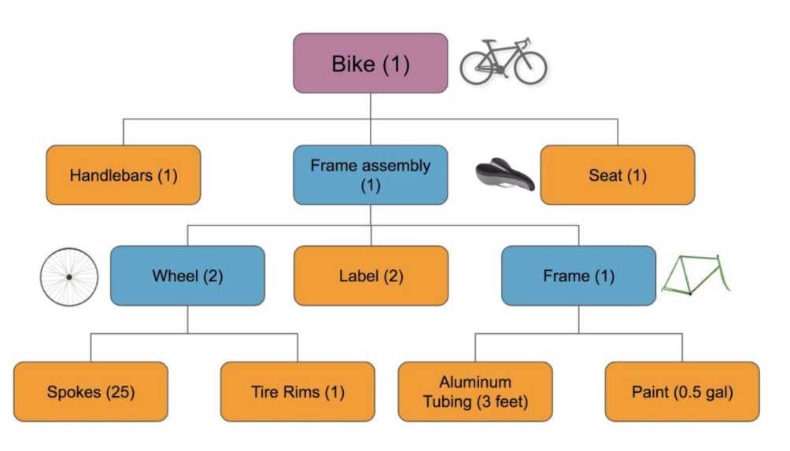

SAP Material No and Material Definitions are given below.

|  |  |
| --- | --- |
| 2234 | Handlebars(AGU-MT) |
| 2237 | Seat(AGU-MT) |
| 2238 | Spokes(AGU-MT) |
| 2239 | Tire Rims(AGU-MT) |
| 2241 | Aluminum Tubing(AGU-MT) |
| 2242 | Paint(AGU-MT) |
| 2240 | Label(AGU-MT) |

1. (CS02) Planning staff recognized that there is a mistake in the BOM. In fact 3 labels are used for the frame assembly instead of 2. Open the BOM you created from CS02 and make the required change.
2. (10 pts) (CA01) Define the routing for you Bike, Frame assembly, Wheel and Frame. Workcenters Z_PKT and Z_MNT are already defined in the system.

Wheel➔ Workcenter Z_PKT Setup 5 min. /Machine 10 min. /Labor 15 min

Frame ➔ Workcenter Z_MNT Setup 12 min. /Machine 15 min. /Labor 27 min

Frame Assembly ➔ Workcenter Z_PKT Setup 15 min. /Machine 20 min. /Labor 35 min

Bike ➔ Workcenter Z_PKT Setup 8 min. /Machine 12 min. /Labor 20 min

*Choose control key as PP03 for both of the workcenters Z_PKT and Z_MNT

1. (C223) Match the BOMs and the routings.
2. (MD61) Define a forecast of 100 units of your bike for the May 2023.
3. (MD02) Run an MRP only for your bike. Check if planned order are created for your bike and semi-finished goods from MD04. There are already stocks of the raw material in the system. For that reason, there will be no purchasing demand for these raw materials after you run the MRP.

MRP Parameters should be

NETCH-1-3-1-3-1

1. (MD04) Convert the planned order releases of the bike and semi-finished goods to production order.
2. (CO11N) Assume that the production of the bikes and semi-finished goods are completed. Complete your production orders. Start from the semi-finished goods.
3. Now you should be able to see the stock of your bikes in the storage location Z001, check this from MMBE and MB52. From MB52 export the table to an excel file.