[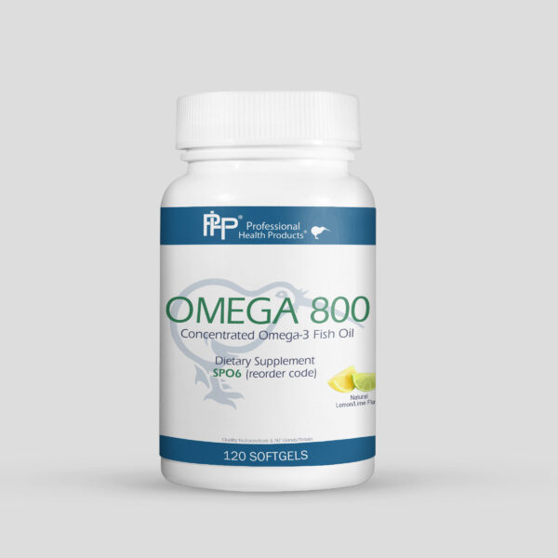](https://professional-health-products.com/wp-content/uploads/2019/04/SP06_Omega-800_rev3-1-bottle.jpg)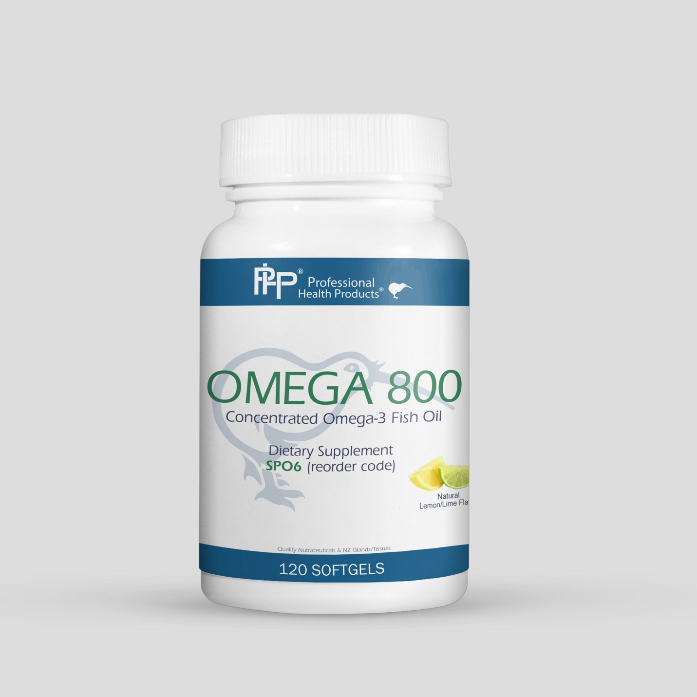

[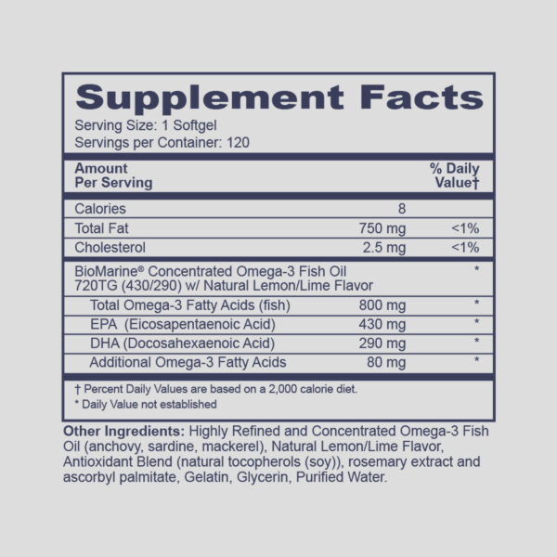](https://professional-health-products.com/wp-content/uploads/2019/04/SP06_Omega-800_rev3-1-supp.jpg)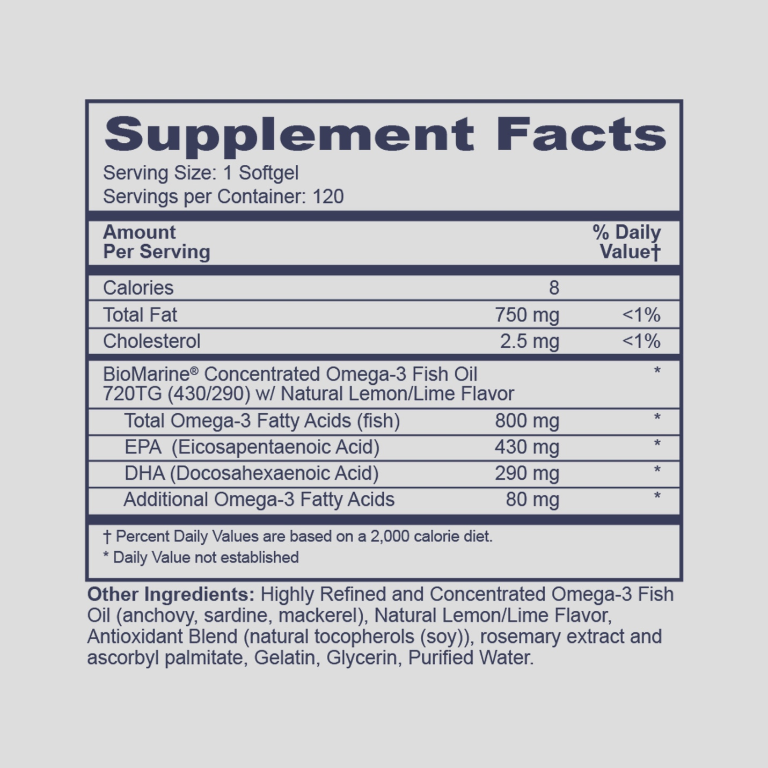

1. 