Fahim

A Little Yes

STATUS  Build baseline |  | OWNER  Fahim |  | LAST UPDATED  October 13, 2026

Authors | Codex
Reviewers | Owner; engineering review
Related docs | plan.txt; ARCHITECTURE.md; DATA_MODEL.md
Scope | One romantic invitation with private responses and editable settings.

1. Abstract
A personal invitation for Fahim’s wife opens as a romantic love letter, then guides her through an answer, a date and time, activities, an optional note, and a review. Next.js hosts the experience and private admin dashboard; Supabase stores complete responses and authenticates Fahim. A saved receipt appears only after the database commits.
The launch audience is one real recipient on her phone. Both acceptance and decline are valid outcomes. Drafts remain in memory; one private invite permits one completed response. The design supports editable invitation settings and CSV/Excel exports, with no payments, visitor analytics, or recipient account.

2. Goals and Non-Goals
Goals | Non-goals
A polished phone-first Yes/No journey. | Payments, bookings, or fake charges.
One complete response per invite, with a real receipt. | Partial-response tracking or visitor analytics.
Private admin tools, exports, and editable settings. | Public signup or a general form builder.
Safe retries and preserved historic answer labels. | Multi-couple SaaS or automated messaging.

3. Background and Problem Statement
Fahim wants to give his wife a thoughtful website. The local WhatsApp video supplies the soft pink invitation mood and step sequence. Design quality, an accessible phone experience, and a trustworthy private reply matter more than traffic. Launch succeeds when she completes the invitation and Fahim retrieves that exact response securely.
The browser owns the interaction and unfinished choices. Next.js owns validation, private sessions, and server boundaries. Supabase owns durable state, Auth, and admin access policies. The main invariant is simple: only a complete, explicitly confirmed answer is stored, at most once per private invite.

4. Proposed Architecture

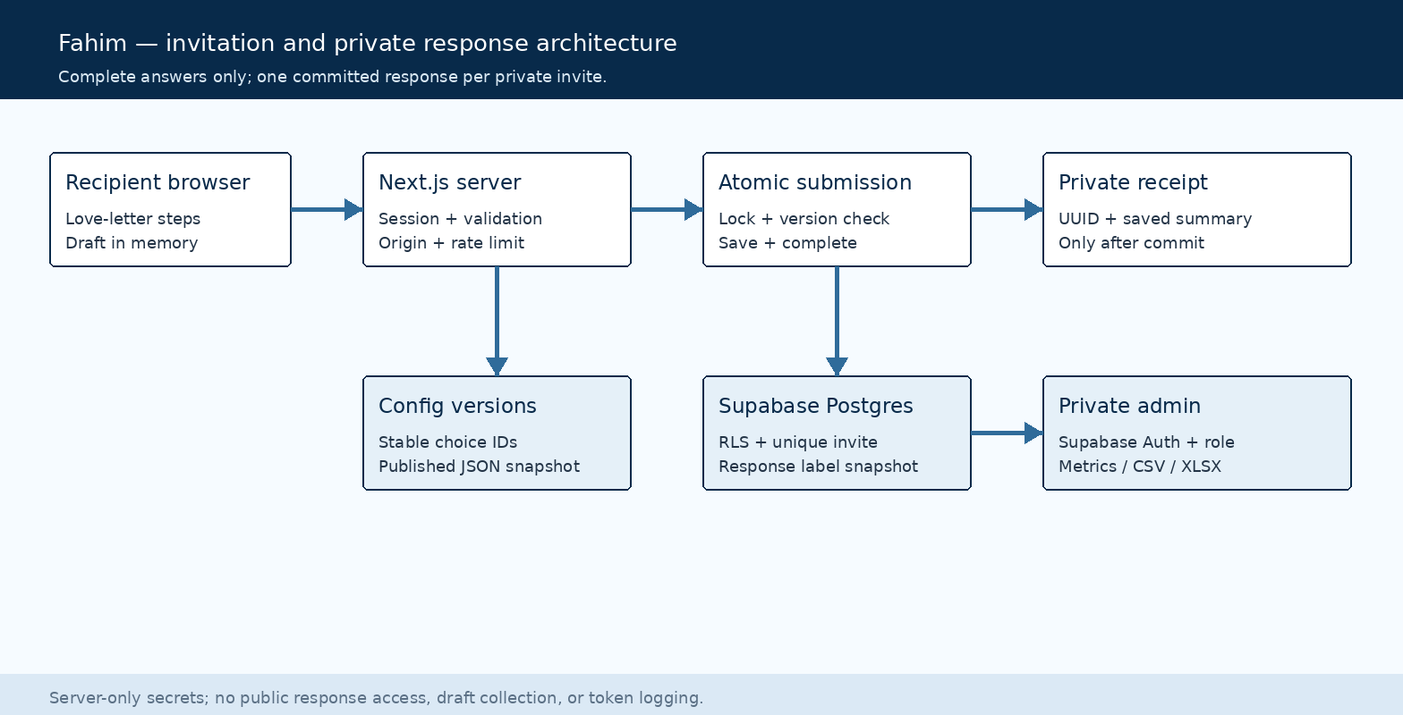
Figure 1. Invitation, server, and private data boundaries.

Core components

Component | Responsibility | Primary storage | Failure behavior
Recipient UI | Accessible steps, review, receipt. | In-memory draft | Retain selections; retry.
Next.js server | Sessions, validation, exports. | Scoped cookies | Fail closed; clear errors.
Config versions | Publish validated JSON settings. | Postgres | Reject stale versions.
Response store | Atomic answer + completion. | Postgres | Rollback; safe retry.
Admin dashboard | Auth, metrics, edit/delete. | Auth + RLS | Deny without membership.

5. Request Lifecycle
- Open the private invite, validate its random token, and exchange it for a scoped HttpOnly session.
- Load only public invitation settings. Keep all unfinished choices in browser memory.
- Yes requires valid scheduling; either answer must complete its applicable configured questions.
- On submit, verify session, origin, payload bounds, rate limit, expected version, dates, and option IDs.
- In one transaction, lock the invite, insert the complete response, and mark the invite completed.
- Retry safely with the same request key/content. Return the existing authorized receipt after a lost reply.
- Show the committed summary and UUID. Keep errors friendly and log no private note or token.

6. API and Data Contracts

Primary data contract

Field | Type | Required | Description
answer | yes / no | Yes | Confirmed invitation outcome.
chosenDate / slot | Local / ID | For Yes | Valid future slot in invitation timezone.
configVersion | Integer | Yes | Must match current published settings.
idempotencyKey | Random ID | Yes | Retry identity; server checks payload hash.
message | Plain text | No | Bounded note; never HTML.
selections | ID arrays | By question | Allowed IDs, counts, and label snapshot.
id / submittedAt | UUID / UTC | Server | Saved receipt and commit timestamp.

Contract guarantees

- Success requires a committed complete response; validation failures create no response rows.
- One invite has one final response. Matching retries return it; conflicting key reuse is rejected.
- Capture the published version and label snapshot so later edits cannot rewrite prior meaning.
- Stored responses describe completed answers only; they do not measure visits or abandoned forms.
The data model and validation contract are documented in
DATA_MODEL.md; keep it aligned with schema migrations and server validation.

7. Consistency, Idempotency, and Replay

Database uniqueness and a recipient row lock enforce one completion across tabs, devices, and network retries. The response and completion marker commit together. A normalized payload hash detects conflicting replay. Drafts have no server persistence, and final receipts require the invite’s scoped authorization.
Scenario | Expected behavior | Reasoning
Repeated submit | Return same authorized receipt. | Unique invite + payload hash.
Database failure | Keep draft; allow retry. | Transaction leaves no partial answer.
Reply lost after save | Retry returns saved receipt. | Completion is durable, independent of HTTP.
Published settings change | Ask recipient to review latest settings. | Atomic version check avoids stale labels.

8. Security and Privacy Considerations

- Admins need verified Supabase Auth plus provisioned invitation membership. Enforce owner scope in RLS and every endpoint.
- Hash random invite tokens; exchange them for scoped sessions. Never log notes, bearer links, credentials, or full payloads.
- Keep elevated keys server-only. Recipient operations using them must enforce authorization explicitly because they bypass RLS.
- Use HTTPS cookies, origin checks, plain-text escaping, security headers, persistent rate limits, and formula-safe exports.
- Collect complete answers only. Deletion removes content while preserving completion; provide link revocation and documented cleanup.

9. Operational Readiness
Signal | SLO or alert | Owner | Launch gate
Saving | Yes/No and retry scenarios pass. | Engineering | Required
Phone usability | Inspect phone/desktop + reduced motion. | Engineering | Required
Access boundary | Anonymous/other-user reads denied. | Engineering | Required
Configuration | Stale versions rejected; history intact. | Engineering | Required
Recovery | Duplicate race and deletion checks pass. | Engineering | Required
Rollout: use separate test links, connect real Supabase, verify Auth/RLS, then configure Vercel HTTPS and release the personalized private invite.

10. Alternatives Considered

Alternative | Why it was considered | Why it was not selected
Fully normalized question tables | Flexible general form querying. | JSON versions suit this small gift and simplify snapshots.
Recipient accounts | Stronger identity checks. | Login adds friction; a revocable private link fits the gift.
Browser-only saving | Fast visual prototype. | Cannot provide trustworthy private persistence or admin tools.
Process-local rate limits | Simple implementation. | Do not reliably share state across Vercel instances.

11. Open Questions
- Personalization: wife’s display name and final copy/media. Local default: “my love”, English, signed Fahim.
- Scheduling: final dates, slots, and activities. Initial timezone is Asia/Dhaka; settings remain editable.
- Launch: actual Supabase/Vercel projects, repository owner, admin email, and approved Auth redirect URLs.
- Privacy: whether an extra access code is needed and how long the final note should be retained.

12. Decision and Next Steps
Build the agreed personal gift with the requested stack, versioned settings, and secure final saving. Verify the romantic flow locally first, then exercise the connected database and admin operations with test invites. Release to the one intended recipient only after real setup, security checks, and final personalization. No live service or deployment is implied by this blueprint.
Milestone | Deliverable | Exit criteria
M1 | Responsive invitation and honest setup states. | Phone/desktop and keyboard flows verified.
M2 | Schema, Auth, RLS, atomic saving. | Connected tests prove access and duplicate rules.
M3 | Dashboard, configuration, CSV/XLSX. | Metrics/filters/history and export safety verified.
M4 | Personalized release and handover. | Real owner setup, tested private link, docs and source delivered.

A private bearer link grants access to whoever possesses it; it is not proof of identity.

