Health & Wellness
News Digest — Q1 2026

A curated collection of the latest research and insights across nutrition, pharmacology, mental health, and preventive medicine. Sources include NPR, WebMD, Healthline, Mayo Clinic, and BBC Health.

FEATURED ARTICLE

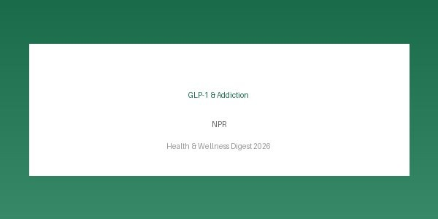
Image: GLP-1s have transformed weight loss and diabetes. Is addiction next? — NPR

GLP-1s have transformed weight loss and diabetes. Is addiction next?
Source: NPR | Author: Jon Hamilton | Published: 2026-03-10
A large study found that people taking GLP-1 drugs like Ozempic for diabetes were less likely to be diagnosed with substance use disorder.
A large-scale study involving over 600,000 veterans demonstrated that individuals prescribed GLP-1 receptor agonists for diabetes management showed approximately 15% lower rates of substance use disorder diagnoses. Researchers believe the drugs may modulate reward pathways in the brain,

reducing compulsive behaviours associated with addiction. This finding opens a new frontier for GLP-1 treatments beyond their established roles in weight management and glycaemic control.

ARTICLE SUMMARY TABLE — WITH BORDERS
The table below summarises all five articles in this digest, including source, author, and publication date. Bordered tables are ideal for structured data comparison.

# | Title | Source | Author | Date
1 | GLP-1s have transformed weight loss and diabetes. Is ad… | NPR | Jon Hamilton | 2026-03-1  0
2 | Mediterranean Diet Linked to Lower Risk of Heart Diseas… | WebMD | Sarah Klein | 2026-03-0  8
3 | 7 Science-Backed Benefits of Intermittent Fasting | Healthline | Rachael Ajmera | 2026-03-0  5
4 | Mental Health and Exercise: What's the Connection? | Mayo Clinic Staff | Mayo Clinic | 2026-03-0  1
5 | Ultra-processed foods linked to early death, major stud… | BBC Health | James Gallagher | 2026-02-2  5
VISUAL HIGHLIGHTS

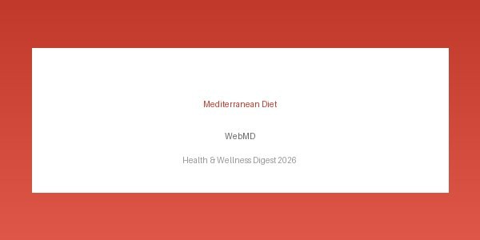
Image: Mediterranean Diet Linked to Lower Risk of Heart Disease — WebMD



Image: 7 Science-Backed Benefits of Intermittent Fasting — Healthline

KEY STATISTICS — NO BORDERS
Borderless tables convey information with a cleaner, more editorial look. Subtle row shading maintains readability without visible grid lines.

Statistic | Value | Context
GLP-1 addiction risk reduction | ~15% | Study of 600,000+ veterans
Heart disease risk reduction (Mediterranea2n8d%iet) 25,000 participants over 10 years
Antidepressant equivalence (exercise) Comparable 49 clinical trial review
Ultra-processed food mortality risk increase+19% 20-country Lancet study
Average weight loss — orforglipron trial ~20 lbs Eli Lilly clinical trial, 2026

MORE ARTICLES

Mediterranean Diet Linked to Lower Risk of Heart Disease
WebMD · Sarah Klein · 2026-03-08
New research confirms that adherence to the Mediterranean diet significantly reduces the risk of cardiovascular events in adults over 50.

7 Science-Backed Benefits of Intermittent Fasting
Healthline · Rachael Ajmera · 2026-03-05
From weight loss to improved brain function, intermittent fasting has a growing body of evidence supporting its health benefits.

Mental Health and Exercise: What's the Connection?
Mayo Clinic Staff · Mayo Clinic · 2026-03-01
Regular physical activity can ease symptoms of depression and anxiety, and experts now say it should be a standard part of mental health treatment.

Ultra-processed foods linked to early death, major study finds
BBC Health · James Gallagher · 2026-02-25

People who eat large amounts of ultra-processed foods face a significantly higher risk of premature death, according to research spanning 20 countries.

ADDITIONAL VISUALS

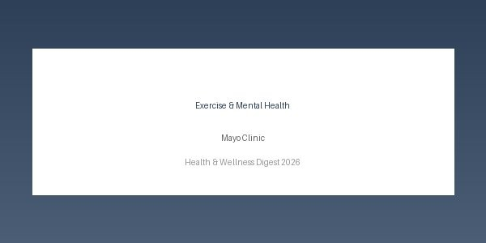
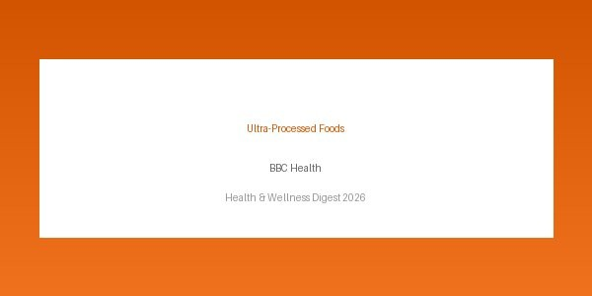
Image: Mental Health and Exercise: What's the Connection? — Mayo Clinic Staff

Image: Ultra-processed foods linked to early death, major study finds — BBC Health

