GLP-1 DRUGS & ADDICTION
ARTICLE STATS — WITH BORDERS

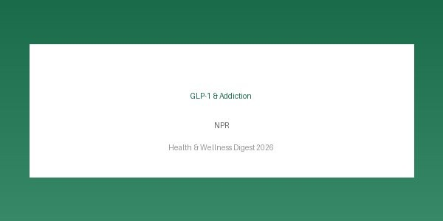
Source | Key Finding | Date
NPR | 15% addiction risk drop | 2026-03-10
WebMD | 28% lower CVD risk | 2026-03-08
Healthline | Multi-benefit fasting | 2026-03-05
Mayo Clinic | Exercise = antidepressants | 2026-03-01
BBC Health | +19% mortality risk | 2026-02-25

Source: NPR

GLP-1s have transformed weight loss and diabetes. Is addiction next?
Jon Hamilton · 2026-03-10
A large study found that people taking GLP-1 drugs like Ozempic for diabetes were less likely to be diagnosed with substance use disorder.
A study of over 600,000 veterans found that GLP-1 drug users had roughly 15% lower rates of substance use disorders, suggesting these medications may modulate brain reward pathways beyond their metabolic effects.
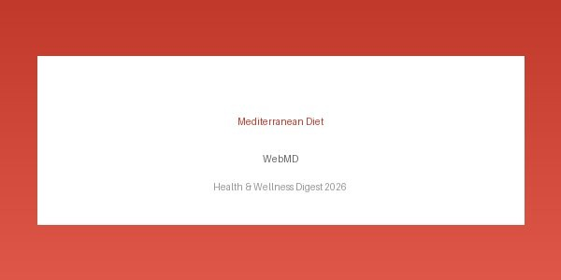
MEDITERRANEAN DIET & HEART HEALTH

Source: WebMD

Mediterranean Diet Linked to Lower Risk of Heart Disease
Sarah Klein · 2026-03-08
New research confirms that adherence to the Mediterranean diet significantly reduces the risk of cardiovascular events in adults over 50.

INTERMITTENT FASTING
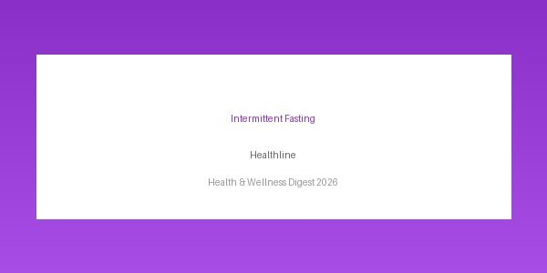
Source: Healthline

7 Science-Backed Benefits of Intermittent Fasting
Rachael Ajmera · 2026-03-05
From weight loss to improved brain function, intermittent fasting has a growing body of evidence supporting its health benefits.
KEY NUMBERS — NO BORDERS

Metric Value

GLP-1 addiction reduction ~15%
CVD risk reduction 28%
Exercise vs antidepressants Equivalent
Ultra-processed food risk +19%
Orforglipron weight loss ~20 lbs

MENTAL HEALTH & EXERCISE
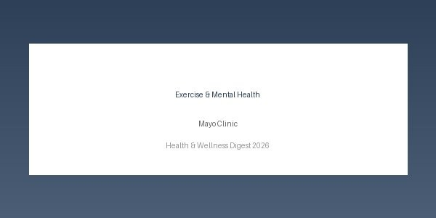
Source: Mayo Clinic Staff

Mental Health and Exercise: What's the Connection?
Mayo Clinic · 2026-03-01
Regular physical activity can ease symptoms of depression and anxiety, and experts now say it should be a standard part of mental health treatment.
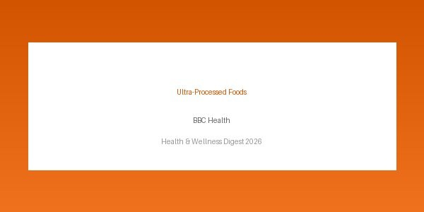
ULTRA-PROCESSED FOODS

Source: BBC Health

Ultra-processed foods linked to early death, major study finds
James Gallagher · 2026-02-25
People who eat large amounts of ultra-processed foods face a significantly higher risk of premature death, according to research spanning 20 countries.

